Investigation on Parameters Influencing Natural Rubber Rebound Resilience Properties

Alif Ngimbi Diambu1, Binnur Gören Kıral2, Zeki Kıral2

*1MSc, Dokuz Eylul University University, The Graduate School of Natural and Applied Sciences, Izmir, Turkey.*

*2Prof. Lecturer, Dokuz Eylül University, Faculty of Engineering, Department of Mechanical Engineering, Izmir, Turkey*

*Corresponding Author: Binnur Gören Kıral, binnur.goren@deu.edu.tr*

*ABSTRACT: Rubber has a wide range of industrial applications. One of important properties of rubber is rebound resilience. This property is related to its energy absorption capacity when subjected to dynamic loads. There are applications where a high resilient rubber is necessary and so, absorb less energy and vice versa. Thus, the choice of rubber type shall depend on the application. Studies on rubber rebound resilience properties are notably limited in the literature. This study investigates the parameters influencing natural rubber rebound resilience properties. To this end, a Schob type pendulum rebound resilience testing machine was designed and manufactured according to DIN 53512 and other equivalent standards like ISO 4662 and ASTM D7121 to determine the bounciness (elasticity) of rubber having a Shore-A hardness between 30 IRHD and 85 IRHD. Then, two types of test specimens were manufactured. The first type is the natural rubber from the Democratic Republic of Congo (D.R. Congo) Mayombe forest Hevea trees and the second type is the natural rubber from Vietnam. In this study, rubber aging effect on hardness, the relation between rebound resilience and hardness, the relation between rubber origin and rebound resilience, and the effect of temperature on rebound resilience were investigated. Results showed that rebound resilience is proportionally related to hardness. An increase in hardness implies an increase in rebound resilience. For equal hardness, rubber from D.R. Congo would be more suited for applications where damping properties are needed, while rubber from Vietnam would be suitable for applications where high resilience is needed. In the interval between 40°C and 90°C, temperature increase leads to an increase in natural rubber rebound resilience.*

***KEY WORDS:*** *Rebound resilience, Natural rubber, Shore-A hardness*

---------------------------------------------------------------------------------------------------------------------------------------

Date of Submission: xx-xx-xxxx Date of acceptance: xx-xx-xxxx

---------------------------------------------------------------------------------------------------------------------------------------

# INTRODUCTION

Polymers are among the most widely used materials in different fields and several products. Among polymers, rubber material has an essential role in many applications due to its properties such as incompressibility, reversibility, large elongation, high mechanical strength, long-term hardness stability, waterproof, poor heat and electric conductivity, and service life. Specifically, rubber can withstand deformation up to several hundred percents and resume its original shape within a short time after stress release [1]. In view of all these properties of rubber, it is not surprising to find it used in products like tires, adhesives, roofing membranes, protective gloves, electrical cables, inflatable boats, balloons, etc. The choice of the right type of rubber will largely depend on the environment of use. In applications where rubber is under repeated shocks and dynamic loads in machine elements, for instance, the choice of a convenient rubber type is necessary, and that choice is guided by the rebound resilience testing. Rebound resilience is defined differently according to several authors. It enters in the category of unforced dynamic motion testing where test pieces are subjected to one-half of deformation. Roger defined it as a percentage of “the ratio of the energy of the indentor after impact to its energy before impact”, hence, in the case where the indentor falls under gravity, is equal to “the ratio of rebound height to the drop height” [2]. The same author defined it as “the ratio of the square of velocities before and after impact …”. Deutsche Norm DIN 53512 (2000) defines the rebound resilience, R as “the ratio of energy returned to energy applied or as the ratio of the height of rebound (h) of a pendulum by its height of fall (H)” as shown in Figure 1 [3,4].

PENDULUM ROD

SPECIMEN

ANVIL

HAMMER

HAMMER PEEN

PENDULUM LENGTH

**H**

**h**

****

**Reference**

**Figure 1: Schematic representation of the Schob pendulum**

Rebound resilience is an important test used in quality control of rubber products. However, few studies have focused on rubber rebound resilience properties in the literature. Martinovs et al. conducted a study on determination constants of 4-element rheological model with rebound resilience method, where a mathematical model to describe collision was elaborated using an algorithm for the determination of the constants of the chosen model [5]. Luo et al. proposed an approach based on rebound resilience to account for the Mulins effect during loading and unloading of rubber products [6]. Jones and Snyder investigated the effect of temperature on resilience of natural and synthetic rubber, where it was found that both these materials have very good resilience at elevated temperatures [7]. Ajay determined the rebound resilience and the contact time of balls with the surface of impact for three different types of ball by calculating the coefficient of restitution of the ball-surface combination from the experimentally measurable physical quantities, such as initial drop height and time interval between successive bounces [8]. Luo et al. used a resilience experiment to perform dynamic analysis on solid rubber anti-vibration systems [9]. Ajay studied the motion of a bouncing ball by representing it through an equivalent mass-spring system executing damped harmonic oscillations. A differential equation was solved to study the elastic and dynamic properties of the motion expressed in terms of contact time; coefficient of restitution related to rebound resilience [10]. Voda et al. used nuclear magnetic resonance, differential scanning calorimetry and rebound resilience techniques to characterize the molecular chain mobility, phase composition, glass transition temperature and angle of rebound of a series of thermoplastic polyurethane with different content in the hard segments and different molecular weight of the soft segments [11]. Mullins investigated the effect of temperature on resilience of rubber vulcanisates [12].Bedriye and Bağdagül studied the reinforced natural rubber with chopped and hydrocarbon sized carbon fiber to get improved tensile modulus [13]. Rebound resilience was improved for natural rubber/epoxidized natural rubber compound. Pandian and Govindan compared rebound resilience results between natural rubber and carbon black filled natural rubber composites. It was observed that pure natural rubber presents lower rebound resilience [14]. Phanny studied the effect of different origins (From Malaysia and Vietnam) of natural rubber on the properties of carbon black filled natural rubber composites. Carbon black filled natural rubber from Vietnam showed higher resilience compared to Carbon black filled natural rubber from Malaysia, which can be associated to better recovery from loading force of carbon black filled natural rubber from Vietnam [15]. Moonchai and Moonchai modeled and optimized hardness and rebound resilience of natural rubber vulcanisates filled with defatted rice bran (DRB)/Calcium Carbonate (CaCO3). Higher rebound resilience was observed with lower filler loading. Compared to CaCO3, DRB-filled NR vulcanisates exhibited higher hardness, with CaCO3 giving higher rebound resilience at similar filler loading levels [16].

In this study, in order to investigate the parameters that influence natural rubber rebound resilience properties, a Schob type pendulum rebound resilience tester was designed and manufactured according to DIN 53512, ISO 4662 and ASTM D7121 standards [3,4]. Two categories of test specimens from different origins were prepared and tested. At last, rubber hardness was measured at different dates to evaluate the aging effect on hardness. The relation between rebound resilience and hardness, rubber origin and rebound resilience, and the effect of temperature on rebound resilience results are presented and discussed.

# MATERIAL AND METHODS

In this study, firstly, a rebound resilience testing machine based on related standards was designed to examine the rebound resilience of the rubber. The design parameters are presented below. A number of basic engineering applications have entered into action for this project, starting with computer-aided design, electronics, laser-cut manufacturing, plastic 3D printing, machining, assembling, fitting, rubber molding, testing, etc. At the end of the manufacturing process, a basic electronic circuit was made to collect data from the dynamic angular positions of the pendulum in real-time, using Arduino and the gyro-accelerometer device (MPU6050). Tracked data were transferred to MATLAB to find the value of rebound resilience. Two software were used for this purpose, Arduino IDE and MATLAB.

The concept of rebound resilience (R) of rubber is somehow related to the concept of coefficient of restitution (e2) of the dynamics of bodies subjected to impacts.

$\text{R=}{\text{e}}^{\text{2}}\text{=}\frac{\text{h}}{\text{H}}\text{=}\frac{\text{1-cos(angle of rebound )}}{\text{1-cos(angle of fall )}}\text{=}\frac{\text{Work during the impact (compression)}}{\text{Work after the impact (Restitution)}}$……………………………………..(1)

Where h and H are respectively the height of rebound of the pendulum and its height of fall shown in Figure 1. The main characteristics of the machine are presented in Table 1. Detailed information on the design and values in Table 1 can be seen in the thesis by Diambu [17].

***Table I*. General characteristics of the rebound resilience tester used for this study.**

|  |  |
| --- | --- |
| **Characteristics** | **Values** |
| Machine length | 345.82 mm |
| Machine overall length | 524.49 mm |
| Machine width | 200 mm |
| Machine height | 353.5 mm |
| Machine weight | 44.925 kg |
| Apparent strain energy density | 429.253 kJ/m3 |
| Pendulum potential energy | 503 mJ |
| Pendulum indentor diameter | 15 mm |
| Pendulum rod diameter | 7 mm |
| Pendulum length | 200 mm |
| Pendulum reduced length | 201.215 mm |
| Pendulum impact mass | 254.92 g |
| Pendulum effective impact mass | 275 g |
| Angle of fall | 90° |
| Impact velocity | 1.9866 m/s |
| Anvil motion | 25 mm |
| Test Specimen diameter | 31 mm |

Figure 2 shows the rebound resilience testing machine manufactured for this study. The angular position of the pendulum after the first strike is acquired using a gyro-accelerometer (MPU6050) connected to Arduino board. Data collected are transferred into MATLAB to calculate the rebound angle.

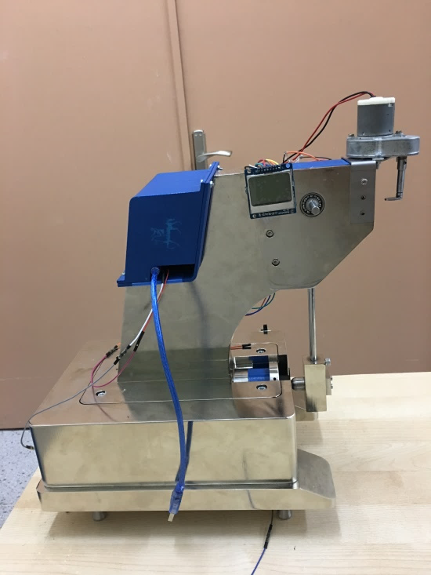 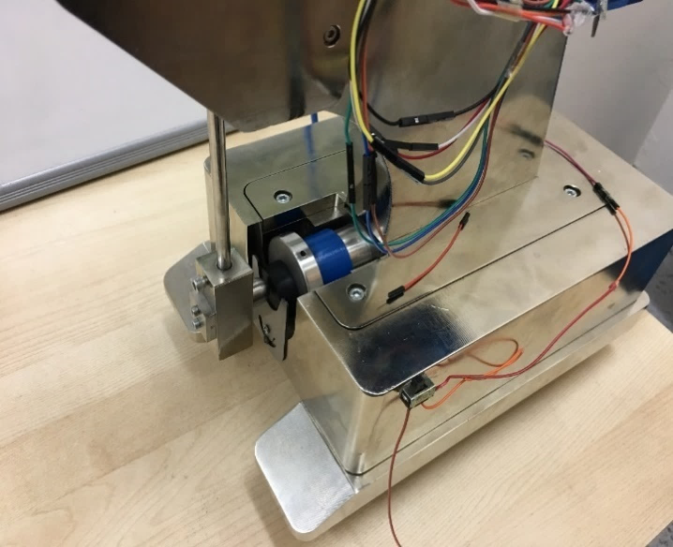

**Figure 2: Rebound resilience testing machine.**

Rubber manufacturing process is based on some key operations that can be summarized into three main stages: Mixing, shaping and vulcanizing [18]. The finished product quality depends straightly on these operations. Test specimens were prepared from rubber from Vietnam and from D.R. Congo rubbers. Figure 3 shows the raw rubber from D.R. Congo. Some rubber specimens were carefully kept at 0oC to maintain their properties in order to examine the aging effect on the resilience behaviors of rubber samples and, tests were carried out on these two rubber types in a space of six months (on January 21, 2019 and July 26, 2019). First samples were prepared to study the aging effect on hardness and its effect on rebound resilience property. According to standards, after vulcanization, rebound resilience test shall be carried out over a period of 16 hours to one month (Deutsche Norm DIN-53512 2000). Natural rubber from Vietnam was supplied by Polimak-Mete Kauçuk company. Compared to rubber from Vietnam, rubber from the D.R. of Congo Mayombe forest was very sticky so, it was difficult to mix it alone and remove it from the roll-mixer (Figure 4). To overcome that issue, an equal quantity Vietnam rubber (500g) was added to the rubber from the D.R. of Congo to boost the mixing process. Then after, necessary chemicals for vulcanization were added to the mixture gradually. Mixing was realized with a two-roll-mill. Rubber was added on the front roll, different additives of the natural rubber recipe were added consequently to get the needed final product (Figure 5).

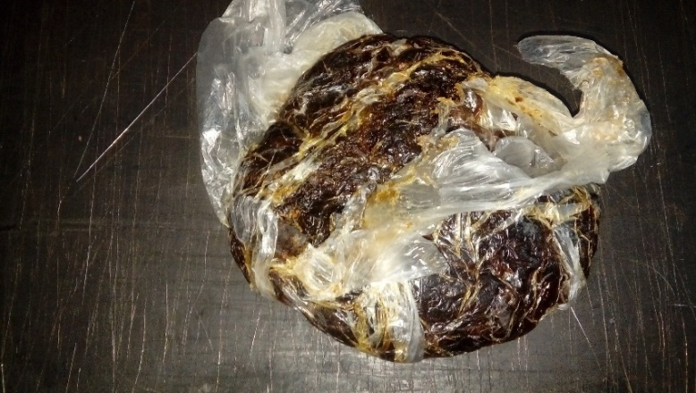

**Figure 3: Rubber raw from Congo**

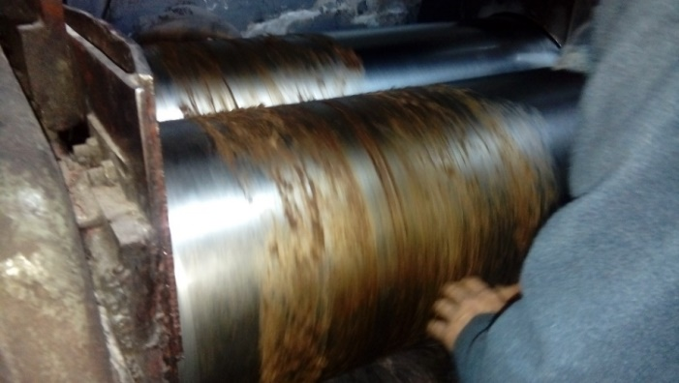

**Figure 4: Sticky rubber from D.R. Congo on the roll-mill.**

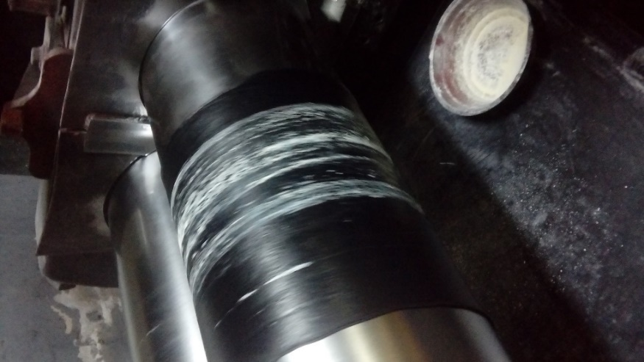

**Figure 5: Adding additives to the sticky D.R. Congo rubber on the roll-mill**

After that process, five blanks were cut for both rubber types and put into the mold under the hydraulic press for the molding process (Mold dimension: 12 mm of thickness and 31 mm of diameter). On July 26, 2019, the same molding process done in January was repeated (Figure 6). Mixed rubber was shaped in the mold heated to 160 °C. The control unit of the molding process is shown in Figure 7.

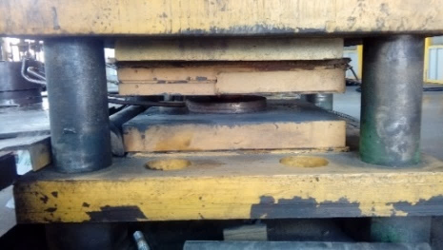

**Figure 6: Rubber sample in the mold**

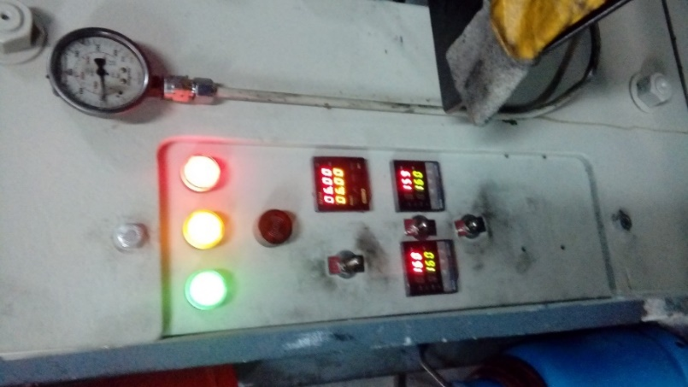

**Figure 7: Mold temperature and time control unit**

Chemicals used for the vulcanization process are presented in Table 2.

***Table II.* Chemicals used for natural rubber vulcanization.**

|  |  |  |
| --- | --- | --- |
|  | **Designation** | **Quantity in 1 kg of natural rubber** |
| 1 | Zinc Oxide | 50 g |
| 2 | Sulfur | 25 g |
| 3 | Dibenzothiazyl disulfide (DM Accelerator) | 20 g |
| 4 | Diphenyl guanine (DPG Accelerator) | 10 g |

Ten specimens from each category were prepared. Some of the specimens are presented in Figure 8.

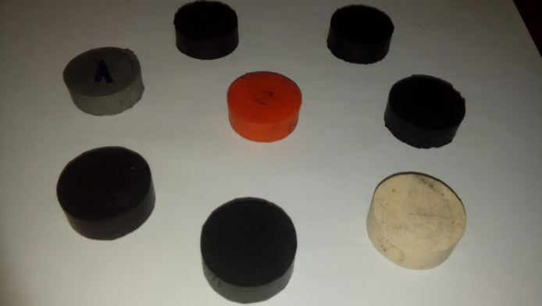

**Figure 8: Prepared rubber samples**

***Table III.* Rubber samples characteristics**

|  |  |  |
| --- | --- | --- |
| **N°** | **Designation** | **Characteristics** |
| 1 | OC | Black colored ( ∅31 x 12 mm) |
| 2 | OC | Black colored ( ∅31 x 12 mm) |
| 3 | OC | Black colored ( ∅31 x 12 mm) |
| 4 | OC | Black colored ( ∅31 x 12 mm) |
| 5 | OC | Black colored ( ∅31 x 12 mm) |
| 6 | OV | Grey colored ( ∅31 x 12 mm) |
| 7 | OV | Orange colored ( ∅31 x 12 mm) |
| 8 | OV | Black colored ( ∅31 x 12 mm) |
| 9 | OV | Black colored ( ∅31 x 12 mm) |
| 10 | OV | Black colored ( ∅31 x 12 mm) |
| 11 | NC | Black colored ( ∅31 x 12 mm) |
| 12 | NC | White colored ( ∅31 x 12 mm) |
| 13 | NC | White colored ( ∅31 x 12 mm) |
| 14 | NC | Black colored ( ∅31 x 12 mm) |
| 15 | NC | Black colored ( ∅31 x 12 mm) |
| 16 | VC | Black colored ( ∅31 x 12 mm) |
| 17 | VC | Black colored ( ∅31 x 12 mm) |
| 18 | VC | Black colored ( ∅31 x 12 mm) |
| 19 | VC | Black colored ( ∅31 x 12 mm) |
| 20 | VC | Black colored ( ∅31 x 12 mm) |

Table 3 presents some rubber specimens designations and characteristics determined by inspection only. In this table, notations OC (Old Congo) and OV (Old Vietnam) respectively, refer to the first specimens prepared from D.R. Congo and Vietnam natural raw rubbers, on January 21, 2019. NC (New Congo) and VC (Old Congo) refer to specimens prepared six months later from Congolese and Vietnamese raw rubbers, respectively, on July 26, 2019. We should mention that first rubber samples prepared were kept in a plastic bag partially perforated (thin hole) and out of daylight.

A Shore-A durometer was used for the hardness testing (Figure 9). Tests were performed according to the Deutsche Norm DIN53505-A standards.

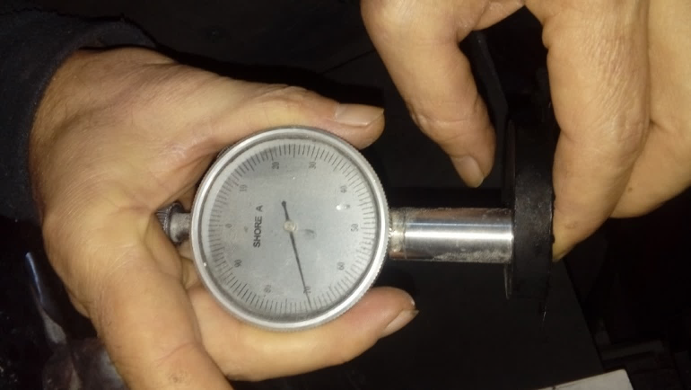

**Figure 9: Shore-A hardness testing on rubber sample hardness**

Rebound resilience tests were performed at different temperatures in the Tribology Laboratory of Mechanical Engineering Department of Dokuz Eylül University. For higher temperature testing, test pieces were packed in a plastic bag and plunged into a hot water bath heated to over 100°C and they were removed from the hot water bath only for test. The temperature was constantly measured using an infrared thermometer (Fluke 576 in Figure 10).

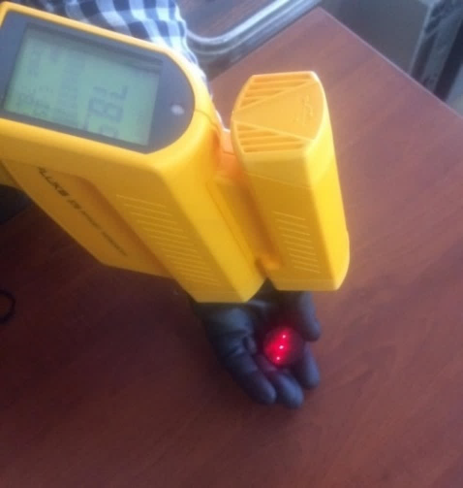

**Figure 10: Specimen temperature measurement**

Test procedure involves impacting a standard test sample clamped at the anvil of the tester by a falling pendulum hammer under the effect of gravity from the horizontal position. The rebound resilience value is the ratio of the maximum height of the hammer after the first strike by the fall height. After the test sample is clamped at the tester anvil, a series of at least six rebounds is carried out; the median value of the last three rebounds represents the rebound resilience (Figure 11). The first three rebounds are made for mechanically conditioning the test piece. The pendulum motion is plotted using data collected from Arduino and transferred to MATLAB.

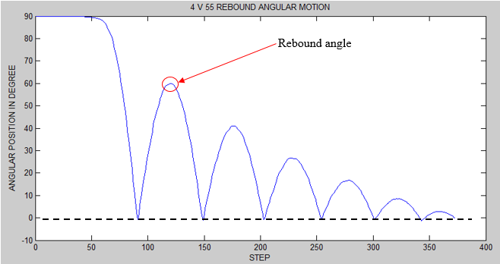

**Figure 11: Pendulum motion plot.**

# RESULTS

Results obtained by the tests are presented in this section. Tests were performed at ambient and different temperatures in order to determine the hardness and the rebound resilience values of both D.R. Congo and Vietnam originated rubber specimens. A Schob type pendulum was used to measure the rebound resilience of rubber having a Shore A hardness between 30 and 85 according to DIN 53512, ISO 4662 or ASTM D7121 standards.

Table 4 shows the hardness values of rubber specimens at ambient temperature measured on January 21, 2019 and July 19, 2019. The results Table 4 show that the average hardness values of rubber from D.R. Congo and Vietnam tested on January 21, 2019 are 60 and 70.8, respectively. The hardness values of rubber from Vietnam are higher than rubber from D.R. Congo. In addition, average hardness values of rubber from D.R. Congo and Vietnam tested on July 19, 2019 are 66.7 and 78.8, respectively. An increase in hardness of 11.16% is observed for rubber from D.R. Congo and 11.29% for rubber from Vietnam.

***Table IV.* Hardness values for first rubber specimens molded in January 2019 (Shore A).**

|  |  |  |
| --- | --- | --- |
| **Specimen**  **nr.** | **Hardness (Shore A)**  **(tested on January 21, 2019)** | **Hardness (Shore A)**  **(tested on January 19, 2019)** |
| 1 OC | 70 | 71 |
| 2 OC | 52 | 67 |
| 3 OC | 57 | 62 |
| 4 OC | 66 | 67.5 |
| 5 OC | 55 | 66 |
| 1 OV | 70 | 78 |
| 2 OV | 70 | 78 |
| 3 OV | 74 | 81 |
| 4 OV | 70 | 79 |
| 5 OV | 70 | 78 |

Figure 12 compares values of hardness at different dates for the same specimens. In the figure, it can clearly be seen that aging increases the hardness of the specimens. Based on these results, in a period of six months, the same specimens have hardened on an average of around 7.35%. This justifies why the standards of rubber testing specify a limited period for testing to be performed after vulcanization. It will be shown later that hardness has a link with rebound resilience. That comes to say that, the same rubber sample tested in two different periods of time will not have the same rebound resilience. Thus, the aging effect should be considered in the choice of rubber by taking into consideration the service environment.

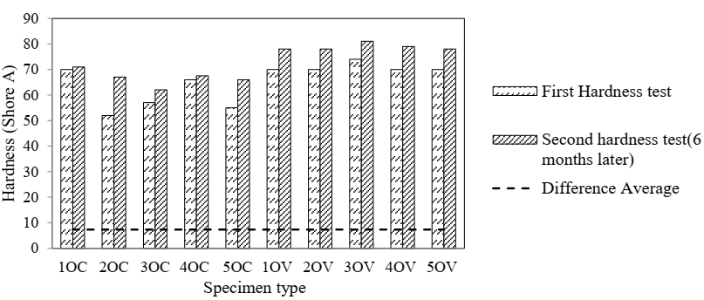

**Figure 12: Change in hardness of the same specimens (Molded in January 2019) in different periods (in 6 months)**

Table 5 shows hardness values for rubber specimens from D.R. Congo raw rubber mixed in January 2019 and kept 6 months at a temperature under 0oC for molding and testing (on July 26, 2019).

***Table V.* Hardness values of rubber specimens from mixed D.R. Congo raw rubber kept 6 months at a temperature under 0oC.**

|  |  |  |
| --- | --- | --- |
| **N°** | **Designation** | **Hardness (Shore A)** |
| 1 | 1NC | 70 |
| 2 | 2NC | 67.5 |
| 3 | 3NC | 72 |
| 4 | 4NC | 72.5 |
| 5 | 5NC | 72 |

Figure 13 presents the change in hardness for specimens prepared from the same mixed-rubber but molded at different times. As seen from the figure, the specimens molded in July showed a greater hardness (average hardening of 10.8%) than those molded in January 2019, even though they were well preserved in the cold. Comparing Table 5 to Table 4 (OC and NC values), it can be seen that the average hardness value of this samples has increased. The average hardness value of new specimens is 70.8.

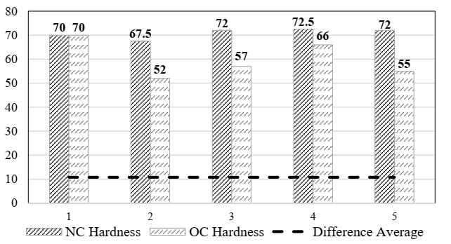

**Figure 13: Change in hardness of the same mixed rubber molded 6 months later**

Hardness values are compared to rebound resilience values in Figure 14 for new samples (Molded in July 2019). Different charts are presented for rebound resilience, hardness and the difference in hardness and rebound resilience. It is observed that the hardness values are proportionally related to rebound resilience for both specimen types. An increase in hardness implies an increase in rebound resilience.

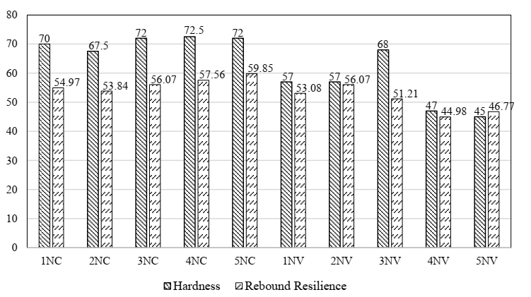

**Figure 14: Hardness and rebound resilience (%)**

Hardness value of the 3NV or 5NV sample draws attention because of its distinctive character from the others from the same group. This might have to do with some structural defects created during molding, for instance, it is not easy to homogenize the mold temperature or completely get rid of gas bubbles that remain trapped in the rubber during molding. During the preparation of the samples, those with visible defects such as the swelling of the contact surface were put aside. The swelling of the contact surface is an indicator of the existence of gases trapped inside the sample. But unfortunately, sometimes it is not possible to distinguish inequality from the surface of specimens. Thus, adverse cases such as that of the 3NV specimen can be observed.

Figure 15 shows the rebound resilience and hardness curves. Both curves have positive slops. In addition, in most of cases, rebound resilience values (in percentage) are lower and/or sometimes close to hardness values. But it is not still possible to accurately predict the variation since all depends on the type of rubber and chemical preparation. However, it should be noted that rubber from Vietnam appears to have rebound resilience values close to rubber from Congo rebound resilience values, but with lower hardness values. Based on the statement at previous paragraphs on the proportionality between hardness and rebound resilience, rubber from Vietnam rebound resilience values can be expected to be higher than that from D.R. Congo in case the former specimens were prepared to have the same hardness as the latter providing that the difference between them in rebound resilience values is low compared to the difference in hardness values (Figure 15). In this way, for the same hardness, rubber from D.R. Congo absorbs more energy than that from Vietnam. This comes to say that rubber from D.R. Congo would be better suited for applications where damping properties are needed, whereas rubber from Vietnam would be suitable for applications where high resilience is sought. Rebound resilience data are not so tractable mathematically and represents a much more complex problem. The results from one test are not always showing similarity to the results of another test. So, the engineer has to rely on tests conducted in a particular way or on service behavior [7].

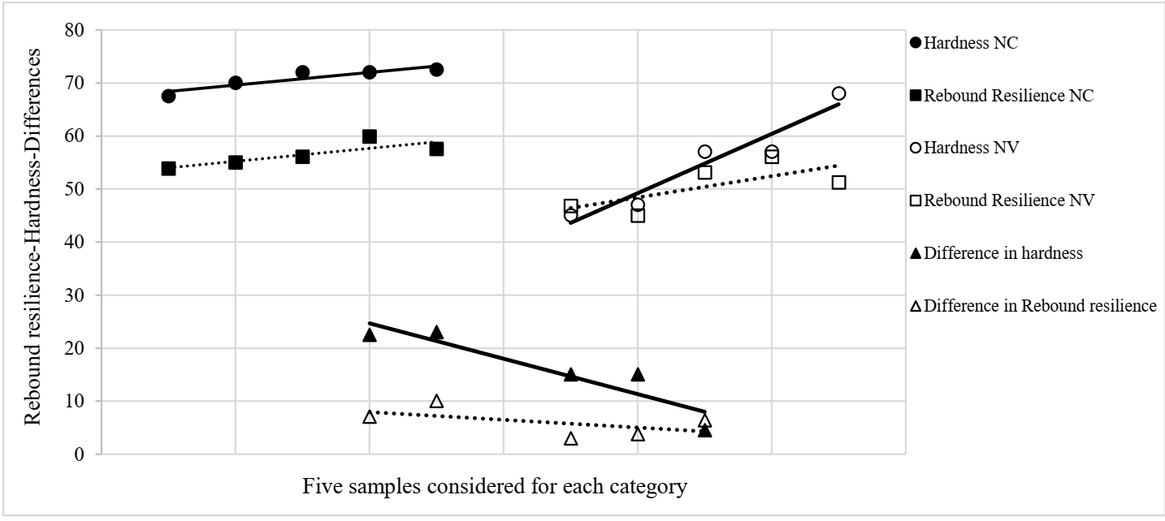

**Figure 15: Rebound resilience graphs-hardness graphs and their differences graphs for each category**

Figures 16 and 17 present the variation in rebound resilience with respect to temperature using tested data from tables 6,7,8 and 9. These tables give numerical values for the temperature range in which the maximum rebound resilience values were observed. Graphs for rebound resilience depending on temperature are presented for two specimens from each rubber category 1NC and 5NC for rubber from D.R. Congo and 2NV and 4NV rubber from Vietnam.

***Table VI.* Rebound resilience for 1 NC specimen at five different temperatures (70 Shore A).**

|  |  |
| --- | --- |
| **Temperature °C** | **Rebound Resilience (%)** |
| 41 | 51.29 |
| 46 | 57.36 |
| 51 | 62.17 |
| 56 | 65.75 |
| 67 | 61.54 |

***Table VII.* Rebound resilience for 5 NC specimen at five different temperatures (72 Shore A).**

|  |  |
| --- | --- |
| **Temperature °C** | **Rebound Resilience (%)** |
| 46 | 55.08 |
| 56 | 58.63 |
| 68 | 61.72 |
| 81 | 59.90 |
| 90 | 57.61 |

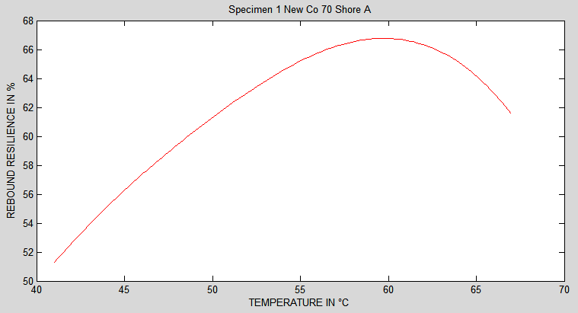

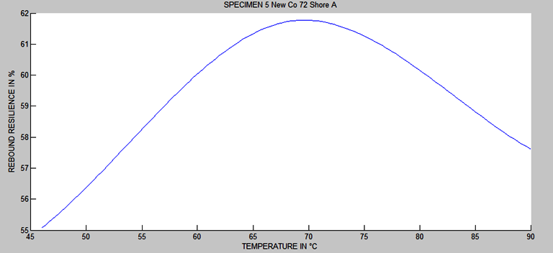

**Figure 16: Temperature-dependent rebound resilience for NC specimens**.

***Table VIII.* Rebound resilience for 2 NV specimens at five different temperature (57 Shore A)**

|  |  |
| --- | --- |
| **Temperature °C** | **Rebound resilience (%)** |
| 42 | 54.99 |
| 49 | 56.13 |
| 61 | 59.17 |
| 65 | 57.79 |
| 70 | 55.82 |

***Table IX.* Rebound resilience for 4 NV specimen at five different temperature values (47 Shore A)**

|  |  |
| --- | --- |
| **Temperature °C** | **Rebound resilience (%)** |
| 55 | 49.79 |
| 63 | 47.53 |
| 70 | 49.40 |
| 75 | 53.45 |
| 80 | 52.70 |

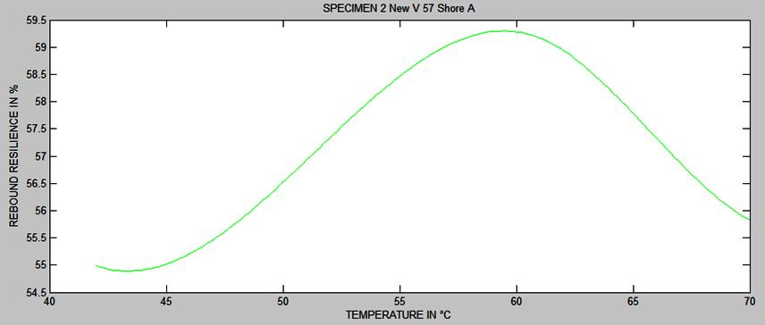

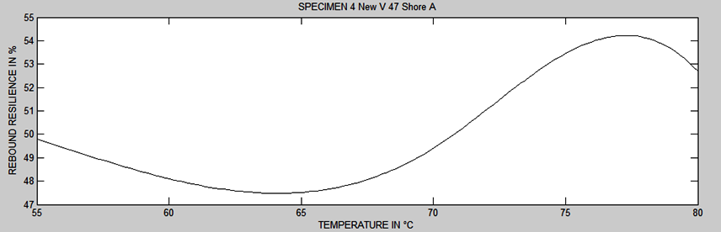

**Figure 17: Temperature-dependent rebound resilience for NV specimens**

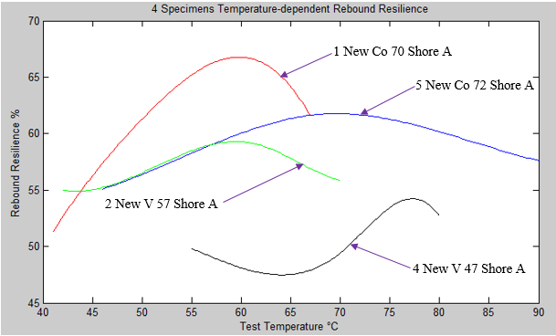

**Figure 18: Temperature-dependent rebound resilience curves of four specimens**

Referring to the experimental results presented in Figures 16,17, and 18, temperature increase leads to an increase in rubber (natural) rebound resilience in the domain of temperature of this study (between 40 °C and 90 °C). Curves have downward-oriented concavities. Most of tested specimens have similar curve. Rebound resilience reaches a maximum value and then tends to decrease. There is a similarity of results in the literature test temperatures [2,7,19].

Based on the numerical results shown above, it is obvious to conclude that the origin of rubber also affects its properties. Another result that should be highlighted here is the hyper-sticky character of rubber from D.R. Congo. This can be an advantage for applications where adhesive properties are an asset.

# CONCLUSIONS

This study was based on the investigation of parameters that affect rebound resilience properties of natural rubber. For that purpose, a rebound test machine was designed and manufactured according to related standards. Natural rubber from Vietnam and from the Democratic Republic of Congo were used to prepare specimens for testing on standard specifications. Properties that influence the rebound resilience of rubber include chemical treatment (additive) during vulcanization, specimen hardness, temperature, rubber origin and specimen conservation conditions. The following conclusions have been drawn from the study:

* In a period of six months, it was observed that the specimens that were kept in a partially perforated plastic bag through a thin hole and away from daylight, hardened at an average rate of 7.35%.
* Specimens made from mixed rubber and ready for molding kept in the cold and molded six months later showed an average hardness of 10.8% higher than the first specimens.
* For natural rubber examined in this study, rebound resilience is proportionally related to the hardness. An increase in hardness implies an increase in rebound resilience.
* For the same hardness, specimen from D.R. Congo rubber would absorb more energy than that from Vietnam. Meaning that rubber from D.R. Congo would be more suited for applications where damping properties are needed, while rubber from Vietnam would be suitable for applications where high resilience is needed.
* Rebound resilience and hardness are influenced by internal structural defects, for instance, the existence of gases trapped inside the samples.
* In the interval between 40°C and 90°C, temperature increase leads to an increase in natural rubber rebound resilience.
* Rubber from D.R. Congo has a sticky property which represents an advantage for applications where adhesive properties are needed.
* The origin of the rubber has an effect on its rebound resilience properties.

**REFERENCES**

[1]. Luo, Y. Liu, Y. Yin, H.P. (2013). Numerical investigation of nonlinear properties of a rubber absorber in rail fastening systems, International Journal of Mechanical Sciences, 69, 107–113.

[2]. Roger, B. (2006). Physical testing of rubber (4th ed.), New-York U.S.A: Springer.

[3]. Deutsche Norm DIN-53512. (2000). Determining the rebound resilience of rubber using the Schob pendulum, Berlin : Deutsches Institut für Normung.

[4]. ASTM International. (2018). Standard Test Method for Rubber property-resilience using Schob type rebound pendulum. Retrieved May 28, 2019, from www.kutuphane.deu.edu.tr.

[5]. Martinovs, A., Polukoshko, S. Apeinans, E. Zaicevs, E. (2017). Determination constants of 4-element rheological model with rebound resilience method, Engineering for Rural Development, 16, 924-931.

[6]. Luo, R.K., Wu, X.P. (2013). Rubber Unloading Behavior Evaluation using Product-orientated Specimen Based on a Resilience test. Polymer Testing, 34, 49–57.

[7]. H.C. Jones, E.G. Snyder (1943). Effect of Temperature on Resilience of Natural and Synthetic Rubber (Reprinted from the Indian Rubber World, Vol.108, No.2, 137-140), Research Division, The New Jersey Zinc Co, Palmerton, Pennsylvania.

[8]. Ajay, W. (2012). Measuring the Rebound Resilience of a Bouncing Ball, Physics Education, 47 (5).

[9]. Luo, R.K., Guo, N., Chen, X. et al. (2017). NFR (Natural Frequency Region) Approach for Dynamic Evaluation of Anti-vibration Systems with Rebound Resilience Method, Polymer Testing, 57, 288-295.

[10]. Ajay, W. (2013). Study of the Dynamic Properties and Effects of Temperature Using a Spring Model for the Bouncing Ball, European Journal of Physics, 34, 703–713.

[11]. Voda, A., Beck, K., Schauber, T., Adler, M., Dabisch, T., Bescher, M., Viol, M., Demco, D.E., Blümich, B. (2006). Investigation of Soft Segments of Thermoplastic Polyurethane by NMR, Differential Scanning Calorimetry and Rebound Resilience. Polymer Testing, 25, 203–213.

[12]. Mullins, L. (1947). Effect of Temperature on Resilience (Reprinted from the Transactions of Institution of the Rubber Industry, Vol.22, No.5, 235-258), Research Association of British Rubber Manufacturer, Croydon, English.

[13]. Bedriye N.Y., Bağdagül, K. (2016). Properties of NR and NR/ENR Based Rubber Compounds Reinforced with Chopped and Sized [1]. Carbon Fiber, Anadolu University Journal of Science and Technology. Vol.17, No.5, 926-935.

[14]. Pandian, J., Govindan T. (2015). Comparative Studies on the Mechanical Properties of Natural Rubber and Natural Rubber Carbon Black Composites, International Journal of Emerging Technology in Computer Science & Electronics (IJETCSE). 2 (13).

[15]. Phanny, Y., Azura, R. Ismail, H. et al. (2012). Effect of Different Origins of Natural Rubber on the Properties of Carbon Black Filled Natural Rubber Composites, ASEAN Engineering Journal Part B, Vol 2 No 1, ISSN 2286-7694 p.60.

[16]. Moonchai, S., Moonchai, D. (2013). Modelling and Optimization of Rebound Resilience and Hardness of Defatted Rice Bran/Calcium Carbonate-filled NR Vulcanisates. Polymer Testing, 32, 1472–1478.

[17]. Diambu, A. N. (2019). Design and Implementation of Energy Absorption Test Apparatus, M.Sc.Thesis, Dokuz Eylul University, The Graduate School of natural and Applied Sciences.

[18]. Freakley, P. K. (1985). Rubber processing and production organization, New York and London: Plenum Press.

[19]. Maurice, M. (1999). Rubber technology (3rd ed.), Ohio U.S.A: Springer Science Business Media Dordrecht.