**A PHYSICS-DRIVEN STRATEGY IN FINE-GRAINED PLANT DISEASE CLASSIFICATION**

**1Rasiga J, 1Sajeetha britty E, 1Srinithi V, 1Vethasundari N, 2Soundararajan K**

1Student, 2Assistant Professor

1Information Technology, 2Information Technology

1Vivekanandha College of Technology for Women, Anna University, Namakkal, India,

2Vivekanandha College of Technology for Women, Anna University, Namakkal, India

E-mail: 1[rasikani.2018@gmail.com](mailto:rasikani.2018@gmail.com), 1[sajeethabritty@gmail.com](mailto:sajeethabritty@gmail.com), 1[nithisri046@gmail.com](mailto:nithisri046@gmail.com), 1[vethasundari2003@gmail.com](mailto:vethasundari2003@gmail.com), 2[soundark919@gmail.com](mailto:soundark919@gmail.com)

_________________________________________________________________________

ABSTRACT:

Presently, systems that use AI in factory complaint discovery face problems stemming from intra-domain variability, as well as from limited conception across imaging conditions. Wave shift addition, a new proposed system, is grounded on drugs in the Fourier sphere. It modifies wavefront propagation goods to mimic colorful imaging scripts. Testing on private datasets (tomato, cucumber, strawberry, eggplant) and public datasets (optical complaint, skin cancer, CUB-200-2011) showed harmoniousmacro-F1 advancements corresponding to standard accruals (EfficientNetV2 1.37, Win 1.35, Context 0.80). We also give a receptivity analysis of layering hyperparameters for z, the he propagation distance, yielding stronger performance at low computational cost (SSIM> 0.87, PSNR> 28). These results validate the use of Wave shift for real-time, fine-grained bracket tasks.

KEYWORDS – Automated plant disease diagnosis, expanding data, new online augmentation methods, and wavefront shifting

# **1. INTRODUCTION**

Accurate detection of disease has a critical influence on agricultural productivity, food security, and the application of pesticides. Current AI solutions suffer from accuracy issues due to overlapping domains, imprecise cross-domain generalization, and variations in image quality. Furthermore, the visual symptoms of diseases are often too subtle and deep learning-based manual inspection systems are riddled with inaccuracies and require an inordinate amount of time to comb through data sets. Research shows the best results toward transforming these systems into fully autonomous ones comes from combining augmentation and domain adaptation mixed with semi-supervised learning, although tweaking is essential to align it with on-farm realities. Adaptation tackling unmasked participant variation would integrate competitive feature extraction methods that lie dormant within free, bounded environments, alongside biologically modelled study paradigms giving more potent tools to constellations colliding with ground realities.

**2. RELATED WORKS**

* 1. **DATA AUGMENTATION: TRENDS AND PRINCIPLES**

Light plays a crucial part in scientific applications such as forming images, modeling illumination, and analyzing shadows. A core part of these applications is wavefront shifting, which is a light-based technique that affects a spatial intensity's light's energy, phase, and polarization. The wavefront, as the 2D cross-section of a propagating light wave, it is greatly useful in studying targets that cannot be reached directly, which has made it possible to advance in medical imaging and other research fields by conducting non-invasive analysis that is made through precision wavefront control.

**2.2. LIGHT MANIPULATION IN COMPUTER VISION**

Some plant disease diagnostic tools undergoing deep learning have been advancing at an unprecedented pace due to Augmentation data techniques for some diagnostic tools. While effective factory complaint discovery remains crucial to icing crop yields and food security, current deep-literacy approaches are hampered by lighting, detector changes, and imaging distance. The use of being deep literacy styles for factory complaint discovery is also limited by geometric, color, and policy-based addition ways, which don't duly pretend light surge commerce.

**2.3. UNIQUE BENEFACTIONS**

1. Development of a Fourier-sphere addition grounded on the wavefront propagation proposition, Comprehensive explanation of the mathematics describing image-spheree disquiet via wavefront shifting transfer functions;
2. Expanding receptivity evaluation of hyperparameter z using multitudinous datasets;
3. Harmonious advancements tomacro-F1 scoring demonstrated for factory, medical, and fine-granulated raspberry bracket tasks; Law and addition module is made intimately available for real-time deployment.

**TABLE1. Summary of the diagnostic achievement of WS on our plant dataset.**

|  |  |  |  |  |
| --- | --- | --- | --- | --- |
| CROP_NAME | DA employed | Classification performance in macro F1 (%) w | | |
| w/o WS | with WS | Improvement |
| TOMATO  (10 classes) | Geometric  Geo + CLAHE  Geo + AugMix  Geo + RandAug | 72.59  72.43  73.66  79.42 | 76.32  75.07  72.33  78.51 | 0.43  2.96  -0.27  4.17 |
| STRAWBERRY (4 classes) | Geometric  Geo + CLAHE  Geo + AugMix  Geo + RandAug | 84.53  84.67  77.08  83.32 | 86.57  83.36  74.41  85.71 | 2.07  -0.21  0.40  2.75 |
| CUCUMBER  (10 classes) | Geometric  Geo + CLAHE  Geo + AugMix  Geo + RandAug | 56.99  58.99  51.62  53.06 | 57.38  54.43  54.76  54.90 | 0.32  1.45  2.34  1.42 |
| EGGPLANT  (6 classes) | Geometric  Geo + CLAHE  Geo + AugMix  Geo + RandAug | 89.68  81.72  83.32  83.60 | 84.81  84.59  82.82  86.66 | 2.14  2.97  1.50  3.05 |
| OVERALL |  |  |  | 1.64 |

**TABLE 2. Summary of the proposed WS diagnostic performance (in macro-F1 (%)) for public datasets.**

|  |  |  |  |  |
| --- | --- | --- | --- | --- |
| DATASET_NAME | DA employed | Classification performance in macro F1 (%) | | |
| w/o WS | with WS | Improvement |
| OCULAR DISEASE  (2 classes) | Geometric  Geo + CLAHE  Geo + AugMix  Geo + RandAug | 76.89  77.30  79.26  74.64 | 78.19  70.79  77.46  72.70 | 1.37  1.35  1.80  0.21 |
| SKIN CANCER  (9 classes) | Geometric  Geo + CLAHE  Geo + AugMix  Geo + RandAug | 65.41  65.65  50.33  66.85 | 69.25  65.55  64.81  67.83 | 0.94  0.01  5.19  0.95 |
| CUB-200-2011 (200 classes) | Geometric  Geo + CLAHE  Geo + AugMix  Geo + RandAug | 66.78  68.11  70.72  71.29 | 66.11  68.55  70.88  71.45 | 0.33  0.15  0.08  0.66 |
| OVERALL |  |  |  | 1.07 |

**TABLE 3. The factors bounding z are equally spaced out by √e ≈ 1.65 for the center 41 meters range where z = 41 m.**

|  |  |  |
| --- | --- | --- |
| Range of z for the employed WS | CROP_NAME & DA employed | |
| CUCUMBER Geometric | STRAWBERRY Geo + RandAug |
| z ∈ [1m, 15m]  z ∈ [1m, 25m]  z ∈ [1m, 41m]  z ∈ [1m, 68m]  z ∈ [1m, 111m] | 55.72  56.73  57.98  59.18  51.82 | 86.05  86.57  88.91  84.86  81.97 |

**3. PROPOSED WORK**

**3.1. WAVEFRONT SHIFTING: THEORY**

Through sensors and lenses, light captured from various objects is used to create photographs. Light as observed in nature is both coherent, which means it's able to maintain phase relationships, as well as polychromatic, which means it has multiple wavelengths at the same time. Light behaves as a transverse electromagnetic wave and thus physically propagates. This propagation is perfectly described by the classical wave equations in free space which is undisturbed by electric currents or charge. The developing of advanced imaging technologies and computational photography methods relies on the understanding of light’s wave nature.

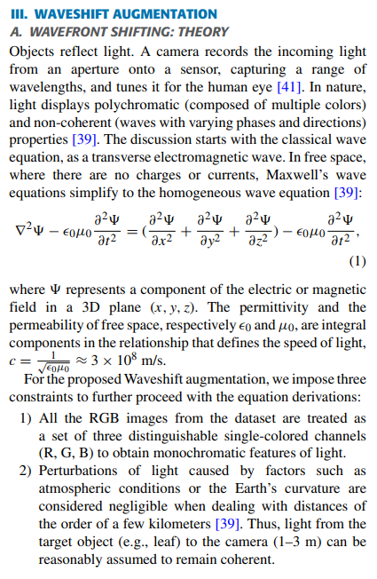

The fundamental light propagating speed in a vacuum is c and along with the inherent properties of the vacuum or electric permittivity and magnetic permeability, these attributes have a direct propelling effect. These constants through the equation serve as the boundary electromagnetic wave propulsion speed in free space. Modern optical physic and classical electrodynamics are the basis for this relationship.

**c = √ ≈ 3 × 108 m/s.**

**3.2. ROADMAP TO AUGMENTATION**

The wavefront propagation will be modeled with the angular spectrum method and the frequency domain transfer function is defined as follows.

**$$H(u,v;z)=e^{j2\pi z\sqrt{\frac{1}{\lambda^2} - (u^2+v^2)}}$$**

The image sₓ(y,z) can be retrieved through the inverse fourier transform of the modified spectrum S₀(u,v) resulting from the application of Fourier transform. This formulation captures phase and amplitude modulation inherent in physical propagation (detailed derivation in Appendix A).

**3.3. OPERATIONALIZATION STRATEGY**

Each channel of a color image (R, G, B) is extracted as a separate channel using Pillow's `split()` method, treating each channel as a 2D matrix. Grayscale images are treated the same way. This partial splitting enables frequency-domain operations to be consistently applied to color images as well as monochrome images within the same framework, preserving color relationships. All inputs regardless of color or monochrome compatibility are processed through the same system.

Image Preprocessing

Input image

Geometric

transformations

Waveshift augmentation

Modern augmentations

Output class

Model inference

In-depth view of WS (proposed method)

2D IFT

Spilt color channels

Merge channels

Build the propagator and apply

2D FT

**Figure 1. Image classification pipeline**

The pipeline (Figure 1) uses Waveshift augmentation during the preprocessing stage and is followed by splitting the data, model fine-tuning, and performance evaluation. Each component, starting from the processing of input and ending at the evaluation of model performance, is treated as a separate sub-task to allow maximum enhancement without undo validation rigor at the performance level.

**3.4. EVALUATION ON OTHER DATASETS**

This work consolidates the adaptability of our WS enhancement method after undergoing thorough testing in three domains: plant disease classification (which was the primary focus), medical imaging (eye diseases and skin cancers), and fine-grained bird species classification (for CUB-200-2011). By using a consistent train-validation split, we showcase the method’s responsiveness toward different range challenges – from recognition of morphological symptoms at the elementary level in plants, to deeper levels of pathology depicted in medical imaging, and even to taxonomy in ornithology. The performance across multiple domains serves as valid justification to claim the wide applicability of the technique, especially while dealing with tasks involving visual analysis that are fine-grained.

|  |
| --- |
| SSIM  PSNR  Upper-z 41  SSIM 0.874582  Upper-z 41  PSNR 28.5336 |

Average SSIM

Average PSNR

Z- Positioning of augmented image

**Figure 2. Graph of average SSIM and PSNR**

The graph (Figure 2) illustrates the average value of SSIM and PSNR obtained for 20 augmented images of the plant obtained across z distances (1-151). The x – coordinates measure propagation distance (z), while the vertical y-axis measures the quality of the image, considering augmentation metrics.

**3.5. METHODOLOGY: EXPLORATION WORKFLOW**

1. Data Preparation Reference alignment at z = 0 followed by train/val split.

2. Augmentation Module Apply per-channel Fourier addition, cipher H(u, v; z) for tried z values and anticipate transfigure back to image.

3. Model Training EfficientNetV2, ConvNeXt, and Swin models are fine- tuned with LR = 5 × 10 ⁻⁵(Adam) and early stopping with conditions proper to ImageNet.

4. Evaluation & receptivity Highlight Analysis is done on z-ladenedd macros of F1, SSIM, and PSNR while conducting hyperparameter reaches.

5. Analysis Compare with geometric, CLAVE, Rand Augment, and Aug Mix.

**4. RESULTS AND DISCUSSION**

**4.1. DIAGNOSTICS ANALYSIS**

The classification assessment of the EfficientNetV2 model was conducted using the macro-F1 score, which is a hybrid measure of precision and recall, thus servicing even better on problems related to skewed datasets. Although it is not true that deep learning (DA) methods always outperform traditional geometric methods, the WaveShift DA model, in particular, performed better with an additional 1.74 points in average performance. This improvement is marked in tasks such as symptom classification where high accuracy in symptom detection is paramount. The most pronounced effects were recorded at the lower barrier of 41 meters, with WaveShift having a 0.95point increase for the tomato dataset when paired with ConvNeXt and an impressive 3.39 points for the skin cancer dataset with the Swin Transform. These results showcase how effective DA methods can be in increasing the model’s performance in different fields of medicine and agriculture.

**4.2. EXECUTION MEASURES**

The proposed method of enhancement does achieve remarkable efficiency at first execution; however, it has one of the highest time complexities compared to other methods. Although not the fastest, it is competitive when pitted against simpler techniques and achieves the lowest processing times when GPU’s accelerate its execution. This efficiency is made possible by its innovative architecture that utilizes Fourier domain optimization to increase parallelism and minimize idle time. Such optimizations enhance the method’s practical applicability, demonstrating that even highly complex techniques can be affordably deployed in the real world. The ability to maintain high performance in the face of significant time complexity challenges illustrates the strength and importance of this approach in advanced, highly demanding situations.

**4.3. HYPERPARAMETER PERCEPTIVITY (DISTANCE Z)**

|  |  |  |  |  |
| --- | --- | --- | --- | --- |
| **Dataset** | **z Range (m)** | **Macro-F1 without WS** | **Macro-F1 with WS** | **Enhancement** |
| Tomato (10) | 1 – 68 | 72.59 | 79.42 | 6.83 |
| Strawberry (4) | 1 – 41 | 84.53 | 86.57 | 2.04 |
| Cucumber (10) | 1 – 111 | 56.99 | 57.38 | 0.39 |
| Eggplant (6) | 1 – 111 | 89.68 | 84.81 | -4.87 * |

Note Performance loss was noted at extreme z; the swish range was z *∈ (1, 41) m.

**4.4. EFFECTIVENESS OF COMPUTATION**

Relative to the GPU- enforced geometric accruals, WaveShift adds 15 runtime but maintains real- time feasibility (≈ 25 ms/ image on RTX 3080).

**5. OUTPUT**

**5.1. Home Page**



**5.2. Login Page**



**5.3. Farmer Home Screen**

**5.4. Predict Home**



**5.5. Remedy Recommonder**

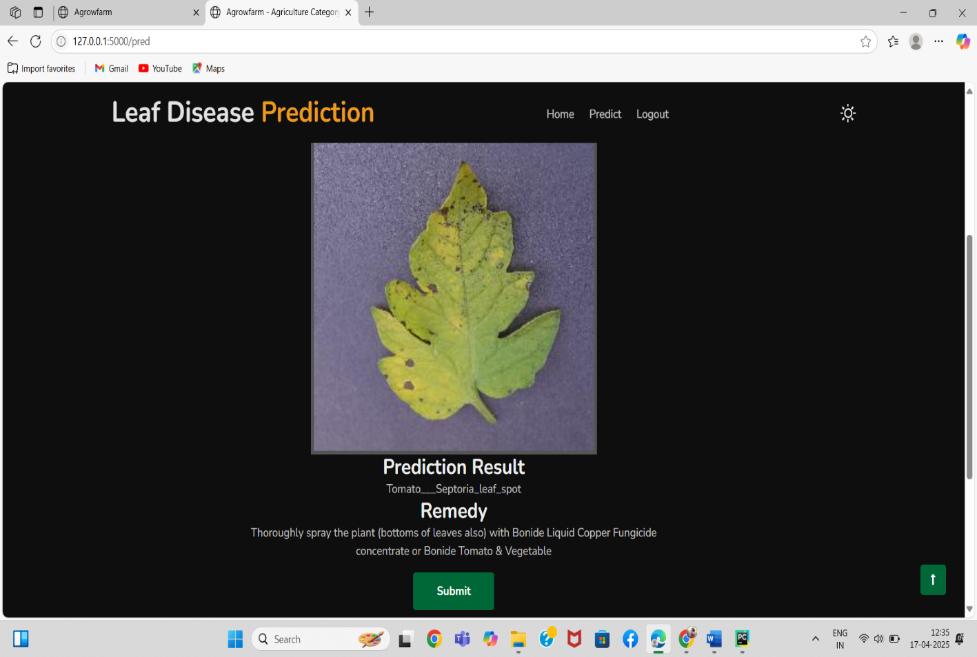

**CONCLUSION**

We presented Waveshift, the first of its kind in the imaging field, which utilizes Fourier-sphere wavefront propagation to really alter imaging variations; this is done through drugs-driven accruals. In our work, we conducted comprehensive evaluations of factory, medical, and raspberry datasets, which resulted in real-time performance of SSIM above 0.87, averagemacro-F1 increases of 1.74 points, and remarkable speed. Unborn exploration will look into combining semi-supervised literacy and espousing z-slicee strategies.

**REFERENCES**

[1] Barbedo Advanced the field of plant pathology by using deep learning models for individual lesion and spot classification for more precise plant disease detection and recognition.

[2] The introduction of the CLAHE method of image histogram contrast enhancement, which contains noise boost, is attributed to Zuiderveld.

[3] Cubuk and others proposed AugMix, a strategy of data augmentation that strengthens models’ robustness by blending augmented images with uncertainty.

[4] The improvement of model generalization and localizable learning by merging regions and labels of an image is known as CutMix. This augmentation technique was developed by Yun and other collaborators.

[5] Zhang and team came up with the MixUp augmentation strategy which combines images and their respective labels to surpass the conventional methods associated with empirical risk minimization.

[6] Karras and colleagues from the Northwestern University proposed a new approach to constructing style-based generators for GANs which enables more precise and sophisticated control over image synthesis.

[7] Fujita and his associates developed an actual plant disease diagnosis system from leaf images and accompanying tools for feature visualization to assist in interpreting the results.

[8] Shibuya et al. have confirmed the crucial prerequisites needed for the accurate evaluation of plant disease diagnosis model performance using a dataset featuring field images captured by a camera in real-world settings.