Dynamical Virtual-fenced Warning Technology to Prevent Bridge Pier from Collision with Ships

Liangfei Zheng and Lan Liu

*Hunan City University，PRC.*

*ABSTRACT:*

*In order to prevent collision of bridge piers with ships, this paper introduces a dynamical virtual-fenced warning technology to develop warning system for ships' sailing in the rivers. By means of the technology, geofencing lines are calculated with parameters related land data, water data, ship data, climate data, and other unpredicted data. The technology proposes to assign the geofencing lines in multi-tier so that alert signals can be emitted with different levels according to the ship's being inside or outside of the fencing zones. By defining dangerous velocity and warning displacement, the paper presents details in calculating virtual control points that are used to compute the geofencing lines with cubic B-spline curve. The method and the technology is helpful to develop warning system to prevent bridge from colliding with ships..*

***KEY WARDS:*** *Intelligent navigation, collision, bridge pier, B-spline, warning system.*

---------------------------------------------------------------------------------------------------------------------------------------

Date of Submission: xx-xx-xxxx Date of acceptance: xx-xx-xxxx

---------------------------------------------------------------------------------------------------------------------------------------

# INTRODUCTION

Bad news of bridges being collapsed by collision with ships extremely caught people's eyes in the first season of 2024. On March 26, 2024，the famous Baltimore bridge was collapsed by a collision with the container ship ‘DALI’ only after one month a Lixinsha bridge in China had been broken down by a container ship on February 22, 2024, as shown in figure 1.

|  |  |
| --- | --- |
|  |  |
| *(a) The collapsed Lixinsha bridge in China* | *(b) The collapsed Baltimore bridge in USA* |
| **Figure 1: Bridges collapsed by collision with ships** | |

The accidents enhanced people's concerns on the topics to prevent bridge pier from collision with ships, which has been researched by engineers and researchers. From recent published literatures [1], [2], [3], and [4], it is known that, people have developed methods in two aspects, to enhance the reliability bridges by means of engineering itself and to developing protective technologies. As for the protective technologies, the one with intelligent navigation has been popularly researched , as the literatures [5]~[9]. For example, [5] explored ship navigation in restricted waters, [6] researched ship and barge over navigable waterways, and [9] investigated flexible guided anti-collision for bridge pier protection. As reviewed in [10], intelligent ship path planning can both guide the ships travel in the way of safety, efficiency, and accessibility.

Algorithm is of course the core of the intelligent navigation. There are many algorithms with different traits, which are seen in [11]-[15]. Particularly, algorithms related with avoidance of collision raised interests, as overviewed in [16]. However, with so much navigating software in use, collisions still happened frequently, which shows something is still in need. Accordingly, this paper proposes a dynamical virtual-fenced warning technology to prevent bridge pier from collision with ships.

This paper consists of five parts. The first one is this introductory section, the second one is a framework to model the algorithm, the third one is the description of the algorithm, the fourth is the some numerical tests, and the last one is the conclusion.

# Essence of Geofencing-based Warning Technology

Geofencing is a technology that allows creating a virtual boundary around a physical location, using GPS, RFID, Wifi, cellular data, or other methods. Fabrice Reclus introduced the technology in detail in book [17]. Geofencing can be used for various purposes, such as triggering an action, sending a notification, collecting data, or providing a service, when a device or an object enters or exits the geofenced area. Literatures [18] and [19] gave practical examples of applying the technology.

This subsection first briefly introduces the principle of the geofencing base warning system, then presents the main idea of dynamical warning system to prevent bridge pier from collision with ships.

***2.1 Principle of the Geofencing Technology***

In practice, geofencing consists of establishing a virtual perimeter around a geographical zone and then connecting mobile devices to it; an alert is emitted when one of these mobile devices crosses the perimeter. In T Banu's words, geofencing technology is gathering attention. When a user enters a geofence, the event is detected and predefined actions are triggered automatically. The technology is directly implemented within software solutions for tracking and managing mobile assets. The global navigation satellite system (GNSS), the electric maps, and wireless communication are the foundations of the technology. In the aspect of transportation in the cities and sail on the water, GPS is inevitable. The principle can be simply described as follows.

1. Assign a geofence area to pay attention to by drawing a geofence, as illustrated with figure 2.

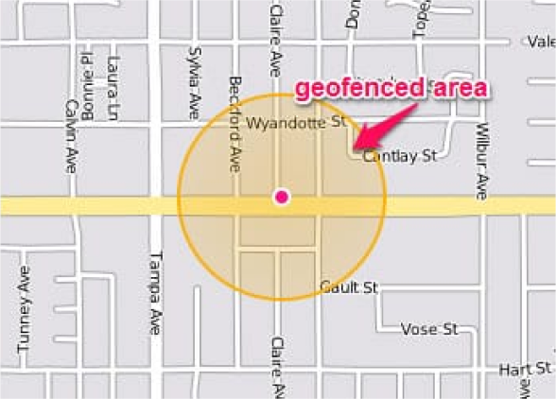

**Figure 2: Assign a geofenced area**

1. Associate the concerned moving object (CMO), e.g., a car or a ship, with the assigned geofenced area via software, e.g., APP, or warning system.
2. Set the alert message or information for the CMO to go inside or outside of the area.
3. Switch on the GNSS or GPS embedded in the CMO.
4. Notice if there is an alert message received from the APP or the warning system.

Therefore, once the CMO is going inside or outside the geofenced area, the supervisor of the CMO is warned by an alert message. By this means, a ship approaching a bridge is surely monitored and controlled if it is going to hit for a bridge pier.

***2.2 Dynamical Virtual-fenced Warning Technology***

As stated in previous subsection, a ship approaching a bridge can be monitored and controlled if it goes inside or outside of a geofenced area. Hence a geofenced warning system can be surely designed to avoid a ship's hitting for a bridge pier by means of geofencing the piers. The assignment of the geofence is the critical issue because it is a dynamic one and unlike the one assigned on land. Drawing a geofence on land is simply to draw perimeter around a geographical zone on the electric map because everything on land, e.g., trees, buildings, rivers, mountains, and so on, is fixed once they were formed. The geofence for a bridge pier is flexible because it depends not only the location of the pier but also the situation of the water on which the ships sail, the climate particularly the wind, as well as the voyages of other ships.

A dynamical geofenced warning system shall automatically calculate a geofence by parameters that are previously set or instantly detected. The parameters can be sorted by land-related, water-related, climate-related, ship-related, and other-related.

1. The land-related parameters are static ones such as the locations of the piers, the shores of the river near the bridge, and so on, as described in figure 3.
2. The water-related parameters are variable ones including the velocity, the depth of the water near the bridge because their variable with if it is a flood season or not.
3. The climate-related parameters are related with the states of the wind, the rain, and so on. They are of course variable ones.
4. The ship-related parameters include the size, the mass, the loads, the velocity, the location, the up-down-status of the ship, and so on. Such data of other ships sailing nearby are also this kind. These data are surely variable data.
5. The other-related parameters include some accidental or uncertain ones. For example, to indicate if there is a damaged ship on near the route or not.

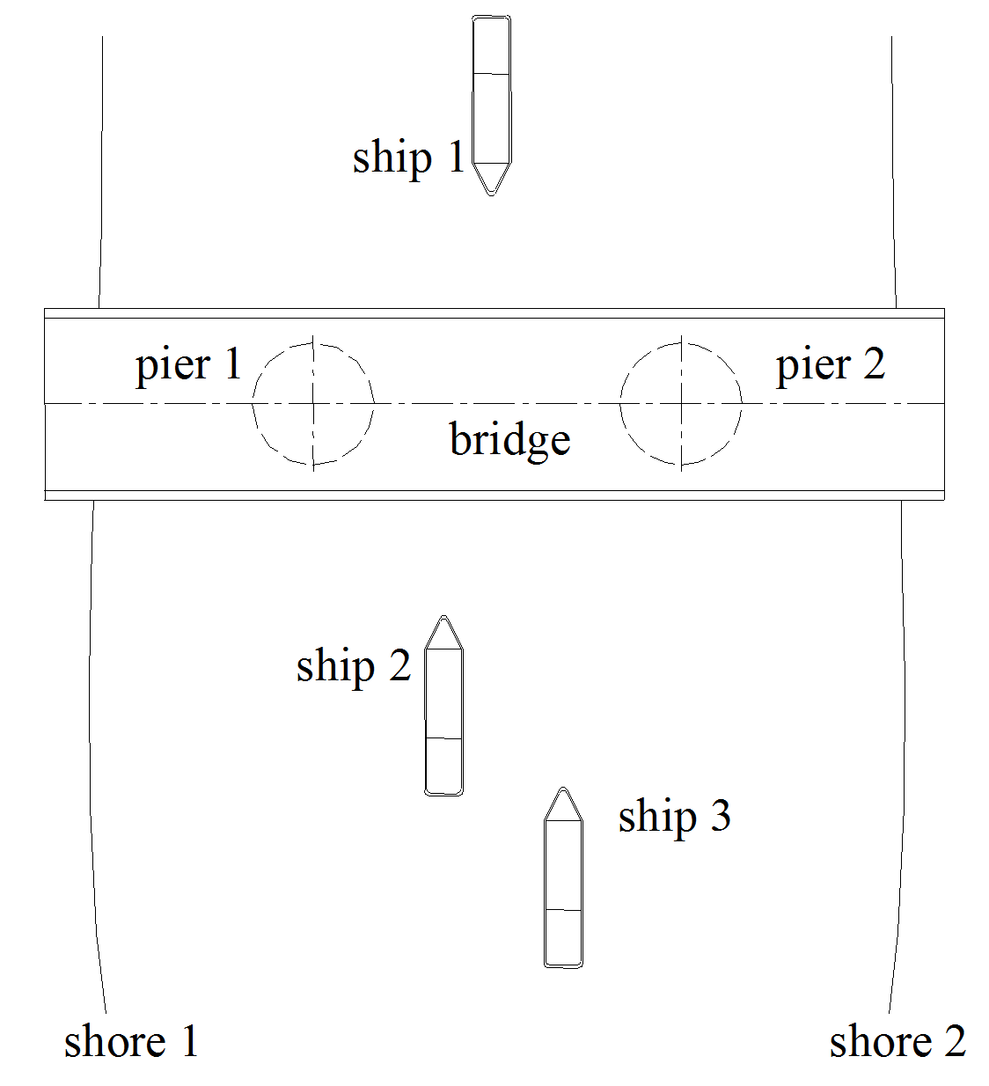

**Figure3：River shores, bridge, piers, and ships**

# KEY ISSUES

After knowing the essence of the geofencing-based warning system, it leaves the matter to design and realize the system. Seen in the previous analysis, automatic calculation of the geofence is the primary key issue in the system. Meanwhile, how to assign the geofence is also important factor. This subsection first analyzes the key issues in design and then presents a strategy to realize the system.

***3.1*** ***Multi-tiered Geofencing Lines***

In order to be safe enough, more than one the geofencing line is arranged in tier. Here suggest to use three or more ones that are distributed in terms of the predict time at which a ship arrives at the bridge. The geofencing lines are encoded with a number according to their level of emergency. The 0-level is the most emergent one, and thus it is the nearest to the bridge. the 1-level is next to the 0-level, and so on. Take a 3-leveled system as an example, level 2 geofencing line is assigned to an hour's sailing, level 1 is associated with that of half an hour, and level 0 is 15 minutes. Figure 4 demonstrates the layout of the geofencing lines.

By such arrangement, the supervisor of the ship will be alerted with an alert information when the ship is an hour's way to the bridge, alerted once again when the ship is half an hour's way, and alerted the third time when the ship is 15 minutes away from the bridge.

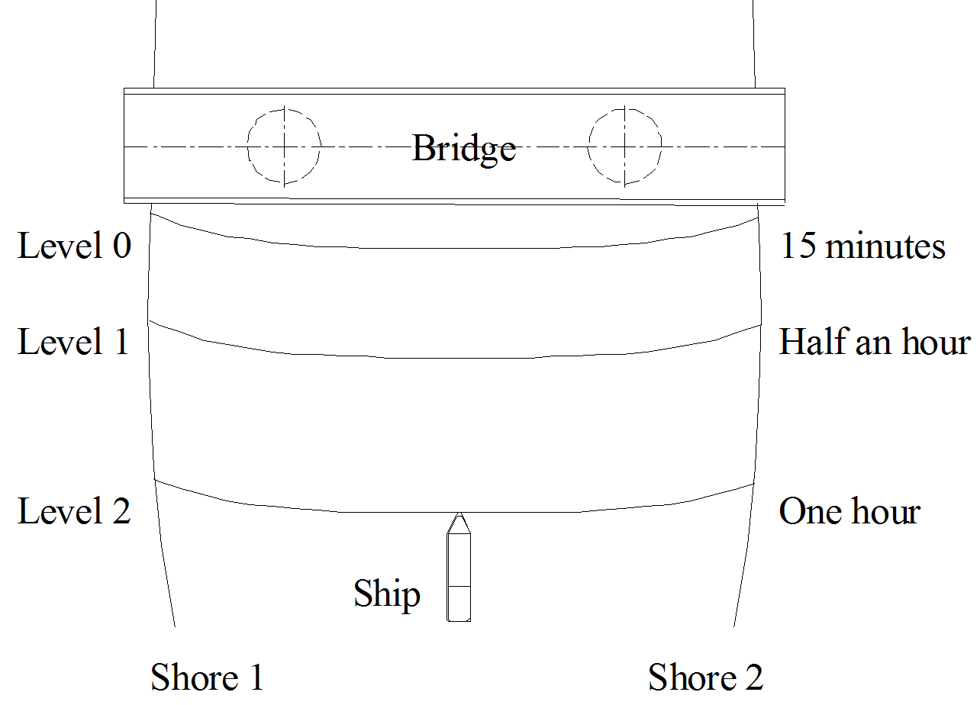

**Figure 4: Multi-tiered Geofencing Lines**

***3.2 Detection of Variable Parameters***

Detection of variable parameter is mandatory because they are basic data to determine the geofencing lines. To do, detective equipments (sensors) are pre-installed on the shores of the river or at specified location. For example, in figure 5 (*a*) is to measure the latitude of the water and (b) is for velocity. All the measured data are sent to the data center and processed to be used in warning instantly.

|  |  |
| --- | --- |
|  |  |
| *(a) Measurement of latitude* | *(b) Measurement of velocity* |
| **Figure 5: Real time measurement** | |

***3.3 Calculation of Geofencing Line***

A geofencing line g is mathematically a cubic B-spline curve defined by

 (1)

where



and is called a virtual control point explained later.

A point  on a geofencing line can be described by

 (2)

The parameters in (2) act as following descriptions:

(1). *t* is the time at which the calculation is done.

(2). *l* is the level of the calculated geofencing line.

(3). is an array to express the locations of the bridge piers; normally it contains all the locations of the piers as well as two end-points of the bridge. If the bridge has *n* piers, then

.

where and are locations of the bridge's two ends.

(4). is the instant location of the ship at time *t*.

(5). is the instant velocity of the ship at time *t*.

(6). is the velocity of the water at time *t*.

(7). is a array to express the outline of the shore 1; it is also an array to recode a serious of locations taken from the shore 1, with the first one is the nearest to the bridge.

(8). is a array to express the outline of the shore 2, like .

(9). is the depth of the water where the ship is staying.

(10). is the mass of the ship.

(11). is the mass of the cargoes the ship is loading. For an empty ship, .

(12). is the number of the ships in the water ranged from  and .

(13). is the status of climate. for a good climate ; for a bad climate; the worse the climate is, the smaller  is.

(14). is the status of the flood. for no flood; for a bad climate; the worse the climate is, the smaller  is.

(15). is a preserved status to describe accidental events.  means no accidental events;  means there are accidental events; the more accidental events, the smaller  is.

(16). *k* is the index of virtual geo-point.

It needs pointing out that the result calculated by (2) is a array of dimension n that is determined by the array , the point , the points in  and . The minimal value of *n* is 5, corresponding to the case the bridge has no piers, as illustrated in figure 6.

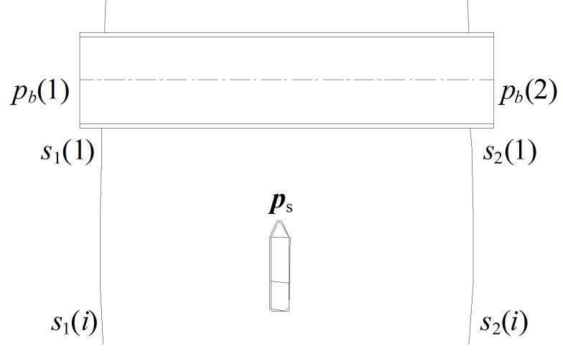

**Figure 6:** **The simplest case to calculate** 

This time, means two end-points of the bridge, and  are respectively two start-points of shore 1 and shore 2. This five points form the base to compute the simplest case. By property of the cubic B-spline curve, two segments of the curve can be calculated by the 5 points. If the bridge has piers, the dimension of  increases with the number of the piers added. If the ship is far away from the bridge, more data of the shores are taken into account.

With and , a dangerous coefficient *d* is calculate by

  (3)

where  is an ***h***-related experience value.

And a *dangerous velocity*  is defined by

 (4)

It is seen that the dangerous velocity is bigger than in bad climate, flood status, accidental event , or with large loads or big number of ships nearby. The higher the dangerous velocity is, the more dangerous the ship's sail is.

With dangerous velocity, the warning displacement is defined by

 (5)

where is the *warning time.*

Accordingly, warning displacements at are respectively ,, and . Note that, is different at different point because changes from point to point; therefore is variable from point to point.

Computation of the virtual control point for the B-spline (1) needs to compute for each pier a warning displacement and then form a set F of the control points along with those form the two shores. Use figure 7 to show the principle.

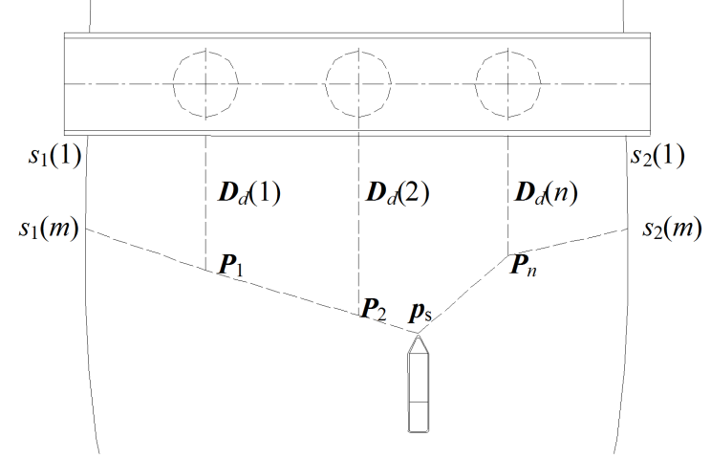

**Figure 7: Virtual control points**

By this means, the virtual control points form the set F, namely,

 (6)

where *m* is biggest number of *j* such that the dot product for *j*=1,2,...,dimension of .

Regarding each element in F as a control point, the B-spline (1) is easily calculated.

***3.4 Different Alert Signals***

A signal consists of a message and a voice. To distinguish the level of the warning, it is necessary to use different messages and voice. For example, messages "You are arriving at a bridge in an hour", "You are arriving at a bridge in half an hour", and "You are arriving at a bridge in 15 minutes", are proposed. Readers of course design some other messages.

# IMPLEMENTATION AND APPLICATION

With principle introduced in the previous section, implementation of the warning system is easy by developing APP or warning software embedded in ships. As seen in figure 8, geofencing lines are calculated perfectly. The technology is going to be applied and equipped on ships of Hunan province.

# CONCLUSIONS AND RECOMMENDATIONS

Prevention of bridge piers from collision with ships has been a research topic in bridge engineering and informatics. Despite the intelligent navigation for ship provides many skills in ships' sailing, the warning system is still in need. Development of proper warning system is necessary. The dynamical geofencing warning technology can help develop such systems. Hope certain work will be done and benefits will be revealed in the future.

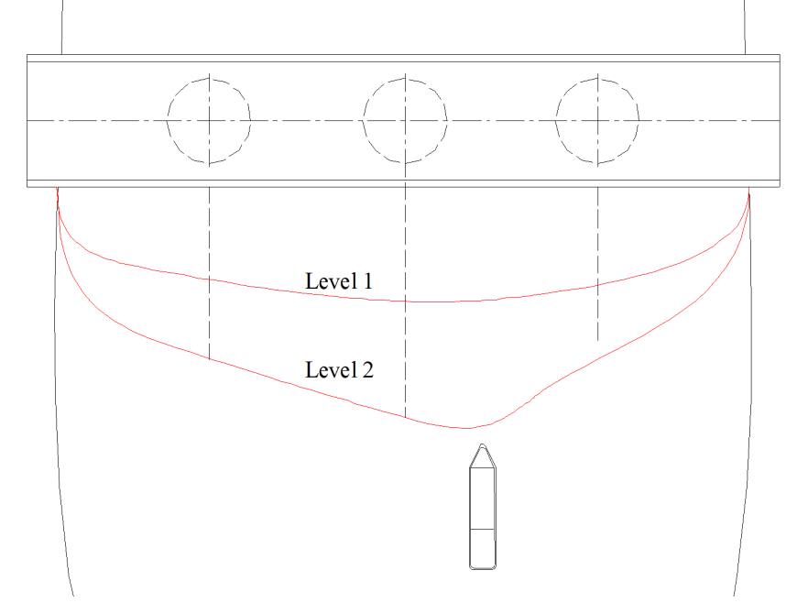

**Figure 7: Geofencing lines**

**Acknowledgement**

The paper is supported by project founded by Hunan Natural Science Foundation under no.2022JJ50283. Author sincerely thanks all the supports.

**REFERENCES**

1. Pedersen P T, Chen J, Zhu L. (2020). "Design of bridges against ship collisions", Marine Structures, 74, Article 102810. DOI: 10.1016/j.marstruc.2020.102810
2. Wang Y G, Yang L M, Zhou F H, et al. (2022). "Flexible Protection Technology of Bridge Pier against Ship Collision", Proceeding of IABSE Congress: Bridges and Structures: Connection, Integration and Harmonisation, Nanjing, pp.1038-1045, DOI: 10.2749/nanjing.2022.1038
3. Ma W,Zhu Y,Grifoll M, et al. (2022). "Evaluation of the Effectiveness of Active and Passive Safety Measures in Preventing Ship–Bridge Collision",Sensors, volume 22, 2857. DOI:10.3390/s22082857
4. Wen Zhe Zhang, Jin Pan, Javier Calderon Sanchez, et al. (2024). "Review on the protective technologies of bridge against vessel collision", Thin-Walled Structures, volume 201, Part B,112013. DOI: 10.1016/j.tws.2024.112013
5. Jonathas Marcelo Pereira Figueiredo, Rodrigo Pereira Abou Rejaili. (2018). "Deep Reinforcement Learning Algorithms for Ship Navigation in Restricted Waters",Mecatrone, volume 18, issue 3, pp. 1-10.
6. Michael Knott P E, Mikele Winters P E. (2018). "Ship and Barge Collision With Bridges Over Navigable Waterways", The 34-th PIANC-World Congress Panama City, Panama 2018,28.
7. Agnieszka Lazarowska. (2019)."Research on algorithms for autonomous navigation of ships", WMU Journal of Maritime Affairs, DOI:10.1007/s13437-019-00172-0.
8. Wenyang Gan, Lixia Su, Zhenzhong Chu. (2023). "A PSO-enhanced Gauss pseudospectral method to solve trajectory planning for autonomous underwater vehicles", Mathematical Biosciences and Engineering ,volume 20, Issue 7, 11713–11731. DOI:10.3934/mbe.2023521.
9. Fei Wang, Hui-Juan Chang, Bo-Han Ma, et al. (2023). "Flexible guided anti-collision device for bridge pier protection against ship collision: Numerical simulation and ship collision field test", Ocean Engineering,271, 113696. DOI: 10.1016/j.oceaneng.2023.113696.
10. Yixuan Song1,Xi Cao. (2024). "Review of Intelligent Ship Path Planning Algorithms", Frontiers in Management Science,volume 3, issue 1,pp.90-101.DOI:10.56397/FMS.2024.02.
11. Rui, Y., Wang, R., Zhao, J., Xiong, Z., Liu, J. (2024). "Research on Intelligent Navigation Algorithm of Long and Short Term Memory Network Based on Firework Algorithm Optimization in Satellite Blocking Environment", In: Yang, C., Xie, J. (eds) China Satellite Navigation Conference (CSNC 2024) Proceedings. CSNC 2024. Lecture Notes in Electrical Engineering, vol 1093. Springer, Singapore. DOI:10.1007/978-981-99-6932-6_50.
12. Zhang X, Kanf J, Yu H.(2024). "Intelligent Navigation System Based on Big Data Traffic System",Scalable Computing: Practice and Experience,volume 25,issue 2,pp.1124–1133.DOI 10.12694/scpe.v25i2.2654.
13. Müller T, Grabowski N, Hohenberger C, Zöllner J M. (2022). "Autonomous driving: A literature review on behavior prediction and planning", IEEE Transactions on Intelligent Vehicles, volume 7,issue 2, p.227-241.Al-Senafy, M.; Fadlelmawla, A.; Mukhopadhyay, A.; Al-Khalid, A. and Al-Fahad, K.,(2016). "Groundwater Protection in Kuwait: Design of Monitoring Network and Recommended Path", Proceeding of Nineteenth International Water Technology Conference, IWTC19, 21-23 April 2016. Pp 13-20.
14. Ming G. (2023) "Exploration of the intelligent control system of autonomous vehicles based on edge computing",PLOS ONE,volume 18,issue 2,pp.e0281294. DOI:10.1371/journal.pone.0281294.
15. Jwo D J, Biswal A,Mir I A. (2023). "Artificial Neural Networks for Navigation Systems: A Review of Recent Research", Appl. Sci. volume 13, p.4475. DOI:10.3390/app13074475.
16. Jiancheng Jing. (2023)."Research progress and prospects of intelligent planning algorithms in navigation collision avoidance", Proc. SPIE 12799, Third International Conference on Advanced Algorithms and Signal Image Processing (AASIP 2023), 127990A (10 October 2023); DOI: 10.1117/12.3005997.
17. Fabrice Reclus. (2013). "Geofencing", chapter 6 of Geopositioning and Mobility, John Wiley & Sons, Ltd., DOI:10.1002/9781118743751.ch6.
18. Banu T, Daiya K,Rathi P. (2018)."Perimeter Security Using Geo-Fencing Technology",International Journal of Engineering Research & Technology, volume 2,issuem 10,pp.175-178.
19. Jia L, Yang D, Ren Y, et al. (2022). "An Electric Fence-Based Intelligent Scheduling Method for Rebalancing Dockless Bike Sharing Systems", Applied Sciences,volume 12,issue 10,pp.5031. DOI:10.3390/app12105031.