Developing an Artificial Intelligence Platform for Analyzing Open-Source Information in Distributed Microservice Architecture

Hüseyin AKARSLAN1, Şeref SAĞIROĞLU2

*1PhD Candidate, Management Information Systems, Graduate School of Informatics, Gazi University, Ankara, Türkiye*

*2Prof., Computer Engineering Department, Engineering Faculty, Gazi University, Ankara, Türkiye.*

*Corresponding Author: Hüseyin AKARSLAN (huseyinakarslan@gazi.edu.tr)*

*ABSTRACT: Management and information systems are considered as two major disciplines which have to be combined to benefit from knowledge for rational decision-making that means strict procedure utilizing objective knowledge and logic since many years. Effective and efficient use of already invested organizational resources is a key subject to gain a competitive advantage by making decisions with the help of AI techniques which benefit from both internal and external knowledge. This paper introduces a new model to get benefits from open-source intelligence (OSINT) in the context of external knowledge with a green computing approach for solving global organizational challenges. The developed application according to proposed model was put into action in some organizations for testing and feedbacks of experts who participated in proof of concept (POC) activities was evaluated and discussed. Finally, findings of our research, advantages of our model and both academic and business future work were summarized.*

***KEY WORDS:*** *management information systems (MIS), open-source intelligence (OSINT), green computing, external knowledge, distributed computing, containerization*

---------------------------------------------------------------------------------------------------------------------------------------

Date of Submission: xx-xx-xxxx Date of acceptance: xx-xx-xxxx

---------------------------------------------------------------------------------------------------------------------------------------

# INTRODUCTION

The previous research by the authors [1, 2] suggested as a concept that proposes a new model which combines open-source intelligence (OSINT) techniques and management information systems (MIS) to use external data for decision-making in different levels of any organization. In the previous study it was stated that the proposed model would be developed as software and put into practice in a number of organizations as a future work. As a result, an open-source information analysis platform with the name of "Gazi.AI" was first developed and put into practice in a number of organizations. Finally, the feedbacks of experts who participated in test process were evaluated.

Different studies related to our work were made by different academics [3, 4, 5], but these studies don't cover our research totally. Previous studies mostly focused on analysis of social media or scientific data in distributed architecture on server or public cloud systems. While these studies principally based on open-source data analysis or microservices on server systems, our study is a combine of different concepts and differs from others by targeting end user computers as a system resource.

This study consists of five chapters excluding introduction. In the second chapter, the background of our research is analyzed from the multidisciplinary viewpoint of management information systems (MIS). In the third chapter, developed open-source information analysis platform according to previous research is explained in technically. In the fourth chapter, research methodology and data collection of this study is described. Collected information according to feedbacks of experts is discussed in the fifth chapter. Finally, problems encountered in this research are highlighted and future works are pointed out in the conclusion chapter.

The problem of our research that we addressed in our previous study;

*For every organization today, collecting and analyzing the data from open sources and applying the knowledge to their business process is not an option; it is a requirement. Each organization needs data scientists, hardware and software resources for fulfilment of this requirement. Big enterprise companies can make an investment to solve this problem, but small and medium-sized enterprises (SMEs) may not have enough budget because employment of data scientists, purchasing server systems and analytical software are expensive operations.*

Both qualitative and quantitative research methods were used in our ongoing research. While qualitative research methods were used in the theoretical framework of our study such as literature review and model proposing, quantitative research methods were used in evaluation and measuring of feedbacks. Our hypotheses below that identified in our previous study are defined again and discussed systematically with quantitative results of given answers by the experts who participated in test phase.

H0: External information available from open sources is an important component of MIS, and the outputs to be obtained as a result of open-source intelligence benefit managers in decision-making processes.

H1: In order to solve the problem discussed in our research, an open-source information analysis platform based on distributed microservice architecture can be run on desktop computers that organizations already have.

H2: Pre-defined open-source data analysis scenarios according to business requirements of an organization that required high-performance computing and expensive analytical software can be processed and reported on end-user desktop computers with distributed microservice architecture without any new investment.

H3: In the Internet age, since many businesses invest in a large number of desktop computers to carry out their current operations, the model proposed in our study can be realized by using these resources in cases where the hardware resources of these computers are not actively used.

H4: Using resources effectively, efficiently and economically is the main factor for every organization to maximize their profits. Any new solution which requires a new investment or an additional budget for analyzing open-source information would be a riskier decision for the managers in the point of view of the return of investment (ROI).

Many topics that we predicted in our previous study and experienced in this study such as information security concerns, network saturation and performance issues are excluded from the scope of our research. Each problem that we encountered in theoretical and practical phases of our research will be considered as a new research problem/opportunity with the aspect of an academic project.

***1.1 Background***

Data, information, and finally, knowledge are hierarchical terms, and they are derived from each other. Since the beginning of the 21st century, knowledge has been considered one of the most important management resources [6]. From small non-governmental organizations or institutions to big enterprise companies, each organization has an ultimate purpose (socially and/or economically), which is producing value. To achieve that purpose, the best decisions should be made by the decision makers with the help of knowledge. Creating value with the help of data makes it mandatory to combine different disciplines such as management and information systems [7, 8, 9, 10]. There are several frameworks that were developed to standardize the correlation between knowledge and decision making. The Knowledge Value Chain (KVC) [11] is a structured framework for understanding, accelerating, and optimizing the stepwise transformation of the data into knowledge and intelligence, and finally into outcomes and operating results. In the KVC framework, which starts with raw data and ends with organizational value, while a step is the output of a process, it is also the input of another process (See Figure 1).

Knowledge is accepted as a critical asset of the organization in knowledge management and it refers to the set of business processes developed in an organization to create, store, transfer, and apply knowledge. According to the KVC and other related knowledge management aspects, data from external sources, such as news feeds, industry reports, legal opinions, scientific research, and government statistics, are defined as the other vital data for an organization [12].

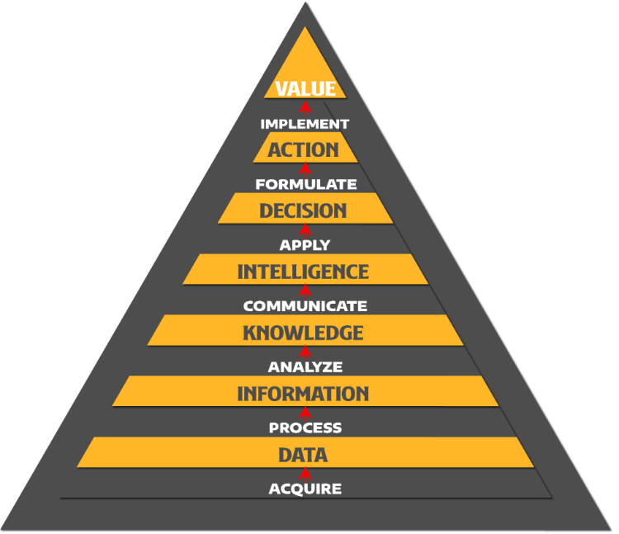

**Figure 1: Knowledge Value Chain (KVC)**

Since the first years of 2000s, the development of information systems as a discipline and its possible effects on other disciplines in the future have attracted the attention of researchers and it has been predicted that information systems will be a center of balance especially in terms of technology, organization, management and sociology [13]. MIS, which is a multidisciplinary field, has developed in different countries by being influenced by different disciplines. Computer science, business/management and industrial engineering are mostly effective in the field of MIS in Türkiye according to the academic studies [14]. In our study, in accordance with the basic approach of MIS, a theoretical and applied research was carried out to solve a problem that exists in practice, by considering the fields of MIS and OSINT together with a multidisciplinary perspective.

An important issue that organizations which need to put information at the centre of their decision-making processes should not overlook is the change in the quality of information. “Qualified information” that managers should benefit from in rational decision-making processes through MIS should contain features such as timely, relevant and sufficient [15], which is only possible by evaluating internal (internal) and external (external) information together. Current empirical studies using quantitative and qualitative market research methods show that companies that benefit from external data in their decision-making processes can only manage radical R&D processes and make innovation [16]. In addition, it has been determined that the technological information produced by different organizations and shared through open sources not only reduces the costs of other organizations, but also increases their economic performance [17]. Studies comparing companies that can't improve with dynamic and innovative companies have revealed that companies that come to a standstill focus more on their internal data, while companies that make progress can push the limits of their corporate intelligence by being interested in external knowledge/ideas [18]. Field studies clearly show that external data has a multiplier effect in the correct and rational decision-making processes of organizations. In our study, by taking this concrete fact into consideration, we tried to contribute to the literature on how to use external data obtained from open sources by OSINT techniques in the field of MIS. While making this contribution, not only a theoretical solution was proposed, but also a practically applicable project was developed.

OSINT means every kind of printed or digital intelligence, which is obtained from publicly available open (not concealed or secret) sources. Although the term OSINT involves both digital and non-digital forms of information, it represents digital intelligence in this day and age with the increase of digital data. At first glance, OSINT acknowledged as a subject of the state security and/or information security domain but each organization under any industry which engaged with knowledge has to benefit from the approach of OSINT directly or indirectly. From raw data to information, knowledge and intelligence, OSINT procedure can be divided into four distinct processes; accessing and storing the data (collecting), analyzing the data and finally reporting. Thanks to the multiple structures of the OSINT processes, each of four essential steps (data accessing, data storing, data analysis and data reporting) can be developed as microservice-based software and can be run on different hardware resources as long as they communicate successfully with each other by means of a good orchestration.

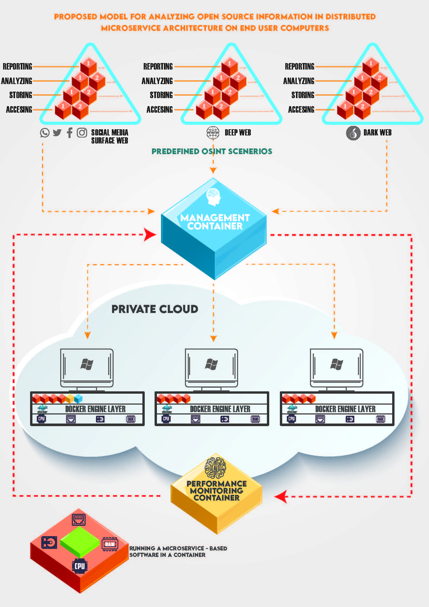

**Figure 2. Proposed Model**

A microservices is a small-scale independent working application which is designed for single-purpose that is focusing on doing just one thing (task/job) well [19]. Our proposed model (See Figure 2) in the previous study is based on distributed microservices which fulfil a specific task by running on different end user computers. In this study we developed a platform according to this concept and evaluated results by testing practically in different organizations.

A microservice-based application mostly runs in a container which is a typical software unit that packages up both code and all its dependencies to make it possible to run quickly and reliably on different computing infrastructures. A Docker container can be run by mounting a Docker image on desktop or server computers which Docker Engine virtualization feature enabled. A Docker container image is a lightweight, standalone, executable package of software that includes everything needed to run an application: code, runtime, system tools, system libraries and settings [20]. Each organization purchases end-user computers every budget year to use them for organizational purposes, thus our model is targeting these corporate resources which already have been invested in. In case of the existing end-user computers of any organizations are not used efficiently for end-user needs, these corporate resources can be used for other organizational operations like open-source data analysis.

To prove the feasibility of our proposed model, a set of container-based applications (Table 1) have been developed by authors. While main container images such as "gaziai" and "gaziaiwatcher" are unique, other container images belong to pre-defined open-source intelligence scenarios are many. Because, there have to be at least four container images for each pre-defined open-source intelligence scenario that named as "Module".

***Table I.* Gazi.AI platform Docker container images**

|  |  |  |  |  |
| --- | --- | --- | --- | --- |
| **1** | **Name\*** | gaziai | **Docker Hub URL\*\*** | hub.docker.com/r/hakarslan/gaziai |
| **Role** | Management Container. This container manages both Docker hosts (end user desktop computers) which act as a worker node and OSINT projects from start to finish. | | |
| **2** | **Name** | gaziaiwatcher | **Docker Hub URL** | hub.docker.com/r/hakarslan/gaziaiwatcher |
| **Role** | Performance Monitoring container monitors the utilization of the Docker hosts and creates performance reports by using AI algorithms. According to the performance reports, OSINT analysis containers can be deployed to hosts manually or automatically. | | |
| **3** | **Name** | ModuleXXAccess | **Docker Hub URL** | hub.docker.com/r/hakarslan/moduleXXaccess |
| **Role** | This microservice works as a connector and has two functions. The first function of this microservice is accessing the open-source data over any network and the second function is sending the data to the Data Storing Microservice. | | |
| **4** | **Name** | ModuleXXStore | **Docker Hub URL** | hub.docker.com/r/hakarslan/moduleXXstore |
| **Role** | This microservice works as a data store and stores the data which is sent by the Data Accessing Microservice. Data can be stored in the file system or relational and non-relational databases according to the open-source data format. Stored data in this microservice can be accessed by the Data Analysis Microservice to use in the analysis process. | | |
| **5** | **Name** | ModuleXXAnalyze | **Docker Hub URL** | hub.docker.com/r/hakarslan/moduleXXanalyze |
| **Role** | Processing the data to convert it to information, knowledge or intelligence is vital to the OSINT process. According to the business requirements, ordinary data analysis methods can be insufficient, and AI-based techniques, such as machine learning and deep learning, can be necessary. Thus, this microservice probably utilizes more hardware resources. Analysis step ends with a reporting operation, and this microservice sends the reports to the Reporting Microservice. | | |
| **6** | **Name** | ModuleXXReport | **Docker Hub URL** | hub.docker.com/r/hakarslan/moduleXXreport |
| **Role** | The most lightweight microservice is the Reporting Microservice because its only function is to serve as a file server or web server that publishes reports which are created by the Data Analysis Microservice, but it has a crucial role in the OSINT process to use the intelligence for decision making. | | |

* XX means module code e.g., A1, A2, B1 etc.

** gaziai and gaziawatcher container images are private due to patent application, so they are not accessible for anyone except project team.

# GAZI.AI OPEN-SOURCE INFORMATION ANALYSIS PLATFORM

A proof-of-concept (POC) demonstrates the feasibility of a proposed product, model, method or idea [21]. POC's goal is focusing on building or developing the idea, it tests whether the idea is feasible and viable. In addition, it enables those involved in the proof-of-concept exercise to explore its industrial potential [22]. From this point of view the best way to prove that our theoretical research can also solve a real-world problem is to develop an application. Gazi.AI is still being developed for this purpose, but to title Gazi.AI as a platform, not as an application is more accurate, because it means a set of container-based applications and it has the ability to manage other hosts to run applications. Furthermore, other open-source projects can be implemented to Gazi.AI to be able to run on distributed architecture.

* 1. ***System Architecture***

Gazi.AI platform consists of three main components (Figure 3), but end users can only access management container via user interface to manage the whole infrastructure. On the other hand, software developers can customize and adapt the system according to different needs with the aspect of open-source philosophy.

**Management interface**: The most important container component of the system. The container image was created with the name “gaziai” and uploaded to the Docker Hub platform as “private”. Docker Hub is a service that serves on https://hub.docker.com, where end users and corporate companies can upload and test Docker container images they have developed and share them with users [23]. As our patent application process continues regarding to our research, the Docker image that contains source codes is not shared publicly.

**Performance monitoring**: It is the container that monitors the resource usage of the end user computers to be used by the system and serves the performance reports generated as a result of the evaluation with artificial intelligence algorithms to the access of the management interface. According to the performance reports produced by the performance monitoring container, it can be applied automatically (according to the schedule suggested by the system), semi-automatically (calendar is recommended by the system, but the system administrator can apply it fully or partially) or manually (decided by the system administrator according to the recommendations) in three different ways via the management interface container, which module container will run on which computer when. The performance monitoring container was created as a Docker image with the name "gaziaiwatcher", but it is still under development.

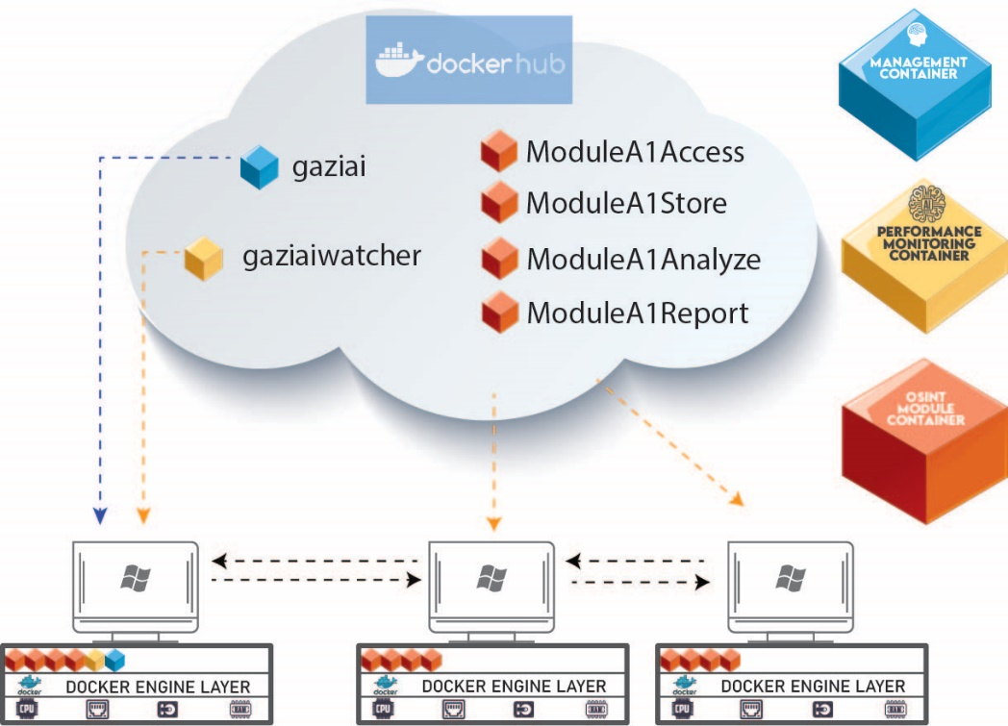

**Figure 3: System architecture**

Pre-defined OSINT modules: Open-source intelligence processes, which will be carried out according to the data to be obtained from different layers of the internet (surface web, deep web and dark web), are integrated into the system as different modules. As we mentioned in the second part of our study, each module consists of four separate containers in which four separate microservices run (Table 2).

***Table II*.Pre-defined OSINT scenarios modules containers**

|  |  |  |  |  |
| --- | --- | --- | --- | --- |
| **ID** | **Name** | **Layer** | **No** | **Containers** |
| **1** | Twitter Sentiment Analysis with TextBlob | A (Surface Web) | 1 | **ModuleA1Access** |
| **ModuleA1Store** |
| **ModuleA1Analyze** |
| **ModuleA1Report** |
| **2** | Twitter Sentiment Analysis with Microsoft Azure Text Analytics | A (Surface Web) | 2 | **ModuleA2Access** |
| **ModuleA2Store** |
| **ModuleA2Analyze** |
| **ModuleA2Report** |
| **3** | Twitter - Turkish Personal Data Disclosure Analyze | A (Surface Web) | 3 | **ModuleA3Access** |
| **ModuleA3Store** |
| **ModuleA3Analyze** |
| **ModuleA3Report** |
| **4** | Telegram Group Content Analysis* | B (Deep Web) | 1 | **ModuleB1Access** |
| **ModuleB1Store** |
| **ModuleB1Analyze** |
| **ModuleB1Report** |
| **5** | Dark Web Page Content Analysis* | C (Dark Web) | 1 | **ModuleC1Access** |
| **ModuleC1Store** |
| **ModuleC1Analyze** |
| **ModuleC1Report** |

* Under development

All necessary container images were developed and uploaded to the Docker Hub platform, so it is possible to pull and run any images on end user computers via management interface. In order for the system to work properly, Docker Desktop must be installed on all computers, internet connection must be available, and computers must be able to communicate with each other on the same local network through the required ports (22, 80, 443, 2375, 27017).

* + 1. ***Management Interface***

Management container image includes all the necessary components to run the platform except pre-defined OSINT module's container images, but it has the knowledge and capability to pull an image from Docker Hub platform and make it run on a specific host as an orchestrator. There are several container orchestration tools in the market, but they don't support Docker Desktop version, thus it is needed to develop our own orchestration tool to put into practice the proposed model. PHP and HTML software languages are used for the end user interface both frontend and backend, MySQL as the database and Python for the system services (Figure 4).

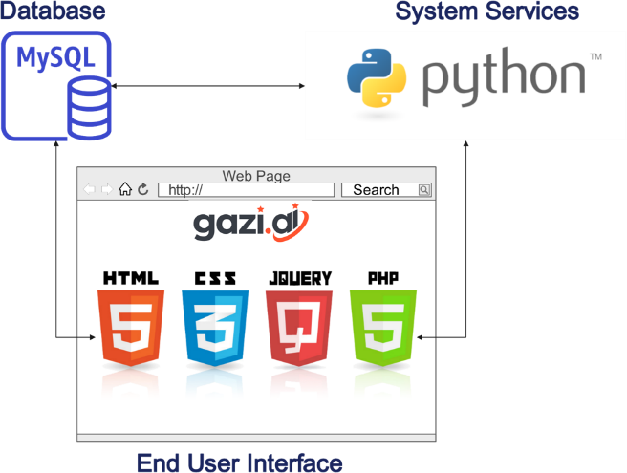

**Figure 4. Technologies used in management interface**

First step to use the platform is running the “gaziai” container image on any Docker Desktop installed computer. When the container is working properly, the end user can log in to the system via http://IPAddress/ with a web browser. This is the only interface that the end user interacts with for all processes with the Gazi.AI project. Accessing the database which stores every detail about the system processes and interacting with system services is only possible through management interface layer. All data related to the administration of the application and administrative data related to each open-source intelligence project to be created are stored in a single database. But pre-defined OSINT modules store the data they collect in structured or unstructured databases in another container (ModuleXXStore) of their own.

Requests coming from the end user interface are processed and transferred back to the end user interface and stored in the database through the web service developed with “Python Flask”. For the "info" request coming through the interface, the hardware and software features of the computers added to the system as Docker Host are discovered, inserted into the database and displayed to the end user. The open-source intelligence project created in the "initialize" request is run in a distributed structure on selected computers in accordance with the relevant parameters, and the results are inserted into to the database and displayed to the end user. In the "clear" request, all containers belonging to the relevant open-source intelligence project are cleaned from end-user computers and made ready for the next open-source intelligence project. The connection between the system service and the end-user computers with Docker Desktop installed is made through the "Docker SDK for Python" module over port 2375 at the "Docker Engine API" layer. Since our research is an academic project, an SSL-certified connection is not established, but it should communicate with an SSL-encrypted connection over port 2376 in production to provide information security.

* + 1. ***Performance monitoring container (gaziaiwatcher)***

For the POC phase of our applied research this container is not mandatory, but according to our proposed model and patent application, another container should monitor the private cloud infrastructure which consists of desktop computers and understand the resource utilization with AI techniques to guide the management container. Our model is targeting Microsoft Windows 10 and newer versions which are the most used desktop computer OS. In Windows OS, it is possible to collect performance monitoring data with different parameters both hardware and software components, and also collected data can be stored in another database [24] on another computer in the local or remote network.

The role of this container is to collect the performance monitor data and detect the suitable time period by analyzing the utilization of resources for running pre-defined OSINT modules' containers. Enterprise and community level performance monitoring tools with a modern look dashboard are also available in the market, but mostly these products don't share the reports in a Business to Business (B2B) mode by web services that makes it possible for using by another application. Therefore, to provide the automatic deployment of containers according to free status of desktop computer resources, this container is necessary. Collecting and analyzing data, then serving reports need high computing resources particularly fast and large-scale storage, so this requirement should be considered carefully before running performance monitoring container. One of the most important advantages of using Docker Desktop technology in our research, the capability to dynamically limit the resources dedicated to any container [25]. Memory, CPU and GPU usage can be limited dynamically according to resource utilization host computer, even it is possible to pause any container for a temporary time until the resources became available again.

* 1. ***Pre-defined OSINT modules***

Considering the huge size of the internet in the context of publicly accessible data, the numbers of open sources can be assumed endless. Thus, the best way to develop an OSINT platform is to design it flexible for different OSINT projects through different layers of internet. The same principle was adopted in our study and it is planned to increase the numbers of pre-defined OSINT modules with the participation of volunteer contributors. Currently three modules are working properly and two modules are under development, but enough to test and prove the concept. In this section these modules and their containers are explained briefly.

* + 1. ***ModuleA1 “Twitter sentiment analysis with TextBlob***

ModuleA1Access container can connect to Twitter by Twitter API [26] to collect tweets and store in the ModuleA1Store container which is a MongoDB database container. Sentiment analysis is the process of analyzing digital text to determine if the emotional tone of the message is positive, negative, mixed or neutral [27]. Sentiment analysis is still one the most common techniques in the fields of text mining, because popular social media platforms include huge amount of text data to be analyzed with the approach of OSINT.

TextBlob is a Python library for processing textual data. It provides a consistent API for diving into common natural language processing (NLP) tasks such as part-of-speech tagging, noun phrase extraction, sentiment analysis, and more [28]. ModuleA1Analayze analysis the tweets with the TextBlob library and creates and uploads an OSINT report to ModuleA1Report container. ModuleA1Report container is a simple webserver that hosts pdf files which includes detailed information about OSINT project as a report. This module was developed and tested many times during the development and test phases, but TextBlob library gives reasonable results for English tweets.

* + 1. ***ModuleA2 “Twitter sentiment analysis with Microsoft Azure text analytics”***

The size of the data as a training set for artificial intelligence is crucial for the success of the model. Top three cloud services providers are also biggest technology companies which manages the giant-size data of organizations and individuals. Amazon, Google and Microsoft have the capability to develop and serve high level AI services. In this module, "Azure Text Analytics” service [29] is used for sentiment analysis of tweets. While ModuleA2Access and ModuleA2Store have the similar design with ModuleA1Access and ModuleA1Store, ModuleA2Analyze analyzes the tweets by cloud service and creates a more detailed report. Generated report is uploaded to ModuleA2Report container which acts as lightweight web/file server.

Microsoft Azure Cognitive Services, AWS AI Services and Google AI and Machine Learning Products are very advanced and affordable artificial intelligence services. But mostly users prefer to purchase additional expensive services such as storage and computing to use AI services on the same cloud platform even if it is not mandatory. This practice is not productive for efficient use of organizational resources. Our model also solves this problem by using desktop computers for storage and computing needs while using advanced cloud services. Especially considering the low privacy status of open-source data, storing this data in an expensive cloud or local storage environment is totally inefficient solution for the organizations which has limit resources. Storing open-source data on desktop computers and deleting after the analysis process done is more accurate way for SMEs.

* + 1. ***ModuleA3 “Twitter - Turkish Personal Data Disclosure Analyze”***

In this module another academic applied OSINT project [30, 31] was implemented to Gazi.AI platform as specified in our model. The amount of sensitive personal data disclosed by users in social networks due to lack of awareness increasing day by day. Developed model regarding to this academic research has the ability to detect any personal data disclosure such and classify such as health, religious, politic etc. in Turkish social media posts. We could easily transform and implement this research to Gazi.AI platform as a new module by working together with the research team. Developed application by the research team to demonstrate the effectiveness of the model had a monolithic infrastructure. The application was redesigned in microservice architecture and divided into four containers such as accessing, storing, analyzing and reporting like the other modules.

ModuleA3Access, ModuleA3Store and ModuleA3Report containers have been developed similarly to ModuleA1 and ModuleA2, but ModuleA3Analyze container was developed according to know-how which was gained in the other research as a "fastText" module file. This file includes classification algorithm which is developed by tagging thousands of text string by project volunteers. Finally, collected tweets could be analyzed in the context of personal data disclosure with the help of another project in distributed architecture with Gazi.AI platform. This module is an important example to demonstrate that other projects could be integrated to Gazi.AI platform.

* + 1. ***ModuleB1 “Telegram group content analysis”***

As explained in our previous study, we did not only focus on surface web layer, but also deep and dark web layers as an open source. Because, proposing a model and developing an application which is only capable of collecting and analyzing data from surface web means missing the opportunity of a broader perspective. Telegram is a cloud-based mobile and desktop messaging app with a focus on security and speed which is one of the most popular social media platforms with 700 million monthly active users and advanced features such as groups and channels [32]. Millions of users writing or reading something from open groups and channels. With the increase of usage of these platforms, huge size amount of data is becoming available to be analyzed with the aspect of open-source intelligence. But by design, this operation has some challenges what make it harder to accomplish automatically. Different text mining techniques were used by different researchers [33] to accomplish, and we are still developing this module which will be able to connect Telegram open groups and channels for analyzing their content.

* + 1. ***ModuleC1 “Dark web page Content analysis”***

Darknet is the most isolated layer of the internet which is only possible to access through special protocols by specific applications. Dark web pages hosted via darknet include different kind of information that attracts both ordinary users and cyber criminals. According to the reports published by European Union Agency for Law Enforcement Cooperation (EUROPOL), terrorism supporters connect through various social media and online forums, including some on the dark web [34]. Online marketplaces, both on the surface and dark web, offer access to illicit goods and illicit services [35] for individuals or criminal groups. Many of the threats in the cyberspace are exacerbated by the growing crime-as-a-service market on the Dark Web [36]. Systematic approaches are being developed by researchers [37] to search and analyze information in dark net. This module is under development and aims to collect information from a list of dark web pages and analyze the content according to keywords.

# RESEARCH METHODOLOGY AND DATA COLLECTION

In this research, which is also an applied academic project, both qualitative and quantitative research techniques were used together. Literature review was conducted to prepare conceptual foundation and theory building, then these workings became the basis of hypotheses formulation. For the literature review not only academic papers but also formal reports and technical manuals were reviewed. Developed platform regarding the proposed model has been tested in practice with the participants from different organizations. Feedbacks of the experts who participated in test phase was collected with a survey by asking multiple choice and open-ended questions. In order to build a practical and effective way feedbacks were collected digitally through the platform, otherwise participants behave reluctantly to share their experience.

Once an OSINT project was created in the Gazi.AI platform, a button with the name of "Send Feedback" is activated. By clicking the "Send Feedback" button, feedback form is expanded. End user can send feedbacks by answering eleven multiple choice and one open ended question under different sections (Table 3). For multiple choice questions five options are available, Strongly Disagree (1), Disagree (2), Neither Agree nor Disagree (3), Agree (4), Strongly Agree (5).

Test users can also share the logs and OSINT report which is obtained from the OSINT project with the feedback form, all feedback data and files are stored in the same database under www.gazi.ai in the cloud environment by encrypted. The text box at the end of the feedback form is designed for the open-ended question with the title of "Additional comments", so test users can share their personal experience without any limitations. These comments are considered very useful for both our academic and industrial purposes, because expert opinions also mean customer requests in the case of converting the research to a product.

All feedbacks are published in the project page with the URL "http://www.gazi.ai/feedbacks.php" without any personal data of participants. Password protection is enabled for the page, because of the publication process. Password of the page is "Gazi1926". Up to the present more than twenty experts from different organizations have participated in test process and sent thirty feedbacks as shown in Table 4.

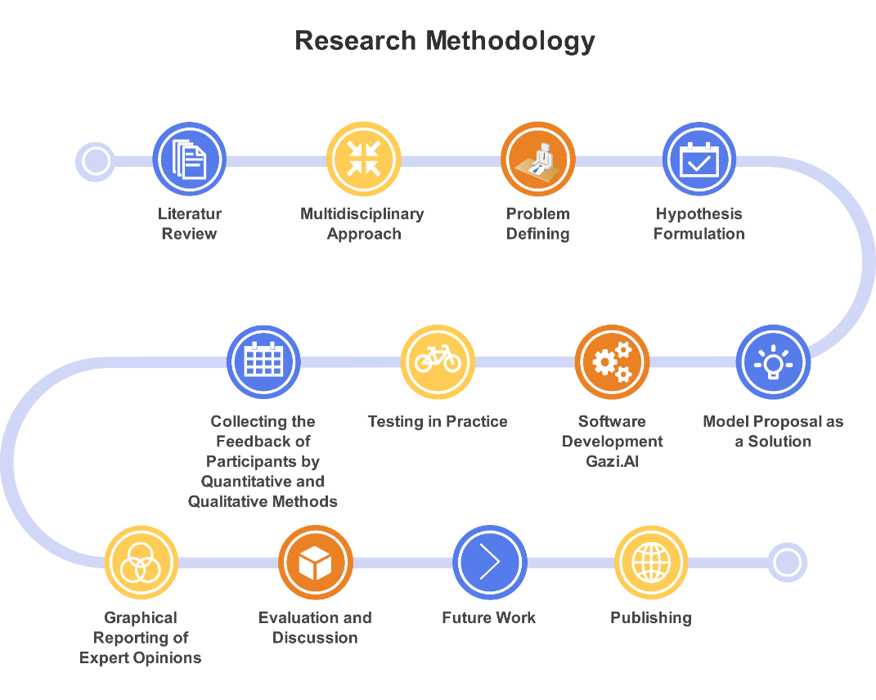

**Figure 5. Research methodology**

***Table III.* Feedback questions**

|  |  |
| --- | --- |
| ***Usability of the Application*** | |
| **Q1** | Open-Source Intelligence (OSINT) techniques are critical and crucial for the Management Information Systems (MIS). |
| **Q2** | OSINT Report is detailed and useful. |
| **Q3** | OSINT Project results are reasonable and meaningful. |
| **Q4** | OSINT Project outputs can be used for decision making process in different levels for the organization. |
| ***User Interface*** | |
| **Q5** | User Interface is user friendly and simple. |
| **Q6** | Information about the project and modules are sufficient. |
| **Q7** | I could use the menus and buttons without any help from the project team. |
| ***Performance*** | |
| **Q8** | System resources was able to be used effectively and efficiently. |
| **Q9** | Project processes were accomplished in reasonable time period. |
| **Q10** | There were no information security concerns regarding the project. |
| **Q11** | Project platform can be used for different distributed computing projects which need high computing. |

Before starting the test process a brief explanation about the research was made according to technical level and interest of the expert. While for some participants ten minutes explanation is enough, some experts were interested in our project and discussed all technical details. Installing our Docker based application was easy for some organizations, but it was not for some others because of information security policies. At first, we encouraged participants to make the installation according to instructions and preliminary actions by themselves, then assisted them when they fail or need help. For system administrators who have experience in virtualization technologies, installing a Docker based application was something new but unchallenging, for most of the other IT experts participated in test it was really a new concept to understand and operate. It is understood that some feedback question was not clear for some participants during the sending feedbacks, because they asked about the terms and the main idea behind the question before answering. The background of the experts was really effective for their answers; thus, we took into consideration this issue while evaluating the feedbacks.

All feedback results were visualized by pie and column charts, and published in the project page with the URL "http://www.gazi.ai/results.php" without any personal data of participants. Password protection is enabled for the page, because of the publication process. Password of the page is "Gazi1926". Evaluation of the feedback results were done according to visualized data for better understanding and discussion.

***Table IV.* Feedbacks**

|  |  |  |  |  |  |  |  |  |  |  |  |  |
| --- | --- | --- | --- | --- | --- | --- | --- | --- | --- | --- | --- | --- |
|  | **ProjectID** | **Q1** | **Q2** | **Q3** | **Q4** | **Q5** | **Q6** | **Q7** | **Q8** | **Q9** | **Q10** | **Q11** |
| 1 | prhZL | 5 | 5 | 5 | 5 | 5 | 4 | 4 | 5 | 5 | 5 | 5 |
| 2 | AMw4F | 5 | 3 | 4 | 3 | 3 | 3 | 3 | 5 | 4 | 5 | 5 |
| 3 | haH20 | 4 | 4 | 4 | 5 | 5 | 4 | 5 | 5 | 5 | 2 | 5 |
| 4 | 6P0Wa | 5 | 5 | 5 | 5 | 5 | 5 | 5 | 5 | 5 | 1 | 5 |
| 5 | n4VE1 | 5 | 3 | 3 | 3 | 1 | 2 | 2 | 1 | 3 | 3 | 1 |
| 6 | eGkjx | 2 | 2 | 3 | 2 | 4 | 4 | 5 | 2 | 1 | 1 | 2 |
| 7 | T2RhL | 5 | 5 | 5 | 5 | 5 | 5 | 5 | 5 | 5 | 3 | 5 |
| 8 | onLfj | 4 | 5 | 5 | 5 | 3 | 1 | 1 | 3 | 5 | 3 | 3 |
| 9 | Y7SfJ | 4 | 4 | 5 | 5 | 4 | 4 | 3 | 5 | 3 | 5 | 5 |
| 10 | OU3gM | 4 | 4 | 5 | 1 | 4 | 5 | 5 | 5 | 5 | 3 | 5 |
| 11 | 6wUaj | 1 | 1 | 1 | 1 | 4 | 4 | 5 | 5 | 5 | 5 | 5 |
| 12 | YAJDZ | 5 | 4 | 5 | 5 | 5 | 4 | 5 | 4 | 5 | 3 | 5 |
| 13 | YyldS | 5 | 1 | 2 | 3 | 2 | 4 | 5 | 5 | 5 | 2 | 4 |
| 14 | 51oKf | 5 | 5 | 4 | 4 | 5 | 5 | 5 | 5 | 5 | 5 | 5 |
| 15 | XcpgN | 3 | 4 | 3 | 5 | 5 | 5 | 5 | 5 | 5 | 5 | 5 |
| 16 | TWf6P | 5 | 5 | 5 | 5 | 4 | 5 | 4 | 5 | 5 | 5 | 5 |
| 17 | Dtalf | 3 | 4 | 4 | 3 | 4 | 3 | 1 | 3 | 4 | 3 | 4 |
| 18 | bUKzS | 3 | 4 | 4 | 4 | 5 | 3 | 3 | 3 | 5 | 4 | 4 |
| 19 | BtbCa | 4 | 5 | 4 | 3 | 4 | 3 | 3 | 4 | 2 | 3 | 5 |
| 20 | JQxLt | 5 | 5 | 5 | 3 | 5 | 3 | 4 | 3 | 5 | 3 | 3 |
| 21 | RFgH4 | 5 | 5 | 4 | 5 | 5 | 3 | 4 | 4 | 5 | 4 | 5 |
| 22 | vNZ5L | 5 | 4 | 4 | 5 | 3 | 4 | 4 | 5 | 5 | 5 | 5 |
| 23 | OWJpX | 3 | 5 | 5 | 4 | 5 | 5 | 4 | 3 | 5 | 4 | 5 |
| 24 | WBiNR | 4 | 4 | 4 | 3 | 5 | 3 | 5 | 3 | 5 | 5 | 5 |
| 25 | sHfST | 5 | 5 | 5 | 5 | 5 | 5 | 5 | 5 | 5 | 5 | 5 |
| 26 | VKc9g | 5 | 5 | 5 | 5 | 5 | 5 | 5 | 4 | 5 | 4 | 5 |
| 27 | PNa8n | 5 | 4 | 5 | 5 | 5 | 5 | 5 | 5 | 5 | 5 | 5 |
| 28 | fQcNi | 5 | 3 | 3 | 5 | 5 | 5 | 5 | 5 | 5 | 5 | 5 |
| 29 | 9sMRQ | 5 | 3 | 5 | 5 | 5 | 5 | 5 | 5 | 5 | 2 | 5 |
| 30 | PznTU | 5 | 4 | 4 | 1 | 4 | 3 | 4 | 4 | 4 | 2 | 5 |

# FINDINGS AND DISCUSSION

In this section all findings of the research are explained by referencing our hypotheses according to expert opinions regarding their experience with our applied project. Each of the eleven questions which was answered by participants were discussed in separate sub-sections.

* 1. ***Question 1 “Open-Source Intelligence (OSINT) techniques are critical and crucial for the Management Information Systems (MIS).”***

Related Hypotheses: H0, H1, H2

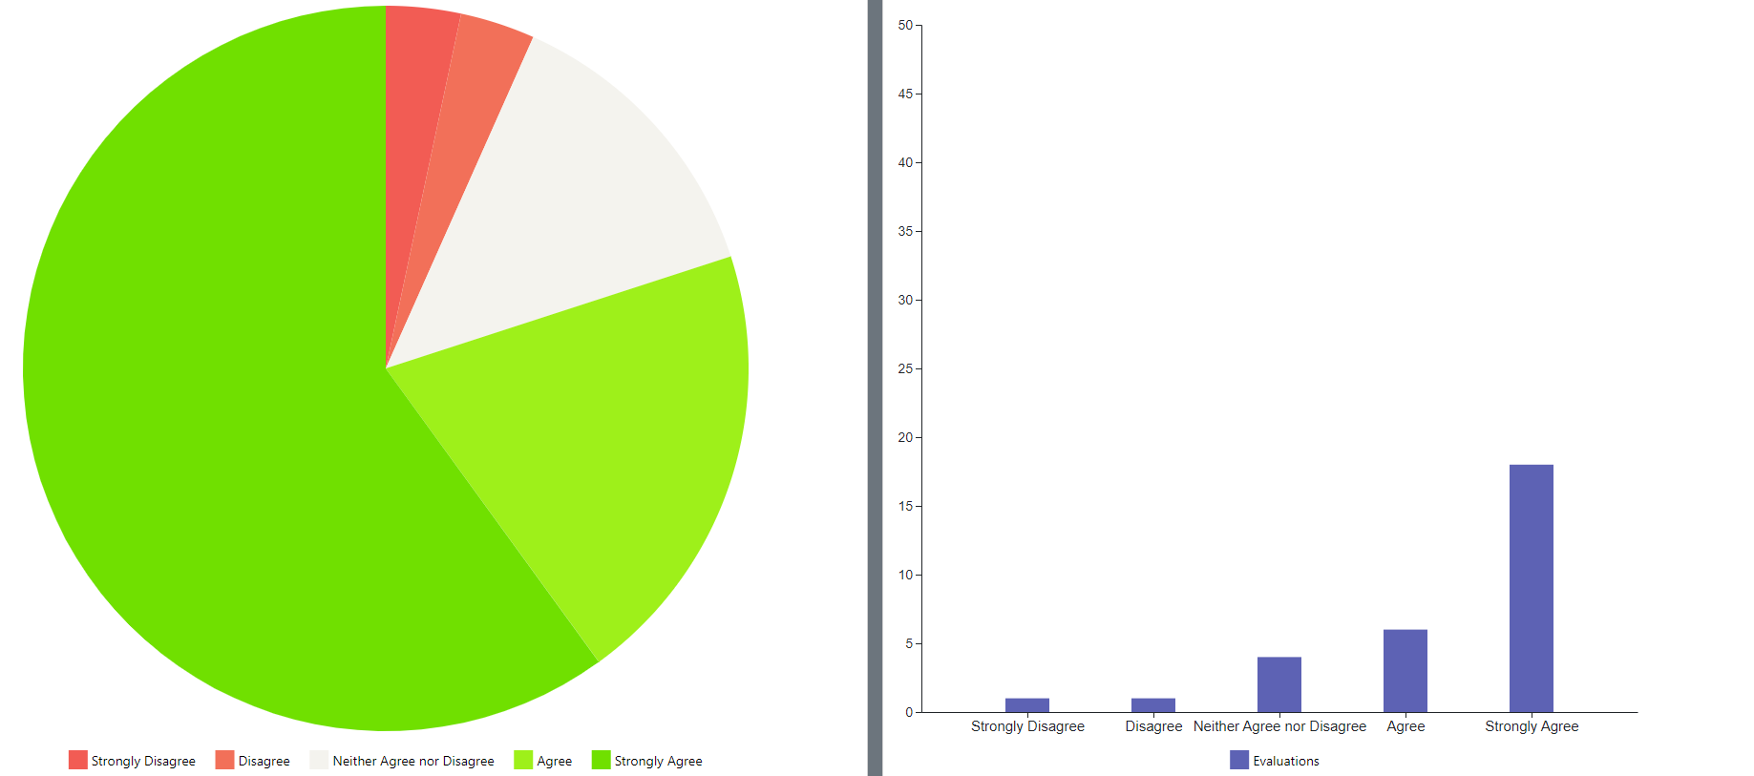

**Figure 6. Question 1 Expert opinions**

Before receiving the opinions of the expert personnel who participated in the testing process, the basic publications [1, 2] about our study was shared and it was ensured that they had information on the subject. In addition, face-to-face information was given before the installations. Despite this preliminary, the majority of the experts who tested the platform we developed and gave their opinions agreed on the importance of OSINT in terms of MIS, and it was seen that a significant number of participants were neither agree nor disagree on this issue. Regarding MIS, which aims to provide information to users on time and at low costs, it was predicted in studies conducted 20 years ago that MIS would fail as an independent discipline and would only exist at the intersection of disciplines such as computer science, business, economics, communication and engineering. The main reason for this situation is stated that MIS, which aims to solve the practical problems of organizations, changes in parallel with the change of these problems over time, making use of different disciplines [38]. In fact, our research fits this situation, because today the OSINT discipline is presented as an alternative solution to the changing need of organizations to benefit not only from internal information, but also from external information. The fact that an innovative approach is not immediately accepted by all researchers in this field and some hesitation is an expected situation in terms of our study. While the answers to this question support our hypotheses, they also show that more academic research and applied projects should be developed in this area.

* 1. ***Question 2 “OSINT Report is detailed and useful.”***

Related Hypotheses: H0, H1, H2

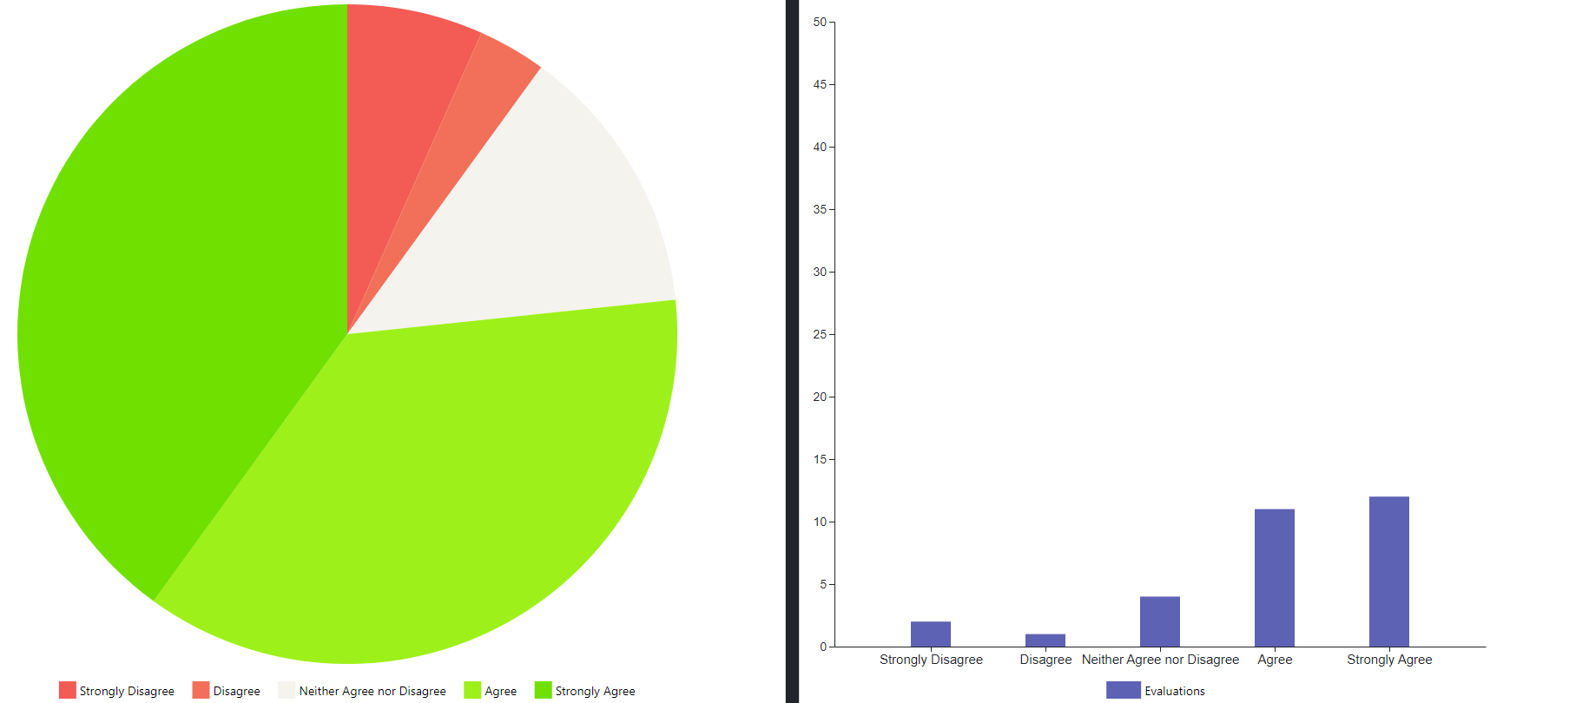

**Figure 7. Question 2 Expert opinions**

The reports produced within organizations thanks to MISs are expressed as the most important unit of intellectual capital [39] and are of vital importance in the success of decision makers. Regarding the reports, which are the final product of the Gazi.AI platform that we have developed within the scope of the study and can be used in decision-making processes, the majority of the participants gave positive feedbacks, although some participants were neither agree nor disagree on this issue. It is natural by intelligence theory that an open-source intelligence report is satisfactory for certain people (customer) and insufficient for others. Because the most important thing that separates intelligence from useful information or knowledge in general is that it answers a personal, subjective question. For this reason, while the information contained in an intelligence report is meaningful and useful for certain decision makers, it may be evaluated as insufficient and inconsistent for others. In both cases, the relevant hypotheses proposed in our study are supported, because an information-based intelligence product was produced by the platform and evaluated by the participants.

* 1. ***Question 3 “OSINT Project results are reasonable and meaningful.”***

Related Hypotheses: H1, H2

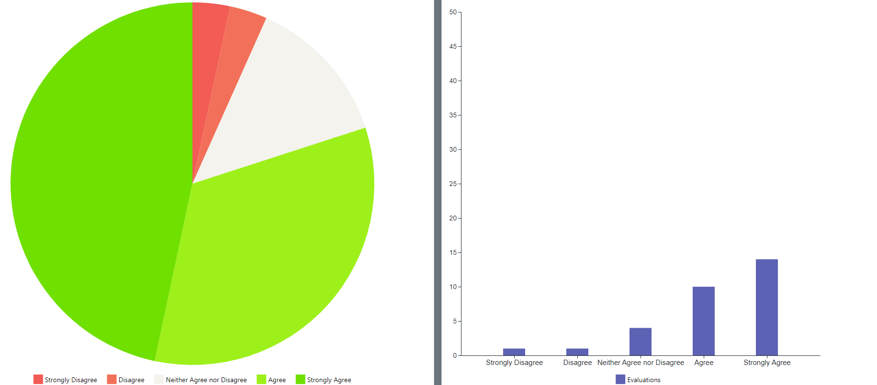

**Figure 8. Question 3 Expert opinions**

Context, the connection between events, situations and relationships in a case, is an important concept for the evaluation of intelligence. Although context and intelligence are different concepts, contextual intelligence which means interpreting the new information obtained in terms of existing experiences and applying it to the solution of existing problems is accepted as a style used by leading managers [40]. Any successfully managed open-source intelligence process is expected to yield reasonable and meaningful results, but in some cases, meaningless results are also obtained, as open-source intelligence related to large amounts of data and relies on data mining techniques. It is an acceptable result that some of the predefined open-source intelligence projects in which artificial intelligence techniques are used will create meaningless outputs. The fact that some participants, even a minority, gave negative feedback on this question is sufficient to prove our hypotheses. However, in line with these negative feedbacks, it is possible to improve the artificial intelligence algorithms used and to obtain more reasonable results.

* 1. ***Question 4 “OSINT Project outputs can be used for decision making process in different levels for the organization.”***

Related Hypotheses: H0, H1, H2

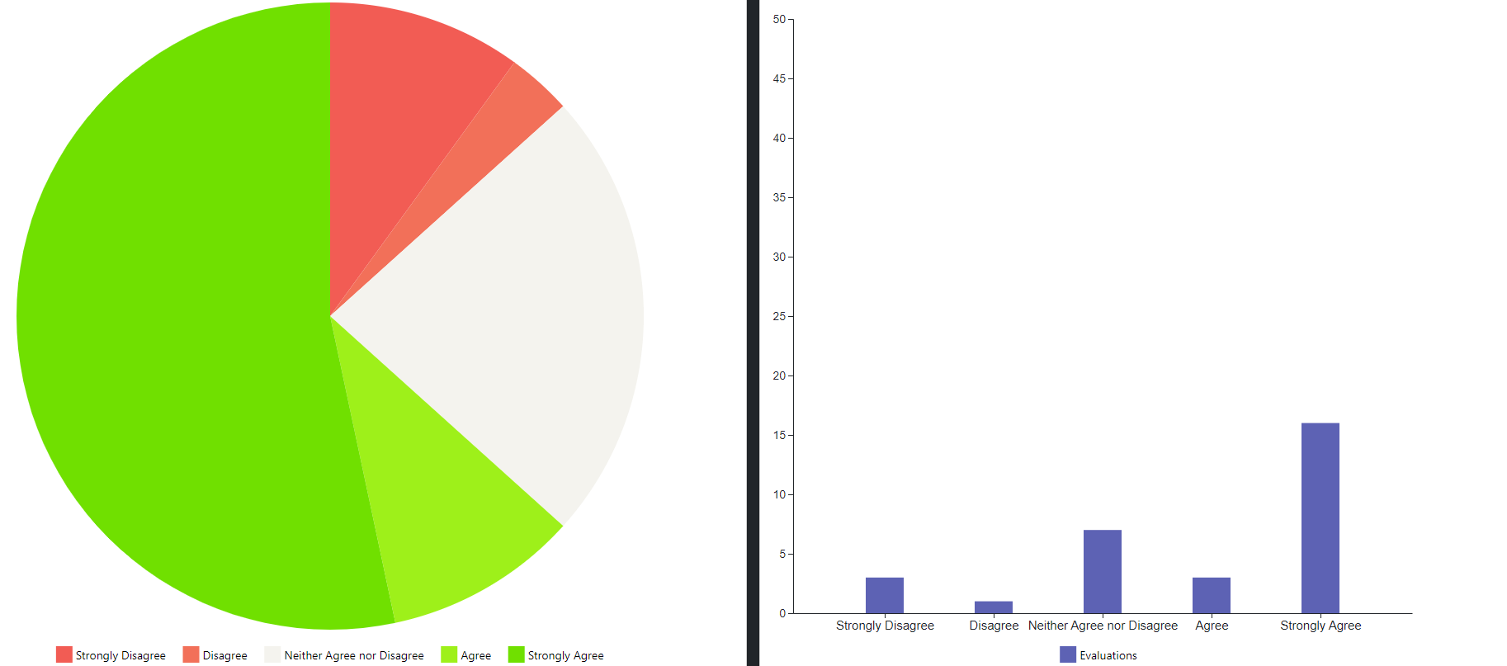

**Figure9. Question 4 Expert opinions**

The general purpose of the information systems developed and used within organizations is to increase the quality of the work and to increase the individual/organizational performance. However, every information produced by information systems as a result of data processing cannot be used directly in decision-making processes and this information is not transferred to the corporate memory, instead some of the obtained information can be used directly in decision-making processes after additional efforts [41]. Although knowledge-based decision-making falls under the responsibility of managers at every level, employees who make operational decisions at the lowest level are not always aware of this situation. The reason why some of the participants think that the open-source intelligence reports obtained in our study can be useful in decision-making processes, but some of them are of the opposite opinion, is because the participants' feelings and thoughts about the decision-making processes of their own organization. In some cases, employees feel that senior managers are ignoring social media content that reflects what is going on around them, especially customer/employee views available from open sources. In addition, since a limited number of predefined open-source intelligence scenarios can be used in our study, the reports obtained may actually be worthless in the decision-making processes of the organization. For these reasons, the negative opinions of some of the participants falsified our hypotheses, but it is thought that more positive feedback will be received by expanding the scope of the platform by adding new modules.

* 1. ***Question 5 “User Interface is user friendly and simple.”***

Related Hypotheses: H1, H2

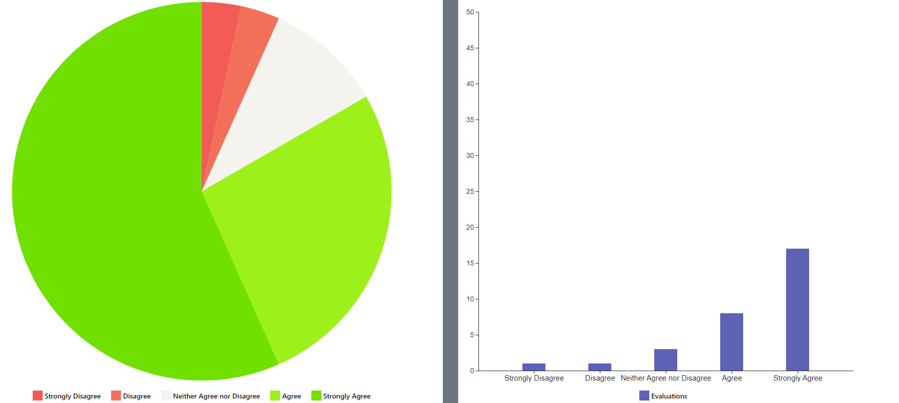

**Figure10. Question5 Expert opinions**

The model we developed and proposed in our study has been practically experienced by experts who participated in the testing process of the Gazi.AI platform The success of software projects is mainly based on the success of the interface that interacts with the end user. For this reason, the opinions of the experts about the user interface were also included in the evaluation criteria of the research. In order to develop a successful user interface, it is inevitable to be open-minded to the feedback of end users and to make continuous improvement [42]. While the participants generally expressed positive opinions on this question, they explained their different wishes and expectations by answering our open-ended question at the end of the feedback form. Some of the submitted requests were handled urgently and were quickly completed during the testing process and added to the current version of the platform.

* 1. ***Question 6 “Information about the project and modules are sufficient.”***

Related Hypotheses: H1, H2

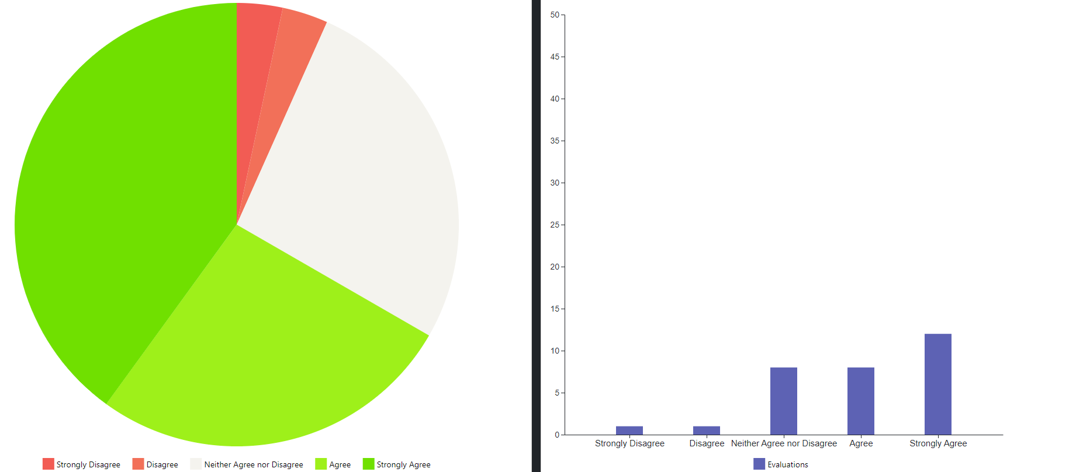

**Figure 11. Question 6 Expert opinions**

Information pages have been added to the user interface regarding the Gazi.AI platform and predefined open-source intelligence modules that we have developed in our study. However, since each module contains extensive technical details, only summary information has been added. In this case, the information pages were insufficient for the participants who did not have prior knowledge of open-source intelligence and especially data mining on social media platforms. Informative screens included in the software include detailed technical explanations about coding as well as practical information that will enable the user to use the software effectively. Although some users want to learn these technical details, mostly software developers only include practical information about the use of the software in the documentation [43]. Only practical summary information was included for the experts who participated in the testing process, but it was understood that more detailed information pages should be prepared by taking this situation into account in new updates.

* 1. ***Question 7 “I could use the menus and buttons without any help from the project team.”***

Related Hypotheses: H1, H2

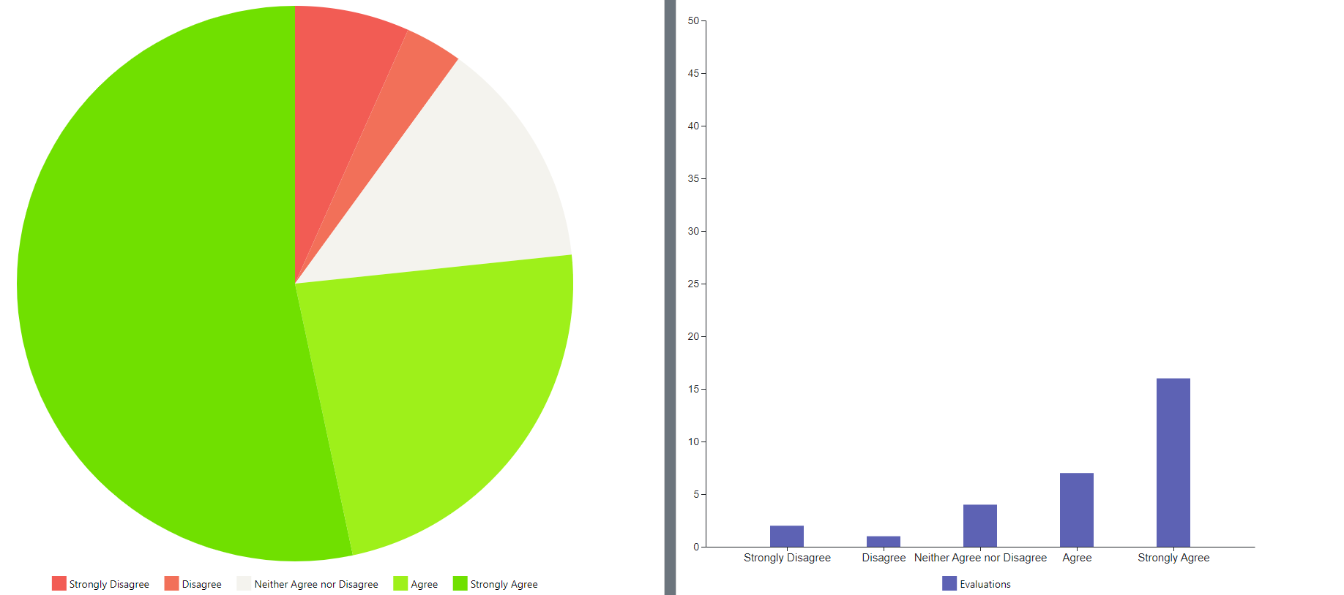

**Figure 12. Question 7 Expert opinions**

The Gazi.AI project developed in our study is actually designed with a platform approach instead of a uniform software. Running like an orchestration platform, Gazi.AI has the ability to run sub-software (container) of related OSINT modules by connecting to other computers. Thus, it is not possible for users to use the project without any help during the first use. Although the negative answers of the participants to this question are expected, it has been understood that in the newer versions, at least a video that describes how the project to be used should be added. Since the development of the Gazi.AI platform will continue after the publication process for our research is completed, it is aimed that participants who want to voluntarily test the project and send feedback can easily install and use the platform. So, it is planned to add training videos in different languages to the project page (www.gazi.ai), since on-site training cannot be provided to every volunteer person or organization. Despite the negative feedback, the fact that the participants were able to use the Gazi.AI platform and send feedback by getting help from the project team supported the relevant hypotheses of our study.

* 1. ***Question 8 “System resources was able to be used effectively and efficiently.”***

Related Hypotheses: H1, H2, H3, H4

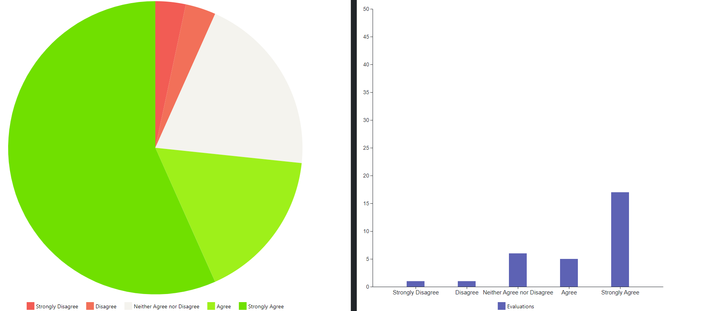

**Figure 13. Question 8 Expert opinions**

The effective and efficient use of the system resources that organizations have already invested in the name of profit maximization is one of the main subjects that our research focuses on. Consequently, the answers given by the experts to this question are important in proving our hypotheses. Although the participants were asked to use system resources effectively and efficiently while conducting an open-source intelligence project, the participants actually experienced successfully running containerized applications on end-user computers with a very light virtualization layer, thanks to the Docker Desktop. The high rate of positive feedback on this question shows that we have achieved the goal of effective and efficient use of the organizational resources we mentioned in our hypotheses. Additionally, the expert personnel who participated in the testing process, especially in positions such as system administrators, expanded their visions on virtualization technologies. Especially in cloud computing projects with the green computing approach, which aims to reduce energy costs and be less harmful to the environment, serious problems can be experienced in maintaining the balance between system performance and savings [44]. Organizations that offer cloud computing infrastructure, benefits from the containerization technologies as an effective method in order to provide the promised service quality at low costs [45]. The idea of using system resources for another process thanks to containerization on desktop computers, which are currently used by end users for daily operations, received positive feedback from the majority of the participants and supported our hypotheses.

* 1. ***Question 9 “Project processes were accomplished in reasonable time period.”***

Related Hypotheses: H1, H2, H3

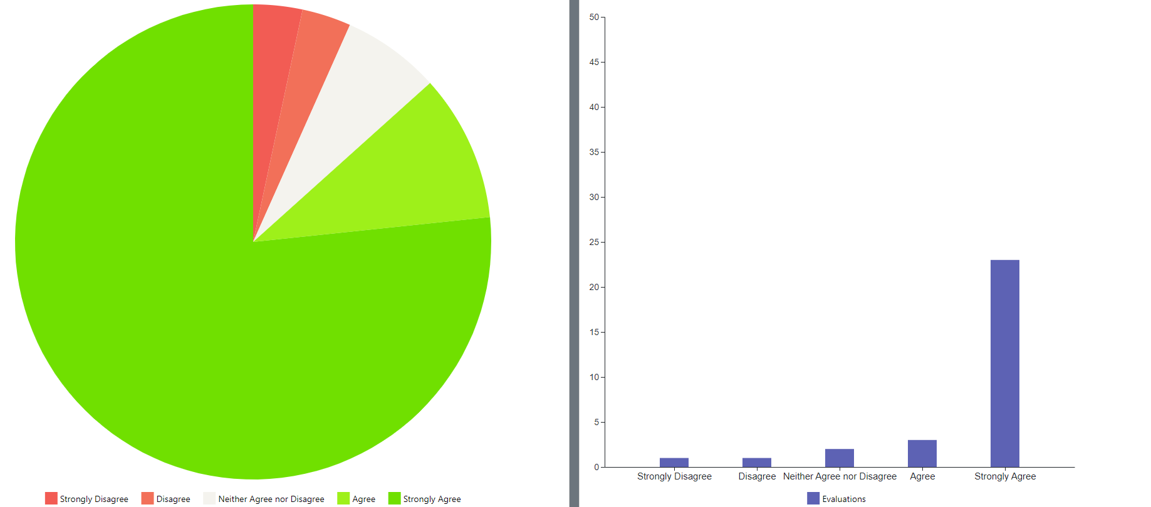

**Figure 14. Question 9 Expert opinions**

When open-source intelligence reports produced by expert personnel participating in the testing process are examined, it is seen that they mostly analyzed thousands of rows of data sets. Since this amount is not very high in terms of analysis processes using artificial intelligence algorithms, the project processes were completed quickly. But, analysis of data sets with millions or billions of rows may take much longer. The performance of the Gazi.AI platform, which is currently an academic project and which we have developed at the basic level to test our hypotheses, is sufficient for our research at this level and also highly satisfied the participants. On the other hand, in distributed computing projects, the execution of consecutive or parallel processes in a reasonable time is very important for the healthy management of the system, otherwise the desired results will not be obtained. When our research process is completed, it is necessary to test the Gazi.AI platform with large data sets and complex infrastructures, and to optimize the process management according to time performance in order to make it a standard product.

* 1. ***Question 10 “There were no information security concerns regarding the project.”***

Related Hypotheses: H1, H2

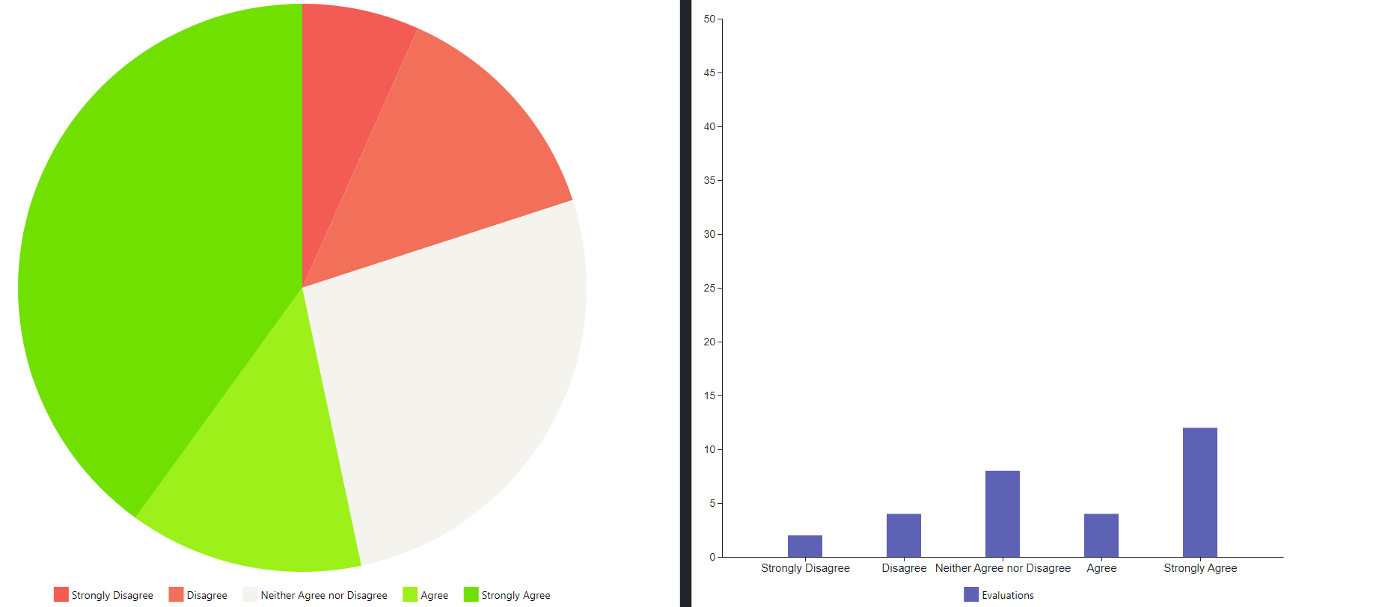

**Figure 15. Question 10 Expert opinions**

While conducting theoretical research on our study, it was foreseen that subjects such as information security, system performance and network utilization should be investigated and developed in more detail in terms of the model we proposed, but it was stated that they were excluded from the scope of our study at the first stage. Information security has been one of the most controversial issues, especially in the Internet of Things (IoT), edge computing and blockchain infrastructures, where computers with a large number of small computing power are used [46]. Because the distribution of the data being processed by the system on different devices or the collection of the analysis results in the distributed architecture from different devices and providing a holistic information security has been defined as a challenge to be overcome. It does not seem to be a problematic situation that new discussion topics emerge from a model developed to solve a problem from an academic point of view. In our study, new problems that arise in subjects such as information security and system performance are actually seen as new research areas and accepted as a starting point for our future work. It is understood that some of the experts participating in the testing process do not have information security concerns due to their trust in the project team and the fact that the processed data is open-source data that does not contain privacy.

* 1. ***Question 11 “Project platform can be used for different distributed computing projects which need high computing.”***

Related Hypotheses: H1, H2, H3, H4

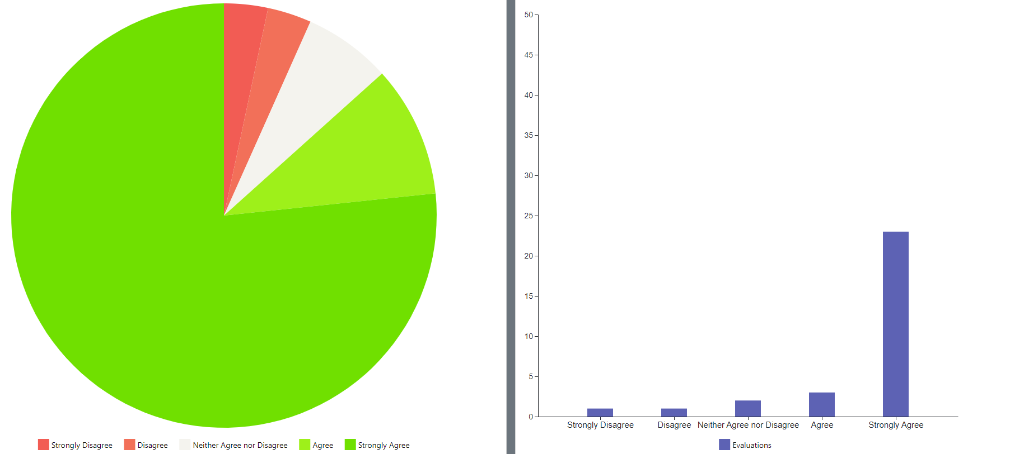

**Figure 16. Question 11 Expert opinions**

Most of the experts who participated in the testing process have reported positive feedback on the approach we have developed, as they are experienced in classical virtualization projects and big data infrastructure projects. While different applications (P2P computing, cluster computing, utility computing, jungle computing, grid computing, cloud computing, fog computing) are accepted in the classification of distributed computing technologies [47], emerging new technological opportunities add new concepts to this classification. Containerization, the newest of these concepts is adopted by both software developers and system administrators, especially due to low resource usage and scalability. In terms of the hypotheses, we proposed in our study, the opinion that Docker containerization technology was found to be highly successful by the experts. And, the idea that it could be used in projects that require other distributed computing power was dominant.

# CONCLUSION

This study introduces a new platform supporting analysis OSINT data in an efficient approach. The hypotheses that we suggested as new solutions of the problem we determined in our research were discussed in practice by testing the applied project with the participation of experts from different organizations. Consequently, it is proved that our proposed model is the ability of being applicable in real life according to opinions of more than twenty IT experts who participated in test phase and experienced Gazi.AI platform. On the other hand, it is clearly understood from the all feedbacks that our platform needs to be developed in many fields to be used professionally, while it is considered enough for proof of concept (POC) as an academic project.

As a result, main advantages of the model which was proposed as a subject of our applied academic research that distinguish from other studies are listed below;

• Provides an innovative approach for external knowledge management.

• Uses existing corporate resources and does not require new investment.

• Possible to integrate different OSINT and data analysis projects.

• Reduces cost by using available disk and CPU resources to benefit from advanced cloud services.

Some theoretical and practical challenges have been faced in different phases of our research. To propose a new model or concept based on different areas with a multidisciplinary approach and to discuss with academics from different fields is something difficult unless summarizing briefly and depiction simply. Developing a solution for a problem could bring some other problems to be solved. This phenomenon is not an issue from the view point of academics, because it also means new opportunities to make new research, but for the industry a solution which fixes some problems is not expected to create new problems. As a conclusion, some problems will be discussed in future work as a subject of new study, and development of the application will be continued by the project team.

**Acknowledgments**

A patent application related to our research was made to Turkish Patent and Trademark Office with the number of "2022/00233".

**Statements and Declarations**

The authors declare that they have no conflict of interest.

This research received no specific grant from any funding agency in the public, commercial, or not-for-profit sectors.

Both authors confirm contribution and sole responsibility for the following: study conception and design, data collection, analysis and interpretation of results, and manuscript preparation.

The data that support the findings of this study are openly available in http://www.gazi.ai/feedbacks.php with the password “Gazi1926”.

The questionnaire and methodology for this study was approved in the meeting number "07" on Tuesday, 04 April 2023 by the Gazi University Ethics Committee.

Informed consent was obtained from all individual participants included in the study.

**REFERENCES**

1. Akarslan, H. (2020). Açık kaynak istihbaratı (Open Source Intelligence OSINT). Ş. Sağıroğlu ve S. Akleylek (Editörler). Siber güvenlik ve savunma: Biyometrik ve kriptografik uygulamalar. Ankara: Nobel Akademik Yayıncılık.
2. Akarslan, H. (2021). A model proposal for analyzing open-source ınformation in end-user computers. International Journal of Intelligence and CounterIntelligence, 35(3), 482-503, DOI: 10.1080/08850607.2021.1899514
3. Hakeem M. (2019). A software architectural design for automated data processing in data-ıntensive software systems, (Publication No.  27547398) [Doctoral dissertation, University of Colorado]. ProQuest Dissertations Publishing
4. Concas, M., Berzano, D., Bagnasco, S., Lusso, S., Masera, M., Puccio, M. & Vallero, S. (2017). Plancton: An opportunistic distributed computing project based on Docker containers. Journal of Physics: Conference Series, 898, 092049. DOI: 10.1088/1742-6596/898/9/092049
5. Merelli I., Fornari, F., Tordini, F., D’Agostino, D., Aldinucci, M. & Cesini, D. (2019). Exploiting Docker containers over Grid computing for a comprehensive study of chromatin conformation in different cell types. Journal of Parallel and Distributed Computing, 134, 116-127. DOI: 10.1016/j.jpdc.2019.08.002.
6. Anumba, C. J., Egbu, C. O. ve Carrillo, P. M. (2005). Knowledge management in construction (First Edition). Oxford: Blackwell Publishing.
7. García-Morales, V.J., Lloréns-Montes, F.J. and Verdú-Jover, A.J. (2008), The Effects of Transformational Leadership on Organizational Performance through Knowledge and Innovation. British Journal of Management, 19: 299-319. https://doi.org/10.1111/j.1467-8551.2007.00547.x
8. Easterby-Smith, M. and Prieto, I.M. (2008), Dynamic Capabilities and Knowledge Management: an Integrative Role for Learning?. British Journal of Management, 19: 235-249. https://doi.org/10.1111/j.1467-8551.2007.00543.x
9. Dubey, R., Gunasekaran, A., Childe, S.J., Blome, C. and Papadopoulos, T. (2019), Big Data and Predictive Analytics and Manufacturing Performance: Integrating Institutional Theory, Resource-Based View and Big Data Culture. Brit J Manage, 30: 341-361. https://doi.org/10.1111/1467-8551.12355
10. Awan, U., Bhatti, S.H., Shamim, S., Khan, Z., Akhtar, P. and Balta, M.E. (2022), The Role of Big Data Analytics in Manufacturing Agility and Performance: Moderation–Mediation Analysis of Organizational Creativity and of the Involvement of Customers as Data Analysts. Brit J Manage, 33: 1200-1220. https://doi.org/10.1111/1467-8551.12549
11. Powell, T. W. (2023) Knowledge Value Chain® Methodology. https://timwoodpowell.com/methodology/, accessed: 29.05.2023.
12. Laudon, K. C. & Laudon, J. P. (2012). Management information systems: Managing the digital firm (Twelve Edition). New Jersey: Pearson Education.
13. Baskerville, R. L. ve Myers, M. D. (2002). Information systems as a reference discipline. MIS Quarterly, 26(1), 1–14. DOI: 10.2307/4132338
14. Özköse, H. & Temel Gencer, C. (2017). Bibliometric analysis and mapping of management information systems field. Gazi University Journal of Science, 30(4), 356-371.
15. İraz, R. & Zerenler, M. (2008). Turizm işletmelerinde yönetim bilişim sistemleri kullanımının yönetsel kararlar üzerindeki etkisi. Sosyal Ekonomik Araştırmalar Dergisi, 8(15), 375-391.
16. Guerrero, A. J., Heijs, J. & Huergo, E. (2022). The effect of technological relatedness on firm sales evolution through external knowledge sourcing. The Journal of Technology Transfer. DOI:10.1007/S10961-022-09931-3
17. Alonso-Muñoz, S., Pelechano-Barahona, E. ve González-Sánchez, R. (2020). Participation in group companies as a source of external knowledge in obtaining and making profitable radical innovations. Sustainability, 12(18), 7701. DOI: 10.3390/SU12187701
18. Deverell, A. & Lassen, A. H. (2006). The challenge of managing knowledge in innovative organizations: Internal versus external knowledge acquisition. Donnellan, B., Larsen, T. J., Levine, L.ve DeGross, J.I. (Editörler). The Transfer and Diffusion of Information Technology for Organizational Resilience. TDIT 2006. IFIP International Federation for Information Processing, Boston, MA.: Springer, 206. DOI:10.1007/0-387-34410-1_11
19. Newman, S. (2015). Building microservices: Designing fine-grained systems (Birinci Baskı). Sebastopol: O’Reilly Media.
20. Docker Inc., Use containers to Build, Share and Run your applications, https://www.docker.com/resources/what-container/, accessed: 29.05.2023
21. Asana Inc., (2022). Proof of Concept (POC): How to Demonstrate Feasibility, https://asana.com/resources/proof-of-concept, accessed: 31.05.2023
22. Gillis, A. S., (2023). What is a proof of concept (POC)?, https://www.techtarget.com/searchcio/definition/proof-of-concept-POC, accessed: 31.05.2023
23. Mell, E. (2017). What is Docker Hub? - Definition from WhatIs.com. https://www.techtarget.com/searchitoperations/definition/Docker-Hub, accessed: 31.15.2023.
24. Erkeç, E. (2020). Importing Performance Monitor data into SQL databases, https://www.sqlshack.com/importing-performance-monitor-data-into-sql-databases/. accessed: 01.06.2023
25. Docker Docs, Runtime options with Memory, CPUs, and GPUs, https://docs.docker.com/config/containers/resource_constraints/. accessed: 02.06.2023
26. Twitter Developer Platform, Twitter API Documentation, https://developer.twitter.com/en/docs/twitter-api. accessed: 02.06.2023
27. AWS, What is Sentiment Analysis? - Sentiment Analysis Explained, https://aws.amazon.com/what-is/sentiment-analysis/. accessed: 02.06.2023
28. Loria, S. (2020). TextBlob: Simplified Text Processing — TextBlob 0.16.0 documentation, https://textblob.readthedocs.io/en/dev/,
29. Microsoft, Text Analytics | Microsoft Azure, https://azure.microsoft.com/en-au/products/cognitive-services/text-analytics, accessed: 02.06.2023
30. Erol, S.E. (2022). Developing data privacy sensitive awareness models in social media enviroments. (Publication No. 759663) [Doctoral dissertation, Gazi University]. CoHE Thesis Center
31. Erol, S. E., Sağıroğlu Ş. & Demirezen U. (2022). Detecting Personal Health Data Disclosures in Turkish Social Data, International Journal of Information Security Science, 11 (2), 69-84.
32. Telegram, What is Telegram?, https://telegram.org/faq#q-what-is-telegram-what-do-i-do-here. accessed: 07.06.2023
33. Hashemi, A. & Zare Chahooki, M.A. (2019). Telegram group quality measurement by user behavior analysis. Social Network Analysis and Mining. 9 (33). DOI: 10.1007/s13278-019-0575-9
34. Europol (2022), European Union Terrorism Situation and Trend Report, Publications Office of the European Union, Luxembourg.
35. Europol (2021a), European Union serious and organised crime threat assessment, A corrupting influence: the infiltration and undermining of Europe's economy and society by organised crime, Publications Office of the European Union, Luxembourg.
36. Europol (2021b), Internet Organised Crime Threat Assessment (IOCTA) 2021, Publications Office of the European Union, Luxembourg.
37. Nazah, S., Huda S., Abawajy J. and Hassan M. M. (2020). Evolution of Dark Web Threat Analysis and Detection: A Systematic Approach. IEEE Access. 8. 71796-171819. DOI: 10.1109/ACCESS.2020.3024198.
38. Briggs, R. O., Nunamaker, J. F., Sprague, R. & Zwass, V. (1999), Special section: Exploring the outlands of the MIS discipline. Journal of Management Information Systems, 16(3), 5-9. DOI: 10.1080/07421222.1999.11518253
39. Petty, R. & Guthrie, J. (2000). Intellectual capital literature review: Measurement, reporting and management. Journal of Intellectual Capital, 1(2), 155-176. DOI: 10.1108/14691930010348731
40. Kutz, M. & Bamford-Wade, A. (2014). Contextual intelligence: A critical competency for leading in complex environments. Erbe, N. (Ed.), Approaches to managing organizational diversity and innovation. Hershey. PA: IGI Global, 42-59. DOI: 10.4018/978-1-4666-6006-9.ch003.
41. Nam-Hong, Y., Soung-Hie, K., Hee-Woong, K. & Kee-Young, K. (2004). Knowledge based decision making on higher level strategic concerns: System dynamics approach. Expert systems with applications. Issue, 27(1), 143-158. DOI:10.1016/j.eswa.2003.12.019
42. Jitnupong, B. & Jirachiefpattana, W. (2018). Information system user ınterface design in software services organization: A small-clan case study. MATEC Web of Conferences. DOI: 10.1051/matecconf/201816401006
43. Ummelen, N. (1997). Procedural and declarative information in software manuals: Effects on information use, task performance and knowledge. Amsterdam: Brill Rodopi.
44. Wanneng, S., Ken, C. & Neal Naixue, X. (2021). Research on strong agile response task scheduling optimization enhancement with optimal resource usage in green cloud computing. Future Generation Computer Systems, 124, 12-20. DOI: 10.1016/j.future.2021.05.012
45. Liu, J., Wang, S., & Zhou, A. (2020). SLA-driven container consolidation with usage prediction for green cloud computing. Front. Comput. Sci., 14, 42–52. DOI: 10.1007/s11704-018-7172-3
46. Bonnah, E. & Shiguang, J. (2020). DecChain: A decentralized security approach in Edge Computing based on Blockchain. Future Generation Computer Systems, 113, 363-379. DOI:10.1016/j.future.2020.07.009 .
47. Hajibaba, M. and Gorgin, S. (2014) A Review on Modern Distributed Computing Paradigms: Cloud Computing, Jungle Computing and Fog Computing. Journal of Computing and Information Technology, 22, 69-84. DOI: 10.2498/cit.1002381