*Sustainable advantages of demountable construction and evaluation of current GBRS. Case study: R4House*

Luis De Garrido

PhD. Architect, PhD Computer Engineer. Universidad Politécnica de Valencia.

Director ANAS Research Center. Avda. Blasco Ibañez 114. 46022 Valencia. Spain

[info@luisdegarrido.com](mailto:info@luisdegarrido.com), pontmare@hotmail.com

**Keywords**

Case study, comparative evaluation, deficiencies, demountable construction, Green Building Rating System, improving future GBRS, , sustainable house.

**Abstract**

This case study evaluated for the first time the contribution of *demountable and modular construction* to the sustainable level of a building using some of the best GBRS (*Green Building Rating Systems*), whose evaluation capacity was also assessed.

The scores of a demountable and modular house were compared with those of conventional design, in both cases using 11 of the most important GBRS.

The analysis performed by the various GBRS quantifies the increase in the sustainable level of a given demountable and modular construction, and this can be extrapolated to demountable and modular construction in general. However, the resulting scores varied widely (from an increase of 1.4% to an increase of 17.41%), and only three GBRS clearly identified the obvious advantages of *demountable construction*, while the rest value it very little, and four of them barely valued it, despite its important environmental advantages. As it is not acceptable for the same building to have a different score depending on the GBRS chosen, it follows that most of the current GBRS are not capable of correctly evaluating the sustainability of a building and must be improved.

This case study is important for understanding the contribution of demountable and modular construction to a building's overall sustainability.

**1. Introduction**

This paper evaluates the environmental advantages of container-based *modular and industrialized construction*. *Modular demountable construction* is currently being widely researched due to its sustainable advantages. This type of construction combines the advantages of *modular construction* [1, 2, 3, 4] and the advantages of *prefabricated and industrialized construction* [5, 6, 7, 8, 9], to which must be added the functional, economic and sustainable advantages of using containers [10, 11, 12, 13, 14, 15, 16, 17, 18].

Several studies have defined a large number of *demountable construction* systems, showing their general advantages [19, 20, 21, 22, 23, 24, 25, 26, 27, 28, 29] and also their environmental and sustainable advantages [30, 31, 32, 33, 34, 35, 36, 37, 38, 39, 40, 41, 42, 43]. However, in almost all of these studies very few sustainable indicators were used to carry out the sustainable analysis (such as waste reduction, resource optimization, construction speed), while hardly any studies have analyzed in a global and complete way the contribution of modular demountable construction to the overall level of sustainability of a building [44].

To evaluate the overall level of sustainability of buildings, multivariate assessment tools, called GBRS (*Green Building Rating Systems*) have been implemented in recent years. However, these tools have hardly been used to analyze the general environmental benefits of *modular and demountable construction*.

The objective of this work was thus to use various GBRS to determine the increase in the sustainable level of a *modular and demountable construction*.

A modular demountable house was evaluated using eleven of the most important and globally used GBRS: ASGB, BEAM, BREEAM, CEDES, DNGB, GBI, GG, GS, IGBC, LEED and SBTools. The same home was also evaluated as if it had been built conventionally (not demountable). By comparing both results the contribution of *modular and demountable construction* to the buildings’ sustainability could be determined.

It should be noted that an increasing number of studies are appearing that question the validity of the current GBRS. Some works doubt their validity due to the fact that they are very different from each other, and therefore provide different results when evaluating the same building. This is because there is no international consensus on the concept of sustainability and there is no common framework to achieve and evaluate it [45]. Other studies indicate that the current GBRS cannot evaluate sustainability correctly since they do not consider architectural design in their scoring system [34, 35, 15, 46, 47, 48, 49], while still others are even more critical and conclude that when analyzing many buildings designed according to some of these GBRS substantial energy savings or optimization of resources were compared to conventional buildings [46, 47, 50, 51]. As if that were not enough, there are increasingly more works that harshly criticize the usefulness of some of the best-known GBRS, such as LEED [52, 53].

The modular and demountable house evaluated, the *R4House* (Fig. 1), was based on containers and can be disassembled and assembled as many times as desired, since all its components can be removed, repaired and reused as many times as required.

The *R4House* can be said to have a high level of sustainability, since its durability can be extended to the maximum, reducing its environmental impact per unit of time to the maximum. Furthermore, the materials used were also optimized to the maximum, waste and emissions were reduced to a minimum and the energy consumed in its construction, maintenance and useful life was also reduced to a minimum.

It could therefore be expected that the chosen GBRS would adequately assess the sustainable level of this home, giving it a high score, although this was not the case.

To achieve its two objectives, this work is structured into five sections: i.e. 1. Introduction: statement of objectives, 2. Description of the two buildings under study; and evaluation methodology, 3. Results: Contribution of *demountable construction* to the sustainability level of a building, 4. Discussion: Assessing the evaluation capacity of current GBRS, 5. Conclusions of the study.

**2. Description of the houses to be evaluated: *R4House* and *ND-R4House***

To accurately determine the contribution of the *modular and* *demountable design* in the sustainable score of a building, a demountable house (*R4House*) was compared with its conventionally constructed version *(ND-R4House*). To simplify the study, only the indicators whose scores varied from one home to another are shown in the comparison. The house was analyzed using 11 of the best and most widely used GBRS.

The *R4House* was built in 2007 and can be assembled and disassembled as many times as desired. In fact, since its construction it has been disassembled and reassembled twice [54].

**2.1. Description of the demountable house. *R4House***

2.1.1. *General information*

The *R4House* contains two single-family homes and was built using 6 containers (Figs. 1, 2). One, with a constructed area of 173 m2, on the ground floor has a kitchen, a living-dining room, a bathroom and a studio, and on the first floor two bedrooms and two bathrooms. The other house has a constructed area of 30 m2 and has a living-dining room, a bathroom and a bedroom (Figs. 3, 4).

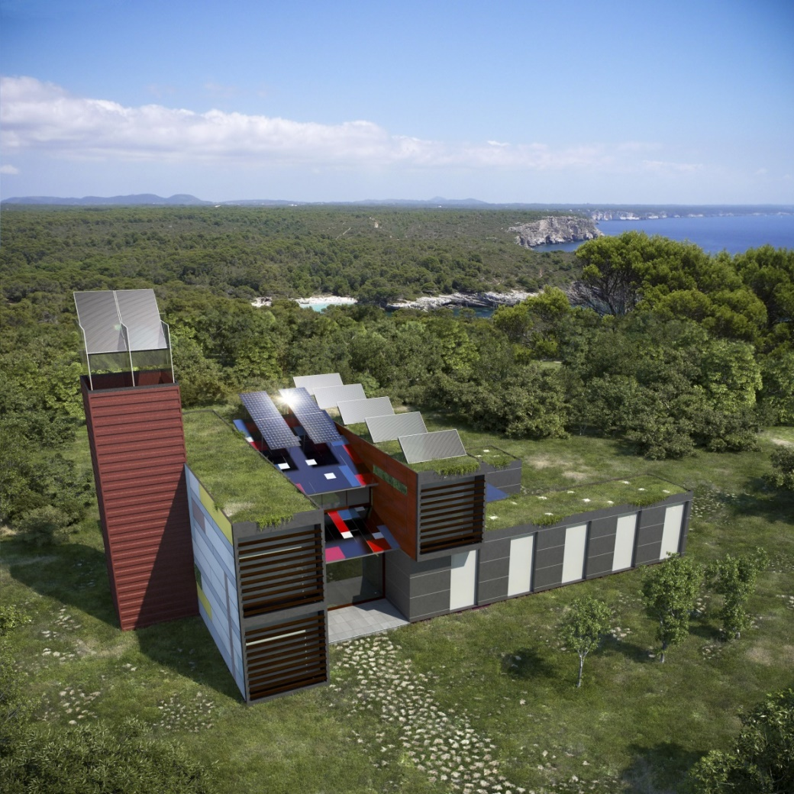

**Figure 1.** *R4House*

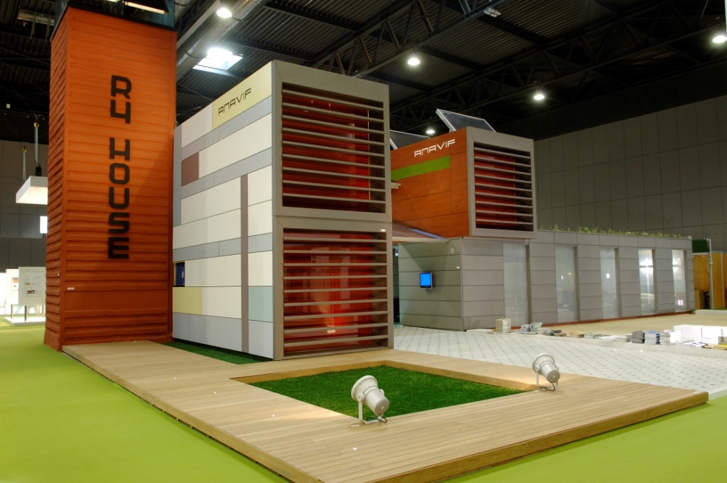

**Figure 2.** *R4House*

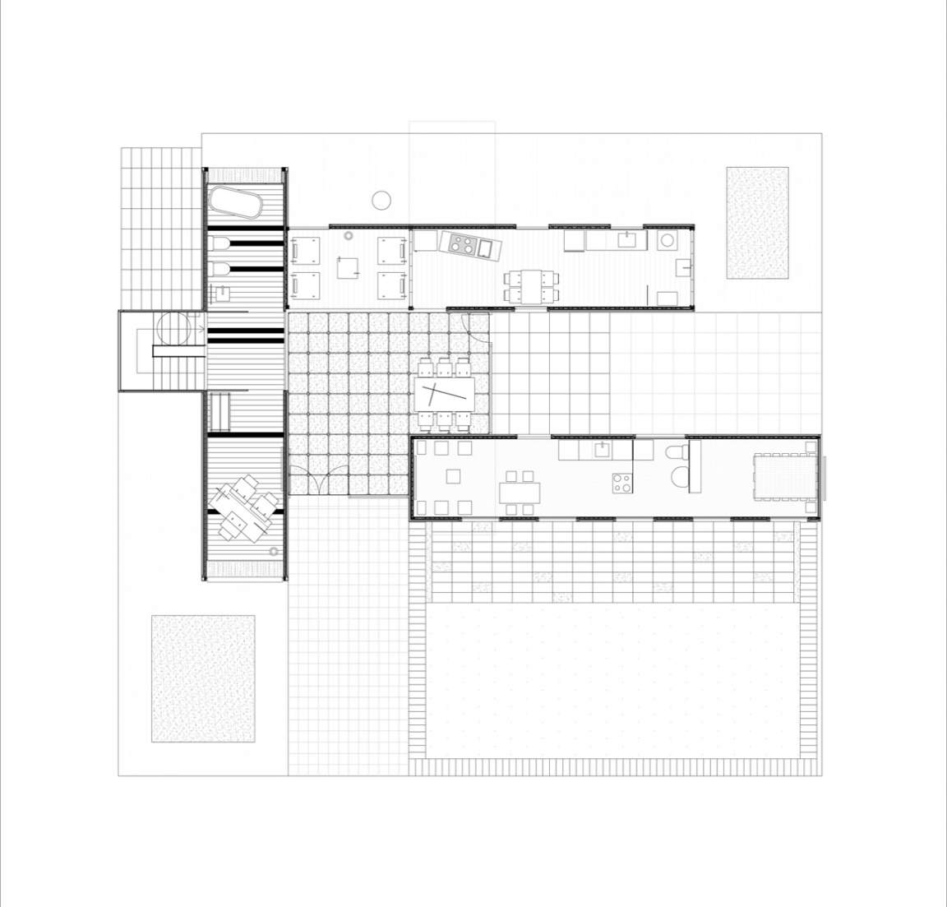

**Figure 3.** *R4House ground floor layout*

*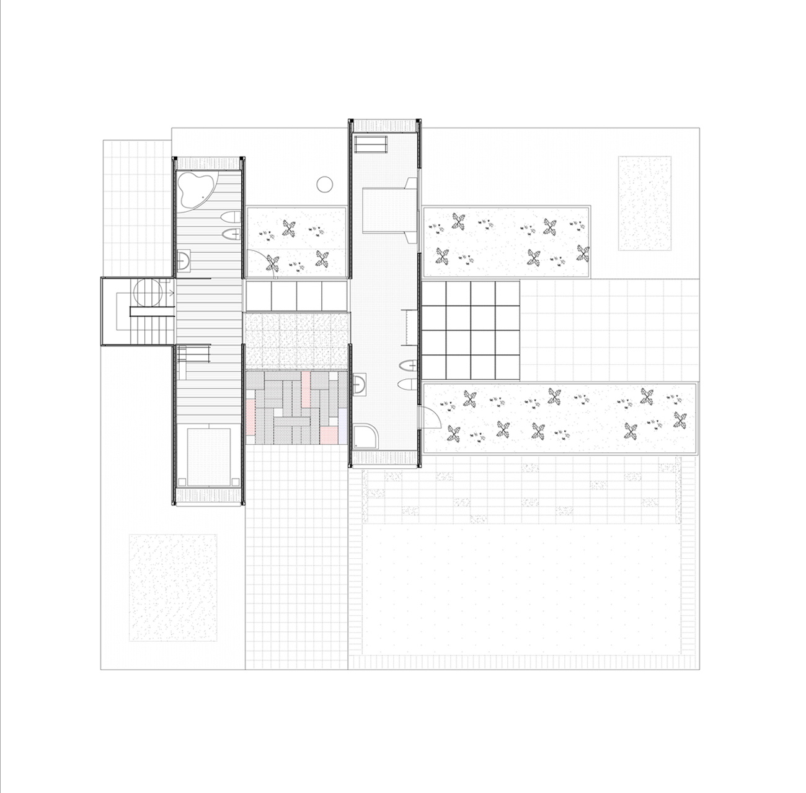*

**Figure 4.** *R4House first floor layout*

*2.1.2. Demountable design*

The building is demountable since it was made with containers and all its components are assembled using screws and threaded nails (Figs. 4, 5, 6). The building does not need a foundation, since the lower part of each container has been solidified with concrete, so simply resting them on the ground is enough. The interior and exterior coatings and finishes (made from wooden panels, wood derivatives, ceramics and waste panels) are assembled by means of screws, nails and pressure devices (Figs. 7, 8, 9). In *R4House* all the components are demountable, including water pipes (threaded polypropylene pipes), drains (pressurized polyethylene pipes) and electricity (pressurized polypropylene pipes).

As a result, all *R4House* components can be easily removed, repaired, and reused indefinitely. In this way the building can have a durability that tends to infinity and the least possible need for maintenance.

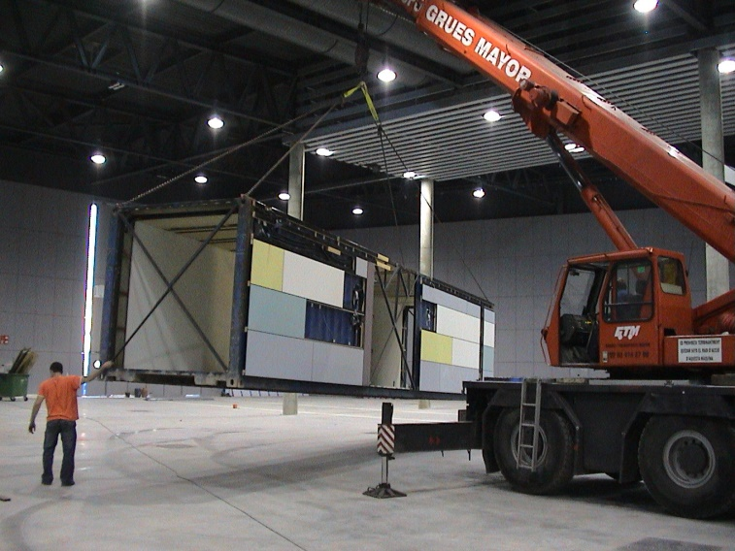

**Figure 4.** *Each R4House module was partially manufactured separately.*

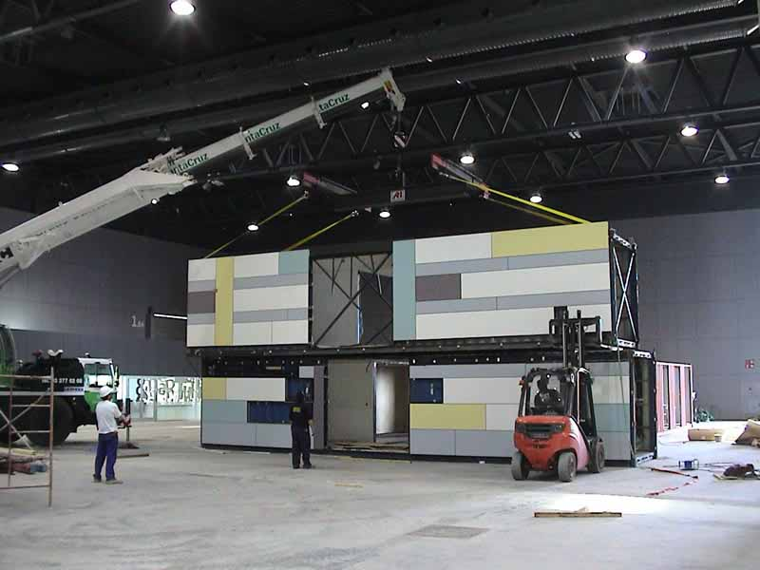

**Figure 5.** *The 6 partially manufactured modules were ensembled in just one day.*

*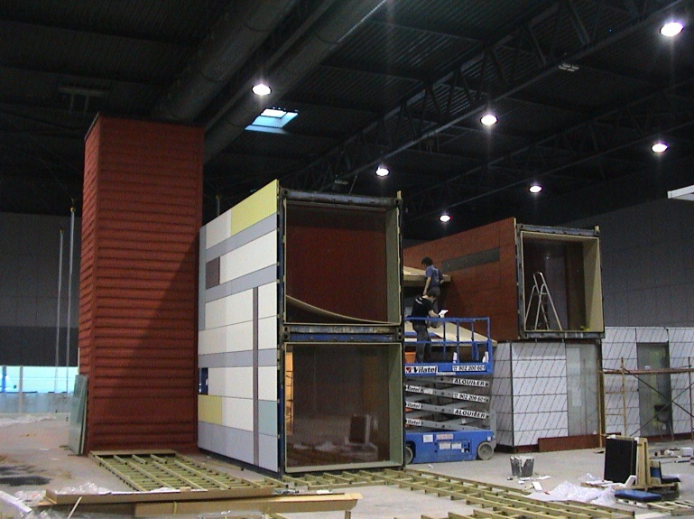*

**Figure 6.** *After putting the 6 partially manufactured R4House modules into place, construction was completed in two weeks.*

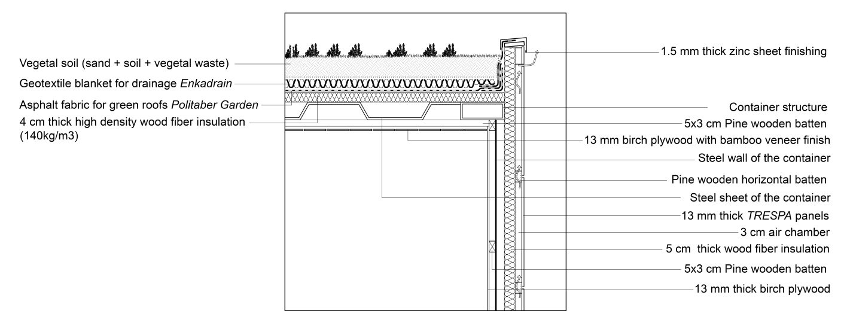

**Figure 7.** Detail of *R4House*

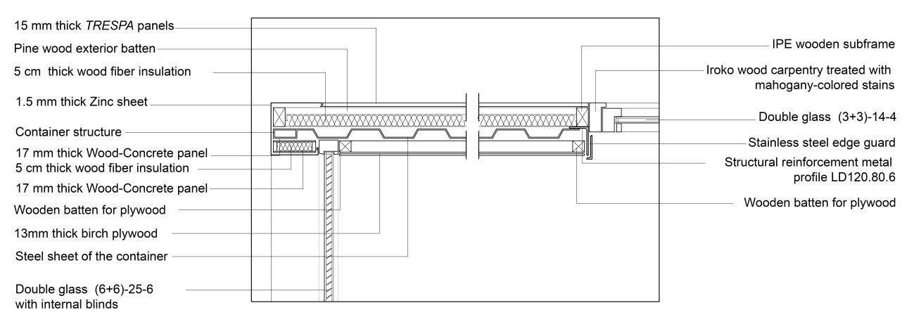

**Figure 8.** Detail of *R4House*

*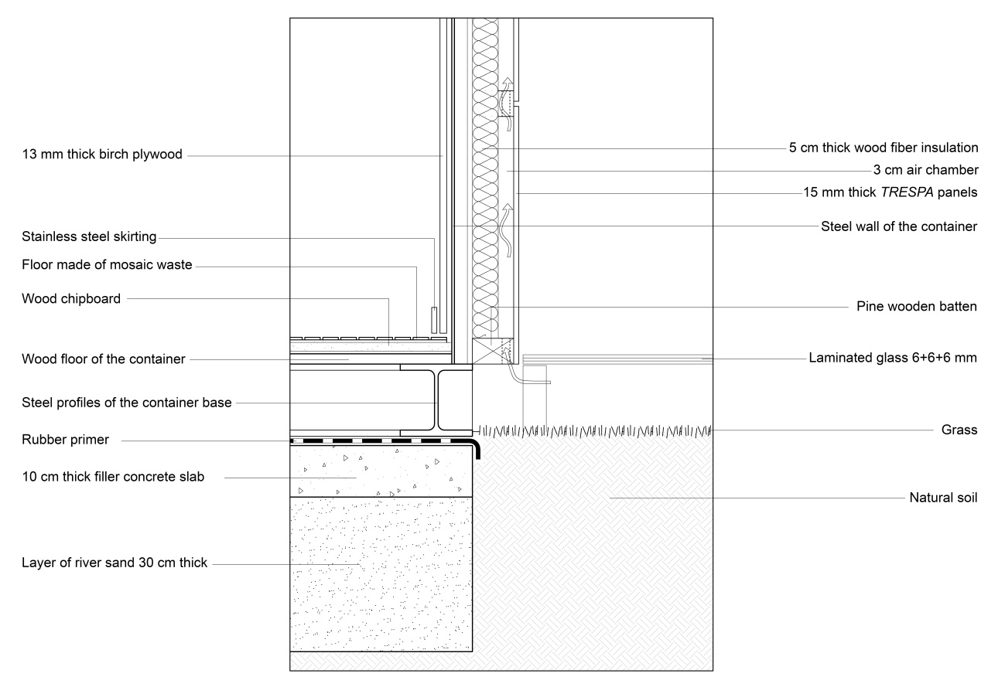*

**Figure 9.** Detail of *R4House*

*R4House* has a high ecological and sustainable level, since ecological waste and materials were used in its construction (Fig. 10). It was built in just three months (Fig. 11) and was designed with the aim of being able to self-regulate thermally and provide a comfortable internal temperature without the need for heating or air conditioning (Figs. 12, 13).

However, in this work we only wanted to assess the contribution of total disassembly in the sustainable score of the building, using the most important and well-known GBRS.

As in previous studies [30, 31, 32, 33, 36, 37, 38, 39, 40, 41, 42, 43], the environmental and economic advantages of a demountable building are many, including the following:

- Adaptability to new uses

- Easy reconfiguration of the building

- Easy repair of all components

- Low energy consumption

- Maximum optimization of resources

- Minimum need for maintenance

- Simple reconfiguration of the building

- Quick construction

- Zero generation of emissions and waste

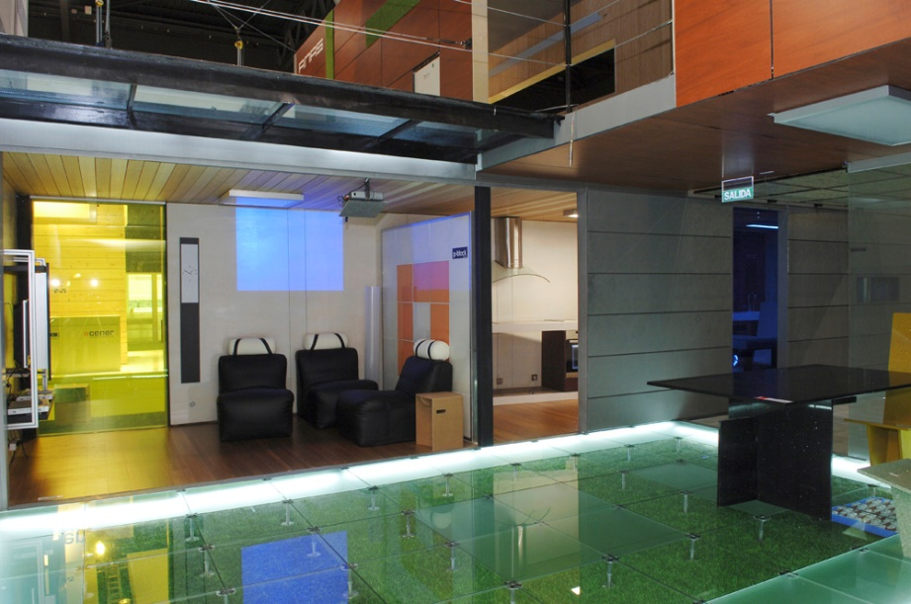

**Figure 10.** *Only industrial waste was used in the manufacture of R4House.*

It is quite reasonable to think that the various GBRS used should adequately value the major environmental and sustainable benefits mentioned above and give a high score to demountable construction as otherwise it could be said that the GBRS that do not adequately value them are deficient and inadequate.

*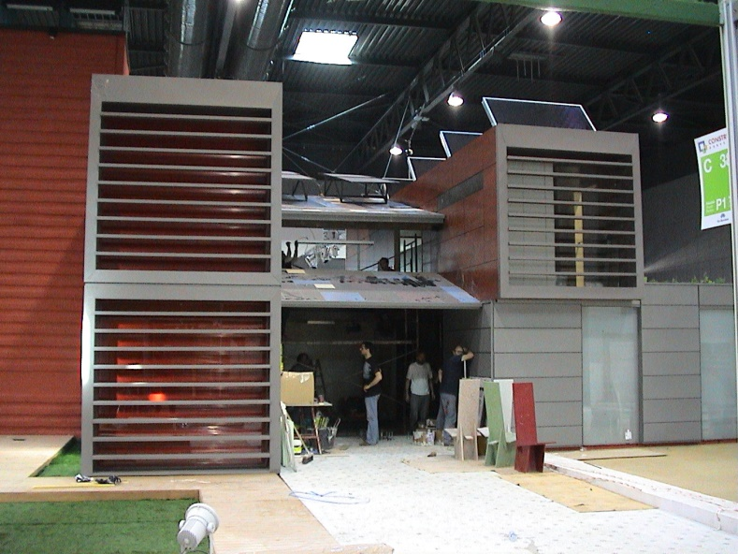*

**Figure 11.** *R4House was built in three months.*

**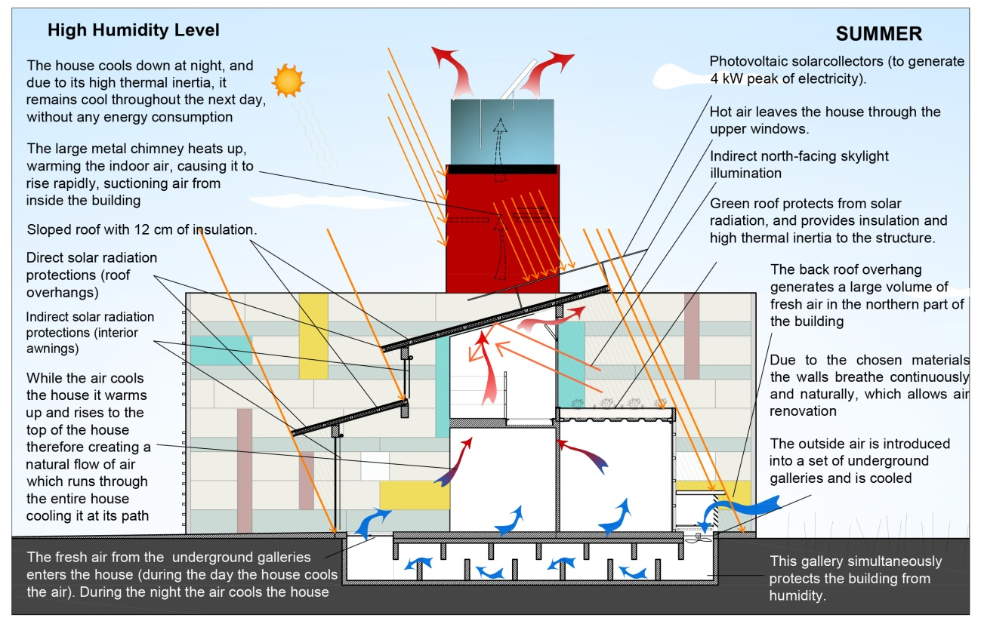**

**Figure 12.** *R4House has a very special bioclimatic design, protecting from solar radiation in summer and generating a flow of cool air to provide a comfortable temperature inside.*

**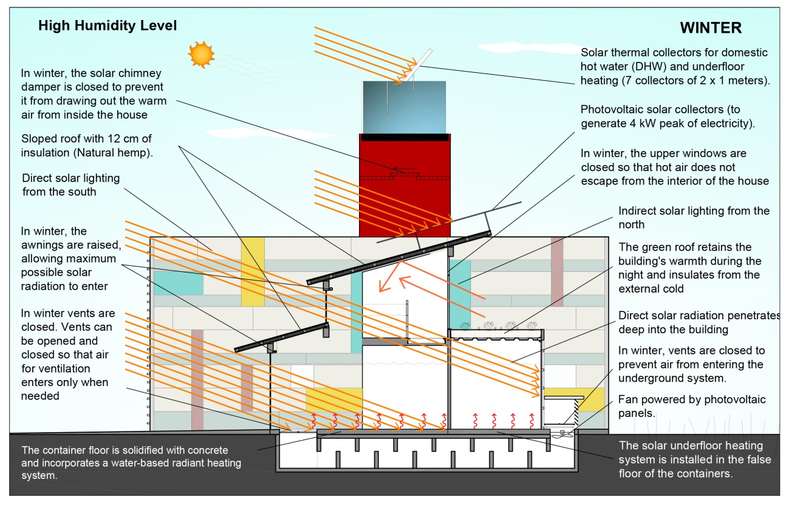**

**Figure 13.** *R4House has a very special bioclimatic design and in winter is heated by the greenhouse effect, allowing maximum solar radiation to enter.*

**2.2. Description of the non-demountable house. *ND-R4House***

In order to measure the differential score that each GBRS system gives to the *demountable construction*, the sustainable score of *R4House* was compared with the score given to a non-demountable house with the same characteristics, known as the *ND-R4House*. We assumed that *ND-R4House* has the same shape and characteristics as *R4House* but was built in a conventional way, like most single-family houses in Spain. The foundation is based on continuous reinforced concrete footings, the structure on load-bearing concrete block walls, reinforced concrete pillars and a slab based on prestressed semi-joists and reinforced concrete vaults. The interior compartmentalization is based on brickwork and gypsum-cellulose panels, the pitched roof on a conventional slab with prestressed concrete semi-joists and concrete vaults and the interior and exterior coatings are based on cement troweling and plaster with conventional plastic paints.

**3. Comparative evaluation of *R4House* and *ND-R4House***

The evaluation of *R4House* and *ND-R4House* was carried out using a selection of the most important and representative GBRS.

*3.1. Choice of the most emblematic GBRS*

Eleven of the most important and well-known GBRSs with which we have the most experience were chosen: ASGB [55], BEAM [56], BREEAM [57], CEDES [58], DNGB [59], GBI [60], GG [61], GS [62], IGBC [63], LEED [64] and SBTools [65].

*3.2. Comparative evaluation results between R4House, and ND-R4House*

As this was a comparative evaluation, only the indicators with different scores in each case were taken into account. We called the set of indicators whose score varies when comparing a bioclimatic building with a non-bioclimatic building a "demountable group".

The evaluation tables show the scores obtained by both houses:

* The score given to each indicator
* The maximum possible score for each indicator.
* The weight of the indicator within the category to which it belongs.
* The weight of the category
* The conversion factor of the scoring scale of each method, to a scale of 0-100 (since some GBRS score from 0 to 75, others from 0 to 100, others from 0 to 110, others from 0 to 1000. The conversion factors used are therefore: 100/75, 100/100, 100/110, 100/1000).

By multiplying the percentage score of an indicator (score/maximum score), by its weight within the category, by the weight of the category, and by the conversion coefficient, a value is obtained (from 0 to 100), which is the contribution of each indicator to the total score, so that adding the score of all the indicators of the "demountable-group" gives the total score that each group gives to *both* *R4House* and *ND-R4House*. Finally, by subtracting both scores, the contribution of *demountable construction* is obtained in the final score provided by each of the GBRS used.

It should be noted that each GBRS has a different internal structure and a different scoring system. Some GBRS do not have categories but only indicators, and the determination of the specific weight of each system is different and has to be calculated on a common weighting basis of 0 to 100. However, essentially all the tables show the same: the final score of each indicator on a scale from 0 to 100 and the total score of all of them for both houses.

To describe the evaluation process and the contribution of each indicator in the final evaluation of the building, let us take an example from ASGB (Table 1).

The ASGB indicator “Building adaptability (BA)” has a maximum score of 18 points. This indicator has a weight of 18/100 within the category “Security and durability (SD)”, and in turn this category has a weight of 10 out of 110 (ASGB has a total evaluation range of 0 to 100+10).

The *R4House* was given the maximum score (18), that is ((18/18) = 1). By multiplying this value (1) by the weight of the BA indicator within the category, a value of ((1) \* (18/100)) is obtained, that is 0.18. Multiplying this value by the weight of the SD category in the total score gives (0.18 \* (10/100)) = 0.018, based on a score of (0-110). Converting this percentage to a common base of (0-100), the final score is (0.018 \* (100 / 110)) = 0.0164. That is, 1.64%.

The *ND-R4House* was given a score of 12 out of a maximum of 18, that is, ((12/18) = 0.66). Multiplying this value (0.66) by the weight of the BA indicator within the category gives a value of (0.66 \* (18/100)), that is, 0.12. Multiplying this value by the weight of the SD category in the total score gives (0.12 \* (10/100)) = 0.012, percentage based on a score of (0-110). Converting this percentage to a common base of (0-100), the final score is (0.012 \* (100 / 110)) = 0.0109, i.e. 1.09%.

Repeating the process for the 5 indicators that can evaluate the demountability of a building in ASGB, *R4House* has a score of 4.85%, compared to 2.79% for *ND-R4House*. According to ASGB, a demountable building like *R4House* has an increase in the level of sustainability of 2.06% (4.85 – 2.79) (Table 1).

*3.2.1. ASGB evaluation*

|  |  |  |  |  |  |  |  |  |  |  |  |  |  |  |  |  |  |  |  |  |  |  |  |  |  |
| --- | --- | --- | --- | --- | --- | --- | --- | --- | --- | --- | --- | --- | --- | --- | --- | --- | --- | --- | --- | --- | --- | --- | --- | --- | --- |
| ***Demountable group*** | | | | ***R4House*** | | | | | | | | | | | | ***ND-R4House*** | | | | | | | | | |
| Indicators | | Category | | Score | | Max. Score | | Indicator weight | | Category weight | | Result  (0-110) | | Result  (0-100) | | Score | | Max. Score | | Indicator weight | | Category weight | | Result  (0-110) | Result  (0-100) |
| BA (\*1) | | SD (\*6) | | 18 | | 18 | | 18/100 | | 10% | | 1.80 | | 1.64% | | 12 | | 18 | | 18/100 | | 10% | | 1.20 | 1.09% |
| LULC (\*2) | | SD | | 10 | | 10 | | 10/100 | | 10% | | 1.00 | | 0.91% | | 6 | | 10 | | 10/100 | | 10% | | 0.60 | 0.55% |
| IIDP (\*3) | | RC (\*7) | | 8 | | 8 | | 8/200 | | 20% | | 0.80 | | 0.73% | | 4 | | 8 | | 8/200 | | 20% | | 0.40 | 0.36% |
| URRWM (\*4) | | RC | | 12 | | 12 | | 12/200 | | 20% | | 1.20 | | 1.09% | | 6 | | 12 | | 12/200 | | 20% | | 0.60 | 0.55% |
| SSIC (\*5) | | II (\*8) | | 10 | | 10 | | 10/190 | | 10% | | 0.53 | | 0.48% | | 5 | | 10 | | 10/190 | | 10% | | 0.27 | 0.24% |
|  |  | |  | |  | |  | |  | |  | |  | |  | |  | |  | |  | |  | |  |
| Partial Score | | | |  | | | | | | | | | | 4.85% | |  | | | | | | | | | 2.79% |
| Difference | | | | 2.06% | | | | | | | | | | | | | | | | | | | | | |

Notes:

ASGB provides a maximum score of 100 points, and can provide an additional 10 points, therefore, the total score ranges from 0 to 110

(\*1) Building adaptability

(\*2) Longer useful life of components

(\*3) Industrialized interior design parts

(\*4) Use of recyclable, reusable and waste materials

(\*5) Structural system and industrialized components

(\*6) Security and durability

(\*7) Resource conservation

(\*8) Improvement and innovation

**Table 1.** ASGB indicators involved in demountable construction.

Score differences between *R4House*and *ND-R4House.*

ASGB has 5 indicators involved in *demountable construction* and therefore, their scores vary in the evaluation of *R4House*, and *ND-R4House*. The score difference for both cases is only 2.06 % ecause ASGB does not consider many important factors such as: Economic cost, Resources needed, Level of exploitation of resources, Energy consumption in building construction and in demolishing/disassembling.

*3.2.2. BEAM evaluation*

|  |  |  |  |  |  |  |  |  |  |  |  |  |  |  |  |  |  |  |  |  |  |  |  |  |  |
| --- | --- | --- | --- | --- | --- | --- | --- | --- | --- | --- | --- | --- | --- | --- | --- | --- | --- | --- | --- | --- | --- | --- | --- | --- | --- |
| ***Demountable group*** | | | | ***R4House*** | | | | | | | | | | | | ***ND-R4House*** | | | | | | | | | |
| Indicators | | Category | | Score | | Max. Score | | Indicator weight | | Category weight | | Result | | Result  (0-100) | | Score | | Max. Score | | Indicator weight | | Category weight | | Result | Result  (0-100) |
| MSD (\*1) | | MW (\*4) | | 2 | | 2 | | 2/35 | | 9% | | 0.51 | | 0.47% | | 1 | | 2 | | 2/35 | | 9% | | 0.26 | 0.23% |
| PREF (\*2) | | MW | | 4 | | 4 | | 4/35 | | 9% | | 1.03 | | 0.93% | | 1 | | 4 | | 4/35 | | 9% | | 0.26 | 0.23% |
| AD (\*3) | | MW | | 2 | | 2 | | 2/35 | | 9% | | 0.51 | | 0.47% | | 0 | | 2 | | 2/35 | | 9% | | 0.00 | 0.00% |
|  |  | |  | |  | |  | |  | |  | |  | |  | |  | |  | |  | |  | |  |
| Partial Score | | | |  | | | | | | | | | | 1.87% | |  | | | | | | | | | 0.47% |
| Difference | | | | 1.40% | | | | | | | | | | | | | | | | | | | | | |

Notes:

BEAM provides a maximum score of 100 points, and can provide an additional 10 points, therefore, the total score ranges from 0 to 110

(\*1) Modular and standardized design

(\*2) Prefabrication

(\*3) Adaptability and deconstruction

(\*4) Materials and waste

**Table 2.** BEAM indicators involved in demountable construction.

Score differences between *R4House*and *ND-R4House.*

BEAM has only 3 indicators involved in *demountable construction* and therefore, their score varies in the evaluation of *R4House*, and *ND-R4House*. The score difference for both cases is only 1.40% and this is because BEAM does not consider many important fsctors such as: Economic cost, Resources needed, Level of exploitation of resources, Energy consumption in building construction and in demolishing/disassembling.

*3.2.3. BREEAM evaluation*

|  |  |  |  |  |  |  |  |  |  |  |  |  |  |  |  |  |  |  |  |  |  |  |  |  |  |
| --- | --- | --- | --- | --- | --- | --- | --- | --- | --- | --- | --- | --- | --- | --- | --- | --- | --- | --- | --- | --- | --- | --- | --- | --- | --- |
| ***Removable group*** | | | | ***R4House*** | | | | | | | | | | | | ***ND-R4House*** | | | | | | | | | |
| Indicators | | Category | | Score | | Max. Score | | Indicator weight | | Category weight | | Result  (0-110) | | Result  (0-100) | | Score | | Max. Score | | Indicator weight | | Category weight | | Result  (0-110) | Result  (0-100) |
| MAN02 | | MAN (\*1) | | 4 | | 4 | | 19.05% | | 11% | | 2.10 | | 1.91% | | 1 | | 4 | | 19.05% | | 11% | | 0.52 | 0.47% |
| MAT05 | | MAT (\*2) | | 1 | | 1 | | 7.14% | | 15% | | 1.07 | | 0.97% | | 0 | | 1 | | 7.14% | | 15% | | 0 | 0% |
| WST01 | | WST (\*3) | | 3 | | 5 | | 45.45% | | 6% | | 1.64 | | 1.49% | | 0 | | 5 | | 45.45% | | 6% | | 0 | 0% |
| WST06 | | WST | | 1 | | 2 | | 18.18% | | 6% | | 0.55 | | 0.50% | | 0 | | 2 | | 18.18% | | 6% | | 0 | 0% |
|  |  | |  | |  | |  | |  | |  | |  | |  | |  | |  | |  | |  | |  |
| Partial Score | | | |  | | | | | | | | | | 4.87% | |  | | | | | | | | | 0.47% |
| Difference | | | | 4.40% | | | | | | | | | | | | | | | | | | | | | |

Notes:

BREEAM provides a maximum score of 100 points, and can provide an additional 10 points, therefore, the total score ranges from 0 to 110 (\*1) Management

(\*2) Materials

(\*3) Waste

**Table 3.** BREEAM indicators involved in removable construction.

Score differences between *R4House* and *ND-R4House.*

BREEAM has only 4 indicators involved in *demountable construction*, each of which gave different scores when evaluating both homes. The score difference in both cases is only 4.40% because BREEAM does not consider many important factors such as: Economic cost, Energy consumption in building construction and in demolishing/disassembling.

*3.2.4. CEDES evaluation*

|  |  |  |  |  |  |  |  |  |  |  |  |  |  |  |  |  |  |  |  |  |  |  |  |  |  |
| --- | --- | --- | --- | --- | --- | --- | --- | --- | --- | --- | --- | --- | --- | --- | --- | --- | --- | --- | --- | --- | --- | --- | --- | --- | --- |
| ***Demountable group*** | | | | ***R4House*** | | | | | | | | | | | | ***ND-R4House*** | | | | | | | | | |
| Indicators | | Category | | Score | | Max. Score | | Indicator weight | | Category weight | | Result | | Result  (0-100) | | Score | | Max. Score | | Indicator weight | | Category weight | | Result | Result  (0-100) |
| 1.2.1 | | RO (\*1) | | 5 | | 5 | | 0.072 | | 18% | | - | | 1.30% | | 2 | | 5 | | 0.072 | | 18% | | - | 0.52% |
| 1.2.4 | | RO | | 4 | | 5 | | 0.306 | | 18% | | - | | 4.41% | | 1 | | 5 | | 0.306 | | 18% | | - | 1.10% |
| 1.2.6 | | RO | | 4 | | 5 | | 0.225 | | 18% | | - | | 3.24% | | 3 | | 5 | | 0.225 | | 18% | | - | 2.43% |
| 2.4 | | ECIC (\*2) | | 5 | | 5 | | 0.115 | | 34% | | - | | 3.91% | | 2 | | 5 | | 0.115 | | 34% | | - | 1.56% |
| 2.7 | | ECID (\*3) | | 5 | | 5 | | 0.024 | | 34% | | - | | 0.82% | | 1 | | 5 | | 0.024 | | 34% | | - | 0.16% |
| 4 | | WE (\*4) | | 5 | | 5 | | 1 | | 12% | | - | | 12% | | 1 | | 5 | | 1 | | 12% | | - | 2.4% |
| 6 | | EC (\*5) | | 5 | | 5 | | 1 | | 10% | | - | | 10% | | 5 | | 5 | | 1 | | 10% | | - | 10% |
|  |  | |  | |  | |  | |  | |  | |  | |  | |  | |  | |  | |  | |  |
| Partial Score | | | |  | | | | | | | | | | 35.68% | |  | | | | | | | | | 18.17% |
| Difference | | | | 17.51% | | | | | | | | | | | | | | | | | | | | | |

Notes:

(\*1) Resources optimization

(\*2) Energy consumption in building construction

(\*3) Energy consumption in demolishing/disassembling

(\*4) Reduction of Waste and emissions

(\*5) Economic cost

**Table 4.** CEDES indicators involved in demountable construction.

Score differences between *R4House* and *ND-R4House.*

CEDES is the best-performing GBRS and has 7 indicators involved in *demountable construction* and therefore their scores vary in the evaluation of *R4House*, and *ND-R4House*. The score difference for both cases is 17.51%.

*3.2.6. DNGB evaluation*

|  |  |  |  |  |  |  |  |  |  |  |  |  |  |  |  |  |  |  |  |  |  |  |  |  |  |
| --- | --- | --- | --- | --- | --- | --- | --- | --- | --- | --- | --- | --- | --- | --- | --- | --- | --- | --- | --- | --- | --- | --- | --- | --- | --- |
| ***Demountable group*** | | | | ***R4House*** | | | | | | | | | | | | ***ND-R4House*** | | | | | | | | | |
| Indicators | | Category | | Score | | Max. Score | | Indicator weight | | Category weight | | Result | | Result  (0-100) | | Score | | Max. Score | | Indicator weight | | Category weight | | Result | Result  (0-100) |
| ENV1.1 | | ENV (\*1) | | 122.5 | | 130 | | 10/24 | | 25% | | - | | 9.82% | | 60 | | 130 | | 10/24 | | 25% | | - | 4.81% |
| ENV1.2 | | ENV | | 120 | | 135 | | 5/24 | | 25% | | - | | 4.63% | | 115 | | 135 | | 5/24 | | 25% | | - | 4.44% |
| ECO1.1 | | ECO (\*2) | | 70 | | 130 | | 4/10 | | 25% | | - | | 5.38% | | 47,5 | | 130 | | 4/10 | | 25% | | - | 3.65% |
| TEC1.6 | | TEC (\*3) | | 110 | | 125 | | 3/9 | | 25% | | - | | 7.33% | | 60 | | 125 | | 3/9 | | 25% | | - | 2.40% |
| PRO1.6 | | PRO (\*4) | | 280 | | 280 | | 2/10 | | 25% | | - | | 5.00% | | 180 | | 280 | | 2/10 | | 25% | | - | 3.21% |
| PRO2.1 | | PRO | | 110 | | 110 | | 2/10 | | 25% | | - | | 5.00% | | 85 | | 110 | | 2/10 | | 25% | | - | 3.86% |
|  |  | |  | |  | |  | |  | |  | |  | |  | |  | |  | |  | |  | |  |
| Partial Score | | | |  | | | | | | | | | | 37.16% | |  | | | | | | | | | 22.38% |
| Difference | | | | 14.79% | | | | | | | | | | | | | | | | | | | | | |

Notes:

(\*1) Environmental quality

(\*2) Economic quality

(\*3) Technical quality

(\*4) Process quality

**Table 5.** DNGB indicators involved in demountable construction.

Score differences between *R4House*and *ND-R4House.*

DNGB has 6 indicators involved in *demountable construction*, each of which gave different scores when evaluating *R4House*, and *ND-R4House*. The score difference in both cases was 14.79% and this was because DNGB does not consider some factors such as: Economic cost, Resources needed, Level of exploitation of resources.

*3.2.7. GBI evaluation*

|  |  |  |  |  |  |  |  |  |  |  |  |  |  |  |  |  |  |  |  |  |  |  |  |  |  |
| --- | --- | --- | --- | --- | --- | --- | --- | --- | --- | --- | --- | --- | --- | --- | --- | --- | --- | --- | --- | --- | --- | --- | --- | --- | --- |
| ***Demountable group*** | | | | ***R4House*** | | | | | | | | | | | | ***ND-R4House*** | | | | | | | | | |
| Indicators | | Category | | Score | | Max. Score | | Indicator weight | | Category weight | | Result | | Result  (0-100) | | Score | | Max. Score | | Indicator weight | | Category weight | | Result | Result  (0-100) |
| SM7 | | SSPM (\*1) | | 2 | | 2 | | - | | - | | - | | 2% | | 0 | | 2 | | - | | - | | - | 0% |
| MR1 | | MRSC (\*2) | | 2 | | 2 | | - | | - | | - | | 2% | | 1 | | 2 | | - | | - | | - | 1% |
| MR2 | | MRSC | | 2 | | 2 | | - | | - | | - | | 2% | | 0 | | 2 | | - | | - | | - | 0% |
| MR6 | | MRSC | | 2 | | 2 | | - | | - | | - | | 2% | | 0 | | 2 | | - | | - | | - | 0% |
|  |  | |  | |  | |  | |  | |  | |  | |  | |  | |  | |  | |  | |  |
| Partial Score | | | |  | | | | | | | | | | 8% | |  | | | | | | | | | 1% |
| Difference | | | | 7% | | | | | | | | | | | | | | | | | | | | | |

Notes:

(\*1) Sustainable site plan management

(\*2) Material resources

**Table 6.** GBI indicators involved in demountable construction.

Score differences between *R4House* and *ND-R4House.*

GBI has 4 indicators involved in *demountable construction*, each of which gave different scores in evaluating *R4House*, and *ND-R4House*. The score difference in both cases was 7% because GBI does not consider many important factors such as: Economic cost, Resources needed, Level of exploitation of resources, Energy consumption in building construction and demolishing/disassembling.

*3.2.8. GG evaluation*

|  |  |  |  |  |  |  |  |  |  |  |  |  |  |  |  |  |  |  |  |  |  |  |  |  |  |
| --- | --- | --- | --- | --- | --- | --- | --- | --- | --- | --- | --- | --- | --- | --- | --- | --- | --- | --- | --- | --- | --- | --- | --- | --- | --- |
| ***Demountable group*** | | | | ***R4House*** | | | | | | | | | | | | ***ND-R4House*** | | | | | | | | | |
| Indicators | | Category | | Score | | Max. Score | | Indicator weight | | Category weight | | Result  (0-1000) | | Result  (0-100) | | Score | | Max. Score | | Indicator weight | | Category weight | | Result  (0-1000) | Result  (0-100) |
| 1.3 LCCA | | PM (\*1) | | 12 | | 12 | | - | | - | | 12 | | 1.20% | | 0 | | 12 | | - | | - | | 0 | 0% |
| 5.2 PLC | | MAT (\*2) | | 39 | | 39 | | - | | - | | 39 | | 3.90% | | 10 | | 39 | | - | | - | | 10 | 1% |
| 5.5.1 S&E | | MAT | | 11 | | 22 | | - | | - | | 11 | | 1.10% | | 0 | | 22 | | - | | - | | 0 | 0% |
| 5.5.2 MROS | | MAT | | 8 | | 8 | | - | | - | | 8 | | 0.80% | | 0 | | 8 | | - | | - | | 0 | 0% |
| 5.7.1 OSFC | | MAT | | 4 | | 4 | | - | | - | | 4 | | 0.40% | | 2 | | 4 | | - | | - | | 2 | 0.2% |
| 5.7.2 DFD | | MAT | | 6 | | 6 | | - | | - | | 6 | | 0.60% | | 0 | | 6 | | - | | - | | 0 | 0% |
|  |  | |  | |  | |  | |  | |  | |  | |  | |  | |  | |  | |  | |  |
| Partial Score | | | |  | | | | | | | | | | 8.00% | |  | | | | | | | | | 1.20% |
| Difference | | | | 6.80% | | | | | | | | | | | | | | | | | | | | | |

Notes:

(\*1) Project Management

(\*1) Materials

**Table 7.** GG indicators involved in demountable construction.

Score differences between *R4House* and *ND-R4House.*

GG has 6 indicators involved in *demountable construction*, each of which gave different scores when evaluating *R4House*, and *ND-R4House*. The score difference in both cases was 6.80% because GG does not consider some factors such as: Economic cost, and Energy consumption in building construction.

*3.2.9. GS evaluation*

|  |  |  |  |  |  |  |  |  |  |  |  |  |  |  |  |  |  |  |  |  |  |  |  |  |  |
| --- | --- | --- | --- | --- | --- | --- | --- | --- | --- | --- | --- | --- | --- | --- | --- | --- | --- | --- | --- | --- | --- | --- | --- | --- | --- |
| ***Demountable group*** | | | | ***R4House*** | | | | | | | | | | | | ***ND-R4House*** | | | | | | | | | |
| Indicators | | Category | | Score | | Max. Score | | Indicator weight | | Category weight | | Result  (0-110) | | Result  (0-100) | | Score | | Max. Score | | Indicator weight | | Category weight | | Result  (0-110) | Result  (0-100) |
| 5 | | MGMT (\*1) | | 2 | | 2 | | - | | - | | 2 | | 1.818% | | 1 | | 2 | | - | | - | | 1 | 0.909% |
| 19 | | MAT (\*2) | | 7 | | 7 | | - | | - | | 4 | | 6.364% | | 3 | | 7 | | - | | - | | 3 | 2.727% |
| 22 | | MAT | | 1 | | 1 | | - | | - | | 3 | | 0.909% | | 0 | | 1 | | - | | - | | 0 | 0.000% |
|  |  | |  | |  | |  | |  | |  | |  | |  | |  | |  | |  | |  | |  |
| Partial Score | | | |  | | | | | | | | | | 9.09% | |  | | | | | | | | | 3.64% |
| Difference | | | | 5.46% | | | | | | | | | | | | | | | | | | | | | |

Notes:

GS provides a maximum score of 100 points, and can provide an additional 10 points (innovation), therefore, the total score ranges from 0 to 110

(\*1) Management

(\*2) Materials

**Table 8.** GS indicators involved in demountable construction.

Score differences between *R4House* and *ND-R4House.*

GS has only 3 indicators involved in *demountable construction*, each of which gave different scores when evaluating *R4House*, and *ND-R4House*. The score difference in both cases was only 5.46% because GS does not consider many important factors such as: Economic cost, Resources needed, Level of exploitation of resources.

*3.2.11. IGBC evaluation*

|  |  |  |  |  |  |  |  |  |  |  |  |  |  |  |  |  |  |  |  |  |  |  |  |  |  |
| --- | --- | --- | --- | --- | --- | --- | --- | --- | --- | --- | --- | --- | --- | --- | --- | --- | --- | --- | --- | --- | --- | --- | --- | --- | --- |
| ***Demountable group*** | | | | ***R4House*** | | | | | | | | | | | | ***ND-R4House*** | | | | | | | | | |
| Indicators | | Category | | Score | | Max. Score | | Indicator weight | | Category weight | | Result  (0-75) | | Result  (0-100) | | Score | | Max. Score | | Indicator weight | | Category weight | | Result  (0-75) | Result  (0-100) |
| C2 | | MR (\*1) | | 1 | | 1 | | - | | - | | 1 | | 1.33% | | 0 | | 1 | | - | | - | | 0 | 0% |
| C3 | | MR | | 2 | | 2 | | - | | - | | 2 | | 2.66% | | 2 | | 2 | | - | | - | | 2 | 2.66% |
|  |  | |  | |  | |  | |  | |  | |  | |  | |  | |  | |  | |  | |  |
| Partial Score | | | |  | | | | | | | | | | 3.99% | |  | | | | | | | | | 2.66% |
| Difference | | | | 1.33% | | | | | | | | | | | | | | | | | | | | | |

Notes:

IGBC provides a maximum score of 75, therefore, the total score ranges from 0 to 75

(\*1) Material Resources

**Table 9.** IGBC indicators involved in demountable construction.

Score differences between *R4House* and *ND-R4House.*

IGBC has only 2 indicators involved in *demountable construction*, each of which gave different scores when evaluating *R4House*, and *ND-R4House*. The score difference in both cases was only 1.33% because IGBC does not consider many important factors such as: Economic cost, Resources needed, Level of exploitation of resources, Energy consumption in building construction, and demolishing/disassembling.

*3.2.13. LEED evaluation*

|  |  |  |  |  |  |  |  |  |  |  |  |  |  |  |  |  |  |  |  |  |  |  |  |  |  |
| --- | --- | --- | --- | --- | --- | --- | --- | --- | --- | --- | --- | --- | --- | --- | --- | --- | --- | --- | --- | --- | --- | --- | --- | --- | --- |
| ***Demountable group*** | | | | ***R4House*** | | | | | | | | | | | | ***ND-R4House*** | | | | | | | | | |
| Indicators | | Category | | Score | | Max. Score | | Indicator weight | | Category weight | | Result  (0-110) | | Result  (0-100) | | Score | | Max. Score | | Indicator weight | | Category weight | | Result  (0-110) | Result  (0-100) |
| EPP (\*1) | | MR (\*3) | | 4 | | 5 | | - | | - | | 4 | | 3.64% | | 3 | | 5 | | - | | - | | 3 | 2.73% |
| CDWM (\*2) | | MR | | 1 | | 2 | | - | | - | | 1 | | 0.91% | | 0 | | 2 | | - | | - | | 0 | 0 |
|  |  | |  | |  | |  | |  | |  | |  | |  | |  | |  | |  | |  | |  |
| Partial Score | | | |  | | | | | | | | | | 4.55% | |  | | | | | | | | | 2.73% |
| Difference | | | | 1.82% | | | | | | | | | | | | | | | | | | | | | |

Notes:

LEED provides a maximum score of 100 points, and can provide an additional 10 points, therefore, the total score ranges from 0 to 110

Indicators of the manual for single-family housing

(\*1) Environmentally Preferable Products

(\*2) Construction and Demolition Waste Management

(\*3) Materials and Resources

**Table 10.** LEEDindicators involved in demountable construction.

Score differences between *R4House* and *ND-R4House.*

LEED has only 2 indicators involved in *demountable construction*, each of which gave different scores in evaluating *R4House*, and *ND-R4House*. The score difference in both cases was only 1.82% because LEED does not consider many important factors such as: Economic cost, Resources needed and Level of exploitation of resources, Energy consumption in building construction, and in demolishing/disassembling.

*3.2.14. SBTools evaluation*

|  |  |  |  |  |  |  |  |  |  |  |  |  |  |  |  |  |  |  |  |  |  |  |  |  |  |
| --- | --- | --- | --- | --- | --- | --- | --- | --- | --- | --- | --- | --- | --- | --- | --- | --- | --- | --- | --- | --- | --- | --- | --- | --- | --- |
| ***Demountable group*** | | | | ***R4House*** | | | | | | | | | | | | ***ND-R4House*** | | | | | | | | | |
| Indicators | | Category | | Score | | Max. Score | | Indicator weight | | Category weight | | Result | | Result  (0-100) | | Score | | Max. Score | | Indicator weight | | Category weight | | Result | Result  (0-100) |
| B 1.1 | | ERC (\*1) | | 5 | | 5 | | 6.48% | | - | | - | | 6.48% | | 3 | | 5 | | 6.48% | | - | | - | 3.89% |
| B 1.2 | | ERC | | 5 | | 5 | | 3.24% | | - | | - | | 3.24% | | 3 | | 5 | | 3.24% | | - | | - | 1.94% |
| B 3.3 | | ERC | | 5 | | 5 | | 0.20% | | - | | - | | 0.20% | | 0 | | 5 | | 0.20% | | - | | - | 0.00% |
| B 3.5 | | ERC | | 5 | | 5 | | 0.20% | | - | | - | | 0.20% | | 3 | | 5 | | 0.20% | | - | | - | 0.12% |
| B 3.6 | | ERC | | 5 | | 5 | | 0.20% | | - | | - | | 0.20% | | 0 | | 5 | | 0.20% | | - | | - | 0.00% |
| C 1.1 | | EL (\*2) | | 5 | | 5 | | 4.86% | | - | | - | | 4.86% | | 3 | | 5 | | 4.86% | | - | | - | 2.92% |
| C 1.2 | | EL | | 3 | | 5 | | 4.86% | | - | | - | | 2.92% | | 0 | | 5 | | 4.86% | | - | | - | 0.00% |
| E 4.1 | | SQ (\*3) | | 5 | | 5 | | 0.05% | | - | | - | | 0.05% | | 3 | | 5 | | 0.05% | | - | | - | 0.03% |
| E 4.2 | | SQ | | 5 | | 5 | | 0.41% | | - | | - | | 0.41% | | 3 | | 5 | | 0.41% | | - | | - | 0.25% |
| E 4.3 | | SQ | | 3 | | 5 | | 0.05% | | - | | - | | 0.03 | | 0 | | 5 | | 0.05% | | - | | - | 0.25% |
| G 1.1 | | CEA (\*4) | | 5 | | 5 | | 0.10% | | - | | - | | 0.10% | | 0 | | 5 | | 0.10% | | - | | - | 0.00% |
| G 1.2 | | CEA | | 5 | | 5 | | 0.10% | | - | | - | | 0.10% | | 0 | | 5 | | 0.10% | | - | | - | 0.00% |
| G 1.3 | | CEA | | 5 | | 5 | | 0.10% | | - | | - | | 0.10% | | 3 | | 5 | | 0.10% | | - | | - | 0.06% |
|  |  | |  | |  | |  | |  | |  | |  | |  | |  | |  | |  | |  | |  |
| Partial Score | | | |  | | | | | | | | | | 18.89% | |  | | | | | | | | | 9.46% |
| Difference | | | | 9.43% | | | | | | | | | | | | | | | | | | | | | |

Notes:

(\*1) Energy and Resources Consumption

(\*2) Environmental Loadings

(\*3) Service Quality

(\*4) Cost and Economic Aspects

**Table 11.** Indicators of SBTool involved in demountable construction.

Score differences between *R4House* and *ND-R4House.*

SBTools has 13 indicators involved in *demountable construction*, each of which gave different scores in evaluating *R4House* and *ND-R4House*. The score difference in both cases was only 9.43% because SBTools does not consider some factors such as: Economic cost, Resources needed, Level of exploitation of resources.

**4. Results**

The first result of this work is that *modular and disassembled construction* increases a building’s general sustainable level. A modular demountable house (*R4House*) was evaluated using eleven of the most important and best-known GBRS and the results obtained were as follows: ASGB: 2.06 %, BEAM: 1.40 %, BREEAM: 4.40 %, CEDES: 17.51 %, DNGB: 14.79 %, GBI: 7 %, GG: 6.80 %, GS: 5.46 %, IGBC: 1.33 %, LEED: 1.82 % and SBTool: 9.43 % (Table 12).

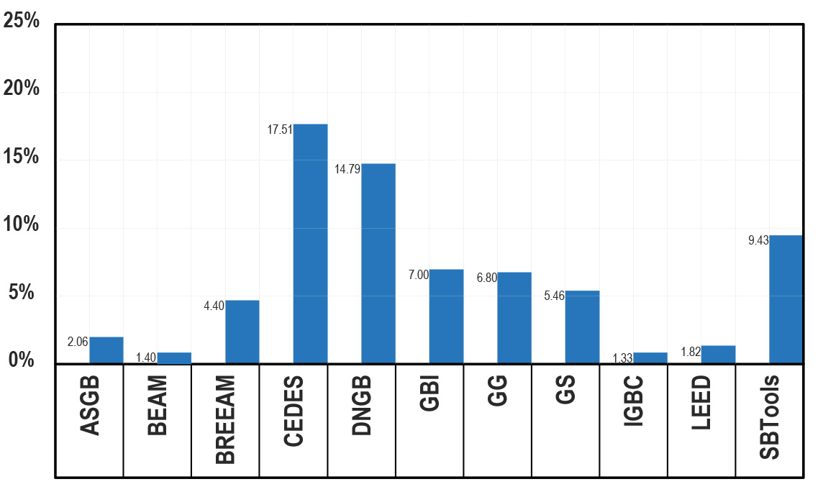

**Table 12.** Contribution of *demountable construction* to a building’s sustainability level, using 11 GBRS

*R4House* can be dismantled and reassembled as many times as desired. In addition, all its components are easily dismantled, repairable and reusable, so the durability of the building can be maximized and with minimal maintenance required the environmental impact per unit of time can be minimized. Likewise, its construction reduced energy consumption to a minimum, resources were optimized to the maximum and the generation of emissions and waste was greatly reduced.It could thus be expected that all the GBRS would adequately value these environmental advantages by giving to *R4House* a high score, although this was not the case.

Only three GBRS adequately assessed the sustainable level of modular and *demountable construction* (CEDES: 17.51 %, DNGB: 14.79 %, SBTools: 9.43) while the rest gave it a low score, and four gave it an extremely low score (IGBC: 1.33 %, BEAM: 1.40 %, LEED 1.82 %, ASGB: 2.06 %).

However, the most surprising aspect of the results is the enormous disparity in the scores obtained. It is certainly not acceptable for the same building to have a different sustainable level according to the GBRS used.

**5. Discussion**

In this work, a demountable house was analysed by eleven of the most internationally known GBRS. The results show that *demountable and modular construction* increases a building’s level of sustainability.

However, it is surprising that only three GBRS adequately assessed the sustainability of a modular demountable house, while the others considered it of little importance, with three of them giving it an extremely low score. To make matters worse, the results obtained varied widely. The evaluation process followed in each GBRS was reviewed several times in search of a possible error, although none was found.

It could have been expected that all the existing GBRS would adequately and similarly assess the contribution of *demountable construction* in containers to the building’s sustainability level. However, this was not the case, since there were significant differences in the scores. It is not acceptable for the level of sustainability to depend on the GBRS chosen. It follows from this that the GBRS analysed are not suitable for properly assessing a building’s level of sustainability.

More comparative studies should be carried out to determine whether there are other GBRS that are more suitable for assessing sustainability. However, if the eleven GBRS analysed are among the best it can be assumed that the remainder will be equally deficient.

The current GBRS should therefore be substantially modified or replaced by more suitable ones.

The disparity in the results obtained suggests that each GBRS was designed according to a different interpretation of the concept of “sustainability”. And this is something very dangerous, since if we intend to massively promote sustainability on a global scale the first thing that should be done is to define it in detail to avoid ambiguities and local interpretations. Of course, this general concept of sustainability should have small local variations, depending on each socio-economic environment, but they should be of little importance.

Once the concept of sustainability has been agreed upon and detailed, a new GBRS internationally valid should be created. This global GBRS would have to be adapted to the different socio-economic environments, but this would involve only minor variations.

Once the sustainability concept has been agreed and detailed, a common framework for the design of new GBRS should be created. Of course, each GBRS could have slight differences from the others, but they must share the same core, so that all their results do not significantly vary when evaluating the same building.

The common framework for the design of new GBRS should have a taxonomic structure on several levels in order to include all the sustainability aspects, so that the necessary evaluation indicators should be structured into categories and subcategories. These indicators must be perfectly justified, none should be in excess or missing should have a perfectly justified relative weight and they must be easily evaluated.

Another important point is that these GBRS, in addition to evaluating the level of sustainability of an already planned or constructed building, should above all serve to guide the design process. In this way, any professional could include it in the design to guarantee that the new buildings have the highest possible sustainable level, which means the evaluation process would only consist of a simple free administrative check.

**6. Conclusions**

This work has shown that *demountable constructions* have a higher level of sustainability than conventional constructions. For this, a demountable and a conventional house were assessed by 11 GBRS and the results obtained were compared. The chosen GBRS were: ASGB, BEAM, BREEAM, CEDES, DNGB, GBI, GG, GS, IGBC, LEED and SBTools. The house analyzed, *Green Box*, is completely demountable, and its components can be easily assembled and disassembled, so they can be easily removed from the building, repaired and reused as many times as necessary to extend its durability to the maximum and reduce its environmental impact per unit of time to the minimum.

Taking into account the considerable environmental benefits of demountable construction (maximum durability, minimum environmental impact per unit of time, reduced emissions and waste, optimized resources, low energy consumption, elimination of programmed obsolescence, etc.) one would expect all GBRS to rate them appropriately, providing a high score. However, that has not been the case.

Although the eleven GBRS used gave a higher level of sustainability to the demountable house, eight gave it very low scores, despite its obvious environmental benefits. To make matters worse, the scores of the eleven GBRS varied widely, which is unacceptable, since the same building obtained different scores depending on the GBRS used.

The study’s first conclusion is thus that the GBRS used should provide a higher level of sustainability to the *demountable construction*.

The second conclusion, and confirming the conclusions reached by previous authors is that most current GBRS cannot correctly assess sustainability and should be modified.

The third conclusion is that the CEDES, SBTools and DNGB GBRS can be recommended to adequately assess demountable buildings’ level of sustainability.

**Acknowledgements**

We are very grateful to Carlos Bermudez Velasco, Fidel Ernesto González Rojas, Mario José Guerrero Villareal, Camila Navas Gago and Nicolas Ezequiel Picco, students and professors involved in the *Advanced Master of Sustainable, Bioclimatic and Self-Sufficient Architecture* [66], managed by the *National Association for Sustainable Architecture* [67], in Spain. In this Master, the 16 GBRS analyzed are studied in depth.

# References

[1] Delfani, M., Ibrahim, R., Mat Raschid, M., Hejazi, F. & Haron, N. (2016). Towards designing modular of industrialized building systems. *Jurnal Teknologi, 78*(5), <https://doi.org/10.11113/jt.v78.8342>

[2] Di Pasquale, J., Innella, F. & Bai, Y. (2020). Structural Concept and Solution for Hybrid Modular Buildings with Removable Modules. *Journal of Architectural Engineering, 26*(3).

[https://doi.org/10.1061/(ASCE)AE.1943-5568.00004](https://doi.org/10.1061/(ASCE)AE.1943-5568.0000423)

[3] Generalova, E., Generalov, V. & Kuznetsova, A. (2016). Modular Buildings in Modern Construction. *Procedia Engineering, 153*, 167-172.

<https://doi.org/10.1016/j.proeng.2016.08.098>

[4] Hua, H., Hovestadt, L. & Li, B. (2022). Reconfigurable Modular System of Prefabricated Timber Grids. *Computer-Aided Design, 146*, <https://doi.org/10.1016/j.cad.2022.103230>

[5] Abbood, A., Al-Obaidi, K., Awang, H. & Abdul Rahman, A. (2015). Achieving energy efficiency through industrialized building system for residential buildings in Iraq. *International Journal of Sustainable Built Environment, 4*(1), 78-90

<https://doi.org/10.1016/j.ijsbe.2015.02.002>

[6] Ahmad Bari, N., Mohd Yusuff, R., Ismail, N. & Jaapar, A. (2018). Industrialised Building Systems (IBS): It’s attribute towards enhancing sustainability in construction. *Asian Journal of Environment-Behaviour Studies 3*(8), 109-119

<https://doi.org/10.21834/aje-bs.v3i8.284>

[7] Dave, M., Watson, B. & Prasad, D. (2017). Performance and Perception in Prefab Housing: An Exploratory Industry Survey on Sustainability and Affordability. *Procedia Engineering, 180*, 676-686.

<https://doi.org/10.1016/j.proeng.2017.04.227>

[8] Minunno, R., O’Grady, T., Morrison, G., Gruner, R., & Colling, M. (2018). Strategies for Applying the Circular Economy to Prefabricated Buildings. *Buildings, 8*(9), 125

<https://doi.org/10.3390/buildings8090125>

[9] O’Brien, M. (2015). *Success and failure in industrialised prefabricated housing.* Dept of Architecture, Texas A&M University, College Station, Texas, U.S.A.

[10] Bowley, W. & Mukhopadhyaya, P. (2017). *International Review of Applied Sciences and Engineering 8*(2), 145-152

<https://doi.org/10.1556/1848.2017.8.2.7>

[11] Damian Figaj, R., Laudiero, D. M. & Mauro, A. 2024. Climate Characterization and Energy Efficiency in Container Housing: Analysis and Implications for Container House Design in European Locations, *Energies 17*(12) 2926.

<https://doi.org/10.3390/en17122926>

[12] De Garrrido, L. (2007). *R4House: Reuse, Recover, Recycle and Reason*. A self-sufficient house made by containers. ANAVIF editions. Legal Deposit V-2252-2007

[13] De Garrrido, L. (2011). *Sustainable Architecture with Containers*. Monsa. ISBN. 978-84-152-2335-1

[14] De Garrrido, L. (2015). *Green Container Architecture*. Monsa. ISBN. 978-84-15829-81-2

[15] De Garrrido, L. (2017). *Manual of Advanced Ecological Architecture*. Editorial Nobuko Design. 354 pages. ISBN. 978-98-74160126

[16] Ling, M. (2021). Container housing: Formal informality and deterritorialised home-making amid bulldozer urbanism in Shanghai. *Urban Studies*, *58*(6), 1141-1157.

<https://doi.org/10.1177/0042098019899353>

[17] Murat Tanyer, A., Tavukcuoglu, A. & Bekboliev, M. (2018). Assessing the airtightness performance of container houses in relation to its effect on energy efficiency, *Building and Environment 134*, 59-73,

<https://doi.org/10.1016/j.buildenv.2018.02.026>

[18] Yan Hong, Y. (2017). A study on the condition of temporary housing following disasters: Focus on container housing. Frontiers of Architectural Research 6 (3), 374-383, <https://doi.org/10.1016/j.foar.2017.04.005>

[19] Al-Muslih, A. & Al-Hadithy, L. (2019). Performances of Steel-Concrete Composite Construction with Demountable Shear Connectors – Review. *IOP Conference Series: Materials Science and Engineering*, *518*(2), 022058

DOI:[10.1088/1757-899X/518/2/022058](http://dx.doi.org/10.1088/1757-899X/518/2/022058" \t "_blank)

[20] Boben Paul, E. (2022). *Design of a Demountable Steel Timber Floor System: Design Rules and Recommendations for the Application of a Demountable Steel Timber Floor* System [Master´s thesis, Delft University of Techology]. Faculty of Civil Engineering and Geosciences, Delft.

[21] Braendstrup, C. (2017). *Conceptual design of a demountable, reusable composite flooring system* [Master´s Thesis, Delft University of Technology]. Delft University of Technology.

[22] Foster, C. & Krishnakumar, S. (1987). A Class of Transportable Demountable Structures. *International Journal of Space Structures, 2*(3), 129-137.

<https://doi.org/10.1177%2F026635118700200301>

[23] Girão Coelho, A., Lawson, R. & Aggelopoulos, E. (2019). Optimum use of composite structures for demountable construction. *Structures*, *20*, 116-133.

<https://doi.org/10.1016/j.istruc.2019.03.005>

[24] He, J., Suwaed, A., Vasdravellis, G. & Wang, S. (2021). Shear performance of a novel demountable connector for reusable steel-concrete composite structures. In A. Chen, X. Ruan, & D. Frangopol, *Life-Cycle Civil Engineering: Innovation, Theory and Practice.* 775-781

[25] Kollna, M. (2018). Demountable prototype house – from facade to water tap. *Mauerwerk - European Journal of Masonry, 22*(1), 38-43

<https://doi.org/10.1002/dama.201700026>

[26] Van Glabbeek, L. (2019). *Development of an innovative demountable floor system: Structural design and verification.* [Master´s thesis, Delft University of Technology]. Delft University of Technology.

[27] Wang, J., Uy, B. & Li, D. (2018). Analysis of demountable steel and composite frames with semi-rigid bolted joints. *Steel and Composite Structures, 28*(3), 363-380

<https://doi.org/10.12989/scs.2018.28.3.363>

[28] Wang, J., Uy, B., Thai, H.-T. & Li, D. (2018). Behaviour and design of demountable beam-to-column composite bolted joints with extended end-plates. *Journal of Constructional Steel Research, 144*, 221-235

<https://doi.org/10.1016/j.jcsr.2018.02.002>

[29] Westbury, P. (1996). Demountable Buildings - A New Design Strategy? *WIT Press, 24*

DOI:10.2495/MRS960391

[30] Akanbi, L., Oyedele, L., Omoteso, K., Bilal, M., Akinade, O., Ajayi, A., Dávila Delgado, J.M. & Owolabi, H. (2019). Disassembly and deconstruction analytics system (D-DAS) for construction in a circular economy. *Journal of Cleaner Production, 223*, 386-396.

<https://doi.org/10.1016/j.jclepro.2019.03.172>

[31] Boedianto, P. & Walraven, J. (2000). Optimizing the environmental impact of demountable building. *International Symposium on Intergrated Life-Cycle Design of Materials and Structures*, Ed. A. Sarja, 135-141

[32] Brambilla, G., Lavagna, M., Vasdravellis, G. & Castiglioni, C. (2019). Environmental

benefits arising from demountable steel-concrete composite floor systems in buildings.

*Resources, Conservation and Recycling, 141*, 133-142.

<https://doi.org/10.1016/j.resconrec.2018.10.014>

[33] Cruz Rios, F., Chong, W. & Grau, D. (2015). Design for Disassembly and Deconstruction - Challenges and Opportunities. *Procedia Engineering, 118*, 1296-1304.

<https://doi.org/10.1016/j.proeng.2015.08.485>

[34] De Garrrido, L. (2008). *Analysis of Sustainable Architecture Projects. “Artificial Natures 2001-2008”*. McGraw-Hill. 485 pages. ISBN 978-84-481-6802-5

[35] De Garrrido, L. (2012). *A New Paradigm in Architecture*. Monsa. 528 pages. ISBN 978-84-152-2375-7

[36] García Marín, A., Barrios Corpa, J., Terrados Cepeda, J., de la Casa Higueras, J. & Aguilera Tejero, J. (2015). Self-Sufficient Prefabricated Modular Housing: Passive Systems Integrated. In A. Sayigh, *Renewable Energy in the Service of Mankind Vol I*.

<https://doi.org/10.1007/978-3-319-17777-9_60>

[37] Liu, C., Mao, X., He, L., Chen, X., Yang, Y. & Yuan, J. (2022). A new demountable light-gauge steel framed wall: Flexural behavior, thermal performance and life cycle assessment. *Journal of Building Engineering, 47*

<https://doi.org/10.1016/j.jobe.2021.103856>

[38] Nam, S., Yoon, J., Kim, K. & Choi, B. (2020). Optimization of Prefabricated Components in Housing Modular Construction. *Sustainability, 12*(24)

<https://doi.org/10.3390/su122410269>

[39] Negrin, F. & Plitt, T. (2019). Designer demountable. *Sanctuary: Modern Green Homes, 48*, 16-21

<https://www.jstor.org/stable/26906361>

[40] Ortlepp, S., Masou, R., & Ortlepp, R. (2015). Demountable construction for sustainable buildings. *High Performance Fiber Reinforced Cement Composites (HPFRCC)*, Stuttgart, vol. 7

[41] Ortlepp, S., Masou, R. & Ortlepp, R. (2017). Green construction methods of buildings capable for disassembly to support circular economy. In F. da Silva, H. Bártolo, P. Bártolo, R. Almendra, F. Roseta, H. Almeida, & A. Lemos, *Challenges for Technology Innovation: An Agenda for the Future.* Taylor & Francis Group

<https://doi.org/10.1201/9781315198101>

[42] Reinhardt, H. (2018). Demountable concrete structures – an energy and material saving building concept. *International Journal of Sustainable Materials and Structural Systems 1*(1), 18-28.

DOI:[10.1504/IJSMSS.2012.050452](http://dx.doi.org/10.1504/IJSMSS.2012.050452" \t "_blank)

[43] Salama, W. (2018). *Design for disassembly as an alternative sustainable construction approach to life-cycle-design of concrete buildings*. [Doctoral thesis, Gottfried Wilhelm Leibniz University].

<https://doi.org/10.15488/5121>

[44] Pai, V. & Elzarka, H. (2021). Whole building life cycle assessment for buildings: A case study ON HOW to achieve the LEED credit. *Journal of Cleaner Production 297*,126501

<https://doi.org/10.1016/j.jclepro.2021.126501>

[45] Andújar, J. M., Gómez, S. & Sánchez, A. (2020). Green building rating systems and the new framework level(s): A Critical Review of Sustainability Certification within Europe. *Energies* 13(1), 66

<https://doi.org/10.3390/en13010066>

[46] Chen, X., Yang, H. & Lu, L. (2015). A comprehensive review on passive design approaches in green building rating tools. *Renewable and Sustainable Energy Reviews*, Elsevier, 50(C), 1425-1436

<https://doi.org/10.1016/j.rser.2015.06.003>

[47] Katiyar, M., Sahu, A.K., Agarwal, S.K. & Tiwari, P.K. (2021). Role of Spatial Design in Green Buildings-A Critical Review of Green Building Rating Systems. *IOP Conference Series: Materials Science and Engineering* 1116, 1, 12-166

<https://doi.org/10.1088/1757-899x/1116/1/012166>

[48] Lee, W. (2013). A comprehensive review of metrics of building environmental assessment schemes. *Energy and Buildings* 62, 403-413

<https://doi.org/10.1016/j.enbuild.2013.03.014>

[49] He, Y., Kvan, T., Liu, M. & Li, B. (2018). How green building rating systems affect designing green. *Building and Environment* 133, 19-31

<https://doi.org/10.1016/j.buildenv.2018.02.007>

[50] Scofield, J. H. & Cornell, J. (2019). A critical look at “Energy savings, emissions reductions, and health co-benefits of the green building movement”. *Journal of Exposure Science & Environmental Epidemiology* 29, 584-593. <https://www.nature.com/articles/s41370-018-0078-1.pdf>

[51] Conniff, R. (2017). Why Don't Green Buildings Live Up to Hype on Energy Efficiency? *Yale Environment* 360: New Haven, CT. <https://e360.yale.edu/features/why-dont-green-buildings-live-up-to-hype-on-energy-efficiency>

[52] Scofield, J. H. (2009). “Do LEED-certified buildings save energy? Not really…”. Energy and Buildings 41, 1386-90

<https://doi.org/10.1016/j.enbuild.2009.08.006>

[53] Scofield, J. H. & Doane, J. (2018). Energy performance of LEED-certified buildings from 2015 Chicago benchmarking data, Energy and Buildings, Volume 174, Pages 402-413.

<https://doi.org/10.1016/j.enbuild.2018.06.019>

[54] R4House 2024

<https://luisdegarrido.com/es/r4house-luis-de-garrido-vivienda-ecologica-bioclimatica-autosufficiente-con-consumo-energetico-cero-real-a-precio-convencional-2/>

[55] ASGB 2019. Assessment Standard for Green building

<https://www.eia543.com/documents/14%E5%BB%BA%E7%AD%91%E8%AE%BE%E8%AE%A1%26%E5%AE%A4%E5%86%85%E7%A9%BA%E6%B0%94%E6%B1%A1%E6%9F%93%E7%A0%94%E7%A9%B6/%E7%BB%BF%E8%89%B2%E5%BB%BA%E7%AD%91%E8%AF%84%E4%BB%B7%E6%A0%87%E5%87%86%EF%BC%88GB%20T%2050378-2019%EF%BC%89.pdf> (accessed 1 november 2024)

[56] BEAM 2024. Building Environmental Assessment Method

HK-BEAM Plus. 4/04 New Buildings – Technical Manual

<https://www.ibeam.hk/public/knowledgeDatabase/?tab=downloadArea>

<https://www.beamsociety.org.hk/files/_4-04%20New%20Buildings%20(Full%20Version).pdf>

<https://www.beamsociety.org.hk/en/BEAM-Plus/BEAM-Plus-New-Buildings> (accessed 1 november 2024)

[57] BREEAM UK New Construction 2018 3.0 – Technical Manual

<https://breeam.es/manuales-tecnicos>

Building Research Establishment Group. BREEAM Worldwide. 2019. <https://www.breeam.com/worldwide>; Building Research Establishment Environmental Assessment Method ES. 2019. <http://www.breeam.es/>

BREEAM International: Watford, UK, 2017; <https://hbreavis.com/wp-content/uploads/2017/06/BREEAM-International-New-Construction-2016>

(accessed 1 november 2024)

[58] CEDES 2024

CEDES Technical Manual

GBRS designed by National Association for Sustainable Architecture in Spain

<https://www.anas-sostenible.com/> (accessed 1 november 2024)

[59] DGNB 2023. Deutsche Gesellschaft für Nachhaltiges Bauen

DNGB system 2023 – Technical Manual

<https://www.dgnb.de/en/certification/buildings/new-construction/version-2023> (accessed 1 november 2024)

[60] GBI 2014. Green Building Index

2014 V. 3.1– Technical Manual

<https://www.greenbuildingindex.org/gbi-tools/>

<https://www.greenbuildingindex.org/Files/Resources/GBI%20Tools/RNC%20Reference%20Guide%20V3.1.pdf> (residential buildings)

<https://www.greenbuildingindex.org/Files/Resources/GBI%20Tools/RNC%20Reference%20Guide%20Amendment%20Notes%203.1.pdf> (accessed 1 november 2024)

[61] GG 2022. Green Globes

Green Globes New Construction 2021 - Technical Reference Manual Version 1.0 - September 2022

<https://thegbi.org/wpcontent/uploads/2022/11/Green_Globes_NC_2021_ES__BEQ_Technical_Reference_Manual.pdf> (accessed 1 november 2024)

[62] GS 2022. Green Star

Green Star Design & As Built V1.2 – Technical Manual

[https://s3.ap-southeast-2.amazonaws.com/hdp.au.prod.app.nthbch](https://s3.ap-southeast-2.amazonaws.com/hdp.au.prod.app.nthbchyoursay.files/1415/6214/8137/2018_701322__Green_Star_Design_and_As_Built_Submission_Guidelinev1.2_GBCA_1.PDF)

[yoursay.files/1415/6214/8137/2018\_701322\_\_Green\_Star\_Design\_and\_As\_Built\_Submission\_Guideline](https://s3.ap-southeast-2.amazonaws.com/hdp.au.prod.app.nthbchyoursay.files/1415/6214/8137/2018_701322__Green_Star_Design_and_As_Built_Submission_Guidelinev1.2_GBCA_1.PDF)

[v1.2\_GBCA\_1.PDF](https://s3.ap-southeast-2.amazonaws.com/hdp.au.prod.app.nthbchyoursay.files/1415/6214/8137/2018_701322__Green_Star_Design_and_As_Built_Submission_Guidelinev1.2_GBCA_1.PDF)

[https://www.gbca.org.au/shop/green-star-rating-tools/#](https://www.gbca.org.au/shop/green-star-rating-tools/) (accessed 1 november 2024)

[63] IGBC 2019. Indian Green Building Council

IGBC Green New Buildings Rating Systems V3.0 – Technical Manual

https://igbc.in/igbc-green-homes.php (accessed 1 november 2024)

[64] LEED 2019.Leadership in Energy and Environmental Design

LEED v4.1 Residential BD+C Multifamily Homes – Technical Manual

<https://www.usgbc.org/tools/leed-certification/homes_CLASIFICACION.pdf>

<http://www.spaingbc.org/web/leedv4-1-bd+c.php> (accessed 1 november 2024)

[65] SBTool 2022.

SBtools for performance assessment 2022

https://www.iisbe.org/sbmethod (accessed 1 november 2024)

[66] MAS 2024. Advanced Master in Sustainable, Bioclimatic and Self-Sufficient Architecture (M.A.S.)

[www.masterarquitectura.info](http://www.masterarquitectura.info) (accessed 1 november 2024)

[67] ANAS 2024. Asociación Nacional para la Arquitectura Sostenible, España

[www.anas-sostenible.com](http://www.anas-sostenible.com) (accessed 1 november 2024)

**Highlights**

- Evaluation of a demountable house by 11 GBRS

- Capacity for evaluating demountable construction by current GBRS

- ASGB, BEAM, BREEAM, CEDES, DNGB, GBI, GG, GS, IGBC, LEED, SBTools.

- Contribution of demountable construction to the sustainability rating of a building

- Improve current Green Building Rating Systems, and design new GBRS