Research incubators experience in Basic and Secondary Education of Medellin with the support of TIC within the framework of the research component of the CIER Occidente.

Claudia Alejandra Rosero Noguera¹, Mónica María Rojas Rincón², Gustavo Alberto Moreno López³
¹Systems Engineer, Master in Engineering, PhD Candidate in Educational Sciences. Research professor at the Faculty of Engineering, Politécnico Colombiano Jaime Isaza Cadavid, Medellín, Colombia
²Systems Engineer, Master in Systems and Computer Engineering, Professor at Politécnico Colombiano Jaime Isaza Cadavid, Medellín (Retired), Universidad ICESI, Cali, Colombia
³ Electronic Engineer, master’s degree in Telecommunications Engineering and PhD in Engineering - Systems and Computer Science. Research professor at the Faculty of Engineering, Politécnico Colombiano Jaime Isaza Cadavid, Medellín, Colombia
ABSTRACT: This article presents the experience in the development of a planning service as a basis for a work plan for the research incubators who attend Basic and Secondary Education of the city of Medellin, with the support of TIC within CIER Occidente. Within the project we seek to develop two innovative schools with the same research training activities, with the aim to plan meetings between the research incubators and socialize their experiences and progress. The support of the teachers of these innovative schools are the key to the continued implementation of the planning and research program that gave rise to the termination of the research incubators; what is sought is a strategy to conserve these research incubators number in which they comprise, in addition, continue to grow and strengthen their skills in research and technological appropriation.
KEY WARDS: Competitions, research incubators, research, planning, TIC

---------------------------------------------------------------------------------------------------------------------------------------
Date of Submission: xx-xx-xxxx Date of acceptance: xx-xx-xxxx
---------------------------------------------------------------------------------------------------------------------------------------

INTRODUCTION
Research is an essential component in the training process. Starting this in early stages helps the student to strengthen different types of competencies; therefore, under the framework of the CIER component of the West (Project proposed by the Ministry of National Education of Colombia), two seedlings were formed in Secondary Education Institutions: Gabriel García Márquez and INEM José Félix de Restrepo in the city of Medellín, articulated with the Higher Education Institution Politécnico Colombiano Jaime Isaza Cadavid. The seedbeds were formed randomly, with awareness meetings with students between the ages of 10 and 18 years, it should be noted that their admission is voluntary.

This article shows the work plan proposed and applied to the seedlings of the two innovative schools, indicating the competencies to be developed, taking into account the levels of research training proposed in [1]. And the methodological route for the continuity of the seedbed.

LITERATURE REVIEW

  - Definitión of competence

Analyzing the definition of competency requires reviewing different references, however, for the purposes of this project the following are taken:

In [2] cited by the Ministry of National Education they indicate that a competence is "A set of knowledge, skills, attitudes, understandings and cognitive, socio-affective and psychomotor dispositions appropriately related to each other to facilitate the flexible, effective and meaningful performance of an activity in relatively new and challenging contexts". For his part [3] says that "A competence is more than just knowledge or skills. It involves the ability to meet complex demands, by drawing on and mobilising psychosocial resources (including skills and attitudes) in a particular context. For example, the ability to communicate effectively is a competence that may draw on an individual's knowledge of language, practical IT skills and attitudes towards those with whom he or she is communicating".

For [4] skill is the ability to perform tasks and solve problems, while he points out that a competency is the ability to apply the results of learning in a given context (education, work, personal or professional development). A competency is not limited to cognitive elements (use of theory, concepts or implicit knowledge), but also encompasses functional aspects (technical skills), interpersonal attributes (social or organizational skills) and ethical values. A competency is therefore a broader concept that can, in fact, be composed of skills (as well as attitudes, knowledge, etc.).

For [5] "A competence involves three fundamental dimensions of the human being: the cognitive, the attitudinal-valorational and the practical or procedural, thus the development of competence brings into play these three interdependent and integrated dimensions" and for [6] "Being competent means: having declarative knowledge (information and knowledge), i.e. knowing what you do, why you do it and knowing the object on which you act. Being competent also implies having the capacity for execution, i.e. the procedural knowledge or the intellectual and psychomotor skills to actually carry out the execution on the object. Finally, being competent implies having the attitude or disposition (attitudinal knowledge) to want to make declarative and procedural use and act in a way that is considered correct”.

Considering the conceptual references presented above, competence can be defined as the ability of a person to perform a job according to pre-established rules and methods in a given context, which implies the development of three aspects: cognitive, procedural and attitudinal.

  - Competencies in Information and Communication Technologies (ICTs)

This article is based on the standards determined by the International Society for Technology in Education - ISTE (International Society for Technology in Education), for Information and Communication Technologies - ICT.

In [7] contains the "ICT standards for students developed by the NETS project in 1998. The criteria for basic technology training for students are divided into six broad, concrete and relevant categories. Although these standards were updated in 2007, many educational institutions in Latin America, which are just starting with ICT projects, can use them", which are presented below:

    - National Standards (Usa) of Information and Communication Technologies (Ict) for Students: The Next Generation

“What students should know and be able to do to learn effectively and live productively in an increasingly digital world…” [7]

- Creativity and innovation: Students demonstrate creative thinking, build knowledge and develop innovative products and processes using ICT. The students:

a. They apply existing knowledge to generate new ideas, products or processes.
b. They create original works as a means of personal or group expression.
c. They use models and simulations to explore complex systems and issues.
d. They identify trends and foresee possibilities

- Communication and Collaboration: Students use digital media and environments to communicate and work collaboratively, even remotely, to support individual learning and contribute to the learning of others. The students:

a. They interact, collaborate and publish with their peers, with experts or with other people, using a variety of environments and digital media.
b. They effectively communicate information and ideas to multiple audiences, using a variety of media and formats.
c. They develop cultural understanding and global awareness by connecting with students from other cultures.
d. They participate in teams that develop projects to produce original work or solve problems.

- Research and Information Management: Students apply digital tools to obtain, evaluate and use information. The students:

a. They plan strategies that guide the investigation.
b. They locate, organize, analyze, evaluate, synthesize, and ethically use information from a variety of sources and media.
c. They evaluate and select sources of information and digital tools to perform specific tasks, based on their relevance.
d. They process data and communicate results.

- Critical Thinking, Problem Solving, and Decision Making: Students use critical thinking skills to plan and conduct research, manage projects, solve problems, and make informed decisions using appropriate digital tools and resources. The students:

a. They identify and define authentic problems and meaningful questions to investigate.
b. They plan and manage the activities necessary to develop a solution or complete a project.
c. They gather and analyze data to identify solutions and/or make informed decisions.
d. They use multiple processes and diverse perspectives to explore alternative solutions.

- Digital Citizenship: Students understand human, cultural and social issues related to ICT and practice legal and ethical conduct. The students:

a. They promote and practice the safe, legal and responsible use of information and ICT.
b. They exhibit a positive attitude towards the use of ICT to support collaboration, learning and productivity.
c. They demonstrate personal responsibility for lifelong learning.
d. They exercise leadership for digital citizenship.

- Operation and Concepts of ICT: Students demonstrate an adequate understanding of the concepts, systems and operation of ICT. The students:

a. They understand and use Information and Communication technological systems.
b. They select and use applications effectively and productively.
c. They investigate and resolve problems in systems and applications.
d. They transfer existing knowledge to learning new Information and Communication Technologies (ICT).

Figure 1 graphically represents the ISTE standard for Information Technologies and focused communication for students, with the purpose of interpreting it in a simpler way.

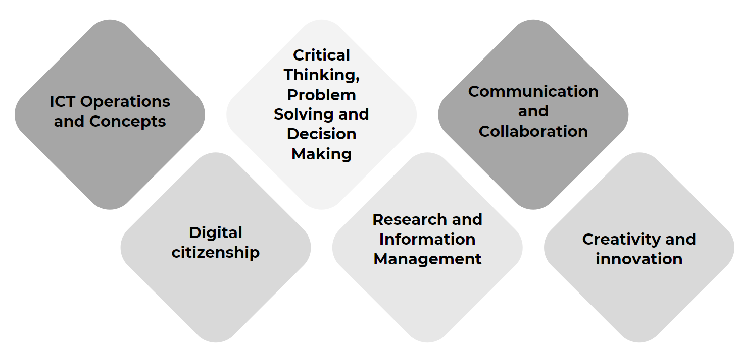
Figure1: ISTE ICT standards for students. Adapted [7]

  - 21st century skills and competencies

According to the Organization for Economic Cooperation and Development OECD [8] the “21st century skills and competencies for new millennium learners in OECD countries”, of which Colombia requested entry in May 2013, are the following:
Dimensions: information, communication and ethical-social impact

Information:
The information explosion unleashed by ICT requires new skills for accessing, evaluating and organizing information in digital environments. At the same time, in those societies where knowledge plays a central role, it is not enough to be able to process and organize information; it is also necessary to model and transform it to create new knowledge or to use it as a source of new ideas.

The typical skills belonging to this dimension are research and problem-solving skills, which involve at some point definition, search, evaluation, selection, organization, analysis and interpretation of information.

Communication:
Communication plays an important role in preparing students not only as lifelong learners, but also as members of a community with a sense of responsibility toward others. Young people need to have the ability to communicate, exchange, criticize and present information and ideas, including the use of ICT applications that promotes participation and positive contribution to digital culture.

Research in this area suggests that ICT applications strengthen and increase communication possibilities, as well as coordination and collaboration skills among equals.

Ethics:
Globalization, multiculturalism and the rise of ICT bring with them ethical challenges. Therefore, skills and competencies related to ethics and social impact are also important for workers and citizens of the 21st century.

1.4 Appropriation in ICT

For the Ministry of National Education, [9] ICT competencies are classified into three levels: exploration, integration and innovation, taking into account that each one can be executed independently. That is, a teacher can be at different levels of performance at the same time.

Regardless of the classification of ICT competencies, a teacher within the context of innovation must develop: Technological, pedagogical, investigative, communicative and management competencies.
• Technological Competencies: Use of technological tools in the classroom, selecting the most relevant ones for the teaching-learning process.
• Communicative Competence: Ability to establish contact, express oneself orally or in writing with other people in physical or virtual spaces.
• Pedagogical Competence: Willingness to use ICT to strengthen the development of competencies in the teaching and learning processes and in their professional development.
• Management Competence: Skill to use ICT in planning, organization, evaluation and administration activities of all educational processes.
• Investigative Competence: Ability to take advantage of all the opportunities provided by ICT, in knowledge management such as internet repositories and cloud computing.

METHODOLOGY
It begins with the diagnostic activity, the Metaplan methodology is used to identify the use and appropriation of ICT and the application of a survey to know the research training in the students, managers and teachers of the Gabriel García Márquez Educational Institution (14 people) and INEM José Felix de Restrepo (9 people).
The Metaplan tool “is a group moderation method for searching for problem solutions, which involves all participants. Metaplan is a set of Communication Tools to be used in groups that seek ideas and solutions to their problems, for the development of opinions and agreements, for the formulation of objectives, recommendations and action plans. [10]

In Figure 2, applying the Metaplan methodology for the diagnosis of ICT appropriation, at the Gabriel García Márquez Educational Institution, it is highlighted that the main achievement is research, and the greatest difficulty is the misuse of the equipment.

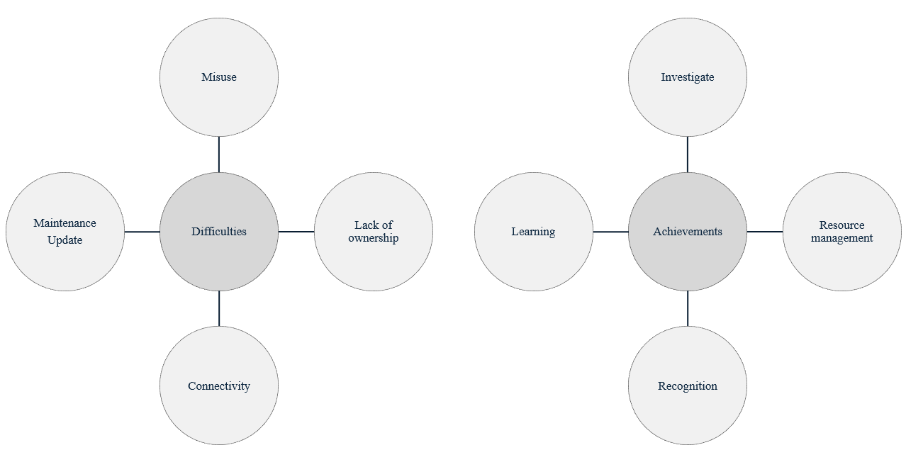
Figure 2: Achievements and difficulties of the Gabriel García Márquez Educational Institution

In figure 3, applying the same methodology, at the INEM José Félix de Restrepo Educational Institution, it is highlighted that the main achievement is knowledge, and the greatest difficulty is training.

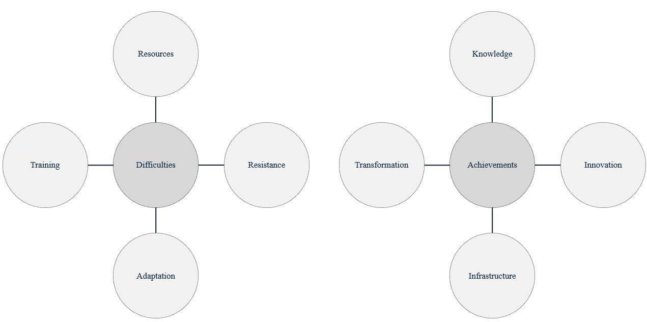
Figure 3: Achievements and difficulties of the INEM José Félix de Restrepo Educational Institution

According to [11] and [12], it proposes the following tasks that are developed in the formative research process: Tasks of openness, expression, creative ingenuity and scientific rigor, socialization of scientific work, construction and the strategy.

Based on this classification, the tasks were grouped into levels, in each of which construction and communication tasks are developed, at different levels of development.

Table I. Research training levels
LEVEL | TASKS
Explorer | Opening
 | Expression
Creative | Creative ingenuity and scientific rigor
 | Socialization of scientific work
Builder | Construction
 | Strategy

The Participatory Action Research or PAR methodology is applied, which allows combining research, action and participation with the purpose of reflecting and studying the current state of individuals in the investigative process, through a survey.

Considering the results of the survey and table 1, the research training of the teaching and management staff has been immersed in the three levels, likewise, the students are classified in the exploratory level, as shown in table 2.
Table II. General result level of training in the EI
Educational Institution | Staff | Level of Education
EI Gabriel García Márquez | Teacher and Manager | Immersed in the three levels, in certain degrees of depth, due to her undergraduate and postgraduate degrees.
 | Students | Exploratory level, since these relate the research to the queries assigned in certain subjects, through the basic search for information in books or the Internet.
EI INEM José Félix de Restrepo | Teacher and Manager | Immersed in the three levels, in certain degrees of depth, due to her undergraduate and postgraduate degrees.
 | Students | Exploratory level, since these relate the research to the queries assigned in certain subjects, through the basic search for information in books or the Internet and through the systems and degree works modality.

Table 3 presents a summary of the answers given to the questions about the areas of interest, the usefulness and needs or expectations of research training.

Table III. Answers about area of ​​interest, usefulness, and research needs.
Area of interest | Utility | Research needs
EI Gabriel García Márquez
Research knowledge (types of research, methodology)  Troubleshoot or identify for improvement  Documentation classification, writing  ICT use in research | Research would be useful to learn, deepen, update knowledge, find answers to daily life cases, and expand topics of interest. It is also highlighted that several considered being able to strengthen or acquire skills and competencies and transform teaching practice (that favors learning). | Delve into research methodologies, and the steps to carry out an investigation well.  Presentation standards  Innovations  Use of ICT in research  Correct steps to find good information  Types of research  Field research  New techniques  Topics about health, medicine, the human body and the planet
EI INEM José Félix de Restrepo
Support those starting out in research practice  Delve into educational action research  Publication of articles, national and international presentations, helping with the technological and educational development of the country  Project writing  Develop learning objects in the area of ​​mathematics.  Methodology | Complement other research, acquire, expand and apply knowledge, develop degree work, and acquire more skills. For teachers, it is useful to transform teaching practice, create knowledge, change the routine of learning and teaching, develop technology for specific purposes, carry out projects to solve societal problems, and improve aspects of learning. | Deepen Educational Research  Strengthen the writing and publication of articles  Strengthen project development  Develop learning objects  Delve into research methodologies,  Research foundations. How the research is carried out, what must be taken into account when carrying it out, what standards exist and what is its fundamental purpose.  Application for degree work  Training in the application and development of the research itself.  Topics such as robotics, circuits and electronics  ICT topics

RESULTS AND DISCUSSIONS
For the continuity of the seedbeds in the Innovative Schools, the following Methodological Route is proposed, which is presented in figure 4.

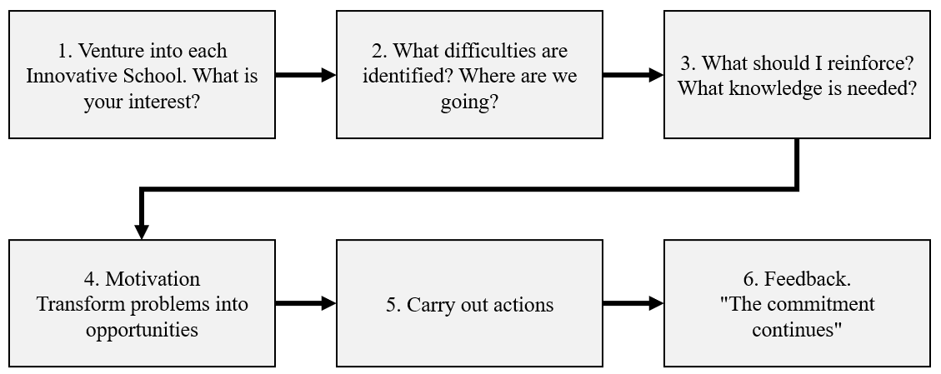
Figure 4: Methodological Route

Enter each Innovative School. Students or teachers who want to join as new members of the seedbed must know the environment, the educational environment and know what activities are carried out and identify the members of the seedbed. It is an encounter with reality, to carry out activities different from the usual ones.
What difficulty is identified? Where are we going? To start a new project, you must identify what difficulties stand out in the environment. If you are going to join a project that has advanced, you must understand the problem and answer: where are we going?
What should I reinforce? What knowledge is needed? Once the problem or need has been identified, a diagnosis of difficulties, abilities and skills must be made. In order to plan activities to improve difficulties and share skills and abilities.
Motivation. In any research process, one must be motivated, the accompanying teacher must support and accompany the students so that all the difficulties encountered become opportunities and solutions. Identify Objectives and Goals
Specify actions. Planning, developing and executing
Feedback. Feedback the experience and motivation with the phrase “The commitment continues”
Based on the standards determined by the International Society for Technology in Education - ISTE (International Society for Technology in Education) [7], the following competencies are proposed with their respective performance descriptors:

Table IV. Competencies and performance descriptors
Level | Competencies | Performance descriptors
Explorer | 1. Creativity and innovation: Students demonstrate creative thinking, build knowledge and develop innovative products and processes using ICT. | a. They apply existing knowledge to generate new ideas, products or processes.
 |  | b. They create original works as a means of personal or group expression.
 |  | c. They use models and simulations to explore complex systems and issues.
 |  | d. They identify trends and foresee possibilities
 | 2. Communication and Collaboration: Students use digital media and environments to communicate and work collaboratively, even remotely, to support individual learning and contribute to the learning of others. | a. They interact, collaborate and publish with their peers, with experts or with other people, using a variety of environments and digital media.
 |  | b. They effectively communicate information and ideas to multiple audiences, using a variety of media and formats.
 |  | c. They develop cultural understanding and global awareness by connecting with students from other cultures.
 |  | d. They participate in teams that develop projects to produce original work or solve problems.
 | 3. Research and Information Management: Students apply digital tools to obtain, evaluate and use information. | a. They plan strategies that guide the investigation.
 |  | b. They locate, organize, analyze, evaluate, synthesize, and ethically use information from a variety of sources and media.
 |  | c. They evaluate and select sources of information and digital tools to perform specific tasks, based on their relevance.
d. They process data and communicate results.
to. They identify and define authentic problems and meaningful questions to investigate.
 | 4. Critical Thinking, Problem Solving, and Decision-Making Students use critical thinking skills to plan and conduct investigations, manage projects, solve problems, and make informed decisions using appropriate digital tools and resources. | a. They identify and define authentic problems and meaningful questions to investigate.
 |  | b. They plan and manage the activities necessary to develop a solution or complete a project.
 |  | c. They gather and analyze data to identify solutions and/or make informed decisions.
 |  | d. They use multiple processes and diverse perspectives to explore alternative solutions.
 | Digital Citizenship: Students understand human, cultural and social issues related to ICT and practice legal and ethical conduct. | a. They promote and practice the safe, legal and responsible use of information and ICT.  b. They exhibit a positive attitude towards the use of ICT to support collaboration, learning and productivity.
 |  | c. They demonstrate personal responsibility for lifelong learning.
 |  | d. They exercise leadership for digital citizenship.
Creative | 6. Operation and Concepts of ICT: Students demonstrate an adequate understanding of the concepts, systems and operation of ICT. | a. They understand and use Information and Communication technological systems.
 |  | b. They select and use applications effectively and productively.
 |  | c. They investigate and resolve problems in systems and applications. (Does not apply)
 |  | d. They transfer existing knowledge to learning new Information and Communication Technologies (ICT)

Proposed work Plan
Below is the work schedule for Innovative Schools. The proposed dates may vary depending on the circumstances of each Institution or external events that affect the normal development of the school year.

Table V: Work plan innovative schools
Session | Activity Seedbed | Activity | Competence
1 | Planning with IE teachers | Plan work activities with the seedbeds | N/A
2 | Motivational greeting, awareness | - Seedbed presentation - Students  - Motivation (social service hours, additional grade, seedbed participation certificate)  - Video awareness | Competency 5. Performance descriptor c.
3 | Seedbed identity | Give it a name, propose a logo and presence on the web with the help of ICT tools | Competence 1. Performance descriptor a, b.
4 | Talk 1 research fundamentals | Motivational video – teamwork  Talk about what research is, importance, advantages | Competency 5. Performance descriptor c.
5 | Didactic workshop. Identifying problem | Didactic workshop that allows students to identify and deduce a problem in a specific situation. | Competency 1. Performance descriptor b. Competency 3. Performance descriptor a.
6 | Talk 2 research foundations. | Awareness of the problem and aspects of the research question | Competence 3. Performance descriptor a, b Competency 3. Performance descriptor b.
7 | Socialization | Meeting to socialize topics of interest with other students or seedbeds (in person) | Competence 2. Performance descriptor a.  Competency 3. Performance descriptor b,c,d  Competency 6. Performance descriptor b.
8 | Talk 3 research fundamentals | Awareness and tools on information search | Competence 5, 6. Performance descriptor b.
9 | Problem and research question | Prepare the problem according to the topic of interest. | Competency 4. Performance descriptor a.  Competency 2, 6. Performance descriptor b.
10 | Didactic workshop. Identify objectives | Teach to indirectly deduce what the general and specific objectives | Competency 1, 2. Performance descriptor b. Competence 3. Performance descriptor a.
11 | Talk 4 research foundations | Raising awareness of the basic aspects to formulate general and specific objectives | Competency 1. Performance descriptor b. Competency 3. Performance descriptor a.
12 | Construction objectives | Based on the problem, define the objectives | Competency 2, 4. Performance descriptor b.  Competency 6. Performance descriptor a.
13 | Awareness raising in new ICT | Motivational video of new technologies -Importance of ICT | Competence 1. Performance descriptor d.  Competency 6. Performance descriptor a, d
14 | Talk 5 fundamentals of research project development | Raising awareness about the phases of a project such as introduction, problem, theoretical framework, objectives, schedule, resources | Competence 2, 4. Performance descriptor b.  Competency 6. Performance descriptor a.
15 | Project construction | Initiate and document the research project according to the topic of interest | Competency 3. Performance descriptor b, c.  Competency 4. Performance descriptor a, b.
16 | Socialization | SEED GROWER MEETING (virtual)  -Project formulation progress | Competency 6. Performance descriptor a, b.  Competency 3, 5. Performance descriptor a.  Competency 1. Performance descriptor b.  Competency 5. Performance descriptor d.
17 | Talk and workshop about the legality of information. | Awareness and importance of information management. Copyright and referencing. Standards (APA, ICONTEC). Creative commons | Competency 5. Performance descriptor a, c.
18 | ICT Training  Bibliographic management workshop | Basic training with Zotero tool or other | Competency 6. Performance descriptor b, d.  Competency 3. Performance descriptor c.
19 | Advance project development | Develop the stated objectives | Competency 2, 4. Performance descriptor b.  Competency 6. Performance descriptor a.
20 | Advance state of the art | Search for OA in the research topic  And do different searches for research carried out | Competency 2, 3, 5. Performance descriptor b.
21 | ICT Training | Video and image editor.  Preparation for effective presentation | Competency 6. Performance descriptor a, b.
22 | Pedagogical visit | Didactic learning hotbed meeting (e.g. explora park) | Competency 5. Performance descriptor c, a.  Competency 1. Performance descriptor a.  Competency 2. Performance descriptor c.  Competency 3. Performance descriptor d.
23 | ICT Training | Use of ICT tools to prepare socialization | Competence 6. Performance descriptor a, b.  Competency 5, 3. Performance descriptor a.
24 | Presentation of project results | Socialize the results of the project | All competencies
25 | Retrospective seedbed | Feedback on experiences, and project new research into the future | Competence 1,5. Performance descriptor a.  Competency 2. Performance descriptor b.

CONCLUSIONS AND RECOMMENDATIONS
Defining a work plan based on the competencies that you want to develop and the levels of research training, allows you to determine a work path for the Innovative Schools, which, although it is not mandatory, does manage to create habits in the students. in a scientific formulation of their projects.

The existence of planning allows the teachers of both the Innovative Schools (central axis in the continuity of the project) and those of the Higher Education Institution to organize their orientation and support activities for the seedbeds.

REFERENCES

[1] | C. A. Rosero Noguera, G. A. Moreno López, M. M. Rojas Rincón and L. Echeverri, "Pedagogical appropriation of ICT in the innovative schools of CIER occidente..," 2014.
[2] | C. E. Vasco, Basic quality standards for education., Bogotá: Mimeo, 2003.
[3] | D. S. Rychen and L. H. Salganik, "A holistic model of competence. En D. S. Rychen, & L. H. Salganik (Eds.), Key competencies for successful life and a well-functioning society.," Göttingen: Hogrefe & Huber., 2003.
[4] | G. Straka, "Has Germany sacrificed its concept of competence on the altar of the EU?, "European Journal of Vocational Education and Training., vol. 2, no. 44, pp. 4-8, 2008.
[5] | J. De Zubiría Samper, "What are competencies?. A view from human development," 2007.
[6] | A. R. Villarini Jusino, The curriculum oriented to integral human development., San Juan, Puerto Rico: Critical Thinking Library, 2007.
[7] | EDUTEKA, ICT Standards for Students (NETS-S 1998) - Updated in 2007., 2007.
[8] | Organization for Economic Cooperation and Development - OECD. 21st century skills and competencies for new millennium learners in OECD countries.., 2010.
[9] | Ministerio de Educación Nacional, ICT skills for Teacher Professional Development., Bogotá, 2014.
[10] | X. Cisnado and R. Ávila , "METAPLAN. A group diagnosis and moderation methodology," 2014.
[11] | T. Sabogal , V. Lozano, M. Restrepo and L. Ochoa, " Improvement Project for the articulation and strengthening of research training at UPB (Progress Report). Work document," Universidad Pontificia Bolivariana, Medellín, 2010.
[12] | A. Peimbert, R. García and R. Albarrán, " Competency model for training in educational research in the master's degree in physical education of the normal school of physical education of the state of Mexico," Veracruz, 2009.

