“Analysis of a Boiler with using different types of fuel and mixing with other fuel like Bagasse to find Energetic and Exergetic performance to produce steam in Gujarat Narmada Valley Fertilizers and Chemicals LTD., Bharuch”

Ketan T Patel, Tushar D Patel
¹M.E.,Lecturer in Mechanical Engineering Department in Government Polytechnic, Navsari, Gujarat
²B.E. Lecturer in Mechanical Engineering Department in Government Polytechnic, Navsari, Gujarat
ABSTRACT: Due to increases population and race of becoming developing nation generate more power at economic base is required now days. So Energy sector is one of the most important areas in the economic development of any country. Meeting the growing energy demands at acceptable costs in various sectors like industries, commercial, transport, etc., is the challenge to the energy planner.
The present work is an account of energy and exergy losses in the captive power plant of M/s G.N.F.C., BHARUCH [1]. The captive power plant of G.N.F.C., BHARUCH, consist of 50 MW capacity turbine generator set. The capacity of the each Boiler for the steam generation 180 t/hr. for coal, NG, and Oil fired boiler supplied by BHEL (3 nos.) and NG and Oil fired boiler supplied by THERMAX BABCOCK & WILCOX LTD., PUNE.
Due to economically and reduce environmental pollution by mixing of fuel is best for steam generation plant. Energy analysis give only quantities result while energy analysis presents qualitative result about actual energy consumption. Exergy is maximum theoretical useful work at dead state that may be received from energy in a system of ideal machines. Take all data from GNFC, BHARUCH. So here, energetic & exergetic analysis, exergetic destruction by mixing of bagasse and coal used in boiler to analyze energetic and exergetic analysis done and select best for (40% B+ 60% L) used to produce economical for steam generation.
Keywords— Boiler Plant, Fuel, combustion, Energetic & Exergetic analysis Direct and Indirect method, Efficiency calculation, sankey and Grassman Diagram.

---------------------------------------------------------------------------------------------------------------------------------------
Date of Submission: xx-xx-xxxx Date of acceptance: xx-xx-xxxx
---------------------------------------------------------------------------------------------------------------------------------------

INTRODUCTION
The objective of this is to introduce in detail the energy and exergy analysis and procedure for computing first law and second law (exergetic) efficiency and their merits and demerits [2]. The principle of conservation of mass is used to find out the mass flow rate for a given capacity and sizes of various components. The energy analysis enables one to correlate the performance with working conditions of the system. This enables us to find out the degree of perfection of the system and enables us to find out the extent to which performance can be improved and likely way of improvement. Thus one can review the proposal for improvement without resorting to the costly and time-consuming trial and error method.
It is known fact that no process consumes even a single unit of energy and it is the quality of energy that is consumed in the processes. The quality deteriorates in an irreversible process. Thus, the second law of thermodynamics, the law that governs the quality of energy is used for analysis and assessments of thermal systems.

I.1 COMPARISON OF FIRST LAW & SECOND LAW AND ENERGY & EXERGY.
Table 1 and Table 2 provide the comparisons between First Law & Second Law and Energy and Exergy, respectively.
TABLE: 1 COMPARISION OF FIRST AND SECOND LAWS
SR. NO. | FIRST LAW | SECOND LAW
1. | In the eyes of the first law, heat and work are of equal value or quality. | Work is considered to be superior to heat.
2. | First law results in the definition of the extensive property ‘energy’. | Second law results in the definition of the extensive property ‘entropy’.
3. | First law states that the energy of an isolated system can be neither created nor destroyed. | Second law states that the entropy of an isolated system also cannot be destroyed, but it can be created.
4. | Clausius: The energy of the universe is constant. | Clausis: The entropy of the universe increases towards maximum.
5. | In every real process energy is conserved. | In every real process, in addition, energy is degraded.
6. | No directional implication concerning possibility of real processes. | Is the only natural law relating to the possible direction of real processes.
7. | Is a necessary but not a sufficient condition for a real process. | In conjunction with the first law constitutes the necessary & sufficient condition for a real process.
8. | The first law efficiency is the ratio of the energy transfer of the desired type achieved by device or system to the energy input to the device or system. | The second law efficiency is the ratio of the energy transfer achieved by the device or system to the maximum possible heat or work usefully transferable by any device or system using the same energy input as that given to the system.
9. | The maximum value of efficiency depends on the type of system considered, and may be greater than less than or equal to 1. | The maximum value of efficiency is always less than 1.
10. | Without the means to discriminate between the qualities of different forms of energy, it is insufficient to provide guidelines for achieving energy resources conservation. | For any task requiring heat or work, maximizing the second law efficiency is equivalent to minimizing energy resource consumption.

TABLE: 2 COMPARISION OF ENERGY AND EXERGY
SR. NO. | ENERGY | EXERGY
1. | Is dependent on the parameters of matter or energy flow only, and independent of the environment parameters. | Is dependent on the parameters of matter or energy flow and on the environment parameters.
2. | Has the value different from zero (equal to mc² upon Einstein’s equation). | Is equal to zero (in dead state by equilibrium with the environment).
3. | Is governed by the FLT for all the processes. | Is governed by the FLT for reversible processes only (in irreversible processes it is destroyed partly or completely).
4. | Is limited by the SLT for all processes (incl. reversible ones). | Is not limited for reversible processes due to the SLT.
5. | is motion or ability to produce motion. | Is work or ability to produce work.
6. | Is always conserved in a process, so can neither be destroyed nor produced. | Is always conserved in a reversible process, but is always consumed in an irreversible process.
7. | is a measure of quantity only. | Is a measure of quantity and quality due to entropy.
8. | It is subjected to the law of conservation. | It is destroyed in every real process.
9. | It is function of the state of the system under consideration. | It is the function of the state of the system and of the surroundings.
10. | It may be calculated on the basis of any assumed reference state. | In this case reference state is imposed by the environment.
11. | It increases with the increase in temperature. | For Iso – baric process, it attains its minimum value at T₀; At lower temperatures; it increases as the temperature drops.
12. | It does not depend on pressure for ideal gases. | It depends on pressure.

India is second largest country to produce bagasse in the world approximately 14%. In India presently there are more than 571 sugar mills in operation and they produce 20.2 million tons of sugar. Bagasse is the fibrous residue of the sugar cane stalk coming from the mill after crushing and extraction of juice. So there is largest raw material like a fuel is used for Boiler to economical compare to other fuel and produce low pollution. The main problem is to present moisture contents in Bagasse is reduce the performance. So Fuels like Lignite coal and Bagasse is mixing with different percentage and analysis of Boiler Direct and Indirect Method and analysis is done on basis of 1st and 2nd law, after completing the result which is economic fuel and best suitable for power generation.
The objective of this paper is to study the process plant components using the first and second laws of thermodynamics. The concepts of energy and exergy destruction enable us to evaluate the efficiency with which the available energy is consumed. Exergetic analysis provides the tool for a clear distinction between energy losses to the enviornment and internal ireeversibilites in the process.
Exergy analysis is a methodology for the evaluation of the performance of devices and processes, and involves examining the exergy at different points in a series of energy conversion steps. The analysis shows that the first law efficiency of Boiler Plant with different fuels like Bagasse and Lignite coal and also to use different percentage of them mixing respectively 73.88 % for (40% B+60% L) is best & as well as exergetic rational efficiency of Boiler Plant is 35.30 % . So to suggested for the economic generation of steam is used for different fuel or mixing fuel for required design parameter for the boiler operating and perfomance.

FUELS, IT’S COMBUSTION
1 FUEL: - Fuel is [3], technically speaking, a substance which can chemically react with oxygen and produce heat energy [1]. It can be found in large quantities in nature, it can be transported and stored, it has an acceptable price, and the products of its chemical processes pollute the environment within reasonable limits. Its natural substances are of organic origin with more or less combustible parts. The knowledge of the fuel properties helps in selecting the right fuel for the right purpose and efficient use of the fuel.

2 COMBUSTION: - Combustion involves a chemical reaction during which the interatomic bonds of the molecules of fuel and oxygen are broken and there is rearrangement of atoms in new molecular combination. The new compounds have less energy, and the energy released during combustion equals the difference in the energy of reactants of that of products formed:
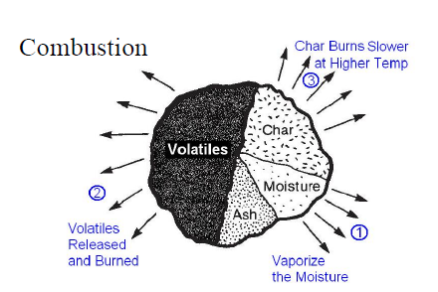
Fuel + Oxygen CO₂ + H₂O + N₂
---------------- = ------------------- + Heat
Products Reactants
Combustion is obviously an exothermic reaction; during combustion energy is released to the surroundings in the form of heat which can be used economically for industrial and domestic purposes.
Combustion refers to the rapid oxidation of fuel accompanied by the production of heat, or heat and light. Complete combustion of a fuel is possible only in the presence of an adequate supply of oxygen[2].
Nitrogen reduces combustion efficiency by absorbing heat from the comustion of fuels and siluting the flue gases. This reduces the heat available for trasfer through the heat exchange surfaces. Fig. 1 Simplified view of solid fuel
The objective of good combustion is to release all of the heat in the fuel. This is accomplished by controlling the “3T’s” of combustion which are:
- Temp. High enough to ignite & maintain ignition of fuel,
- Turbulence or intimate mixing of the fuel and oxygen, and
- Time sufficient for complete combustion.

Fig. 2 3 T’s of Combustion

III. BOILER PLANT
A boiler is an enclosed vessel that provides a means for combustion heat to be transferred into water until it becomes heated water or steam. The hot water or steam under pressure is then usable for transferring the heat to a process. Water is a useful and cheap medium for transferring heat to a process. When water is boiled into steam its volume increases about 1,600 times, producing a force that is almost as explosive as gunpowder. This causes the boiler to be extremely dangerous equipment that must be treated with utmost care.
The process of heating a liquid until it reaches its gaseous state is called evaporation. Heat is transferred from one body to another by means of (1) radiation, which is the transfer of heat from a hot body to a cold body without a conveying medium, (2) convection, the transfer of heat by a conveying medium, such as air or water and (3) conduction, transfer of heat by actual physical contact, molecule to molecule.
A Boiler is a main part or Heart of the various industries as well as power plant industries because the steam is the main blood for the working media for power plant industries or other various processes. So that Boiler is very important or most useful equipment.

III.1 Boiler Systems

The boiler system comprises of: feed water system, steam system and fuel system. The feed water system provides water to the boiler and regulates it automatically to meet the steam demand. The steam system collects and controls the steam produced in the boiler. Steam is directed through a piping system to the point of use. Throughout the system, steam pressure is regulated using valves and checked with steam pressure gauges. The fuel system includes all equipment used to provide fuel to generate the necessary heat. The equipment required in the fuel system depends on the type of fuel used in the system.
The water supplied to the boiler that is converted into steam is called feed water. The two sources of feed water are:
(1) Condensate or condensed steam returned from the processes and
(2) Makeup water which must come from outside the boiler room and plant processes. For higher boiler efficiencies, the feed water is preheated by economiser, using the waste heat in the flue gas.
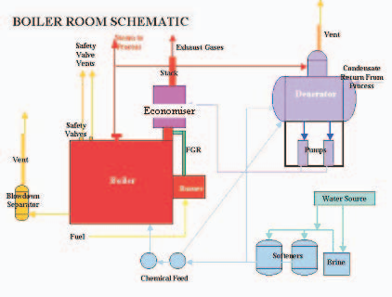

Figure 3 Boiler Room Schematic
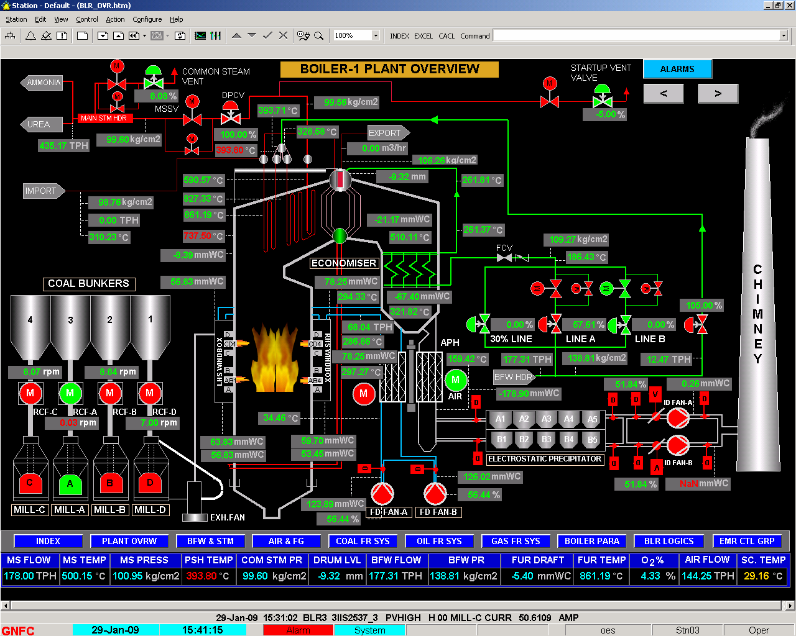
Figure 4. PLANT LAYOUT DIAGRAM OF CAPTIVE POWER PLANT

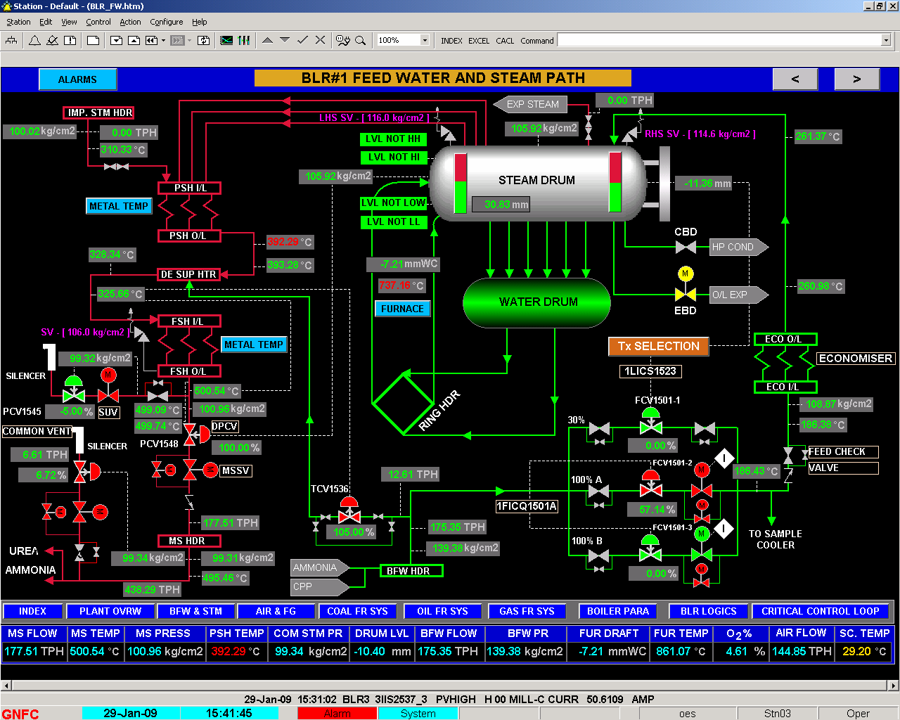

Figure 5. FEED WATER AND STEAM PATH

IV ANALYSIS METHODOLOGY
Difference in the steam generation and steam consumption is attributed to the loss of steam through steam trap, gland leakages and inaccuracies of the instruments. This difference is kept under the heading of unaccounted and leakages loss.
Following assumptions are made for present analysis
- Combustion products are treated as ideal gas.
- Combustion process in combustion chamber is complete.
- Kinetic & potential components of exergy are negligible.
- Losses in various pumping devices are not considered.

IV.1 ENERGY ANALYSIS:-
Performance of the boiler, like efficiency and evaporation ratio reduces with time, due to poor combustion, heat transfer fouling and poor operation and maintenance. Deterioration of fuel quality and water quality also leads to poor performance of boiler. Efficiency testing helps us to find out how far the boiler efficiency drifts away from the best efficiency. Any observed abnormal deviations could therefore be investigated to pinpoint the problem area for necessary corrective action. Hence it is necessary to find out the current level of efficiency for performance evaluation, which is a pre requisite for energy conservation action in industry.

Basically Boiler efficiency can be tested by Direct & Indirect method. Direct is old method which is simple and easy but losses are not identified at various stages of boiler system and it is not use now a days. Indirect method is also called as heat loss method. We can idenfified losses of various system and prevent them and increses the efficiency by decresses the losses. The efficiency can be arrived at, by subtracting the heat loss fractions from 100.
ASME Standard: PTC-4-1 Power Test Code for Steam Generating Units [3]
This consists of
- Part One: Direct method (also called as Input -output method)
- Part Two: Indirect method (also called as Heat loss method)
IS 8753: Indian Standard for Boiler Efficiency Testing
Most standards for computation of boiler efficiency, including IS 8753 and BS845 are designed for spot measurement of boiler efficiency. Invariably, all these standards do not include blow down as a loss in the efficiency determination process.
Basically Boiler efficiency can be tested by the following methods:
- The Direct Method: Where the energy gain of the working fluid (water and steam) is compared with the energy content of the boiler fuel.
- The Indirect Method: Where the efficiency is the difference between the losses and the energy input.

IV.1.2 The Direct Method Testing

The Direct method is old method and is considered as a standard. This is also known as 'input-output method' due to the fact that it needs only the useful output (steam) and the heat input (i.e. fuel) for evaluating the efficiency. This efficiency can be evaluated using the formula:

Figure 6 Direct Method Testing

Parameters to be monitored for the calculation of boiler efficiency by direct method are:

- Quantity of steam generated per hour (Q) in kg/hr.
- Quantity of fuel used per hour (q) in kg/hr.
- The working pressure (in bar) and superheat temperature (K), if any
- The temperature of feed water (K)
- Type of fuel & gross calorific value of the fuel (GCV) in kJ/kg of fuel

Where, hg – Enthalpy of saturated steam in kJ/kg of steam, hf – Enthalpy of feed water in kJ/kg of water

IV.1.3. The Indirect Method Testing

The efficiency can be measured easily by measuring all the losses occurring in the boilers using the principles to be described. The disadvantages of the direct method can be overcome by this method, which calculates the various heat losses associated with boiler. The efficiency can be arrived at, by subtracting the heat loss fractions from 100. An important advantage of this method is that the errors in measurement do not make significant change in efficiency.
Thus if boiler efficiency is 90% , an error of 1% in direct method will result in significant change in efficiency. i.e. 90 ± 0.9 = 89.1 to 90.9. In indirect method, 1% error in measurement of losses will result inEfficiency = 100 - (10 ± 0.1) = 90 ± 0.1 = 89.9 to 90.1.
Indirect method is also called as heat loss method. The efficiency can be arrived at, by subtracting the heat loss fractions from 100. The standards do not include blow down loss in the efficiency determination process. A detailed procedure for calculating boiler efficiency by indirect method is given below.

Figure 7 The Indirect Method Testing

However, it may be noted that the practicing energy mangers in industries prefer simpler calculation procedures.
The following losses are applicable to liquid, gas and solid fired boiler

- L1 - Loss due to dry flue gas (sensible heat)
- L2 - Loss due to hydrogen in fuel (H₂)
- L3 - Loss due to moisture in fuel (H₂O)
- L4 - Loss due to moisture in air (H₂O)
- L5 - Loss due to carbon monoxide (CO)
- L6 - Loss due to surface radiation, convection and other unaccounted*.
*Losses which are insignificant and are difficult to measure.

The following losses are applicable to solid fuel fired boiler in addition to above

- L7 - Unburnt losses in fly ash (Carbon)
- L8 - Unburnt losses in bottom ash (Carbon)

Boiler Efficiency by indirect method = 100 - (L1 + L2 + L3 + L4 + L5 + L6 + L7 + L8)
In the above, loss due to moisture in the fuel and the loss due to combustion of hydrogen are dependent on the fuel, and cannot be controlled by design.

The data required for calculation of boiler efficiency using indirect method are:
- Ultimate analysis of fuel (H2, O2, S, C, moisture content, ash content)
- Percentage of Oxygen or CO2 in the flue gas
- Flue gas temperature in °K (Tf)
- Ambient temperature in °K (Ta) & humidity of air in kg/kg of dry air
- GCV of fuel in kJ/kg
- Percentage combustible in ash (in case of solid fuels)
- GCV of ash in kJ/kg (in case of solid fuels)

V EXERGY ANALYSIS:-
The exergy [4] analysis of boiler plant is carried out in order to find out the lost work. i.e. the difference in exergy supplied and exergy output is the lost work of the system or component.
The basic Exergy equation for one kg substance in flowing open systems, disregarding kinetic and potential exergy terms is as follows:
Ex = (H – H₀) – T₀ (S – S₀)

Often a subdivision into physical, chemical and mixing exergy is made. In calculating the exergy flow, the exergy terms are multiplied by the flow:

Ex_{Total} = m (Ex_{Chem} + Ex_{Phys} + ∆Ex_{Mix})

For calculating the exergy, each exergy term has to be calculated separately.
Hence from ‘Kotas’[11] for dry organic substance contained in solid fuels consisting of C, H, O, and N, with a mass ratio of oxygen to carbon less than 0.667, the following expression was obtained in terms of mass ratios.

Φ_{dry} = 1.0437 + 0.1882 x (h/c) + 0.0610 x (o/c) + 0.0404 x (n/c)

Where c, h, o, and n are the mass fractions of C, H, O, and N respectively. Within the restriction regarding the upper limit of o/c, is applicable to a wide range of industrial solid fuels but not to wood. The accuracy of the expression is estimated to be better than ±1%.

For the fossil fuels with the mass ratio 2.67 > o/c > 0.667, which in particular, includes wood.

1.0438 + 0.1882 x (h/c) - 0.2509[1 + 0.7256 x (h/c) - 0.0383 x (n/c)]
Φ_{dry} = ---------------------------------------------------------------------------------------
1- 0.3035 x (o/c)

For liquid fuels the effect of sulphur was included in the correlation giving the expression:

Φ = 1.0401 + 0.1728 x (h/c) + 0.0432 x (o/c) + 0.2169 x (s/c) x [1- 2.0628 x (h/c)]

Hence the Φ is the ratio of chemical exergy to the calorific value of a fuel. The significance of Φ is that, it is assumed that Φ is same for the fuel and a pure chemical substance having the same ratios of constituent chemicals as that of fuel.
Now Chemical Exergy is given as

ε⁰ = [ Calorific value (kJ/kg) + 2442 x (Moisture)] x Φ + 9417 x Sulphur

V.1 EXERGY ANALYSIS OF THE BOILER:

Here, assuming that the boiler consists of a number of regions as shown in figure.
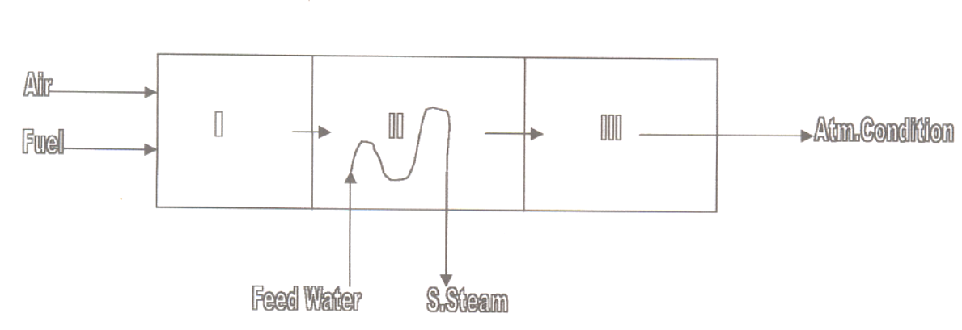

Figure 8 Boiler Sub Regions

Here different sub regions are as follows,

Sub Region I Combustion Chamber
Sub Region II Heat Transfer to Water
Sub Region III Flue gas mixing with atmosphere

V.1.1 Analysis of Sub Region I:
Air and fuel enters this sub region at atmospheric condition. Fuel is burned and combustion gases are produced in this sub region. The exhausts of this region are the combustion gases. The combustion gases are used to heat up water in the sub region II. The control volume used for analyzing this region is shown in figure.

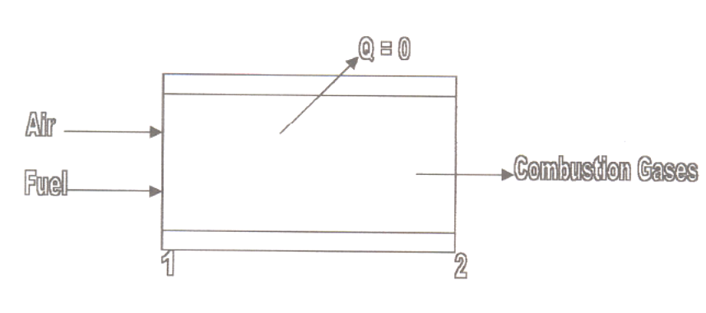

Figure 9 Sub Region I

Here, assuming that the combustion process is adiabatic.
Since air enters this sub region at atmospheric conditions so we get,
T₁ = T₀
, P₁ = P₀
Employing energy balance between Section 1 and Section 2 so,

m_{Fuel} x GCV = (θ₂ – θ₁) Σ n Cp^{h}
where
n = No of moles
Cp^{h} = Molar specific heat of gas.
In this equation θ₂ is unknown and hence Cp^{h} is also unknown (it is a function of temperature). Now value of θ₂ finding out by iteration method and for Cp^{h} use table in the Annexure IV.
Exergy balance in the sub region I gives
I₁ = Ex₁ - Ex₂

Where, Ex₁ = Ex_{Fuel} + Ex_{Air,} Ex₁ = Ex_{Fuel}
Since, Ex_{Air} = 0

Ex₂ = n_{p2} x ε_{p2}⁰ + Σ n ε_{p}^{h}

Now, ε_{p2}⁰ = Σ X_{K} ε⁰_{k} + R T₀ Σ X_{K} lnX_{K}

Σ n ε_{p}^{h} = (θ₂ - θ₀) Σ n Cp^{ε}

And, Ex₁ = m_{Fuel} x ε⁰_{Fuel}

Hence irreversibility of Sub Region is

I₁ = Ex₁ - Ex₂

So, the 2nd law efficiency of region I is

η₂nd_{law} = (Ex₂ / Ex₁) x 100%

V1.1.2Analysis of Sub Region II:

The product of combustion coming out from combustion chamber is used to heat up the feed water. This heat transfer produces steam. This region of heat transfer from combustion product to feed water is the sub region II. This sub region is main part of boiler. Here super heating steam is produce for turbine work and process work. The control volume used for analyzing this region is shown in figure.

Figure 10 Sub Region II
To find the heat lost Q_{L} from the boiler, energy balance of the sub region II.
H₂ + h_{FW} m_{FW} = H₃ + m_{s} h_{s} + Q_{L}
Where, H₂ = Enthalpy of incoming combustion product
H₃ = Enthalpy of flue gas
Q_{L} = Heat Lost
h_{FW} = Specific enthalpy of feed water
m_{FW} = Mass of feed water
h_{S} = Specific enthalpy of super heating steam
m_{S} = Mass of super heating steam
Now, H₂ = (θ₂ - θ₀) Σ n Cp^{h}
And, H₃ = (θ₃ - θ₀) Σ n Cp^{h}

Now Exergy Balance,
Ex₂ + Ex_{FW} = Ex₃ + Ex_{S} + I₂

Irreversibility,
I₂ = (Ex₂ - Ex₃) – (Ex_{S} - Ex_{FW})

Where, Ex₃ = Ex₃⁰ + Ex_{ph3}
Ex₃⁰ = Ex₂⁰ = Chemical Exergy of gases.
Ex_{ph3} = Physical Exergy at Temperature θ₃
= (θ₃ - θ₀) Σ n Cp^{ε}
Hence the efficiency of the sub region II

η₂nd_{law} = [(Ex_{S} - Ex_{FW}) / Ex₂] x 100%

V.1.1.3 Analysis of Sub Region III

In this sub region the flue gases mix with atmosphere. So the exergy of the flue gases coming out from the boiler is entirely lost as irreversibility.
So, Irreversibility I₃ = Ex₃
Hence the rational efficiency of the boiler is
ψ = [(Ex_{S} - Ex_{FW}) / Ex₁] x 100%
A short calculation of flue gas exergy will be provided based upon certain assumptions. Fuel used in calculation is Bagsse with standard composition which is given in Data. Combustion is complete with 50% of air excess and outgoing flue gas temperature is 151 ⁰C.
- Chemical composition as per data
- Stoichiometric air to fuel ratio: λ = 5.59 : 1 (Total mass of air supplied = 5.59 which is calculated in Energy analysis)
- Flue gas temperature: θ_{fg} = 151 ⁰C
- Lower heating value:

- Stoichiometric air quantity:

- Flue gas composition: n_{fg} = n_{CO2} + n_{H2O} + n_{SO2} + n_{N2} + n_{O2}
- Flue gas mole mass and mole heat capacity:

[C_{mp fg}] ₀¹⁵¹ = n_{CO2} [C_{mpCO2}] ₀¹⁵¹ + n_{H2O} [C_{mpH2O}] ₀¹⁵¹ + n_{SO2} [C_{mpSO2}] ₀¹⁵¹ + n_{N2} [C_{mpN2}] ₀¹⁵¹ + n_{O2} [C_{mpO2}] ₀¹⁵¹ -------------------------------------------------------------------------------------------------------------------
n_{fg}
- Fuel mass flow rate:
q_{mF} = [m_{s} (h_{S} – h_{W})] / [∆h_{L} – (n_{fg} [C_{mp fg}] ₀¹⁵¹ θ_{fg})]

VI RESULTS AND DISCUSSIONS

The energetic analysis done on different fuel used in boiler and find out various losses or heat losses in indirect method analysis as follow on table.
Table 3 Energetic Efficiency of Various fuel used in Boiler
Fuel | L1 | L2 | L3 | L4 | L5 | L6 | L7 | L8 | Total | Efficiency
Indian Coal | 5.91 | 3.66 | 2.39 | 0.17 | 2.58 | 0.46 | 1.77 | 6.52 | 23.46 | 76.54
Imported Coal | 5.58 | 3.78 | 1.52 | 0.16 | 2.421 | 0.33 | 0.68 | 2.5 | 16.97 | 83.03
(60% Imp + 40% Ind) coal | 5.85 | 3.94 | 1.8 | 0.17 | 2.54 | 0.37 | 1.01 | 3.72 | 19.4 | 80.60
LSHS Oil | 5.28 | 5.95 | 0.024 | 0.247 | - | 0.307 | - | - | 11.80 | 88.20
Bagasse | 0.75 | 1.09 | 15.00 | 4.5 | 0.38 | 1.8 | 0.36 | 0.08 | 23.96 | 76.04

Table 4 Heat Losses in Various Fuels used in Boiler (kJ/kg of fuel)
Fuel | L1 | L2 | L3 | L4 | L5 | L6 | L7 | L8 | Total | Heat  Input | Available Heat | %
Indian Coal | 827.1 | 512.2 | 334.4 | 23.7 | 361.0 | 64.3 | 247.6 | 912.4 | 3283.06 | 13995.47 | 10712.41 | 76.54
Imported Coal | 1062.6 | 719.6 | 289.3 | 30.13 | 460.8 | 62.8 | 129.5 | 476.07 | 3231.75 | 19043.99 | 15812.24 | 83.03
(60% Imp + 40% Ind) coal | 995.84 | 670.7 | 306.5 | 28.88 | 432.4 | 62.8 | 171.9 | 633.04 | 3302.75 | 17024.62 | 13721.83 | 80.60
LSHS Oil | 2342.9 | 2640.1 | 10.5 | 109.25 | - | 136 | - | - | 5239.19 | 44371.6 | 39132.23 | 88.20
Bagasse | 135.9 | 197.4 | 2715.00 | 814.5 | 69.25 | 329.8 | 65.16 | 13.58 | 4336.63 | 18100 | 13763..4 | 76.04

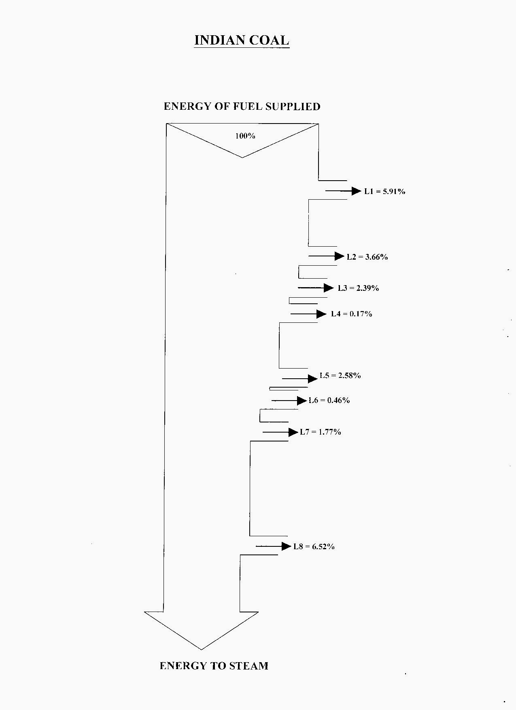
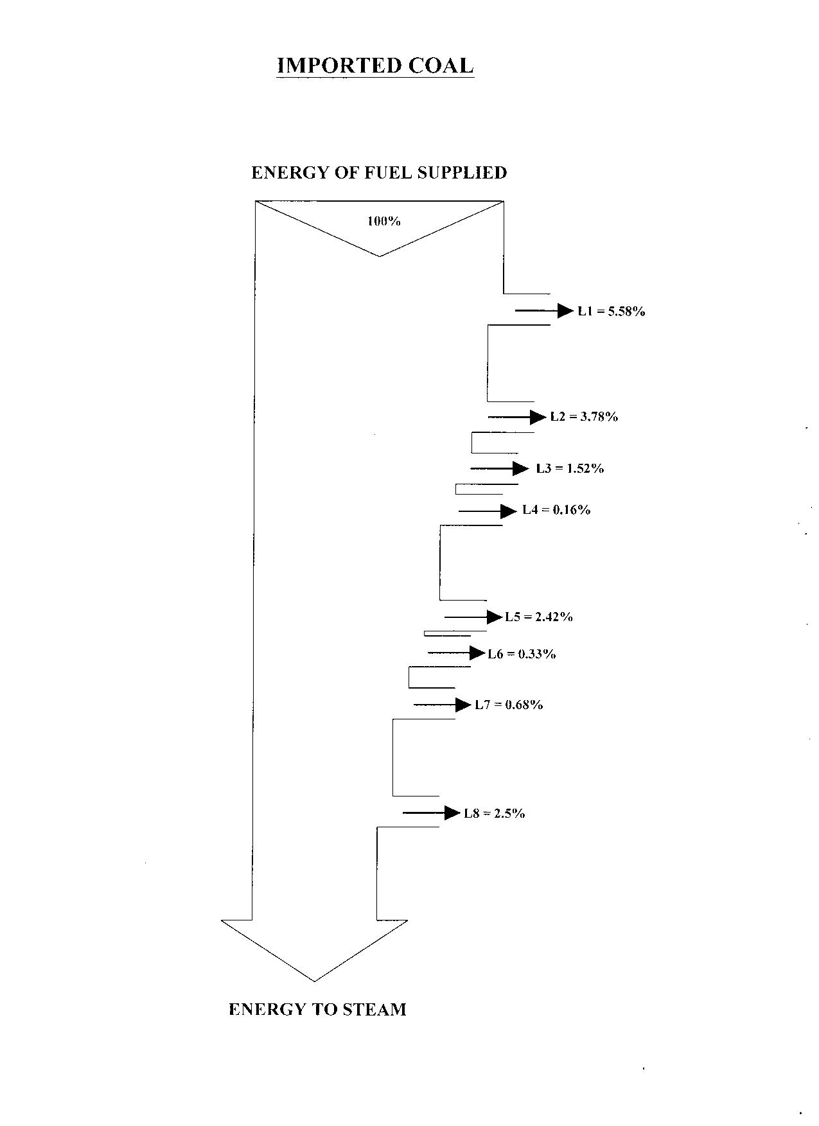
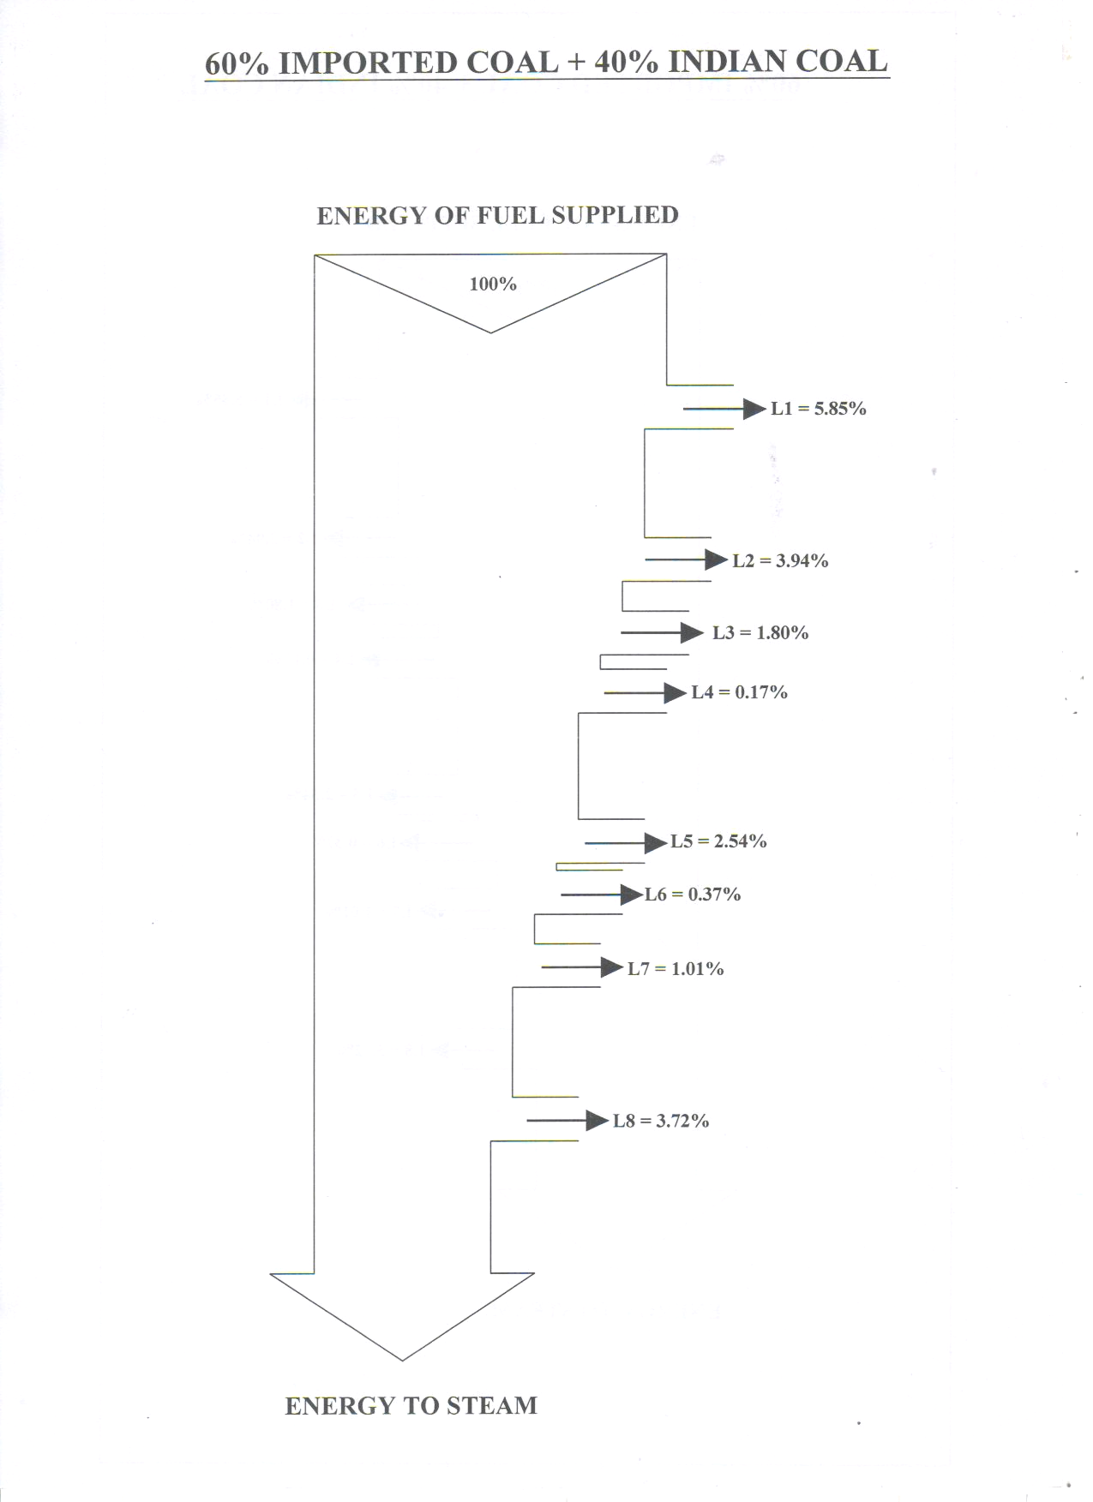

Fig. 10 Sankey Diagrams for Energy Analysis

Table 5 Exergetic Efficiency of Various fuel used in Boiler
 | Sub Region |  |  | Combustion Efficiency η_{comb}
Fuel | I | II | III  (Rational efficiency) | Combustion Efficiency η_{comb}
Indian Coal | 73.43 | 55.70 | 37.00 | 85.24
Imported Coal | 73.70 | 55.78 | 37.70 | 84.90
(60% Imp + 40% Ind) coal | 73.55 | 55.73 | 37.80 | 84.40
LSHS Oil | 76.41 | 62.13 | 40.10 | 90.20

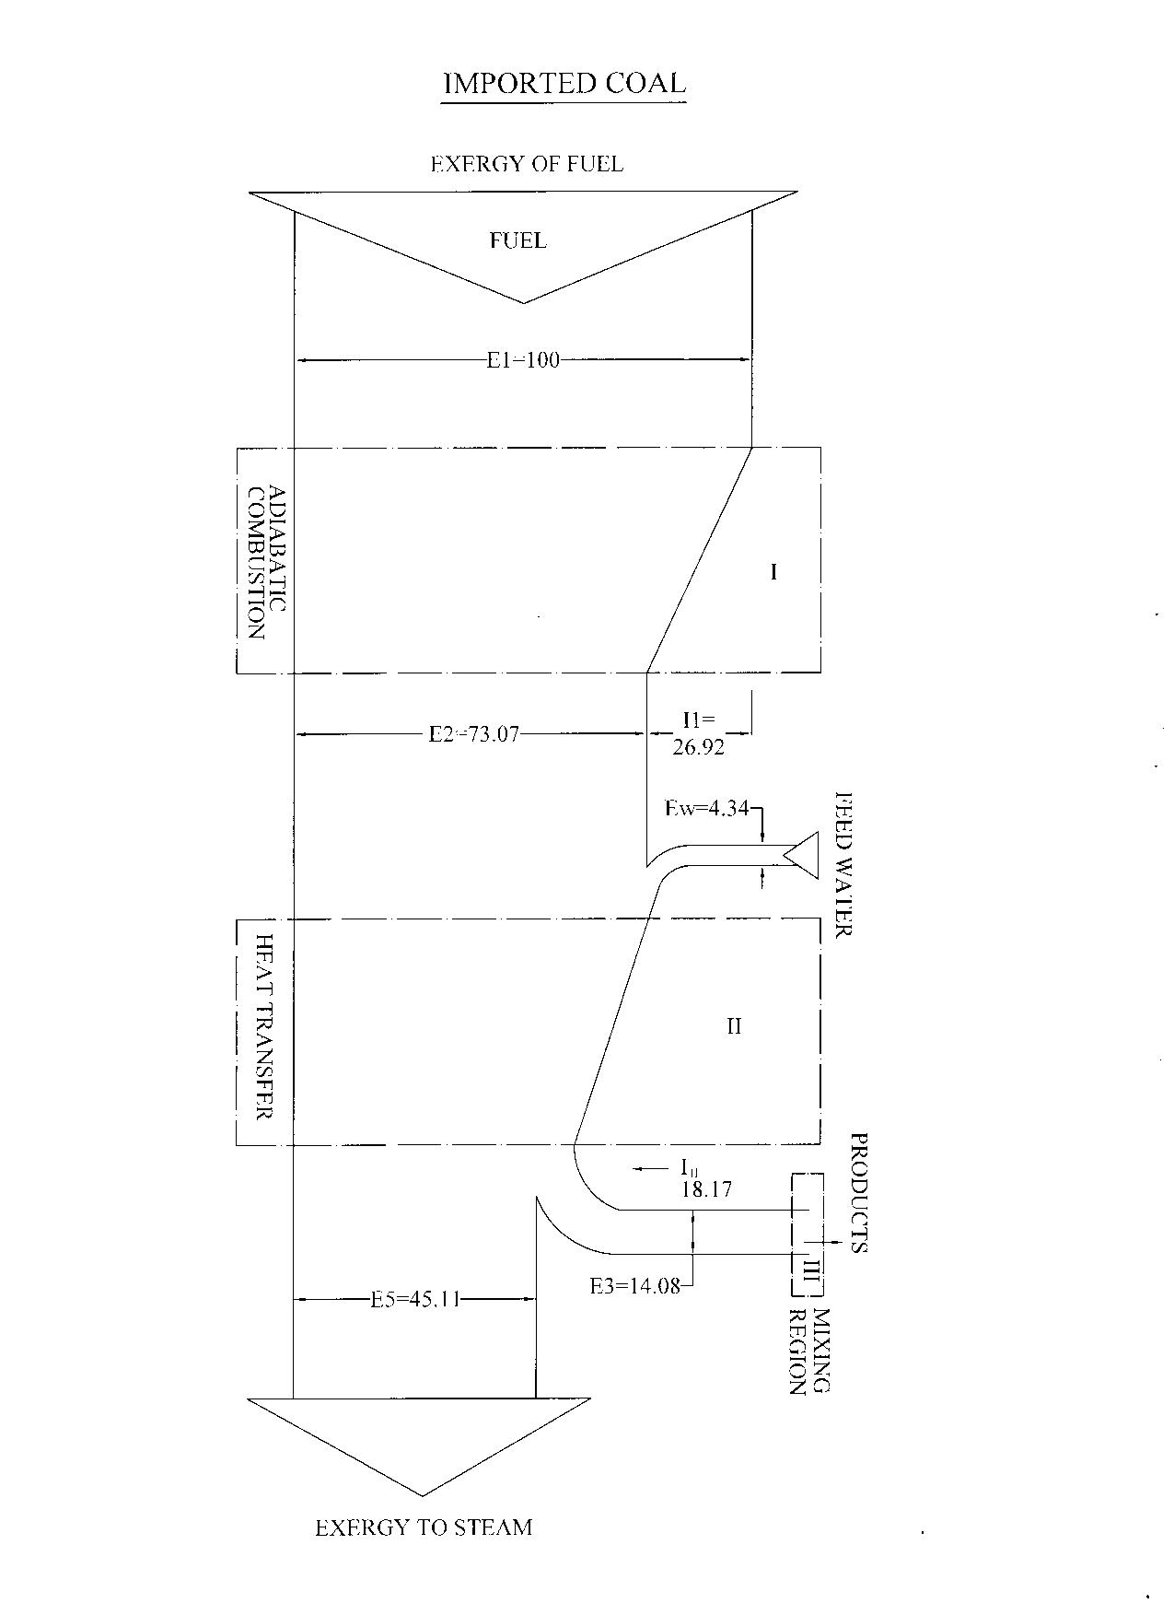
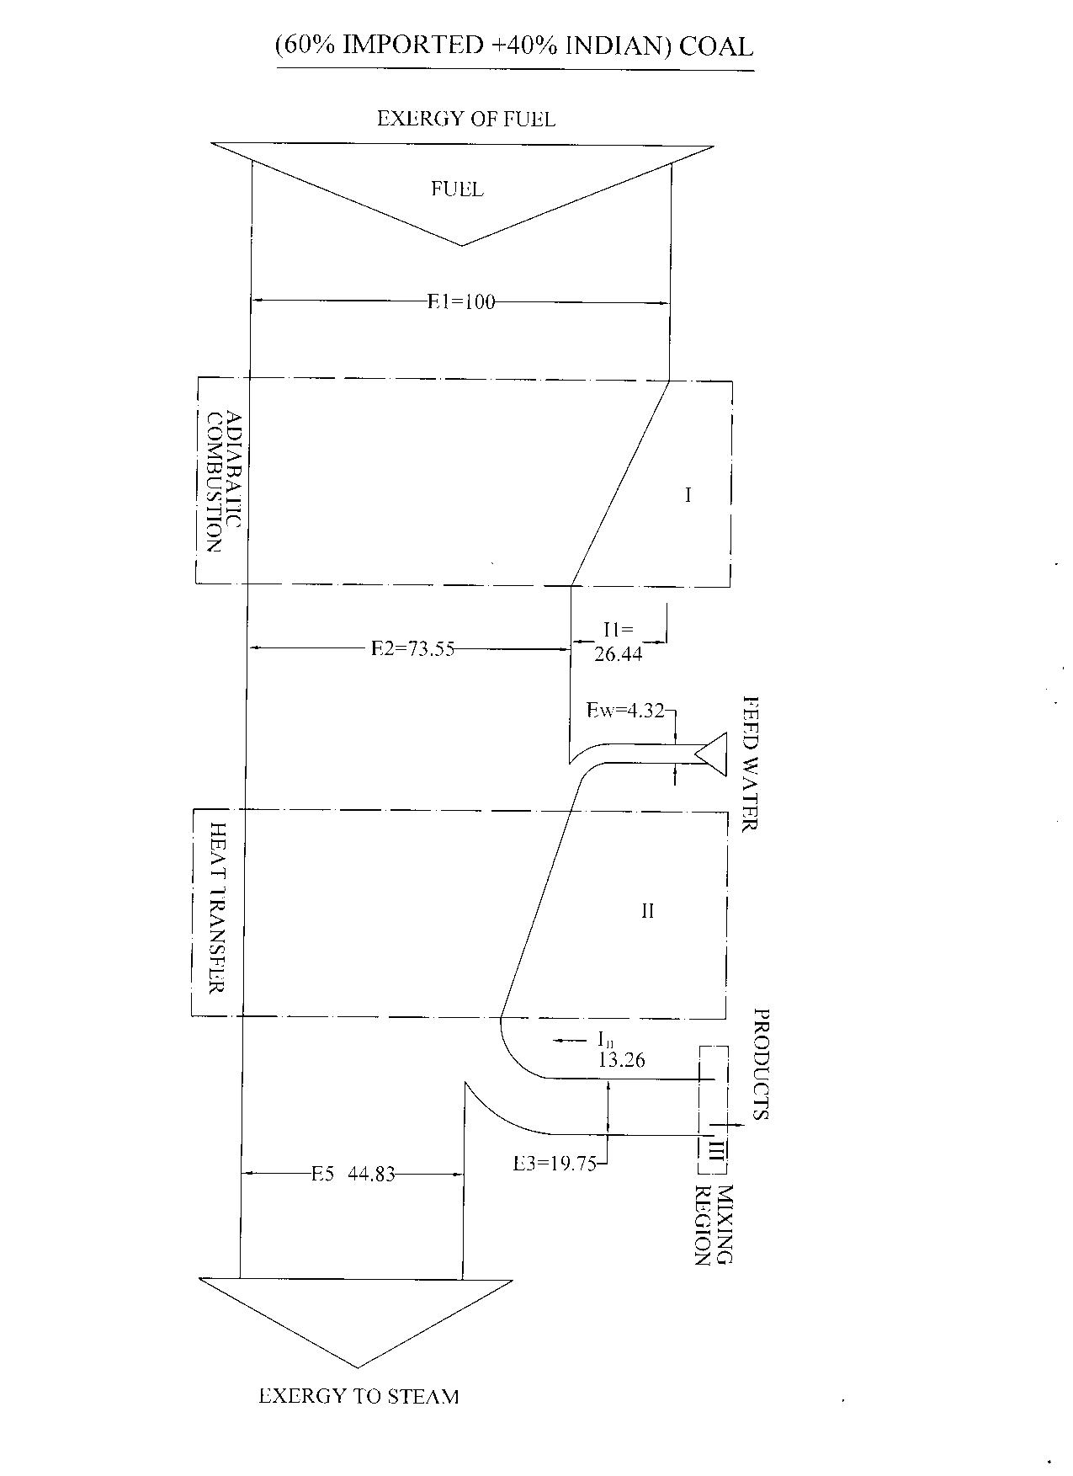
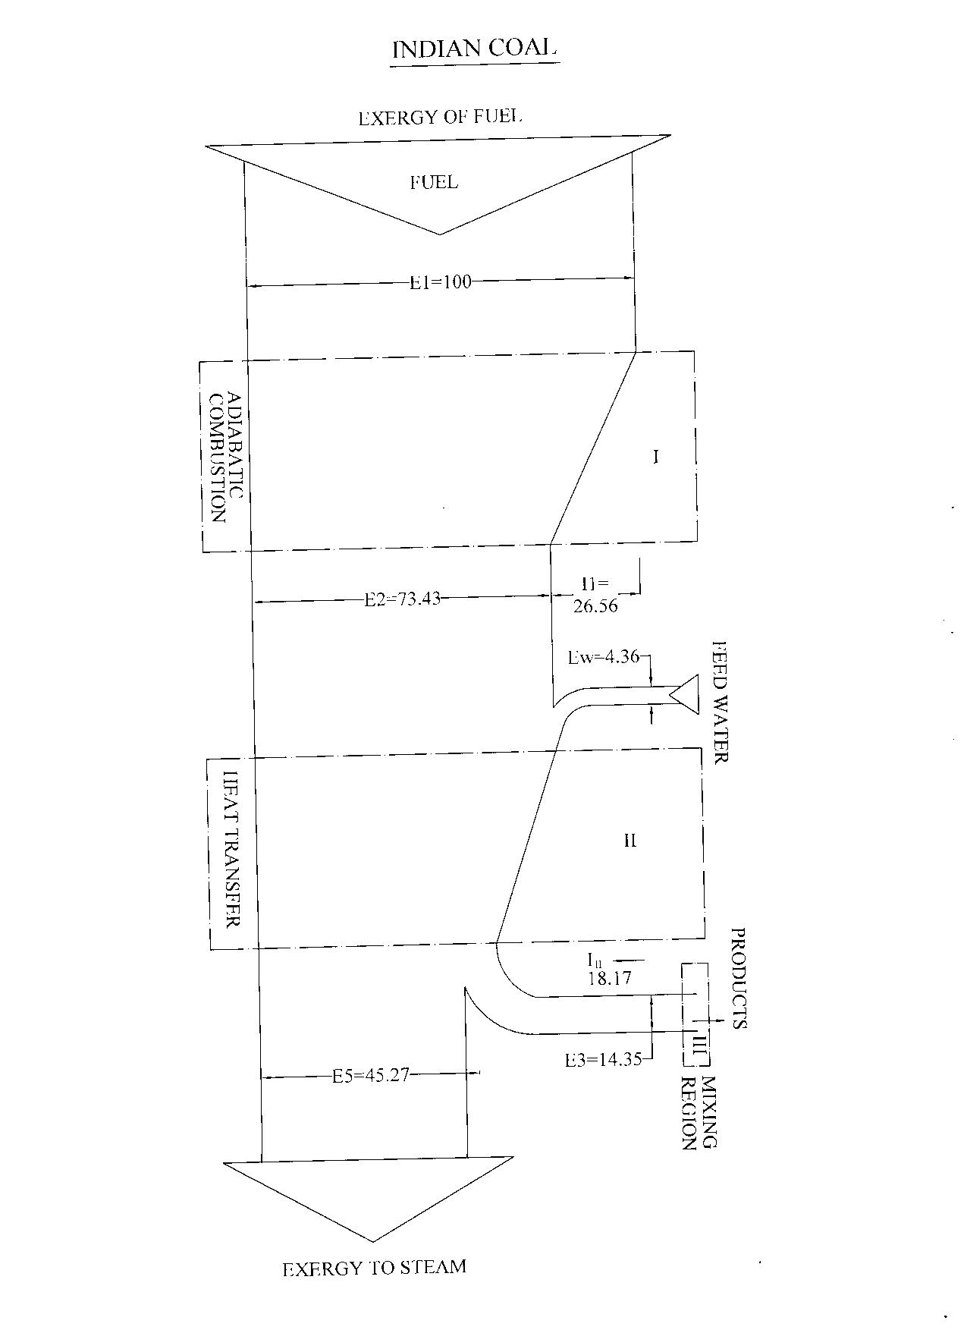

Fig. 11 Grassman Diagrams for Exergey Analysis

Energetic efficiency of the Boiler is calculated after finding out the various losses, which take place in a Boiler. First law analysis shows the efficiency of Bagasse and Lignite coal fired Boiler is gives the energy distribution and losses of various thermodynamic states of Boiler with various fuels used as below table due to economic use of fuel in boiler for different content of mixing with other fuel following result is found for (40% Bagasse + 60 % Indian Coal Lignite) is give better for economic steam generation.

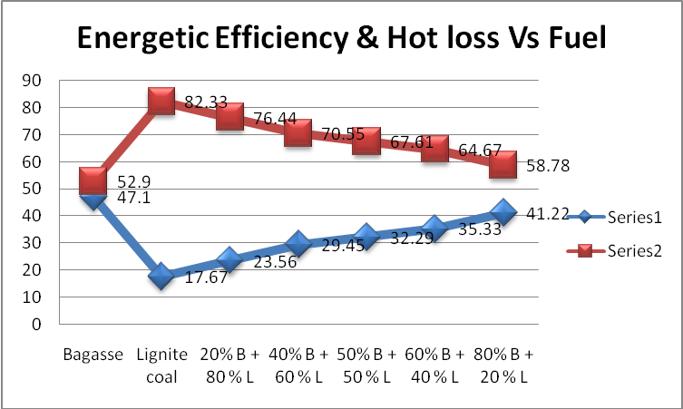
TABLE 6 Energetic Efficiency of fuel used in Boiler
SR  NO | FUEL | TOTAL  LOSS | EFFICIENCY
1 | Bagasse | 47.1 | 52.90
2 | Lignite coal | 17.67 | 82.33
3 | 20% B + 80 % L | 23.56 | 76.44
4 | 40% B + 60 % L | 29.45 | 70.55
5 | 50% B + 50 % L | 32.29 | 67.61
6 | 60% B + 40 % L | 35.33 | 64.67
7 | 80% B + 20 % L | 41.22 | 58.78
Fig. 12 Energetic Efficiency & total loss vs fuel

Exergetic analysis the rational efficiency of this plant takes into account destruction includes the physical and chemical exergy during combustion of fuel in presence of air. In the 2nd law analysis the maximum loss of exergy is while converting the chemical energy of fuel to that in to heat energy. This is due to the high production of entropy during the process of conversion.
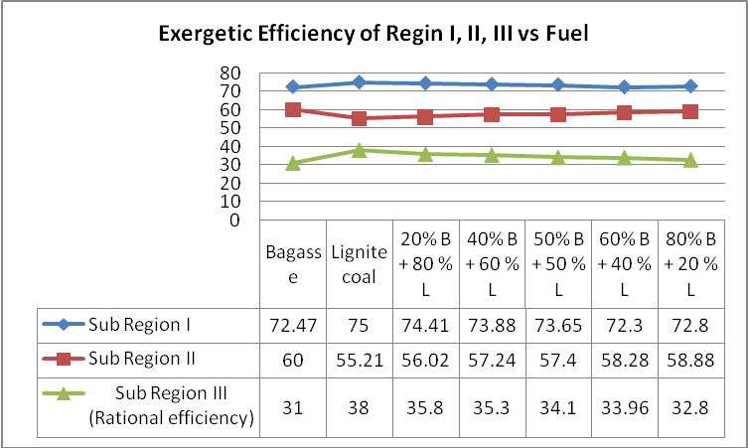
TABLE 7 Exergetic Efficiency of fuel used in Boiler
Fig. 13 Exergetic Efficiency of Region I, II & III vs Fuel
Sr  No | Fuel | Sub Region
Sr  No | Fuel | I | II | III  (Rational efficiency)
1 | Bagasse | 72.47 | 60.00 | 31.00
2 | Lignite coal | 75.00 | 55.21 | 38.00
3 | 20% B + 80 % L | 74.41 | 56.02 | 35.80
4 | 40% B + 60 % L | 73.88 | 57.24 | 35.30
5 | 50% B + 50 % L | 73.65 | 57.40 | 34.10
6 | 60% B + 40 % L | 72.30 | 58.28 | 33.96
7 | 80% B + 20 % L | 72.80 | 58.88 | 32.80

CONCLUSIONS AND RECOMMENDATIONS
The following conclusions are drawn from the energy and exergy analysis of the Boiler plant of G.N.F.C., BHRUCH.
- From the energy and the exergy analysis of the Boiler Plant (Indian coal as a fuel), it is seen that the energy analysis attributes all the inefficiencies to losses as 23.46%. The first law efficiency of the Boiler plant is 76.54%, while the Exergetic efficiency of the plant is 37.00%.
- One can see that there is a huge difference between the first law efficiency and second law efficiency of the Boiler plant such as 76.54% and 37.00% respectively. This is due to large amount of energy degradation. This degradation of energy increases the entropy and hence a decrease in the exergy or second law efficiency.
- So the mixing with different fuels with bagasse at varous content and try to produce steam genration in boiler at economic rate for (40% Bagasse + 60 % Lignite) but some of effeciencey is not achieve maximum rate. So current now a days economically tryit for productio of steam.
- After completion of combustion process of bagasse, ash is mostly use for the raw material of the Brick and Cement manufacturing so pollution is also reduce and complete the cycle of environment. This is due to large amount of energy degradation. This degradation of energy increases the entropy and hence a decrease in the exergy or second law efficiency.
- Second law analysis indicates the destruction of exergy of various components of the Boiler plant. Therefore to increase second law efficiency (Exergetic efficiency is 37.00%) of the plant attempt should be made to reduce the destruction of exergy as far as possible.
- In general operating the boiler at proper air – fuel ratio, supplying fuel – air mixture at higher temperature use of suitable combustion catalyst selection of appropriate size of coal, proper insulation, reduction in steam and gland leakages and adoption of absorption cooling to utilize heat of condensing steam may help in improving over all energetic and exergetic efficiency of the plant.
- To increases boiler efficiency by 1% to reduce temperature of flue gas at 22 ⁰ C so that preheat combustion of air with waste heat. Improve oxygen trim control (e.g. limit excess air to less than 10% on clean fuels). 5% reduction in excess air increases boiler efficiency by 1% or 1% reduction of residual oxygen in stack gas increases boiler efficiency by 1%. And also 6 ⁰C raise in feed water temperature by economizer recovery corresponds to a 1% saving in fuel consumption, in boiler.
REFERENCES

[1] General Manual for Operating Boiler plant, GNFC
[2] Energy & Exergy analysis of a boiler with different fuels like Indian coal, Imported coal & L.S.H. S. oil, M.E. Thesis, MSU Baroda-2009 and 1st National TFMS-2012 CKPECT SURAT by Ketan T. Patel.’
[3] Energy efficiency in Thermal Utilities by B.E.E. (Bureau of Energy Efficiency), www.bee-india.nic.in
[4] Kotas, T. J. : ‘The energy method of Thermal Plant Analysis,’ Butter Worths, London, 1985.
[5] Energetic and Exergetic Analysis of Bagasse & coal fired Boiler use in Textile Process Plant,
IJMTER 2016.
[6] Efficient use of Electricity : ‘ Devki Energy Consultant.’

