

ISSN 2063-5346

A FIBRE BASE WASTE FISHNET SHEET REPLACEMENT WITH ASBESTOS

# Mr. Yogesh Pawar, Prof. Jayant Patil , Dr. Sahil Salvi

## 1Lecturer in Civil Engineering Government Polytechnic, Ratnagiri, Maharashtra, India.

2Assistant Professor, Department of Civil Engineering, Ashokrao Mane Group of Institutions, Kolhapur Maharashtra, India.

## 3Assistant Professor, Department of Civil Engineering, Pimpri Chinchwad Collage of Engineering and Research, Pune, Maharashtra India.

**Article History: Received:** 02.04.2023 **Revised:** 20.05.2023 **Accepted:** 22.06.2023

# Abstract

## Using fishnet as reinforcement in cement mortar sheets is one possibility. In a preliminary analysis, the mechanical characteristics of mortar with nylon fishnet reinforcement are assessed. Waste nylon fishnet is employed in this study as mortar reinforcement. The compressive strength of mortar has decreased as a result of the addition of nylon fishnet. Also, the adding together of nylon based fishnet enhances several mortar qualities, such as its capacity to support a load. The sheet reinforced with fishnet is cheap and eco-friendly. Even though more research is required, it looks that using nylon fishnet as reinforcement could improve load carrying capacity and flexural strength.

### INTRODUCTION

As an alternative to cement sheets made of asbestos, this fishnet-reinforced sheet uses fishnet as its reinforcement. Since fishnet is an elastic material, the stress that develops when a load is placed on the sheet doesn't go above the permitted stress. When under operating load conditions, the stress and strain are linear. The issue at hand revolves around the disposal of waste fishnets, which are commonly discarded in oceans and water bodies, posing a significant threat to marine life and ecosystems (Natarajan et al. 2022). Additionally, the use of asbestos, a known carcinogen, has been a cause for concern due to its detrimental health effects on humans when inhaled or ingested. However, the good news is that researchers and manufacturers (Sanjeev Salvi et al. 2021) have been actively working towards developing a sustainable replacement for fishnet sheets, without the use of asbestos. One promising alternative is a fiber-based material derived from recycled plastics and other environmentally friendly components (Mr Sahil Sanjeev Salvi 2020).

These fiber-based waste fishnet sheets offer several advantages over traditional fishnet materials. Firstly, they help combat marine pollution by utilizing discarded plastic waste as a raw material, thereby reducing the overall environmental impact. By repurposing and recycling plastics, this innovative solution contributes to waste reduction and promotes a circular economy (Sabale et al. 2023). Secondly, the fiber-based material is designed to be durable and long-lasting, ensuring it can withstand harsh marine conditions. This characteristic extends the lifespan of the replacement sheets, reducing the need for frequent replacements and decreasing resource consumption

.

Moreover, the absence of asbestos in these fiber- based alternatives eliminates the health risks associated with exposure to the hazardous mineral. This aspect is of paramount importance in ensuring the safety and well-being of workers involved in the production, installation, and maintenance of fishnet sheets (Salvi 2017).

### About Nylon: -

#### The synthetic fibre nylon is produced from fuel. It was created in the 1930s as a silk substitute. Nylon is prized for its light heaviness, extraordinary tensile strong point, longevity, and damage resistance. It degrades at a very gradual rate. Strong and lightweight synthetic fibre is nylon. An amine and an acid chloride are polymerised to create nylon thread. Two immiscible liquids' interface is

where the thread is lifted. Wallace Carothers invited the creation of nylon on February 28, 1935. Many synthetic fabrics are made with nylon fibres, and solid nylon is utilised in engineering.

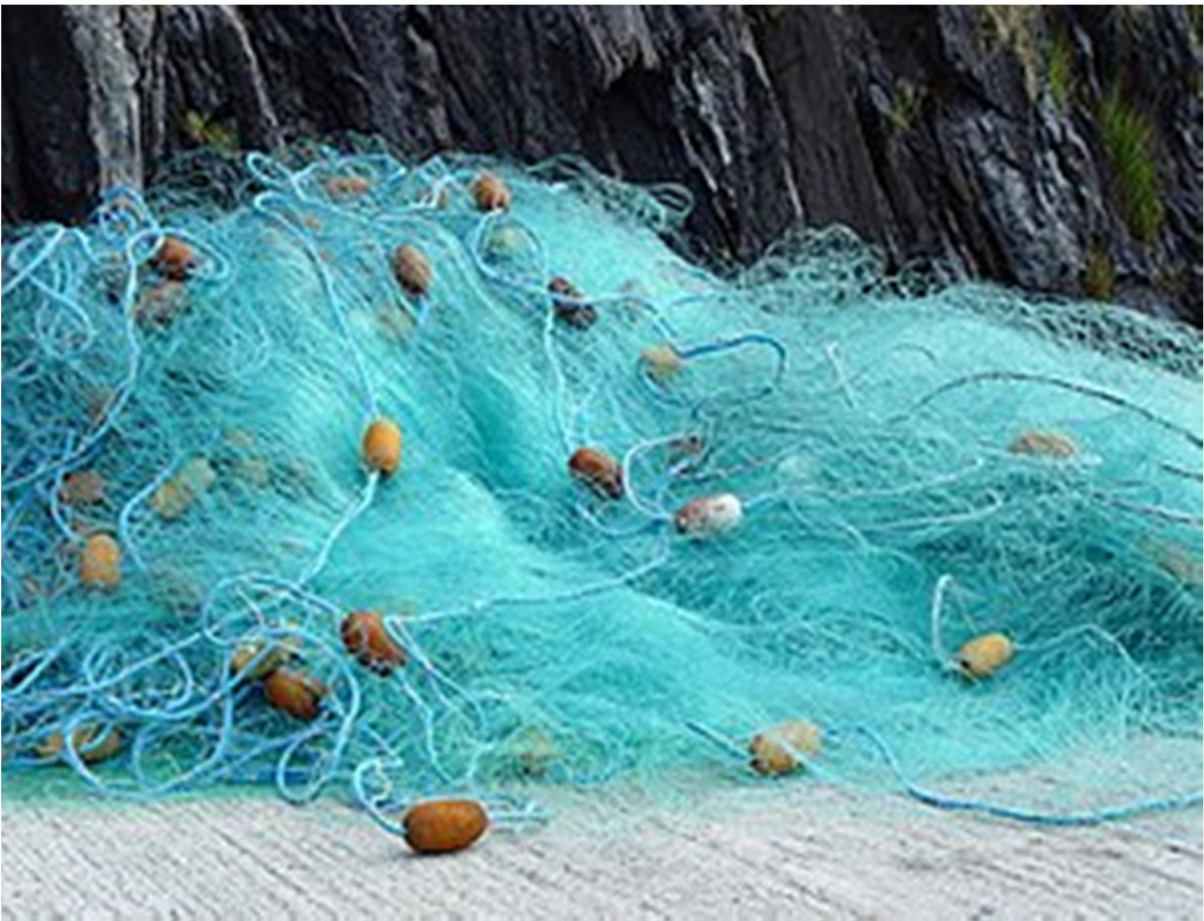

### Selection of Materials

* Current research, we created a Fishnet sheet to serve as an asbestos cement sheet substitute.
* Also, we made a fishnet sheet sample. In the beginning, we choose materials like cement, fine agregate, and course aggregate and substituted them with earth, brick residue, black cotton earth, etc. We then performed various tests on it, like compression tests, and analysed the results to find that fishnet sheet is ineffective in terms of strength or load carrying parameters.
* In order to address this issue, we changed the materials, prepared the prototype once more, and conducted the test again. Upon analysing the results, we discovered that the fishnet sheet is moderately providing better results.

### MATERIAL REQURIMENT

The following list includes various materials used in experimental research:

1. Cement: To prepare concrete, OPC 43 grade cement with initial setting times of 39 minutes and final settings of 432 minutes is used. Other physical and chemical characteristics of cement, such as its soundness, specific gravity, lime content, alumina content, and magnesia content, are those reported by the supplier.
2. Water: Organic, inorganic, and chemical contaminants such as sulphates, chloride, and other contaminants must be kept to a minimum in water used for cement mixing and curing. This is where municipal corporation-supplied potable water or fresh water from lakes and rivers are found to be satisfactory.

#### Fine gravel: Sand for fine aggregate is purchased from a local vendor. Sand's sieve analysis reveals that it complies with Zone-II of the IS code (IS 383). To make sure it's

devoid of organic matter, etc., the sand is examined.

1. **RESULTS AND DISCUSSIONS** When nylon fibres and water are combined to make cement concrete, it has been observed that the fibres tend to form a number of small lumps and are not distributed evenly. To achieve a uniform consistency of fibres in cement concrete, these lumps must be broken up and thoroughly mixed. This section provides the outcomes of experimental tests conducted on the various mixes listed in Table
2. The split tensile strength is also provided because fibres of all kinds are known to increase tensile strength.

##### Workability:

Table 2 displays the findings from slump tests conducted on various mixes. It was discovered that concrete with a high fibre content of 1% to 1.5% forms lumps and segregates, creating harsh concrete.

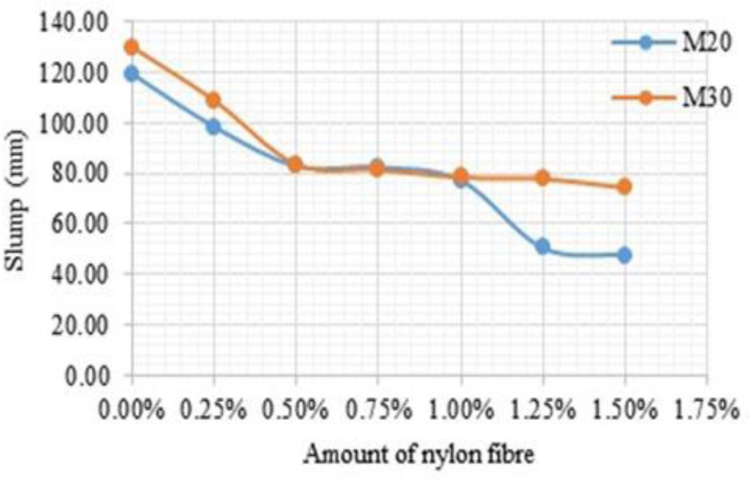

##### Compressive Strength:

Table 3 displays the results for mixes' compressive strength. Figures 3 and 4 show the results of the compressive strength tests performed on M20 and M30 concrete at 7 and 28 days, respectively.

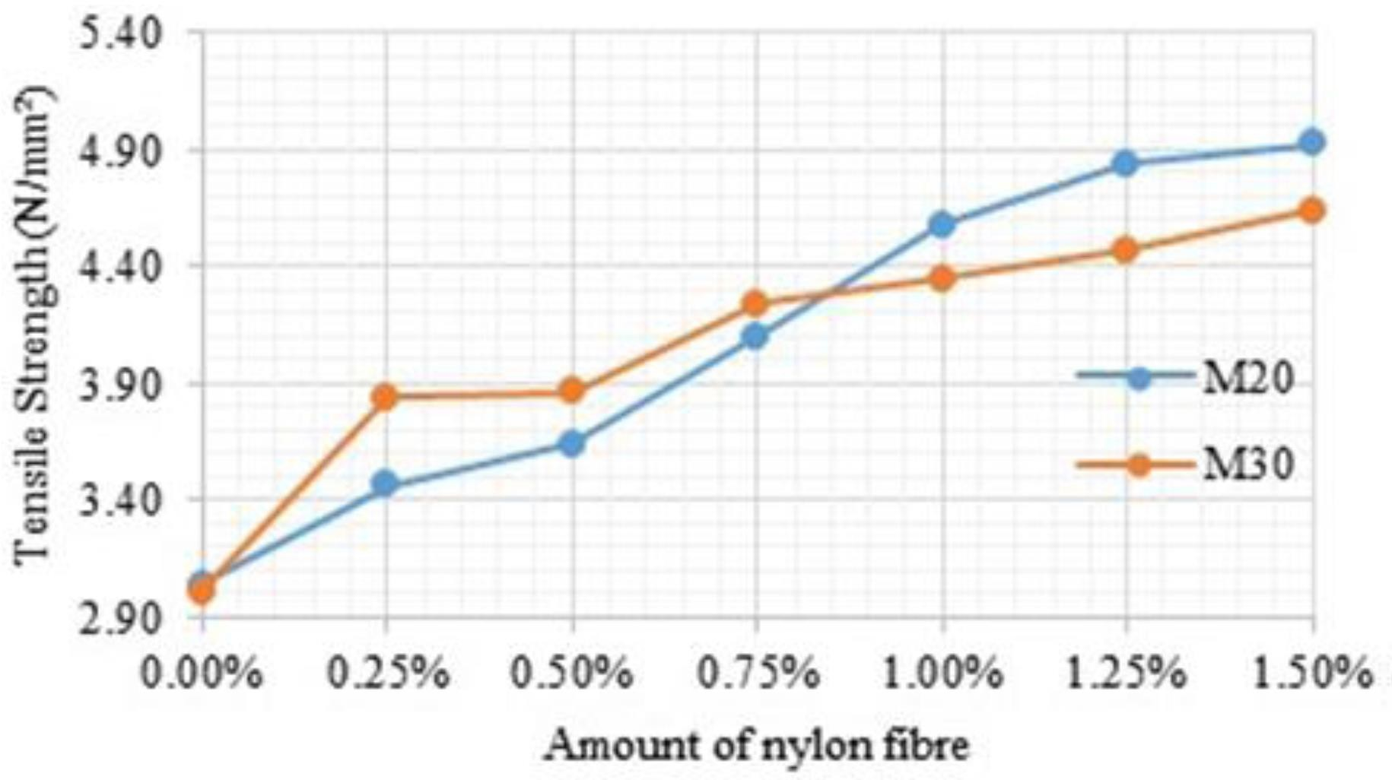As the concentration of nylon fibres is increased, it is evident that the compressive strength of both M20 and M30 concrete significantly increases. Only amounts of fibre close to 1% have an increase in strength before the strength starts to decline. This decrease in strength is primarily caused by the concrete's decreased workability, which causes segregation and uneven mixing.

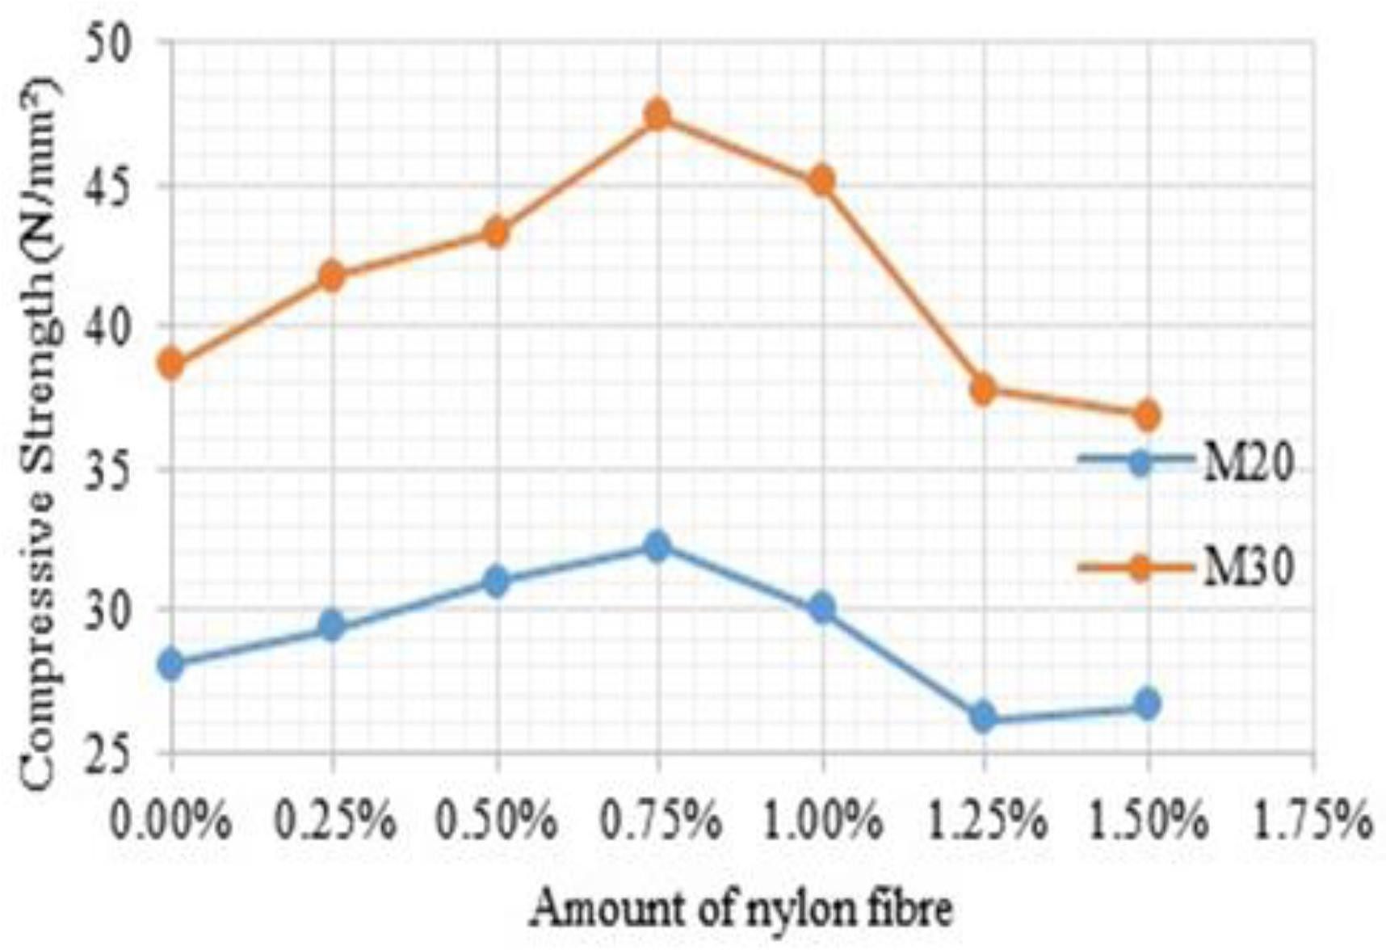

Fig. 2 also shows the slump test variation for mixes. As seen, the slump value increases as the amount of nylon fibres increases, becoming approximately 55–65%.

##### Tensile Strength:

Utilising fibres (of any kind) has several advantages, one of which is that they improve tensile strength. Split tensile strength tests on concrete mixtures are used to determine whether adding nylon fibre to concrete improves its tensile strength. Table 4 presents the findings.

Figures 4 and 5 depict the deviation in tensile strength of various concrete mixtures with changing amounts of nylon fibre. Based on these findings, it can be deduced that adding nylon fibre to concrete increases its tensile strength by 50%.

## 70%.

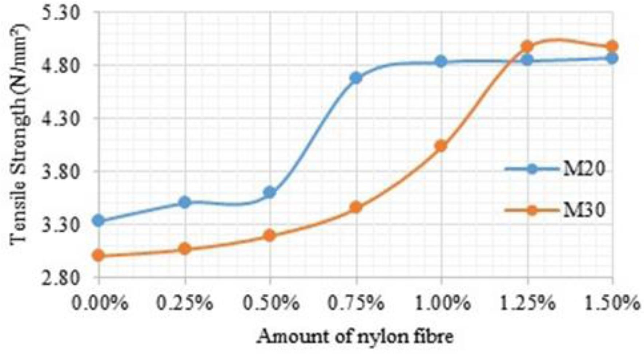

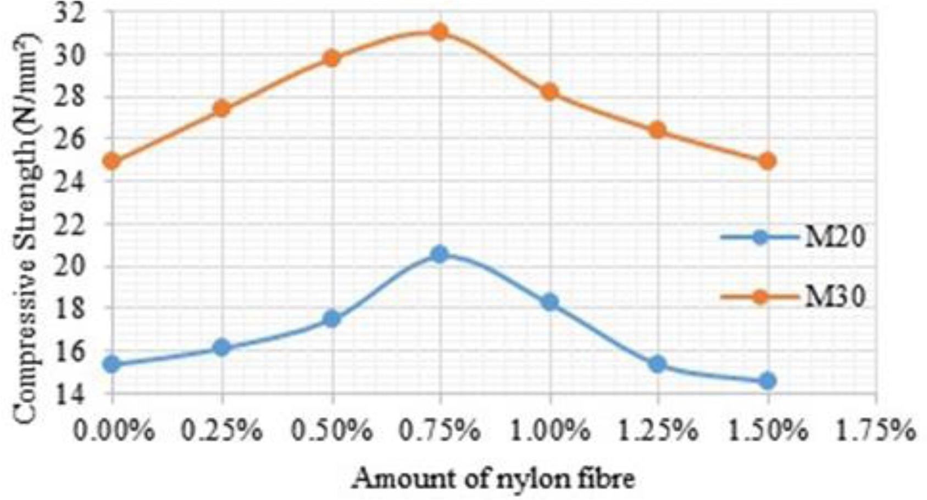

**Table -1:** Compressive Strength of Samples in N/mm2

|  |  |  |
| --- | --- | --- |
| Designation | Compressive strength, N/mm² (7-  days) | Compressive strength, N/mm²(28-  days) |
| S10 | 15.345 | 28.018 |
| S11 | 16.123 | 29.400 |
| S12 | 17.478 | 31.015 |
| S13 | 20.456 | 32.256 |
| S14 | 18.233 | 30.055 |
| S15 | 15.345 | 26.167 |
| S16 | 14.534 | 26.655 |
| S20 | 24.912 | 38.644 |
| S21 | 27.367 | 41.767 |
| S22 | 29.789 | 43.333 |
| S23 | 30.956 | 47.378 |
| S24 | 28.189 | 45.088 |
| S25 | 26.345 | 37.755 |

* + 1. **Tensile Strength*:***

Utilising fibres (of any kind) has several advantages, one of which is that they increase tensile strength. Split tensile strength tests on concrete mixtures are used to determine whether adding nylon fibre to concrete improves its tensile strength.

**Table -2:** Tensile Strength of Samples in N/mm2

|  |  |  |
| --- | --- | --- |
| Designation | Tensile strength, N/mm² (7-  days) | Tensile strength, N/mm² (28-  days) |
| S10 | 3.333 | 3.034 |
| S11 | 3.500 | 3.456 |
| S12 | 3.579 | 3.644 |
| S13 | 4.677 | 4.100 |
| S14 | 4.833 | 4.588 |
| S15 | 4.844 | 4.834 |
| S16 | 4.867 | 4.912 |
| S20 | 3.000 | 3.011 |
| S21 | 3.066 | 3.824 |
| S22 | 3.199 | 3.876 |
| S23 | 3.445 | 4.214 |
| S24 | 4.023 | 4.315 |
| S25 | 4.987 | 4.467 |

### 3. CONCLUSIONS

1. Environmental Aspect:
2. The challenge of disposing of spent fishnets is likely to be difficult in developing nations like India. Both the environment and people are in risk from it.
3. When compared to asbestos cement sheet, it reduces pollutants.
4. Placing used fishnets in a landfill may result in parasite breeding issues.
5. Structural integrity: The fishnet reinforced sheet has superior flexural integrity. After testing, we found that the fishnet reinforced sheet's flexure strength is 3500 N/mm wide, compared to the AC sheet's 5250 N/mm width.
6. Economical

The price of nylon reinforced sheet is significantly less than that of A/C sheet. Nylon fibres, which are utilised in a variety of goods, must be properly disposed of in order to minimise environmental impact. The fibres are renowned for their power, toughness, and resilience. These characteristics, when applied in concrete, greatly raise the calibre of the material while resolving the disposal issue. In the current investigation, nylon fibres are added to concrete in mixed amounts, and the impact on the material's properties is assessed. The slump indicates that concrete with nylon fibre, which is comparable to other types of fibre, has less workability. However, the slump value is discovered to drastically decrease at 1% to 1.5% amount of fibre, and concrete was seen to be highly harsh. The compressive strength test exhibits the effect of decreased workability. It was discovered that the amount of nylon fibre improved the compressive strength. However, the compressive strength dramatically decreased at roughly 1% of fibre, primarily because of lower workability.

A large proportion of nylon fibre was shown to boost the tensile strength of concrete by 60–70%, making it helpful in locations at which it is anticipated that minor tensile stress may be defeat, such as warmth stressors, creep etc.

### REFERENCES

* 1. A. Beyerlein, “Nylon Fiber Facts,” Clemson University, Department of Chemistry, College of Engineering & Science 223 Howard L. Hunter Chemistry Laboratory Box 340973, Clemson.
  2. P. Europe, Eco-profiles and Environmental Product Declarations of the European Plastics Manufacturers: Polyamide 6.6. Brussels: PlasticsEurope AISBL, 2014.
  3. J. Saxena and A. Saxena, “Enhancement

the Strength of Conventional Concrete by using Nylon Fibre,” Research Inventy: International Journal Of Engineering And Science Issn, vol. 5, no. 2e, pp. 56–59, 2015.

* 1. R. F. Zollo, “Fiber-reinforced concrete: an overview after 30 years of development,” Cement and Concrete Composites, vol. 19, no. 2, pp. 107–122, 1997.
  2. P. S. Song, S. Hwang, and B. C. Sheu, “Strength properties of nylon- and polypropylene-fiber-reinforced concretes,” Cement and Concrete Research, vol. 35, no. 8, pp. 1546–1550, 2005.
  3. O. B. Ozger, F. Girardi, G. M. Giannuzzi, V. A. Salomoni, C. E.

Majorana, L. Fambri, N. Baldassino, and

* 1. R. Di Maggio, “Effect of nylon fibres on mechanical and thermal properties of hardened concrete for energy storage systems,” Materials and Design, vol. 51, pp. 989–997, 2013.
  2. Mr Sahil Sanjeev Salvi, M. S. S. K. (2020). “Quality Assurance and Quality Control for Project Effectiveness in Construction and Management.” IJERT, 9(02), 26–29.
  3. Natarajan, S., Jeelani, S. H., Sunagar, P., Magade, S., Salvi, S. S., and Bhattacharya, S. (2022). “Investigating Conventional Concrete using Rice Husk Ash (RHA) as a Substitute for Finer Aggregate.” Journal of Physics: Conference Series, 2272(1).
  4. Sabale, R., Karande, U., Kolhe, A., Kulkarni, A., and Tapase, A. (2023). “Recycling of Used Foundry Sand and Fly Ash in Concrete as a Partial Replacement for Conventional Ingredients.” 2, 169–181.
  5. Salvi, S. S. (2017). “EXPERIMENTAL INVESTIGATION OF BOND STRENGTH IN STEEL FIBER REINFORCED CONCRETE.” IJARIIE, 3(2), 4617–4625.
  6. Sanjeev Salvi, S., Mantute, K., Sabale, R., Lande, S., Kadlag, A., and Professor,

A. (2021). “a Study of Waste Plastic Used in Paving Block.” International Journal of Creative Research Thoughts, 9(May), 2320–2882.