**Strategic Network Expansion: Geospatial Data Visualization in Telecom Planning for GSM Operators in Iraq (Asia Cell, Zain, and Korek)**

Intisar Mohsin Saadoon  
 *Department of Computer Science (College of Education)*

*Al-Mustansiriyah University*Baghdad, Iraq  
[dr.intisar_muhson@uomustansiriyah.edu.iq](mailto:dr.intisar_muhson@uomustansiriyah.edu.iq)

**Abstract:** The fast growth of the phone and internet world in recent years has made planning for infrastructure and market study more difficult. Many cell towers have grown and there is a big struggle between network managers. They need new ideas to learn about the ever-changing field of wireless phone connections. In this study, we look at how to best show and understand data about where cell towers are located on a map. We suggest using some tools from Python programming language which will help solve the issue. We show how these libraries, not giving them a name, can help solve the problem. We also give useful tips for planning telecommunications networks and infrastructure management. The Study Case is Mobile Phone Companies in Iraq (Asia Cell, Zain and Korek).

The phone and internet business is changing really fast. With 5G technology growing, more data use and need for connection in far-off places coming up. It's now more important than ever to have a good plan with efficient infrastructure setup that works well all around. But, the huge amount of data from cell towers and their complicated location make it very hard.

Showing information about the world on maps is a useful way to understand and share details with others. In this article, we will start a trip through many code examples that demonstrate different ways to see geographical data. We will learn to use Python tools like Matplotlib, Seaborn, Folium and Selenium for making interesting maps and pictures. Pygal can also be helpful in this area. Every piece of code will be talked about deeply. We'll focus on what it does, its features and the knowledge we can get from it. By the end of this article, you will know more about different ways to show data on a map and how they can be used in real life.

**Keywords:** Geospatial Data, Pygal, Asia Cell, Zain and Korek, Matplotlib , Seaborn

**1. Introduction**

The phone industry is a big part of today's computer age. It helps us stay connected all around the world with phones and messaging. Its deep impact on society, businesses and the way government works has changed how we view our world. Today, many choices are made with data. The telecommunications field has a need to expand and improve its infrastructure while planning smartly for the future. Knowing the physical layout of this complicated structure is very important. Here, the ability to show information about places using maps is used. It helps those involved in phone companies use big amounts of data for making good choices.

In the last few years, people who work in phone companies have seen a big increase in data they get from many places like towers for phones, how their customers use them and where we are. This flood of data shows both a problem and chance. The problem is to get helpful knowledge from all this data, while the chance comes in being able to make network work better, plan big growth moves and deal with shifting market situations. It gives a space for people who work with phone systems, like engineers and others making big choices. They can plan what they need to make their networks work better with more understanding of all the details involved. Geospatial data visualization makes decisions easier by turning complex information into simple pictures. This is done without getting too deep into the tech details behind it all. We used the cell phone companies in Iraq as an example, see table (1).

Cell towers, network coverage expansion and always trying to make phone service better are all key parts of the telecommunications world. How far apart cellular towers go with their planning for networks helps keep connections smooth everywhere.

But, the problem is to analyze and show clearly a huge amount of geographic data connected with these efforts.

Table (1) the operators in Iraq

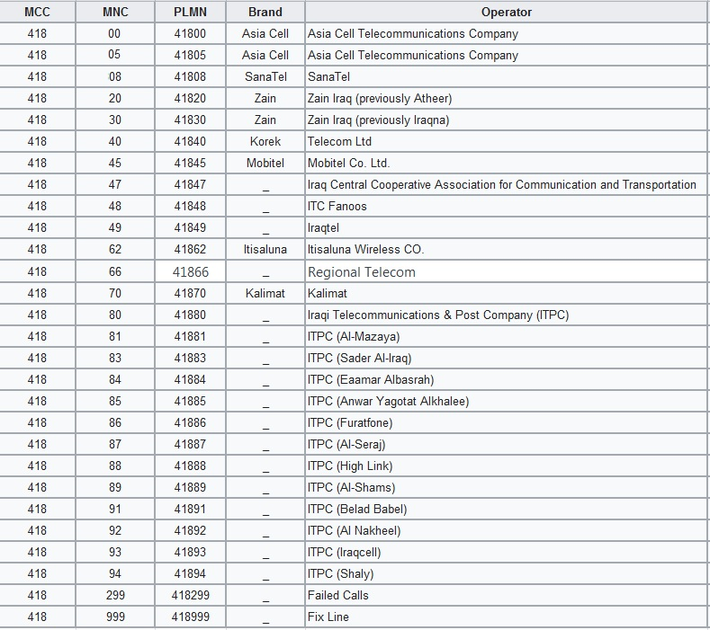

**2. Analyzing Cellular Infrastructure Dynamics**

The issue now is understanding how cellular structures work. This means knowing where cell towers are found, finding important market leaders, checking how strong the networks are and making smart choices about expanding or improving data for Iraq's phone companies as shown in figure (1).

Building up cell towers, extending network coverage and always working for better service quality are all important parts of the phone communications business. The placement of cell phone towers and smart planning for network equipment are very important to keep connection going without any problems. The problem is to look at and understand a lot of geographical data related with these projects.

The phone industry gets a lot of data from different places like cell towers, how people use phones and where they are located. This flood of data is both a problem and a chance. The problem is finding important information from all these data, while the chance includes making network work better, planning big moves before they happen and reacting to changes in market trends.

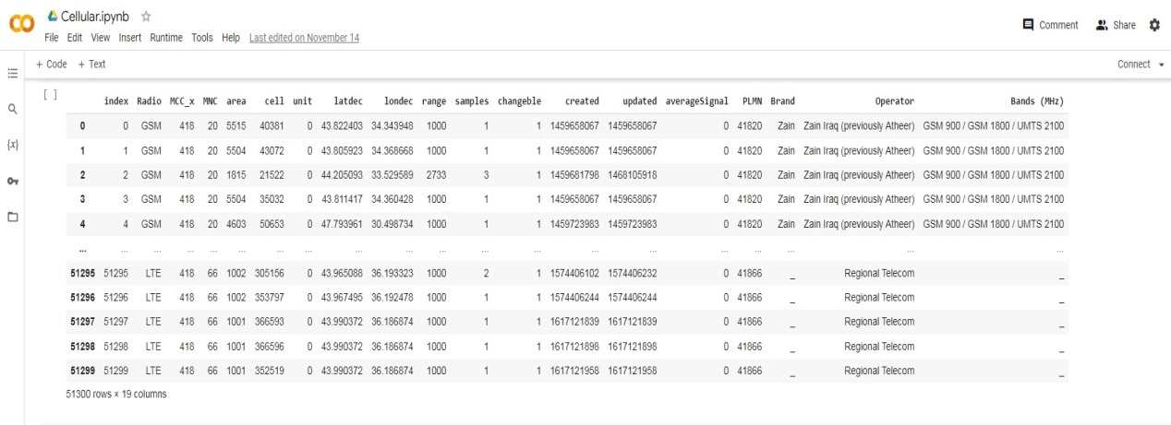

Figure (1) the dataset of operators in Iraq

**3. Geospatial Data Visualization**

The answer can be found in the strength of maps and images that show where things are on earth. We can use Python libraries to make useful graphics. This helps people understand important information better and take action based on it. In this article, we explore various techniques without explicitly naming the libraries used:

**3.1. Identifying Key Market Players**

First, we show the most important phone tower companies in a certain area using pictures. By making a ranking list, leaders can quickly find the top of markets. This knowledge is very important for checking competition, making team choices and knowing the phone communication world.

In the growing phone industry, it's very important to know what big companies in the market are doing. People in charge must quickly and easily find the best workers so they can make smart big choices. To handle this problem, we make a flat bar chart showing the best mobile tower companies by number of towers in certain area as shown in figure (2). This picture helps us quickly and easily understand how our competition works.

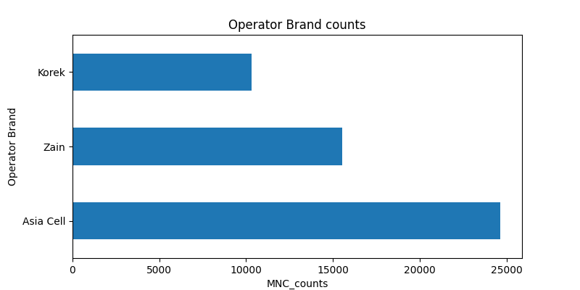

Figure (2) phone tower companies

**3.2. Infrastructure Planning with Interactive Maps**

To deal with the issue of planning infrastructure, we use helpful maps. These maps focus on certain areas, giving details about where towers are located and their place in the world. People who make choices can look at these maps, check where network coverage is and use facts to decide on how best to improve the network.

In the fast world of phone communication, making plans for buildings and equipment is very important to give good service. Old-fashioned spreadsheets and databases might not completely show the location details needed for good planning. To deal with this problem, we use interactive maps. These maps focus on certain areas. They let people see where towers are located in a bigger picture. They give leaders the power to make smart decisions about where they need coverage and how much more infrastructure is needed as shown in figure (3).

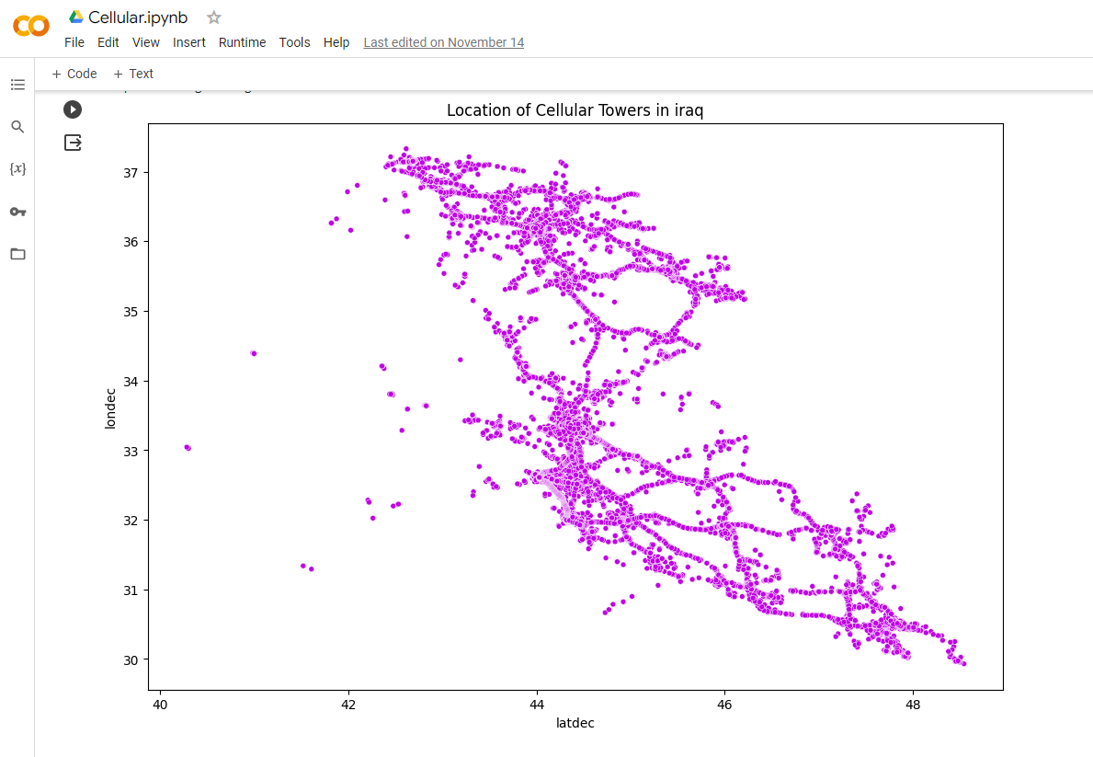

Figure (3) Infrastructure Planning with Interactive Maps

**3.3. Understanding Infrastructure Density**

The way cell towers are spread out is very important when planning main structures. A 2D heatmap or histogram shows in a clear way how many towers there are at different latitude and longitude points. This method gives a complete picture of buildings, helping to spot where there are more or fewer tall structures.

In planning for infrastructure, knowing how close towers are to each other is very important. Looking at where towers are located in different parts of the world gives us information about areas with many or few tall structures. We use a 2D picture or chart to show this data in an effective way. By changing things like how many bins we use and the colors, we make a picture that helps people who have power see where there is too much or not enough infrastructure. This can be seen in figure 4.

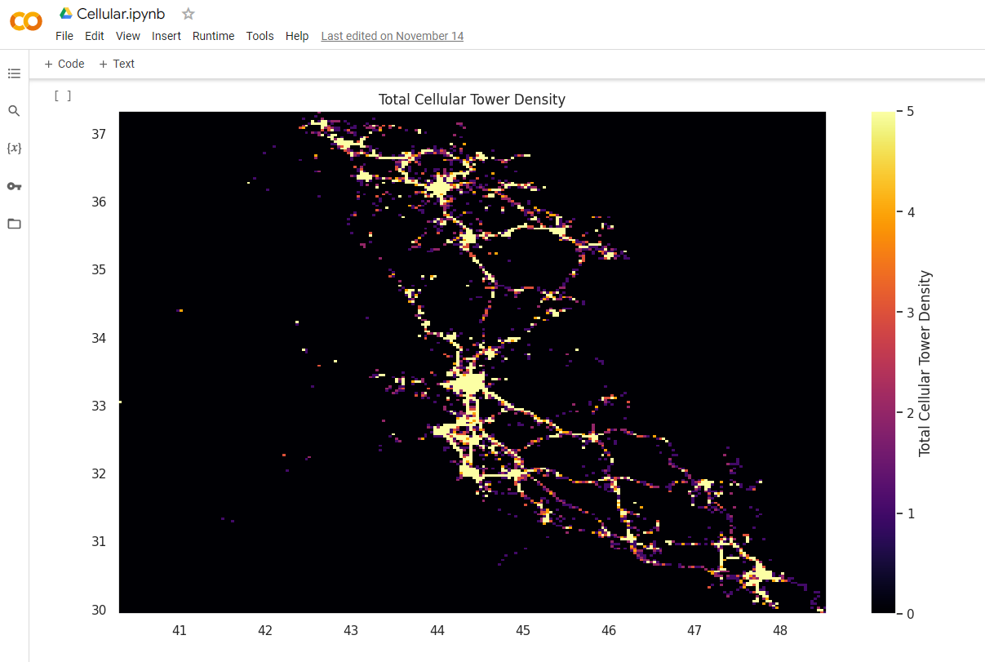

Figure (4) Infrastructure Density

**3.4. Custom Geospatial Maps**

Another solution is making special maps of places that meet particular needs. People in charge can tag areas, nations or construction spots. This lets them show information easily and precisely. The maps can change a lot and they work for many different uses.

Every project about phone networks is different, and often we need special pictures to show the information. People who make decisions need the ability to label certain areas, places or locations. They can then alter maps based on what they specifically require from them. These maps made just for you are very flexible and can be used in many different ways. Custom geospatial maps are a strong tool when planning to spread out in an area or improve network coverage. As shown in figure 5, this helps get the right service and goods closer to people who need them most with minimum cost cuts.

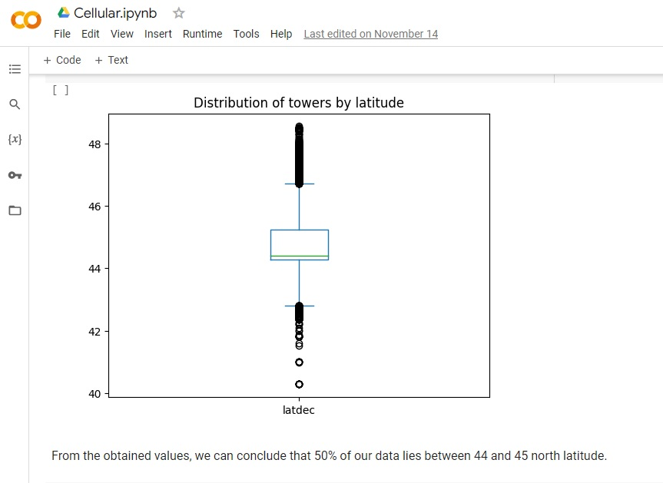

Figure (5) The Custom Geospatial Maps

**3.5. Regional Analysis**

To get a closer look, we check how many towers are in states or areas. A bar chart shows a picture of how many towers there are in each state for chosen companies. We can easily see differences in patterns across regions, which helps us make choices about building plans.

Knowing how cell phone networks work in different areas is very important for making good choices. In this part, we look closely at a place-based study. We focus on mobile phone companies and the way they work in different locations. By making a bar chart that shows the towers by state or area for some mobile companies, those who care about it can find out any differences in these places. This information is very valuable for making improvements aimed at specific areas, improving network performance and growing wisely as shown in figure (6).

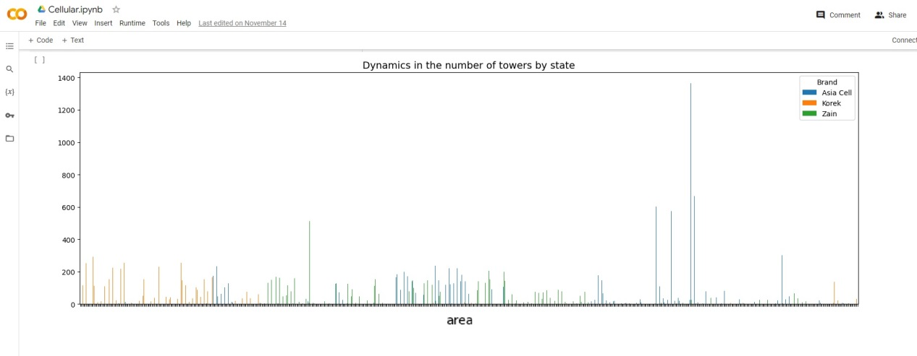

Figure (6) mobile phone companies works in different locations

**4. Enhancing Telecommunications Infrastructure Planning**

To illustrate the practical application of these techniques, we present a case study. A fictional telecommunications company faces the challenge of expanding its network while understanding its competition. By implementing the solutions proposed, the company gains insights into market dynamics, infrastructure density, and regional disparities, ultimately making informed decisions.

**4.1. Creating a World Map with Pygal**

Pygal, a Python tool for making SVG charts that change as needed. We generate world map visualization and label Iraq on the map. Pygal lets data analysts make their own maps on geography. It's a great start for showing information interactively as shown in figure (7).

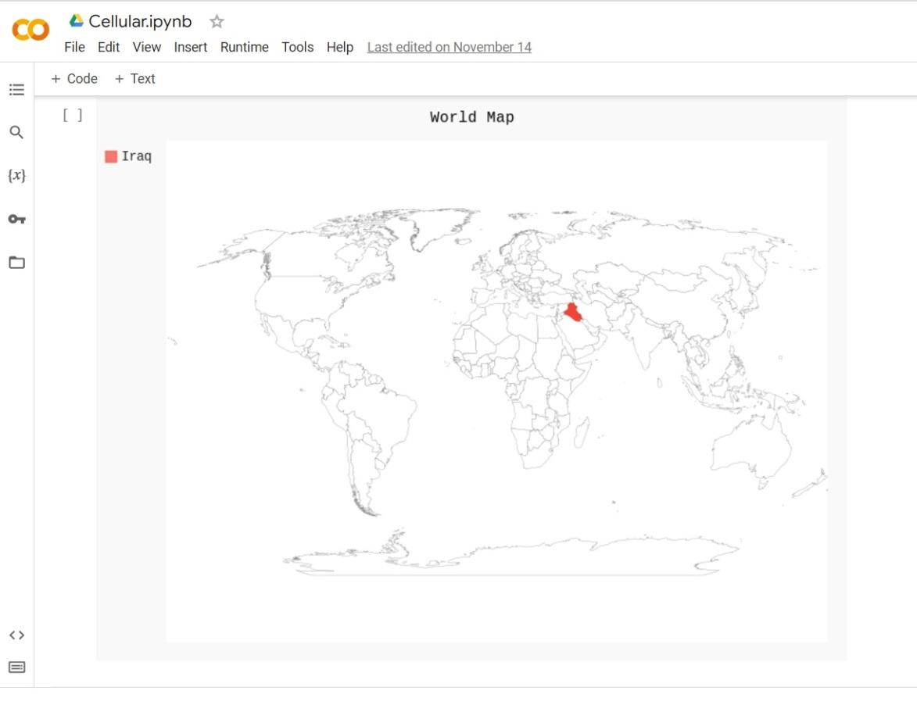

Figure (7) world map visualization for Iraq map

**4.2. Mapping Cellular Towers in Iraq with Folium**

The Folium library that makes maps can be used to make a map focusing on Iraq. It lets you put in an optional marker and save it as HTML under the steps shown in figure (8).

Additionally, we are taught to use Selenium in order to take a picture of the map and show it inside a Jupyter notebook.  This mix of tools makes it possible for data analysts and map lovers to make interesting maps that can be explored. They can also share these with other people.

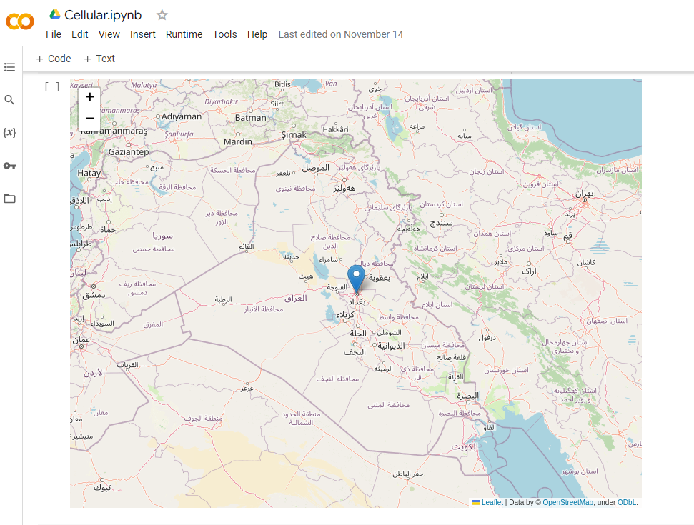

Figure (8) Mapping Cellular Towers in Iraq with Folium

**4.3. Exploring Cellular Tower Data with Matplotlib and Seaborn**

We explore the use of cell tower data visualization with Matplotlib and Seaborn libraries. We make a bar chart going from left to right that shows the top three biggest cellular tower companies based on how many towers they have. It gives a bright picture of the competition in the telecommunications business area. By showing information like this, important people can quickly find the main players in markets. This is a useful tool for making big decisions about strategies as shown in figure (9).



Figure (9) cell tower data visualization with Matplotlib and Seaborn

**4.4. Visualizing Cellular Tower Density with Matplotlib and Seaborn**

We go back to Matplotlib and Seaborn so we can look at how many cell phone towers there are. It makes a 2D picture or heatmap, that shows on the map where cell towers are located by their latitude and longitude points. By changing settings such as the number of sections and colors used, this picture gives us a clear idea about where cell areas are spread. This method is very important for looking at places on maps and preparing buildings in the communications field as shown in figure (10).

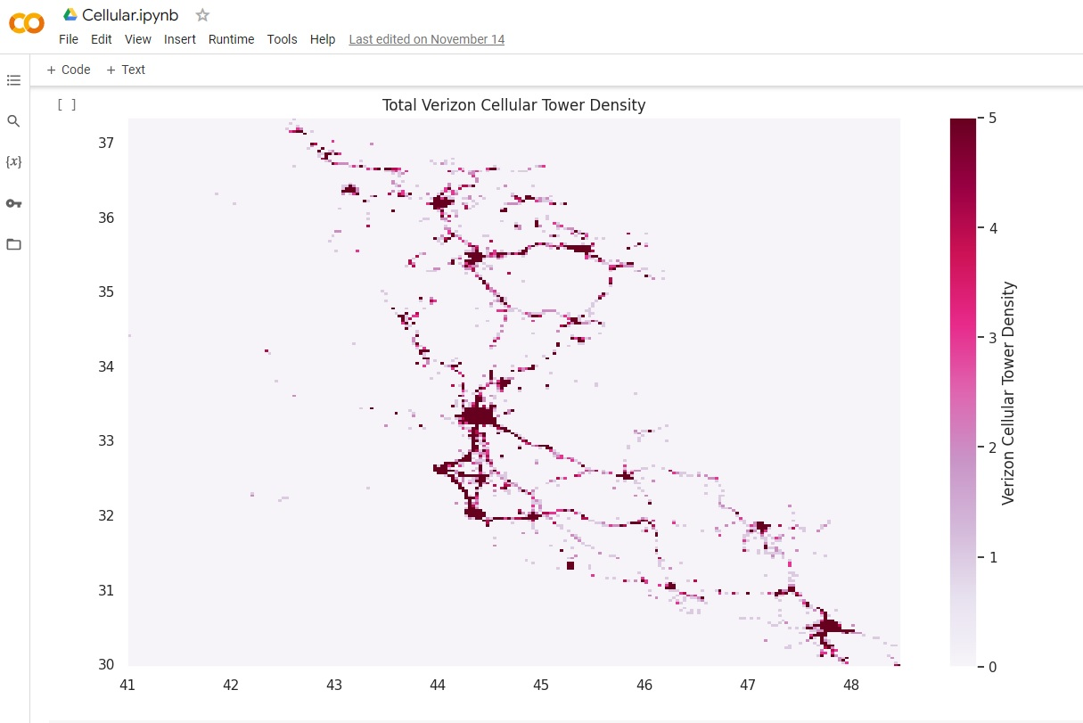

Figure (10) Visualizing Cellular Tower Density with Matplotlib and Seaborn

**4.5. Analyzing Cellular Tower Dynamics with Matplotlib and Seaborn**

We return to the world of cellular towers, but this time, we analyze their dynamics across different states or regions. The code creates a bar chart that presents the number of towers by state for select cellular operators. The visualization is instrumental for understanding regional trends and helping stakeholders identify opportunities and challenges in the telecommunications market as shown in figure (11).

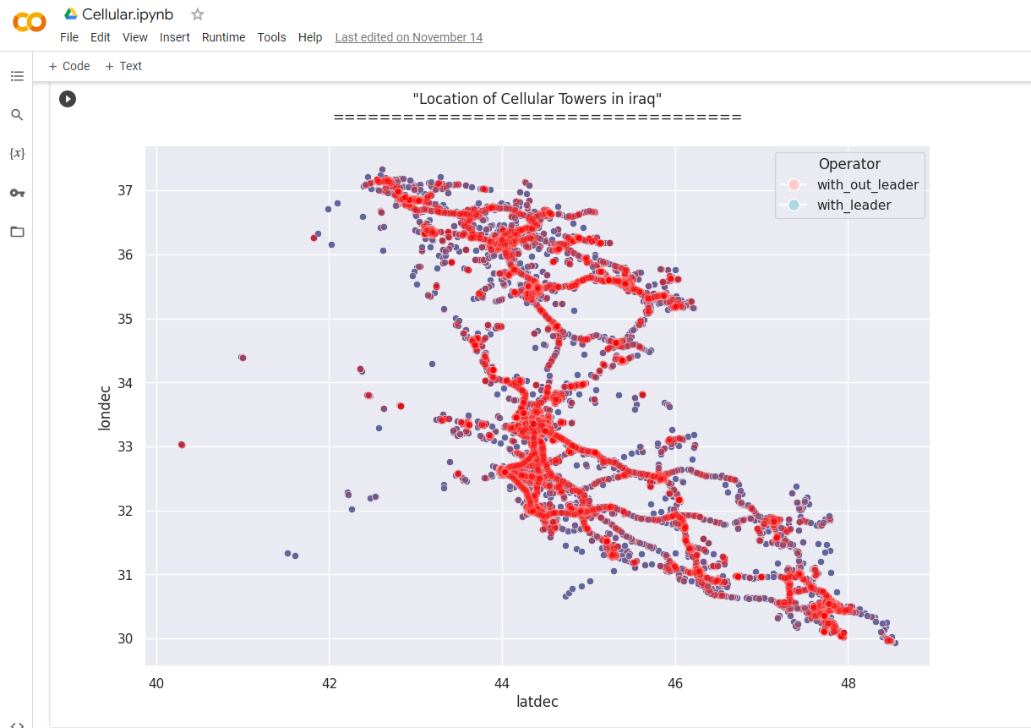

Figure (11) Cellular Tower Dynamics with Matplotlib and Seaborn

**4.6. Exploring Cellular Tower Locations with Matplotlib and Seaborn**

We go back to cell phone towers world, but this time we study their changes in different areas or parts. The code makes a bar chart that shows how many towers each state has for some mobile phone companies. The visualization helps people to know about local changes and find chances and problems in the phone service market as shown in figure (12).

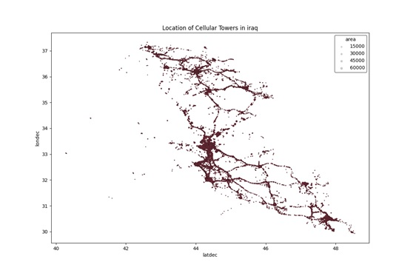

Figure (12) Exploring Cellular Tower Locations with Matplotlib and Seaborn

**5. Conclusion:**

Geospatial data visualization gives a strong answer to the problems faced by people who work in telecommunications. We showed how these methods can help leaders make better choices without directly saying the Python tools used. They let them see what's happening, understand market changes and improve their things needed for work or connect with others more easily. The growth and competition in the industry need new ways to understand data. Geospatial picture showing where things are on a map, is very helpful for meeting these needs.

Geographic data that can be seen by maps help many businesses, from phone lines to city planning and looking at nature. It is very useful in different ways. By looking at these examples, we learned more about what Python libraries like Matplotlib, Seaborn and others can do for showing geographical data on maps. These tools include Folium, Pygal and also help with using websites in a program called Selenium. Be it looking at market changes, number of buildings in an area or where people are based - these things help us turn information into useful knowledge that we can use. These techniques can help you use geographic data better and make your choices stronger. We've found that code can help us learn about the world using data graphics.

**6. Future Directions**

The telecom business is always changing. This means that planning for things like roads and bridges has its own set of problems and chances too! In the future, researchers might study new methods and computer learning tools for making predictions. This could help make choices early on. Moreover, using real-time data sources and IoT devices in geospatial study can better improve the skills of this field.

**7. References:**

1. Songnian Li et al.(2016)," Geospatial big data handling theory and methods: A review and research challenges". ISPRS Journal .Vol.115, May 2016, Pages 119-133. https://doi.org/10.1016/j.isprsjprs. 2015.10.012.
2. Martin Breunig et al.(2020)," Geospatial Data Management Research: Progress and Future Directions". ISPRS Journal .Vol. 9, Iss: 2, pp 95. https://doi.org/10.3390/ ijgi9020095.
3. [Huayi Wu](https://typeset.io/authors/huayi-wu-50496aefgd) et al.( 2020)," Geospatial big data for urban planning and urban management".Geo-spatial Information Science Journal. Vol. 23, Iss: 4, pp 273-274. https://doi.org/10.1080/ 10095020.2020.1854981
4. Hansen, M. C., P. V. Potapov, R. Moore, M. Hancher, S. A. Turubanova, A. Tyukavina, D. Thau, et al. (2013). "High-Resolution Global Maps of 21st-Century Forest Cover Change." Science [342](https://doi.org/10.1126/science.1244693) ([6160](https://doi.org/10.1126/science.1244693)): 850–853. doi:10.1126/science.1244693.
5. Lara, D. V. R., and A. N. Rodrigues da Silva. (2020). "Equity Issues and the PeCUS Index: An Indirect Analysis of Community Severance." Geo-spatial Information Science [23](https://doi.org/10.1080/10095020.2020.1843373) ([4](https://doi.org/10.1080/10095020.2020.1843373)): [293–304](https://doi.org/10.1080/10095020.2020.1843373). doi:10.1080/10095020.2020.1843373.
6. Li, F., Z. Gui, H. Wu, J. Gong, Y. Wang, S. Tian, and J. Zhang. (2018). "Big Enterprise Registration Data Imputation: Supporting Spatiotemporal Analysis of Industries in China." Computers Environment and Urban Systems [70](https://doi.org/10.1016/j.compenvurbsys.2018.01.010): 9–23. doi:10.1016/ j.compenvurbsys.2018.01.010.
7. Lock, O., and C. Pettit. (2020). "Social Media as Passive Geo-participation in Transportation Planning – How Effective are Topic Modeling & Sentiment Analysis in Comparison with Citizen Surveys" Geo-spatial Information Science [23](https://doi.org/10.1080/10095020.2020.1815596) ([4](https://doi.org/10.1080/10095020.2020.1815596)): [275–292](https://doi.org/10.1080/10095020.2020.1815596). doi:10.1080/10095020.2020.1815596.
8. Qi, Y., S. C. Drolma, X. Zhang, J. Liang, H. Jiang, J. Xu, and T. Ni. (2020). "An Investigation of the Visual Features of Urban Street Vitality Using a Convolutional Neural Network." Geo-spatial Information Science [23](https://doi.org/10.1080/10095020.2020.1847002) ([4](https://doi.org/10.1080/10095020.2020.1847002)): [341–351](https://doi.org/10.1080/10095020.2020.1847002). doi:10.1080/ 10095020.2020.1847002.
9. Shen, P., L. Ouyang, C. Wang, Y. Shi, and Y. Su. (2020). "Cluster and Characteristic Analysis of Shanghai Metro Stations Based on Metro Card and Land-Use Data." Geo-spatial Information Science [23](https://doi.org/10.1080/10095020.2020.1846463) ([4](https://doi.org/10.1080/10095020.2020.1846463)): [352–361](https://doi.org/10.1080/10095020.2020.1846463). doi:10.1080/ 10095020 .2020.1846463.
10. Smirnov, E., S. Dunaenko, and S. Kudinov. (2020). "Using Multi-Agent Simulation to Predict Natural Crossing Points for Pedestrians and Choose Locations for Mid-Block Crosswalks." Geo-spatial Information Science [23](https://doi.org/10.1080/10095020.2020.1847003) ([4](https://doi.org/10.1080/10095020.2020.1847003)): [362–374](https://doi.org/10.1080/10095020.2020.1847003). doi:10.1080/ 10095020.2020.1847003.
11. Tong, Z., H. Yang, C. Liu, T. Xu, and S. Xu. (2020). "Quantification of the Openness of Urban External Space through Urban Section." Geo-spatial Information Science [23](https://doi.org/10.1080/10095020.2020.1846464) ([4](https://doi.org/10.1080/10095020.2020.1846464)): [316–326](https://doi.org/10.1080/10095020.2020.1846464). doi:10.1080/10095020.2020.1846464.
12. Yamada, T., and T. Hayashida. (2020). "Analysis of Shopping Behavior Characteristics in the Keihanshin Metropolitan Area in Japan Based on a Person Trip Survey." Geo-spatial Information Science [23](https://doi.org/10.1080/10095020.2020.1845984) ([4](https://doi.org/10.1080/10095020.2020.1845984)): [305–315](https://doi.org/10.1080/10095020.2020.1845984). doi:10.1080/10095020.2020.1845984.
13. Yang, C., Q. Zhan, S. Gao, and H. Liu. (2020). "Characterizing the Spatial and Temporal Variation of the Land Surface Temperature Hotspots in Wuhan from a Local Scale." Geo-spatial Information Science [23](https://doi.org/10.1080/10095020.2020.1834882) ([4](https://doi.org/10.1080/10095020.2020.1834882)): [327–340](https://doi.org/10.1080/10095020.2020.1834882). doi:10.1080/ 10095020.2020.1834882.
14. Yao, Y., X. P. Liu, X. Li, J. B. Zhang, Z. T. Liang, K. Mai, and Y. T. Zhang. (2017). "Mapping Fine-scale Population Distributions at the Building Level by Integrating Multisource Geospatial Big Data." International Journal of Geographical Information Science [31](https://doi.org/10.1080/13658816.2017.1290252) ([6](https://doi.org/10.1080/13658816.2017.1290252)): 1220–1244. doi:10.1080/13658816.2017.1290252.
15. Jo, J.; Lee, K.-W. Map Reduce-Based D_ELT Framework to Address the Challenges of Geospatial Big Data. ISPRS Int. J. Geo-Inf. 2019, 8, 475.
16. Zhao, K.; Jin, B.; Fan, H.; Song, W.; Zhou, S.; Jiang, Y. (2019)."High-Performance Overlay Analysis of Massive Geographic Polygons That Considers Shape Complexity in a Cloud Environment". ISPRS Int. J. Geo-Inf. 2019, 8, 290.
17. Kang, J.; Fang, L.; Li, S.; Wang, X. (2019)." Parallel Cellular Automata Markov Model for Land Use Change Prediction over MapReduce Framework". ISPRS Int. J. Geo-Inf. 2019, 8, 454.
18. Safanelli, J.L.; Poppiel, R.R.; Ruiz, L.F.C. (2020). "Bonatti, B.R.; Mello, F.A.d.O.; Rizzo, R.; Demattê, J.A.M. Terrain Analysis in Google Earth Engine: A Method Adapted for High-Performance Global-Scale Analysis". ISPRS Int. J. Geo-Inf. 2020, 9, 400.
19. Zhang, T.; Wang, J.; Cui, C.; Li, Y.; He, W.; Lu, Y. (2019)." Qiao, Q. Integrating Geovisual Analytics with Machine Learning for Human Mobility Pattern Discovery". ISPRS Int. J. Geo-Inf. 2019, 8, 434.
20. Yang, T.; Xie, J.; Li, G.; Mou, N.; Li, Z.; Tian, C.; Zhao, J. (2019)." Social Media Big Data Mining and Spatio-Temporal Analysis on Public Emotions for Disaster Mitigation". ISPRS Int. J. Geo-Inf. 2019, 8, 29.
21. Wu, H.; Xu, Z.; Wu, G. (2019)." A Novel Method of Missing Road Generation in City Blocks Based on Big Mobile Navigation Trajectory Data". ISPRS Int. J. Geo-Inf. 2019, 8, 142.
22. Zhuang, C.; Xie, Z.; Ma, K.; Guo, M.; Wu, L. (2018). "A Task-Oriented Knowledge Base for Geospatial Problem-Solving". ISPRS Int. J. Geo-Inf. 2018, 7, 423.
23. H. Goyal, C. Sharma and N. Joshi, (2017). "An integrated approach of GIS and spatial data mining in big data", Int. J. Comput. Appl., vol. 169, no. 11, pp. 8887-8975, 2017.
24. S. Li, S. Dragicevic, F. A. Castro, M. Sester, S. Winter, A. Coltekin, et al. (2016). "Geospatial big data handling theory and methods: A review and research challenges", ISPRS J. Photogramm. Remote Sens., vol. 115, pp. 119-133, May 2016.
25. C. Zhou et al.,(2020). "COVID-19: Challenges to GIS with big data", Geography Sustainability, vol. 1, no. 1, pp. 77-87, Mar. 2020.