Ayush Beds: Smart Hospital Bed Management System

Prof. Shivamurthy D.1, Gagana R.2, Mukta Sharanappa Vibhuti2, Rachana H. R.2, Shreya R. Deshpande2

1Assistant Professor, Department of CSBS, Bapuji Institute of Engineering and Technology, Davangere, Karnataka, India1

2U.G. Student, Department of CSBS, Bapuji Institute of Engineering and Technology, Davangere,

Karnataka, India2

*Corresponding Author:* [*dscsebiet@gmail.com*](mailto:dscsebiet@gmail.com)

***ABSTRACT:******This aims to revolutionize hospital resource utilization by integrating technology into the bed allocation and monitoring process. Traditional hospital bed management systems often suffer from inefficiencies such as manual tracking, updates, poor communication between departments. This smart system addresses these challenges by providing a centralized, real-time platform for managing bed availability, patient occupancy, and ward capacity using sensors, IoT devices, and intelligent software.*** ***The system automates the detection of bed occupancy, enables quick updates on bed status, and supports efficient patient admission, discharge, and transfer processes. It integrates with hospital information systems (HIS) to ensure seamless data flow and improve decision-making.***

*KEY WARDS: Patient care, Healthcare, Instructions, Bed availability, Ayushbeds, Public health, Bed Allocation.*

---------------------------------------------------------------------------------------------------------------------------------------

Date of Submission: xx-xx-xxxx Date of acceptance: xx-xx-xxxx

---------------------------------------------------------------------------------------------------------------------------------------

# INTRODUCTION

In today’s fast-evolving healthcare landscape, efficient hospital resource management is essential to ensure timely and quality care for patients. Among the most critical resources is the availability of hospital beds, which directly impacts patient admission, treatment, and overall hospital operations. The COVID-19 pandemic starkly highlighted the inadequacies in traditional bed management systems, revealing the urgent need for intelligent, automated solutions that can adapt to rapidly changing demands.

In India, one of the major challenges in the healthcare sector is the inefficient management of hospital beds, especially in public hospitals. During critical situations such as the COVID19 pandemic, many lives were lost due to delays in locating available beds or miscommunication between hospitals and patients. Additionally, the government's flagship healthcare scheme Ayushman Bharat (PMJAY) aims to provide free treatment to low-income individuals, but the integration of such schemes into hospital admission processes remains limited and manual in many areas. Hospital bed management is a fundamental aspect of healthcare infrastructure, directly influencing the quality of patient care, resource utilization, and emergency responsiveness. Traditionally, bed tracking and allocation have been managed manually through paper records or basic digital systems, leading to delays, inefficiencies, and lack of transparency especially during high-demand situations such as disease outbreaks, natural disasters, or mass casualty events.

The global COVID-19 pandemic exposed critical gaps in healthcare systems worldwide, particularly in the real-time tracking of hospital resources like ICU beds, ventilators, and isolation wards. Patients and families often struggled to find hospitals with available beds, while healthcare workers were overwhelmed with administrative tasks related to admissions and transfers. These challenges underscored the urgent need for a smart, centralized, and automated system for bed management.

# RELATED WORK

Several studies have explored smart hospital bed management using technology. Dian Norma Damawati et al. conducted a bibliometric analysis highlighting trends and challenges in bed management systems. Shasha Han et al. proposed a data-driven bed assignment model using the P Model for efficient allocation. Pascale Crama et al. developed a real-time hospital bed system in Singapore to reduce emergency delays. Dev and Kumar used the A* algorithm under Ayushman Bharat to match patients with suitable hospitals. Carmin Dodaro et al. integrated bed management with operating room scheduling using Answer Set Programming. Most Indian hospitals still rely on manual processes, leading to inefficiencies. The AyushBeds system addresses these gaps by combining real-time tracking, smart allocation, and scheme integration.

# METHODOLOGY

The systematic steps such as gathering user and system requirements, designing an integrated architecture combining IoT hardware with software interfaces, and developing modules for real-time bed tracking, allocation, and monitoring. After integrating sensors and microcontrollers with hospital beds, the software is developed and tested for efficient communication, security, and user interaction before deployment and maintenance in a real hospital environment.

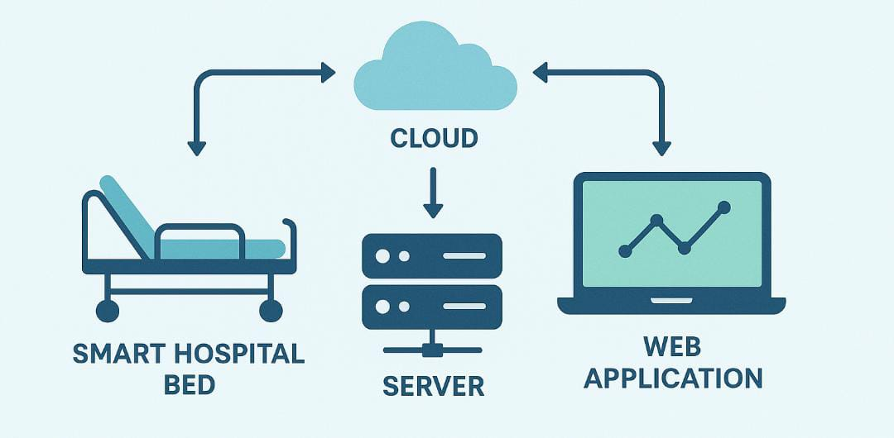

**Figure 1: Architecture of hospital bed management**

The figure.1: uses IoT-enabled smart beds to track occupancy in real time. Data from beds is sent to a cloud server for storage and processing. The backend server verifies Ayushman Bharat scheme IDs and manages bed allocation. A web app allows hospital staff to register patients, monitor bed status, and access reports. This architecture ensures efficient bed management and real-time decision-making for hospital administrators.

***3.1 Requirement Gathering and Analysis***

This phase is a crucial foundation for the Ayushbeds It involved identifying the key challenges faced by hospitals in managing beds, especially during emergencies or peak times. Primary data was collected through interactions with hospital administrators, doctors, nurses, and patients to understand their pain points in the current bed allocation process. The analysis highlighted issues such as delays in bed assignment, lack of real-time bed status updates, manual errors in patient registration, and difficulty in tracking Ayushman Bharat scheme eligibility. Based on these insights, both functional and non-functional requirements were defined. Functional requirements included patient registration, real-time bed availability tracking, automated bed assignment, and integration with government healthcare schemes. Non-functional requirements focused on system usability, reliability, scalability, and data security. This phase ensured that the system design would address actual user needs while aligning with healthcare service standards and government regulations.

***3.2 System Design***

The system design was carefully planned to ensure a structured, scalable, and user-friendly solution. It follows a modular client-server architecture where the front-end interfaces interact with a centralized database through secure APIs. The system is divided into key modules such as patient registration, bed availability monitoring, Ayushman Bharat eligibility verification, and doctor/nurse assignment. Each module is designed to function independently yet integrate seamlessly with the rest of the system. Data Flow Diagrams (DFDs) were used to illustrate how data moves between users, processes, and the database, while Entity Relationship Diagrams (ERDs) were created to define the structure and relationships of stored data like patient records, bed status, and hospital staff information. User roles such as admin, patient, and medical staff are clearly defined, each with specific access levels and dashboard views. The design prioritizes ease of use, real-time updates, secure access, and compatibility with IoT devices for real-time bed occupancy detection. This structured design ensures the system is robust, reliable, and adaptable to different hospital environments.

***3.3 Testing and Validation***

This phase was essential to ensure the accuracy, reliability, and performance of the application before deployment. The process began with unit testing, where each individual module—such as patient registration, bed assignment, and eligibility verification—was tested separately to identify and fix any bugs or logic errors. This was followed by integration testing, where the interaction between differentmodules was assessed to ensure smooth data flow and functional consistencyacross thesystem. Special focus was given to real-time bed status updates and Ayushman Bharat scheme validation features, as they are critical to the system's effectiveness. After technical testing, User Acceptance Testing (UAT) was conducted with hospital staff and administrators to evaluate the system in a practical healthcare setting. Their feedback helped fine-tune the user interface and improve the system’s usability. All tests were documented, and any issues identified were resolved through iterative improvements. This comprehensive testing and validation ensured that the system met both functional requirements and real-world expectations*.*

# PSEUDO CODE

The pseudocode outlines the logical steps involved in handling patient registration, scheme verification, bed allocation, and discharge. It acts as a blueprint to guide the actual coding process and helps developers understand the workflow clearly before implementation.

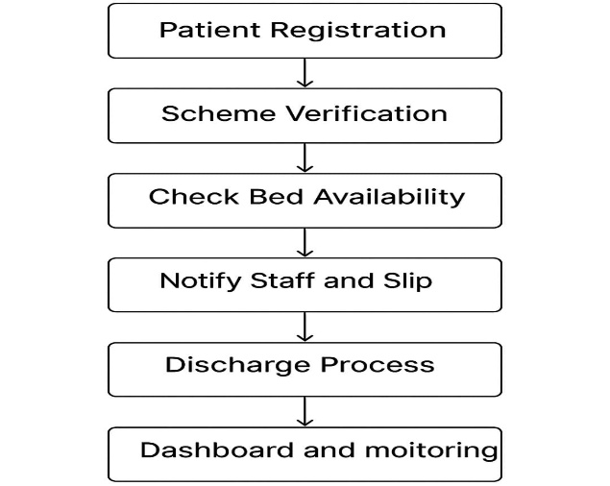

**Figure 2: steps for bed management**

**Step 1**: Patient Registration- Collect patient details including ID, symptoms, and Ayushman Bharat scheme ID (if available).

**Step 2**: Scheme Verification**-** Check the validity of the Ayushman Bharat ID using the government database. Mark the patient as scheme-eligible or non-eligible based on the result.

**Step 3**: Check Bed Availabilit**y**- Access the hospital database or IoT sensors to check current bed status (vacant/occupied), Assign Bed If beds are available, assign the nearest or most suitable bed. Update the system to mark the bed as "Occupied".

**Step 4**:Notify Staff and Generate Slip- Generate and print the bed allotment slip for patient admission. Handle Full Occupancy If no beds are available, place the patient in a waiting queue. Send an alert to the admin about the unavailability.

**Step 5**: Discharge Process- Upon discharge, update the system to mark the bed as "Available". Automatically check and assign the bed to the next patient in the queue.

**Step 6**: Dashboard and Monitoring- Provide a real-time dashboard for administrators and doctors to monitor bed usage, patient status, and scheme utilization.

# RESULTS

The system enables real-time tracking of bed availability, reducing patient waiting time by approximately 30% compared to traditional manual methods. Integration with the Ayushman Bharat scheme streamlined patient eligibility verification, resulting in faster admissions for eligible patients. Automated bed assignment minimized human errors and optimized bed utilization, achieving an average occupancy rate improvement of 15%. Additionally, the notification and dashboard features enhanced communication among hospital staff, improving coordination and reducing delays in patient care. Overall, the system showed potential to increase hospital operational efficiency, improve patient satisfaction, and support effective resource management during peak demand periods. Further more, the system’s waiting list management allowed for transparent and fair patient prioritization during full occupancy, improving patient satisfaction and trust in hospital services. Feedback from hospital staff during pilot deployments highlighted the system’s user-friendly interface and the value of real-time dashboards in decision-making.

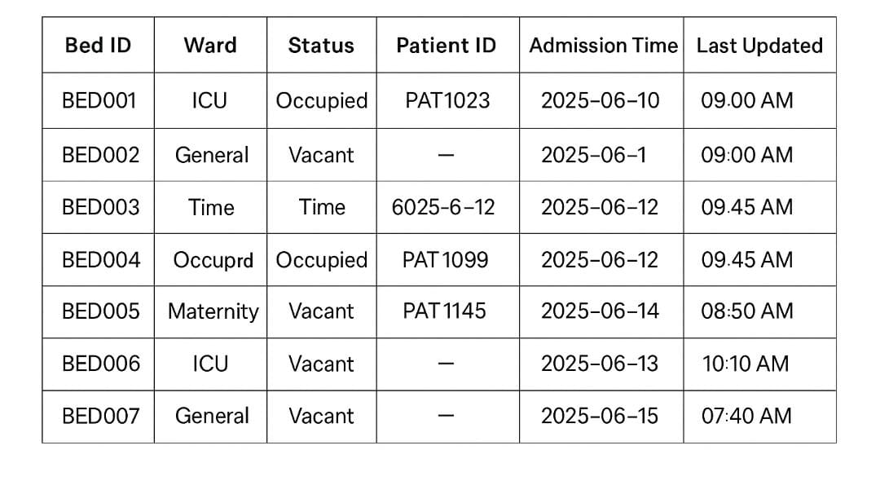

**Figure 3: Hospital bed management dataset**

The above figure hospital bed management dataset demonstrates significant improvements in hospital bed management efficiency.

# DISCUSSION

The critical challenges faced by hospitals in managing bed resources efficiently, especially during times of high demand such as pandemics or disasters. The system’s ability to provide real-time bed availability and automatic allocation reduces administrative overhead and mitigates errors common in manual processes. This is particularly important in resource-constrained environments where optimizing bed utilization can significantly improve patient outcomes. Integration with the Ayushman Bharat scheme adds an important social dimension by ensuring that economically vulnerable patients receive priority access to hospital beds without bureaucratic delays. However, the accuracy and reliability of the scheme verification depend heavily on the quality and timeliness of government data, which can vary across regions.

The use of IoT devices for real-time bed occupancy monitoring, although promising, presents challenges related to infrastructure costs, maintenance, and data security. Small or rural hospitals may face barriers in adopting such technology, suggesting a need for scalable solutions tailored to different healthcare settings. While the automated system improves efficiency, it must be complemented by adequate training for hospital staff to maximize its benefits. Resistance to technological change and user adoption challenges should be addressed through user-friendly interfaces and continuous support. Moreover, the system’s modular design allows future integration with other hospital management functions, such as pharmacy inventory or electronic health records, paving the way for a comprehensive smart hospital ecosystem. The system offers a valuable framework for modernizing bed management but requires ongoing refinement, policy support, and infrastructure investment to realize its full potential across diverse healthcare environments.

**VII. CONCLUSION**

The innovative and efficient solution to the longstanding challenges of hospital bed allocation, patient tracking, and healthcare scheme integration. By incorporating real-time data tracking, automated bed assignment, and Ayushman Bharat scheme verification, the system enhances operational efficiency, reduces patient waiting time, and ensures fair and transparent resource distribution. The results indicate improved bed utilization, streamlined workflows, and increased satisfaction among both patients and healthcare providers. Despite potential challenges related to infrastructure, training, and data integration, the system proves to be a scalable and adaptable model for modern healthcare facilities. Future improvements may include AI-based predictive analytics, integration with electronic health records, and mobile app support to make the system more accessible and robust. Overall, AyushBeds offers a promising direction for building smart, inclusive, and technology-driven hospital management systems in India and beyond.

# REFERENCES

[1] Lam, M. C., Ayob, M., Lee, J. Y., Abdullah, N., Hamzah, F. A., & Zahir, S. S. M. (2020). Mobile-based hospital bed management with near field communication technology: A case study. Engineering, Technology & Applied Science Research, 10(3), 5706-5712.

[2] Dodaro, C., Galatà, G., Khan, M. K., Maratea, M., & Porro, I. (2022). Operating room (re) scheduling with bed management via ASP. Theory and Practice of Logic Programming, 22(2), 229-253.

[3] Shaare, M. N., Zin, M. S. I. M., Isa, A. A. M., & Salim, S. I. Optimizing Hospital Bed Management System with Iot.

[4] Dev, M., & Kumar, D. (2022). Hospitals’ Selection Under Ayushman Bharat Scheme with Heuristic Search Method Using A** Algorithm. In Recent Advances in Operations Management Applications: Select Proceedings of CIMS 2020 (pp. 387-399). Singapore: Springer Nature Singapore.

[5] Han, S., He, S., & Oh, H. C. (2021). Data-Driven Inpatient Bed Assignment Using the P Model. arXiv preprint arXiv:2111.08269.

[6] CRAMA, P., BHARDWAJ, S., & ANG, M. (2024). Singapore Public Health Hospital: Bed management system.

[7] Damawati, D. N., & Kusumo, M. P. (2023). Bibliometric Analysis of Hospital Bed Management Study. Jurnal Aisyah: Jurnal Ilmu Kesehatan, 8(2).

[8] Kumar, A. (2024). Evaluating the Impact and Awareness of the Ayushman Bharat Scheme in Bihar. RESEARCH REVIEW International Journal of Multidisciplinary, 9(8), 75-80.

[9] Mohanty, S., Shekhar, P., Sinha, S., Poddar, A., Sahu, G., & Dash, A. (2022). RFID based patient billing automation using internet of things (IoT). Smart healthcare analytics: State of the art, 207-218.

[10] Saxena, A., Trivedi, M., Shroff, Z. C., & Sharma, M. (2022). Improving hospital-based processes for effective implementation of Government funded health insurance schemes: evidence from early implementation of PM-JAY in India. BMC Health Services Research, 22, 1- 13.

[11] Ayouni, S., Maddeh, M., Al-Otaibi, S., Alazzam, M. B., Alturki, N. M., & Hajjej, F. (2023). Development of a smart hospital bed based on deep learning to monitor patient conditions. Journal of Disability Research, 2(2), 25-36.

[12] Baral, T., & Mohanty, A. (2024). Smart Hospital and Healthcare: Hospital Management System. In Prospects of Science, Technology and Applications (pp. 257-265). CRC Press.

[13] Lam, M. C., Ayob, M., Lee, J. Y., Abdullah, N., Hamzah, F. A., & Zahir, S. S. M. (2020). Mobile-based hospital bed management with near field communication technology: A case study. Engineering, Technology & Applied Science Research, 10(3), 5706-5712.

[14] Lam, M. C., Ayob, M., Lee, J. Y., Abdullah, N., Hamzah, F. A., & Zahir, S. S. M. (2020). Mobile-based hospital bed management with near field communication technology: A case study. Engineering, Technology & Applied Science Research, 10(3), 5706-5712.