Development of Spiral Curry Puff Production Machine for Small and Medium Enterprises in Malaysia

Mohd Nezuan bin Othman¹, Saiful Nizam Zakariah², Zulhisyam Salleh ³
¹Electrical Engineering Department, Politeknik Kuching, Sarawak, Malaysia.
² Commerce Department, Politeknik Melaka, Melaka, Malaysia.
³Electrical Engineering, Politeknik Ungku Omar, Perak, Malaysia.
Corresponding Author: zulhisyamsalleh@gmail.com
ABSTRACT: This paper discusses the development and implementation of a semi-automated system aimed at improving the production of spiral curry puffs (karipap pusing), a well-known traditional Malaysian snack. In many small and medium enterprises (SMEs), the production process still relies heavily on manual labour, particularly for dough handling, rolling, and cutting. These activities are not only time-intensive but inconsistent in production and highly reliant upon skilled laborers. To solve these problems, Politeknik Melaka teamed up with an interdisciplinary group to design five purpose-built machines: a dough extruder, vertical and horizontal dough sheeters, a dough roller, and a dough cutter. Each has a particular process stage in mind, complementing others to enhance consistency, minimize physical labor burdens on workers, and increase overall productivity. These machines were designed using local materials to ensure minimal costs and the system replicable to local manufacturers. Integration with this semi-automated system led to enhanced efficiency, improved consistency of the product, and improved hygiene along the production line. This project demonstrates how academia-industry collaboration can result in cost-efficient, practical innovations, providing innovative modern solutions to traditional foods production that does not taint cultural authenticity
KEYWORDS: Mechatronics, Spiral Curry Puff, Food Processing Automation, SME Innovation, Mechanical Design, Industrial Collaboration

---------------------------------------------------------------------------------------------------------------------------------------
Date of Submission: xx-xx-xxxx Date of acceptance: xx-xx-xxxx
---------------------------------------------------------------------------------------------------------------------------------------

INTRODUCTION
SMEs, with the current competitiveness of the food industry, are finding it increasingly difficult to be efficient, produce the same high levels of product quality, and ramp up production, especially in traditional food manufacturing industries, such as the SME located in Selangor, Malaysia, that produces frozen spiral curry puffs. These curry puffs are distinguished by their distinctive layered structure and prolonged crispiness after deep-frying. Traditionally, production has been carried out using manual processes, which are not only labour-intensive but also lead to inconsistent product quality and limited production levels
In response to the challenges, Politeknik Melaka embarked upon a joint research and development project with the SME. It was aimed at mechanizing crucial phases of the curry puff production process to support Malaysia’s national agenda of promoting SME productivity through the adoption of technology[1]. It was to devise a modular, semi-automated setup that decreases the use of manual labour, keeps variability to the minimum, and increases overall productivity in the context of a small to medium-scale manufacturing facility.
To achieve this, five fundamental machine components were designed and added to the production line. These included a dough extruder, controlled using a programmable logic controller (PLC), that replaced manual weighing with computer-controlled portioning to produce uniform 10-gram pieces of dough. Vertical and horizontal dough sheeters were then designed to roll the dough at various points along the process. These served to press the mixture of water and oil dough with the vertical sheeter, while the horizontal sheeter uniformised the base dough layer. Adjustable rollers were fitted to each machine to produce consistent thickness according to recipe specifications. Later, a motorized dough roller using the conveyor-driven type was added to automate the spiral-forming process. This machine created uniform rolled dough layers with no structural damage, which is paramount to the final look and feel of the curry puff. The final unit to be added to the chain was the manual yet finely crafted dough cutter with adjustable wire blades. This piece allowed uniform division into 3 mm dough pieces with minimal operator fatigue. Together, these innovations constitute an efficient, user-oriented production platform that enables SMEs to upgrade their processes. Having maintained the cultural authenticity of traditional foods while injecting technological efficiency, the platform resolves the dilemma of heritage versus innovation into one integrated solution. The widening use of automation among food processing companies is one sign of the widening appreciation of its application to improved production efficiency and consistent production quality. To SMEs, where there can be limited resources and labour, the adoption of automation is a strategic move to update operations to remain competitive. Ghosh and Smith [2] discuss the benefit of using mechatronics to optimize the production of foods, with the observation that automation decreases labour dependence, enhances hygiene, and provides consistent production output—instrumental aspects to uphold the integrity of the product along with the cornerstones of market demand.
A good example of the local manufacturers' transformation journey in the Malaysian context is that of HEXA. With digitalisation, HEXA achieved massive improvements in operating efficiency and responsiveness to the dynamics of the marketplace [3]. This is supported by Singh [3], who further attests that the application of the principles of engineering to the production of food makes what are essentially labour-intensive activities scalable and predictable systems.
One of the critical areas requiring accuracy is dough management, where consistency of the final product in terms of thickness, texture, and weight is crucial to final quality. Modular systems, which can be set to adjust to changing needs and scaled up or down with ease, have been particularly helpful to SMEs that need efficient, flexible solutions. Robotics integration and smart automation has also translated to favourable impacts where costs are kept lower, with consistent results at various stages of processing foods [4][5][6][8][10].
Furthermore, the importance of academic-industry collaboration in fostering innovation within SMEs has been extensively documented. Zulkifli et al. [4] emphasise that localised machine development, when supported by institutional expertise, offers contextually appropriate and economically feasible solutions. Governmental support, such as that from the Malaysian Investment Development Authority (MIDA), continues to champion automation and digitalisation as essential strategies in post-pandemic economic recovery [9].
Recent studies also reinforce the value of knowledge exchange between universities and industry players, highlighting that such partnerships have led to the development of sustainable, adaptive technologies tailored to the unique challenges of traditional food manufacturers [7][12][13]. These findings align directly with the present study, which applies collaborative engineering to address real-world challenges faced by a local SME in spiral curry puff production.

METHODOLOGY

This project followed a structured development model that combined engineering design with real-world prototyping. The development of a new production system, detailing the four distinct phases from design conceptualization to final implementation as shown in Figure 1 . Each phase builds upon the previous one, ensuring that the final product meets industry standards and user requirements.

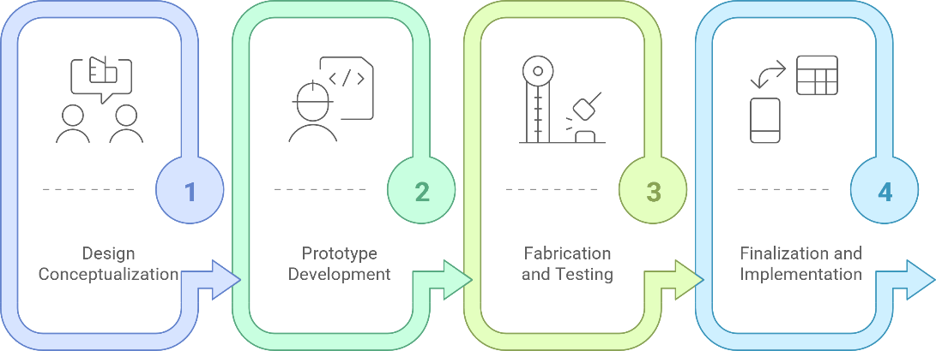
Figure 1: Production System Development Phases
- Project Phases

Phase 1: Design Conceptualization and Functional Requirements
In the initial phase, the focus was on design conceptualization and identifying the functional requirements necessary for the project as described in Figure 2. This was achieved through extensive consultations with industry stakeholders, ensuring that the needs and expectations of end-users were thoroughly understood. Preliminary sketches (as in Figure 3) and Computer-Aided Design (CAD) models depicted in Figure 4 were prepared to visualize the concepts and facilitate discussions among the team and stakeholders.

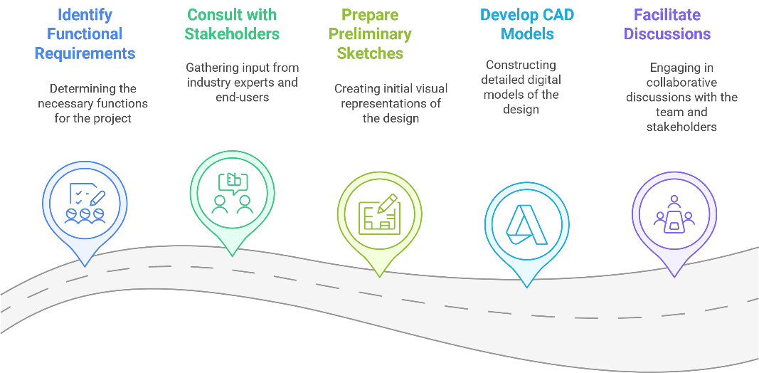
Figure 2: Design Conceptualization and Functional Requirements Phase

(a) | (b)
Figure 3:(a) Preliminary sketches models
(b) Brief description of the design. From Left: Oil Dough Dispenser, Dough Press, Dough Roller, Dough Cutter

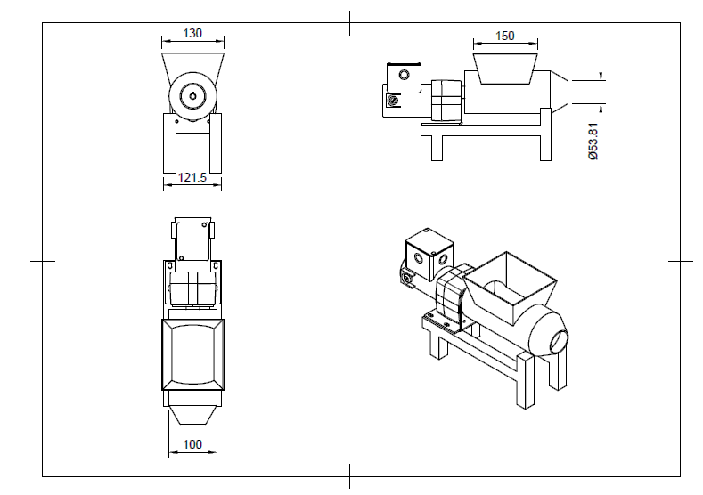
(a)
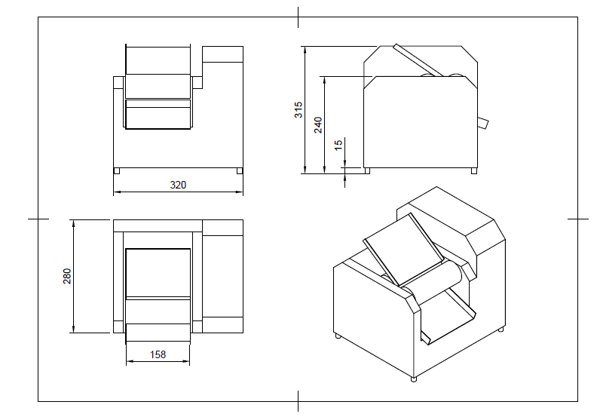 | 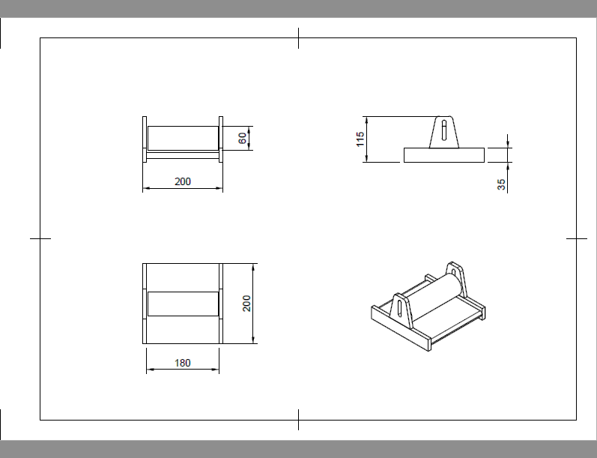
(b) | (c)
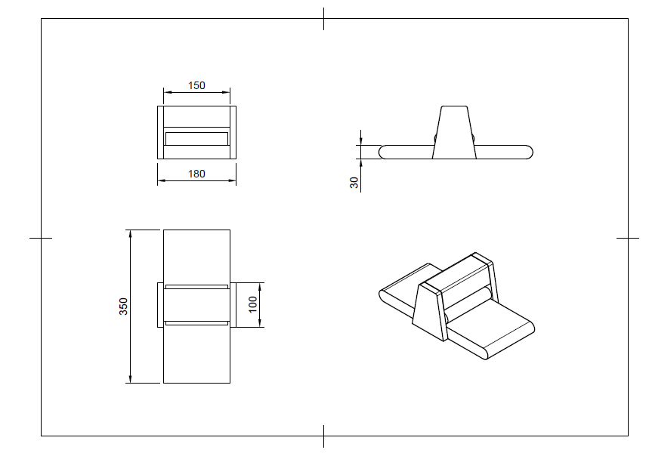 | 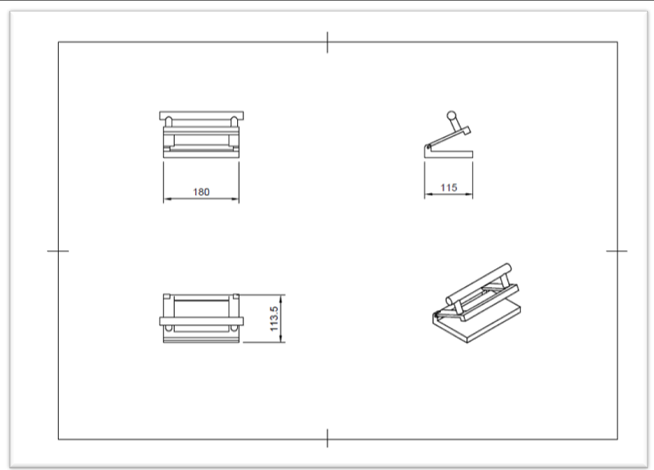
(d) | (e)
Figure 4: Computer-Aided Design (CAD) models
(a) Dough Extruder, (b) Dough Sheeter Vertical, (c) Dough Roller (d) Dough Sheeter Horizontal (e) Dough Cutter

Phase 2: Prototype Development
The second stage included the creation of prototype devices as shown in Figure 5. Main mechanical and electronic components were obtained and fitted into test units to ensure functionality. Every machine was exhaustively tested using fundamental performance parameters such as extrusion accuracy and cutting consistency. This stage was fundamental to detecting any possible problems early enough to adjust before continuing.

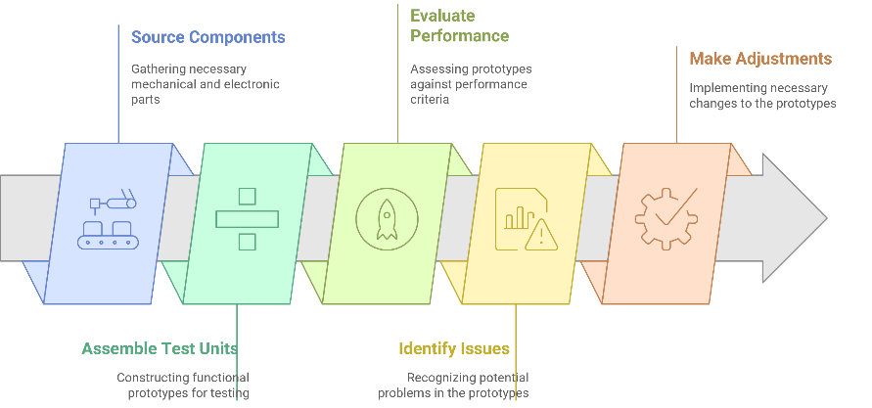
Figure 5: Prototype Development
Phase 3: Fabrication and Testing Process
In Phase 3, the machines were constructed with food-grade stainless steel to be safe to use and meet industry standards. Under practical operating conditions, the machines were then put to the test to see how well they would operate under actual scenarios. Feedback obtained from the tests proved to be very valuable, as it was utilized to adjust the most important parameters like roller alignment and the rate of extrusion to improve the overall efficiency of the machines. An overview of the process is presented in Figure 6.

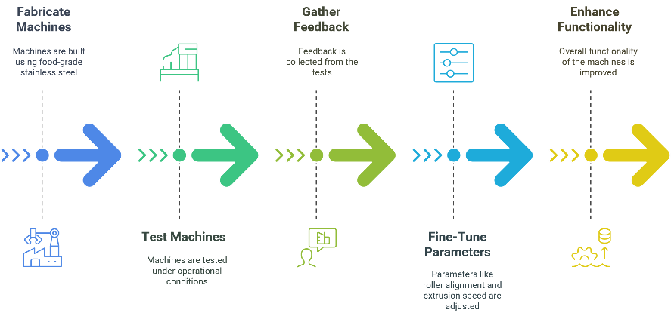
Figure 6: Fabrication and Testing Process

Phase 4: Finalization and Implementation
The last step in this project was to complete the systems as pictured in Figure 7. The machines were integrated successfully into a well-functioning production system and the operators were able to adjust their workload. After all the necessary work was completed, the machines were handed over to the Small and Medium-sized Enterprise (SME). We provided extensive user guides and training sessions for the operators, to give them the necessary skills and knowledge to operate the new production system. They were successfully integrated in a well-functioning production system and the operators were able to change the work load. After all necessary works had been done the machines were handed over to the Small and Medium-sized Enterprise (SME). We provided full user guides as well as training courses for the operators so they could learn the skills and knowledge to use the new production system.

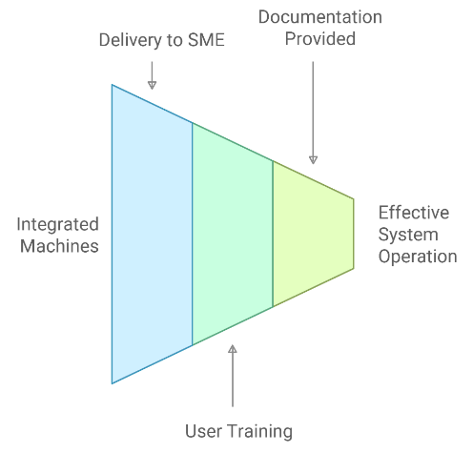
Figure 7: Finalization and Implementation

- Machine Design and Specifications
The spiral curry puff production system was designed as a three-stage integrated line comprising five interdependent machines that automate a particular stage of the process. The main factors that required automation were — in effect — the manually labour-intensive processes of dough proportioning, sheeting, rolling and cutting. Automating these processes improved product quality and manufacturing efficiency and made them scalable to small scale production operations.
The device, known as the dough extruder (Figure 9) (in this example, the most automatic type of equipment), automatically separates dough into 10g fragments. At the same time, when the dough is passed through the outlet, a rotary cutter simultaneously cuts the dough in several intervals so that there is much less labour required by the user and the quantity of dough is maintained in a uniform manner.

Conventional | Automated
Figure 8: Weighing 80g/dough: 15sec | Figure 9: Extruder- auto weighing 80g/dough:5sec

The vertical dough sheeter (Figure 11) then processes the stacked oil and water dough combination. The machine features motorised rollers with adjustable settings, enabling operators to precisely control dough thickness in accordance with specific recipe requirements. It is followed by the horizontal dough sheeter depicted in Figure 13, which handles base dough formation using synchronised rollers powered by dual electric motors. This sheet ensures even sheet distribution and complements the vertical sheeter to preserve dough layering integrity.

Conventional | Semi-Automated
Figure 10: Rolling out dough | Figure 11: Dough sheeter

Conventional | Semi-Automated
Figure 12: Rolling dough: 7sec | Figure 13: Dough Roller: 5 sec
The dough cutter machine uses a set of fine adjustable wire blades to cut the rolled dough into uniform 3 mm thick slices. Although the device is controlled by means of a manual drive, its ergonomic design considerably minimizes operator fatigue and offers a high level of precision with each cut. The simple design means that the equipment can be made cheaper than conventional systems without compromising accuracy normally associated with automated machines.

Conventional | Semi-Automated
Figure 14: Cutting out dough | Figure 15: Dough cutter

To form the spiral layers characteristic of the curry puff, a conveyor-assisted dough roller was integrated into the system. This machine gently compresses and rolls the dough into a spiral structure without damaging the layers, ensuring both functional and aesthetic consistency in the final product. This step is crucial to achieving the unique flakiness of the pastry after frying.

Conventional | Semi-Automated
Figure 16: Spiral dough | Figure 17: Dough Spiral machine

All machines were constructed using food-safe stainless steel and designed for modular use. This allows SMES to adopt individual machines according to their production needs or implement the full system as an integrated line. Each component contributes to a cohesive process that improves productivity, reduces operator dependency, and upholds product quality.

RESULTS AND DISCUSSIONS
The implementation of the automated production line led to a marked improvement across all critical stages of the spiral curry puff manufacturing process. Table 1 illustrates the significant differences observed between manual and automated methods in terms of speed, quality, and labour intensity.

Table 1: Comparative Productivity Manual vs Automated Process
Process Stage | Manual Method | Automated Method | Improvement
Dough Portioning | 15 seconds per unit; inconsistent | 5 seconds per unit; consistent 10g weight | 300% faster; improved accuracy
Dough Rolling | Labour-intensive; inconsistent | Electric-powered; consistent thickness | Reduced physical effort; uniformity
Spiral Formation | Variable spiral quality | Conveyor-assisted rolling, precise layers | Enhanced structure and aesthetics
Dough Cutting | Irregular thickness; manual slicing | Uniform 3mm slices; wire blade cutter | Improved precision and consistency

In the dough portioning process, manual labour typically required 15 seconds per unit and often resulted in inconsistencies in weight. In contrast, the newly developed PLC-controlled extruder reduced the time to only 5 seconds per unit while producing uniform 10-gram portions. This alone accounted for a 300% increase in efficiency, while also eliminating common errors associated with manual weighing and cutting.
The rolling process, formerly dependent on the skill and stamina of the operator, was transformed through the introduction of vertical and horizontal motorised sheeters. These machines not only standardised dough thickness but also significantly alleviated the physical burden on workers. The resulting consistency preserved the integrity of the dough layers, a critical factor in maintaining the product’s structural stability and desirable texture
The spiral forming stage, which traditionally exhibited variability in shape and tightness, demonstrated significant improvement with the implementation of a conveyor-assisted roller system. Automation at this point in development allowed for uniform shape spirals to be produced which was critical both in terms of design aesthetics and in terms of the consistency of fry-ups.
The calibrated, manual operated wire-blade cutter provided much improved precision in the cutting process which previously was restricted to various hand methods. the wire blade cutter consistently cut regular 3 mm slices with minimum operator effort and improved food appearance and portion management.
Implementation of the whole system resulted in an increase of 3 times production capacity. Beyond increases in efficiency, automation also improved quality control, reduced human resources dependence on manual labor and allowed scalability to the future. The results confirm both technical relevance and economic viability of mechatronic technologies in traditional food processing and support both the strategic importance and economic feasibility for SMEs involved in the industry.

CONCLUSIONS AND RECOMMENDATIONS
The spiral curry puff production system is an example of an applied engineering technique that has been applied in actual manufacturing at a high level (industrial and academic level) to address operational problems encountered by SMEs working in the traditional food manufacturing chain. The project utilizes modular semi-automated technology to increase the production speed, consistency, quality and allow the reduction of hand labor and therefore the practical use of applied engineering techniques.
Following the same philosophy that lies at the heart of the technology, in addition to being highly functional but easily portable, cost-effective and adaptable, the system offers SMEs operating in this kind of environment the opportunity to build their own framework for innovation, development and improvement in a replicable and reusable manner. In addition, the project shows that public/private research collaboration contributes significantly towards generating industrial solutions that are long-term and flexible enough to survive and contribute to sustainability of the larger manufacturing community.
Similar development approaches could also be deployed for other traditional food products that would require labour-intensive processes in the future. A consistent flow of cooperation between technical institutions and local industries will be needed to support the digital transformation of small and medium-sized enterprises. The use of smart monitoring technologies (more specifically IoT-based systems for predictive maintenance and quality control) has the potential to significantly improve system performance, operational transparency, and long-term sustainability.

REFERENCES

[1] PPRN Malaysia, “Program Pemindahan Ilmu untuk Industri,” Ministry of Higher Education Malaysia.
[2] A. Ghosh and D. Smith, Mechatronics in Food Processing. Springer, 2018.
[3] Malaysian Investment Development Authority (MIDA), “Automating for the Future: HEXA's Journey of Digitalising Their Food Manufacturing Process,” 2020.
[4] M. Zulkifli et al., “Modular Automation in Food SMEs: Case Studies and Applications,” Journal of Food Engineering, vol. 145, pp. 65–74, 2020.
[5] Southwest Research Institute, “Food Manufacturing Automation,” 2024.
[6] Deskera, “The Role of Automation in Food Manufacturing Processes,” 2023.
[7] IBIMA Publishing, “Driving and Fostering Strategic University and Industry Collaboration,” 2015.
[8] Robotics Tomorrow, “Food Robotics - Transforming the Future of Food Processing,” 2024.
[9] MIDA, “Automation, Digitalisation Impetus to Drive SMEs Recovery and Next Level of Growth,” 2022.
[10] KUKA, “Automation in the Food Industry,” 2024.
[11] LAC Conveyors & Automation, “Robotics and Automation in the Food Industry and Its Future,” 2024.
[12] University Malaysia Perlis (UniMAP), “Academia-Industry Collaboration in the Food Technology Sector,” 2023.
[13] J. T. Tan, “Collaboration Management for University-Industry Projects in SMEs' Food Processing Industry,” Universiti Sains Malaysia (USM), 2017

