**A Review of Artificial Intelligence techniques in Social Media prospective**

Author

*Ms Vanshika Bali ,Student, SGTBIMIT , New Delhi , India*

*DrRatandeep Kaur ,Assistant Professor ,SGTBIMIT, New Delhi, India, ratandeep.sgtbimit@gmail.com*

*ABSTRACT:Social media platforms, in recent times, have become deeply ingrained within modern society, with countless billions of users interacting day in and day out. Behind the scenes of these platforms lie intricate artificial intelligence (AI) algorithms that curate content, offer recommendations, and optimize the user experience. This paper now engages with a review of key ways in which AI enables and enhances social media, encompassing the domains of natural language processing, computer vision, recommendation systems, chatbots, and content moderation. Challenges and ethical considerations concerning the use of AI in social media are further explored. To conclude, this paper asserts that while AI does unlock immense potential, it necessitates the implementation of guidelines and oversight to ensure a responsible deployment.*

---------------------------------------------------------------------------------------------------------------------------------------

Date of Submission: 26-03-2024Date of acceptance: xx-xx-xxxx

---------------------------------------------------------------------------------------------------------------------------------------

# INTRODUCTION

Social media has become deeply embedded into modern life, connecting over 4.5 billion users across online platforms every day (Mohsin, 2022). Services like Facebook, Instagram, Twitter, and TikTok enable unprecedented sharing of ideas, information, news, and entertainment. However, complex artificial intelligence (AI) systems are utilized behind the scenes to curate and personalize user experiences on these platforms.

AI refers to computer systems capable of human-level cognition (McCarthy et al., 2006). On social media, AI powers functions like personalized recommendations, predictive advertising, content moderation at scale, and endless news feeds tailored to individuals. By mining user data, AI algorithms infer preferences, determine engagement, and target users with monetizable content.

Thus, AI drives social media's incredible reach and stickiness. However, concerns persist regarding long-term impacts of uncontrolled, profit-driven algorithms on issues like privacy, misinformation propagation, embedded biases, and vulnerability to manipulation (Tufekci, 2022). Critical knowledge gaps remain about how to responsibly balance innovation and oversight when deploying AI systems that substantively shape how billions around the world connect and communicate

# RESEARCH OBJECTIVE

This paper investigates ethical issues arising from AI utilization in social media through a mixed methods approach. Specifically, it analyzes quarterly reports from platforms like Facebook to understand profit incentives shaping algorithmic curation (Horwitz et al., 2020). Expert interviews contextualize financial findings via perspectives from computer scientists and policy researchers. Additionally, investigative journalism articles reveal controversies around data privacy, misinformation, and discrimination enabled by uncontrolled AI systems (Vincent, 2019). By consolidating these data sources, the research aims to formulate governance recommendations balancing innovation with user rights and societal wellbeing.

**Limited AI or Assisted AI**

Limited AI or Assisted AI refers to systems that exhibit narrow intelligence on specific tasks they are designed for. In social media, this includes AI that analyzes text to understand sentiment, moderates content, or provides recommendations. But the platform functionality is still mostly constrained by manual programming rather than self-directed learning. For instance, a Chabot may hold conversations based on predefined scripts rather than forming its own responses as shown in Figre1.1.

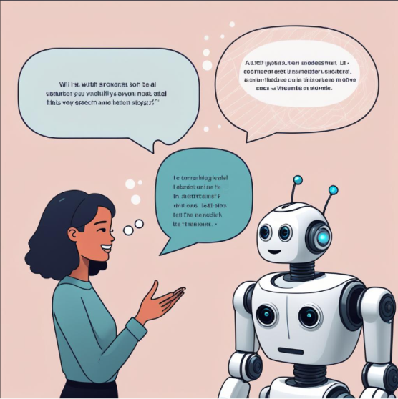

Fig 1.1 Limited AI

**Adaptive AI or Autonomous AI**

Adaptive AI or Autonomous AI suggests systems that continue enhancing themselves automatically beyond their initial programming and without human guidance. This promises more fluid and natural interactions tailored to subtle user cues. An example on social platforms may be conversational bots that train themselves based on millions of real dialogues to improve their language understanding and reply relevance over time rather than rely solely on preset responses.

While most current AI on social media resembles Limited AI focused on augmenting particular functions, steady progress is bringing Autonomous AI capabilities like self learning bots closer to reality. Striking the right balance between usefulness and safety will be crucial as these technologies emerge. But guided properly by ethical principles, AI has immense potential to keep making communication and discovery increasingly intuitive on social platforms evolving in tandem with user needs.

**III. GAP ANALYSIS**

While AI promises advancements in social media, research gaps persist regarding long-term impacts on wellbeing (Burke & Kraut, 2016). Specific vulnerabilities highlight mental health risks from uncontrolled algorithms prioritizing addiction and outrage (Whittaker et al., 2022). Persisting racism and sexism also become amplified by biased datasets and profit-driven optimization absent ethical oversight (Benjamin, 2019). However, opportunities exist to mitigate these issues through policy and multi-stakeholder initiatives promoting transparency, explainability, and accountability (Jobin et al., 2019). Future research must measure real-world impacts supplemented by updated regulations curtailing dangerous practices. Key governance opportunities involve crafting frameworks balancing business incentives with user protections around privacy, agency, and safety (Florid & Cowls, 2021). Ultimately, ensuring equitable advancement of AI in social media requires evidence-based debate on prudent oversight models rooted in digital rights and cantered on human flourishing.

# IV. APPPLICATIOND OF AI AND SOCIAL MEDIA

Social media platforms leverage various AI technologies to optimize user experiences and business objectives. A key application area involves personalized content duration powered by machine learning recommendation engines (Covington et al., 2016). Algorithms analyze user data and activity to model individual interests, then predict engagement with different posts to populate feeds. This provides customized, relevant content to increase time-on-site metrics. Instagram's Explore feature similarly employs AI to surface trending topics and recommendations aligned to taste profiles (Bisong, 2019).

Another major use case is conversational agents, including chatbots and virtual assistants using natural language processing (NLP). These AI agents facilitate personalized customer service at scale for brands (Adamopoulou & Moussiades, 2020), while also enabling transactional capabilities to drive sales.

Looking ahead, generative AI could substantially impact social media landscapes. Systems like DALL-E which create original images and text given prompts could automatize content creation (Hyken, 2020). Combined with avatar and video synthesis technology, tools democratizing media production could transform entertainment and information ecosystems. However, risks around misuse necessitate governance ahead of mass societal integration.

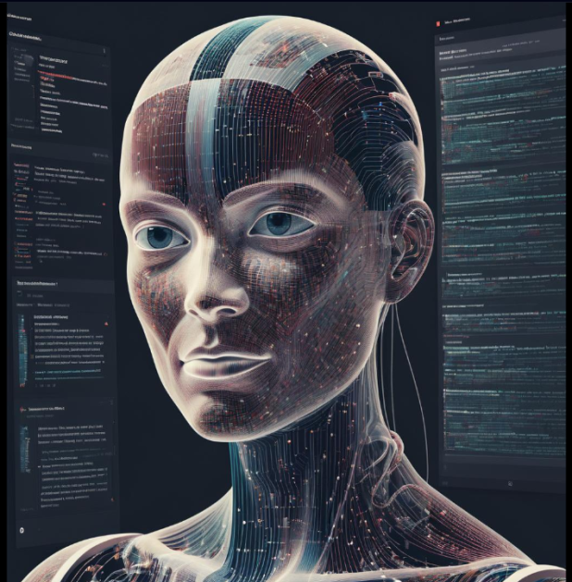

Fig 2.1 Application of AI in Phones Fig 2.2 Application of AI in Robots

**V. CONCLUSIION**

The ascent of social media has restructured communication, entertainment, and information access for billions worldwide. Underpinning the exponential growth are increasingly sophisticated AI technologies unlocking new capabilities. Algorithms parse gigantic datasets to optimize infrastructure, moderate wisely, match users to niche interests beyond their affiliations and automate tasks allowing more creative expressions. Computer vision elevates production aesthetics while natural language processing introduces frictionless navigation. Through hyper-personalization, AI has transformed social platforms into almost sentient environments customizing experiences to align with subtle user preferences. However, this also spotlights pressing ethical dilemmas regarding privacy, algorithmic bias and data Vulnerability falling within exploitative purposes. The incredible prosperity AI brings global networking also highlights its latent perils mandating collective diligence. Fundamentally though, AI represents an immense leap forward driving social media’s evolution - raising human connections and access to opportunity bound only by imagination.

**REFERENCES**

1. McCarthy, J., Minsky, M. L., Rochester, N., & Shannon, C. E. (2006). A proposal for the dartmouth summer research project on artificial intelligence, august 31, 1955. AI magazine, 27(4), 12-12.
2. Mohsin, M. (2022). 10 social media statistics you need to know in 2022 [infographic]. Oberlo. https://www.oberlo.com/blog/social-media-marketing-statistics
3. Tufekci, Z. (2022). Meta Cannot Continue Business as Usual. The Atlantic. https://www.theatlantic.com/ideas/archive/2022/10/meta-facebook-business-model-problem/671645/.
4. Horwitz, J., Seetharaman, P., & Fields, D. (2020). Facebook knows it encourages division. Top executives nixed solutions. Wall Street Journal, 5.
5. Vincent, J. (2019). AI facial recognition software is worryingly good—even if you’re black or female. The Verge.
6. Benjamin, R. (2019). Race after technology: Abolitionist tools for the new jim code. John Wiley & Sons.
7. Burke, M., & Kraut, R. E. (2016). The relationship between Facebook use and well‐being depends on communication type and tie strength. Journal of Computer‐Mediated Communication, 21(4), 265-281.
8. Floridi, L., & Cowls, J. (2021). A unified framework of five principles for AI in society. Harvard Data Science Review, 1(1).
9. Jobin, A., Ienca, M., &Vayena, E. (2019). The global landscape of AI ethics guidelines. Nature Machine Intelligence, 1(9), 389-399.
10. Whittaker, M., Crawford, K., Dobbe, R., Fried, G., Kaziunas, E., Mathur, V., West, S. M., Richardson, R., Schultz, J., & Schwartz, O. (2022). AI now report. AI Now Institute. <https://ainowinstitute.org/AI_Now_2022_Report.pdf>
11. Adamopoulou, E., &Moussiades, L. (2020). Chatbots: History, technology, and applications. Machine Learning with Applications, 2, 100006.
12. Bisong, E. (2019). Google colaboratory. In Building Machine Learning and Deep Learning Models on Google Cloud Platform (pp. 59-64). Apress, Berkeley, CA.
13. Covington, P., Adams, J., &Sargin, E. (2016). Deep neural networks for youtube recommendations. Proceedings of the 10th ACM conference on recommender systems, 191-198.
14. Hyken, S. (2020). AI And Chatbots Are Transforming Social Media. Forbes. https://www.forbes.com/sites/shephyken/2020/07/25/ai-and-chatbots-are-transforming-social-media/?sh=1b7a30b34785