# DESIGN AND CONSTRUCTION OF A GSM AND INTERNET OF THINGS (IoT)-BASED DISTRIBUTION TRANSFORMER MONITORING SYSTEM USING ATMEGA 328P MICRO-CONTROLLER

**IGWE, PAUL EGBE, J.M. MOM Ph.D, E.T. IORKYASE Ph.D DEPARTMENT OF ELECTRICAL AND ELECTRONICS ENGINEERING, JOSEPH**

# SARWUAN TARKA UNIVERSITY, MAKURDI – NIGERIA.

**ABSTRACT**

Distribution transformers are vital components of the power system that require constant monitoring and control to ensure their optimal operation and prevent failures. This work presents the design and construction of a GSM-based distribution transformer monitoring system using ATMEGA328P microcontroller. The system uses various sensors to measure the parameters of the transformer and the substation, such as voltage, current, frequency, oil level, temperature, humidity, and pressure. The system also uses GSM module to send SMS alerts to the substation manager in case of any fault or abnormal condition. The system also has IoT capability which sends and retrieves data from the internet and update an online dashboard. The system also incorporates a wireless camera that can be controlled remotely to monitor the substation vicinity and detect intruders. The system was tested under different scenarios and faults and showed satisfactory performance in monitoring and controlling the distribution substation. The system offers a cost-effective, reliable, and efficient solution for distribution transformer management

***Keywords:*** *Transformer, GSM kit, Microcontroller, Innovation, Sensors, Efficiency.*

# INTRODUCTION

In modern times, humans rely heavily on electricity for day-to-day activities [7]. Electricity is considered the third most important factor of production, following labor and capital, in economic models [5]. It is widely acknowledged in the literature that chronic energy poverty is one of the main factors hindering socioeconomic development in Nigeria and other African countries [6].

To promote socio-economic development in Nigeria, it is crucial to establish an effective and efficient electric power system. The distribution system is a key component of the power system, acting as a link between the high-voltage transmission system and consumer services [3]. The distribution transformer plays a critical role in the distribution network, as it steps down the high

voltage from the transmission network to a lower voltage suitable for end-users [2, 4]. Furthermore, the distribution transformer represents a significant investment in the distribution network [7].

The most common causes of distribution transformer failure include overloading, high temperature, and phase unbalance. Transformer failure can result in abnormal voltage, current, and frequency being supplied to consumers, or a complete power outage. Repairing or replacing a failed transformer requires substantial capital investment. Additionally, other equipment within the distribution substation can be subjected to vandalism, leading to disruptions in power supply to consumers. However, the failure of distribution transformers can be prevented, and regular maintenance can be carried out through remote monitoring of transformer variables.

This research focuses on the remote monitoring of distribution substations using a GSM/GPRS module, ATMEGA328P microcontroller, and Internet Protocol (IP) camera. The microcontroller is connected to sensors that monitor transformer voltage, current, oil level, winding temperature, air pressure, and intrusion. The IP camera captures images within the vicinity of the distribution transformer. Remote communication with the monitoring system is facilitated through GSM technology and IoT. When a malfunction or impending failure is detected, the responsible personnel is alerted. By monitoring the parameters of the distribution transformer remotely, operation at its optimum rating can be ensured, and the reliability of the distribution network can be increased.

# MATERIALS

The materials used in the design of this project include hardware and software material components. The hardware components or materials include; ATMEGA328P microcontroller, current sensor (ZMCT 103C), Voltage sensor(Voltage divider rule), Temperature sensor (DS18B20), Liquid level sensor (XKC Y25 T12V), Gas sensor (MQ-2), Ultrasonic sensor (HC-SR04), GSM/GPRS module, Liquid Crystal Display (LCD), IP Camera.

# METHODOLOGY

GSM

network

LOAD

The working principle of this GSM-IoT based distribution transformer monitoring system is built around the microcontroller (ATmega328P), the various sensors, switching control (relays) and a GSM module which is interfaced with the microcontroller. the sensors, (voltage, current, temperature, oil level, gas, ultrasonic sensor) senses the values of the parameters they are monitoring and send an output signal to the microcontroller. the microcontroller processes these signals received, compare them to the preset levels to determine if there is a variation between the received signal value and the preset value. The MCU sends a control signal to the relay if there is variation between the values compared. The MCU also makes transmission of the status of the transformer to the operator through the GSM module. The module sends an SMS to the operator. A web application has been developed which interfaces with the GSM module through IoT where real-time information about the transformer status can be monitored.

|  |
| --- |
| LCD DISPLAY |
| Relay Unit |
| GSM/GPRS  MODULE |

Fig. 1: Block Diagram

Current

Ultrasonic

Gas Sensor

Oil Level Sensor

Temperature

Voltage

POWER SUPPLY UNIT

Buzze

Utility Company

ATMEGA328P

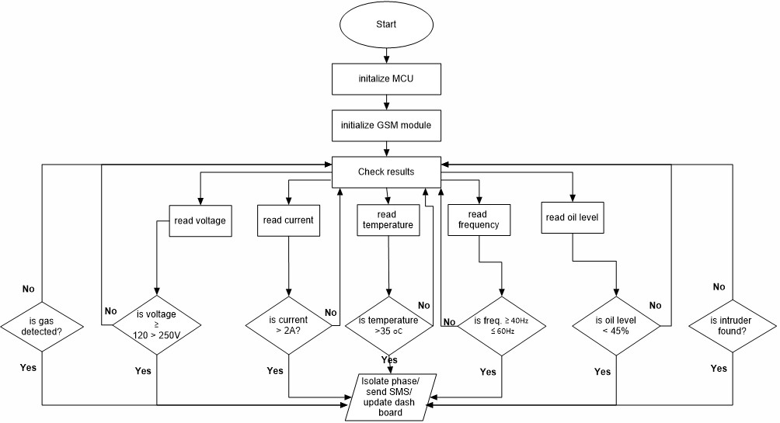

Fig. 2: Flowchart of the entire process

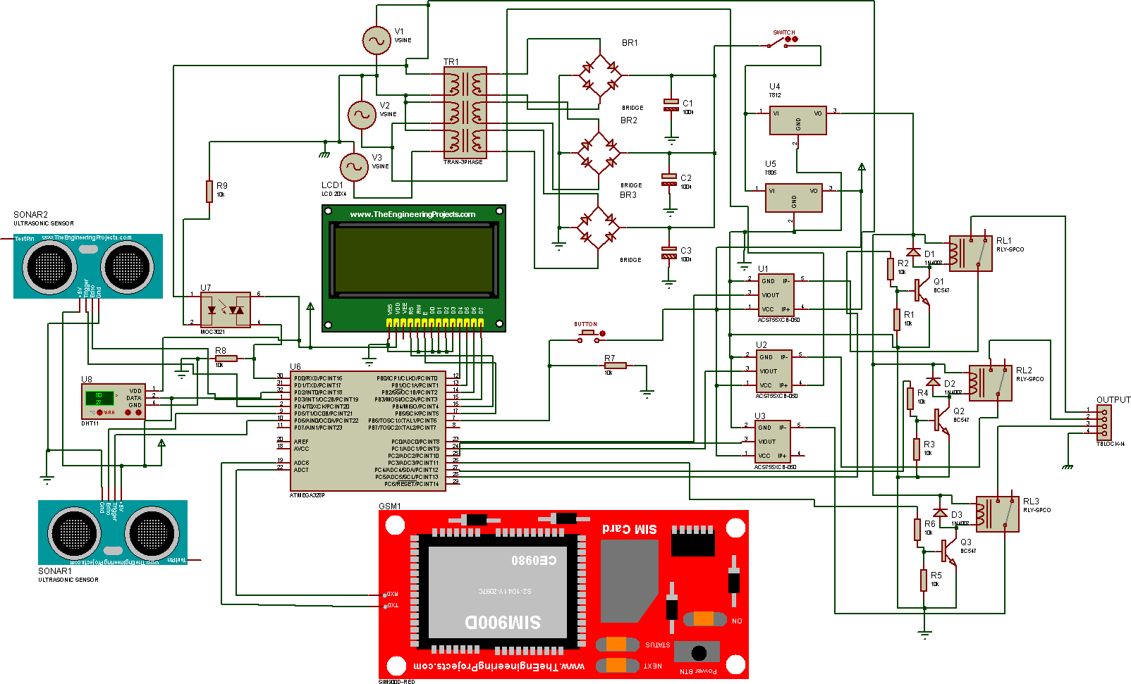

Fig. 3: Circuit Diagram of the Monitoring System

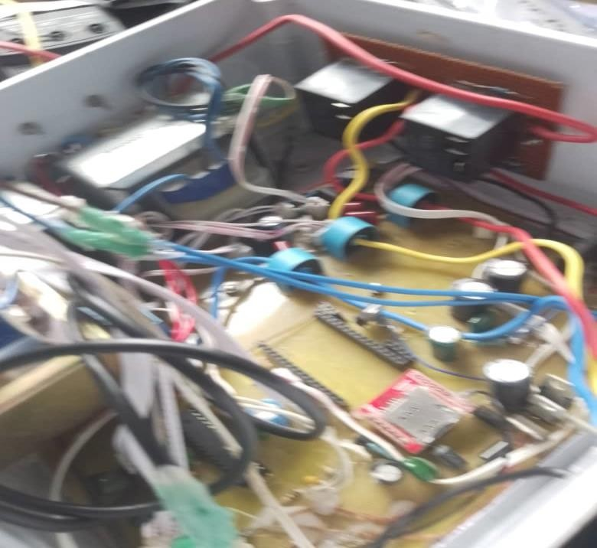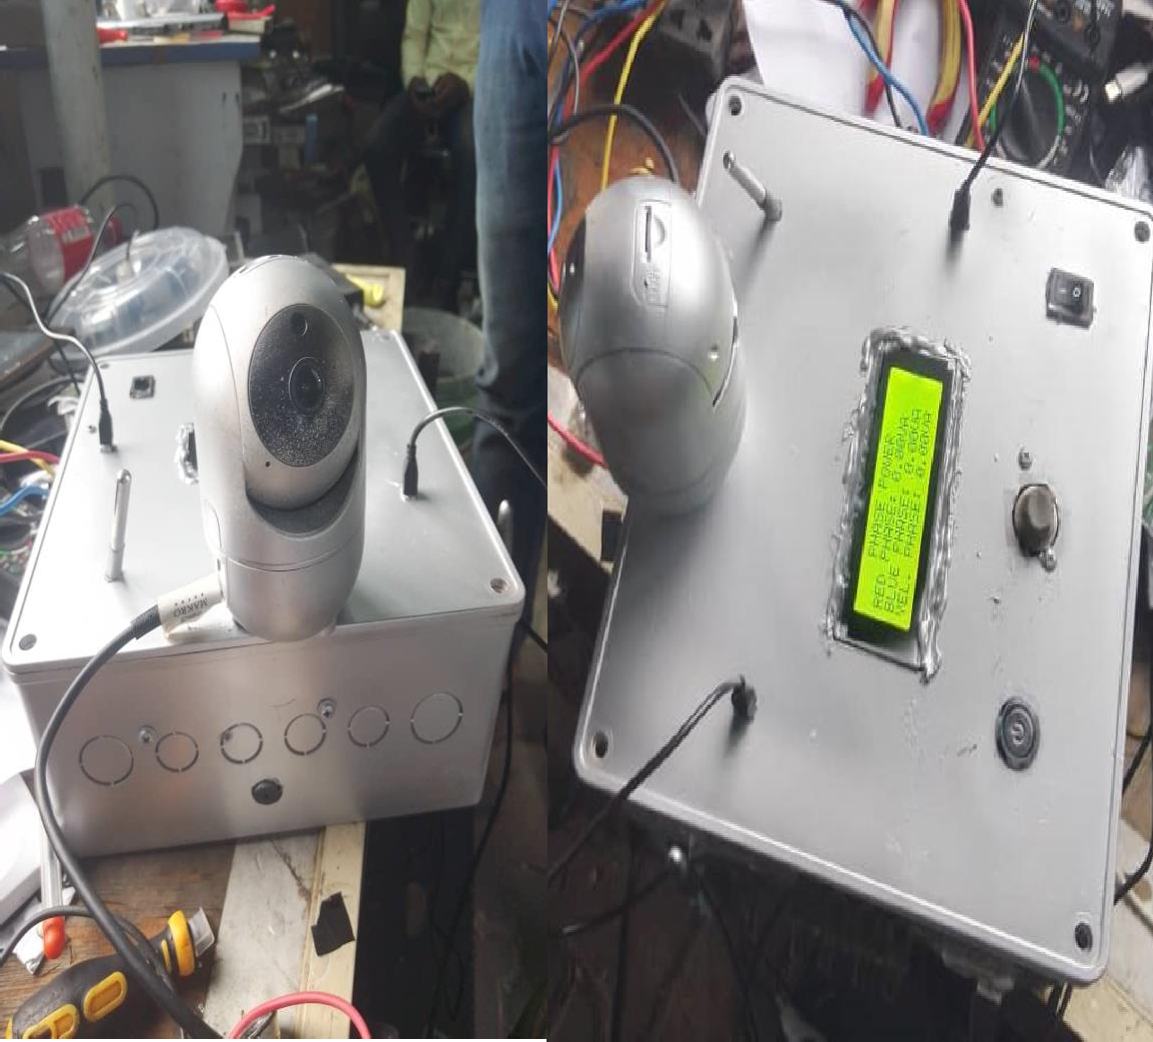

Fig. 4: Complete hardware implementation of the GSM and IoT-based transformer monitoring system

# SOFTWARE DESIGN IMPLEMENTATION

The software design of this thesis includes the software used in programming the microcontroller, the programming languages and the frameworks used in building the web server resources in the substation transformer monitoring system. Each language plays a specific role in creating a dynamic, interactive, and user-friendly web application. The software components used are Arduino IDE with embedded C language, Front end components (HTML, JavaScript, CSS, Ajax, Bootstrap framework), Back end components (PHP and MySQL), IoT platform with Arduino Wi-Fi.

# TESTING AND RESULTS

The GSM-IoT based distribution transformer monitoring system, which employed the ATMEGA328P microcontroller, was rigorously tested to evaluate its performance in detecting and responding to various faults and anomalies in the distribution substation. The following Plates 2 to 7 and Table 2 show the results obtained from the hardware system.

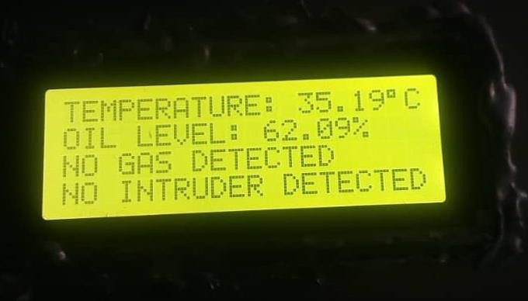

Plate 1: When Gas and Intruder is not Detected, Temperature is 35.19℃ and oil level is 62.09%

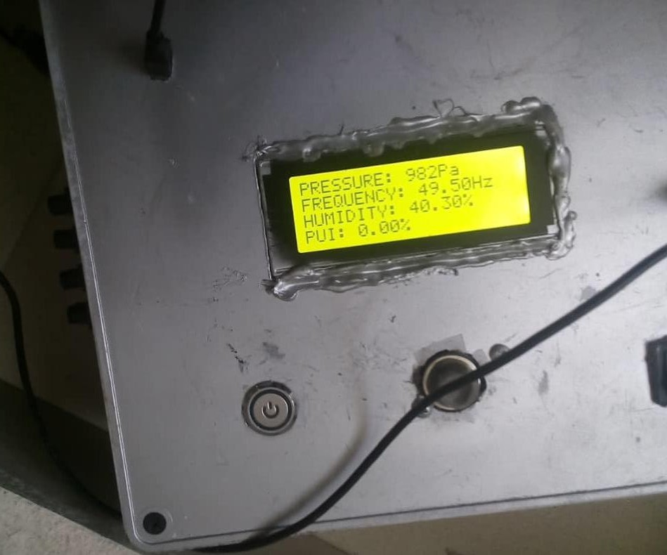

Plate 2: When Pressure is 982Pa, Frequency is 49.50Hz, Humidity is 40.30% and PUI is 0.00%

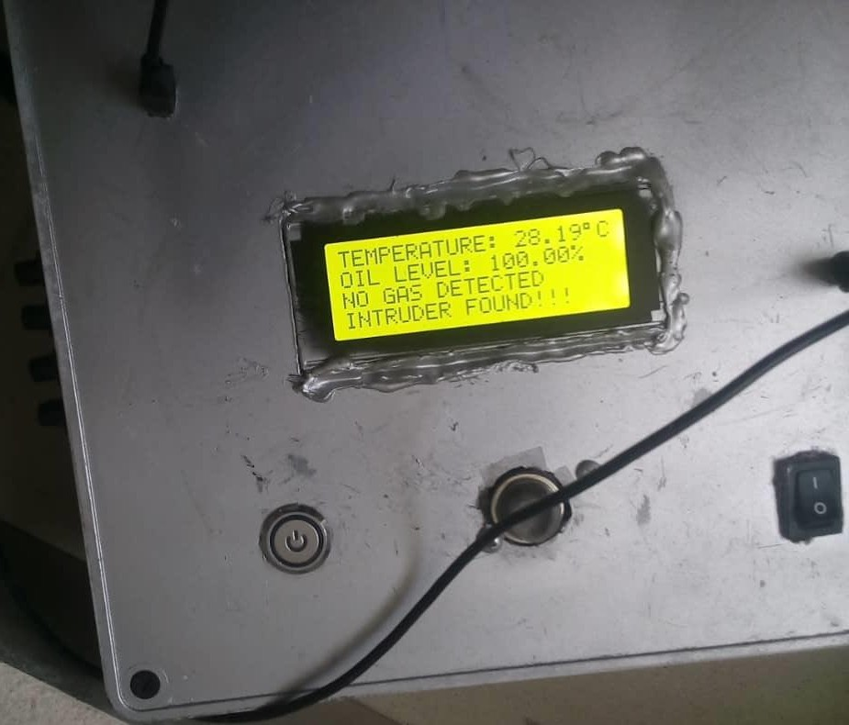

Plate 3: When Gas is not Detected, Intruder is Detected, Temperature is 28.19℃ and oil level is 100.00%

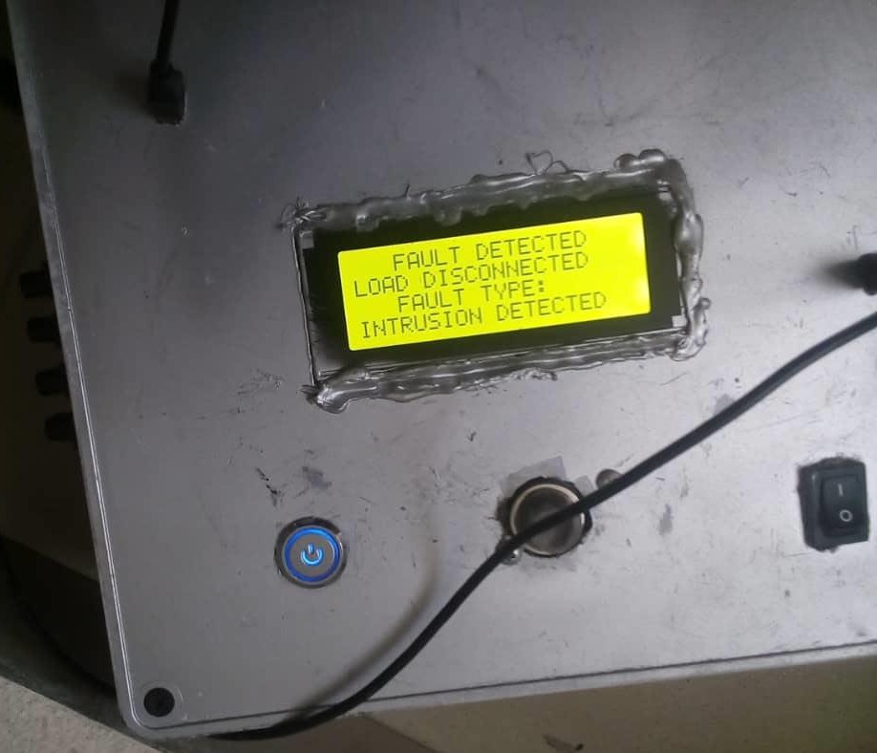

Plate 4: When Fault is Detected, Load is Disconnected and Fault Types is Intrusion

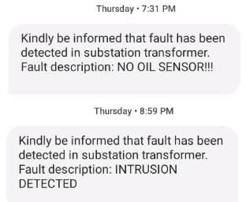

Plate 5: SMS Notifications from the GSM Module

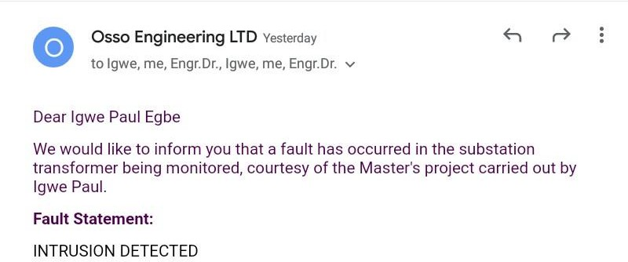

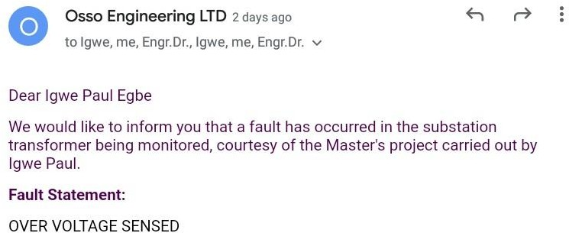

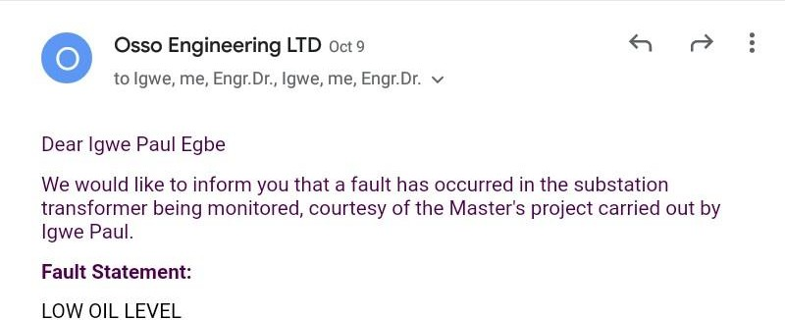

Plate 6: Email Messages Received when Fault is Detected

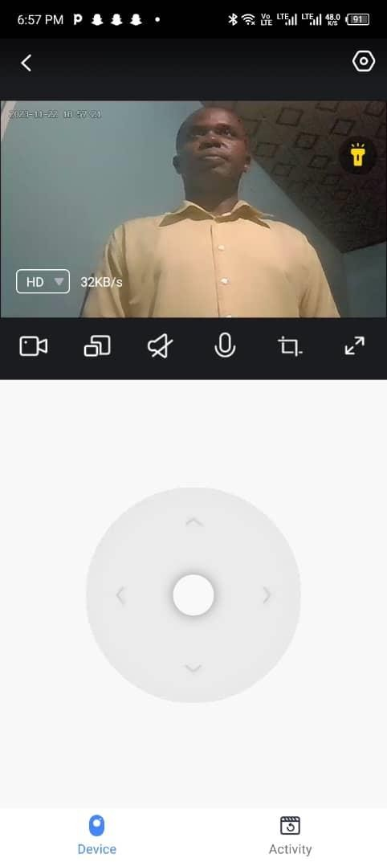

Plate 7: Picture Captured by IP Camera When Intrusion Is Detected

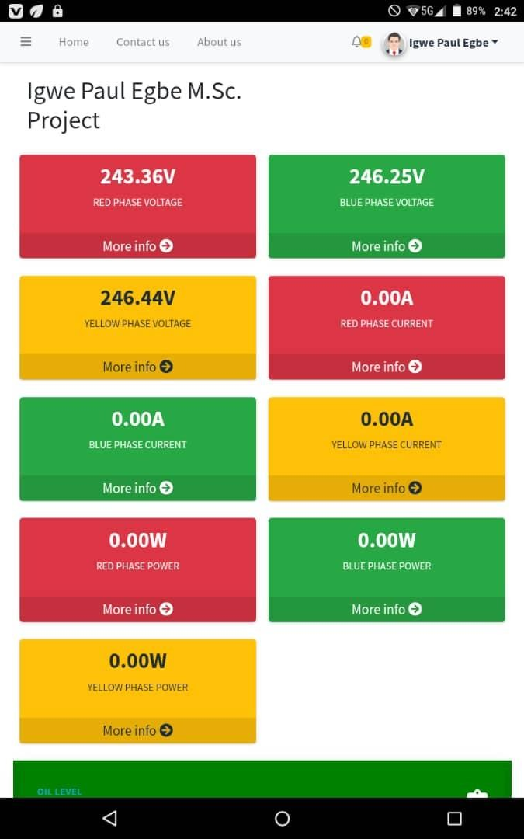 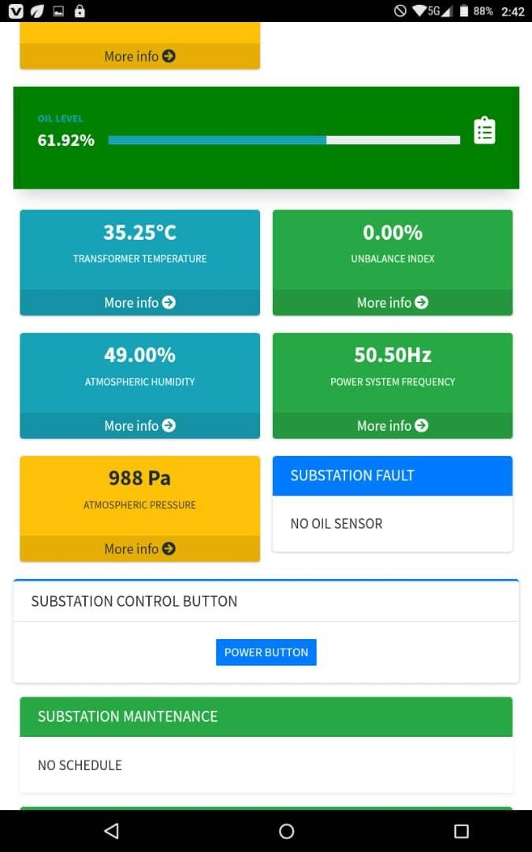

Plate 8: Internet platform for the monitored transformer parameters

Table 1: Data of Monitored Parameters as sent to Internet

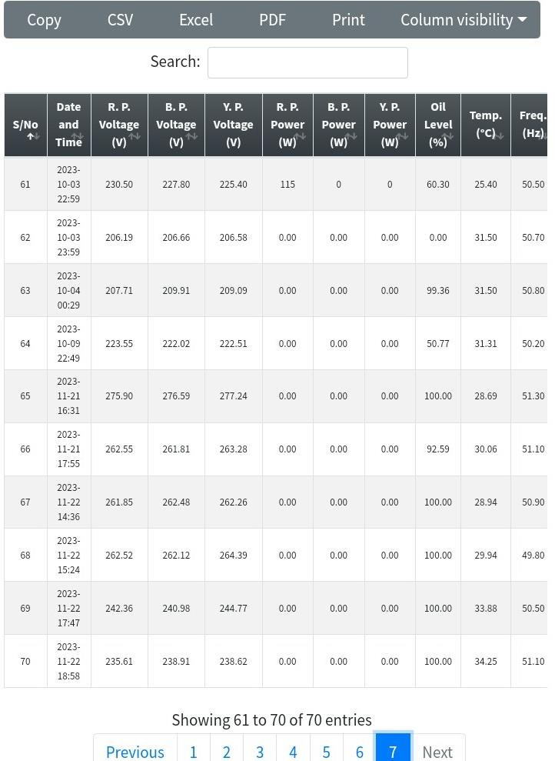

# DISCUSSION OF RESULTS

The results obtained from the GSM-IoT based distribution transformer monitoring system using the ATMEGA328P microcontroller is discussed:

Plate 1 represents when GSM-IoT based distribution transformer monitoring system has not detected gas and intruder. The room temperature was 35.19℃ and oil level was 62.09%. Plate 2 represents when pressure was 982pa, frequency was 49.50hz, humidity was 40.30% and PUI was 0.00%. when the parameters were varied, the outcome is shown in Plate 3 which represents when gas was not detected, intruder was detected, temperature was 28.19℃ and oil level was 100.00%.

Plate 4 represents when fault was detected, the load was disconnected, and fault type was displayed as intrusion while Plate 5 represents the SMS sent by the GSM module interface with the microcontroller of the system and received in a mobile phone and the types of faults detected were sent. Plate 6 represents the email communications of various faults detected and sent to the maintenance personnel on duty. When the fault detected was found to be intrusion, the personnel used the IP camera to take the picture of the intruder as presented in Plate 7. Plate 8 represents the IoT platform for monitoring transformer parameters. Table 1 displays all the information of the status of parameters to be measured and displayed in internet using the in-built Wi-Fi module of the microcontroller used which is sent to internet.

# CONCLUSION

In conclusion, the GSM-IoT based distribution transformer monitoring system using the ATMEGA328P microcontroller has met the defined research objectives. It effectively monitors critical parameters, detects faults, provides remote communication, ensures security, and integrates IoT features. This work has presented the design and construction of a GSM-based distribution transformer monitoring system using ATMEGA328P microcontroller. The system has achieved the following objectives:

1. use of sensors in obtaining the parameter of the distribution transformer and distribution substation.
2. use of GSM communication protocol in remote monitoring of the distribution substation parameter and communication between the system and maintenance personnel.
3. use of IoT technology to send and retrieve data from the internet and update an online dashboard.
4. use of wireless camera to monitor the activities of what is happening in the substation vicinity and detect intruders.

# RECOMMENDATIONS

Based on the findings and limitations of this work, the following recommendations are made for future improvement:

1. The system can be integrated with a solar panel and a battery to provide an alternative power source in case of power outage or emergency.
2. The system can be enhanced with more sensors and actuators to monitor and control other parameters, such as tap changer position, winding resistance, insulation resistance, etc.
3. The system can be upgraded with a more advanced microcontroller or a microprocessor to increase its processing speed, memory, and functionality.
4. The system can relate to a cloud server or a database to store and analyze the data collected from the substation over time.
5. The system can be implemented in multiple substations and coordinated using a central control unit to optimize the power distribution network.

# REFERENCES

* 1. ABB. (n.d.). Distribution transformers. Retrieved from [https://library.e.abb.com/public/a944be11bf1aa2f8c12574d800433571/DistributionTransfo](https://library.e.abb.com/public/a944be11bf1aa2f8c12574d800433571/DistributionTransformers.pdf) [rmers.pdf](https://library.e.abb.com/public/a944be11bf1aa2f8c12574d800433571/DistributionTransformers.pdf)
  2. Desai, P. K., & Hasabe, A. M. (2016). Distribution transformer placement in radial distribution systems: A review. Renewable and Sustainable Energy Reviews, 60, 1009-1030.
  3. Dubey, R. K., Singh, S. N., & Kumar, P. (2013). Power distribution system planning and optimization: A review. *International Journal of Electrical Power & Energy Systems*, 47, 246-265.
  4. George, R., Kumar, S. S., & Sivanagaraju, S. (2018). Optimal placement and sizing of distribution transformers using particle swarm optimization algorithm. *International Journal of Electrical Power & Energy Systems*, 101, 253-261.
  5. Mehta, N. B., & Mehta, P. K. (2002). Energy economics: Concepts, theories, and empirical evidence. Academic Press.
  6. Momoh, J. O., Omoigui, L. O., & Adewuyi, O. B. (2018). Energy poverty in Nigeria: Causes, impacts, and policy options. Energy, 145, 79-88.
  7. Sanjeeya, B. L., Kumar, B. S., & Kumar, M. G. (2018). Optimal sizing and placement of distribution transformers considering reliability constraints. *International Journal of Electrical Power & Energy Systems*, 99, 228-239.