WHALE OPTIMIZATION ALGORITHM APPROACH FOR OPTIMAL SIZING AND LOCATION OF DISTRIBUTED RESOURCES ON NIGERIAN DISTRIBUTION NETWORK
Fashakin A.¹, Adepoju G.A², Baruwa A.A³, Ogunkeyede O.Y⁴
^{1,2}Department of Electronics and Electrical engineering, Faculty of Engineering, Ladoke Akintola University of Technology, Ogbomosho, Nigeria
^{3,}Department of Electrical and Electronics engineering, Osun State College of Technology, Esa Oke, Osun State. Nigeria
4, Department of Electrical and Electronics engineering, Ajayi Crowther University, Oyo. Oyo State. Nigeria
Email address: adebayofasakin@gmail.com, Baruwaabiodun02@gmail.com, olabisiyinka85@gmail.com
ABSTRACT.
Distributed Resources (DR) is electrical power resources that are directly connected to the power network to increase the network power quality, improve the network voltage profile and reduce the network power loss. However, inappropriate installation of DR on distribution network usually resulted in an increase in network power loss and therefore having an undesired effect on the network. Thus, applying an optimization method capable of indicating the best sizing and location of these resources so as to reduce the distribution network power loss to a barest minimum can be more useful for system planning engineers. This study focused on the determination of the optimal sizing and location of DR for power loss minimization on a practical Nigerian network of 33-bus Ilorin industrial distribution feeder using Whale Optimization Algorithm (WOA). Forward and Backward Sweep (FBS) power flow analysis on distribution network without and with inclusion of DR was performed. The location and the corresponding DG size based on the power loss were obtained analytically using Sensitivity Analysis (SA). Thereafter, WOA technique was implemented to determine the global optimal solutions for DR placement. The results showed that WOA is more efficient and produce high quality solution in terms of system loss reduction and best placement for DR in power system compared with the application of SA. Hence, this study can be used by distribution power system engineers for enhancing the optimal operation of electrical distribution network.
Keywords: Distribution Resources, Power Loss, Sensitivity Analysis, Whale Optimization Algorithm, Forward and Backward Sweep, Distribution Network.

- INTRODUCTION
Power loss in distribution network is the major problem in power sector and these losses occur in the process of supplying electrical power to consumers. Thus, the performances of distribution networks are becoming inefficient due to the increase in distribution losses as demand for steady electricity supply increase. This has posed a challenging task to power system engineers in maintaining a reliable network economically [1,2]. With this regard, changing environment of power systems design and operation has necessitated the need to consider active distribution network by incorporating Distributed Resources (DR) unit [1].
Distributed Resources are stand-alone electric generation units located within the electric distribution network close to end user. In addition, installing DR on distribution networks has many different impacts on the parameters of the distribution networks. These impacts can be positive and negative [2]. The positive impacts of installing DR includes increasing the power quality, improving the voltage profile, reducing the power loss and deferring the necessity of improving the capacity of substations [2]. While the negative impact includes increase in fault current, reduction ofthe real-time control,sensitivity and selectivity of the distribution network protection [3].
However, with the advent of restructuring and performance based rates, it is critical for utilities to minimize the negative impact and maximize the positive impacts of DR.These must be solved before choosing DR as a planning option, because, inappropriate installation of DR in a distribution network will result in an increase in power losses and reduction in voltage profile of the network, which will has undesired effect on the network[1-5].
Hence, it becomes necessary to investigate where DR capability and placement could be used to enhance distribution network planning and operation [4-6].Therefore, effort needs to be made for optimal sizing and location of the DR in distribution network to reduce the power loss in the distribution network to the barest minimum [4].
Several evolutionary, swarm intelligent based optimization techniques andmetaheuristic optimization algorithm such as Firefly Algorithm (FA), Genetic Algorithm (GA), Cuckoo Search Algorithm (CSA) and Salp Swarm Algorithm (SSA) among others are reported to have performed excellently to solve power loss minimization on distribution network based on optimal DR sizing and location in terms of quality of solution, computational time and convergence. These techniques also have the advantages of finding set of non-dominated solutions in a single run because of their multi-point search capacity. They are also less prone to dimensionality problems [7-9].
It is base on the foregoing that this study investigate the minimization of power loss on Nigerian distribution network based on optimal sizing and location of Distribution Resources using metaheuristic optimization algorithm(Whale optimization algorithm (WOA)) as optimization technique due to its ability to avoid local optimal and get a global optimal solution in solving optimization problems. This will help to improve the performance of electrical distribution system and also assist power system engineers in enhancing the optimal operation of electrical power systems.

A. Nigeria DistributionNetwork
Distribution network is the most visible part of the supply chain that usually receive attention of governments, financial agencies and associations of concerned citizens for investment, maintenance and operation expense [10].Nigeria distribution network since its inception is designed to operate radially. Whereby electric power flows in one direction from large generating power plants to the customers load along the radial feeder. In addition, Nigeria distribution network is being operated by Electricity Distribution Companies (DISCOS). The Distribution Companies provide the connection between customers and the electricity grid, and responsible for transforming or stepping down electricity from the high voltage of 132 kV at the transmission level, to the lower voltage levels of 33kV/11kV/0.415kV depending on the category of customer [11, 12].
The Nigeria Distribution Companies comprises of Electricity Distribution Companies of Abuja, Benin, Eko, Enugu, Ibadan, Ikeja, Jos, Kaduna, Kano, Port-Harcourt and Yola respectively [11]. However, for the purpose of this research data of practical Ilorin industrial 33 kV feeder distribution network of Ibadan Electric Distribution Company (IBEDC) will be used.
The single-line diagram of 33 kV 33-bus Ilorin industrial distribution feeder of Ibadan Electricity Distribution Company (IBEDC) which spans a length of about 40 km used as a case study is shown in Figure 1. The distribution feeder has thirty three buses with seventy number of substations, four injection substation with a total real power loads and reactive power of 6.15 MW and 3.04 MVar respectively, where 4.27 MW of load is connected upstream of the recloser while 1.18 MW is downstream of the recloser.

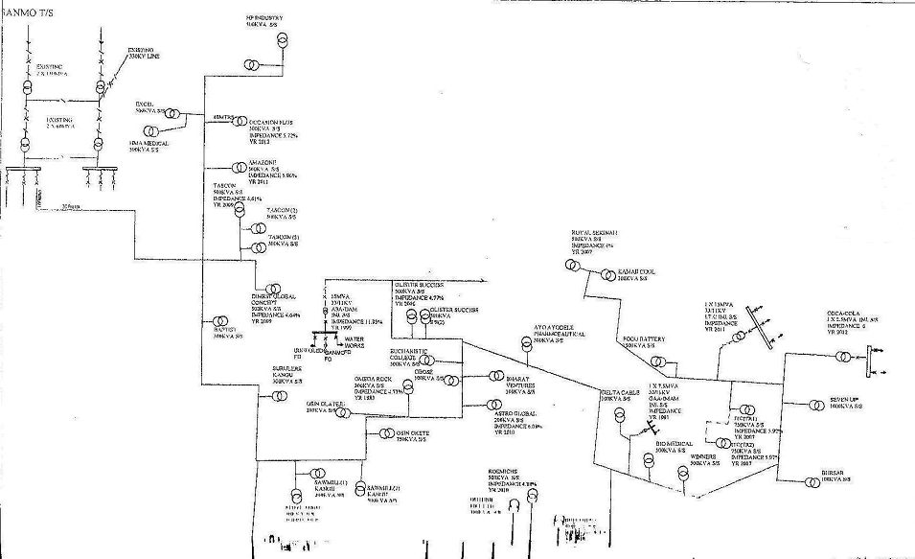

Figure 1: 33-Bus Ilorin Industrial Distribution Feeder

B. Forward and Backward Sweep Distribution Load Flow
Forward and Backward Sweep (FBS) distribution load flow is the most popular distribution load flow technique due to its high computational efficiency, low memory requirements and fast convergence characteristic. The FBS method models the distribution system as a tree network, with the source denoted as the root of the tree and branch networks as the layers that is far away from the root node. In this load flow, weakly meshed networks are converted to radial networks by breaking the loops and computing injection currents. The backward sweep primarily sums either the line currents or power flows from the extreme feeder to the root. The main idea of FBS load flow is based on Kirchhoff Voltage and Current Laws [13, 14].
Consider a single line diagram of distribution network shown in Figure 2, the current and the voltage at a node in the network can be determines in four steps as Equations (1) to (6) [15]:
Step 1: Determine the injected current of each node in the network by assuming that all nodes are to be 1p.u.
$\text{Ng}$ (1)
Step 2: Calculate the current of all branches in Backward Sweep i.e from the end-customer nodes toward the root node as:
$P_{\text{LMVA}}=\sum_{i=1}^{\text{NL}}{\frac{W_{\text{Li}}}{2n}{\left[\frac{S_{i}^{\text{Post}}}{S_{i}^{\text{Max}}}\right]}^{2n}}$$S_{L}<S_{L}^{\text{Max}}$$L=1,2\text{.}\text{.}\text{.}\text{.}\text{.},\text{NL}$$S_{i}^{\text{Post}}$$S_{i}^{\text{Max}}$ (2)
Step 3: Update the voltage magnitude of all nodes in Forward Sweep as:
$i$ (3)
Step 4: Calculate the apparent power of loads with new obtained voltages of all nodes as:
$\text{NL}$ (4)
$P_{\text{IVQ}}<1$ (5)
$P_{\text{LMVA}}<1$ (6)
where;$P_{\text{IVQ}}>1$ is the given apparent load of the node; $P_{\text{LMVA}}>1$is the current of node in iteration k; $W_{\text{Li}}$ is the voltage of node in iteration k-1; $n$is the branch index ; $S_{L}$ is the current of $S_{L}^{\text{Max}}$branch in iteration $i$; $j$and $y_{\text{ik}}$are the voltages of two nodes that are connected through a branch with impedance equal to$y_{\text{ik}0}$; $y_{\text{ki}0}$ is active power mismatch in iteration k; $i$ is the reactive power mismatch in iteration k; $I_{\text{ik}}=I_{\text{ik}1}+I_{\text{ik}0}$is the apparent power of load.
Steps 1 to 4 are repeated until results satisfy the convergence indexes. FBS Load flow aim is set to stop repetition when mismatch power each initially defined boundary.
$$W_{\text{Qi}}$$
Figure 2: Single Line Diagram of Distribution Network

C. Distributed Energy Resources
Distributed Energy Resources (DER) called Distributed Resources (DR) refers to a variety of small, modular electricity-generating or storage technologies that are located close to the load they served [16]. Distributed Resources is a small power source connected at the substation, distribution feeder or at the consumer terminals. These resources include a variety of energy sources, such as turbines, photovoltaic’s, fuel cells, and storage devices, with capacities range between 1 kW to 10MW. Deployment of DR on distribution networks potentially increase the network reliability and lower the cost of power delivery by placing energy sources nearer to the demand centers [17 – 19]
Distributed Resources include renewable and nonrenewable energies. Renewable energies that are applicable for DG include wind, solar, and biomass. Whereas, nonrenewable energies include micro-turbines, gas turbines, and fuel cells [20].However, the environmental benefits of renewable DR energies outweigh that of non-renewable DR energies [3].
Distributed Resources (DR)offer a lot of advantages on distribution network performance However, depending on the characteristic, location and size of DG as well as distribution system, its effects can be negative or positive. The positive aspects include: voltage support, voltage regulation and power loss reduction, while the negative aspects include; injection of voltage with harmonics, dynamic stability and protection coordination. Therefore, there is the need for new network planning that can guarantee the changes in the distribution load configuration for technical constraints and penetration levels, in such a way that the benefits is maximized. These limitations and problems must be settled before introducing DR as a planning alternative [21, 22].

D. Distributed Energy Resources Placement Techniques
Location of Distributed Resources (DR) plays an important role in minimizing the power losses and this due to the size of distribution network in term of load (MW) which play important role in selecting the size of DR. The problem of DR allocation and sizing should be approached with caution. If DR units are connected at non-optimal locations, the system losses may increase and this will lead to undesirable effect on the network stability and reliability. The reason for higher losses is due to the fact that the distribution network was initially designed such that power flows from the sending end to the load and conductor sizes are gradually decreased from the substation to consumer point. Thus without reinforcement of the network, the use of high capacity DR will lead to excessive power flow through small-sized conductors and hence results in higher losses [6, 17, 23].
Various optimization techniques with the consideration of various objective functions have been employed for optimal placement of DR in distribution network. These techniques can be classified as analytical and Artificial Intelligence (AI) techniques. The analytical techniques such as Sensitivity Analysis (SA), Computational or Numerical technique among others are easy to implement and fast to execute. However, their results are only indicative, since they make simplified assumptions including the consideration of only one power system loading snapshot [ 16, 24, 25].
Whereas, the Artificial Intelligence(AI) techniques includes Particle Swarm Optimization (PSO), Firefly Algorithm (FA), Evolutionary Programming (EA), Modified Teaching-Learning-Based Optimization (MTLBO), Gravitational Search Algorithm (GSA), Genetic Algorithm (GA), Fireworks Algorithm (FWA), Cuckoo Search Algorithm (CSA), Ant Colony Search Algorithm (ACS), Runner-Root Algorithm (RRA) and Shuffled Frog Leaping Algorithm (SFLA). Salp Swarm Algorithm (SSA) and Whale Optimization Algorithm (WOA). These algorithms have two basic elements, which are exploitation and exploration; in exploration, different solutions are found to explore the search space to find the global optimal, but in exploitation, local search is used by exploiting information about the best solutions that have been recently found [25, 26].
Usually Artificial Intelligence techniques are robust and provide near optimal solutions for large, complex optimal placement of DR problems. Artificial intelligent represent an intelligent exploitation of solving optimization problems through a random search. Artificial Intelligence techniques are not gradient based and thus not prone to being trapped in local minima when compared to Analytical techniques [26, 27].

E. Whale Optimization Algorithm
Whale Optimization Algorithm (WOA) is a nature-inspired metaheuristic optimization algorithm which is inspired by the hunting behavior of humpback whales [28]. WOA is similar to other optimization algorithms employing swarm intelligence techniques such as Particle Swarm Optimization (PSO), Cuckoo Search Algorithm (CSA), Firefly Algorithm (FA) among others. WOA is a simple, robust and swarm based stochastic optimization algorithm. This algorithm is very efficient and can outperform other conventional algorithms based on statistical performances measured using standard stochastic test functions [25].
The algorithm works based on the behavior of humpback whales in hunting. This hunting is done by two main attacking mechanisms; by chasing the prey with random or the best search agent and by simulating the bubble net hunting strategy. Humpback whales like to hunt a group of small fish close to the surface. The whales have a very remarkable hunting method this hunting behavior is called the bubble net feeding method. The whale swim around the target inside and alongside a thin circle to make a winding shaped way, creating distinct blebs along a circle or nine (9) shaped ways altogether as shown in Figure 4. Simply, bubble-net hunting behavior could describe such that humpback whales dive down approximation 12 m and then create the bubble in a spiral shape around the prey and then swim upward the surface following the bubbles [28 – 30].
Whale Optimization Algorithm (WOA) has shown its ability to solve many optimization problems. Population-based WOA has an ability to avoid local optimal and get a global optimal solution. These advantages cause WOA to be an appropriate algorithm for solving different constrained or unconstrained optimization problems for practical applications without structural reformation in the algorithm [25]. In the context of WOA, a swarm refers to a number of potential solutions to the optimization problem, where each potential solution is referred to as a search agent [26, 28].

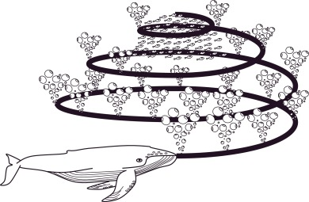

Figure 4: Bubble-Net Feeding Behavior of Humpback Whales
In order to perform optimization, the mathematical model for spiral bubble-net feeding behavior is given as follows [29, 30]:
- Encircling Prey: Humpback whales can recognize the location of prey and encircle them. Since the position of the optimal design in the search space is not known, the WOA algorithm assumes that the current best candidate solution is the target prey or is close to the optimum. After the best search agent is defined, the other search agents will hence try to update their positions towards the best search agent. This behavior is represented by theEquations (7) to (10).
$D=\left|\vec{C}\text{.}{\vec{X}}^{}\left(t\right)−X\left(t\right)\right|$ (7)
$X\left(t+1\right)={\vec{X}}^{}\left(t\right)−\vec{A}\text{.}D$ (8)
Where; $\overline{A}$ and $\overline{C}$ are coefficient vectors, $t$ indicates the current iteration, $\overline{X}$is the position vector of the best solution obtained, $X$ is the position vector, $D$ is the $i^{\text{th}}$whale to the prey (best solution obtained). It is worth mentioning here that $X^{}$should be updated in each iteration, if there is a better solution, $a$ is linearly decreased from 2 to 0 over the course of iterations (in both exploration and exploitation phases) and $r$ is a random vector in [0,1]. The position ($X,Y$) of a search agent can be updated according to the position of the current best record ($X^{},Y^{}$).
- Spiral Bubble Net Attacking Method (Exploitation Stage): Bubble-net attacking method represents the exploitation phase of the Whale Optimization Algorithm. In this model, two approaches are designed s follows namely; Shrinking encircling mechanism and Spiral updating position.
A spiral equation is then created between the position of whale and prey to mimic the helix-shaped movement of humpback whales as Equations (9) to (10) [29]:
$X\left(t+1\right)=\vec{D}\text{.}e^{\text{bl}}\text{.}\text{cos}\left(2πl\right)+{\vec{X}}^{}\left(t\right)$ (9)
$\vec{D}=\left|{\vec{X}}^{}\left(t\right)−\vec{X}\left(t\right)\right|$ (10)
where; $b$is a constant for defining the shape of the logarithmic spiral, $l$ is a random number in the range [-1,1].
The spiral model to update the position of whales during optimization as Equation (11) [29]:
$\vec{X}\left(t+1\right)=\begin{aligned}\left\{{\vec{X}}^{}\left(t\right)−\vec{A}\text{.}D | \right.\end{aligned}$$p≤0\text{.}5$ (11)
where;$p$ is a random number in the range [0,1].
- Search for prey (Exploration Stage): This represents the exploration phase of the humpback whales during the optimization process, the humpback whales search for prey randomly. Humpback whales search randomly according to the position of one another. Therefore, vector$A$ is used with the random values greater than 1 or less than -1 to force search agent to move far away from a reference whale as Equations (12) to (13) [26];
$D=\left|\vec{C}X_{\text{rand}}−\vec{X}\right|$ (12)
$\vec{X}\left(t+1\right)=X_{\text{rand}}−\vec{A}\text{.}\vec{D}$ (13)
where; $X_{\text{rand}}$ is a random position vector (a random whale) chosen from the current population.

- MATERIALS AND METHOD
This study optimizes and evaluates the Distributed Resources for loss minimization on Nigerian distribution network, using Whale Optimization Algorithm (WOA) in placement and sizing the DR. Forward and Backward Sweep (FBS) distribution load flow analysis was performed on 33-bus Ilorin industrial distribution feeder without and with inclusion of DG. Optimal sizing and location of DR for network power loss reduction was carried out using both Sensitivity Analysis (SA) and Whale Optimization Algorithm (WOA) and simulation was carried out in MATLAB R(2021).The set of data (load point 33/0.415kV and 33/0.415kV substations, bus, and line data and other system components data) required for this research were obtained from Ibadan Electricity Distribution Company (IBEDC)

A. Problem Formulation
The main objective of this study is to determining the size and location of DG unit in radial distribution network that minimized the power loss in the network. Thenetwork power losses were considered as indices for the DG placement that have the most and the least effect on the efficiency of reducing power losses in the network. Mathematically, the objective function for this research is given in term of total active power losses as Equations (14) and (15):
$S_{\text{ik}}$ (14)
$i$$k$ (15)
where;$P_{\text{ik}}$is the objective function; $i$ number of branches; $k$ is branch number; $Q_{\text{ik}}$ is the total real power loss; $i$ is the branch current at bus $k$; $P_{\text{Loss}}$is the resistance of network at bus $S_{i}$
The minimization problem is subjected to the following constraints:
The power load flow constraints as Equation (16) to (17):
$δ$ (16)
$θ$ (17)
where, is real power flow at bus 𝑖; is reactive power flow at bus 𝑖; is real power generation from DG placed at bus 𝑖; is reactive power generation from DG placed at bus 𝑖;is real power demand at bus 𝑖 ; is reactive power demand at bus 𝑖
The generator voltages, real power outputs and reactive power outputsconstraints are restricted by their lower and upper limits as Equations (18) to (22):
$\text{Miniize}$ (18)
$f(x,u)$ (19)
$g(x,u)=0$ (20)
$h(x,u)≤0$ (21)
$u^{\text{Min}}≤u≤u^{\text{Max}}$ (22)
The power balance constraints as Equation (23):
$x^{T}=\left[P_{G},V_{L},\text{.}\text{.}\text{.}V_{L_{\text{NL}}},Q_{G},\text{.}\text{.}\text{.}Q_{G_{\text{NG}}},S_{l}\text{.}\text{.}\text{.}\text{.}S_{l_{\text{nl}}}\right]$ (23)
B. Application of FBSLoad Flow with Sensitivity Analysis without and with DR
Forward and Backward Sweep (FBS) distribution load flow technique was performed without and DR model incorporated, critical buses were identified and ranked based on network power loss. Then, Sensitivity Analysis (SA) technique was used to find the most sensitive candidate for allocating the DR based on power loss reduction and simulation was carried out in MATLAB R(2021).
From the load flow calculation, the amount of power loss in the absence and presence of DR in the distribution network is given as Equations (24) and (25), respectively:
$\text{nl}$(24)
$P_{\text{Loss}}^{\text{withDR}}=3R_{G}×{\left(I_{S}\right)}^{2}+3R_{G}×{\left(I_{L}\right)}^{2}$(25)
where;$I_{S}$ and $I_{L}$are the branch current, $Q_{i}=−\sum_{j≠i}{\left|V_{i}\right|\left|V_{j}\right|\left|Y_{\text{ij}}\right|\text{sin}\left(θ_{\text{ij}}−δ_{i}−δ_{j}\right)}$is the resistance of network.
In addition, in handlingthe operational constraints, using SA, the optimization problem is formulated as Equation (26) and the best sensitivity factors were nominated as the most sensitive to DG placement using Equation (27)
Optimize $f\left(x\right)=\sum_{i=1}^{n}{I_{i}^{2}×R_{i}}$ (26)
$\frac{∂P_{\text{Loss}}}{∂P}=\frac{\left(2×P\left[j\right]×R\left[k\right]\right)}{{\left(V\left[j\right]\right)}^{2}}≤1$ (27)
where; , is the vector of variables or particles ; $n$ is the branch current; $S_{L}$ is the resistance of the line; $S_{L}^{\text{Max}}$is the real power load injection at the receiving bus; $i$ is the reactive power load at the receiving bus; $k$ is branch number; $j$is load bus; $j$is the voltage at the receiving bus; $y_{\text{ik}}$ is the real power injection from installed DG placed; $y_{\text{ik}0}$ is the power load demand at bus $y_{\text{ki}0}$

C. Implementation and Simulation of WOAfor Optimal DG Placement
In order to obtain the global optimal solutions for distribution network power loss minimization with incorporation of DR, Whale Optimization Algorithm (WOA) wascarried out to place the DR unitin an appropriate location. The WOAis a meta-heuristic optimization algorithm, which is inspired by the hunting behavior of humpback whales. The hunting is done by two main attacking mechanisms; by chasing the prey with random and by simulating the bubble net hunting strategy. These hunting mechanisms were formulated based on objective function and a script was written in MATLAB R(2021) to solve the resulting optimization method based on Equation (26).
The following parameters were considered in the optimization process:
- The optimal location of DR in the network was considered as the first step of optimization process. The network variables such as voltage changes, power loss and system balance condition was incorporated with the optimization algorithm.
- The capacity of DR was determined according to the working range of network in which the shunt voltage source converter injected voltage range was determined.
- The power flow model of DR was examined and also the stability of the system was evaluated.
Whale Optimization Algorithm was implemented and the encircling prey location, spiral bubble-net feeding updating position and global search updating positionwas calculated using Equations (28) to (32)
$D=\left|\vec{C}\text{.}{\vec{X}}^{}\left(t\right)−X\left(t\right)\right|$ (28)
$\vec{X}\left(t+1\right)=\begin{aligned}\left\{{\vec{X}}^{}\left(t\right)−\vec{A}\text{.}D | \right.\end{aligned}$$p≤0\text{.}5$ (29)
$D=\left|\vec{C}X_{\text{rand}}−\vec{X}\right|$ (30)
$\vec{X}\left(t+1\right)=X_{\text{rand}}−\vec{A}\text{.}\vec{D}$ (31)
$\text{FF}=P_{L}−P_{L,\text{DR}}$ (32)
where;$\overline{A}$ and $\overline{C}$ are coefficient vectors; $t$ indicates the current iteration; $b$is a constant for defining the shape of the logarithmic spiral; $p$ is a random number in the range [0,1]; $l$ is a random number in the range [-1,1]; $X_{\text{rand}}$ is a random position vector chosen from the current population; $a$ is linearly decreased from 2 to 0 over the course of iterations ; $X$ is the position vector; $\overline{X}$is the position vector of the best solution obtained; $D$is the $i^{\text{th}}$whale to the prey (best solution obtained); is the power loss with DR; is the system power loss; is the fitness function
The following are the stepwise procedure for the simulation of the WOA for optimal DR placement.
Step 1: Read the system data while satisfying different equality and inequality constraints.
Step 2: The whale population $X_{i}$$\left(i=1,2\text{.}\text{.}\text{.}\text{.}\text{.}\text{.}\text{.}\text{.}n\right)$are initialize and the maximum number of iterations are set.
Step 3: The FBS load flow for initial network status and Sensitivity Analysis was performed
Step 4: The fitness value of each search agent are evaluated using the mathematical representation of objective function in Equation (32) for maximum loss reduction and the best search candidate solution without violating the constraints are identified.
Step 5: For each search agent, the values of $a,A,C,l$and $p$are updated
Step 6: The position of the current search agent are updated using equation (28)
Step 7: A random search agent ($X_{\text{rand}}$) are selected and the new positions of the current search agent are updated using equation (31).
Step 8: Check if there is any boundary violation of search space, then, amend accordingly and go to step 2
Step 9: The new fitness function of each search agentare calculated.
Step 10: The new position $X^{}$ is updated, if there is a better solution, otherwise go to step (8)
Step 11: Output the optimal solution.
The flowchart of WOA for optimal solution of DR is shows in Figure 5.
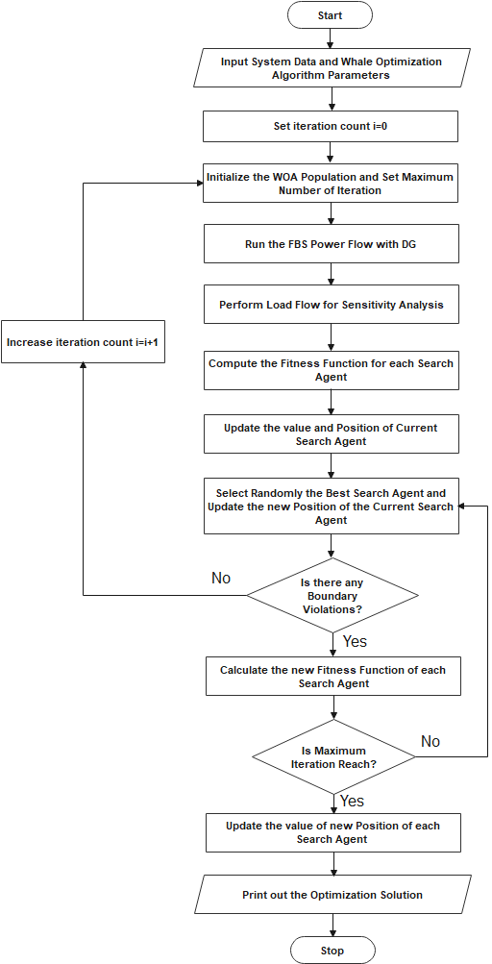
Figure 5: Flowchart of Whale Optimization Algorithm for Optimal Solution of DR
- DISCUSSION OF RESULTS
The simulation results of optimal integration of Distributed Resources (DR)into distribution network aimed at power loss minimization using Whale Optimization Algorithm(WOA)were analyses and presented.The performance of the WOA with inclusion of DRmodel was implemented on 33-busIlorin industrial distribution feeder of Ibadan Electricity Distribution Company (IBEDC).Simulation was done in MATLAB R(2021) and FBS power flow analysis was performed with permissible working rangevalues of 0.95 to 1.05 p.u. The results were presented according to bus voltages, line flow and power loss as shown in Table 1 to 4 and Figure 6 to 9, respectively.
. Figure 6 showed the comparison of voltage magnitude with the bus number of the system without DR. It was observed that buses 5, 14, 19 and 31 with voltage magnitude of 1.0558, 0.9237, 0.9312and 1.0542 p.u, respectively, are buses whose voltage falls short of the ±5 % tolerance.
Also, the line flow and line loss results of the system without DR are shown in Table 1. It was observed that the lowest active line flow were along line connecting buses, 21 to 22, 20 to 21 and 23 to 24 with active power values of 1.10, 1.12 and 1.13 MW, respectively. Similarly, it was also observed that the lines with the highest active power loss were lines connecting buses 1 to 2 and 4 to 5, respectively. The total active and reactive power losses in the system are 247.29 MW and 393.04 MVar, respectively.
Figure 7 showed the comparison of voltage magnitude with the bus number of the system with inclusion of DG. Four (4) DGs were placed at buses 5, 14, 19 and 31under base case to control the voltage magnitude to acceptable working range.With DG incorporated at these buses, it was observed that the bus voltage limits that are violated under the base case was rectified by having voltage magnitude at all the buses within voltage limit of ±5% tolerance.
Similarly, the line flow and line loss results of the system are shown in Table 2.With the integration of DG unit, the active power flow from base case was redistributed and the result indicates an increase in active power flow along the line. The lowest active line flow was along line connecting buses, 23 to 24, 21 to 22 and 20 to 21, respectively. Also, the lines with the highest active power loss are line connecting buses 1 to 2 and 4 to 5, with active power loss values of 115.59 and 53.55 MW, respectively. With the integration of DR unit, the power losses along the line were minimized compared to base case and the total active and reactive power loss in the system were reduced to 234.51 MW and 376.50 MVar, respectively.
Figure 8 presented the comparison of voltage magnitude with the bus number of the system with inclusion of DG and WOA for Industrial 33-bus distribution system. With application of WOA, all the bus voltages were maintained within their voltage limit of ±5% tolerance. Also, Table 3 illustrated the line flow and line loss results of the system.It was observed that with application of WOA in the system, all the active power flow from base case was further redistributed and the result indicates an increase in active power flow along the line. In addition, the power loss along the line was further reduced compared to base case and the total active and reactive power loss in the system was reduced to 201.97 MW and 343.09 MVar, respectively.
Similarly, Figure 9 indicated the total active power loss comparison for the three cases. The total active power loss for base case, DG with SA, and DG with WOA were 247.29, 243.51 (5.2 % reduction) and 201.97 (18.3 % reduction), respectively. Also, Table 4indicated the best location and size of DG unit in the system using WOA.The best location and size of DG unit in the system is at buses 4, 8 and 17 with DG size of 12.5, 10.5 and 10.0 MW, respectively.
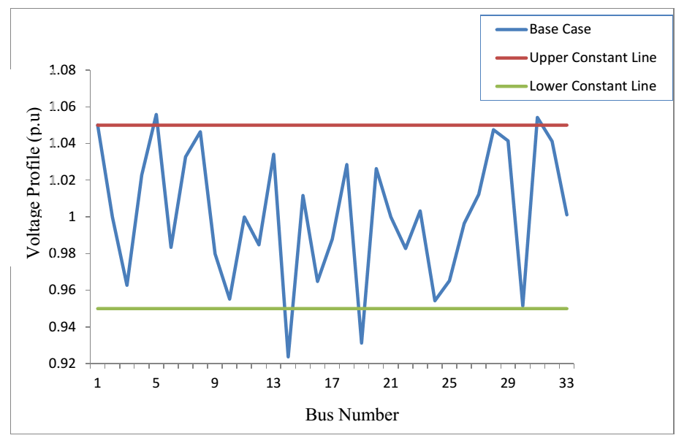
Figure 6: Comparison of Voltage Profile without DR

Table 1: Line Flow and Line Loss Resultwithout DR
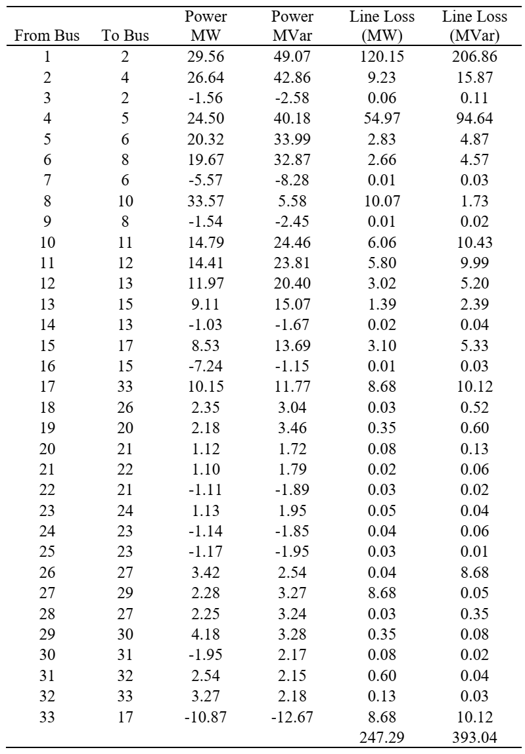

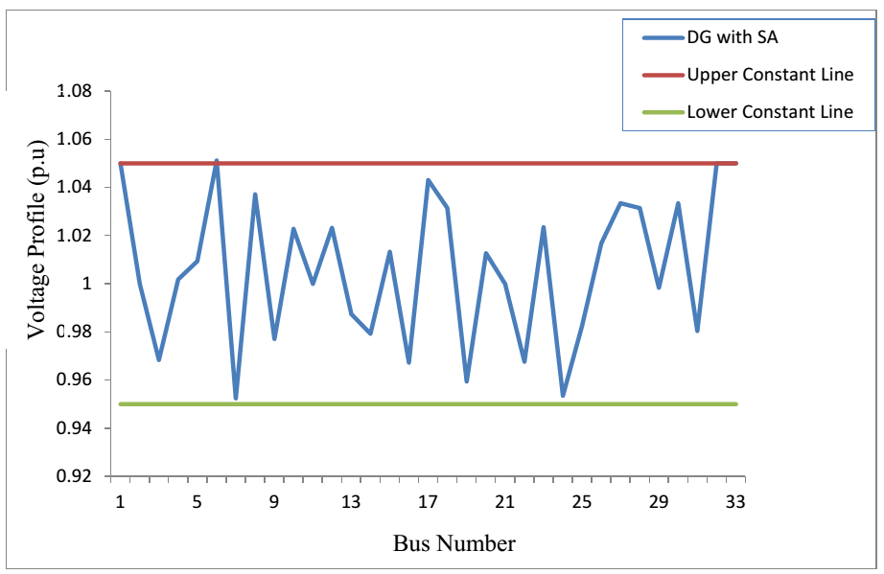
Figure 7: Comparison of Voltage Profile with DG and SA

Table 2: Line Flow and Line Loss Result with DG and SA
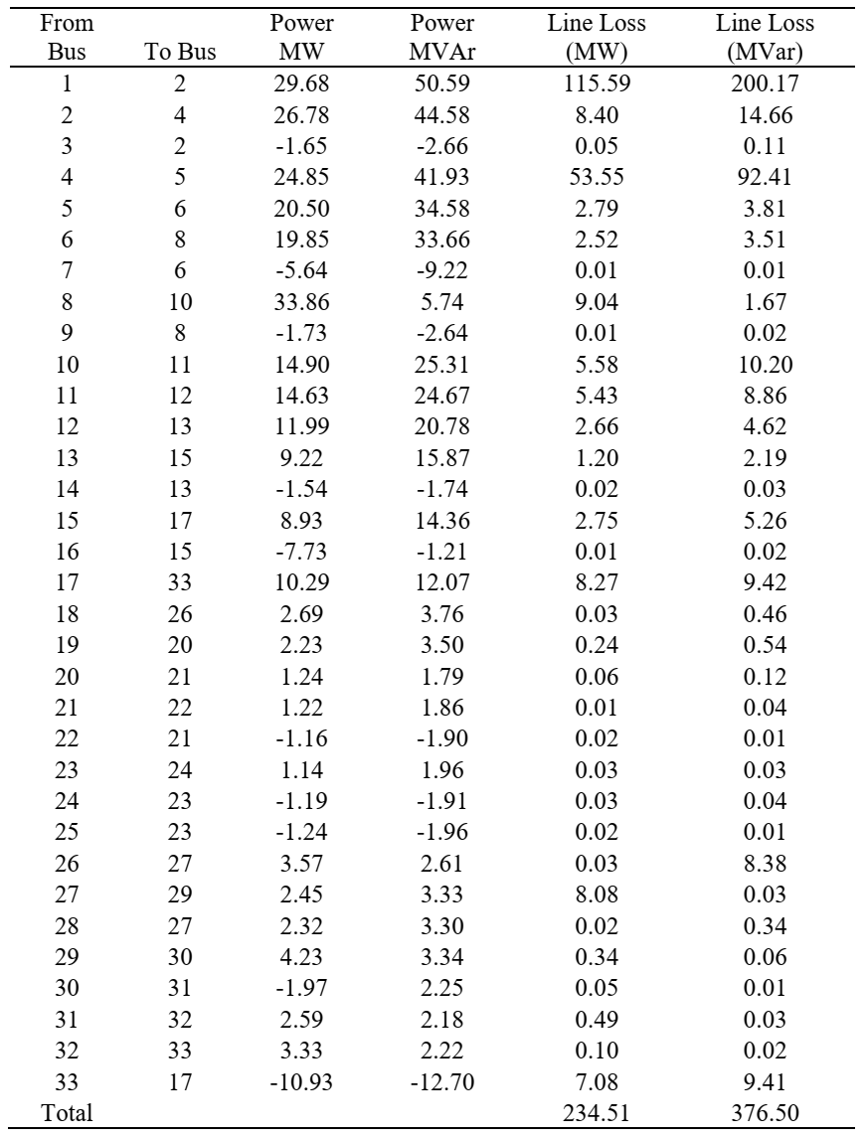

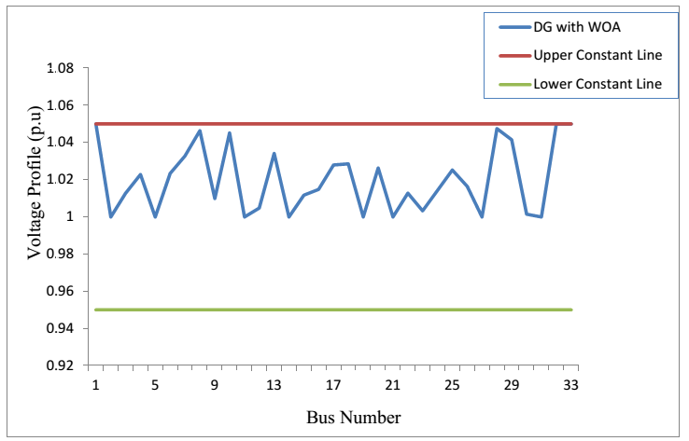
Figure 8: Comparison of Voltage Profile with DG and WOA

Table 3: Line Flow and Line Loss Result with DG and WOA
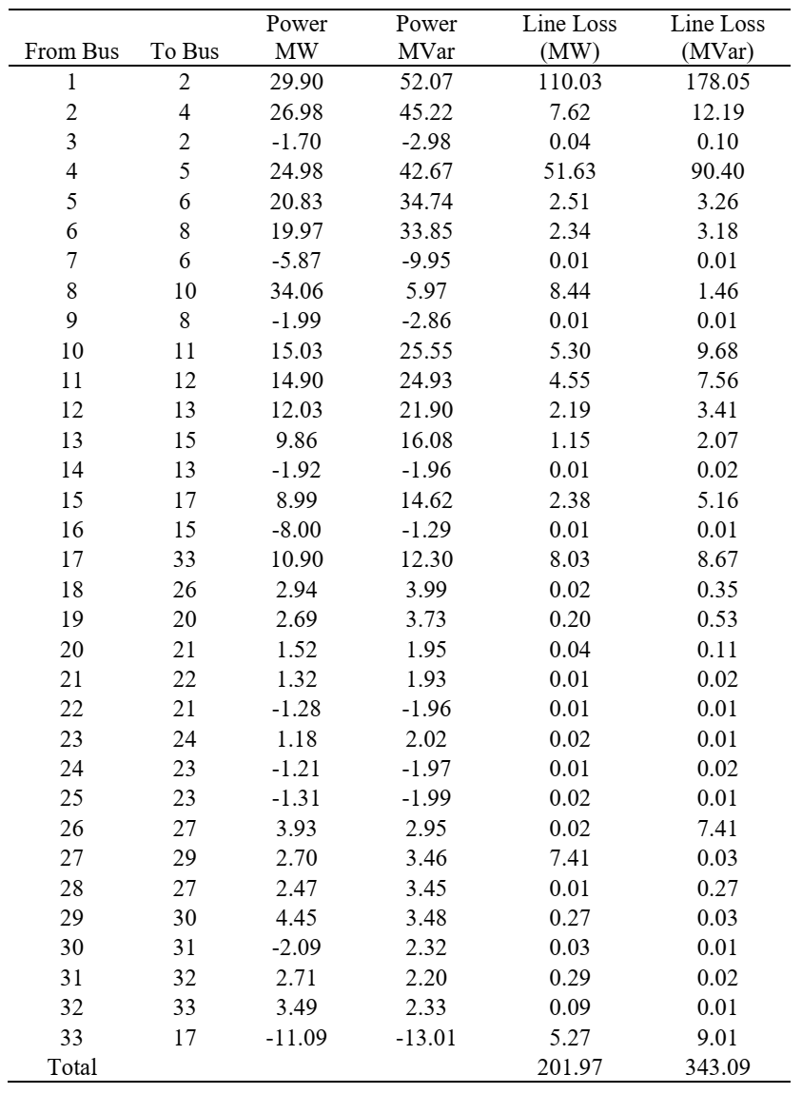

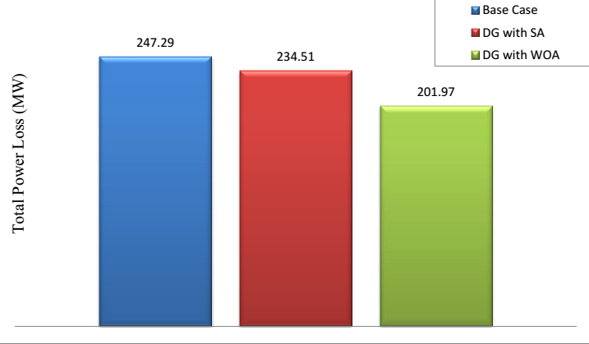
Figure 9: Comparison of Total Active Power Loss

Table 4: Optimal Placement and Sizing of DR
Test Case | DR  Bus | From Bus | To Bus | VSF | Voltage Profile (p.u) | DG Size (MW)
With SA | 5 | 5 | 6 | 0.9402 | 0.9552 | 10
 | 14 | 14 | 13 | 0.7250 | 0.9793 | 12.5
 | 20 | 20 | 21 | 0.6929 | 1.0127 | 10.5
 | 27 | 27 | 29 | 0.8518 | 1.0335 | 15
 | 28 | 28 | 27 | 0.9590 | 1.0315 | 10
With DG | 4 | 4 | 5 | 0.3768 | 1.0228 | 12.5
 | 8 | 8 | 10 | 0.3569 | 1.0464 | 10.5
 | 17 | 17 | 33 | 0.1052 | 1.0279 | 10

- CONCLUSION
This study has successfully presented the application of Whale Optimization Algorithm(WOA) for power loss minimization on 33-busIlorin industrial distribution feeder of IBEDC with optimal integration of Distributed Resources (DR).The FBS load flow technique was performed for both steady state and with integration of DG. The SA was used to obtain the most sensitive buses for allocating the DR based on the power loss results. The WOAwas implemented as optimization technique to rectify the problem of voltage violations, reducethe power losses, and optimally locate the best placement and size of DR unit.Thus with implementation of WOA with DR in the network, the bus voltage limits violation was rectified to voltage limit of ±5% tolerance, the total active power loss was reduced to barest minimum and the potential buses for best location of DR unit in the network were identified. The simulation results obtained verify the accuracy and efficiency of the WOA with DR model for power loss minimization in distribution system.
- Acknowledgment
I acknowledge the Prof. G.A. Adepoju for providing the necessary information and arrangement of this study.I thank Eng. A. Fasakin for providing necessary data(s) for this study. Also, I thank Mrs. O. A. Fasakin for his assistance in typesetting and editing ofthis work.

Funding
This study not received any external funding.
Conflicts of Interest
The author declares no conflict of interest.

- REFERENCES
[1] Al-Tameemi, Z. H., Neda, O. M., Jumaa, F. A., Al-Mamoori, D. H., Aljanabi, M. H. and Jasim, J. M. (2019). Optimal sizing and location of DG units for enhancing voltage profile and minimizing real power losses in the radial power systems based on PSO technique. 2nd International Conference on Sustainable Engineering Techniques, Series: Materials Science and Engineering, 518: 1-14.
[2] Praveena, K., Reddy, Y. P. K. and Reddy, A. V. (2015). Power loss minimization incorporating distributed generator in distribution system using Supervised Big Bang Big Crunch Method. International Journal of Engineering Research and General Science, 3(3): 1077-1086.
[3] Shanmugapriyan, J., Karuppiah, N., Muthubalaji, S. and Tamilselvi, S. (2018). Optimum placement of multi type DG units for loss reduction in a radial distribution system considering the distributed generation suitability index using evolutionary algorithms. Bulletin of the Polish Academy of Sciences Technical Sciences, 66(3): 345-354.
[4] Atwa, Y. M., E. F. El-Saadany, E. F., Salama, M. M. A. and Seethapathy, R. (2010). Optimal renewable resources mix for distribution system energy loss minimization. IEEE Transactions on Power Systems, 25(1): 1-11.
[5] Athari, M, H., Yang, C. and Wang, Z. (2017). Sequential optimal placement of distributed photovoltaic’s using downstream power index. EEE Power and Energy Society Innovative Smart Grid Technologies Conference (ISGT): 1-6.
[6] Kumawat, M., Gupta, N., Jain, N. and Bansal, R. C. (2017). Optimally allocation of distributed generators in three-phase unbalanced distribution network. 9th International Conference on Applied Energy, ICAE2017, 21-24 August 2017, Cardiff, UK, Energy Procedia, 142: 749-754.
[7] Abbagana, M., Bakare, G. A. and Mustapha, I. (2010). Optimal placement and sizing of a distributed generator in a power distribution system using differential evolution. Proceedings of the 1st International Technology, Education and Environment Conference (c) African Society for Scientific Research, Human Resource Management Academic Research Society: 536-549.
[8] Afzalan, E., Taghikhani, M, A, and Sedighizadeh, M. (2012). Optimal placement and sizing of DG in radial distribution networks using SFLA. International Journal of Energy Engineering, 2(3): 73-77.
[9] Gopiya, N. S. (2016). Planning of distribution system using distributed generation. Ph.D Thesis Submitted to Alternate Hydro Energy Centre Indian Institute Of Technology Roorkee, India, Roorkee-247667: 1-8.
[10] Naik, S. G., Khatod, D. K. and Sharma, M. P. (2018). Optimal siting and sizing of dg in distribution networks for power loss saving. IOSR Journal of Electrical and Electronics Engineering, 13(1): 42-53.
[11] Olaniyan, A., Boyi, J. and Jibril, Y. (2015). Application of Analytical-Firefly Algorithm for optimal location and sizing of Distributed Generator in standard IEEE 30-bus distribution network. Conference: International Engineering Conference (IEC 2015),Federal University of Technology, Minna.1-6.
[12] Anthony, O. I., Eseosa, O. and Kayode, I. (2017). Voltage stability analysis of Nigerian power system using distributed generation. Applied Research Journal 3(2): 1-7.
[13] Hung, D. Q., Mithulananthan, N. and Bansal,R. C. (2010). Analytical expressions for DG allocation in primary distribution networks. IEEE Transactions on Energy Conversion, 25(3): 814-820.
[14] Hosseini, S. A., Madahi, S. S. K., Razavi, F., Karami, M, and Ghadimi, A. A. (2013). Optimal sizing and siting distributed generation resources using a multi objective algorithm. Turkish Journal of Electrical Engineering and Computer Sciences, 21: 825 – 850.
[15] Injeti, S. K. and Kumar, N. P. (2011). Optimal planning of distributed generation for improved voltage stability and loss reduction. International Journal of Computer Applications, 15(1): 40-46.
[16] Krishna, R. K. R. and Ananthapadmanabha, T. (2018). Optimal allocation of DG units for voltage stability enhancement and power loss minimization in radial distribution system. International Journal of Electrical Engineering and Technology, 9(6): 35–46.
[17] Lasseter, R. H. (2012). Control of distributed resources. Bulk Power System Dynamics and Control IV - Restructuring, August 24-28, Santorini, Greece: 1-8.
[18] Tellez, A. A., Lopez, G., Isaac, I. and Gonzalez, J. W. (2018). Optimal reactive power compensation in electrical distribution systems with distributed resources review. Heliyon, 4, e00746: 1-30.
[19] Adepoju, G. A., Salimon, S. A., Aderinko, H. A. and Bisiriyu, A. (2019). Optimal placement and sizing of distributed generation in a Nigerian distribution network using cuckoo search algorithm. Current Journal of Applied Science and Technology,38(6): 1-12.
[20] Suresh, M. C. V. and Belwin, E. J. (2018). Optimal DG placement for benefit maximization in distribution networks by using dragonfly algorithm. Renewable, 5(4): 3-8.
[21] Rao, R. S., Ravindra, K., Satish, K. and Narasimham, S. V. L. (2013). Power loss minimization in distribution system using network recon figuration in the presence of distributed generation. IEEE Transactions on Power Systems, 28(1): 317-325.
[22] Sultanaa, U., Khairuddina, A., Mokhtara, A. S., Qazia, S. H. and Sultana, B. (2017). An optimization approach for minimizing energy losses of distribution systems based on distributed generation placement. Jurnal Teknologi (Sciences and Engineering), 79(4): 87–96.
[23] Bindumol, E. K. and Babu, C, A. (2016). Analytical and sensitivity approaches for the sizing and placement of single DG in radial system. Advances in Energy Research, 4(2): 163-176.
[24] Lavaei, J. and Low, S. H. (2010). Relationship between power loss and network topology in power systems. 49th IEEE Conference on Decision and Control December 15-17, 2010 Hilton Atlanta Hotel, Atlanta, GA, USA: 4004-4011.
[25] Mohammed, H. M., Umar, S. U. and Rashid, T. A. (2019). A systematic and meta-analysis survey of whale optimization algorithm. Hindawi Computational Intelligence and Neuroscience,2019, Article ID 8718571, 1-26.
[26] Prakash, D. B. and Lakshminarayana, C. (2016). Multiple DG placements in distribution system for power loss reduction using PSO algorithm. Global Colloquium in Recent Advancement and Effectual Researches in Engineering, Science and Technology, Procedia Technology, 25: 785-792.
[27] Kelsey, H., Peterson, Z., Coddington, M., Ding, F., Sigrin, B., Saleem, D, and Baldwin, S. E. (2019). An Overview of Distributed Energy Resource (DER) Interconnection: Current Practices and Emerging Solutions. Golden, CO: National Renewable Energy Laboratory. NREL/TP-6A20-72102: 1-84.
[28] Mirjalili, S. and Lewi, A. (2016). The whale optimization algorithm. Advancement Engineering Softwares, 95, 51–67.
[29] Nasiri, J. and Khiyabani, F. M. (2018). A whale optimization algorithm approach for clustering, Cogent Mathematics and Statistics,5(1): 1-13.
[30] Shehata, R. H., Mekhamer, S. F., Abdelaziz, A. Y. and Badr, M. A. L.(2018). Solution of the capacitor allocation problem using an improved whale optimization algorithm. International Journal of Engineering, Science and Technology, 10(4): 1 -1 1

