**START-UP IN DEGRADATION OF PHARMACEUTICAL WASTEWATER USING SECONDARY SEWAGE SLUDGE**

**A.Sathiya Priya1, Dr. S.Sundararaman2**

1Research Scholar, 2 Professor and Head

Department of Civil Engineering,

Sri Manakula Vinayagar Engineering College, Pondicherry,India.

***Abstract: Pharmaceutical industry is developed due to the population growth and human health needs. It leads to increase the manufacture of drugs and consequently they discharged to the environment after complete or partial treatment. It releases the toxic compounds into the environment. The present study aims by acclimatize the pharmaceutical wastewater with secondary sewage sludge in various ratios 1:1, 1:2, 1:3, 1.5:2.5, 2:1 and 3:1 to enhance biological degradation. The batch mode operation is carried out for a period of 90 days. Conclusion is drawn based on the Total solids and Chemical Oxygen Demand (COD) concentration. Of the entire six ratios considered for degradation of pharmaceutical wastewater the 1:3 ratio gives a better result in terms of degradation of Total Solids and Chemical Oxygen Demand.***

***Keywords: Batch mode, Degradation, Pharmaceutical wastewater, secondary sewage sludge, Toxic compound.***

**1. INTRODUCTION**

In India, pharmaceutical industry is developed due to the population growth and human health needs. It leads to increase the manufacturing drugs and consequently release the wastewater during manufacturing [1]. It is one of the one-third water pollution in industrial wastewater discharge and represents hazards to the natural water [4]. The effluent released from pharmaceutical industry which affect the environment and create threats to humans. Some antibiotics are not completely removed by wastewater treatment methods [5].The level of water pollution varies depending on the type of process and size of industry. When the pharmaceutical wastewater is directly discharged, it makes harmful impact on human health and aquatic life such as water toxicity and genotoxicity [7].

Biological treatment is not expensive solution to treat this kind of effluent and there is no need to add chemicals [2]. The biological method is low cost method for treatment of wastewater and it controls the pollution of aquatic environment [3]. In aerobic condition, the period of degradation may take several days [5].Secondary sewage sludge contain more number of microorganisms such as bacteria and fungi, some other microorganisms may also multiple in secondary sewage sludge which in turn reduces the chemical oxygen demand (COD) [10]. In the present study the degradation of pharmaceutical wastewater using secondary sewage sludge in different ratios is presented below in subsequent headings. During degradation, chemical characteristics monitored at an interval of 7 days in order to study the stability of the process.

**2. MATERIALS**

**2.1 Pharmaceutical wastewater**

Pharmaceutical wastewater used in present study was collected from a pharmaceutical major unit in Pondicherry, where the company manufactures antibiotics. During the process, wastewater is generated and goes for conventional treatment process. The wastewater from the industry is collected prior to its entry to the treatment system that is from the equalization tank. The raw pharmaceutical wastewater is tested for its initial Physico Chemical characteristics and shown in the Table 1.0.

**Table 1.0: Physico-Chemical characteristics of pharmaceutical wastewater**

|  |  |
| --- | --- |
| **Properties** | **Result** |
| pH | 7.81 |
| Electrical conductivity (µS/cm) | 8.1 |
| Turbidity(NTU) | 92 |
| Alkalinity (mg/L) | 420.56 |
| Chlorides (mg/L) | 600 |
| Total solids(TS) mg/L | 20000 |
| Total Dissolved Solids(TDS) mg/L | 10000 |
| Total Suspended Solids(TSS) mg/L | 10000 |
| Biological Oxygen Demand (BOD) mg/L | 4.17 |
| Chemical Oxygen Demand (COD) mg/L | 9400 |

**2.2 Secondary Sewage Sludge**

Secondary sewage sludge is collected from the oxidation pond of common wastewater treatment plant, located at Pondicherry. This oxidation pond sewage contains more amounts of microorganisms which enhance the biological degradation. The initial characteristic of Secondary sewage sludge is presented in Table 2.0.

**Table 2.0: Initial Physico Chemical Characteristics of Secondary Sewage Sludge**

|  |  |
| --- | --- |
| **Properties** | **Result** |
| pH | 7.06 |
| Electrical conductivity (µS/Cm) | 1.7 |
| Turbidity(NTU) | 21.1 |
| Alkalinity (mg/L) | 2340 |
| Chlorides (mg/L) | 2178.72 |
| Total solids(TS) mg/L | 11000 |
| Total Dissolved Solids(TDS) mg/L | 9000 |
| Total Suspended Solids(TSS) mg/L | 1800 |
| Biological Oxygen Demand (BOD) mg/L | 9.74 |
| Chemical Oxygen Demand (COD) mg/L | 1200 |

**3. METHODOLGY**

The pharmaceutical wastewater and secondary sewage sludge were mixed in ratio of 1:1 ,1:2,1:3,1.5:2.5,2:1 and 3:1. 25 litres plastic cans were used to mix the different ratios of pharmaceutical wastewater and secondary sewage as shown in figure 1.0. The cans were kept open and an empty space at the top of each can is left over to undergo aerobic condition so as to enhance the growth of aerobic microorganisms. The can are aerated so that there is continuous supply of oxygen which enhances the growth of aerobic microorganisms for degradation of complex compounds present in pharmaceutical wastewater. The characteristics of each ratio were studied for an interval of 5 days and 7 days.

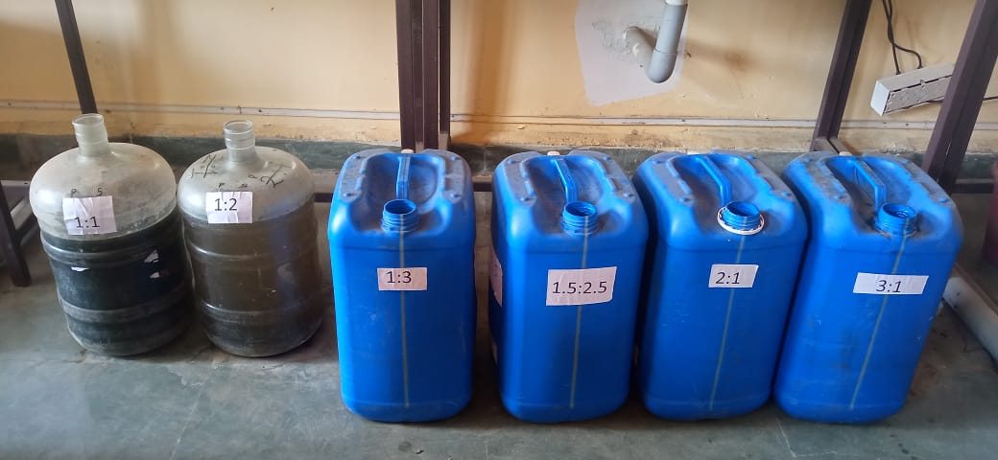

***Fig 1: Photographic view of different ratios of pharmaceutical wastewater and secondary sewage sludge***.

**4. RESULTS AND DISCUSSIONS**

**4.1 pH**

The pH values ranges from 7.18 to 8.61 as shown in the fig 2, throughout the entire period study for various mix ratios for pharmaceutical wastewater and secondary sewage sludge (1:1, 1:2, 1:3, 1.5:2.5, 2:1and 3:1). It was observed that there was a slight variation in the values of pH for different ratios and a steady state of 8.6 was observed in the ratio of 1:3, from day 0th day to 90th days.

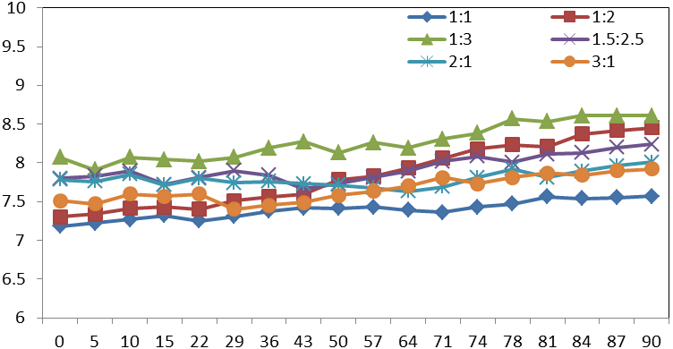

**No. of Days**

**pH**

***Fig 2: Variation of pH for different ratios of Pharmaceutical wastewater and Sewage Sludge with respect to number of days***

**4.2 Total solids**

The Total solids ranges from 12050 mg/L to 7627 mg/L throughout entire period study for various mix ratios for pharmaceutical wastewater and secondary sewage sludge (1:1, 1:2, 1:3, 1.5:2.5, 2:1and 3:1). From the fig 3, it was observed that was a consistency in the Total Solids value for the ratio of 1:3 for 8687 mg/L at the end of 90 days.

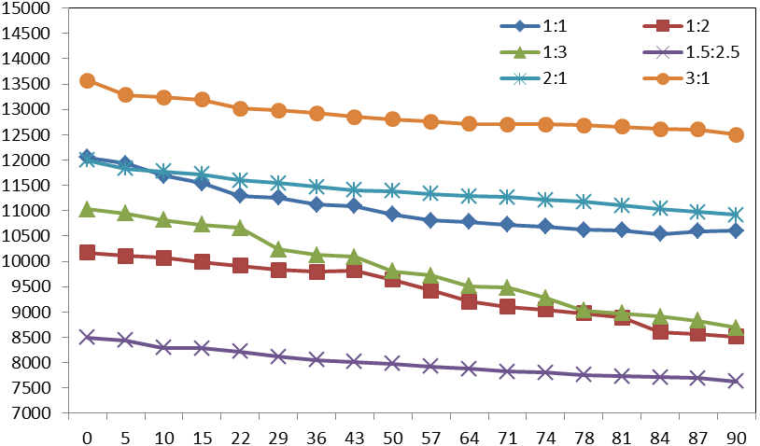

**No. of Days**

**Total Solids**

***Fig 3: Variation of Total Solids for different ratios of Pharmaceutical wastewater and Sewage Sludge with respect to number of days.***

**4.3 Chemical Oxygen Demand (COD)**

COD Values ranges from 1520 mg/L to 10100 mg/L throughout the entire period of study as shown in fig 4, for various mix ratios for pharmaceutical wastewater and secondary sewage sludge (1:1, 1:2, 1:3, 1.5:2.5, 2:1and 3:1). It was observed that there was a maximum reduction in COD value for mix ratio 1:3 with 68.84% when compared to other ratios of pharmaceutical wastewater and sewage sludge. Also a steady state was observed in the ratio of 1:3 wherein the COD value is in the range of 1500 to 1600 mg/L at the end of 90 days.

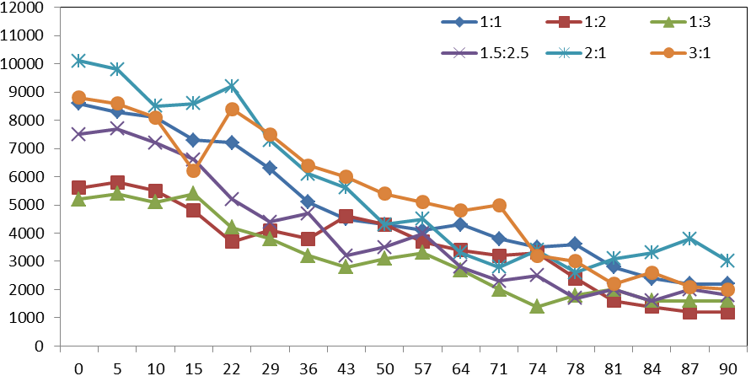

**No of days**

**COD**

***Fig 4: Variation of COD for different ratios of Pharmaceutical wastewater and Sewage Sludge with respect to number of days.***

**4.4 Biochemical Oxygen Demand (BOD)**

BOD Values ranges was from 2.26 mg/L to 32.21 mg/L throughout the entire period of study as shown in Fig 5, for various mix ratios for pharmaceutical wastewater and secondary sewage sludge (1:1, 1:2, 1:3, 1.5:2.5, 2:1and 3:1). It was observed that a maximum reduction in BOD value for mix 1:3 was 33.27 mg/L, when compared to other ratios of pharmaceutical wastewater and sewage sludge. Also a steady state was observed in the ratio of 1:3 wherein the BOD value is in the range of 30 to 35 mg/L at the end of 90 days.

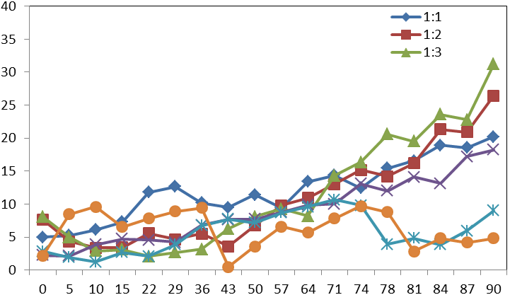

**No. of days** Days

**BOD**

***Fig 5: Variation of BOD for different ratios of Pharmaceutical wastewater and Sewage Sludge with respect to number of days.***

**CONCLUSIONS**

A steady state condition was attained at end of 90 days. On Comparison with different ratios of pharmaceutical wastewater and sewage sludge it was observed that the ratio of 1:3 showed a maximum reduction in COD, TS and BOD which indicates that the degradation of the chosen pharmaceutical wastewater takes place when the sewage sludge is 3 times the industrial wastewater. During the degradation phase, the pH was maintained in the range of 8.60 to 8.67. This indicates that the ratio of 1:3 (Pharmaceutical: sewage sludge) is the best ratio to degrade the microorganisms in the chosen pharmaceutical wastewater. It was observed that a maximum reduction in Total Solids was found to be 8687mg/l which is 56.57%, when compared to the initial characteristics of the pharmaceutical wastewater. A similar pattern in reduction of COD was observed in the ratio of 1:3 wherein there was a reduction of 68.84% .This indicates that the growth of microorganism is necessary for biological degradation of the pharmaceutical wastewater. Hence, before the treatment of pharmaceutical wastewater, the degradation phase is very much essential to acclimatize the microorganisms to that particular environment and reduce the load to the subsequent treatment processes.

**Reference**

[1] Mohammadreza Kamali , Tejraj M. Aminabhavi (2022) “Acclimatized activated sludge for enhanced phenolic wastewater treatment using pinewood biochar”, [Chemical Engineering Journal](https://www.sciencedirect.com/journal/chemical-engineering-journal) [Volume 427](https://www.sciencedirect.com/journal/chemical-engineering-journal/vol/427/suppl/C),131708

## [2] Nishant Dafale , N. Nageswara Rao (2008) “Decolorization of azo dyes and simulated dye bath wastewater using acclimatized microbial consortium – Biostimulation and halo tolerance”. [Bioresource Technology](https://www.sciencedirect.com/journal/bioresource-technology), volume 99, Pages 2552-2558.

[3] Dr Sundararaman S. and Sathiyapriya A. (2016), “Acclimatization of an Industrial Pharmaceutical Wastewater In An Aerobic Batch Mode Of Operation”. International Journal of Environmental Research and Development. ISSN 2249-3131 Volume 6, Number 1 pp. 1-10.

[4] Rajender singh Rana, Prashant singh, vikash Kandari (2017**)**, “A review on characterisation and bioremediation of pharmaceutical industries wastewater: an Indian perspective”, Appl water sci DOI 10.1007/sl 3201-014-0225-3.

[5] George Z. Kayzas, Eleni A.Deliyanni (2015), “Modified activated carbons from potato peels as green environmental friendly coagulant for the treatment of pharmaceuticals effluents". Chemical Engineering Research and Design 97:135 144DOI:10.1016/j.cherd.2014.08.020.

[6] Mesquita, D. P. , Louvet, J. N. , Potier, O. , Amaral, A. L. , Pons, M. N. , and Ferreira, E. C.(2009), “Surveying activated sludge changes during acclimation with artificial wastewater”.

[7] Wiggings, B. A., Jones, S. H.,and Alexander, M. A. , (1987), “Explanations for the acclimation period preceding the mineralization of organic chemicals in aquatic environments” App. Environ. Microbial, 53, pp. 791–796.

[8] Jones, O. A. H. , Voulvoulis, N. , and Lester, J. N. , 2007, “The occurrence and removal of selected pharmaceutical compounds in a sewage treatment works utilizing activated sludge treatment, " Environmental Pollution, 145 (3), pp. 738-744.

[9] Marrot, B.Barrios-Martinez, A. Moulin, P. and Roche, N., 2006, Biodegradation of high phenol concentration by activated sludge in an immersed membrane bioreactor” Biochemical Engineering Journal, 30, pp. 174–183.

[10] [Yongkui Yang](https://pubmed.ncbi.nlm.nih.gov/?term=Yang%20Y%5BAuthor%5D), [Longfei Wang](https://pubmed.ncbi.nlm.nih.gov/?term=Wang%20L%5BAuthor%5D), [Feng Xiang](https://pubmed.ncbi.nlm.nih.gov/?term=Xiang%20F%5BAuthor%5D), [Lin Zhao](https://pubmed.ncbi.nlm.nih.gov/?term=Zhao%20L%5BAuthor%5D), and [Zhi Qiao](https://pubmed.ncbi.nlm.nih.gov/?term=Qiao%20Z%5BAuthor%5D), “Activated Sludge Microbial Community and Treatment Performance of Wastewater Treatment Plants in Industrial and Municipal Zones”. Int J Environ Res Public Health. 2020 Jan; 17(2): 436.