Theoretical analysis of increasing the lifetime of the disintegration tools of the hammer mill

Peter Križan1, Miloš Matúš2, Michal Svátek3, Jozef Bábics4

*1Assoc. Prof., Institute of Production Engineering and Quality, FME STU in Bratislava, Slovakia.*

*2Assoc. Prof., Institute of Production Engineering and Quality, FME STU in Bratislava, Slovakia.*

*3Assistant, Institute of Production Engineering and Quality, FME STU in Bratislava, Slovakia.*

*4Researcher, Institute of Production Engineering and Quality, FME STU in Bratislava, Slovakia.*

*Corresponding Author: Peter Križan (peter.krizan@stuba.sk)*

*ABSTRACT: Disintegration is the process by which the input raw material is divided (broken down) into smaller parts. The goal is to reduce the volume of input raw material for subsequent transportation, handling, separation and densification into the form of solid fuels. Hammer mills are among the most widespread types of disintegrating machines in the woodworking industry. Their disadvantage is the transmission of shocks arising in the process of disintegration to the bearings of the rotor and their sensitivity to the ingress of hard impurities, which in some cases cause damage not only to the tool but to the entire disintegration machine. An accompanying phenomenon of the disintegration process is a high rate of wear of the disintegration tools, which causes a significant reduction in the lifetime of the tools, and ultimately of the disintegration machine. This article discusses the possibilities of increasing the lifetime of disintegration hammers (tools), defines the basic relationships between the material composition of disintegration tools and the mechanical properties of tools in the process of disintegration of wood raw material. The research results presented here relate to both pelleting and briquetting, as the crushing process is a necessary prerequisite for the successful densification of wood raw materials.*

***KEY WARDS:*** *biomass, hammer mill, disintegration hammers, tools, wear, lifetime, hardness, hard chrome cast iron*

---------------------------------------------------------------------------------------------------------------------------------------

Date of Submission: xx-xx-xxxx Date of acceptance: xx-xx-xxxx

---------------------------------------------------------------------------------------------------------------------------------------

# INTRODUCTION

Disintegrating machines are used in several branches of processing various types of raw materials [1, 2]. In order for the machines to be specified for the needs of the operation and thus ensure the required output fraction, there are several design solutions and principles of disintegration machines. The disintegration of the input raw material can be carried out by cutting, tearing, and the impact of the disintegrating tool on the fragmented raw material, the breaking of the raw material between moving and fixed tools, pressure and the movement of particles between the tools [1]. In the process of disintegration, two or more of the mentioned principles shown in Figure 1 can be applied in the process. This process is used in the extraction and processing of mineral raw materials, recycling of various types of waste, in the furniture and energy industry and other industries [1, 2, 3, and 4].

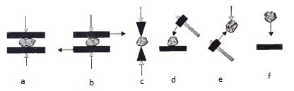

**Figure 1: Basic types of disintegration (a - by pressure, b - breaking and tearing of the raw material between moving and fixed tools, c - shearing and splitting, d - breaking the raw material on a non-moving base by the impact of the tool, e - by the impact of the tool on the free-falling raw material, f - breaking the raw material by impact on a solid base) [2]**

The process of disintegration in hammer disintegration machines occurs due to the dynamic effect of the tool, which we call a hammer, in contact with the crushed input raw material, when this material is divided into fractions with significantly smaller dimensions. The size of the output fraction is externally controlled by a screen that closes the disintegration area. The raw material is crushed until it reaches the required size of the output fraction. The size of the output fraction is given by the size of the holes on the screen that closes the area of the disintegration chamber. The primary prerequisite for the use of these mills is the fulfillment of the requirement that the crushed raw material be fragile and not very flexible [2]. Hammer mills are among the most widespread types of disintegration machines in the woodworking industry [1]. There are two ways of designing the fixing of hammer tools. The mentioned methods of structural fixing are shown in Figure 2. Hammer disintegration machines with fixed hammers are less used. Their disadvantage is the transfer of shocks arising in the process of disintegration to the rotor bearings and their sensitivity to the ingress of hard dirt, which in some cases causes damage not only to the tool but to the entire disintegration machine [1].

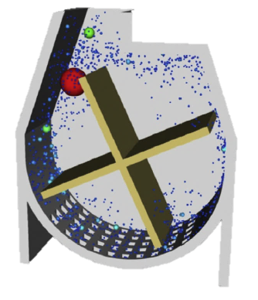 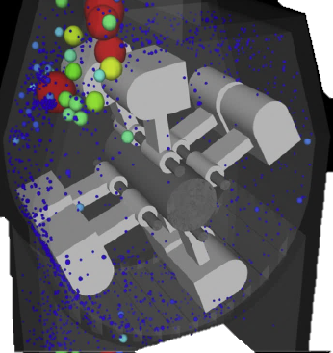 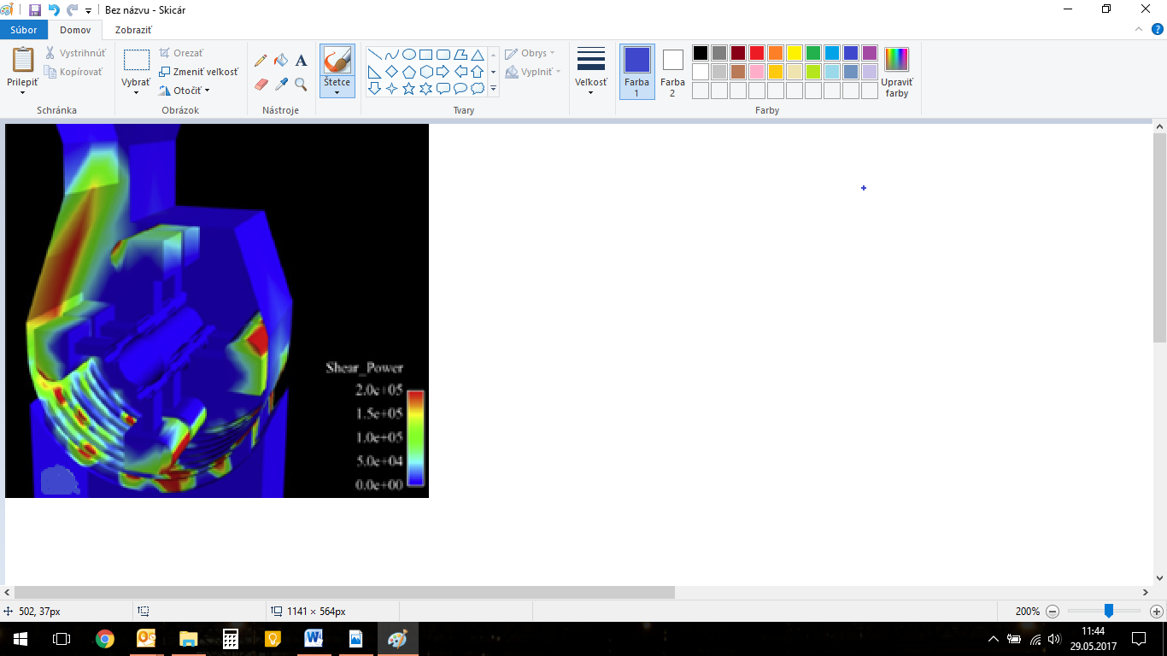

**Figure 2: Model of fixed hammers (left), rotating fixing of hammers (middle), and places of adhesive wear (right) [5]**

The second method of design solution for the fixing of hammer tools is the rotating fixing of tools on a pin. By rotating the rotor, the hammer tools take a radial position due to centrifugal force. The rotating fixing protects the tools and the machine from damage in case of intrusion of a hard body into the disintegration chamber [5]. Hitting a hard unworkable material will cause the hammers to deviate from the radial position, and they will return to it by centrifugal force. The exit part of the disintegration chamber is closed by a sieve, the size of the holes of which determines the size of the exit fraction. The raw material is in the disintegration chamber until it takes on the dimensions of the sieve openings and falls downward due to gravity [1, 5].

The tools of the disintegration machines participate directly in the process of disintegration of the processed raw material in the disintegration chamber of the machine. We distinguish a relatively large number of tools in terms of shape and weight. The shapes of the tools depend on the chosen type of disintegration machine. The shape and weight of these tools are chosen depending on the type of disintegrated raw material and its size. The weights of the hammers of large hammer disintegration machines range from 30 to 130 kg [1, 2, and 5]. Disintegration is a dynamic process in which several parameters affect the wear of functional parts. Due to the nature of the disintegration process, the rate and speed of wear of disintegration tools is generally high. The material and shape of the tool, the processed raw material, as well as the type of disintegration affect the wear of tools and parts of the stands that come into contact with the processed raw material. Wear is in most cases an undesirable process of material degradation. The amount of time it takes to maintain or replace worn parts is associated with the rate of wear. Downtime arising from these actions in some cases causes significant financial losses. The rate of wear and tear, associated with material loss, also affects the financial difficulty of maintenance or replacement of worn parts. The material demand for replacement causes an environmental burden, which is not negligible nowadays. With regard to economic and environmental aspects, we try to prevent wear mechanisms.

The research task, which arose on the basis of cooperation and the direct assignment of an industrial partner, is the impetus and significance of the processing of this paper. The aim of this contribution is to present the information obtained from the design of options for increasing the lifetime of disintegration tools. The basic research task arose from a request from an industrial partner who approached us with a solution to the enormous wear of hammer mill disintegration tools.

# MATERIAL AND METHODS

***2.1 Input analysis of the problem being solved***

For research on the influence of parameters affecting the wear of hammer tools, we collaborated with a company that has been engaged in the production of wood pellets and their sale since 2010. The production plant is located in the village of Sebedražie in the district of Prievidza, Slovakia. As an input material, they use wood waste from wood processing enterprises in the form of sawdust from spruce, oak and beech wood [3]. The daily production of the plant is 15 tons of pellets per day with 24-hour operation. The monthly production of pellets is therefore around 450 tons per month. The distribution of pellets is currently focused only on the Slovak market. As input material, they use wood waste from wood processing enterprises in the form of sawdust from spruce, oak and beech wood without bark. Wood pellets are produced in a combination of spruce wood in the ratio of 20 to 30% with oak and beech wood in the ratio of 70 to 80% [3]. For the homogenization of the input raw material in the preliminary phase of pellet production, the company uses the hammer mill of the Czech company TAURUS, s.r.o., Chrudim (Figure 3) [3], which specializes in the production of machines and complete technological lines for the production of feed mixtures, processing of cereals after harvest, storage of commodities, biomass processing and technologies for breweries, mini-breweries and distilleries [6]. The vertical hammer mill works at constant speed [4]. For the needs of speed regulation, it is possible to install a frequency converter on the main part of the hammer mill motor, but for the needs of this operation, speed regulation is not necessary. The hammer mill with an input of 22 kW operates at a speed of 2,940 min-1 with an hourly production of 3.2 to 4 tons per hour. On the rotor with a diameter of Ø 620 mm, 16 pieces of tools are stored in 4 storage nodes. The pin on which the tools are stored has a diameter of Ø 24 mm, and the distance between the individual tools is ensured by spacer rings. The parameters of the used hammer mill are listed in Table 1. The passage of the raw material through the hammer mill is vertical. Wood waste enters in the upper part by free pouring from the screw conveyor and exits in the lower part.

***Table I.* Hammer mill parameters**

|  |  |  |
| --- | --- | --- |
| Parameter | Unit | Value |
| Producer | - | TAURUS, s.r.o. Chrudim |
| Rotor axes of rotation | - | vertical |
| Number of hammers | pcs | 16 |
| Rotor diameter | mm | 620 |
| Revolutions | rpm | 2940 |
| Weight | kg | 470 |
| Nominal current | A | 40.5 |
| Hour production | tons | 3.2 – 4.0 |
| Power input | kW | 22 |
| Dimensions (L/W/H) | Mm | 1000/1000/1800 |

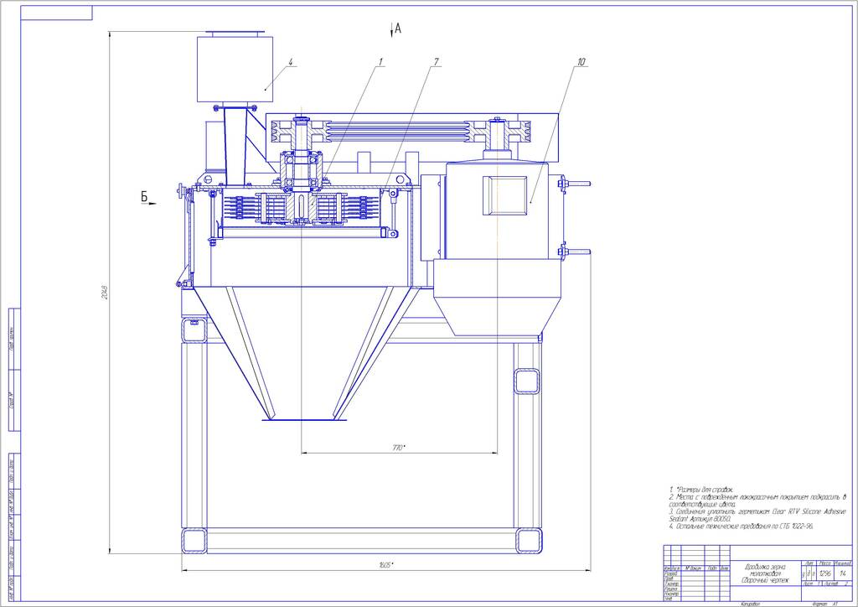

**Figure 3: Scheme of the hammer mill**

Currently, the company uses tools made of structural steel of unknown chemical composition, in order to find out this type of material, it was necessary to carry out a chemical analysis of the material. The tools reach the end of their useful life due to wear and tear after approximately six weeks of operation, when they process approximately 630 tons of wood waste. It should be noted that tool wear is not caused by inappropriate tool geometry or the material used, but is caused by the disintegration process itself. In Figure 4, we can see that the wear on the hammer mill rotor is uneven. The greatest rate of wear is observed in the upper vertical level, i.e. the highest level. The increased rate of tool wear at this level compared to lower levels is due to the proximity of the inlet opening in the vertical direction, where the largest size fractions of the incoming material are disintegrated by the first vertical level of crushing tools. The weight loss of the tool in the middle vertical level is around 22.5 g.

Figure 5 shows the wear of the tools after the above-mentioned period of operation. It can be observed from the picture that the length of the worn tool is greater than the length of the tool before wear. Dimensional deformations are evident from the tool overlay in Figure 5 (c), which shows the tool before use and after wear.

The knowledge from the observation and detection of the current state of wear of the disintegration tools and the quantification of the parameters appearing in the disintegration process had to be reflected in the next procedure for solving this problem. The basic aspect that affects the enormous wear of disintegration hammers is inappropriately used basic material of disintegration hammers and insufficient or absent heat treatment of disintegration hammers. Therefore, we decided to divide the task into 2 basic stages:

1.) Design of a suitable material composition of disintegration hammers, production and testing of disintegration hammers in laboratory conditions.

2.) Experimental research of proposed material compositions of disintegration hammers in dynamic hammer mill operation.

Due to the time-consuming and complex nature of the experimental research, in this paper we will only present the results of the first stage of solving the wear of crushing hammers – theoretical analysis.

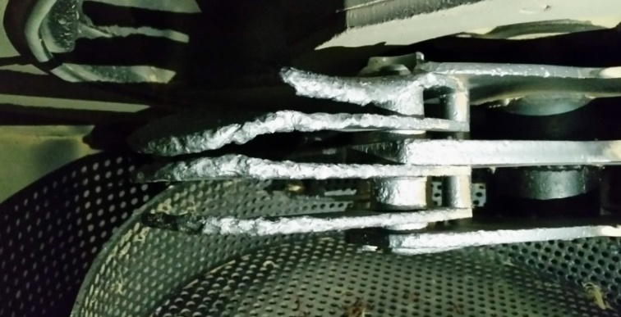 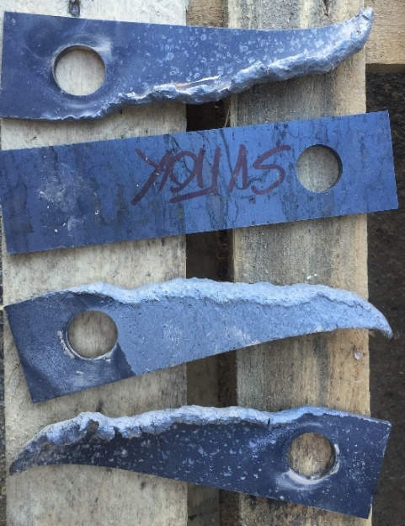

**Figure 4: A view of worn disintegration hammers in a hammer mill (left) and compared to an undamaged disintegration hammer (right)**

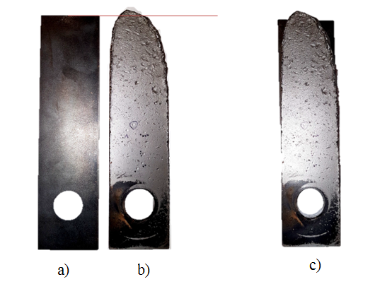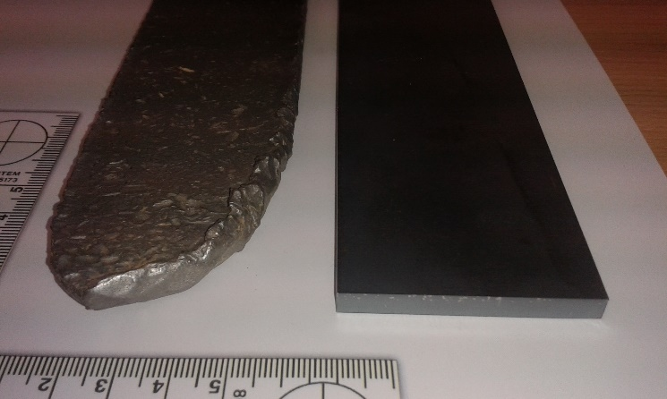

**Figure 5: Disintegration tool views - undamaged (a), worn tool (b), tools overlap (c) for comparison**

***2.2 Design of material composition for disintegration hammers***

For the research within the this stage of the solution, it was necessary to design such a material that has increased resistance to abrasive wear as the wear that most manifests itself in the process of disintegration. After consulting with the experts of the research team in this field and studying the issue, we chose cast iron with a high chromium content as the material for research [7]. Applications of this type of cast iron in the disintegration of wood waste are still unknown. Only unalloyed structural steels are predominantly used. Their advantage is affordability and ease of adjustment.

White wear-resistant cast irons have a matrix and carbide structure. The shape, quantity, dimensions and distribution of primary and eutectic carbides are determined in white cast iron castings by the process of crystallization. By heat treatment and alloying, it is possible to regulate the structure of the metal matrix, while the phase of the carbides is unchanged from the solidification of the casting [3]. Chromium is used as the main alloying element of white wear-resistant cast irons. The chromium content in these cast irons ranges from 11 to 35%. Complex chromium carbides are harder than alloyed cementite, which affects the strength and wear resistance of cast iron. The wear resistance of cast iron increases with increasing carbon and chromium content [2, 3]. The high chromium cast irons generally used contain 23 to 28% Cr and up to 1.5% Mo. The Mo additive ensures maximum hardness and prevents pearlitic transformation. For the above reasons, it is suitable to alloy high-chromium cast iron with Mo, except for thin cross-sections. It prevents the formation of pearlite, which has an adverse effect on the resistance of cast iron to particle wear. The optimal composition of white chrome cast iron for the wear process with free particles is 2.7-2.8% C, 27-28% Cr, 0.5-1% Si, 0.5-1.25% Mn [3]. The applications of castings made of white wear-resistant cast iron are wide, they were used in repair plants, when pressing briquettes for molds and punches, for paddles of stirrers of foundry molding compounds, for rollers of rolling mills, or for hammers of coal crushers, etc. [3, 7].

In order to be able to compare the rate of wear of the designed groups of materials with the simultaneously used materials, it was necessary to carry out a chemical analysis of the simultaneously used material of crushing hammers. The result of the chemical analysis is that the composition of the original tool corresponds to structural steel 1.0338, tempered with aluminum. This steel labelled according by Slovakian norms STN 11 305 and EN ISO DC04 according to the EN labelling. The percentage of the chemical composition of the individual proposed materials and the originally used tool material can be found in the following table 2.

***Table II.* Chemical composition of the original material and proposed materials [7, 8, 9]**

|  |  |  |  |  |  |
| --- | --- | --- | --- | --- | --- |
| The element | Proposed material compositions – cast irons | | | | Original material |
| Material A (%) | Material B (%) | Material C (%) | Material D (%) | 1.0338 (%) |
| C | 3.9470 | 3.9470 | 3.3840 | 2.9380 | 0.0630 |
| Si | 0.4757 | 0.4757 | 0.4524 | 0.3649 | 0.01 |
| Mn | 0.9790 | 0.9790 | 0.9410 | 0.8800 | 0.4200 |
| P | 0.0189 | 0.0189 | 0.0191 | 0.0205 | <0.001 |
| S | 0.0187 | 0.0187 | 0.0049 | 0.0152 | 0.012 |
| Cr | 21.25 | 21.25 | 20.62 | 21.30 | 0.01 |
| Mo | 1.727 | 1.727 | 1.471 | 1.552 | 0.02 |
| Ni | 5.73 | 5.73 | 5.42 | 5.34 | 0.02 |
| Al | <0.0030 | <0.0030 | <0.0030 | <0.003 | 0.038 |
| Co | 0.0116 | 0.0116 | 0.0088 | 0.0098 | <0.001 |
| Cu | <0.0020 | <0.0020 | <0.0020 | 0.0062 | 0.006 |
| Nb | <0.0020 | <0.0020 | <0.0020 | 0.0021 | 0.01 |
| Ti | 0.0119 | 0.0119 | 0.0090 | 0.0083 | <0.00 |
| V | 0.0294 | 0.0294 | 0.0173 | 0.0180 | <0.00 |
| W | <0.0100 | <0.0100 | <0.0100 | <0.0100 | <0.01 |
| B | <0.0010 | <0.0010 | <0.0010 | 0.0011 | <0.00 |
| N | 0.0485 | 0.0485 | 0.0418 | 0.0441 | 0.009 |
| Fe | 65.8 | 65.8 | 67.6 | 67.5 | 99.37 |

The proposed materials will be marked with capital letters A to D. Tool group A is of the same chemical composition as group B. Although high chromium cast irons are proposed for use in the as-cast condition, for group A we suggest heat treatment to determine the effect of this treatment on the processing of wood waste material. In the post-cast state, we suggest using a group of tools from materials B, C and D for measurements. These three groups will have different chromium and carbon content. Figure 6 shows a graphical representation of the percentage chromium content of the originally used material and each of the designed materials.

**Figure 6: Graphical comparison of percentage chromium content in materials [8]**

After determining the chemical composition of individual groups of proposed materials, we made these tools in the form of castings (Figure 7). It was formed on a model board on which there were 7 models of hammer tools. They were cast in a bentonite mold with silica sand. The surface structure was characteristic of sand mold castings.

After the proposed marking of the cast tools, it was necessary to adjust the dimensions of the hole. In the state after casting, the diameter of the hole was smaller by 1 mm. Due to the properties of the designed materials, it was necessary to choose an unconventional machining technology. Such cast irons are difficult to machine with conventional machining technologies [9]. Water jet, laser and EDM technologies are considered [10]. In any case, it is a new research task to solve the technological procedure for machining such materials. The problem was the small amount of material to be removed and the walls of the hole remained slightly inclined. We smoothed out this slant by grinding. For future applications, we would suggest reducing the size of the hole for the casting in order to have enough material for water jet machining and to avoid the mentioned skew.

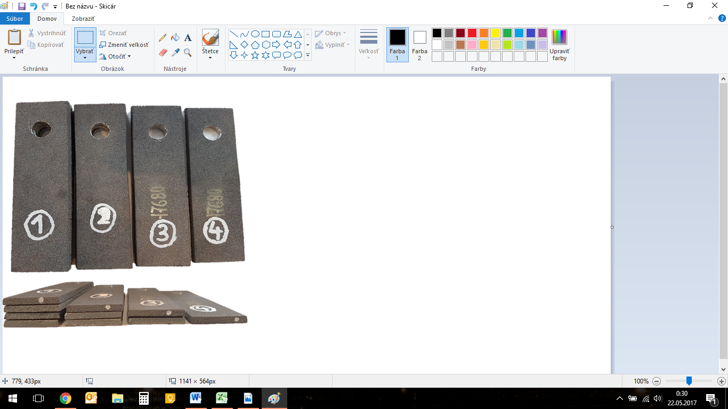

**Figure 7: Cast disintegration hammers from different material compositions [8]**

Marked materials of group A could be thermally processed after marking. We performed heat treatment of tools of material group A using a muffle laboratory furnace of the Czech company LAC, s.r.o. type LMH 07/12. This type is suitable for heat treatment of metals. The working chamber has a volume of 7 liters and the maximum temperature of the furnace is 1200°C [8]. The heat treatment was done by placing a metal pad in the furnace chamber, on which the selected tools were placed after it had been heated to the required temperature. Cast crushing hammers of material A were inserted into the furnace chamber heated to 900°C. After the temperature in the furnace chamber had stabilized at 900°C, austenitization took place for one hour. Hardening of the tools was done in air after being placed on a metal pad. Annealing was performed at a temperature of 600°C for 6 hours with subsequent cooling in air. With this heat treatment, we wanted to achieve higher resistance to wear under the conditions of the experiment.

# RESULTS AND DISCUSSION

***3.1 Laboratory testing of hardness***

Before the measurements to be carried out in operating conditions, we chose to perform laboratory tests of resistance to adhesive wear and tests of the hardness of the materials. We performed laboratory tests with both the originally used and the proposed materials A, B, C, and D. The aim of the sliding friction testing is to quantify the wear rate in the tool storage nodes on the pivot. The purpose of this test is to prevent excessive damage to the studs and to determine the lifetime. Replacing the original tools with proposed wear-resistant tool materials may result in an increased rate of wear at the tool fixing location. An increased rate of wear at the fixing point could cause material degradation of the pin, which could lead to damage to the hammer mill due to excessive damage to the pin at the fixing point, during operating revolutions. The material of the pin is definitely less hard and less resistant to wear than the material of the proposed tools. The material of the pin should meet the requirement for at least the same hardness of the material, so that excessive wear does not occur in this node in the tribological pair. In order to avoid the mentioned damage, we suggest to carry out tests of the chemical composition of the studs. In order to fit the tools, it will be necessary to find, based on the chemical analysis of the used pin, a material pair with the designed materials.

As one of the monitored parameters to determine the influence of the parameters affecting the wear of disintegrating tools, we chose the hardness of the material. The hardness of the material is one of the monitored parameters, which determines the values of the factors affecting tool wear [10]. For this purpose, we measured the hardness of the proposed and simultaneously used materials. For the hardness measurement, we used the Tinius Olsen hardness measuring device from the FH11 SERIES line, which is shown in Figure 8. We used the Rockwell hardness measurement method. The method is designed for serial control tests of hardened, refined or otherwise heat-treated steels [10]. This hardness test does not require surface treatment, because the depth of the indentation is measured by applying a force of 98 N to set the depth measurement to zero and then apply the test force. After unloading to 98N, the indentation depth is read. The measurement takes place after unloading to eliminate elastic deformations of the meter pad and deformations of the stand.

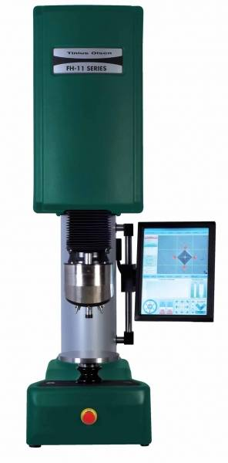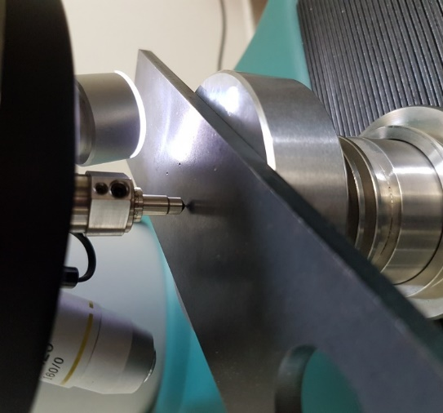 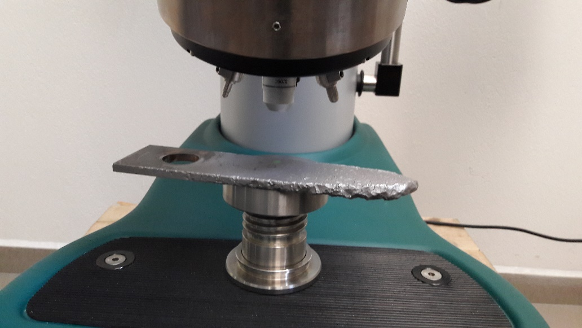

**Figure 8: Used FH11 hardness tester (left), measurement of an undamaged tool (middle) and worn tool (right) [10]**

We measured seven hardness values for each of the measured materials. From these recorded values, we deleted the maximum and minimum measured value during the statistical processing due to the different uneven structure of the material. As can be seen from the graphic representation in Figure 9, we recorded the minus values of the HRC scale in the measured hardness values of the originally used tool material, which means that this hardness scale does not have a usable range for measuring the hardness of the originally used disintegration tool material. The area of application of the HRC scale is from 20 to 70 HRC and is intended mainly for hard heat-treated materials [10]. Minus values mean that we measured a hardness lower than the lower limit of the scale. For this reason, we chose the Vickers hardness measurement method for measuring the hardness of the originally used material, the scale of which is uniform for both soft metals and hard hardened steels.

**Figure 9: Measured hardness of the proposed material compositions of disintegration tools [8]**

The indenter is the same for all Vickers hardness test methods. The body is a diamond in the shape of a regular quadrilateral pyramid with a square base [10]. The apex angle is 136° ± 0.5°. The Vickers method of hardness measurement gives a uniform scale of hardness from the softest metals to the hardest hardened steels. Hardness values do not depend on the size of the load. The test is unsuitable for measuring the hardness of rough and non-homogeneous structures such as cast iron [10]. If the structure of the tested material is too thick and the force with which the needle penetrates the tested material is small, there may be a case where the imprint is only on one part of the structure. The resulting hardness will not correspond to the total hardness. Taking into account the mentioned influencing factors and the structural composition of the tested materials, we eliminated the maximum and minimum value from the measured values during the statistical processing. The evaluation was made from five measured values. The arithmetic mean values of the original materials are shown in Figure 10. We can observe that we measured a higher hardness of the material on the worn originally used material, which may be due to the strengthening of the tool material by plastic deformation. By comparing the Vickers scale with the Rockwell scale, we wanted to point out the hardness values of the original material, which do not fall into the Rockwell scale, but it was possible to make a joint evaluation since we know the transmission relationship between the HV and HRC values. The results are shown in the common HRC scale in Figure 9. Based on the results, we see orders of magnitude different HRC hardness values that predetermine the designed materials for use in highly abrasive processes.

**Figure 10: Hardness of the originally used material before and after wear [8]**

***3.2 Laboratory testing of adhesive wear***

Measurement of adhesive wear requires modification of test material samples. We made test samples from tool castings. Adjustment of the castings to the dimensions of the test sample was carried out using water jet technology. For the purposes of the test, we cut testing specimens with dimensions of 47 x 15 x 7 mm. We will use a body made of the originally used material as a standard test body. No grinding or other surface treatment is required to perform the test. After cutting to the required size and degreasing the test bodies, we recorded their parameters. We chose to mark the test specimens using a waterproof lacquer marker on the metal surfaces of the materials. The marking of individual test specimens consists of the designation of the designed material in capital letters according to the designation in the design and the serial number of the test specimen. Figure 11 shows labeled test specimens from each proposed material group.

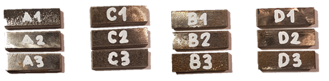

**Figure 11: Prepared testing specimens for measuring of adhesive wear [8]**

Adhesive wear tests were also carried out in laboratory conditions of the faculty. To determine the sliding properties of the proposed materials, we used the testing device of the Swiss company Wolpert Werkstoffprufmachinen GmbH, Amsler A 135, which is shown in Figure 12. The wear test method belongs to the group of comparative tests with test bodies. In the case of boundary friction, the adhesive wear test is of the "disk - attachment" type. The essence of the test consists in the action of the static force *Fn* derived by the spring on the investigated pair of materials during a certain time [10]. The tested material sample is pressed against the rotating disc [10]. During the test, it is possible to record the temperature at the point of contact and the course of the friction moment, with the help of which the coefficient of friction is subsequently determined.

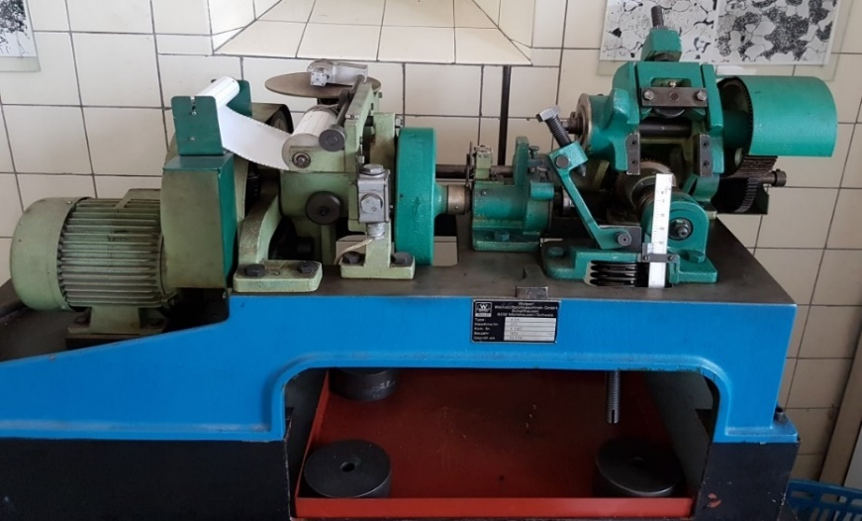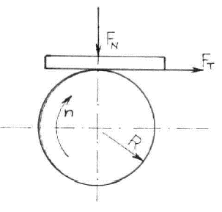

**Figure 12: Amsler A 135 testing device (left) and principle diagram of the test (right) [8]**

A pair of tested materials was subjected to a static loading force *Fn* during the test. The testing sample is a body with a rectangular cross-section of 47 x 15 x 7 mm, which is pressed against the disk with a constant pressing force, which performs a rotational movement. As a result of the friction, a friction moment *Mt* is created during the test at the point of contact, which is continuously recorded during the test. By evaluating the record of the course of the friction moment *Mt* after the test, and from the obtained results, we determined the coefficient of friction *μ*.

From the course of the friction moment and the disc diameter, we determine the friction force *FT* according to the equation:

$F_{T}=\frac{M_{t}}{\frac{d}{2}}=\frac{2.M_{t}}{d} (N)$..........................................................................................................(1)

where,

*FT*– friction force (N),

*Mt* – friction moment (N.m),

*d* – disc diameter (m).

We determined the coefficient of friction from the calculated friction force *FT* and from the known constant value of the pressure force *Fn* according to the equation:

$μ=\frac{F_{T}}{F_{n}}$ (-) ............................................................................................................(2)

***Table III.* Measured values from the testing and calculated values of the coefficient of friction [8]**

|  |  |  |  |  |
| --- | --- | --- | --- | --- |
| Specimen  material | Coefficient of  friction (-) | Hardness  (HV) | Weight loss of  the sample (g) | Weight loss of  the disc (g) |
| 1.0338 | 1.79 | 135.74 | 0.181 | 0.002 |
| A | 1.73 | 513 | 0.007 | 0.005 |
| B | 1.27 | 528 | 0.005 | 0.003 |
| C | 0.81 | 434 | 0.002 | 0.000 |
| D | 1.67 | 484 | 0.005 | 0.007 |

**Figure 13: Graphical comparison of measured weight losses [8]**

The results of the measurement of adhesive wear and the calculation of the coefficient of friction can be seen in Table 3 and Figure 13. From the performed test, we can conclude that the originally used material of the tool has the highest coefficient of friction and weight loss of the sample. The originally used structural steel has the least wear resistance according to the test performed. We calculated the smallest value of the coefficient of friction for the proposed material C, on which we simultaneously measured the smallest value of weight loss. From the comparison of the results of this test, cast iron C appears to be the most suitable material.

# CONCLUSIONS AND RECOMMENDATIONS

Based on the obtained results, it can be clearly confirmed that the proposed material compositions A, B, C and D are more suitable for the production of hammer mill disintegration tools from the point of view of wear. From the known value of the weight loss of the originally used material, it is possible to recalculate the theoretical wear values for the designed tool materials [10]. When calculating, it is possible to consider that the originally used tool made of structural steel 1.0338 processed 630 tons of wood raw material. After the specified amount of processed wooden raw material, it was necessary to replace the worn tools with new ones. If we consider that the rate of wear of disintegration tools has a linear dependence, we can determine their theoretical rate of wear over a certain period of time [10]. All theoretical results can be seen in Table 4, and are calculated on the base of obtained measured results. From the weight loss data from the performed test and real operation, it is possible to determine the theoretical values of the amount of material that we would process using one set of new tools [10]. The proposed tools of material group C show, under the mentioned considered conditions, the highest theoretical resistance to wear. The calculated amount of processed raw material is approximately 96 times greater than the amount of processed wood waste originally used by the 1.0338 structural steel tool, also carry out experimental research in real operation. The thus obtained values of weight loss and thus wear of the disintegration tools will reliably take into account the dynamic effect of the entire process, the specific location of the tools on the pin, or the specific position of the individual crushing tools. These aspects also affect the actual wear and thus the lifetime of the disintegration tools in the process of disintegration on hammer mills.

***Table IV.* Table of theoretical values of financial savings [8]**

|  |  |  |  |  |
| --- | --- | --- | --- | --- |
| Specimen  material | Price of whole tools set /  unit price of tool (€) | Processed raw  material - theoretical  (tons) | Theoretical  lifetime  (month) | Theoretical financial  savings (€) |
| 1.0338 | 60 / 3.75 | 630 | 1.4 | 0 |
| A | 170 /10.625 | 17667 | 39 | 1513 |
| B | 170 /10.625 | 25376 | 56 | 2247 |
| C | 170 /10.625 | 61862 | 137 | 5722 |
| D | 170 /10.625 | 31060 | 69 | 2788 |

**ACKNOWLEDGMENTS**

*The paper is a part of the research done within the project APVV-19-0607 “Optimized progressive shapes and unconventional composite raw materials of high-grade biofuels” funded by the Slovak Research and Development Agency and within the project VEGA 1/0533/23 „Research of technological and structural parameters of the pressing process of composite biofuels from alternative raw materials“, funded by the Ministry of Education of Slovak Republic and to the Slovak Academy of Sciences.*

**REFERENCES**

1. Lisičan, J., (1996). "Theory and technique of wood processing", MatCentrum, Zvolen, Slovakia, ISBN 80-967315-6-4, (in Slovak).
2. Ditner, O., (1984). "Crushing and grinding of mineral raw materials", SNTL, Praha, (in Czech).
3. Zdravecká, E., Smetana, Š. and Suchánek, J. (2012). "Abrasive and erosive wear", TU in Košice, Košice, Slovakia, ISBN 978-80-553-1250-7, (in Slovak).
4. Murgaš, M., Dřímal, D., (2006). "High-chromium cast iron with higher ductility", Proceedings of the 14th International Scientific Conference (CO-MAT-TECH 2006) held in Trnava, Slovakia, October 2006, STU in Bratislava, Bratislava, Slovakia, pp.914-919, ISBN 80-227-2472-6.
5. Sinnott, M.D., Clearly, P.W., (2015). "Simulation of particle flows and breakage in crushers using DEM: Part 2 – Impact crushers", J. Mineng., 74. [doi.org/10.1016/j.mineng.2014.11.017](https://doi.org/10.1016/j.mineng.2014.11.017)
6. Murgaš, M., (1996). "Renovation technologies", STU in Bratislava, Slovakia, (in Slovak).
7. Pokusová, M., Brusilová, A., Šooš, Ľ. and Berta, I., (2016). "Abrasion wear behavior of high-chromium cast iron", A. Founeng., 16. DOI: 10.1515/afe-2016-0028.
8. Šoltýs, S., (2017). "Research on the wear of hammer mill tools during the disintegration of woody biomass", Diploma thesis, Supervisor: Peter Križan. STU in Bratislava, Slovakia, (in Slovak).
9. Kovač, P., Savković, B., Pokusová, M., Kulundžić, N. and Vrabel, M., (2018). "Machinability study of surface grinding of hard high alloyed cast iron", Scientific Research Reports: Development in machining technology. 8. Cracow University of technology, Cracow, Poland.
10. Križan, P., Šooš, Ľ., Pokusová, M. and Matúš, M., (2017). "Materials for densification tools", F.X. s.r.o. Bratislava, Bratislava, Slovakia, (in Slovak).