Animal and Violence Detection Using Artificial Neural Network
¹Kalamani C, ²Bhuvaneswaran R, ³Dhanapal S, ⁴Rajkumar S
¹Associate Professor, ^{2,3,4}UG Scholars,ECE Department, Tamilnadu College of Engineering, Tamilnadu,India
Corresponding Author:kalamec18@gmail.com,santhosravi25@gmail.com,dhanapals2003@gmail.com, rajkumarsg98@gmail.com

ABSTRACT: Animal assaults resulting in crop damage represent a significant risk to crop production reduction. Crop raiding is turning into one of the most vexing human-wildlife conflicts as a result of the extension of farmed land into former wildlife habitat. India's farmers confront significant risks from pests, natural disasters, and animal damage that lowers production. Farmers cannot afford to hire guards to monitor crops and deter wild animals because traditional methods are not very effective. Since animal and human safety are equally important, it's critical to both shield crops from animal damage and safely divert animals away from crops.. Therefore, the system uses deep learning to detect animals visiting our farm by employing the deep neural network idea, a branch of computer vision, in order to overcome the aforementioned issues and achieve our goal. In this project, a camera that records the surroundings all day long will be used by the system to periodically monitor the entire farm. The system detects the arrival of animals with the use of a deep learning model, and it plays the right sounds to scare the animal away. Artificial Neural Network ideas are used in this research to build the model. The suggested system will send out an alarm message in the event that it detects wildlife intrusion in a designated area. Python was used in the system's development. The forestry department can utilize the system to stop poaching and other violations that endanger animals.
KEY WARDS: Artificial Neural Network,Python, Deep learning algorithm,Animal detection.
KEY WARDS: (10 Bold) Markov chain analysis, Soil water level fluctuations, Jaber Al-Ahmadwetland, Kuwait

---------------------------------------------------------------------------------------------------------------------------------------
Date of Submission: xx-xx-xxxx Date of acceptance: xx-xx-xxxx
---------------------------------------------------------------------------------------------------------------------------------------

INTRODUCTION
The practice of informing people or communities of the existence or possible threat of wild animals in their region is known as "wildlife invasion notification." Notifications can come in a variety of formats, such as emergency text messages, social media notifications, and public declarations. Wildlife intrusion detection is the technique of keeping an eye out for and identifying wild animals in regions where people live. It is a crucial component of managing wildlife and lessens the likelihood of confrontations between people and wildlife. Various techniques, including visual inspections, camera traps, sound sensors, and GPS tracking, can be used to identify wildlife intrusions. Depending on the particular wildlife species, the habitat, and the level of human activity in the area, these techniques can be utilized separately or combined. Examining the area visually for evidence of animal activity, such as tracks, droppings, and harm to plants or property, is part of the inspection process. Motion sensors are used by camera traps to take pictures of animals as they move around the scene. Animal sounds, such as vocalizations or movement through vegetation, are picked up by acoustic sensors. Animal movement can be tracked with GPS in order to spot behavioral patterns. In regions where there is a high chance of human-animal interaction, such as close to farms, metropolitan areas, or natural parks, wildlife incursion detection systems are frequently utilized. Wildlife managers can avert conflicts and safeguard human and wildlife populations by promptly identifying the presence of wild animals.
Real-time, effective, and technologically cutting edge solutions are lacking from the current animal monitoring and conservation strategies. The issues of today include insufficient data for effective biodiversity research, inadequate detection and response procedures for illicit activities like poaching, and limited capacities to reduce conflicts between humans and wildlife. In order to solve these problems and support the conservation and sustainable management of a variety of habitats, there is an urgent need for an extensive wildlife notification system that makes use of cutting-edge technologies. Inefficient Wildlife Monitoring: Because traditional wildlife monitoring techniques frequently rely on manual procedures, data collection may be incomplete or delayed. This makes it more difficult to evaluate animal populations' dynamics and general health.
Inadequate Anti-Poaching Measures: The predominance of illicit activities, including poaching, seriously endangers species that are under threat. The level of technological complexity required to promptly identify and address such operations is currently lacking in anti-poaching initiatives. Insufficient Research on Biodiversity Research on biodiversity and our comprehension of environmental dynamics are hampered by the lack of up-to-date information on the behavior and dispersal of wildlife. To gather thorough and ongoing data for scientific study, a more reliable mechanism is needed. Insufficient Resolution of Human-Wildlife Conflicts: There are more conflicts between humans and wildlife, which puts both human societies at risk.
2. LITERATURE REVIEW
The research papers that follow provide an overview of the surveys and improvements in the field of this study. Different approaches are used for tracking, monitoring, and identifying animals in a variety of environments using wired and wireless sensor-based systems.
A Raspberry Pi-based system was proposed by S. Santhiya et al. in 2018[1] to carry out a number of time-consuming and repetitive operations. This technology uses radio frequency identification to find animals entering fields. It is affordable and has many uses, including the ability to detect and count forest animals as well as track them using the Global Positioning System (GPS). This idea uses a totally automated procedure, and the repellent doesn't hurt any animals.

In 2018, Yazhini V. R. et al. [2] presented a motion detection system that employs Raspberry Pi-connected moisture sensors. Additionally, the sensors pick up motion, and if the value goes beyond the threshold, a notification message alerting the user is delivered. While a webcam keeps an eye out for any wild animals, such elephants or small animals, that may be intruding on the crop field. The obtained image is compared to pictures in the database, including pictures of animals that might be harmful. The Raspberry Pi transmits data to the GSM module, which notifies the farmer of impending danger if the captured image corresponds with the image stored in the database. GSM is also in charge of the motors. The heat that the insect's body emits will be detected by an infrared sensor, while The sound the insects produce will be picked up by an ultrasonic sensor.

Ultrasonic or acoustic sound is the repellent mechanism; it irritates the animal at a specific frequency, which keeps the animal away from the area. Uma Maheswari et al. 2016 [3] presented a bird infiltration and detection system that uses buzzers that emit acoustic sounds in addition to wireless sensors. The acoustic sounds are activated when the sensors in the agricultural area detect a bird; the noise irritates the birds, which causes them to fly away because they are unable to handle the sound. The acoustic sounds are produced immediately upon identification of the birds and will only last for a brief period of time before their flight is forced.

In 2017, Shanmugasundaram R et al. [4] suggested tracking the locations of animals kept in zoos. The PIR sensor finds human presence inside the animal's limits or limited areas, while the temperature sensor keeps track of the animal's body temperature. In general, each species has a range of body temperatures. The animal will instantly become hotter if it is injured or has a fever. We're using a temperature sensor to monitor this. It constantly keeps an eye on the animal's temperature. In the event if the temperature changes, the LCD will show it. The PIR sensor detects human presence in restricted areas and near animal borders. A prerecorded voice alert will be sent by the voice processor if a human is detected.

In order to detect wild animals, Sneha Nahatkar et al. (2012) [5] designed a low-cost security system. This technology recognizes the presence of people who are not in thermal symmetry with the surrounding atmosphere by monitoring the signal in the PIR sensor. It calls a pre-stored GSM modem when it senses the presence of any person or animal during a designated period break. Following the transmission of sensor signals to the embedded system by the Microcontroller Unit (MCU), the application initiates the Web camera, capturing and analyzing photos.

An Artificial Neural Network (ANN) will be established to train the image dataset of monkeys, boars, and elephants by Sabeenian et al. 2020 [6], and this model is saved. In order to compare the trained images with the fresh test images from the live capture, the saved model will execute on the driver code. A terrible sound is played through speakers to scare away the lone trained animal if it is found during the live capture.
The development of an algorithm to identify the animals in the wildlife region was suggested by Banupriya et al. 2020[7]. With the help of this program, we can better monitor animals by classifying them based on their images. Animal tracking, animal-vehicle accident prevention, and animal detection and classification can all benefit from deep learning algorithm.
In order to classify the photos of wild animals, Manohar et al. 2019[8] suggested an AlexNet-based convolution neural network. In addition, a multiclass Support Vector Machine (SVM) classifier receives the collected features for classification. Both the accuracy and classification rates of this strategy are very high.

Although they work, manual methods like building various fences and applying natural repellents are not economical. Adding more employees is not the best way to solve this issue.
Negative aspects
Although these current systems are good at spotting wildlife invasions, their accessibility and customizability may be restricted by their high cost and lack of open-source software. Among these disadvantages are:
1. Cost: Because these systems can be costly to install and operate, small organizations and individuals may not be able to use them.
2. Limited customizability: Because these systems are usually made to function with particular animal types, they could not provide a lot of customizability.
3. Proprietary software: These systems may have proprietary software, which makes it challenging for outside developers to alter or enhance the system.

3. PROPOSED SYSTEM

By creating a convolutional neural network, the suggested model will train the image dataset of monkeys, boars, and elephants, and this model is saved. To compare the trained images with the fresh test images from the live capture, the saved model will execute on the driver code. Through the use of speakers, a repulsive sound is emitted in order to scare away any trained animals that are discovered during the live capture. The forestry department can utilize the system to stop poaching and other violations that endanger animals.

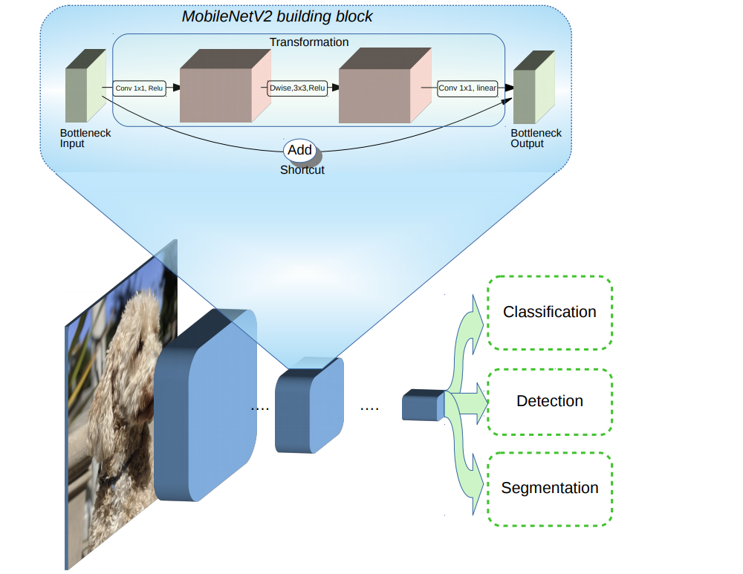

Fig 1. Model Architecture
A group of several perceptrons or neurons at each layer makes up an artificial neural network (ANN).The network's operation can be better understood whether or not it has hidden node layers.Figure 1 shows model architecture. 1. How many layers there are in the network (multi-layered or single-layered) 2. The signal's flow direction (recurrent or forward).3. The quantity of nodes in layers: The quantity of features in the input data set is equivalent to the quantity of nodes in the input layer. The number of classes in the case of supervised learning will determine the number of output nodes based on potential outcomes. However, the user will select how many levels are there in the concealed layer. greater performance is achieved with more nodes in the hidden layer, but an excessive number of nodes can lead to overfitting and greater computational costs. 4. Weight of Interconnected Nodes: Selecting the weights associated with each neuron's connectivity in order to properly solve a particular learning problem is a challenging task in and of itself. Consider an illustration to comprehend the issue. Using a Multi-layered Feed-Forward Network as an example, we must train an ANN model with some data in order for it to categorize a new data set, such as p_5(3,-2). Assume we have inferred that class C1 is represented by p_1=(5,2) and p_2 = (-1,12), and class C2 is represented by p_3=(3,-5) and p_4 = (-2,-1). We take synaptic weights w_0, w_1, and w_2 to be, respectively, -2, 1/2, and 1/4. However, these weight values won't be provided for each learning challenge. In order to use ANN to solve a learning challenge, For synaptic weights, we can begin with a set of values and modify them over time. A threshold value of less than 1% in the rate of misclassification or a maximum of fewer than 25 repetitions might be used as the terminating criterion. Another issue could be that the rate of misclassification might not steadily decline.

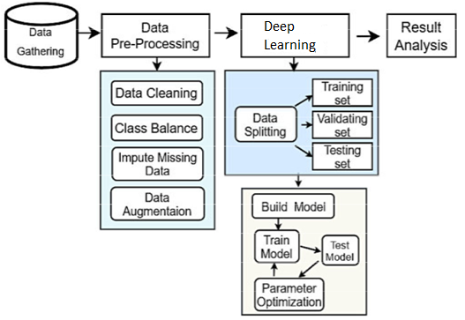
Fig2. System Flow Diagram
The utilisation of deep neural networks, which have multiple layers of interconnected nodes and can learn complex representations of data by discovering hierarchical patterns and features in the data, is a key component of Deep Learning, a subfield of Machine Learning that involves the use of neural networks to model and solve complex problems. Deep Learning algorithms can automatically learn and improve from data without the need for manual feature engineering. Neural networks are modeled after the structure and function of the human brain.

Deep Learning has shown great promise in a number of domains, such as recommendation systems, speech recognition, natural language processing, and image recognition. Artificial Neural Networks (ANNs), Recurrent Neural Networks (RNNs), and Deep Belief Networks (DBNs) are a few of the well-liked Deep Learning designs.
It usually takes a lot of data and processing power to train deep neural networks. Deep neural network training has become simpler, though, because to the advent of cloud computing and the creation of specialized hardware, including Graphics Processing Units (GPUs).
Dataset is downloaded from kaggle repository.
Field Name | Data Type | Description
ID | Varchar(15) | ID
Name | Varchar(25) | Name of animal
Range | Varchar(15) | Range value of image
Normal | Varchar(15) | Normal pixel value

3.1 PERFORMANCE ANALYSIS
The common view of testing held by users is that it is performed to prove that there are no errors in a program. This is extremely difficult since designer cannot prove to be one hundred percent accurate. Therefore, the most useful and practical approach is with the understanding that testing is the process of executing a program with explicit intention of finding errors that make the program fail.
Testing has its own cycle. The testing process begins with the product requirements phase and from there parallels the entire development process. In other words, for each phase of the development process there is an important testing activity. Successful testing requires a methodical approach. It requires focusing on basic critical factors: Planning,Project and process control,Risk management,Inspections,Measurement tools and Organization and professionalism
TEST PLAN
Before going for testing, first the system have to decide upon the type of testing to be carried out. The following factors are taken into consideration:
- To ensure that information properly flows into and out of program
- To find out whether the local data structures maintains its integrity during all steps in an algorithm execution
- To ensure that the module operate properly at boundaries established to limit or restrict processing
- To find out whether error - handling paths are working correctly or not
- To find out whether the values are correctly updated or not
- Check for validations
UNIT TESTING
Unit or module testing is the process of testing the individual components (subprograms or procedures) of a program. Unit testing is done for checking whether camera is detected or not.
Screen name: camera detection
Object name | Test id | Test case description | Action | Expected result | Actual result | Status
Camera detection | Tc001 | To check if the camera is detected using opencv-python | Execution | When the system is executed, camera should be detected | Camera is detected | Pass
Camera detection | Tc002 | To check if the camera is detected using opencv-python | Execution | When the system is executed, camera should be detected | Camera is not detected | Fail
VALIDATION TESTING
Validation testing provides the final assurance that software meets all functional, behavioral and performance requirement. System must detect eye region and facial features. This condition is checked in the validation testing.
Screen name: Face detection
Object name | Test id | Test case description | Action | Expected result | Actual result | Status
Face region selection | Tc001 | To check if the face region is detected properly for animal detection | On camera load | When the camera is loaded, face region should be detected and marked in bounding box | Same as expected | Pass
Face region selection | Tc002 | To check if the face region is detected properly for animal detection | On camera load | When the camera is loaded, face region should be detected and marked in bounding box | Not same as expected | Fail
INTEGRATION TESTING
Integration testing is the process of combining and testing multiple components together. Here facial feature recognition and animal detection are combined and tested together.
Screen name: animal detection
Object name | Test id | Test case description | Action | Expected result | Actual result | Status
Camera input | Tc001 | To predict animal from the facial and eye regions which are extracted already. | Prediction | Animal should be detected and alert message should be displayed | Same as expected | Pass
Camera input | Tc002 | To predict animal from the facial and eye regions which are extracted already. | Prediction | Animal should be detected and alert message should be displayed | Not same as expected | Fail
Camera input | Tc003 | To predict animal from the facial and eye regions which are extracted already. | Prediction | Animal should be detected and alarm should be generated | On animal detection ,alarm is generated | Pass
Camera input | Tc004 | To predict animal from the facial and eye regions which are extracted already. | Prediction | Animal should be detected and alarm should be generated | On animal detection , alarm is not generated | Fail
IMPLEMENTATION
System implementation is the important stage of project when the theoretical design is tunes into practical system. The main stages in the implementation are as follows: Planning,Training,System testing and Changeover planning
Planning is the first task in the system implementation. Planning is deciding on the method and the time scale to be adapted. At the time of implementation of any system people from different departments and system analysis involve. They are confirmed to practical problem of controlling various activities of people outside their own data processing departments. The line manager controlled through an implementation co-ordinate committee. The committee consists of ideas, Problems and complaints of user department. It must also consider,
- The implementation of system environment.
- Self selection and allocation for implementation tasks.
- Consultation with unions and resources available.
- Standby facilities and channels of communication.
4.RESULT & DISCUSSION
The algorithms are implemented using python and simulated. The snapshot of results are discussed as follows, live camera detection are shown in figure4,5.
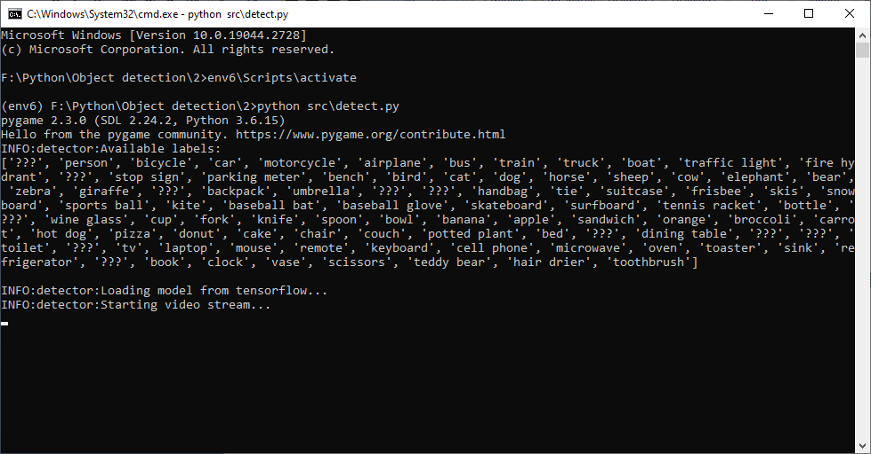
Fig3. All of that points to the sheer number of potential detections in Execution Terminal
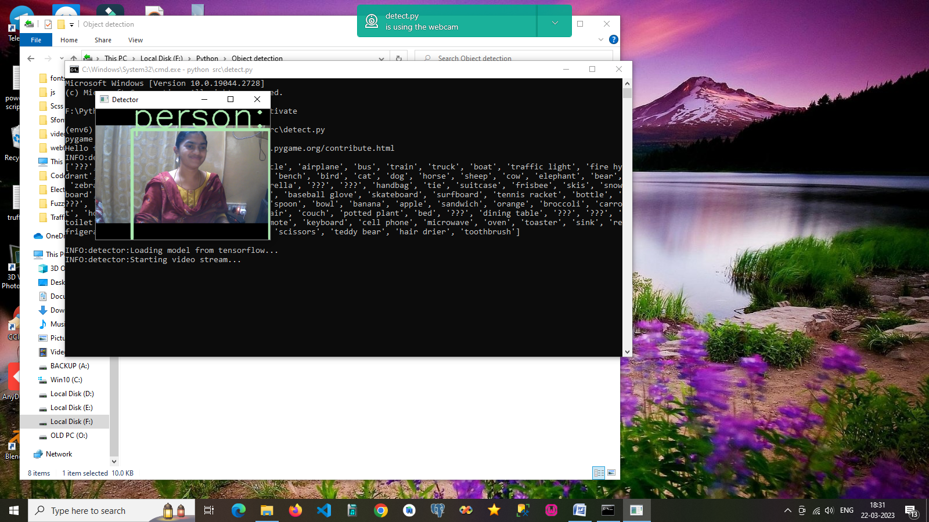
Fig4.It recognises what the live camera is displaying Live Camera Detection

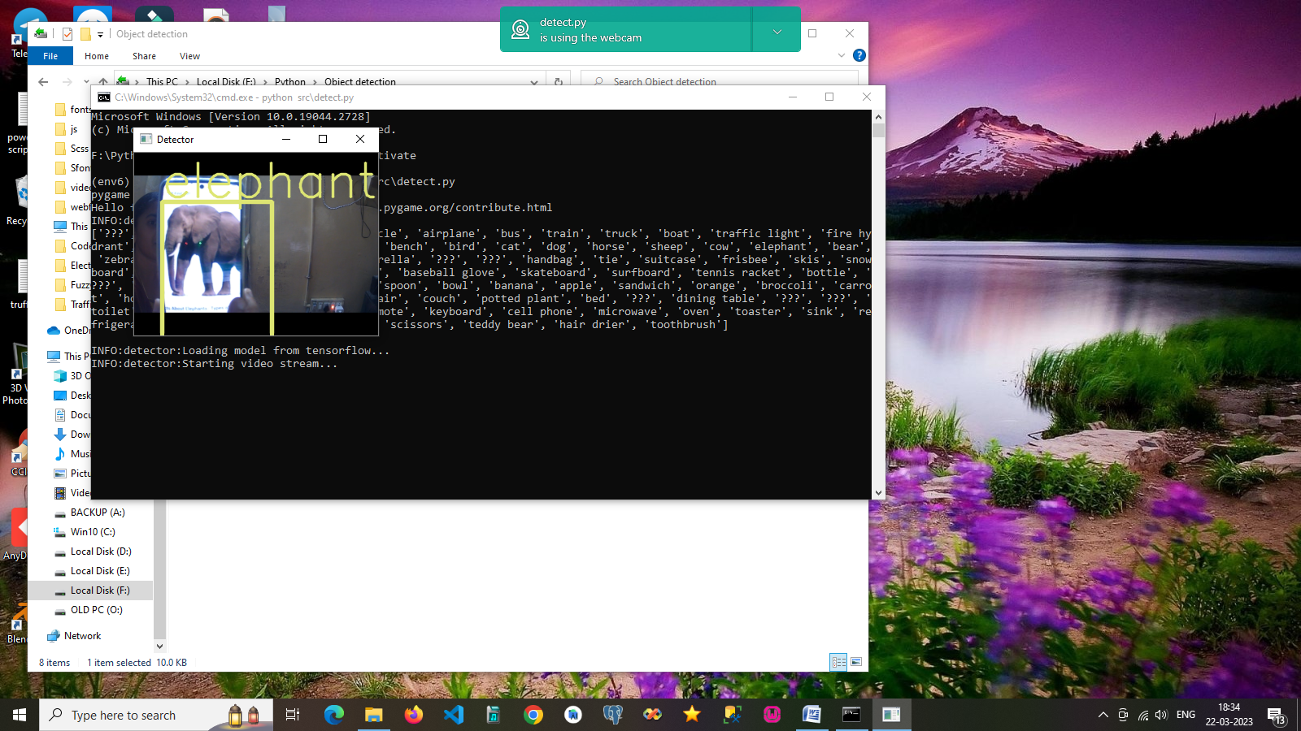
Fig.5 A sound alert would also be generated if any elephants were found in the live cameras.

Image Based Violence Detection are shown in figure6.
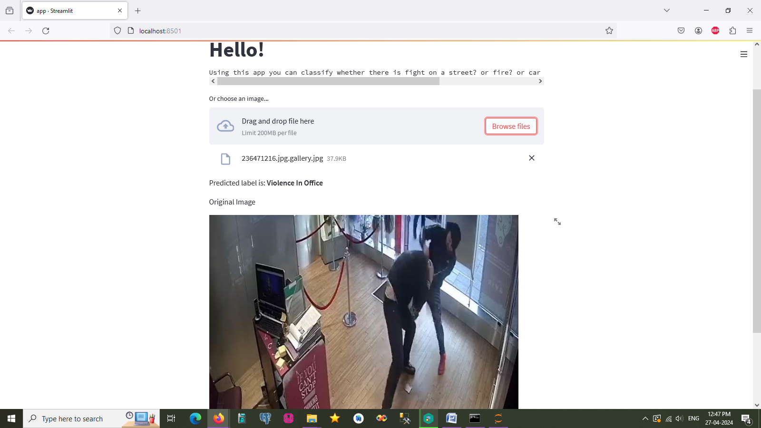
Fig 6.It recognises violence in the pictures. Fight prediction
Fire Incident Detection is shown in figure7.

Fig7.It identifies the fire occurrence from the photos.
Car Crash is shown in figure8.
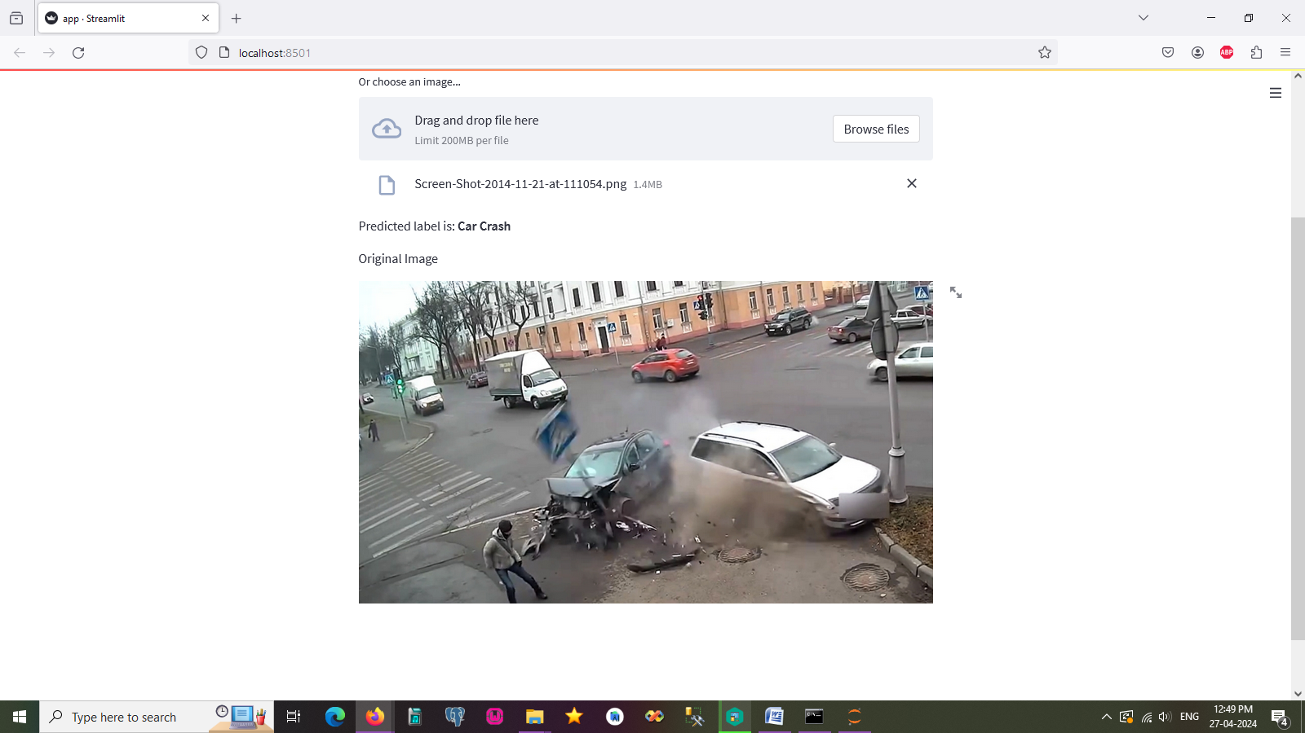
Fig8. It makes sense of the accidents based on the pictures.

Loading dataset
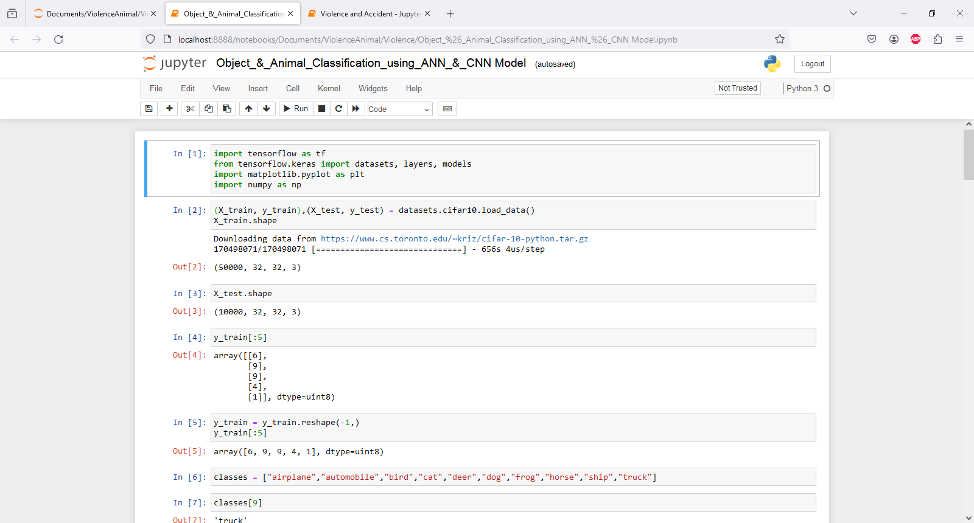
ANN model
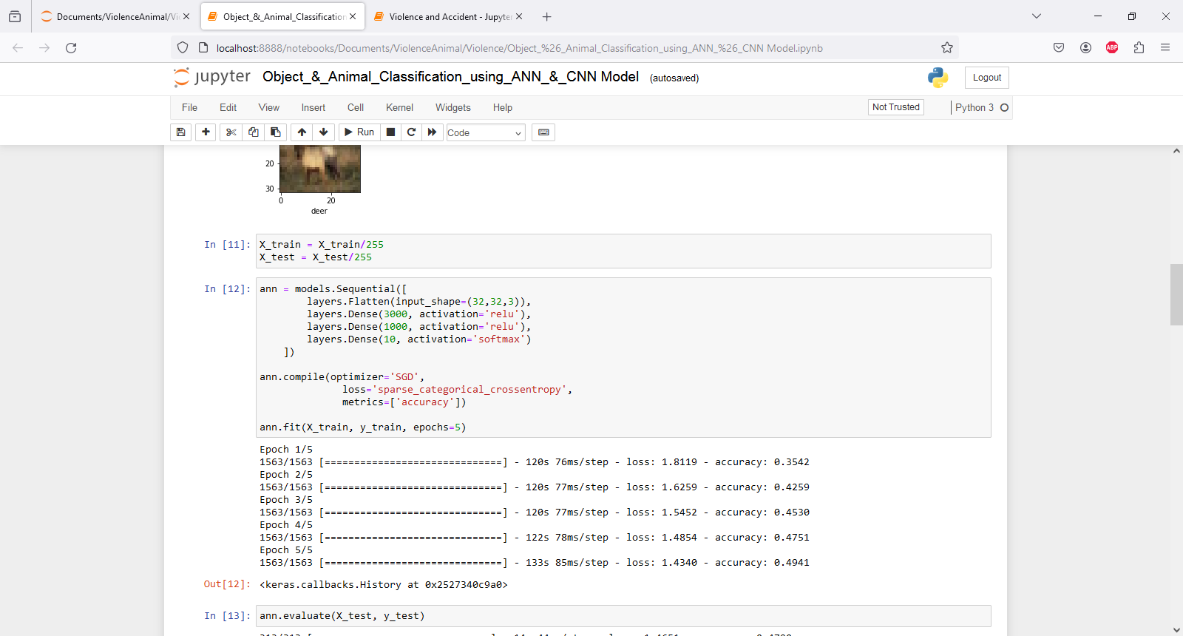
Accuracy classification report
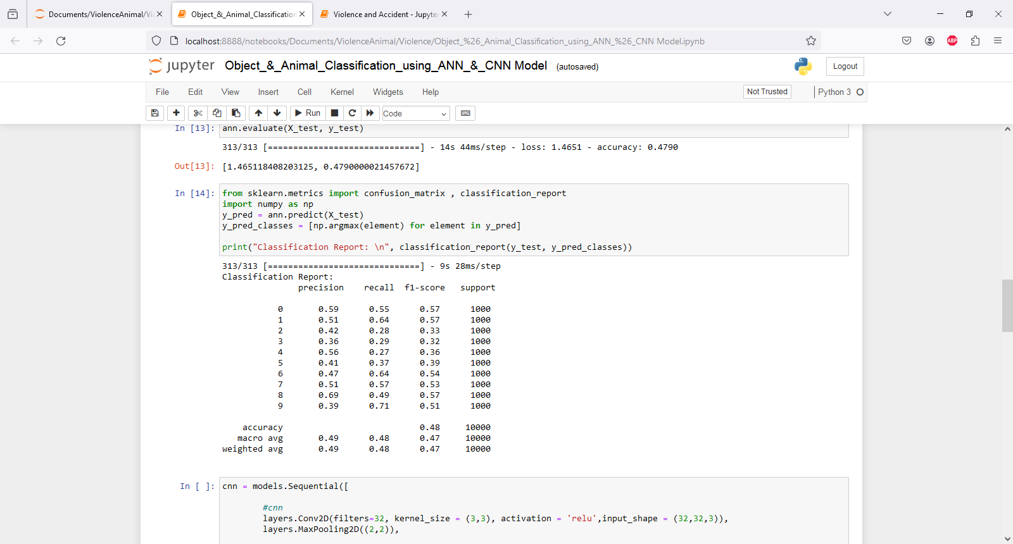

CONCLUSIONS
From camera trap photos, the system can identify animals such as elephants, zebras, horses, and so on. In the first experiment, tagged photos gathered from standard benchmark datasets of several citizen science projects are used to develop a flexible artificial neural network architecture. New camera-trap imagery data (gathered from Bastrop County, Texas) will be added to the algorithm to detect species once it reaches a suitable level of accuracy. The degree of forecast accuracy within their classification is the basis for evaluating the performance. The system generates decisions for resource management, provides an effective monitoring system, and expedites the study of wildlife inquiry.

References
[1] S. Santhiya, Y. Dhamodharan, N. E. K. Priya, C. S. Santhosh, and M. Surekha, “Smart Farmland Using Raspberry Pi Crop Prevention and Animal Intrusion Detection System,” Int. Res. J. Eng. Technol., vol. 5, no. 3, pp. 3829–3832, 2018.
[2] V. R. Yazhini and C. Vijayalakshmi, “a Semi Automatic Crop Monitoring System for Empowerment of India,” vol. 25, no. 5, pp. 13–16, 2018.
[3] A. R. Rajan, “Animal Intrusion Detection System Using Wireless,” vol. 2, no. 10, 2016.
[4] R. Shanmugasundaram, S. Pavithra, V. Sangeetha, S. Tamilselvan, and A. H. T. Ahmed, “Iot Based Animal Tracking and Monitoring System in Zoo,” South Asian J. Eng. Technol., vol. 3, no. 2, pp. 162–168, 2017.
[5] Nahatkar Sneha, Gaur Avinash, and Pattewar M Tareek, “Design of a Home Embedded Surveillance System with Pyroelectric Infrared Sensor & Ultra-Low Alert Power,” International Journal of Advanced Research in Electronics and Communication Engineering, Vol-1-No.3-86-90,2021.
[6] R. S. Sabeenian, N. Deivanai, and B. Mythili, “Wild animals intrusion detection using deep learning techniques,” Int. J. Pharm. Res., vol. 12, no. 4, pp. 1053–1058, 2020, doi: 10.31838/ijpr/2020.12.04.164.
[7] N. Banupriya, S. Saranya, R. Jayakumar, R. Swaminathan, S. Harikumar, and S. Palanisamy, “Animal detection using deep learning algorithm,” J. Crit. Rev., vol. 7, no. 1, pp. 434–439, 2020, doi: 10.31838/jcr.07.01.85.
[8] N. Manohar, Y. H. S. Kumar, R. Rani, and G. H. Kumar, Artificial Neural Network with SVM for Classification of Animal Images, vol. 545. Springer Singapore, 2019.

