**AR application in safety inspections on an infusion pump**

Author

*1Prof. Dr. Ing. Thomas Lekscha, Department of Engineering, Jade University.*

*2Prof. Dr. Ing. Knut Barghorn,* *Department of Management, Information, Technology, Jade University.*

*3Rena Hambsch-Müller M.Sc.,* *Department of Management, Information, Technology, Jade University. 4Gabriele Ernstorfer MA,* *Department of Management, Information, Technology, Jade University.*

*ABSTRACT: This paper examines the design of augmented reality (AR) applications to support the safety testing of medical devices, using the Fresenius Agila SPMC infusion pump as an example. Although AR technologies have existed for over 20 years, their potential remains largely untapped in specific application areas, particularly in safety engineering. This work addresses this research gap to increase the efficiency and usability of such applications, especially in the context of Industry 4.0.*

***KEY WORDS:*** *Augmented Reality, Infusion pump, Safety inspection, Human-machine Interface*

---------------------------------------------------------------------------------------------------------------------------------------

Date of Submission: 14-05-2025 Date of acceptance: xx-xx-xxxx

---------------------------------------------------------------------------------------------------------------------------------------

# INTRODUCTION

To date, AR applications have primarily been used for obvious tasks such as navigation, training/teaching and entertainment; other areas of application such as security technology or emergency planning have not yet been considered. However, the digital transformation process is unstoppable and necessary to meet the demands of Industry 4.0 (BMWK, 2024, p. vii; Knoll & Stieglitz, 2022, p. 15) [1]. This is because it is characterized by a wide variety of products and customized production on demand, which places increasing mental demands on workers. AR systems can help reduce cognitive load and meet the requirements of modern production (BMWK, 2024; Funk, 2016, p. vii) [2]. However, the design of such an application requires careful consideration, as the interface between humans and machines is often still problematic. According to Kunz & Wegener (2015), Industry 4.0 is primarily characterized by the fact that "digital and real worlds form a cyber-physical product [...] into which humans are integrated" (p. 2) (Kunz & Wegener, 2015, p. 2) [3]. This paper therefore aims to answer the question of what must be considered when designing an AR application in order to use it profitably for safety testing of medical devices. For this purpose, a prototype for the safety testing of an infusion pump was developed. The infusion pump is a particularly suitable example because, as a medical device, it must be subjected to regular safety tests. Furthermore, the use of the AR application can be scaled for other medical devices.

# LEGAL REGULATIONS

Safety checks on medical devices are an essential part of healthcare. They provide a structured approach to ensuring the safety and effectiveness of medical devices, ultimately leading to better patient care. Legislators have issued regulations and rules governing safety checks. In Europe, this primarily applies to the Medical Devices Regulation [4] and, in Germany, the Medical Device Operator Regulation [5]. A medical technician must be familiar with the national and international standards, as well as the specific standards for different types of medical devices. This knowledge is necessary to inspect the devices for compliance with patient safety and functional requirements. The owner and operator of medical devices must carry out safety inspections (STK) for all non-implantable active devices listed in Annex 1, in accordance with paragraph 12 of the Medical Device Operator Ordinance in accordance with generally accepted engineering practices. These safety inspections must be carried out at least every two years, at the end of the month in which the product was put into operation or the last safety inspection was performed. Furthermore, the Medical Device Operator Ordinance stipulates in paragraph 4, chapter 6 that before using a product, the user (nurse, doctor) must ensure that the product is functioning properly and is in proper condition. The use of AR glasses support can also be very helpful here.

# MATERIAL AND METHODS

As hardware device, the Meta Quest 2 from Meta was chosen. It is the replacement to the Oculus Quest and has been on the market since the end of 2021. The headset is suitable for VR and AR and is particularly well-suited to its dynamic resolution scaling and high pixel density. The HMD records head, body, and pupil movements, making it possible to control it via eye tracking. Furthermore, the manually adjustable eye relief makes it suitable for glasses wearers and weighs only 574 grams. The headset is equipped with 256 GB of storage, an internal Android-based operating system, and a rechargeable lithium-ion battery. It enables hands-free working and offers the possibility of using the application in a variety of locations. Furthermore, it is lightweight and promises good wearing comfort.

For the development of the prototype the software BlippAR was used. BlippAR is a British AR tool that supported a user-friendly Blippbuilder development for both, beginners and technicians, to create projects quickly and for free, without the need for any programming knowledge.

As soon as users put on the HMD, the controls are explained to them. The application is based on eye-tracking, this allows information to be entered by visually fixing buttons. This method of operation was chosen to enable hands-free and therefore uninterrupted work. After that, users can log in with their name and password by using a projected keyboard. The information about the layout and also other elements of the user interface are shown and explained to users. Additional information about the test device and the test section currently being performed. Furthermore, users can return to the application's main menu and adjust individual settings using a settings button.

Below, some work steps are explained in extracts and illustrated with pictures. The safety inspection essentially involves a visual inspection of the housing and accessories in order to identify possible sources of errors. During the visual inspection, the infusion pump housing is checked for damage, the display and control units for legibility, and accessories such as syringes and delivery systems for authenticity. The results are then recorded using eye tracking as "OK" or "NOK." Figure 1 shows the error on a display on the right side, so the visual check is not passed (NOK).

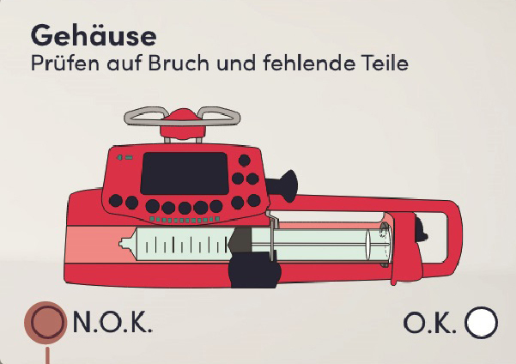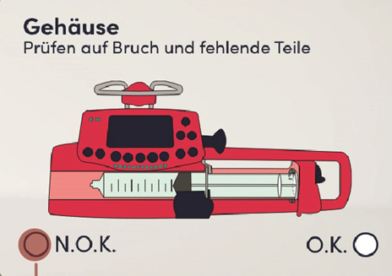

**Visual inspection of the infusion pump**

OK NOK

OK NOK

**Visual inspection of the infusion pump**

Figure 1: Visual check with selection via eye-tracking

In addition to the visual inspection, the safety check also includes testing the functionality of the medical device; in this case the infusion pump. The key points that must be checked during the functional check of an infusion pump are the flow rate, the flow volume over a specific period of time, the cut-off pressure when the blood line is closed and also its alarm, and the alarm when the infusion has ended. During the functional check, images are again displayed via the AR-glasses as an aid. Among other things, the target values ​​or limit values ​​are displayed here so that the inspector can easily identify any exceedance or falling below of the prescribed values. Figure 2 shows an example AR-glass-image for performing a part of the functional check on an infusion pump.

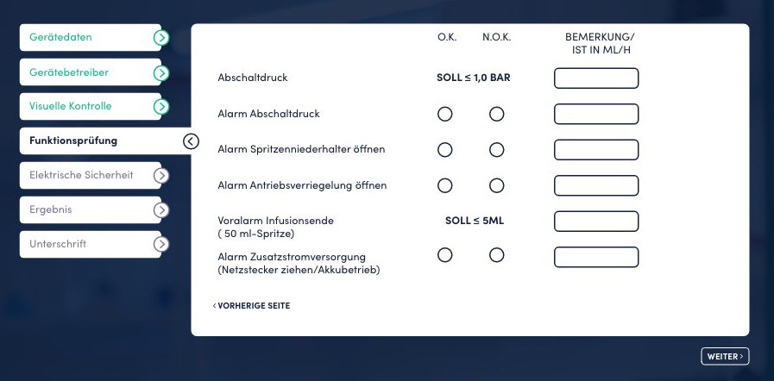

Figure 2: Functional test with displayed limit values

An also important component of a safety inspection of an active medical device is the measurement of electrical safety. These measurements are intended to ensure that, in addition to visual safety and functional safety, there are no electrical safety defects in the device that could affect the safety of patients and operating personnel (nurses and doctors).

For the electrical safety test, the medical technician must measure the following electrical values according to IEC 60601/EN 60601 [6]: Protective Earth Resistance, Earth Leakage Current, Touch or Enclosure Leakage Current, Patient Leakage Current, Patient Auxiliary Leakage Current and Mains on Applied Part Leakage Current. The medical device can only be used on the patient once all electrical measurements are within the specified limits. By displaying the target values ​​via the AR-glasses, the medical technician can quickly compare the actual- and target values ​​to release the Infusionpump for use on patient or to send it for repair. Figure 3 shows example measurements (Total device leakage current left and Applied Part Leakage Current right) with measured actual values ​​and displayed limit values, displayed through the AR-glasses.

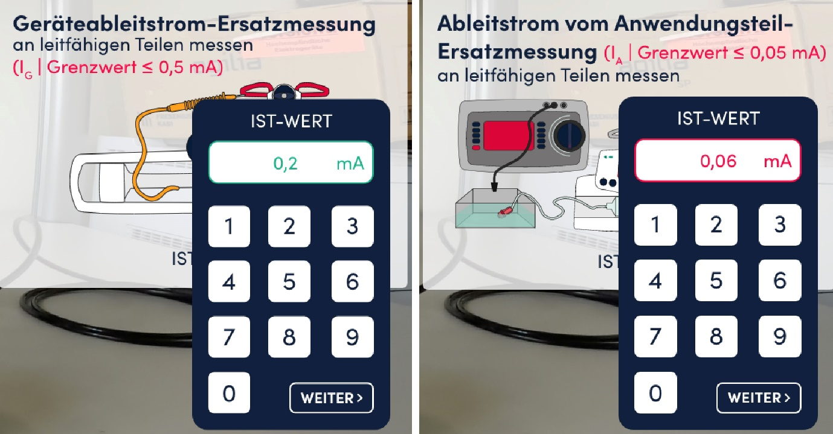

Figure 3: Electrical safety test with displayed limit values (Grenzwert)

# IV. RESULTS

In summary, the developed prototype offers promising approaches that can be optimized through further usability testing and targeted adjustments. A fully implemented and field-tested prototype would be the next step toward realizing the desired improvements in the safety testing of medical devices and fully answering the research question. This work makes an important contribution to closing the research gap in this area. It can serve not only as a basis for AR applications for testing medical devices, but also be relevant for other applications in areas such as production or safety technology.

# CONCLUSIONS AND RECOMMENDATIONS

One way to increase the efficiency of the created prototype would be to integrate QR codes or barcodes on medical devices within facilities such as hospitals. These could act as markers that the system automatically recognizes, eliminating the need to manually select the device to be tested and saving the user additional work steps. In the future, it would also be realistic to expand the prototype for infusion pump safety testing to other medical devices, as the tests essentially involve similar tasks. Since AR applications have proven particularly advantageous in handling complex tasks, there is great potential for use in safety-critical areas. In addition to being expanded to other medical devices, the prototype should therefore also be used to support infusion pump users in their daily work. In this area, too numerous incidents have been reported that are due to a lack of user knowledge or inadequate training. Furthermore, it would be helpful to use the prototype in teaching this field, for example, to support junior doctors in operating new medical technology. During their training, they have to learn how to use a variety of devices in a short period of time, which is why AR-based training could be a valuable support.

**REFERENCES**

1. Knoll, M. / Stieglitz, S.(2022). Augmented Reality und Virtual Reality – Einsatz im Kontext von Arbeit, Forschung und Lehre. HMD Praxis der Wirtschaftsinformatik, 59(1), 6–22. https://doi.org/10.1365/s40702-022-00840-5.
2. Funk, M. (2016). Augmented reality at the workplace: A context aware assistive system using in-situ projection [doctoral thesis]. https://doi.org/10.18419/opus-8997.
3. Kunz, A. / Wegener, K. (2015). Die Mensch-Maschine-Schnittstelle als Schlüsselelement für VR/AR-Anwendungen. https://doi.org/10.3929/ethz-a-010561390.
4. Regulation (EU) 2017/745 of the European Parliament and of the council on medical devices, amending Directive 2001/83/EC, Regulation (EC) No 178/2002 and Regulation (EC) No 1223/2009 and repealing Council Directives 90/385/EEC and 93/42/EEC, Official Journal of the European Union L117/1.
5. Verordnung über das Betreiben und Benutzen von Medizinprodukten (Medizinprodukte-Betreiberverordnung MPBetreibV), 4. Februar 2025, Bundesgesetzblatt BGBl. 2025 I Nr. 38, Bundesministerium der Justiz sowie Bundesamt der Justiz der Bundesrepublik Deutschland.
6. DIN EN 60601-1/A13:2025-03, Medizinische elektrische Geräte; Teil 1: Allgemeine Festlegungen für die Sicherheit einschließlich der wesentlichen Leistungsmerkmale, Deutsche Institut für Normung, DIN Media GmbH, am DIN-Platz, Burggrafenstraße6, 10787 Berlin.