ConnectMe: Streamlined, Professional, and QR-Powered Digital Business Cards

Kuo-pao Yang1, Subin Bista2, Niraj Bhatta3, Aakash Poudel4, Anjali Thapa5

*1, 2, 3, 4, 5Computer Science Department, Southeastern Louisiana University, Hammond, Louisiana, USA*

*ABSTRACT: ConnectMe is a digital business card generator designed to modernize and simplify professional networking. Built using the Flutter framework, ConnectMe allows users to create customized, shareable business cards that can be easily exchanged via QR codes, reducing the need for physical cards. The app’s user-friendly interface and seamless QR integration make it an efficient tool for sharing contact details across both iOS and Android devices. ConnectMe addresses the demand for sustainable, contactless, and easily customizable business cards, making it an ideal solution for professionals in the digital-first world.*

***KEY WARDS:*** *Digital business card, QR code, Dart, Flutter framework, Mobile application*

---------------------------------------------------------------------------------------------------------------------------------------

Date of Submission: xx-xx-xxxx Date of acceptance: xx-xx-xxxx

---------------------------------------------------------------------------------------------------------------------------------------

# INTRODUCTION

In an era where first impressions and quick connections are vital, traditional business cards are becoming less effective as a means of professional networking. Physical cards, though still popular, come with inherent limitations: they are easy to lose, costly to reprint, and can quickly become outdated as contact information changes. Moreover, the demand for sustainable, eco-friendly alternatives to paper-based products has led to a rethinking of how professionals exchange information. The modern world needs a faster, more adaptable, and environmentally friendly solution that aligns with the digital nature of today’s business landscape.

ConnectMe is a mobile application designed to address this need by offering an innovative digital business card solution. Developed using the Flutter framework, ConnectMe provides professionals with a way to create, customize, and share a digital business card that is always current and accessible. Rather than relying on printed cards, ConnectMe enables users to store and present their professional information in a digital format. This digital business card includes essential details such as name, position, company, phone number, email, and links to professional social media profiles like LinkedIn. The app integrates a QR code feature, which allows users to share their contact information instantly, providing a more efficient and memorable networking experience.

The app is particularly valuable for professionals, freelancers, and business owners who want to make lasting connections. Through its QR code feature, ConnectMe simplifies the exchange of information, allowing users to present their digital card in any setting with ease. The QR code directs contacts to the user’s business profile, eliminating the need for physical cards and minimizing the environmental impact associated with printing. With just a scan, all relevant information can be saved directly into a contact list, streamlining the process and ensuring that the user’s connections always have the most up-to-date information.

As digital transformation reshapes how people connect, ConnectMe is part of a larger trend toward fully digital, mobile-enabled professional tools. Beyond the obvious environmental benefits, digital business cards also offer adaptability and accessibility, aligning with the preferences of a generation that values technology-driven solutions. In this context, ConnectMe not only modernizes networking but also provides a more sustainable way to manage professional contacts in an increasingly paperless world.

With the growing shift toward remote work, freelancing, and global business operations, networking has become more dynamic and often transcends geographic boundaries. ConnectMe empowers users to stay connected no matter where they are in the world, eliminating the logistical challenges that arise from exchanging physical business cards in virtual meetings or international conferences. By offering a tool that works seamlessly across different platforms and devices, ConnectMe enables users to manage their professional identities efficiently and in a manner that is consistent with the fast-paced, tech-driven nature of modern business. The app’s flexibility not only streamlines the process of exchanging information but also aligns with the evolving expectations of professionals who seek smarter, more integrated solutions for networking in the digital era.

This paper provides an in-depth look at the background, design, and development of ConnectMe. It examines the demand for digital business card solutions, the advantages of using a digital platform for networking, and the technical architecture behind ConnectMe. Through this, we aim to highlight how ConnectMe bridges the gap between traditional business practices and modern, digital convenience, enabling professionals to connect in a way that is both efficient and forward-thinking.

# RELATED WORK

There are many different methods for managing business contacts and sharing professional information in today’s digital world. Traditionally, individuals relied on physical business cards to exchange their contact details, but with the rise of digital technology, many professionals have moved to digital alternatives. Digital business card solutions have emerged, offering the convenience of storing, sharing, and customizing contact information electronically. However, many of these solutions focus primarily on the basic function of contact management and do not integrate other essential features such as social media links or professional networks directly into the card itself. This is where ConnectMe sets itself apart.

While apps like HiHello [1] and Vistaprint [2] offer simple digital card creation tools, they primarily focus on storing and sharing static information. These platforms provide basic customization options, such as logos and titles, but do not address the need for dynamic and interactive features like integrating social media links or professional profiles within the card. The lack of personalization beyond basic details limits the effectiveness of these solutions for users looking to build and share a more comprehensive professional identity.

Other apps, like Cardhop [3] and CamCard [4], provide more robust contact management, allowing users to scan and store physical business cards or create their own digital versions. While these platforms offer useful features such as contact syncing, categorization, and notes, they still fall short in terms of offering a full suite of tools for networking and personal branding. Users cannot easily integrate their social media profiles or professional networks into these cards, leaving out a key aspect of modern professional interaction. Unlike these apps, ConnectMe goes further by integrating social media links and offering a customizable design that reflects the user’s professional persona.

Social media platforms such as LinkedIn have become integral to professional networking, offering users the ability to create detailed profiles, share updates, and build connections. However, LinkedIn focuses on profile management rather than providing a way to generate a digital business card or to offer a unified solution for networking and contact management. While LinkedIn allows users to add professional information to their profiles, it does not allow for the creation of a personalized digital card that can be shared easily across various platforms. This is where ConnectMe offers a more versatile and integrated solution, allowing users to share their professional and social identities within a single, interactive card.

Apps like Blinq [5] and Inigo [6] are also designed to facilitate contact sharing, offering digital cards that can be exchanged between users. These apps may include integrations with social networks or calendars, making networking more convenient. However, while these tools help with sharing contact details, they often lack the personalization and professional branding that users expect. ConnectMe fills this gap by offering users the ability to integrate links to their LinkedIn, Instagram, Twitter, or other social media profiles directly into the card, creating a richer and more engaging experience that allows users to present their full professional identity in one place.

While digital business card platforms and networking apps are widespread, ConnectMe stands out by offering a comprehensive and streamlined experience that brings together contact management, social media integration, and professional branding. Its unique ability to customize business cards with social media links and other professional details makes it an essential tool for today’s digitally connected professionals. Unlike traditional business card apps, ConnectMe enhances the networking experience by seamlessly combining all the necessary tools into one platform, making it more than just a digital business card—it's a powerful tool for building and maintaining professional relationships in the modern world.

# IMPLEMENTATION

ConnectMe mobile application is implemented using Flutter for the frontend development and Firebase as the backend service. Our goal as developers is to create a cross-platform solution that provides seamless digital ID card generation with integrated QR functionality. The implementation leverages Flutter's rich widget ecosystem and Firebase's robust authentication and storage capabilities to deliver a secure and efficient application.

***3.1 Firebase Integration and User Authentication***

ConnectMe utilizes Firebase as its backend infrastructure, providing both authentication services and data storage capabilities. This integration creates a secure and seamless user experience while maintaining persistent sessions and proper data organization [7]. The application begins by initializing Firebase with appropriate configuration settings. This initialization is crucial as it establishes the connection between our Flutter application and Firebase services. Firebase Authentication secures user data with email and passwords ensuring information remains private.

Fig. 1 illustrates the Firebase dashboard for the ConnectMe app, highlighting real-time Firestore usage metrics. The graph displays the number of reads and writes over time, providing insights into the app's dynamic interaction with Firebase services. These metrics demonstrate the efficient handling of user data and reliable backend functionality [8].

**Figure 1: Firebase Dashboard and Analytics**

***3.2 QR Code Generation and Vercel Integration***

The QR code generation functionality is implemented using the Flutter package, which generates a dynamic QR code using the QrImageView widget [9]. The user's information (name, email, phone, LinkedIn, organization, title) is encoded into a URL and passed to the data property of the widget. The generated QR code encapsulates essential user information that can be easily scanned and retrieved. Fig. 2 illustrates the widget's implementation, highlighting properties like data, version (set to auto-adjust), and size to ensure an optimal QR code display.

child: QrImageView (

data: qrData,

version: QrVersions.auto,

size: 320,

gapless: false,

),

**Figure 2: QR Generation Using QRImageView Widget**

The code Snippet in Fig. 3 generates a dynamic URL containing the user’s encoded information, which is used for creating a digital card in ConnectMe App. The URL is built by encoding the user data using Uri.encodeComponent.

**@override**

Widget build (BuildContext context) {

String qrData = "https://host-connect-me.vercel.app/contact.html?"

"name=${Uri.encodeComponent(widget.name)}"

"&email=${Uri.encodeComponent(widget.email)}"

"&phone=${Uri.encodeComponent(widget.phone)}"

"&linkedIn=${Uri.encodeComponent(widget.linkedIn)}"

*"&photoUrl=${Uri.encodeComponent(widget.photoUrl)}"*

"&organization=${Uri.encodeComponent(widget.organization)}"

"&title=${Uri.encodeComponent(widget.title)}";

**Figure 3: Sending Data to Web App on Vercel for Card Display**

ConnectMe is integrated with Vercel to make digital business cards accessible via web browsers. When a user creates a card in the Flutter app, it generates a URL (https://host-connect-me.vercel.app/contact.html) containing their encoded information (name, email, phone, etc.) as query parameters. This URL is converted to a QR code which, when scanned, opens a responsive webpage displaying the user's digital card. The Vercel-hosted solution ensures cards are instantly accessible worldwide without requiring the app installation, and any updates made in the app are immediately reflected on the web version. Using HTTPS for security and Vercel's Content Delivery Network (CDN) for fast loading, this system provides a seamless way to share and access digital business cards.

***3.3 Implementing Save to Gallery***

The code snippet in Fig. 4 captures a widget's visual representation and saves it as a PNG image to the device's gallery. It first generates image from the widget using boundary.toImage(), specifying a pixelRatio for quality. The image is then converted into a byte array (ByteData). After ensuring the byte data is not null, the image is saved to the device's temporary directory, and its byte data is written on a file. Finally, the image is saved to the gallery using the GallerySaver.saveImage() method, allowing the user to access the captured image in their device's photo gallery.

The app allows users to save the generated QR code and business card to their device's gallery. The app enhances offline access by saving QR codes and business cards to a dedicated folder on the device, ensuring easy access and organization. This functionality is achieved through a few key steps. First, the app captures screenshots of the QR code and business card widgets using Flutter's `RenderRepaintBoundary` and `toImage` APIs captures a specific widget (using a GlobalKey) and renders it as a high-resolution image with a pixel ratio of 3.0.

Additionally, the app disables the save buttons and shows loading indicators while the save processes are in progress. This implementation ensures a seamless user experience, allowing users to easily save and share the digital assets generated by the app [10].

ui.Image image = await boundary.toImage (pixelRatio: 3.0);

ByteData? byteData = await image.toByteData (format: ui.ImageByteFormat.png);

if (byteData != null) {

**final** directory = await getTemporaryDirectory();

**final** imagePath = '${directory.path}/$filename.png';

**final** bytes = byteData.buffer.asUint8List();

File(imagePath).writeAsBytesSync(bytes);

await GallerySaver.saveImage(imagePath);

return;

**Figure 4: GallerySaver. Code Snippet**

***3.4 Graphical User Interface***

After signing up, users are directed to a form page where they input key details such as their name, email, phone number, LinkedIn profile, job title, and organization as shown in Fig. 5 (left) [11]. Once the form is completed, users are taken to their profile page to review and confirm their information.

The Share button on the profile page generates a QR code and digital business card based on the entered details and navigates the users to view their generated QR code and save their details page as shown in Fig. 5 (Right). The QR code allows others to quickly scan and access the user’s information, while the streamlined process makes sharing personal details easy and efficient.

***3.5 Building Cross-Platform Applications with Dart and Flutter Framework***

ConnectMe app is built using Dart and Flutter, a powerful combination developed by Google. Dart is a modern, object-oriented language optimized for client development [12]. Released in 2011, Dart quickly gained traction due to its simplicity, efficiency, and flexibility in building both web and mobile applications. Since Flutter’s release in 2017, Dart has become the primary language for building cross-platform applications, allowing developers to create native experiences for iOS, Android, web, and desktop from a single codebase.

Flutter, the UI toolkit built on Dart, enables developers to create highly customizable and responsive interfaces. Unlike traditional approaches that use platform-specific languages, Flutter renders all components natively, giving users the experience of a truly native app across platforms [13]. This approach offers immense flexibility and allows developers to design unique and appealing user interfaces with ease, including the use of custom animations and detailed styling.

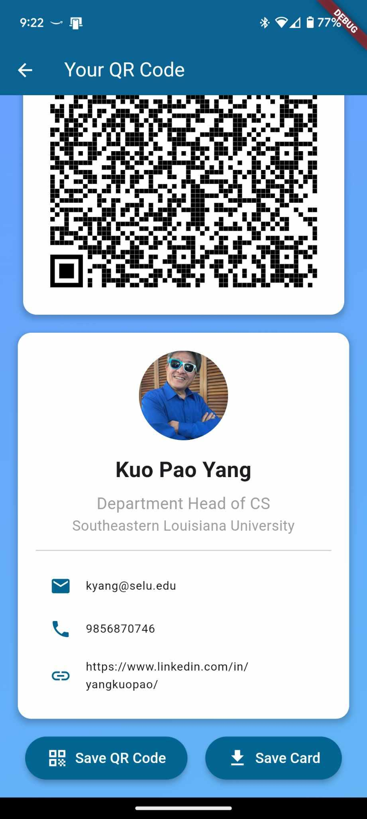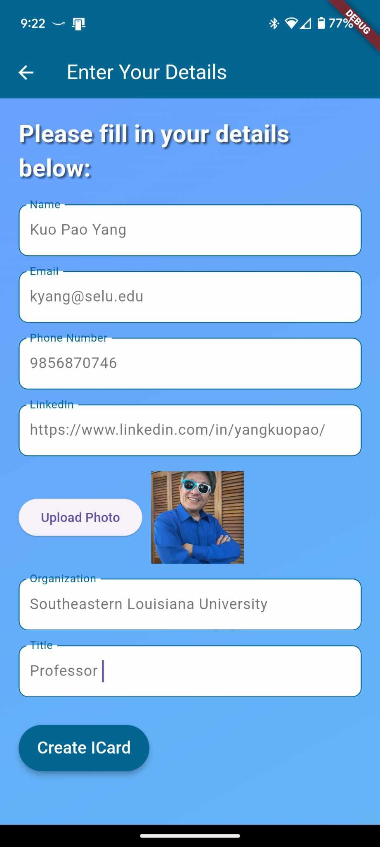

**Figure 5: Form Page and QR Generation User Interface**

Dart and Flutter’s ability to create compatible applications across multiple platforms is a major reason behind our choice of framework and language for ConnectMe. By using Dart and Flutter, our app is accessible to a wider audience, regardless of the operating system they use. The ease of compiling and hot reloading also contributes to a rapid and efficient development cycle. Additionally, the robust support from Google’s open-source community has greatly contributed to the ongoing development of the language and framework, providing essential tools and plugins that streamline the development process [14].

While building Dart and Flutter has offered an exceptional experience, we encountered some challenges. Although Flutter is cross-platform, certain platform-specific features require unique implementations, especially in cases where native functionality for iOS or Android is needed. Nevertheless, the flexibility and community support have allowed us to overcome most limitations, making Dart and Flutter an ideal choice for creating ConnectMe as a highly accessible, cross-platform app [15].

# EVALUATION

The evaluation of ConnectMe was conducted to assess its usability, efficiency, and overall user satisfaction. User testing involved professionals from various fields who utilized the app to create and share digital business cards during networking events. Feedback was collected on key performance indicators, including ease of use, QR code functionality, and customization options.

Results showed that users found ConnectMe to be intuitive, with 90% of participants reporting that they were able to create and share their digital business cards without any assistance [16]. The QR code integration was particularly praised for its reliability and speed. Users highlighted that the ability to link social media profiles directly into the card was a significant advantage over traditional paper-based cards and existing digital alternatives.

Performance tests indicated that the app runs smoothly across different devices and operating systems, with a minimal load time and efficient data retrieval through Firebase. Challenges were noted when integrating platform-specific features, such as the gallery saving function on iOS. These were addressed with targeted updates that improved the overall performance consistency. The app also demonstrated strong data security, ensuring user information was well-protected during creation and sharing processes.

# CONCLUSION

ConnectMe represents a step forward in the realm of professional networking, combining the convenience of digital solutions with sustainable practices. By leveraging the power of Flutter and Firebase, ConnectMe provides a cross-platform application that meets the demands of modern professionals who seek quick, adaptable, and environmentally friendly ways to manage and share their contact information. The integration of QR codes and social media links enhances the networking experience by allowing users to present a comprehensive professional identity seamlessly.

The app's valuable approach not only aligns with current digital trends but also offers a sustainable alternative that minimizes the use of paper, contributing positively to environmental efforts. As remote work and global interactions continue to shape the business landscape, ConnectMe is positioned to be a valuable tool that bridges traditional and digital networking practices.

**REFERENCES**

1. HiHello, Digital Business Cards, https://www.hihello.com, November 2024.
2. Vistaprint, Digital Business Cards, https://www.vistaprint.com, November 2024.
3. Cardhop, Digital Business Cards, https://flexibits.com/cardhop, November 2024.
4. CamCard, Digital Business Cards, https://www.camcard.com, November 2024.
5. Blinq, Digital Business Cards https://blinq.me, November 2024.
6. Inigo, Digital Business Cards, https://inigoapp.com, November 2024.
7. Rutherford, D. and Wu, N., (2023). "Cybersecurity Risks in the Deployment and Use of Digital Business Cards: Implications for Organizations and End-Users," 2023 International Conference on Computational Science and Computational Intelligence (CSCI), Las Vegas, NV, USA, pp. 765-770, December 2023, DOI: 10.1109/CSCI62032.2023.00130.
8. Dangiwa, B. and Kumar, S., (2018). "A Business Card Reader Application for iOS devices based on Tesseract," 2018 International Conference on Signal Processing and Information Security (ICSPIS), DUBAI, United Arab Emirates, pp. 1-4, November 2018, DOI: 10.1109/CSPIS.2018.8642727.
9. Sharma, S., Khare, S., Unival V., and Verma, S., (2022). "Hybrid Development in Flutter and its Widgits," 2022 International Conference on Cyber Resilience (ICCR), Dubai, United Arab Emirates, pp. 1-4, October 2022, DOI: 10.1109/ICCR56254.2022.9995973.
10. Mane, P. and Wakchaure, K., (2023). "Augmented Reality Business Card: Revolutionizing Networking," 2023 4th International Conference on Computation, Automation and Knowledge Management (ICCAKM), Dubai, United Arab Emirates, pp. 1-5, December 2023, DOI: 10.1109/ICCAKM58659.2023.10449545.
11. Cheon, Y. and Chavez, C., (2021). "Converting Android Native Apps to Flutter Cross-Platform Apps," 2021 International Conference on Computational Science and Computational Intelligence (CSCI), Las Vegas, NV, USA, pp. 1898-1904, December 2021, DOI: 10.1109/CSCI54926.2021.00355.
12. Chalin, P., (2014). "Ensuring That Your Dart Will Hit the Mark: An Introduction to Dart Contracts," Proceedings of the 2014 IEEE 15th International Conference on Information Reuse and Integration (IEEE IRI 2014), San Francisco, CA, USA, pp. 369-377, August 2014, DOI: 10.1109/IRI.2014.7051913.
13. Donglan, Z., Darus, M., and Ramli, A., (2024). "Investigating Developer Experiences with UI Components in Flutter: Challenges and Implications," 2024 International Visualization, Informatics and Technology Conference (IVIT), Kuala Lumpur, Malaysia, pp. 128-133, August 2024, DOI: 10.1109/IVIT62102.2024.10692626.
14. Windmill, E., (2020). “Flutter in Action,” Manning publisher, ISBN: 978-1-61729-614-7, EBSCOhost, research.ebsco.com/linkprocessor/plink?id=25545e3f-b9f5-3f62-960c-802e039b4151.
15. Boukhary, S. and Colmenares, E., (2019). "A Clean Approach to Flutter Development through the Flutter Clean Architecture Package," 2019 International Conference on Computational Science and Computational Intelligence (CSCI), Las Vegas, NV, USA, pp. 1115-1120, December 2019, DOI: 10.1109/CSCI49370.2019.00211.
16. Nanavati, J., Patel, S., Patel, U., and Patel, A., (2024). "Critical Review and Fine-Tuning Performance of Flutter Applications," 2024 5th International Conference on Mobile Computing and Sustainable Informatics (ICMCSI), Lalitpur, Nepal, pp. 838-841, January 2024, DOI: 10.1109/ICMCSI61536.2024.00131.