# **TITLE**

Evaluation of Pressure Changes in Orthognathic Surgery using Pressurex® in 3 Years of Follow-up

# **AUTHORS**

Fernando Duarte1, João Neves Silva2, Carina Ramos3, Colin Hopper4

1Fernando Duarte, DMD, MSc, MSc

* Oral Surgeon Specialist by OMD (Portuguese Dental Association)
* Master of Science in Oral and Maxillofacial Surgery at Eastman Dental Institute - University College of London
* Master of Science in Laser Dentistry at Universitá Cattolica del Sacro Cuore - Rome - Italy
* CEO and Clinical Director of Clitrofa - Trofa - Portugal
* E-mail: [**fduarte@clitrofa.com**](mailto:fduarte@clitrofa.com)

2João Neves Silva, BsC, MSc, PhD

* Professor at ISAVE - Instituto Superior de Saúde - Portugal
* Member of the Interdisciplinary Center for Health Sciences (ICHS) - ISAVE - Instituto Superior de Saúde
* E-mail: **joao.neves@docente.isave.pt**

3Carina Ramos, DMD

* MSc Student in Oral Rehabilitation at IUCS – Instituto Universitário de Ciências da Saúde - Portugal
* E-mail: [**cramos@clitrofa.com**](mailto:cramos@clitrofa.com)

4Colin Hopper, MD FRCS FHEA

* UCL Eastman Dental Institute
* Oral & Maxillofacial Surgery Department
* E-mail: [**c.hopper@ucl.ac.uk**](mailto:c.hopper@ucl.ac.uk)

**Corresponding Author:**

Fernando Duarte

Clitrofa - Centro Médico, Dentário e Cirúrgico

Avenida de Paradela 622, 4785-248 Trofa - Portugal

Phone: (351) 252428960

Fax: (351) 252428961

E-mail: [fduarte@clitrofa.com](mailto:fduarte@clitrofa.com)

## **ABSTRACT**

## **Purpose:** Despite its importance, the measurement of pressure in orthognathic surgery often receives little attention. Pressurex® (SPL – Sensor Products LLC, USA) is one of a few pressure indicating sensor films that reveals pressure distribution and magnitude between any two contacting, mating or impacting surfaces, and is currently viewed as a golden standard for that purpose. This study was designed to test Pressurex® in orthognathic surgery.

## **Methods:** Retrospective analysis of 10 patients scheduled for a bimaxillary osteotomy involving a combination of maxillary Le Fort I impaction procedure coupled with a sagittal split advancement of the mandible; in a 3 years follow-up period.

## **Results:** The selection of examiner is not a variable that affects the occlusal pressure (Psi) measured by pressure indicating films in any of the experimental conditions tested. Pressure indicating film position and surgery recovery time does not seem to affect the occlusal pressure measured by pressure indicating films.

**Conclusion:** The pressure indicating film positions used in the present study have shown poor reliability and validity of measurement. Although selection of examiner does not affect the measurement of occlusal pressure (Psi) by pressure indicating films, which is positive, this method lacks sensitivity in detecting variations caused the pressure indicating film position and the recovery surgery time.

**Keywords:** Pressure Measurement; Orthognathic Surgery;Pressurex®

**INTRODUCTION**

Orthodontic and surgical technical advances in recent years have resulted in treatment opportunities for a whole range of craniofacial skeletal disorders either in the adolescent or adult patients. In the growing child these can include myofunctional orthodontic appliance therapy or distraction osteogenesis procedures, whilst in the adult the mainstay approach revolves around orthognathic surgery.

Research evidence suggests that in those cases requiring orthognathic surgery, the stability of the result depends upon such factors as the direction and extent of the surgical move of the facial skeleton, the method of surgical fixation applied and the operative technique employed. Yet, even when the best evidence-based practice is followed, there remains a significant proportion of cases where the surgical outcome (stability) is both unexpected and undesirable [1].

Bite force has been used to evaluate masticatory function in patients before and after orthognathic surgery [2, 3, 4, 5, 6, 7]. Usually, it has been measured with a custom bite force transducer [5, 6, 8]. Pressure is a critical variable in many converting operations. Tactile pressure-sensor films are an accurate, efficient, and inexpensive method to determine pressure. These films offer the converting industry an opportunity to determine both the distribution and magnitude of most operations where pressure is important.

PRESSUREX® SYSTEM

Pressurex® (SPL – Sensor Products LLC, USA) is a pressure indicating sensor film that reveals pressure distribution and magnitude between any two contacting, mating or impacting surfaces. Consists of a thin mylar film (4 to 8 mils) that contains a layer of tiny microcapsules.

The application of force upon the film causes the microcapsules to rupture, producing an instantaneous and permanent high resolution “topographical” map of pressure variations across the contact area. Simply place sensor film, between any two surfaces that touch, mate or impact. Apply pressure, release it; immediately the film reveals a profile of the pressure distribution that occurred between the surfaces. The colour intensity of the image created is directly related to the amount of pressure applied, the greater the pressure, the more intense colour.

During use, visual comparison of colour intensity to a colour correlation chart provides a pressure-measurement reading that is accurate to ±10%. With the use of optical measuring systems, the pressure reading may be more accurately quantified to ±2%. Use of a pressure-sensor film is an alternative to strain gauges and pressure transducers with accompanying electronic equipment. Various films are offered, with some in a range of sensitivities to accommodate varying amounts of pressure. Pressure ranges can start as low as 2-20 psi (0.14-1.4 Kg/cm2) and go as high as 7,100-18,500 psi (500-1,300 Kg/cm2).

Five areas were considered in the following order, the readings were in Psi. Area A: right maxillary second pre-molar and right maxillary first molar between 1st and 4th quadrants; Area B: right maxillary canine and right maxillary first pre-molar between 1st and 4th quadrants; Area C: right and left maxillary central incisors and right and left maxillary lateral incisors area; Area D: left maxillary second pre-molar and left maxillary first molar between 2nd and 3rd quadrants, and finally Area E: left maxillary canine and left maxillary first pre-molar between 2nd and 3rd quadrants.

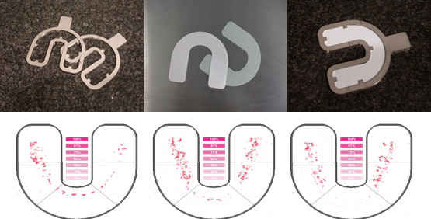

**Fig. 1** **-** Clinical application of the metal framework containing the Pressurex® film. Biting area and pressure distribution in 5 areas.

**MATERIALS AND METHODS**

## The present study is an observational prospective study with quantitative methodology. A study group of 10 patients attending the combined orthodontic/orthognathic surgery clinic at the Clitrofa – Centro Médico, Dentário e Cirúrgico, in Trofa - Portugal was selected to the present study by a convenience non-probability sampling method. All the selected patients were scheduled for a bimaxillary osteotomy involving a combination of maxillary Le Fort I impaction procedure coupled with a sagittal split advancement of the mandible were select to form the study group.

The Pressurex® System was placed between the upper and lower dental arch, and the subjects were instructed to bite as forcefully as possible for about 3 seconds. The values were registered by two different observers (F and C) in different moments: (T0) - before surgery, (T1) - 10 minutes after surgery, (T2) - 1 month after surgery, (T3) - 36 months after surgery.

**STATISTICAL ANALYSIS**

IBM® SPSS®, version 25, was used to analyse the data obtained. Exploratory data analysis was performed by Kolmogorov-Smirnov ($D$) test to assess the normality of the frequency distributions and by Levene test ($L$) to assess the variance homogeneity of the variables.

Descriptive statistics of the study variables was performed by determination of mode and frequencies (nominal variables), median and inter-quartile range (ordinal variables), and arithmetic mean and standard deviation (numerical variables). Bar graphs were also added to facilitate data description and results interpretation.

Inferential statistics was used to compare examiner selection (paired two-tailed Student’s t test), pressure indicating film position (Repeated Measures ANOVA) and surgery recovery time (Repeated Measures ANOVA). Where the requirements for parametric statistical analysis were not met, the inferential tests were replaced, respectively, by Wilcoxon, Friedman and Friedman tests.

The experimental design used in this study is depicted in Figure 1 and comprises 3 separate researches:

1. Research A, which investigated the effect of examiner selection on the occlusal pressure (Psi) measured by pressure indicating films;
2. Research B, which investigated the effect of pressure indicating film position on the occlusal pressure (Psi) measured by pressure indicating films;
3. Research C, which investigated the effect of surgery recovery time on the occlusal pressure (Psi) measured by pressure indicating films.

Where statistically significant differences were found by Repeated Measures ANOVA tests, the multiple-comparison Post-Hoc Bonferroni or Gabriel tests were performed to identify the pairs of categories were the statistically significant differences were located.

Three thresholds of statistical significance (α level) were considered throughout the present study: $p-values$ below 0.05 (*) were considered statistically significant; $p-values$ below 0.01 (*) were considered highly statistically significant, and $p-values$ below 0.001 (*) were considered very highly statistically significant. The lack of statistical significance was designated as non-significant ($ns$).

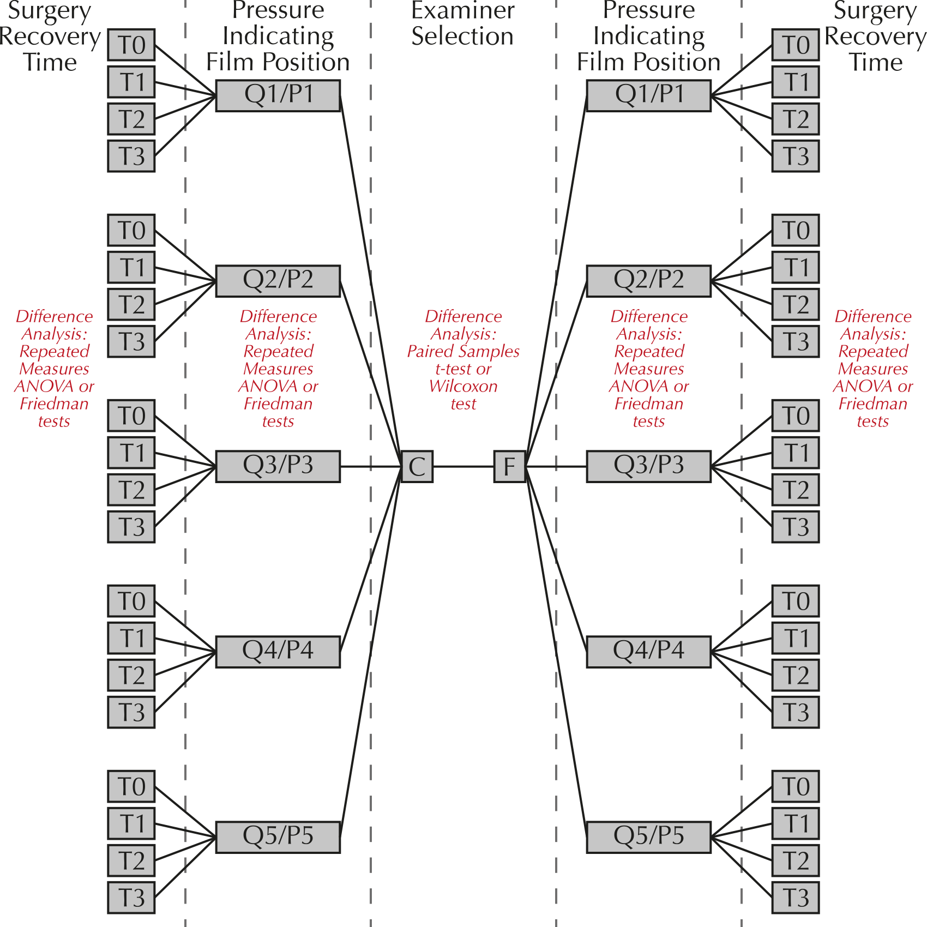

**Fig. 2 -** Experimental design used in the present study to evaluate the effect of examiner selection (F or C), pressure indicating film position (Q1/P1, Q2/P2, Q3/P3, Q4/P4 or Q5/P5) and surgery recovery time (T0 - before surgery, T1 - 10 minutes after surgery, T2 - 1 month after surgery, or T3 - 36 months after surgery) on the occlusal pressure (Psi) measured by pressure indicating films in the 10 patients of the sample.

**RESULTS**

DATA EXPLORATORY ANALYSIS

Kolmogorov-Smirnov ($D$) and Levene ($L$) assumption tests have revealed that the study variables comply with the minimum requirements for an inferential parametric analysis (normality of frequency distributions and variance homogeneity), thus meaning that the effects of examiner selection, pressure indicating film position and surgery recovery time on the occlusal pressure (Psi) measured by pressure indicating films will be analysed by the differences tests of Paired-Samples of Student ($t$), Repeated Measures ANOVA ($F$) and Repeated Measures ANOVA ($F$), respectively.

**Table I** – Data exploratory analysis.

|  |  |  |  |  |
| --- | --- | --- | --- | --- |
| **Study Variables** | **Central Tendency Measures** | **Dispersion Measures** | **Kolmogorov-Smirnov test ($D$); $p-value$** | **Levene test ($L$); $p-value$** |
| **Examiner Selection** | Mode:  C, F | Frequencies:  C (50.0%);  F (50.0%) | $D$: 0.163 $p-value$ : 0.173 | $L$: 0.327 $p-value$ : 0.571 |
| **Pressure Indicating Film Position** | Mode:  Q1/P1; Q2/P2; Q3/P3 ; Q4/P4 ; Q5/P5 | Frequencies:  Q1/P1 (20.0%);  Q2/P2 (20.0%);  Q3/P3 (20.0%);  Q4/P4 (20.0%);  Q5/P5 (20.0%) | $D$: 0.249 $p-value$ : 0.156 | $L$: 1.029 $p-value$ : 0.406 |
| **Surgery Recovery Time** | Median: 2.5 | Interquartile Range: 2 | $D$: 0.231 $p-value$ : 0.138 | $L$: 2.695 $p-value$ : 0.060 |
| **Occlusal pressure (Psi)** | Mean: 950.19 | SD: 81.09 | n/a | n/a |

*(*) significant statistical difference to an alpha level of 0.05;*

*(**) highly significant statistical difference to an alpha level of 0.01;*

*(***) very highly significant statistical difference to an alpha level of 0.001.*

RESEARCH A: EFFECT OF EXAMINER SELECTION ON THE OCCLUSAL PRESSURE (PSI) MEASURED BY PRESSURE INDICATING FILMS

Figure 3 shows the similarity of occlusal pressure (Psi) measurements made by examiners F and C. The relatively high standard deviation of the measures depicted in Figure 3 arises from the fact that the examiners have been compared in different experimental conditions (pressure indicating film positions and surgery recovery times), which are in the graphic are presented in the same group of values.

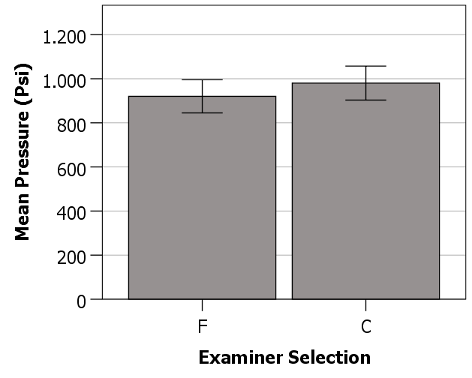

**Fig. 3** - Effect of examiner selection on the occlusal pressure (Psi) measured by pressure indicating films. Error bars represent standard deviation.

Paired Samples ($t$) tests have revealed the general absence of significant statistical differences between examiners F and C regarding the occlusal pressure (Psi) measured by pressure indicating films in the 10 patients of the sample, in the different experimental conditions tested (Table II). The differences observed between Examiners F and C regarding T0 at pressure indicating film positions Q1/P1 and Q2/P2 are probably due to the lack of standardization in the measurement procedure, as this was the first moment where the measurement of occlusal pressure was performed. It is interesting to notice, however, that these differences have not been identified with other methods such as piezoelectric sensors, which may indicate a reliability/validity limitation of the current method that uses pressure indicating films [9, 10].

**Table II** – Effect of examiner selection on the occlusal pressure (Psi) measured by pressure indicating films (Paired Samples ($t$) test).

|  |  |  |
| --- | --- | --- |
| **Experimental Conditions** | **Paired Samples ($t$)** | $$p-value$$ |
| F *vs* C, Q1/P1, T0 | -2,486 | 0,035* |
| F *vs* C, Q1/P1, T1 | -0,045 | 0,965 |
| F *vs* C, Q1/P1, T2 | 1,395 | 0,197 |
| F *vs* C, Q1/P1, T3 | 0,000 | 1,000 |
| F *vs* C, Q2/P2, T0 | -2,393 | 0,040* |
| F *vs* C, Q2/P2, T1 | -2,094 | 0,066 |
| F *vs* C, Q2/P2, T2 | 0,273 | 0,791 |
| F *vs* C, Q2/P2, T3 | n/a | n/a |
| F *vs* C, Q3/P3, T0 | -0,736 | 0,480 |
| F *vs* C, Q3/P3, T1 | -1,426 | 0,188 |
| F *vs* C, Q3/P3, T2 | -1,252 | 0,242 |
| F *vs* C, Q3/P3, T3 | n/a | n/a |
| F *vs* C, Q4/P4, T0 | -0,640 | 0,538 |
| F *vs* C, Q4/P4, T1 | -0,527 | 0,611 |
| F *vs* C, Q4/P4, T2 | -0,163 | 0,874 |
| F *vs* C, Q4/P4, T3 | n/a | n/a |
| F *vs* C, Q5/P5, T0 | -1,130 | 0,288 |
| F *vs* C, Q5/P5, T1 | -0,920 | 0,382 |
| F *vs* C, Q5/P5, T2 | 1,484 | 0,172 |
| F *vs* C, Q5/P5, T3 | n/a | n/a |

*(*) significant statistical difference to an alpha level of 0.05;*

*(**) highly significant statistical difference to an alpha level of 0.01;*

*(***) very highly significant statistical difference to an alpha level of 0.001.*

*(n/a) $t$ cannot be computed because the standard error of the difference is 0.*

RESEARCH B: EFFECT OF PRESSURE INDICATING FILM POSITION ON THE OCCLUSAL PRESSURE (PSI) MEASURED BY PRESSURE INDICATING FILMS

Figure 4 shows the variation of occlusal pressure (Psi) measurements made with the different pressure indicating film positions. Results indicate little variation in occlusal pressure (Psi) as the pressure indicating film position varies in relation to the position of the temporomandibular joint. The relatively high standard deviation of the measures depicted in Figure 4 arises from the fact that the pressure indicating film positions have been compared in different experimental conditions (examiner selection and surgery recovery times), which are in the graphic are presented in the same group of values.

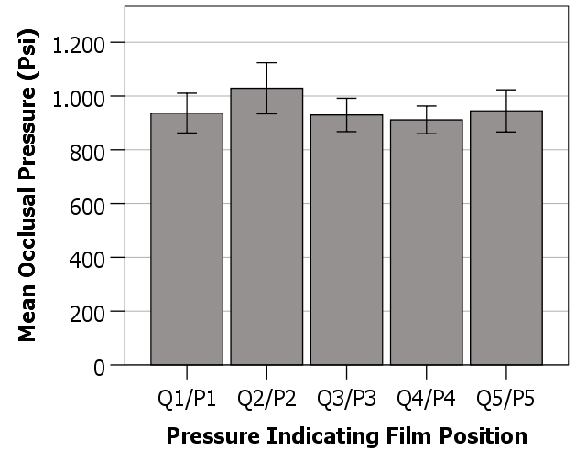

**Fig. 4** - Effect of pressure indicating film position on the occlusal pressure (Psi) measured by pressure indicating films. Error bars represent standard deviation.

Repeated Measures ANOVA ($F$) tests have confirmed the absence of significant statistical differences between the different pressure indicating film positions (Q1/P1, Q2/P2, Q3/P3, Q4/P4 and Q5/P5) regarding the occlusal pressure (Psi) measured by pressure indicating films in the 10 patients of the sample, in the different experimental conditions tested (Table III). Once again, data suggests that this method that uses pressure indicating films presents a lower reliability/validity than other methods that use piezoelectric sensors [9, 10].

**Table III** – Effect of pressure indicating film position on the occlusal pressure (Psi) measured by pressure indicating films (Repeated Measures ANOVA ($F$) test).

|  |  |  |
| --- | --- | --- |
| **Experimental Conditions** | **Repeated Measures ANOVA ($F$)** | $$p-value$$ |
| Q1/P1 *vs* Q2/P2 *vs* Q3/P3 *vs* Q4/P4 *vs* Q5/P5 | 3,069 | 0,069 |

*(*) significant statistical difference to an alpha level of 0.05;*

*(**) highly significant statistical difference to an alpha level of 0.01;*

*(***) very highly significant statistical difference to an alpha level of 0.001.*

RESEARCH C: EFFECT OF SURGERY RECOVERY TIME ON THE OCCLUSAL PRESSURE (PSI) MEASURED BY PRESSURE INDICATING FILMS

Figure 5 shows the variation of occlusal pressure (Psi) measurements at different surgery recovery times. One of the most innovative aspects of the present study is that the follow-up period of the patients has been extended and reported until 36 months, thus allowing a more complete view of the patient’s recovery process, as viewed by the masticatory pressure generated by the mandible. Although a marginal increase in occlusal pressure (Psi) is observed at T3 (36 months after surgery) in the patients, when compared to previous timepoints (T0, T1 and T2), the variation is within the standard deviation value, and therefore is not statistically significant. This may be due to the lack of reliability/validity of the pressure indicating film, because piezoelectric sensors seem to present higher sensitivities in the same conditions [9, 10].

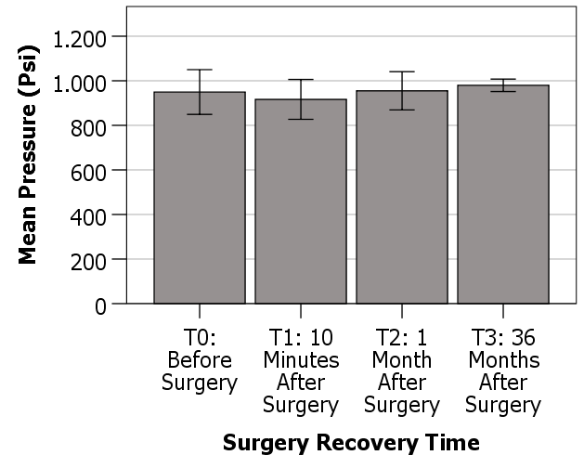

**Fig. 5** - Effect of surgery recovery time on the occlusal pressure (Psi) measured by pressure indicating films. Error bars represent standard deviation.

**Table IV** – Effect of surgery recovery time on the occlusal pressure (Psi) measured by pressure indicating films (Friedman ($H$) test).

|  |  |  |
| --- | --- | --- |
| **Experimental Conditions** | **Repeated Measures ANOVA ($F$)** | $$p-value$$ |
| T0 *vs* T1 *vs* T2 *vs* T3 *vs* T4 | 1.032 | 0.390 |

*(*) significant statistical difference to an alpha level of 0.05;*

*(**) highly significant statistical difference to an alpha level of 0.01;*

*(***) very highly significant statistical difference to an alpha level of 0.001.*

Repeated Measures ANOVA ($F$) tests have confirmed the absence of significant statistical differences between the different surgery recovery times (T0, T1, T2, T3 and T4) regarding the occlusal pressure (Psi) measured by pressure indicating films in the 10 patients of the sample, in the different experimental conditions tested (Table IV).

**DISCUSSION**

In the timepoints (T1, T2 and T3) no statistical differences were observed for the pressure indicating films, it is concluded that the selection of examiner is not a variable that affects the occlusal pressure measured by pressure indicating films in any of the experimental conditions tested.

The pressure indicating film position and the surgery recovery time does not seem to affect the occlusal pressure measured by pressure indicating films, irrespective of the examiner selection and/or the surgery recovery time.

**CONCLUSION**

The pressure indicating film positions used in the present study have shown poor reliability and validity of measurement. Although selection of examiner does not affect the measurement of occlusal pressure (Psi) by pressure indicating films, which is positive, this method lacks sensitivity in detecting variations caused the pressure indicating film position and the recovery surgery time.

This inferior performance compared to piezoelectric sensors, makes pressure indicating films not so suitable to study the follow-up period of patients subjected to surgical dental operations.

**Authors’ contributions**

FD, JNS, and CR read and wrote the manuscript. FD and CR were responsible for conducting surgeries. FD and JNS were responsible for the data collection. FD designed and wrote the entire article. CH was responsible for the final revision of the manuscript. All authors read and approved the final manuscript.

**Funding**

The authors received no financial support for the research, authorship, and/or publication of this article.

**Data availability**

No datasets were generated or analysed during the current study.

**Declarations**

**Ethics approval and consent to participate**

Ethical approval: This project has approval by the Joint Research & Ethics Committee of UCL Hospitals NHS Trust, Reference No.03/E012.

Data registration: This project is covered by the UCL Data Protection Registration Reference No. Z6364106, Section 19, Research: Health Research.

**Consent for publication**

Not applicable.

**Competing interests**

The authors declare that they have no competing interests.

**REFERENCES**

[1] Komori, E., Aigase, K., Sugisaki, M., Tanabe, H. (1989) Cause of early skeletal relapse after mandibular setback. Am.J.Orthod.Dentofac.Orthop. 95(1):29-36

[2] Watanabe, M., Hattori, Y., Satoh, C. (1995) Bite force distribution on the dental arch in normal dentitions. Brain and oral functions: Oral motor function and dysfunction. Elsevier, Oxford 399-403

[3] Johnston, C.P., Throckmorton, G.S., Bell, W.H. (1984) Changes in electromyographic activity following superior repositioning of the maxilla. J.Oral.Maxillofac.Surg. 42:656

[4] Proffit, W.R., Turvey, T.A., Fields, H.W., Phillips, C. (1989) The effect of orthognathic surgery on occlusal force. J Oral Maxillofac Surg 47:457-463

[5] Throckmorton, G.S., Ellis III, E., Sinn, D.P. (1995) Functional characteristics of retrognathic patients before and after mandibular advancement surgery. J Oral Maxillofac Surg 53:898-908

[6] Ellis, E.III., Throckmorton, G.S., Sinn, D.P. (1996) Bite force before and after surgical correction of mandibular prognathism. J.Oral.Maxillofac.Surg. 54:176-181

[7] Kim, Y.G., Oh, S.H. (1997) Effect of mandibular setback surgery on occlusal force. J.Oral.Maxillofac.Surg. 55:121-126

[8] Teenier, T.J., Throckmorton, G.S., Ellis III, E. (1991) Effects of local anesthesia on bite force generation and electromyographic activity. J.Oral.Maxillofac.Surg. 49:360

[9] Hamed AM, Tse ZT, Young I, Davies BL, Lampérth M. Applying tactile sensing with piezoelectric materials for minimally invasive surgery and magnetic-resonance-guided interventions. Proc Inst Mech Eng H. 2009 Jan;223(1):99-110. doi: 10.1243/09544119JEIM473. PMID: 19239071.

[10] Rizal, M., Ghani, J.A., Nuawi, M.Z. *et al.* An embedded multi-sensor system on the rotating dynamometer for real-time condition monitoring in milling. *Int J Adv Manuf Technol* 95, 811–823 (2018). https://doi.org/10.1007/s00170-017-1251-8