Development of a Web-Based Enterprise Personnel electronic records Management Information System

**\*1Odeniyi O. A., 2Aiki. A. A, 3Lawal N. T. A, 4Adewale J. A.,**

**5Makinde B. O., 6Akinwumi A. R. & 7Iyun, O.**

*\*1,5, ,6 Department of Computer Science, Osun State College of Technology, Esa-Oke, Osun State, Nigeria*

*2Ladoke Akintola University of Technology (LAUTECH) Teaching Hospital, Ogbomoso, Oyo State, Nigeria*

*3,4Department of Multimedia Technology, Osun State College of Technology, Esa-Oke, Osun State, Nigeria*

*7Department of Business & Management Studies, Osun State College of Technology, Esa-Oke, Osun State, Nigeria.*

*Corresponding Author: Odeniyi, O. A. (olufemiodeniyi@gmail.com)*

*ABSTRACT: Despite the ever-accelerated deepening of enterprise reform and the continuous progress of enterprises, the informatization construction of human resources management software models in enterprises has demonstrated its shortcomings (the differing nature in terms of scope, nature, effectiveness and longevity) and an increasingly strong necessity for intensification and institutionalization of personnel management information system. In this paper, a Web-based Enterprise Personnel electronic records Management Information System (PerMIS) for Ladoke Akintola University of Technology (LAUTECH) Teaching Hospital, Ogbomoso, Oyo State, Nigeria was designed and developed using Descriptive qualitative research technique and Agile development model of the Software Development Life Cycle. In addition, the technical qualities of the implemented PerMIS was evaluated by IT Experts, Human Resource Practitioners and users from LAUTECH Teaching Hospital, Ogbomoso as end-users, based on ISO/IEC 25010:2011standards. The general rating given by the PerMIS evaluators was 4.25, which means PerMIS is Fully Compliance to ISO/IEC 25010:2011 standards. In addition, the developed web-based enterprise PerMIS was able to excellently perform the expected functionalities, like storing, updating, and generating pertinent reports based on personnel information; offered a great capabilities in improving wider access to personnel information sharing, streamlined and standardized personnel departments‘ processes and services; and reduction of the shortcomings of the existing custom made PMIS software models. It is highly recommended that further system updates to accommodate the growing need of the personnel department for improvement is encouraged by close collaboration with the system developer.*

*KEY WORDS: Personnel, Personnel Management, Information System, Management Information System, Personnel Management Information System*

---------------------------------------------------------------------------------------------------------------------------------------

Date of Submission: xx-xx-xxxx Date of acceptance: xx-xx-xxxx

---------------------------------------------------------------------------------------------------------------------------------------

# INTRODUCTION

The concept of Management Information System (MIS) was first proposed by an American J. D. Gallagher in 1961. This is an emerging comprehensive subject combining the management science, information science, system science as well as computer science. It studies the whole process of information management activities in a company, to achieve effective information management, provide information for various management decisions and assist the company to realize modern management. Leading management thinkers suggest that “it is not technology, but the art of human and humane-management” that is the continuing challenge for executives in the 21st century [1]. Similarly, [2] believed that “future economic and strategic advantage will rest with the organizations that can most effectively attract, develop and retain a diverse group of the best and the brightest human talent in the market place”.

In general, to maintain a competitive advantage in the marketplace, firms need to balance the resources available to the firm to achieve the desired results of profitability and survival. The resources that are available to the firm fall into three general categories: physical, organizational, and human. In discussing how to gain a competitive advantage in the global market, [3] noted that management of the Human Resources (HR) or personnel is the most critical of the three. The idea of treating HR as a means of gaining a competitive advantage in both the domestic and the global marketplace has been echoed by other authors.

As [4] stated, in a growing number of organizations HR are now viewed as a source of competitive advantage. There is greater recognition that distinctive competencies are obtained through highly developed

employee skills, distinctive organizational cultures, management processes, and systems. This is in contrast to the traditional emphasis on transferable resources such as equipment. Increasingly, it is being recognized that competitive advantage can be obtained with a high quality work force that enables organizations to compete on the basis of market responsiveness, product and service quality, differentiated products, and technological innovation.

The effective management of HR in a firm to gain a competitive advantage in the marketplace requires timely and accurate information on current employees and potential employees in the labour market. With the evolution of computer technology, meeting this information requirement has been greatly enhanced through the creation of Human Resource Management Information System (HRMIS) or Personnel Management Information System (PMIS). A basic assumption behind this study is that the management of employee information will be the critical process that helps a firm maximize the use of its HR and maintain competitiveness in its market.

The PMIS is the information system of an organization, which can process data, plan, control, predict and assist the function of decision-making, and its detailed functions are as follows: (i) Process and provide information under the united standard, and exclude the incomplete data which is inconsistent before and after the use; (ii) Provide the complete data needed in management and decision making in a timely manner; (iii) Use the designated data relation formula to analyze the data and predict the future objectively; (iv) Provide reports with different levels of details to the management organs of different levels to shorten the time of analysis and explanation; and (v) Provide the information which is as accurate and reliable as possible at the least cost and in the shortest time, thus to provide the decision makers with the optimal solutions and improve the organization’s economic benefits and win the market in the competition.

PMIS is basically concerned with managing the administration of HR department in an organization. A PMIS refers to the systems and processes at the intersection between Human Resource Management (HRM) and Information Technology (IT). It merges HRM as a discipline and in particular it’s basic HR activities and processes with the IT field, whereas the programming of data processing systems evolved into standardized routines and packages of Enterprise Resource Planning (ERP) software [5]. The addition of IT to the HR industry has revolutionized the contemporary workplace. HR professionals now have an increased capacity not only to gather information, but also to store and retrieve it in a timely and effective manner. This has not only increased the efficiency of the organization but also the effectiveness of management functions.

In this globalized world, a department that is increasingly becoming central to the implementation of organization policy is the HR department. So the PMIS (HRMIS) is now considered an integral part of every organization [6]. In fact, personnel information management is one of the crucial, tasking and, risking aspects of an organization which is glaringly not only important but a necessity [7]. More and more organizations are now developing IT which can help the organization achieve its goals in a timely manner. These information systems can then help the organization make more strategic decisions.

PMIS is an effective tool that can be used for streamlining the administrative functions of the HR department, which involves designing personnel data formats and arranging systems for collection, processing, storage and reporting of personnel information consisting of employee data, position data, education data, reward data, education and training data, family data, attendance data and others (training completed, awards received, projects participated in and finished successfully, number of years of service, skills, competencies, deployment), so that information can be managed about planning employee needs, performance appraisal, coaching and career development, welfare, and dismissal or retirement [8; 9; 10; 11]. With an efficient PMIS in place, the development of HR systems becomes easier [12].

Visitation to some organizations, both private and public sectors in Osun and Oyo States of Nigeria including LAUTECH Teaching Hospital Ogbomoso, revealed that some custom made software models have already been designed for processing of personnel records by most of these organizations. Each of the models, developed with Microsoft Excel or Microsoft Access, fails to cover all major functions of personnel management and the functions covered fall short of complete and standard operation flow. Thus, the models are unable to handle some coherent sets of personnel policies and practices in those organizations. It was found that the initial cost of applying for ready-made solutions lead some of the organizations to develop the in-house solutions, which are characterized with limitations such as data processing delay as records keep growing, poor querying ability, and limited database size.

Furthermore, the solutions for these models were developed as single user solutions, constraining the users to queuing for computing device that implement each of them. Loss of employees’ physical files due to human errors is still common in the sense that these systems yet employed mix mode of manual and automated operations for processing of employees records. Lack of personnel information databank in most of the organizations also hinders local researchers from getting required volume of personnel information to analyze for quality research output. In particular, the process by which the personnel data inputs are transformed into outputs in LAUTECH Teaching Hospital, Ogbomoso Oyo State Nigeria, revealed that the workers of the HR department go through rigorous exercise to get information about employees available for the top management (since the data

are not integrated); this resulted from the spreadsheet solution inadequately developed for use.

To assist these firms, particularly LAUTECH Teaching Hospital, Ogbomoso Oyo State Nigeria, address the limitations faced with the custom made PMIS solutions, and to have seamless operation with regards to managing the tasks of HR department in their respective domain, there is dire need to develop PMIS solution framework that suit the requirements of such organizations and which also ensures timely retrieval and improved generation of employee information in the institution.

As a result of this, a robust PIMS called a Web-based Enterprise Personnel electronic records Management Information System (PerMIS) was developed to assist in carrying out personnel management tasks in line with personnel management practice in the context of Teaching Hospitals in Nigeria. The developed PerMIS helped to resolve the issues mentioned above; served as a managerial control information system for tracking employees’ data and for maintaining employees’ in-service records; and streamline and standardize personnel departments‘processes andservices. The developed PerMIS also helped to reduce costs, improve communication, and reduce time to complete personnel-related activities.

# MATERIAL AND METHODS

In this work, the System Development Life Cycle (SDLC) Agile Scrum methodology or framework in terms of analysis, design, development (implementation), testing and evaluation was adapted. Agile Scrum Methodology is one of the popular Agile software development methods. There are some other Agile software development methods but the popular one which is used widely is Agile Scrum Methodology. The Agile Scrum Methodology is a combination of both Incremental and Iterative model for managing product development. Agile Scrum is a software development methodology that divides system development tasks by regular cadences of work, knows as sprints or iterations. Each sprint coves the phases of development process.

The technical qualities of the implemented PerMIS software in terms of functionality, usability, reliability, efficiency, maintainability, and portability was evaluated and validated by the system evaluators, composed of IT Experts, Human Resources Practioners and Users from LAUTECH Teaching Hospital, Ogbomoso, based on ISO/IEC 25010:2011 standards.

***2.1 System Analysis***

Analysis involved a detailed study of the current system and it includes sub dividing of complex process involving the entire system, identification of data store and manual process. During analysis, data were collected on available files, decision points and transactions handled by the present system. Interviews, case study, document and archives, on-site observations, questionnaire and review of literature ere the tools used to establish the objectives, requirements and services expected from the system.

***2.2 System Design***

System design brings a proposed system much closer by describing the nature of input and output file as well as sharing the processing in which they are connected. These design elements consisted of functional hierarchy, business process diagrams, pseudo code, entity-relationship diagram and flowcharts. In this stage the design elements were defined with the help of interviews, case study, document and archives, on-site observations, questionnaire and review of literature conducted. These design elements provided detail description about the software and each element is related to a specific requirement, as well as the movement of information and relationships of entities, and schedule of development. The major designs for this system were (i) Input Specification and Design; (ii) Output Specification and Design; (iii) Input/Output Specification and Design; and (iv) Database Design.

***2.3 System Development (Implementation)***

The development stage was initialized by the previous design stage. The PerMIS was designed using Client-Server architectural framework on a three-tier architectural layers, in which the user’s interface, functional process logic, computer data storage and data access was developed and maintained as independent modules. During this stage, the modules were divided into sprints attainable in iteration every three weeks of completion.

The developed PerMIS as a web application was implemented using a traditional three-tier architecture. Three-tier architecture includes a presentation layer, business rules/logic layer, and the data layer. The Presentation Layer, also called the Client tier, which is responsible for the presentation of data, receiving user events, and controlling the user interface was implemented with Angular JavaScript and runs in the user’s browser. The user interaction with the system is entirely through this layer.

This middle tier, which is the Business Rules/Logic layer is the middleman between the presentation layer and the data layer. The middle tier provides process management where business logic and rules are executed and can accommodate hundreds of users. This middle tier was introduced to overcome the deployment limitation (whenever the application logic changed the application had to be redistributed at each and every client) in the

two-tier architecture.

The Data layer which is responsible for data storage was implemented using Laravel 5.6 and provided other features such as routing, validation, catching, queues, file storage and more. Primarily this tier (data layer) consists of database servers, or more relational databases and/or file systems and provides the persistent data storage services for the system. MySQL Database Server was used to implement the PerMIS.

The three-tier architecture is generally used when an effective distributed client/server design is needed that provides: increased performance, flexibility, maintainability, reusability and scalability. This model hides the complexity of distributed processing from the user. These features have made the three-tier architecture a popular choice over the two-tier architecture for Internet applications.

The front end was developed using Angular JavaScript while the back end was developed using Laravel 5.6 (PHP Framework). These two ends was integrated with an Application Program Interface (API). PHP programming language was used in coding process with MySQL for defining the database structure. MySQL Workbench was used for data modeling, SQL development, and comprehensive administration tools for server configuration, user administration and backup. Visual Studio Code was used as a text editor for coding, and JavaScript Object Notation (JSON) file in transmitting data objects that consisted of attribute-value pairs to easily manage the administration of the system data entry maintenance.

***2.4 System Testing***

A series of tests (white box and black box) were conducted and examined on each sprint or module delivered in order to check for validity, correctness and completeness of the system. The system was also tested using both valid and invalid data to ensure it can handle different inputs and prevent errors.

***2.5 System Evaluation***

The evaluation phase is the stage wherein technical qualities of the developed PerMIS software was determined. The technical qualities of the implemented PerMIS was evaluated and validated by the system evaluators, composed of seventy (70) IT Experts, seventy (70) Human Resource Practitioners and ten (10) Users from LAUTECH Teaching Hospital, Ogbomoso, using the ISO/IEC Software Quality Assurance Metrics (Questions) based on ISO/IEC 25010:2011 standards. The questions focused on these six areas for determining the system's performance; namely, functionality, usability, reliability, efficiency, maintainability, and portability.

Responses from the ISO/IEC 25010:2011 were directly encoded and analyzed using Microsoft Excel application – descriptive statistics (frequency counts, percentages, and mean). The formula used for the profile of respondents was

P = (f/n) x 100 where:

P = is the percentage

f = is the frequency

n = total responses

The mean of each item in the instrument was determined based on the following formula:

x = (∑xi)/n where;

x̄ = weighted average

x = score of each respondent

n = number of responses

The ISO/IEC 25010:2011 Software Quality Assurance metrics depicted in Table 1 were devised in the evaluation questionnaire.

***Table I. 5 Point Likert Scale that was used for the responses in the Questionnaire***

|  |  |
| --- | --- |
| **Range of Scale** | **Qualitative Description** |
| 4.21 – 5.0 | Fully Functional (FF) |
| Fully Usable (FU) |
| Fully Reliable (FR) |
| Fully Efficient (FE) |
| Fully Maintainable (FM) |
| Fully Portable (FP) |
| 3.21 – 4.20 | Mostly Functional (MF) |
| Mostly Usable (MU) |
| Mostly Reliable (MR) |
| Mostly Efficient (ME) |
| Mostly Maintainable (MM) |
| Mostly Portable (MP) |
| 2.61 – 3.20 | Functional (F) |
| Usable (U) |
| Reliable (R) |
| Efficient (E) |
| Maintainable (M) |
| Portable (P) |
| 1.81 – 2.60 | Slightly Functional (SF) |
| Slightly Usable (SU) |
| Slightly Reliable (SR) |
| Slightly Efficient (SE) |
| Slightly Maintainable (SM) |
| Slightly Portable |
| 1.0 – 1.80 | Not Functional (NF) |
| Not Usable (NU) |
| Not Reliable (NR) |
| Not Efficient (NE) |
| Not Maintainable (NM) |
| Not Portable (NP) |

# RESULTS AND DISCUSSIONS

The result of this study was the developed Web-based Enterprise Personnel electronic records Management Information System (PerMIS). The developed PerMIS was able to perform the expected functionalities, such as storing, updating, retrieving pertinent employee information and generating HR reports provided by the HR department. The PerMIS provided a number of the interfaces each of which represents module that the users can work with. These interfaces reduced the transaction processing overhead, enhanced the organisation-wide data sharing, improved data quality and integrity, and empowered employees and superior officers with the ability to independently manage their personel information seamlessly through the organisation intranet workflow processes.

To gain access to the system, the PerMIS program icon (Figure 1) would be selected to run after which the splash screen (Figure 2) would be displayed, and then the Access Data Entry interface (Figure 3) would be displayed for the user to log on to the system by entering the user’s identification number and access code.

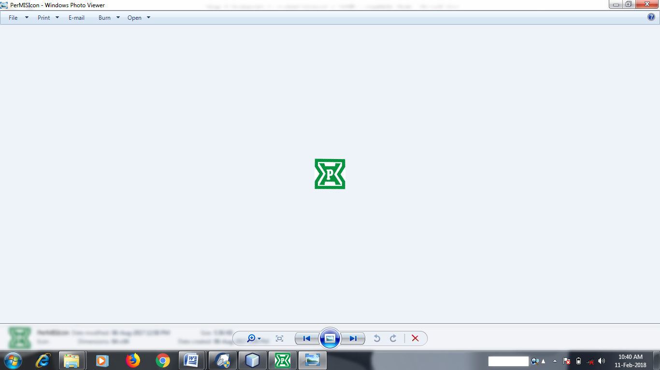

**Figure 1: PerMIS Program Icon on the Screen**

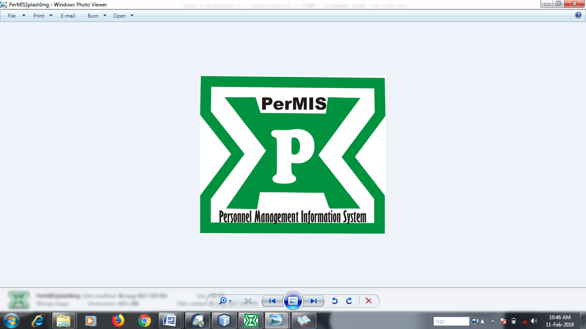

**Figure 2: PerMIS Execution Splash (Introductory) Screen**

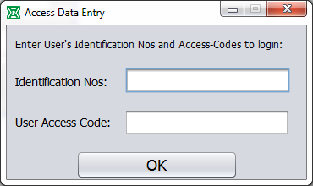

**Figure 3: User’s Access Data Entry Interface**

Some of the other interfaces of the developed system are shown in Figures 4 to 24.

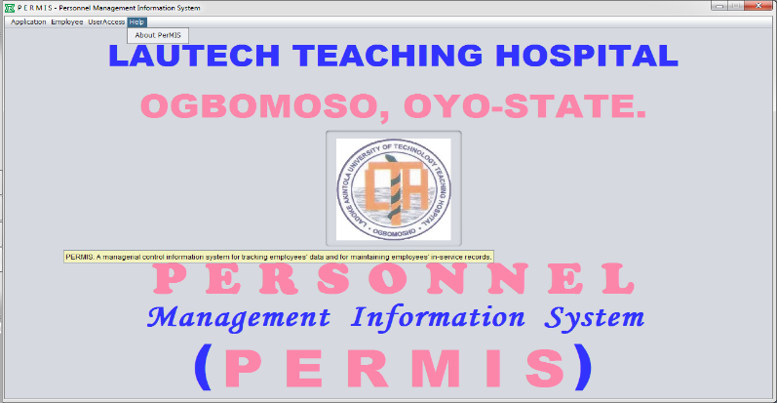

**Figure 4: System Main Interface**

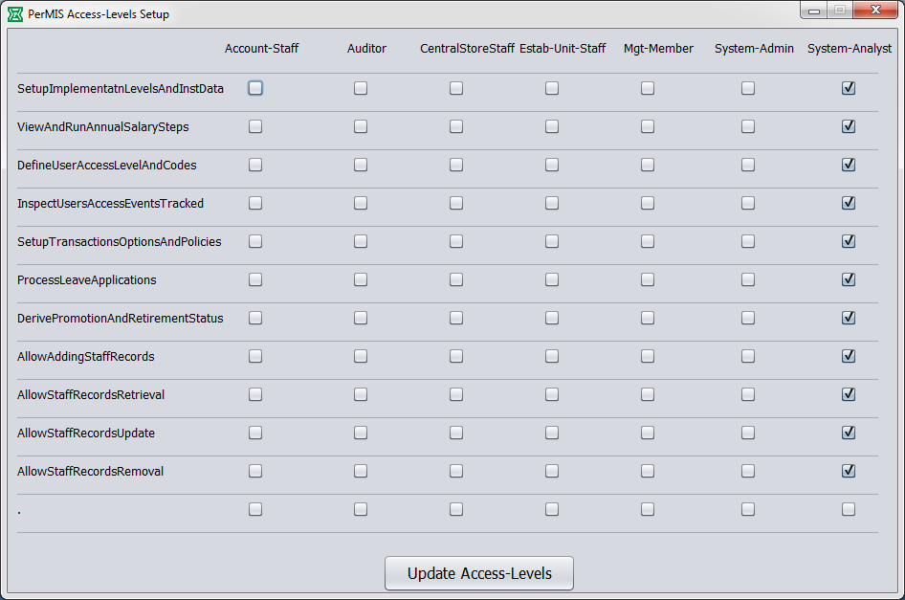

**Figure 5: Software Access-Levels Interface**

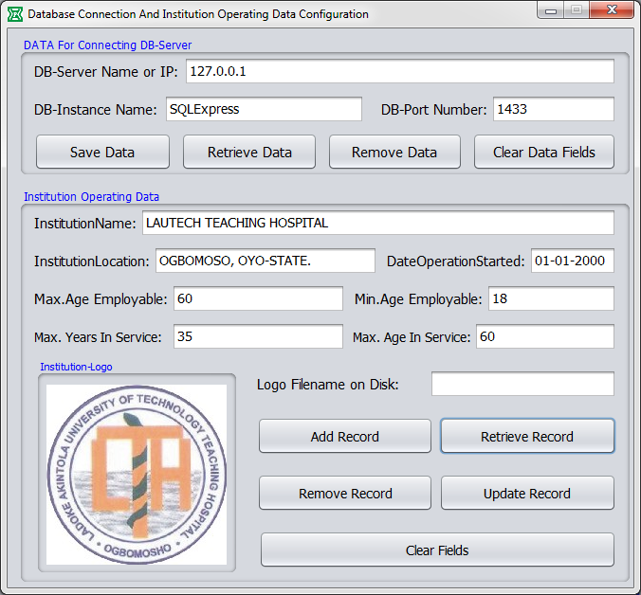

**Figure 6: DB Connection and Institution Operating Data Interface**

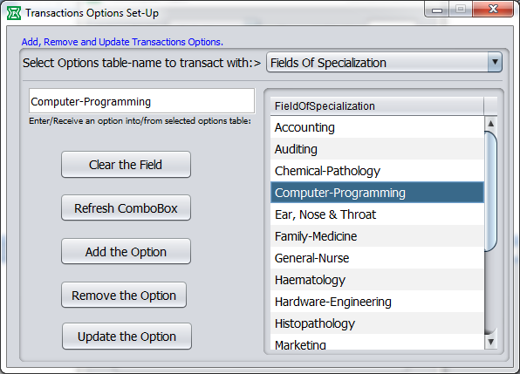

**Figure 7: Transactions Options Set-Up Interface**

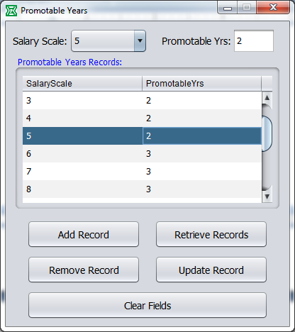

**Figure 8: Promotable Years Interface**

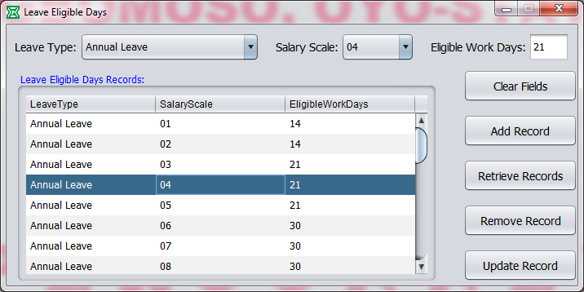

**Figure 9: Leave Eligible Days Interface**

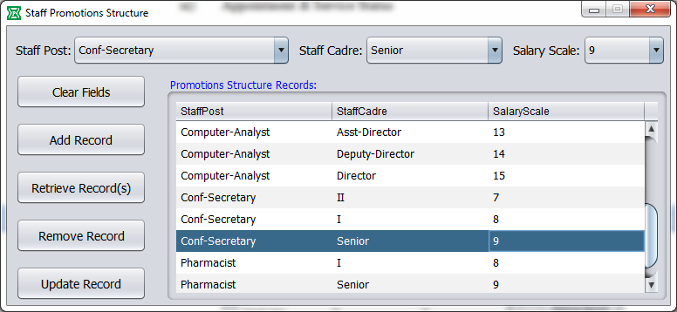

**Figure 10: Staff Promotions Structure Interface**

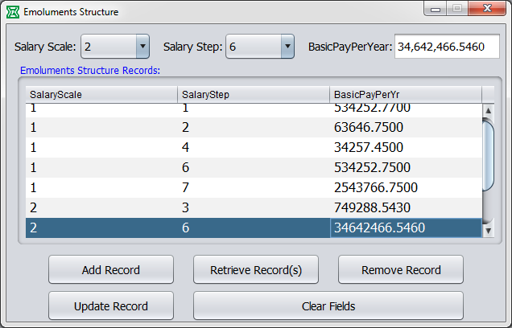

**Figure 11: Emoluments Structure Interface**

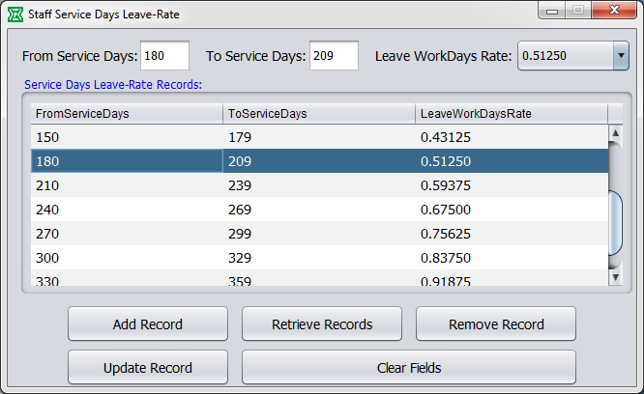

**Figure 12: Staff Service Days Leave Rate Interface**

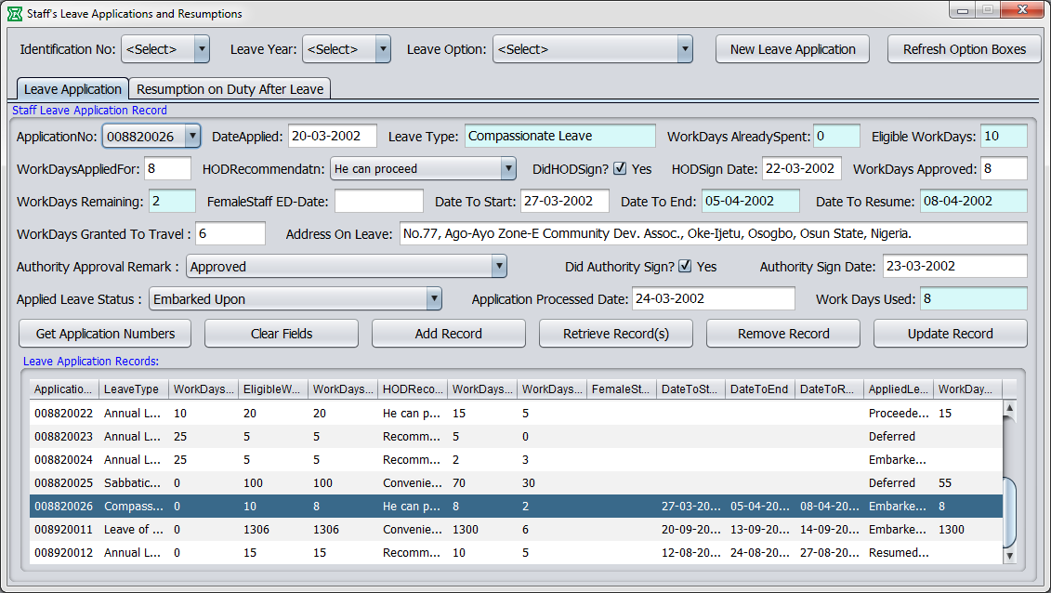

**Figure 13: Staff’s Leave Applications & Resumptions Interface**

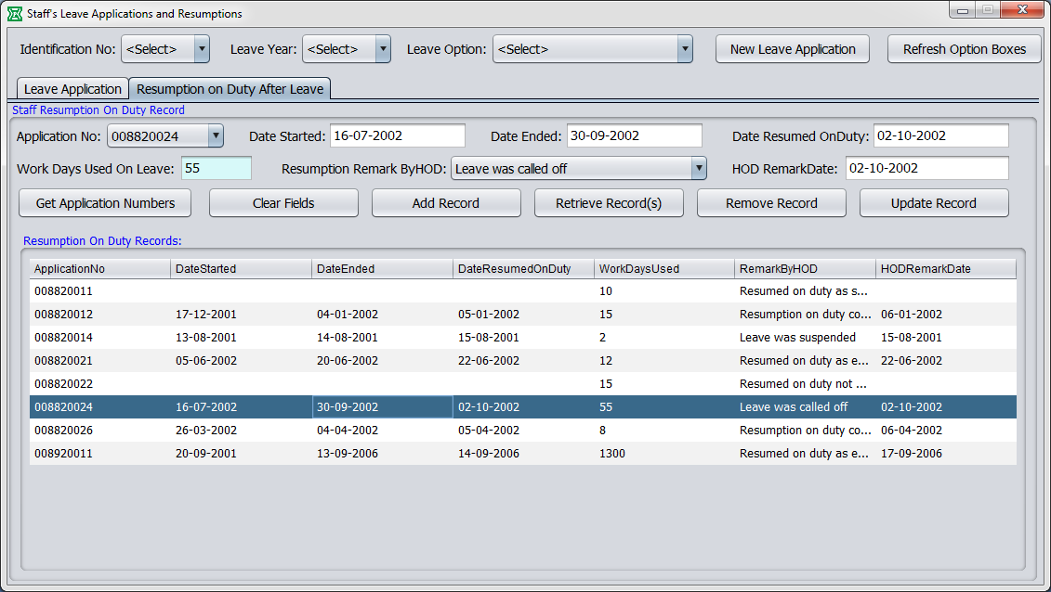

**Figure14: Staff’s Leave Applications & Resumptions Interface**

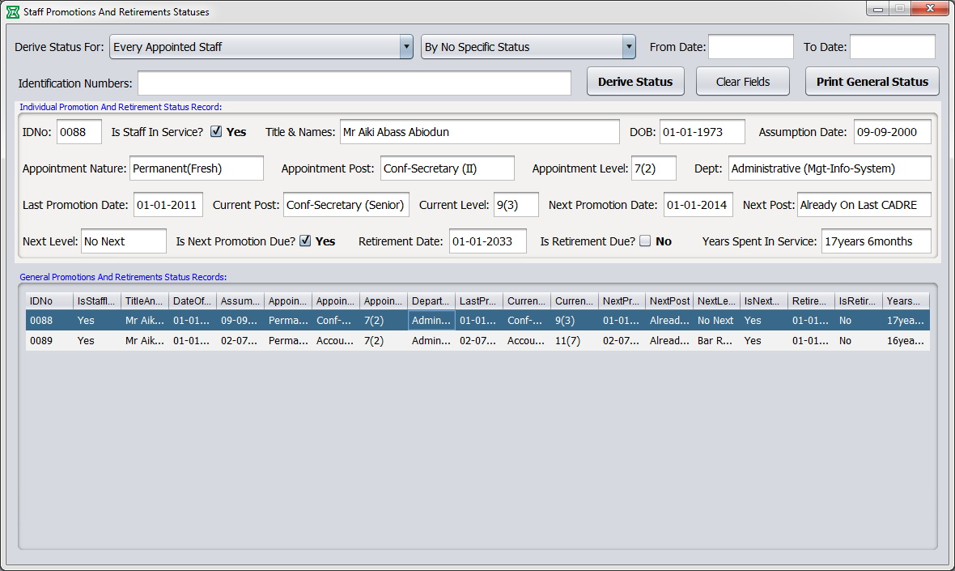

**Figure 15: Staff Promotions & Retirements Status Interface**

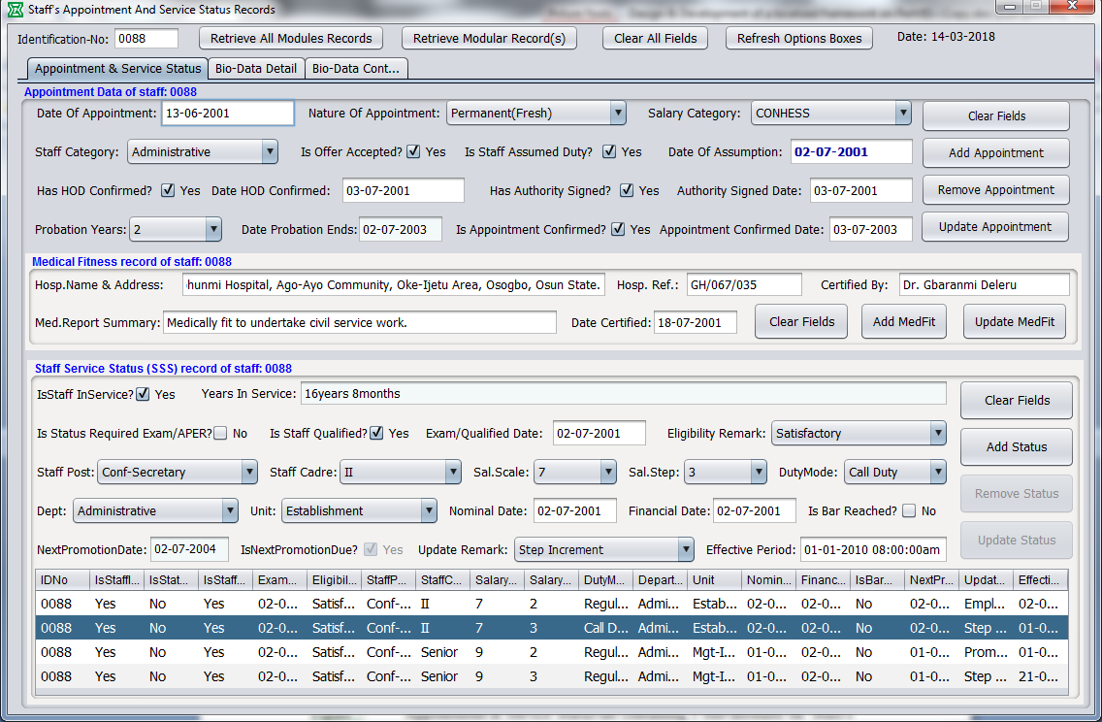

**Figure 16: Staff's Appointment and Service Status Records Interface**

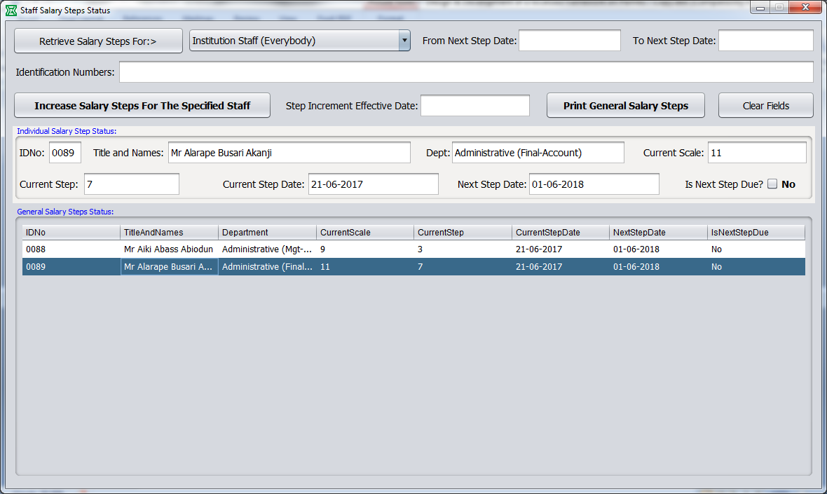

**Figure 17: Annual Salary Steps Status Interface**

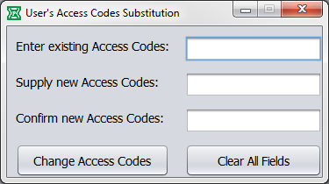

**Figure 18: User’s Access Codes Substitution Interface**

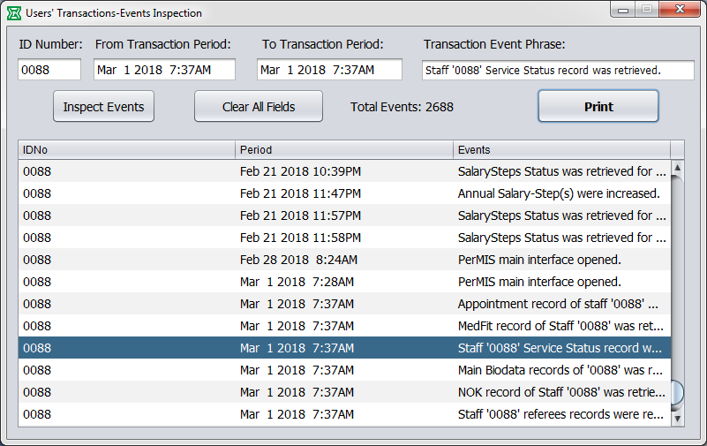

**Figure 19: Users’ Transactions-Events Inspection Interface**

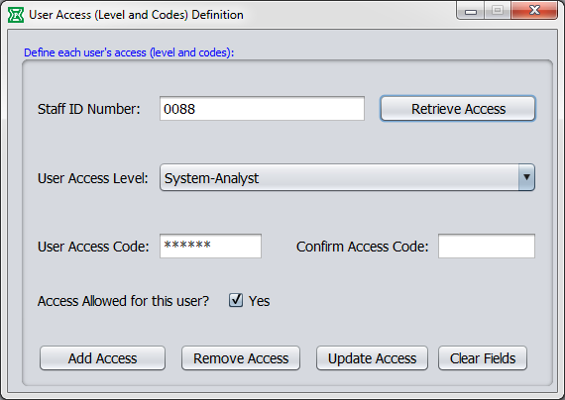

**Figure 20: User Access (Level & Codes) Definition Interface**

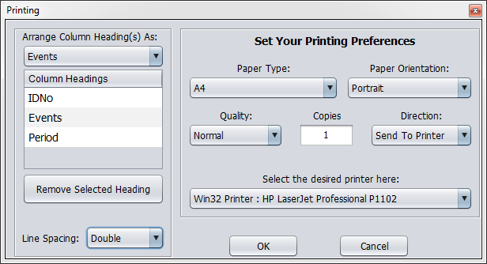

**Figure 21: Printing Interface**

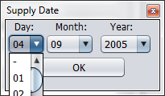

**Figure 22: Date Entry Interface**

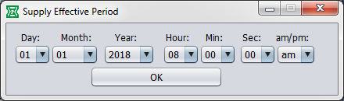

**Figure 23: Period Entry Interface**

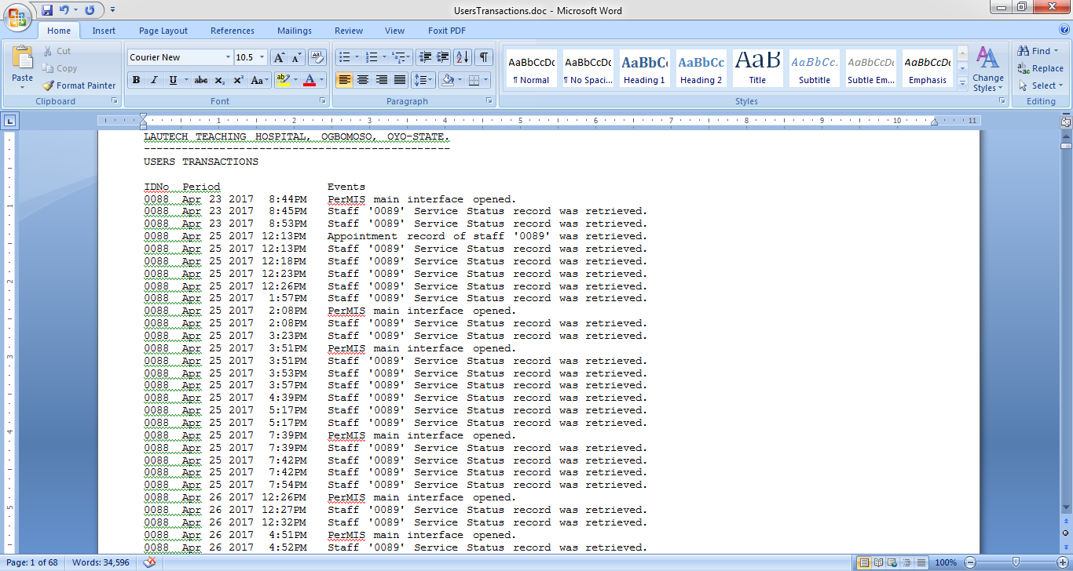

**Figure 24: MS-Word Output Design Interface displaying Users Transactions records**

Web-based Enterprise Personnel electronic records Management Information System (PerMIS).was evaluated based on its functionality, efficiency, validity, reliability, maintainability, and portability through a series of tests based on ISO/IEC 25010:2011 standards and conducted with IT experts, HR practitioners and users from LAUTECH Teaching Hospital, Ogbomoso. The results of the evaluation and feedbacks of the evaluators as shown in Tables 2 to Table 7 were collected and incorporated into the development of PerMIS.

***Table II. Functionality Evaluation Result***

|  |  |  |  |  |  |
| --- | --- | --- | --- | --- | --- |
| **Functionality of the System** | **IT Experts** | **HR**  **Practitioners** | **LAUTECH**  **Users** | **Average** | **Quantitative**  **Description** |
| 1.The system can perform the tasks required | 4.50 | 4.65 | 4.70 | 4.62 | FF |
| 2.The results were as expected | 4.40 | 4.45 | 4.50 | 4.45 | FF |
| 3.The system can interact with other system | 3.04 | 3.08 | 3.10 | 3.07 | F |
| 4.The system prevents unauthorized access | 4.30 | 4.55 | 4.65 | 4.50 | FF |
| **Weighted Mean** | **4.06** | **4.18** | **4.23** | **4.18** | **MF** |

Table II shows the combined assessment of all the respondents’ rating of items which measured the systems overall components and its essential functionalities having a qualitative result of Mostly Functional (MF) and a mean of 4.18. The IT experts’ assessment has a weighted mean of 4.06 qualitatively interpreted as Mostly Functional (MF); HR Practitioners’ assessment has a weighted mean of 4.18 qualitatively interpreted as Mostly Functional (MF), while the End Users tabulated assessment is 4.23 qualitatively interpreted as Fully Functional (FF). As shown in the table, the majority of the items were rated Fully Functional (FF) (the system can perform the task required = 4.62, the results were as expected = 4.45, and the system prevents unauthorized access = 4.50). The result means that the users were able to prove that the functionality of the system complied with their expectations. Furthermore, the item rated as Functional (the system can interact with another system = 3.07) measured reasonably proving that the developed system fulfilled the user’s requirements regarding the functionality of the system.

***Table III. Usability Evaluation Result***

|  |  |  |  |  |  |
| --- | --- | --- | --- | --- | --- |
| **Usability of the System** | **IT Experts** | **HR**  **Practitioners** | **LAUTECH**  **Users** | **Average** | **Quantitative Description** |
| 1.The user comprehends how to use the system easily | 4.20 | 4.25 | 4.35 | 4.27 | FU |
| 2.The user learns how to use the system easily | 4.35 | 4.40 | 4.50 | 4.42 | FU |
| 3.The user use the system without much effort | 4.08 | 4.10 | 4.15 | 4.11 | MU |
| 4.The interface looks good | 4.15 | 4.25 | 4.30 | 4.23 | FU |
| **Weighted Mean** | **4.20** | **4.25** | **4.33** | **4.26** | **FU** |

Table III shows the combined assessment of all the respondents’ rating of items which measured the systems' usability and the ease of use for the client on a given function or transactions within the system having a qualitative result of Fully Usable (FU) and a mean of 4.26. The IT experts’ assessment has a weighted mean of 4.20 qualitatively interpreted as Mostly Usable (MU); HR Practitioners’ assessment has a weighted mean of 4.25 qualitatively interpreted as Fully Functional (FF), while the End Users tabulated assessment is 4.33 also qualitatively interpreted as Fully Functional (FF). As shown in the table, the majority of the items were rated Fully Usable (FU) (the user learns how to use the system easily = 4.42, the user comprehends how to use the system easily = 4.27, and the interface looks good = 4.23). The result means that the users were able to prove that the functionality of the system complied with their expectations. Furthermore, the item rated as Mostly Usable (the user uses the system without much effort = 4.11) measured reasonably proving that the developed system fulfilled the user’s requirements regarding the usability of the system.

***Table IV. Reliability Evaluation Result***

|  |  |  |  |  |  |
| --- | --- | --- | --- | --- | --- |
| **Reliability of the System** | **IT**  **Experts** | **HR**  **Practitioners** | **LAUTECH**  **Users** | **Average** | **Quantitative Description** |
| 1.Most of the faults in the system has been eliminated | 4.50 | 4.55 | 4.75 | 4.60 | FR |
| 2.The system is capable of handling errors | 3.30 | 3.50 | 3.90 | 3.57 | MR |
| 3.The system informs users concerning invalid data entry | 4.20 | 4.50 | 4.65 | 4.45 | FR |
| 4.The system can resume working and restore lost data after failure | 3.25 | 3.45 | 3.60 | 3.43 | MR |
| **Weighted Mean** | **3.81** | **4.00** | **4.23** | **4.01** | **MR** |

Table IV shows the combined assessment of all the respondents’ rating of items which measured the systems Reliability or the capability of the system to achieve its intended functions and operations in a system's environment without experiencing failure having a qualitative result of Mostly Reliable (MR) and a mean of 4.01. The IT experts’ assessment has a weighted mean of 3.81 qualitatively interpreted as Mostly Reliable (MR); HR Practitioners’ assessment has a weighted mean of 4.00 qualitatively interpreted as Mostly Reliable (MR), while the End Users tabulated assessment is 4.23 qualitatively interpreted as Fully Reliable (FR). As shown in the table, the items rated as Fully Reliable were (Most of the faults in the system has been eliminated = 4.60 and the system informs users concerning invalid data entry = 4.45). Furthermore, other items rated as Mostly Reliable were (the system can resume working and restore lost data after failure = 3.57, and the system is capable of handling errors = 3.43) measured reasonably proving that the developed system fulfilled the user’s requirements regarding the reliability of the system.

***Table V. Efficiency Evaluation Result***

|  |  |  |  |  |  |
| --- | --- | --- | --- | --- | --- |
| **Efficiency of the System** | **IT**  **Experts** | **HR**  **Practitioners** | **LAUTECH**  **Users** | **Average** | **Quantitative Description** |
| 1.The system can respond quickly | 4.30 | 4.55 | 4.90 | 4.58 | FE |
| 2.The system’s execution time is appropriate | 3.90 | 4.10 | 4.35 | 4.12 | ME |
| 3.The system utilizes resources efficiently | 4.08 | 4.20 | 4.56 | 4.28 | FE |
| **Weighted Mean** | **4.09** | **4.28** | **4.60** | **4.33** | **FE** |

Table V shows the combined assessment of all the respondents’ rating of items which measured the systems efficiency or the system’s ability to support the number of system users at peak processing with no degradation of system performance having a qualitative result of Fully Efficient (FE) and a mean of 4.33. The IT experts’ assessment has a weighted mean of 4.09 qualitatively interpreted as Mostly Efficient (ME); HR Practitioners’ assessment has a weighted mean of 4.28 qualitatively interpreted as Fully Efficient (FE), while the End Users tabulated assessment is 4.60 also qualitatively interpreted as Fully Efficient (FE). As shown in the table, the majority of the items were rated Fully Efficient (FE) (The system can respond quickly = 4.58, and the system utilizes resources efficiently = 4.28). The result means that the users were able to prove that the efficiency of the system complied with their expectations. Furthermore, the other item rated as Mostly Efficient (the system’s execution time is appropriate = 4.12) measured reasonably proving that the developed system fulfilled the user’s requirements regarding the efficiency of the system.

***Table VI. Maintainability Evaluation Result***

|  |  |  |  |  |  |
| --- | --- | --- | --- | --- | --- |
| **Maintainability of the System** | **IT Experts** | **HR**  **Practitioners** | **LAUTECH**  **Users** | **Average** | **Quantitative Description** |
| 1.The faults in the system can be easily diagnosed | 4.20 | 4.35 | 4.60 | 4.38 | FM |
| 2.The software can be easily modified | 4.30 | 4.40 | 4.80 | 4.50 | FM |
| 3.The software can continue functioning even if changes are made | 4.05 | 4.10 | 4.25 | 4.13 | MM |
| 4.The software can be tested easily | 4.45 | 4.60 | 4.90 | 4.65 | FM |
| **Weighted Mean** | **4.25** | **4.36** | **4.64** | **4.42** | **FM** |

Table VI shows the combined assessment of all the respondents’ rating of items which measured the systems maintainability or the system characteristic of design and installation, expressed as the possibility that software will be retained in or restored to a specified condition within a given period having a qualitative result of Fully Maintainable (FM) and a mean of 4.42. The IT experts’ assessment has a weighted mean of 4.25 qualitatively interpreted as Fully Maintainable (FM); HR Practitioners’ assessment has a weighted mean of 4.36 qualitatively interpreted as Fully Maintainable (FM), while the End Users tabulated assessment is 4.64 also qualitatively interpreted as Fully Maintainable (FM). As shown in the table, the majority of the items were rated Fully Maintainable (FM) (the software can be tested easily = 4.65, the software can be easily modified = 4.50, and the fault in the system can be easily diagnosed = 4.38). The result means that the users were able to prove that the maintainability of the system complied with their expectations. Furthermore, the item rated as Mostly Maintainable (the software can be easily modified = 4.13) measured reasonably proving that the developed system fulfilled the user’s requirements regarding the maintainability of the system.

***Table VII. Portability Evaluation Result***

|  |  |  |  |  |  |
| --- | --- | --- | --- | --- | --- |
| **Portability of the System** | **IT Experts** | **HR**  **Practitioners** | **LAUTECH**  **Users** | **Average** | **Quantitative Description** |
| 1.The system adapts to other environments | 3.45 | 3.65 | 4.05 | 3.72 | MP |
| 2.The system can be installed easily | 4.50 | 4.65 | 4.95 | 4.70 | FP |
| 3.The system can easily replace other software | 4.30 | 4.45 | 4.90 | 4.55 | FP |
| **Weighted Mean** | **4.08** | **4.25** | **4.63** | **4.32** | **FP** |

Table VII shows the combined assessment of all the respondents’ rating of items which measured how easy the system can be moved and used in different environments (operating systems, hardware or locations) having a qualitative result of Fully Portable (FP) and a mean of 4.32. The IT experts’ assessment has a weighted mean of 4.08 qualitatively interpreted as Mostly Portable (MP); HR Practitioners’ assessment has a weighted mean of 4.25 qualitatively interpreted as Fully Portable (FP), while the End Users tabulated assessment is 4.63 also qualitatively interpreted as Fully Portable (FP). As shown in the table, the majority of the items were rated Fully Portable (FM) (the system can be installed easily = 4.70, and the system can easily replace other software = 4.55). The result means that the users were able to prove that the portability of the system complied with their expectations. Furthermore, the other item rated as Mostly Portable (the system adapts to other environments = 3.72) measured reasonably proving that the developed system fulfilled the user’s requirements regarding the portability of the system.

***Table VIII. Summary of Evaluation Result***

|  |  |  |
| --- | --- | --- |
| **Criteria** | **Weighted Mean** | **Quantitative Description** |
| 1.Functionality | 4.18 | Mostly Functional (MF) |
| 2.Usability | 4.26 | Fully Usable (VU) |
| 3.Reliability | 4.01 | Mostly Reliable (MR) |
| 4.Efficiency | 4.33 | Fully Efficient (VE) |
| 5. Maintainability | 4.42 | Fully Maintainable |
| 6. Portability | 4.32 | Fully Portability |
| **Weighted Mean** | **4.25** | **Fully Compliance** |

Table VIII shows the summary of evaluation by system evaluators (IT experts in different field of specialization, Human Resource Practioners and users from LAUTECH Teaching Hospital, Ogbomoso) of the Technical Qualities of the developed PerMIS system and had passed the criteria tool of evaluation of technical qualities in functionality, usability, reliability, efficiency, maintainability and portability based on ISO/IEC 25010:2011 standards. The system evaluators’ result has a weighted mean of 4.25, with a qualitative description of Fully Compliance to ISO/IEC 25010:2011 standards.

# CONCLUSIONS AND RECOMMENDATIONS

Based on the results of this study, it is concluded that Web-based Enterprise Personnel electronic records Management Information System (PerMIS) for Ladoke Akintola University of Technology (LAUTECH) Teaching Hospital, Ogbomoso, Oyo State, Nigeria fully complied to the ISO/IEC 25010:2011standards. In addition, the developed web based PerMIS significantly improved the provision of relevant, efficient, compatible, usable, and reliable information and could generate real-time reports. The developed web based PerMIS also offered capability to improve provision of increased access to valuable HR data and insights that can be used to make informed decisions, improve processes, and develop more effective strategies; streamlined and standardized HR processes; more consistent and accurate data; a higher internal profile for HR; and reduction of the shortcomings of the existing custom made PMIS software models. It is highly recommended that further system updates to accommodate the growing need of the personnel department for improvement is also encouraged by close collaboration with the system developer.

**REFERENCES**

1. Drucker, P. F., Dyson, E., Handy, C., Saffo, P., and Senge, P. M. (1997). "Looking ahead: Implications of the present". *Harvard Business Review, 75*(5), 18–24.
2. Smith, A. F., and Kelly, T. (1997). "Human capital in the digital economy". In F. Hesselbein, M. Goldsmith, & R. Beckhard (Eds.), *The organization of the future* (pp. 199–212)*.* San Francisco: Jossey-Bass.
3. Porter, M. E. (1990). "The competitive advantage of nations".. Boston: Free Press.
4. Greer, C. (1995). "Strategy and human resources: A general managerial perspective". Englewood Cliffs, NJ: Prentice Hall.
5. Wikipedia (2017). “Information System”, Updated 28 Dec 2017; Accessed: 30th December, 2017. URL: <https://en.wikipedia.org/wiki/Information_system>
6. Wyatt, W. (2002). “E-HR: getting results along the journey". Survey Report. Retrieved November 2009 <http://www.watsonwyatt.com/research/resrender.asp?id=W-524&page=1>.
7. Abdulrazaq, B. A. (2015). “IManagement of university records for effective administration of universities in North Central Nigeria”, International Journal of Library and Information Science, 7(3), 47–54.
8. McLeod Jr, R., & Schell, G. P. (2008). "Sistem informasi manajemen edisi” 10. Jakarta: Salemba Empat.
9. Henderson, L, (2011). “Human Resource Management for MBA Students”. Retrieved from https:/lwwvv2.cipd.co.uk/NRIrdonlyr es/29D9D26D-83CE-4E76 -96C6-EB7AFO2B109E/0/9781843982654 sc.pdf
10. Pho, H. T., and Tambo, T. (2014). "Integrated management systems and workflow-based electronic document management: An empirical study". Journal of Industrial Engineering and Management, 7(1), 194–217.
11. Abikoye, O., Oyelakun, T., Aro, T., and Oyeranti, O. (2019). “Design and Implementation of a Personnel Record Management System”. African .Journal, 1(1), 65–94.
12. Dessler, G., Griffiths, J. and Lloyd-Walker, B. (2004), “Human Resources Management", 2nd ed. Frenchs Forest, New South Wales: Pearson Education Australia, pp. 97–99.