**Driver-less Automated Solar Powered Electric**

**Vehicle Prototype With Sensor Control**

ARAJIT SAHA SUDIPTA ROY

PG Scholar UG Scholar

Department of Electrical Engineering,

JALPAIGURI GOVERNMENT ENGINEERING COLLEGE, DENGUAJHAR, JALPAIGURI, WESTBENGAL, INDIA

***Abstract ---* A solar powered electric vehicle has been designed in order to create the modern day transportation evolution. It uses renewable energy sources such as sunlight which never ends until the presence of atmosphere and it also the future of energy savings and reduce carbon emission, so it helps to prevent global warming. It has the feature of solar PV cell which absorbs the sunlight and recharge the battery of these prototype, when the sunlight is present it uses the sunlight for travelling and also recharge the battery and when the sunlight is not present the vehicle still moves with the help of battery. The battery can charge two ways either the help of solar PV or with the help of electricity. If there neither presence of solar PV nor the battery charge then it uses the adaptable jumper wire to connect with charging station and recharge its battery. It has another feature sensor and receiver, it is directly taken instruction using sensor and receiver so it is completely encrypted system that connects user and prototype without the interference of any third party application.**

***Keywords :* Gear motor, Receiver, Sensor, Solar PV cell, Lithium ion battery, wheels.**

1. **INTRODUCTION**

A solar power electric vehicle is completely operated under direct solar energy. It uses solar PV cell which also known as Photovoltaic cell which convert sunlight into electricity. It contains solar power to communicate or control or other functions of this prototype. It does not mode of transportation as much present days but in future it is the main mode of transport for the people. However in future charging station has installed as much as like gas station people refuse to use combustion vehicle and switch to the eco-friendly this prototype. This vehicle has advantage over combustion vehicle because of its light weight(1000 kg - 1400 kg) and long range uses limited power. This vehicle has produced less noise as compared to combustion vehicle.The first solar car STELLA introduced at 2013 at Netherlands. This vehicle too much light weighted. It travels 890 km presence of the sunlight. The average family who can not drive more than 300 km for them this prototype is most cost effective then combustion vehicle in present days only. So there is no doubt this is the future of transportation, now days even race car are installed as a solar race car.Because solar powered electric vehicle system can be installed 2 - 3 hours.Various company even now days make efficient solar car for public, examples of such companies are Aptera Motors an American company and Sono Motors a German company.Despite so much advantages there are some drawbacks for which research to be done. There are mainly three drawbacks the major consideration is power density, cost, complex design, life span. As the size of the vehicle is limited so there was limited number of the solar PV panel so it absorbs a certain amount of power which can not exceed to a certain limit that’s the major drawback, sunlight is free but not the solar PV cell so even the source of energy is free but the capture of this energy still costly as a result the solar electric vehicle become costly present days as compared to combustion vehicle but as the time passes the prices of the PV cell and battery continuously drop as a result in future solar power electric vehicle become most cost effective as compared to combustion vehicle.The another major drawback of solar car there is the life span of the battery how much good it is its life span approx 5-10 years as continues days passing we got several new sources of batteries which last longer around 25-30 years.

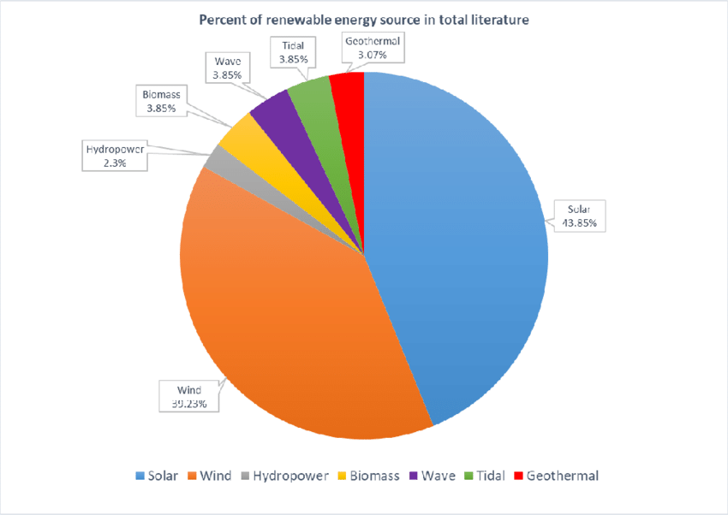

Fig-1: Pie chart showing the percentage of renewal energy uses people all over the world

In this article the author discuss the method of controlling the solar EV without Arduino or any other programming languages. It is completely sensor based receiver control which have directly get instruction from user to device without the interference of any software . Its also contain self

camera and buzzer when any object has come in front or back

or side the camera captures the picture or capture completely the video continuously and send it to the user so user based on that

buzzer and sensor , sensor can sense the object which come around the EV and instructed the Camera to visual of it and if any scope of

**II.BRIEF DESCRIPTION**

The important feature is use in this prototype is provide completely encrypted automated and smart control of the vehicle. vehicle. The uniqueness of this vehicle is automatic control of total devices by the user if at any time driver is not available still it travels with passenger safely and comfortably.Its sensor .obstacles comes identified any obstacle (static or dynamic) and its camera capture that and working its acceleration breaking and horn according to it. Here this prototype uses sensor within the range of 100 meter automated control which connected to the gear motor which is also connected to the wheels so without the instruction from the user prototype wheels can not move.Here uses 2 mg-pixel camera is installed to capture obstacles comes any side of the vehicle and buzzer work as a horn Here 6 wheels are present in this prototype and each and every wheel individually connected with the gear motor as there is to be 6 gear motors. Here uses gear motor for few advantages. Gear motor has fast heat recovery

when any ventilation and flow regulation.It is suitable for telecommunication, locking safety and deterrence system and the major advantage of using that it has the ability of shock absorbed and sunroof adjustment.Here we uses receiver rather than Arduino so receiver get direct information from the sensor remote which control by user.So there is no need of open source platform so prototype function are safe from tampering in front of the vehicle.Here four solar panel installed at the roof of this prototype, each and every solar panel is square shape (70mm x 70mm) and each of them ratings are 5 volt, 100 mA, 0.5 watt.

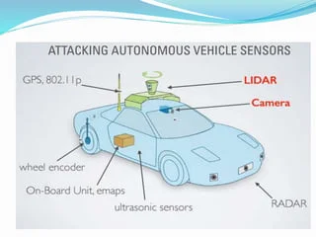

Fig2 :Illustration shows the Working principle

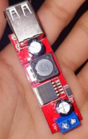

Fig 3 : Receiver of the prototype which discuss in this paper

It also have lithium ion battery which rating is 3 volt is operated as a charging storage based on the either electricity or solar power depend on the connection based on which it is operated.Here using of lithium ion battery has several advantages it has longer life span and safety features as the performance is relatively high that’s why we chose the lithium ion battery.

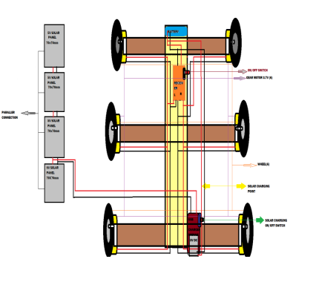Fig 4 : The schematic diagram of the driver-less automated solar powered electric vehicle with sensor control

The overall schematic diagram is shown above fig it has to be maintained the balance of the body weight of total prototype.We uses that shape to maintain low weight cost effective and fast moving .

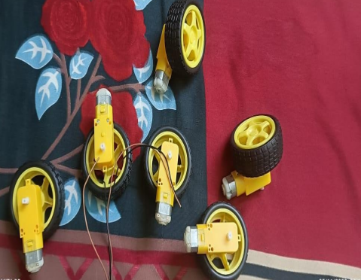

Fig 5: Wheels uses for this prototype

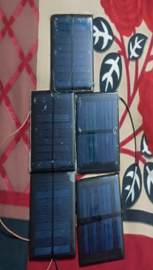

Fig 6 : Solar panel used for the prototype

**DESIGN**

Here using the comprehensive method of designing the solar EV based on the assessment and the aim was lower carbon emission.

We explained the design briefly with the help of block diagram and flow chart

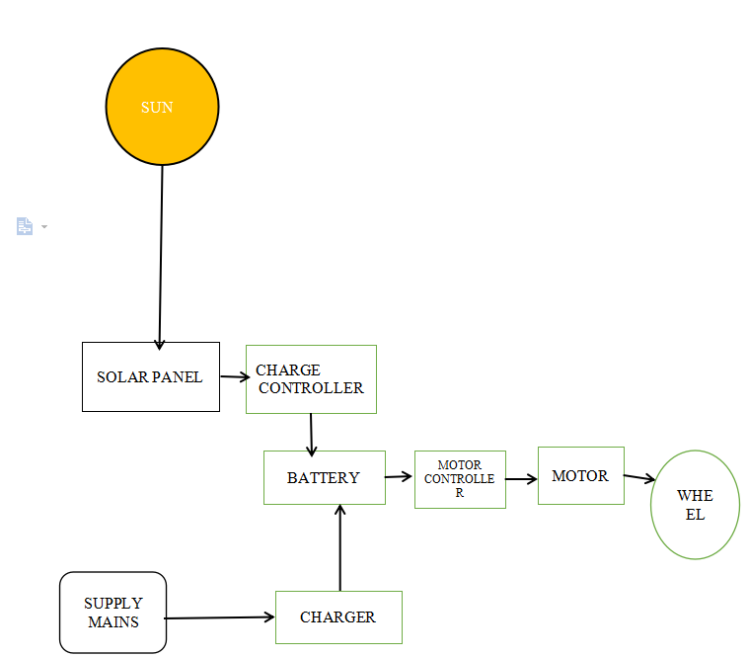

Fig 7 : Block diagram of the prototype

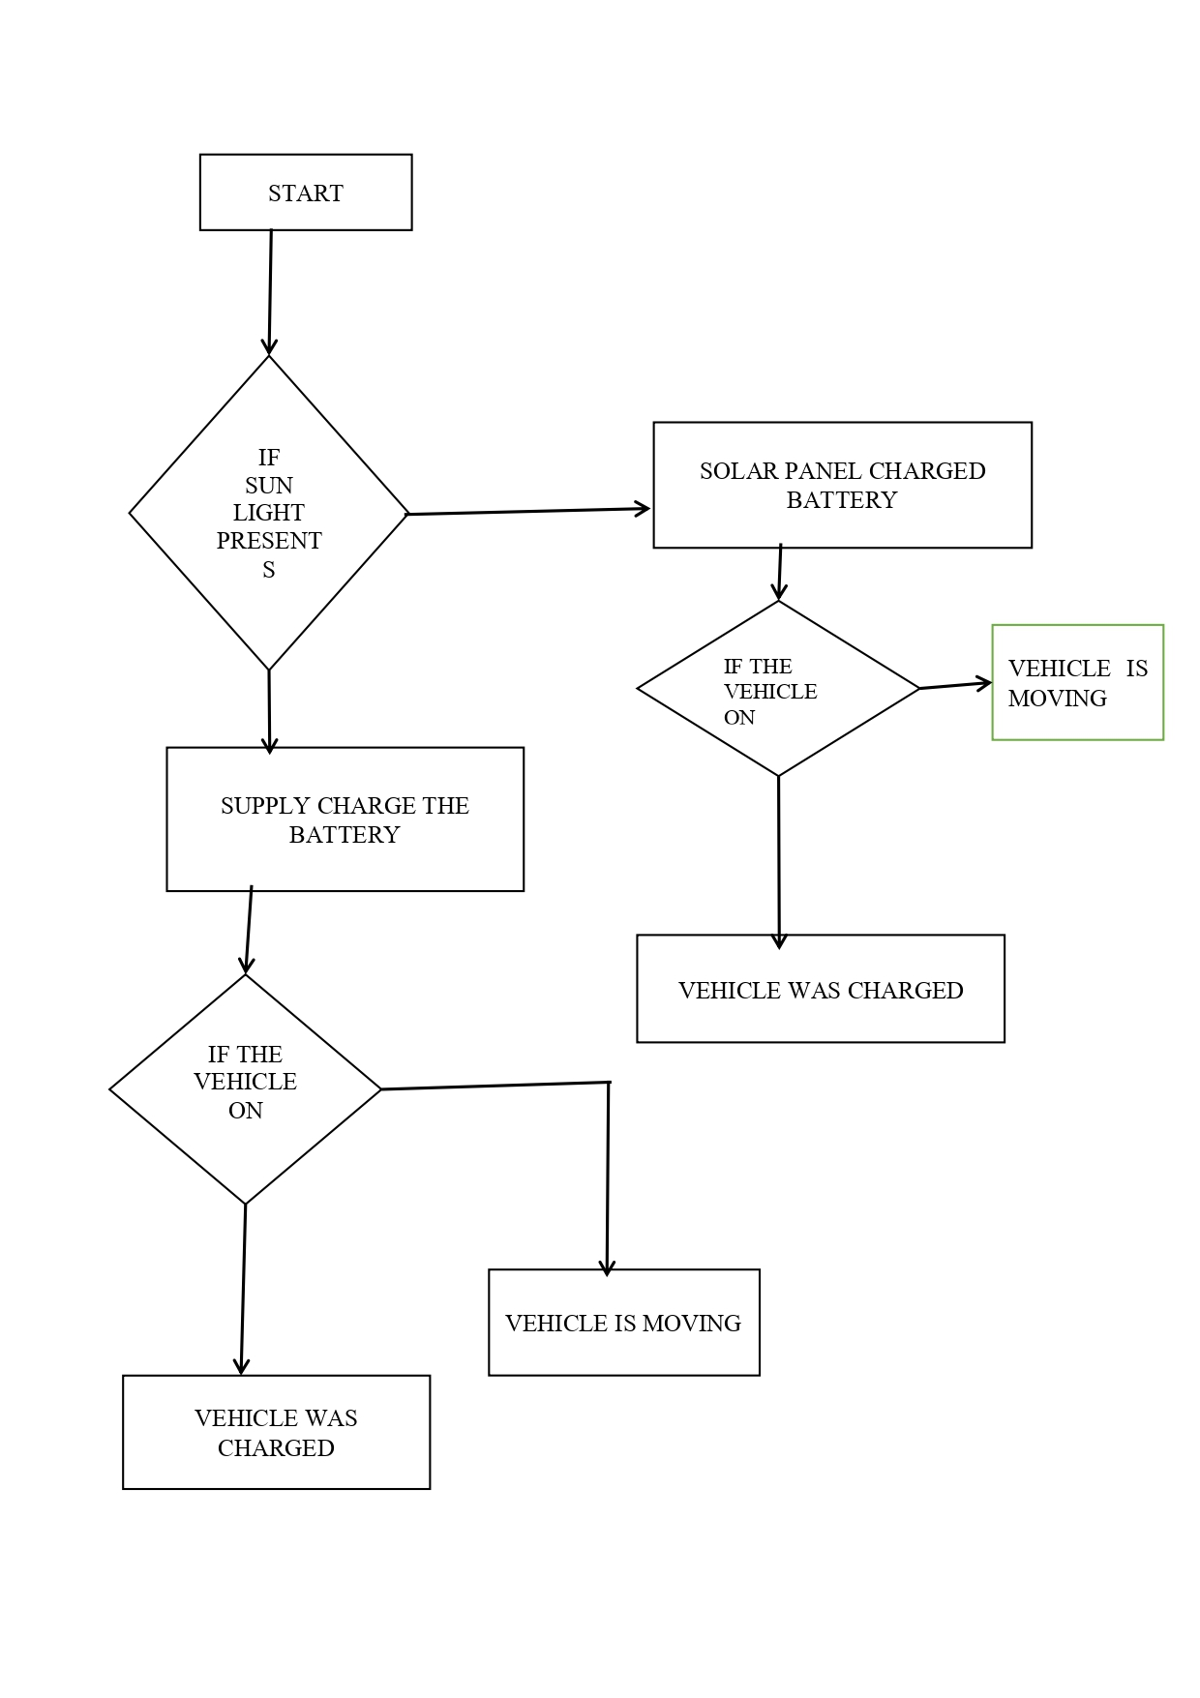

Fig 8: Flowchart of the prototype

Based on the block diagram and flowchart we got to know about the clear cut working principle which states that “When sunlight is present car is move with help of sunlight and also recharge the battery with the help of sunlight and at night when sunlight is not present the car move based on the recharge battery which already recharge with the help of sunlight still if battery is not recharge then battery get charge with the help of electricity so at no condition the vehicle will stop.”Since the vehicle is not need any driver still is completely safe for riding, as there no need of driver sensor worked it on their behalf.

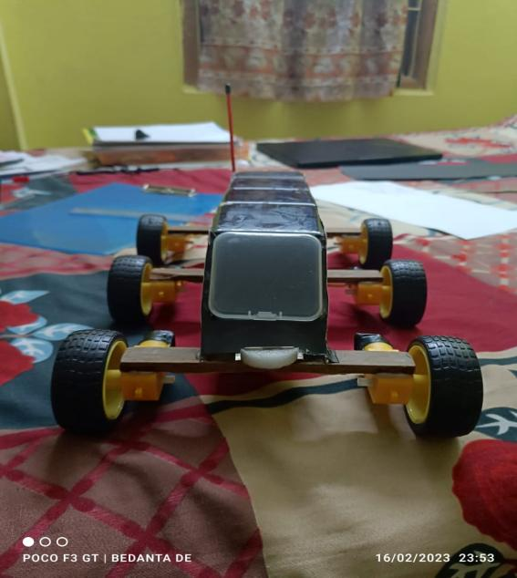

Fig 9: Prototype complete design



Fig 10: Controller of the prototype

**CONCLUSION**

A driver-less solar power electric vehicle has been designed which gives assistance for travelling people who doesn’t know anything about driving.It provide completely safe travelling with proper navigation also encrypted control.In future solar EV is the prime object of travelling and government of India is also focusing about the lower carbon emission vehicle.So this smart vehicle has higher future demand also it is user control device so it has 0 % chance of third party involved and it has uses renewable energy so it is eco-friendly.So moral of this discussion it is eco-friendly, futuristic, smart-control, easy to use and end to end encrypted device.

**REFERENCES**

1. <https://en.wikipedia.org/wiki/Solar_vehicle>
2. <https://www.slideshare.net/PratikThorat5/complete-ppt-on-driverless-car-11-sd>
3. <https://www.researchgate.net/figure/The-pie-chart-in-terms-of-seven-renewable-energy-sources_fig1_343953072>

\

1. https://www.google.com/search?q=solar+powered+electric+vehicle&rlz=1C1ONGR_enIN1022IN1023&oq=&gs_lcrp=EgZjaHJvbWUqCQgBECMYJxjqAjIJCAAQIxgnGOoCMgkIARAjGCcY6gIyCQgCECMYJxjqAjIJCAMQIxgnGOoCMgkIBBAjGCcY6gIyCQgFECMYJxjqAjIJCAYQIxgnGOoCMgkIBxAjGCcY6gLSAQkxNDI2ajBqMTWoAgiwAgE&sourceid=chrome&ie=UTF-8

[5]S. Leitman, and B. Brant, Build Your Own Electric Vehicle. New York, NY, USA: McGraw-Hill, 2008.