**ANALYSIS OF LAND DEGRADATION IN FUFORE AND YOLA-NORTH LOCAL GOVERNMENT AREAS OF ADAMAWA STATE, NIGERIA**

**BY**

Gamaniel Japheth1, Gadona Enoch Alhamdu2, Nicolaus Y. Wamangra3

Department of Surveying and Geoinformatics, Federal Polytechnic Mubi Adamawa State Nigerian

**Abstract**

*Soil erosion is an ecological issue of great concern in most parts of Adamawa State. The research’s study adopts a combination of Geographic Information System (GIS) and Remote Sensing as a tool to study, assess soil degradation in Fufore and Yola-North local government areas of Adamawa State. For this research study, several data sets that represent climate, soil and anthropogenic factors were employed in accessing and analyzing soil degradation in the study area. Land use and Land cover maps for 1986 and 2016 and the Normalized Difference Vegetation Index for 1990 and 2020 was carried out. The result of the soil degradation assessment of 1990 and 2020 and the NDVI of 1990 and 2020 shows the level of soil degradation and the vegetation depletion that occurred in the last thirty years (1990-2020). The research study demonstrates the integration of GIS with Remote Sensing as a tool for effective and efficient assessment of soil degradation.*

**Keywords: *Soil Degradation, Normalized Difference Vegetation Index (NDVI) Remote Sensing, Assessment. Anthropogenic***

**1.00 Introduction**

Land is commonly used to refer to a section of the earth′s surface with all the physical, chemical and biological features influencing the use of land. It thus comprises soil, terrain, climate, hydrology, vegetation and fauna, as well as human activities (land management) (Ann, 2012).

Land degradation is a global issue for a number of reasons, but most significantly because productive land is one of several resources where decline in productivity threaten our capacity to feed a growing world population estimated to be over nine billion by 2050 Mick (2014). This ostentation is buttressed by (Julian Crib, 2014) who point out that of the 1.5 billion hectares of global farm land a quarter is affected by serious degradation, up from 15% two decades ago. Erosion is described as the wearing away of the earth surface material by wind, water, ice or gravity. One important fact remains that these data collected on soil erosion is capital intensive as well as time consuming. Remote sensing data provide better technique to solve this problem. Remote Sensing and GIS enable the manipulation and mapping of spatial data of various types. This include soil erosion, hence the adoption of remote sensing for assessing degradation in the selected two local government areas of Adamawa state for this research study.

Land degradation is generally caused by inappropriate land use and management that jeopardizes soils self-regulatory capacity (and resistance and resilience). The unsustainable land use and management practice themselves are often driven by socio-economic and political forces (Lal, 2004). Human activities such as over cultivation, deforestation and others are some of the main causes of degradation (Allen & Barnes 1985).

Guessess, Klik and Hurni, (2009) observed that poor land use practice and lack of effective planning and implementation approach for soil conservation are responsible for accelerated degradation of Agricultural lands and siltation of dams and reservoirs downstream.

Many national, regional and global assessment of degradation were undertaken over the years, of all these studies one may conclude that many past statements were based on assertion that were unsubstantiated by hard evidence, in fact the influence of land degradation in economic terms continue to be debated ( Freddy, 2010). Lack of cause effective relationship between severity of degradation and productivity criteria for designing different classes of land degradation e.g. Low, Medium and others is the major challenges. And lack of information between cover types and natural phenomenon such as climatic conditions and anthropogenic activities is the major challenges faced in the two local governments in Adamawa state.

In this research study, GIS and Remote Sensing techniques was adopted as an approach to analyze land degradation in the two local government areas. The research work is seeking to unveil the degraded areas, also employed Normalized Difference Vegetation Index (NDVI). The aim is to explore the possibility of using NDVI as a proxy to indirectly assess degradation in the study area. The specific objectives of this research study is to analyze degradation between 1990 and 2020 time period and the Normalize Difference Vegetation Index of the same period and compare the two

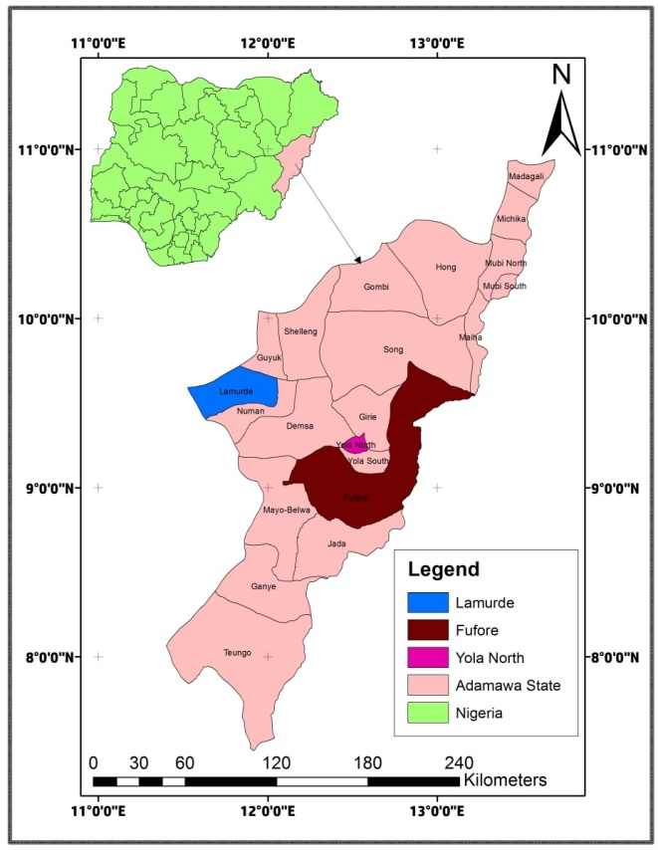

Figure 1: Map of the study area

Figure 1: Map of the Study Area: Fufore and Yola/North local govt Areas

Source: Adamawa State in Maps

Fufore and Yola/North Local government areas of Adamawa State constitute the study area and are located in the Northeast Nigeria between latitudes 8⁰ 54′ 00”N -9⁰ 45′ 15″N and longitudes 12⁰ 40′ 30″E -12⁰ 34′ 15″E of the Greenwich meridian and for Yola/North 9⁰ 12′ 15″N- 9⁰ 45′ 30″N and longitudes 12⁰ 32′15″E 12⁰ 48′ 45″E of the Greenwich meridian. Fufore covers an area of about 3,232.03km₂Yola/North/North covers an area of about 495.64km₂ the area is boarded to the south by Yola/South and to the west by Girei. Fufore is boarded to the north by Maiha and Song local government areas and to the south by Jada and Mayo-Belwa local government areas and to the east by Cameroun Republic.

**2.00 Materials and Methods**

In this research work, Remote Sensing and Geographic Information System (GIS) technique was adopted to achieve the stated aim and objectives. The primary data collected includes; Landsat Thematic Mapper ™ of 1986 and 2006 with 30m resolution, downloaded from the Earth Explorer for the two selected local governments. ASTER Image (DEM), Advance Space borne Thermal Emission and Radiometer downloaded from GLCP. Secondary data,: journals, textbooks, population data obtained from National Population Commission (NPC) and rainfall data obtained from Upper Benue River Basin Development Authority (UBRBDA) Yola.

For mapping soil degradation, the Revised Universal Soil Loss Equation (RUSLE) was adopted; data used to evaluate RUSLE factors and generation of erosion map in the study area was obtained from the primary data. These data were processed using the maximum likelihood classification algorithm in Erdas Imagine and 3D ANALYST Extensions of ArcGIS 10.2. Rainfall distribution and soil erodibility Shape files were downloaded from ASTERGDEM.

**2.10 Rainfall Erosivity Factor (R)**

Precipitation readings in mm are needed and then processed through spatial Analyst/Interpolation spline. Average rainfall data for a period of thirty years (1990-2020) obtained from Nigerian metrological Agency (NIMA). Rainfall pattern in the study area ranges from 500mm to 750mm, with an average rainfall of 600mm annually.

**2.20 Slope Factor (LS)**

Derivation of slope factor (LS) Involved generation of Digital Elevation Model (DEM), thus the creation of slope, flow direction and flow accumulation. LS factor was determined using equation:

LS= (AS/22, 13)ͫ(Sin/0.09)ⁿ

Where AS = upslope contributing area per unit width of cell spacey

Ө = slope angle (degrees)

M and n = exponent of slope parameters for slope length and gradient value of n are 0….4-0.6 and 1.0-1.4. Where value of m = 0.4 and n 1.1

**3.30 Land cover Factor (Cover Management)**

The classification of the study area was done through the classification of Landsat ETM+ using maximum likelihood analysis. The result of this classification was used to drive the C-factor for the land cover.

**3.40 Soil Texture/Erodibility K- Factor**

Data obtained from the soil map with soil types. Data like silt, clay and sandy soil values were used. The L- Factor was then calculated for each soil texture class.

**3.50 Slope Length and Steepness**

Raster calculator was used to perform calculation here, with flow direction, flow accumulation slope to get F, M, and LS Factors.

**3.60 Soil Degradation Map (A-Factor)**

Raster calculation was used to perform calculation by using RUSLE

A = R×K×LS×C×P

Where A = Average soil loss

R = Rainfall erosivity factor

K = Soil erosivity factor

LS = Slope factor

C = Cover fact

**4.00 Results and Discussion**

Once the land degradation process are understood and coast-effect relationship established, appropriate methods of constraints/stress alleviation, and quality enhancement can be developed to reduce the impact of land degradation on the land users. The land users in their turn will only be motivated to adopt these measures if they have clear view on the short long term impact and consequences, Ann (2012)

One important problem noticed in the area, is climate change, they are becoming more threatening to human sustainable development. Thus, this change may lead to reduction of land quality and lo**w** productivity**.**

**4.10 Degraded Areas in Yola North and Fufore Local Government Areas**

Based on Table 4.1 below**,** the major degradation in Yola North is flood. It covers a substantial part of the area. This flood is a long river Benue. The flood occurs between the month of July and August, when water is released from Lagdo dam in Cameroon Republic. This causes a lot of environmental problems, water is polluted, destruction of farmlands and houses, fishing ponds are washed away, sometimes lives are lost. This causes gully erosion along the bank of the river. The flood prone areas are Doubeli, Jambutu and 80 Housing units. The flood in Jambutu is as a result of poor drainage network and most of the available drainages are blocked while Gerio has gully erosion located in the area, this is as a result of mining for sand and gravel for construction works,

Whereas in Fufore Local Government Area, Flood is the major environmental land degradation problem experienced. The river Benue runs through it, when the water is released from Lagdo dam, its effect is first felt before other areas in Nigeria, Washing away farm lands, houses and creating water log areas and deep gully erosion sites. The flood prone areas are along Gurin area. Bare surface or soil is found in Gawi, this is as a result of the rocky nature of the terrain and not suitable for vegetation. Depleted vegetation cover are found in Shigari and Fufore, this is as a result of agricultural and urban expansion, fuel for wood and construction, Gully erosion sites are found in Mayo-Inne as a result of mining of sand and gravel.

**Table 1: Degraded Areas in Yola/North and Fufore Local Government Areas.**

|  |  |  |  |  |
| --- | --- | --- | --- | --- |
| **Yola/North** | **Location** | **Coordinates** | **Types of Degradation** | **Remarks** |
| 1 | Doubeli | 2011032E 1027179N to 2011098 &1027245 | Flood prone | Over flow of river Benue |
| **2** | Gerio | 0217815E 1027961N to 0217875E, 102878 | Gully Erosion | Mining activities |
| **3** | Jambutu | 021897E 102865N to 021988E, 102879 | Flood prone | Blockage of Drainages |
| **4** | 80 Hausing units | 022857E 1029064N to 022865E,1029077N | Flood prone | Over flow of water from river Benue |

|  |  |  |  |  |
| --- | --- | --- | --- | --- |
| **Fufore** | **Location** | **Coordinates** | **Types of Degradation** | **Remarks** |
| 1 | Gawi | 0217858E 1027899N to 0217893E,1027999N | Bare soil | Rock outcrop |
| **2** | Fufore | 0241036E 1019398N to 0241064E,1019399N | Depleted Vegetation | Urban and agricultural expansion, fuel for wood |
| **3** | Shigari | 0250443E 1014977N to  0250479E, 1015967N | Depleted Vegetation | Agricultural expansion ,fuel for wood and construction |
| **4** | Gurin | 026760E 100795N to  026769E, 100896N | Flood prone | Heavy rain fall and over flow of river Benue |
| **5** | Mayo-Inne | 0216758E 1018476N to  0216789E,1018497N | Gully Erosion | Maining Activities |

**4.20 Land Use Land Cover Classification**

**4.21 Land Use Land Cover Classification of Yola-North Local Government Area**

Figures 3, 4, 5 and 6 below shows the land use land cover classification of Yola/North for 1990, 2000, 2010 and 2020 respectively. The land use land cover were classified into five different land cover classes, vegetation, agricultural lands, urban areas, water surface and bare surface areas.

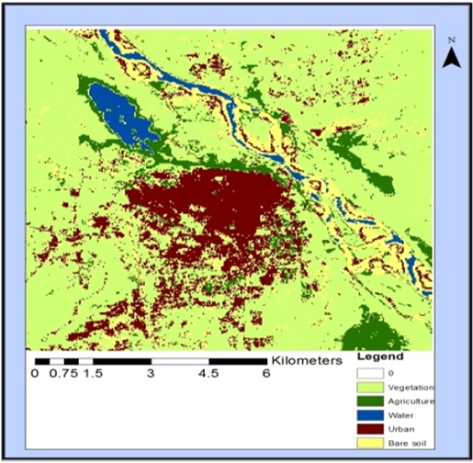 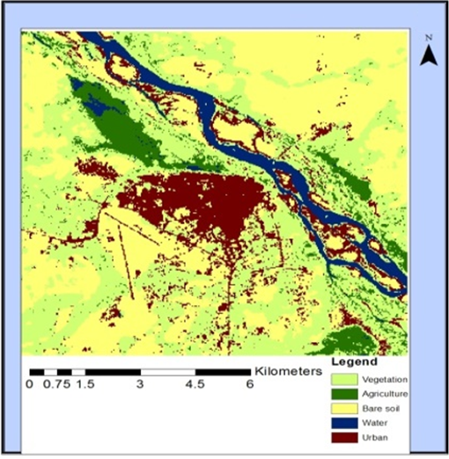

Figure 3: Land Use Land Cover of Yola North 1990 Figure 4: Land Use Land Cover of Yola North 2000

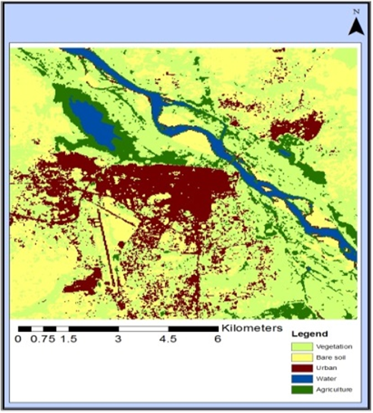 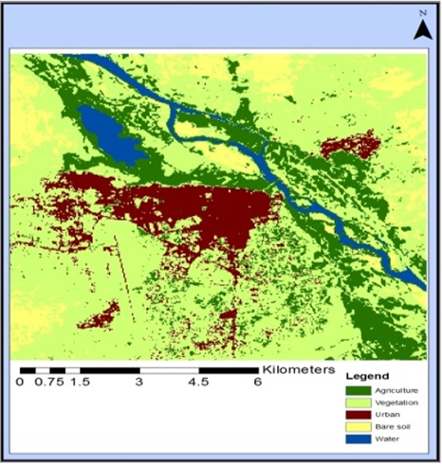

Figure 5: Land Use Land Cover of Yola North 2010 Figure 6: Land Use Land Cover ofYola North 2020

(Source: Landsat ETM downloaded from Earth Explorer)

**4.22 Land Use Land Cover Classification of Fufore Local Government Area**

Figures 7, 8, 9 and 10 shows the land use land cover classification of Fufore for 1990, 2000, 2010 and 2020 respectively. The land use land cover were classified into five different land cover classes, vegetation, agricultural lands, urban areas, water surface and bare surface areas.

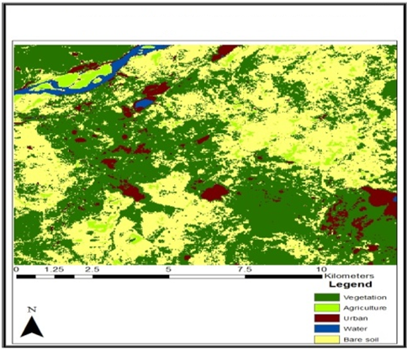 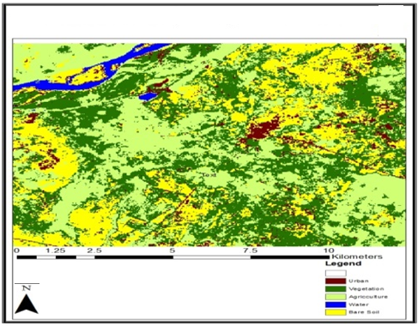

Figure 7: Land Use Land Cover of Fufore 1990 Figure 8: Land Use Land Cover of Fufore 2000

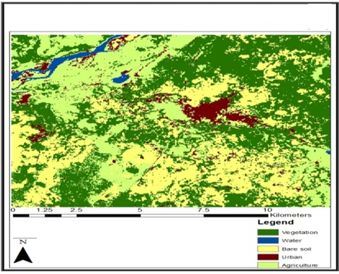 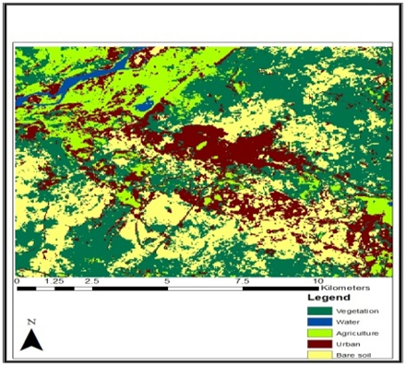

Figure 9: Land Use Land Cover of Fufore 2010 Figure 10: Land Use Land Cover of Fufore 2020

(Source: Landsat ETM downloaded from Earth Explorer)

**Table 2: Land Use Extend of Area Coverage in Square Kilometers**

|  |  |  |  |  |  |  |  |  |  |  |  |  |
| --- | --- | --- | --- | --- | --- | --- | --- | --- | --- | --- | --- | --- |
| **Period**  **Yola-North** | | **Land Area** | | **Agriculture** | **Vegetation** | | **Urban Area** | | **Bare Soil** | | **Water Surface** | |
| 1990 | | 177,810 | | 5407 | 83939 | | 8543 | | 71401 | | 8520 | |
| 2000 | | 177,810 | | 18661 | 58521 | | 26294 | | 58135 | | 16199 | |
| 2010 | | 177,810 | | 20186 | 87523 | | 17907 | | 26681 | | 25513 | |
| 2020 | | 177,810 | | 28461 | 49381 | | 40321 | | 42700 | | 16947 | |
| **Period**  **Fufore** | **Land Area** | | **Agriculture** | | | **Vegetation** | | **Urban Area** | | **Bare Soil** | | **Water Surface** |
| 1990 | 177,807 | | 5407 | | | 83939 | | 8543 | | 71401 | | 8520 |
| 2000 | 177,807 | | 61051 | | | 61969 | | 8198 | | 38097 | | 8492 |
| 2010 | 177,807 | | 65002 | | | 40142 | | 40412 | | 35090 | | 9058 |
| 2020 | 177,807 | | 53441 | | | 39531 | | 39511 | | 32092 | | 13323 |

**4.21 Land Use Classes of Yola-North local government**

Five land use classes were identified, Agriculture, Vegetation, Urban areas, bare soil and Water surface for 1990, 2000, 2010, and 2020.

Agriculture increased between 1990 and 2000 by 3322sqkm and continues to increase in 2010 by 11,951sqkm through to 2020 by 75322sqkm.

Vegetation cover decline between 1990 and 2000 by 35,352sqkm and increase in 2010 by 172,276sqkm and continue to rise in 2020 by 73,381sqkm

Urban area increase from 1990 to 2000 by 7,819sqkm and continue to rise in 2010 by 67,215sqkm and decline in 2020 by 357sqkm

Bare soil decline between 1990 and 2000 by 23,198sqkm, and rise in 2010 by 87,275sqkm with a decline in 2020 by 81,695sqkm

Water surface increased between 1990 and 2000 by 2,253sqkm and rise in 2010 by 37,789sqkm with a decline in 2020 by 27,569sqkm

**4.22 Land Use Classes of Fufore local government area**

Five classes of land use were identified for 1990, 2000, 2010, and 2020; Agriculture, Urban area, Bare soil, Vegetation and Water surface.

Agriculture recorded an increase between 1990 and 2000 from 5407sqkm to 59152sqkm and continues to increase in 2000 to 2010 from 59151sqkm to 169,165sqkm and decline in 2010 to 2020 from 169,145sqkm to 95,590sqkm

Vegetation cover recorded a decline in1990 to 2000 from 83,939sqkm to 61,969sqkm and rise from 2000 to 2010 from 61,969sqkm to 30,2819sqkm and decline in 2010 to 2020 from 302,819sqkm to 271,038sqkm

Urban areas recorded a decline from 1990 to 2000 from 8540sqkm to 8198sqkm and increase from 2000 to 2010 from 8195sqkm to 31418sqkm and continue to increase from 2010 to 2020 from 31418sqkm to 134561sqkm.

Bare soil decline between 1990 to 2000 from 71401sqkm to 38097sqkm and rise between 2000 and 2010 from 38097sqkm to 177729sqkm and continue to rise from 2010 to 2020 from 177729 to 179914sqkm

Water surface recorded a decline from 1990 to 2000 from 852sqkm to 8492sqkm and continue to decline in 2010 to 2478sqkm and continue to decline in 2020 to 2259sqkm

**4.30 Findings**

**4.31 Yola/North Local Government Area**

Result obtained shows that the decline in bare soil was a result of increase in water surface areas resulting from good climatic conditions recorded during this period. Vegetation cover recorded an increase and water surface areas recorded an increase due to the amount of rain fall recorded in the period.

There was decrease in urban expansion and bare soil recorded a decrease, since there was increase in water surfaces areas. Findings revealed that the decline in bare soil was as a result of increase in water surface recorded in the period.

The total land surface area in 1990 was 177,810sqkm and it decline in 2000 to 128,148sqkm; this was as a result of low activities in agriculture and urban areas. From 2000 it continues to increase up to 2020. It showed rapid expansion in agriculture and urban areas, attributed to population growth. There was decline in water surface area in 2000 and thus an increase in bare soil as a result of erratic rainfall and draught.

**4.32 Fufore Local Government Areas**

Findings showed that the decline in vegetation cover was as a result of the increase in agriculture and urban expansion resulting from population growth. While there was increase in bare soil, the water surface recorded a decline as a result of draught and erratic rain fall recorded during the period, thus the land is being degraded as a result of increase in bare soil.

The total land area continued to increase from 1990 to 2020, agriculture and urban areas continued to increase as a result of population growth. Bare soil continued to rise as a result of decline in water surface area; this is attributed to erratic rainfall and draught in the area.

**5.0 Conclusion and Recommendations**

The land use system and land cover maps of 1990 to 2000; 2000 – 2010 and 2010 to 2020 over a period of thirty years (30) showed some of the causes responsible for land degradation in the study area. There was considerable expansion in, built up areas (urban areas) and agricultural lands with considerable or significant decrease in vegetation cover, water surface areas and bare surface cover were decreasing, showing significant increase vegetation.

It is clear from the study that land degradation is often a function of the socio-economic characteristics of the population. For example, agricultural expansion and built up areas were in the increase, thus the natural vegetation clearance is attributed to land shrinkages for urban development and agricultural activities. Results from this study have demonstrated the need for an all-inclusive methodology for mapping and analyzing degraded land. Actual land degradation can be measured and assessed from the socio-economic activities and the field assessment of the nature and severity of land degradation carried out in this study, this contributed in giving a holistic view of the problem of land degradation in the ecological zones of Adamawa state.

This study has unveiled the status of land degradation in two local government areas and have carefully identified and map out the degraded area, this have adverse environment and economic consequences and pose serious threats to food security and land resource.

Land use/land cover mapping using remote sensing and GIS should be encourage in the assessment of land degradation, because of the wide area coverage and cost effective techniques.

There should be improved and affordable land management policy for land users.

**REFERENCES**

Allen J. C. and Barnes D.F. (1985). *The Census of Deforestation in Developing Countries*: Annals of Association of American Geographers75: 163-184.

Ann, V. D. (2012), *Soil Degradation*: International Center for erotology, Universities Gent.

Freddy, O. N. (2010), Land Degradation Assessment Indications and LADA Project: Scape Soil Conservation and Projection from Europe. Land and Water Development Division, FAO Italy.

Guessess, G.D, Kilka, A. and Hurni A. (2009), *Assessment of Soil Erosion and Soil Conservation Planning* In: Ayoubi, S.F; Khormali, K.L; Sahrawat A,C. Rodrigne de Lima (2011) Assessing Impacts of Land Use Change on Soil Quality Indicators in a Loessial Soil, Golestan Province, Iran. Journal of agricultural science Technology 13: 727-742

Julian, M. and Emma, A. (2007).*An Assessment of Land Degradation in the Save Catchment of Zimbabwe*: Journal compilation at Royal Geographical Society 6 (13) 234-358

Lal, R. and Shukla M. K. (2004), Principles of Soil Physics: Marcel Decker, New York.

Mick L. (2014), Land Degradation: The Australian Collaboration, A Collaboration of National community organizations.[www.ausstralliancollaboration.com.al](http://www.ausstralliancollaboration.com.al)