Trajectory tracking control of wheeled mobile robot based on LMPC strategy

Kunxi Tang, Minan Tang*

*(School of Automation and Electrical Engineering, Lanzhou Jiaotong University, Lanzhou, China, 730070)*

*Corresponding Author: tangminan@mail.lzjtu.cn*

*ABSTRACT: The wheeled mobile robot (WMR) is a paradigmatic and foundational entity within the domain of robotics. In this paper, a model predictive control (MPC) phase approach is proposed for the trajectory tracking problem of a WMR in the presence of non-holonomic constraints, input-output constraints, and external disturbances where the center of mass coincides with the geometric center. This approach is based on the pure kinematic model of the robot. To address the computational burden associated with solving the MPC optimization problem, the Laguerre function is employed to reconstruct the MPC optimization problem. The efficacy of the control scheme is validated through Matlab/Simulink joint simulation.*

***KEY WARDS:*** *Mobile robot; Trajectory tracking control; Model predictive control; Laguerre function.*

---------------------------------------------------------------------------------------------------------------------------------------

Date of Submission: 02-04-2025 Date of acceptance: xx-xx-xxxx

---------------------------------------------------------------------------------------------------------------------------------------

# I. INTRODUCTION

The wide range of applications of WMR in fields such as intelligent transportation, intelligent manufacturing, deep space exploration, and national defense construction is due to its high degree of motion accuracy, its fast movement capability, and its simple mechanical structure[1-5]. Ensuring precise and dependable trajectory tracking is paramount for WMR to execute its designated tasks. The physical limitations of actuator saturation and workspace, the prevalence of external interference, and model uncertainty all contribute to higher requirements for motion control of WMR in complex environments.

In recent years, the problem of WMR trajectory tracking control has attracted extensive attention from many scholars, and related studies have emerged. In these studies, WMR systems are typically modeled as a class of unicycle systems, and non-complete constraints are introduced at the kinematic level to more accurately characterize their motion properties. In the literature [6], an anti-disturbance PID control strategy is proposed for solving the trajectory tracking control problem of WMR under unbalanced load. For instance, literature [7] utilizes backstepping control for a WMR based on a vision-based simultaneous localization and map building servo framework.Adaptive control is extensively employed for trajectory tracking control of WMRs. For example, literature [8] implements an adaptive approach based on a kinematic model of a mobile robot to transform the trajectory tracking control problem into a problem of adaptive update rate of uncertain parameters and virtual control input design. Additionally, fuzzy logic plays a significant role in addressing the uncertainty and inaccuracy inherent in WMR trajectory tracking, as it does not rely on an exact mathematical model. A study of a class of adaptive fuzzy control trajectory tracking controllers for wheeled inverted pendulum vehicle systems has been documented in the extant literature [9].

The robot control system is a constrained, nonlinear, and complex nonlinear system, and the aforementioned methods are difficult to solve the constraint problem of WMR.MPC is an effective means to solve the constraint control problem, and it is the only control method that explicitly deals with the system constraints at present[10].MPC has been widely used in the control of autonomous unmanned systems, such as underwater unmanned aerial vehicles, autonomous surface ships, autonomous unmanned aerial vehicles, unmanned vehicles, etc.[11-16].

In this paper, we propose an enhanced MPC control strategy for the WMR tracking control system. This strategy is developed based on the WMR kinematic model and takes into account the practical constraints, such as actuator saturation and environmental state constraints. The MPC is designed to effectively address these constraints, while the Laguerre function is employed to minimize the computational burden of each batch, thereby enhancing the trajectory tracking accuracy.

# II. MATHEMATICAL MODEL OF WMR

In this paper, we consider a standard WMR model, which is composed of two differential driving wheels and one power omnidirectional wheel, as illustrated in Figure 1. The vehicle coordinate system is denoted by , the Cartesian coordinate system by , the center of mass of the WMR by , the midpoint of the line connecting the two driving wheels of the WMR by , and half of the distance between the two driving wheels by . The robot heading angle is indicated by .

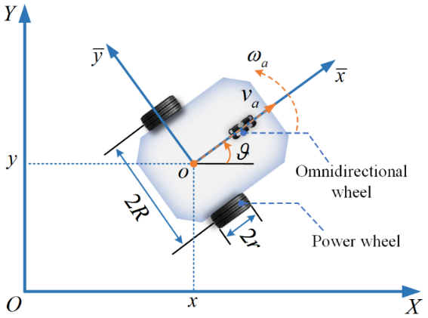

**Figure 1: Schematic diagram of WMR**

In this study, the center of mass of the WMR in the Cartesian coordinate system is denoted by . Assuming that the wheeled mobile robot does not slip laterally, i.e., it cannot move in the direction of the axis of the driving wheel, the robot's velocity along the direction of the axis of the driving wheel is zero. This satisfies the non-holonomic constraints of pure rolling and no sliding as follows:



Thus the mathematical model of WMR subject to non-holonomic constraints can be expressed as:



where  is the attitude vector of the WMR under ,  is the actual velocity vector,  is the actual linear velocity, and  is the actual angular velocity.

Assume that there exists a virtual WMR under the Cartesian coordinate system, given a virtual global coordinate vector , such that  and  are the virtual linear and angular velocities. Then its corresponding virtual kinematic model is：



where ，。

Employing Taylor's formula, the kinematic model Eq.(3) is expanded at the reference point , with higher-order terms being disregarded in this process. The MWR error system can be obtained by differentiating Eq.(2) from Eq.(3):



where ，。

It is evident that the error system, given by Eq.(4), is a manageable entity. In order to carry out the design of the MPC controller, the error system Eq.(34) must be discretized with  as the sampling time. The discretized prediction model is obtained as follows:



where ，.

In this paper, we assume that the matrices  and  are time-variant matrices, i.e., there are  and  at any moment. The augmented state matrix  is defined as follows. Subsequently, Eq.(5) will be utilized to derive the augmented state space model.



where, , , ,  denotes the system control input increment, while  is defined as the sequence of future control input increments at moment  and  is the control time domain.

# III. DESIGN OF THE LMPC CONTROLLER

***3.1 Laguerre function***

The z-transform of the discrete-time Laguerre network is as follows:



where  is the pole of the discrete Laguerre network and  ;  is the rank of the discrete Laguerre network;  is the th Laguerre network, and the Laguerre function is defined as the inverse z-variation of the Laguerre network, and the sequence of the Laguerre function can be expressed in vector form as:



where  is the standard orthogonal Laguerre function.

The sequence of Laguerre functions satisfies the following difference equation in state-space form.



where , .

In particular, the Laguerre function becomes a series of impulse functions when .



Suppose that the impulse response of the discrete stabilized system at moment  is  , and for a given parameter ,  can be expressed as:



where  is the Laguerre factor.

***3.2 Objective function***

Consider the control input increment after moment  as the impulse response of the stabilized system and express it in the following form:



where  in the above equation denotes the impulse function.

According to Eq.(11), Eq.(12) can be approximated as:



where  is a parameter vector consisting of  Laguerre coefficients. Therefore, the problem of solving the optimal control increment  is converted into a problem of solving the parameter vector , thus reducing the number of controller optimization parameters.

From Eq.(6) and Eq.(13), the state variables and output variables of the system at the moment  after the moment  are as follows:





where , .

Thus, the following system objective function is given:



where  and  are the weight matrices of the state and control inputs of the system, respectively,  is the diagonal matrix with diagonal elements of , and  is the positive constant.

If the value of the prediction time domain  is large enough, it can be obtained by substituting the sequence and Eq.(13) into Eq.(16):



Substituting Eq.(3) into Eq.(17) gives:



where , .

It can be seen that the third term in Eq.(18) is independent of . Therefore, to minimize the performance index  is essentially to minimize the sum of the first two terms, and the performance index can be rewritten as:



***3.3 Constrained optimal solution***

In order to prevent the problems of sudden torque change and unstable torque output of the drive motor caused by the sudden change of speed during WMR motion, it is necessary to constrain the speed and speed increment during the control process. To this end, the following input constraints are introduced.



where  and  are the minimum and maximum values of the control quantity, respectively,  and  are the maximum and minimum values of the control increment.

Without loss of generality, it follows from Eq.(13) and  that the constraints of Eq.(20) can also be introduced into the Laguerre function, written as:



where , .

Therefore, for the error system Eq.(4), a quadratic programming problem for the MPC is formed to solve at the discrete sampling moment :



where  ,  ,  ,  are the set of maximum and minimum values of control increments and the set of maximum and minimum values of control quantities in the control time domain respectively.

The above quadratic programming problem can be solved by existing well-established algorithms, where  is chosen to be a positive definite symmetric matrix of . The programming is a strictly convex quadratic programming problem, and if at least one of the vectors  satisfies the constraints and the performance index  has a lower bound on the feasible domain, then the altered quadratic programming problem has a globally unique minimum value .

Based on Eqs.(12) and (13), the sequence of optimal control increments at moment  can be obtained as:



The MPC algorithm applies the first value of Eq.(3.22) as the actual control increment to the system, performing the following feedback correction:



Therefore, the proposed control framework for improving MPC based on Laguerre function (LMPC) is shown in Figure 2.

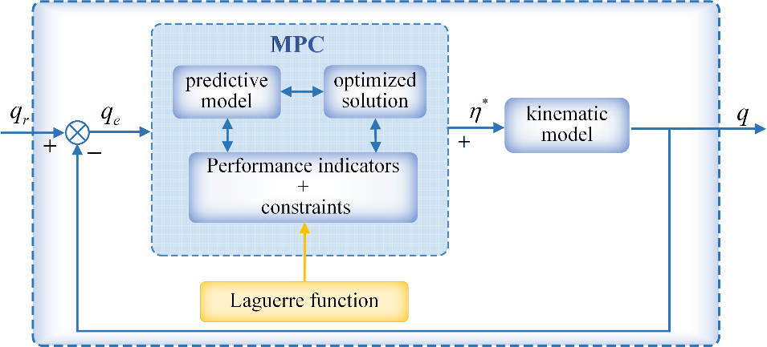

**Figure 2: Control framework**

# IV. EXPERIMENTS AND DISCUSSIONS

To verify the effectiveness of the LMPC strategy proposed in this paper. We are given a circular reference trajectory ,  ,  , and the reference line velocity and angular velocity are , , respectively, and the WMR initial tracking error is . To illustrate the MPC controller's ability to handle the constraints, the experiments are performed with constraints on the velocity and velocity increment, where the assumptions are rad/s, m/s, the velocity increment  , the MPC prediction time domain , the control time domain , and the sampling time .

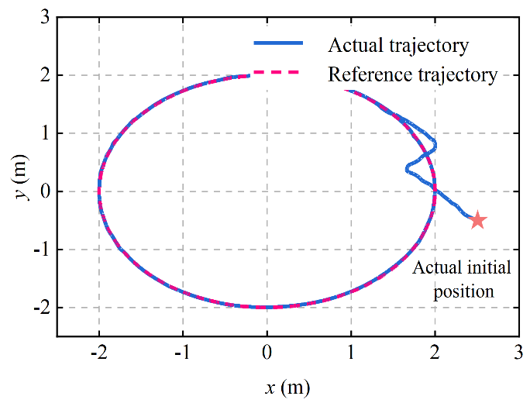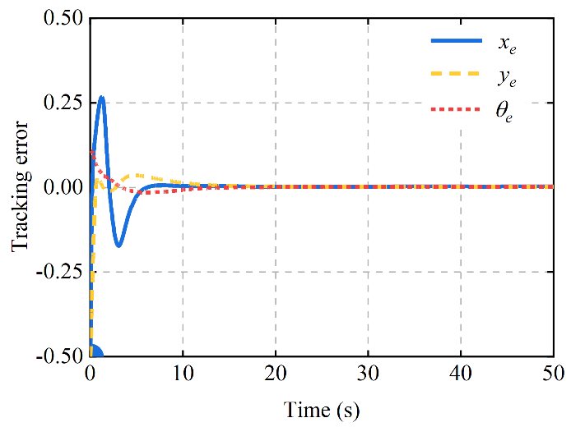

**Figure 3: Circular trajectory tracking error** **Figure 4: Tracking error**

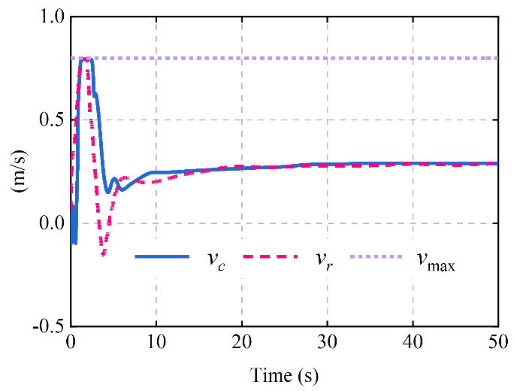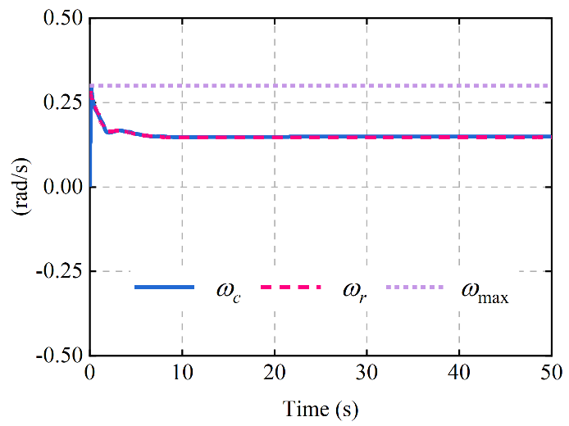

**Figure 5: Linear velocity curve Figure 6: Angular velocity** **curve**

As illustrated in Figure 3, the tracking efficacy of the WMR for a circular reference trajectory is demonstrated in a simulation environment. It is evident that the control strategy presented in this study can be expeditiously adapted to track the upper reference trajectory, particularly in scenarios where the initial positional attitude is substantial. Furthermore, Figure 4 demonstrates that the tracking error converges towards a value of zero. As illustrated in Figures 5 and 6, the LMPC generates optimal velocities that are utilized as the control inputs for the WMR system. These velocities ensure compliance with the established velocity constraints, with linear velocity constraints being activated within the range of 3s to 4s. Concurrently, the WMR system converges towards the reference velocity for both linear and angular velocities following the tracking of the reference trajectory.

# V. CONCLUSIONS

This paper proposes a model predictive control method for trajectory tracking control of wheeled mobile robot, which takes the extended state space model of the system as the predictive model, under the condition of satisfying various types of constraints, adopts the Matlab quadratic programming function to optimize and solve the performance indexes, and introduces the Laguerre function to reconstruct the MPC algorithm, which can effectively reduce the computational load of the traditional periodical sampling MPC. The simulation tracking experiments for circular trajectories illustrate the superiority of the scheme in this paper.

**REFERENCES**

1. Dai, Tianwei, et al. "Autonomous mobile robots for exploratory synthetic chemistry." Nature (2024): 1-8.
2. Verma, Vandi, et al. "Autonomous robotics is driving Perseverance rover’s progress on Mars." Science Robotics 8.80 (2023): eadi3099.
3. Wu, Yalin, et al. "Route planning and tracking control of an intelligent automatic unmanned transportation system based on dynamic nonlinear model predictive control." IEEE Transactions on Intelligent Transportation Systems 23.9 (2022): 16576-16589.
4. Kim, Geono, Hoon Chung, and Baek-Kyu Cho. "MOBINN: Stair-climbing mobile robot with novel flexible wheels." IEEE Transactions on Industrial Electronics 71.8 (2023): 9182-9191.
5. Ding, Liang, et al. "A 2-year locomotive exploration and scientific investigation of the lunar farside by the Yutu-2 rover." Science Robotics 7.62 (2022): eabj6660.
6. Singhal, Kartik, Vineet Kumar, and K. P. S. Rana. "Robust trajectory tracking control of non-holonomic wheeled mobile robots using an adaptive fractional order parallel fuzzy PID controller." Journal of the Franklin institute 359.9 (2022): 4160-4215.
7. Binh, Nguyen Thanh, et al. "An adaptive backstepping trajectory tracking control of a tractor trailer wheeled mobile robot." International Journal of Control, Automation and Systems 17 (2019): 465-473.
8. Liu, Dan, Meiqi Tang, and Junjie Fu. "Robust adaptive trajectory tracking for wheeled mobile robots based on Gaussian process regression." Systems & Control Letters 163 (2022): 105210.
9. Yue, Ming, et al. "Indirect adaptive fuzzy control for a nonholonomic/underactuated wheeled inverted pendulum vehicle based on a data-driven trajectory planner." Fuzzy Sets and Systems 290 (2016): 158-177.
10. Sun, Zhongqi, et al. "Robust self-triggered MPC with adaptive prediction horizon for perturbed nonlinear systems." IEEE Transactions on Automatic Control 64.11 (2019): 4780-4787.
11. Lu, Qun, et al. "Practical fixed-time trajectory tracking control of constrained wheeled mobile robots with kinematic disturbances." ISA transactions 129 (2022): 273-286.
12. Gong, Peng, et al. "Trajectory tracking control for autonomous underwater vehicles based on dual closed-loop of MPC with uncertain dynamics." Ocean Engineering 265 (2022): 112697.
13. Tang, Ligang, et al. "An enhanced trajectory tracking control of the dynamic positioning ship based on nonlinear model predictive control and disturbance observer." Ocean Engineering 265 (2022): 112482.
14. Jiang, Gaoyang, and Zhongsheng Hou. "Iterative learning model predictive control approaches for trajectory based aircraft operation with controlled time of arrival." International Journal of Control, Automation and Systems 18.10 (2020): 2641-2649.
15. Tang, Minan, et al. "Trajectory tracking control of emergency supplies transport robots based on fuzzy MPC." Journal of Industrial & Management Optimization 19.10 (2023).
16. Khan, Subhan, and Jose Guivant. "Fast nonlinear model predictive planner and control for an unmanned ground vehicle in the presence of disturbances and dynamic obstacles." Scientific Reports 12.1 (2022): 12135.