Experimental Study of Tensile Strength for 3D Printed Specimens of PLA material

Danijela Pezer¹, Toni Giljanović²
¹Senior Lecturer, University Department of Professional Studies, University of Split, Split, Croatia.
²Graduate Student, University Department of Professional Studies, University of Split, Split, Croatia.
Corresponding Author: dpezer@oss.unist.hr
ABSTRACT: Considering the importance of the mechanical material properties in the process of the design elements construction, this paper compares the results of the tensile strength of PLA material for two types of infill pattern and different percentages of material infill on test samples made on a 3D printer. Test samples according to the EN ISO 527-2 standard were made by the FDM process of additive technology and tested on an in-house tensile test machine. A central composite design (CCD) experiment was created using Design-Expert software for the test samples. The samples are made as Line and Gyroid infill pattern with layer thickness in range from 0.1 – 0.3 mm and with material infill percentage in range from 30 – 100%. The test results showed that is optimal to make test samples with a medium layer thickness of 0.2 mm for the Line material infill, because relatively high tensile strength (R_{m}) values are achieved with reduced printing time, while with Gyroid pattern infill, by increasing the thickness of the layer, higher tensile strength values are achieved.
KEYWORDS: tensile strength, 3D print, infill pattern, PLA specimens

---------------------------------------------------------------------------------------------------------------------------------------
Date of Submission: xx-xx-xxxx Date of acceptance: xx-xx-xxxx
---------------------------------------------------------------------------------------------------------------------------------------

INTRODUCTION
Additive manufacturing is increasingly represented on the market due to the possibility of manufacturing products at significantly lower costs compared to the conventional processes. Additive technology makes it possible to create models with very complex geometries, and they are most often used to create prototypes and parts of molds and tools. Conventional processes have an advantage over additive technology when high accuracy and dimensional stability are required. Products obtained by the 3D printing process, as part of additive technology, are created directly from the 3D CAD model, and it is not necessary to plan the production process or make a mold, which significantly affects to the amount of total costs. Additive technology is still in development, in terms of the different procedures (FDM, SLS, SLA, PolyJet, etc.) that are applied [1-4] and the type of materials that are available today. The mentioned limitation (type of the material) is observed in relation to, for example, the widespread injection molding process.
Considering that the procedures of additive technology, such as 3D printing, are relatively new procedures (taking into account the new materials appearing on the market) with different possibilities during 3D printing, there is a need for various experiments, especially the examination of mechanical properties (both, the materials and the construction parts). Various studies of the influence of 3D printing parameters on the mechanical properties of PLA materials have been conducted in the literature [5-10].
This paper presents the results of the conducted experiment, central composite design (CCD) with three repetitions in the center for PLA polymer material. During the 3D printing of test samples, the printing speed and temperature are used as constant, while the variable parameters were the layer thickness and the percentage of material infill. The test samples were made according to the experimental plan created in the Design-Expert software for two different material infills: Line and Gyroid. The test samples were conducted to the mechanical test of tensile strength on an in-house tensile test machine. The obtained results were compared and the conclusions presented in the paper.
Different pattern infill geometries are used for different purposes (Table 1) according to [11]. Available geometries are determined by the software (slicer) used for a particular 3D printer.

MATERIAL AND METHODS
The test samples are made according to the EN ISO 527-2 standard for the test sample type 1A (Fig. 1). The test samples are made of PLA material on a 3D printer manufactured by Ender3Pro. PLA material is a material of high stiffness and strength, low breaking elongation and low impact toughness [12]. The diameter of the filament used is 1.75 mm. Recommended printing temperature is 200 - 230 °C, heated substrate temperature (not required) is in the range 50 - 60 °C and printing speed 40-50 mm/min. A nozzle temperature in the amount of 215 °C, a working surface temperature of 60 °C and a printing speed of 45 mm/s were selected for printing all test samples. The used software (slicer) is Ultimaker Cura, which is used to define the desired print parameters and generate G code.

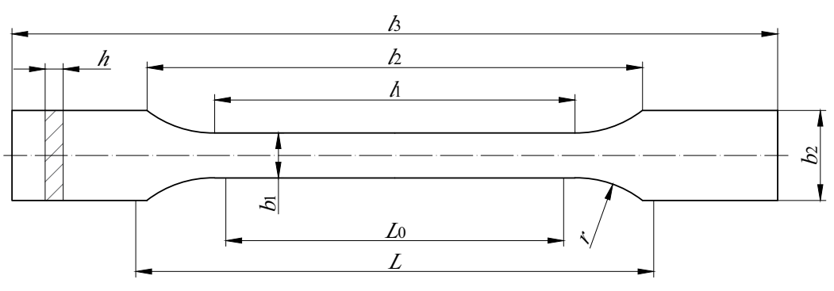
Figure 1: Test specimen type 1A according EN ISO 527-2 standard

The purpose of the experiment was to determine the influence of the type of the pattern infill (according to the Table 1) on the tensile strength of the material.

Table 1. Selected types of 3D pattern infill geometry for experiment implementation

Infill pattern | Purpose | Figure
Line | It consists of several parallel lines per layer, with each layer passing over the previous one at an angle of 90°. The samples do not overlap each other on the same layer reinforcement in two dimensions. Relatively fast printing. | 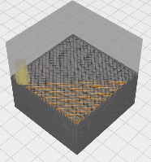
Gyroid | Alternating wavy print lines. It enables almost isotropic mechanical properties. Weaker along the Z axis, resistant to shear along the X and Y axes. Suitable for flexible materials. Printing a sample takes a little longer than other prints. | 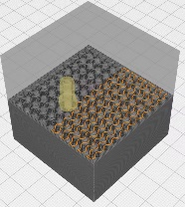

According to the experimental design plan, the test samples were made with different infill percentages and different layer thicknesses for Line and Gyroid type of infill pattern. The 11 test samples for Line infill pattern (group A indicated in the following text) and 11 test samples for Gyroid infill pattern (group B indicated in the following text) were made.
Before the experiment, it is necessary to mark each test sample on both ends. Fig. 2 and Fig. 3 shows the test samples [13] before and after the tensile test for Line ad Gyroid infill patterns.

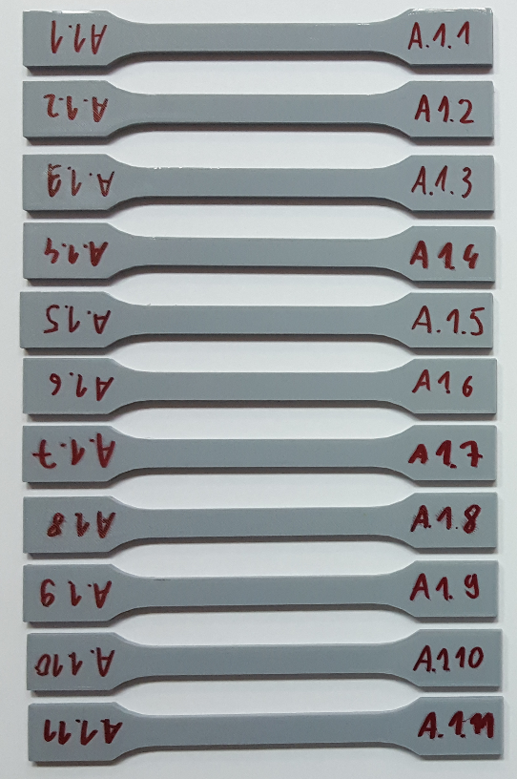 | 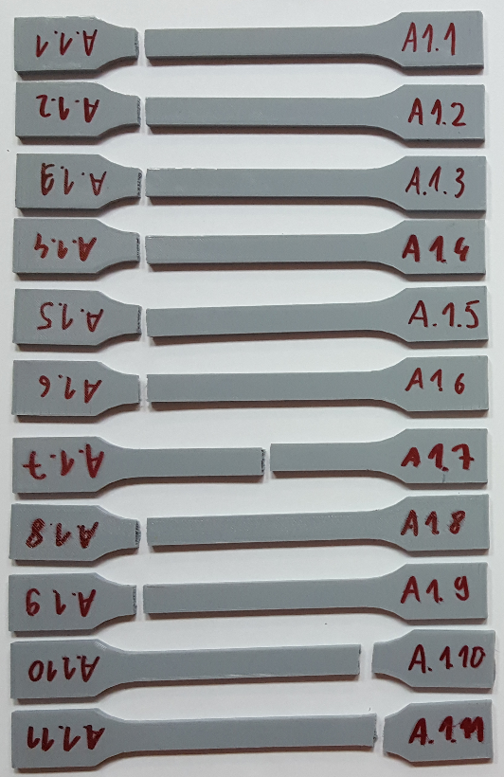
a) | b)
Figure 2: Tensile test “A” specimens before a) and after b) tensile test performance

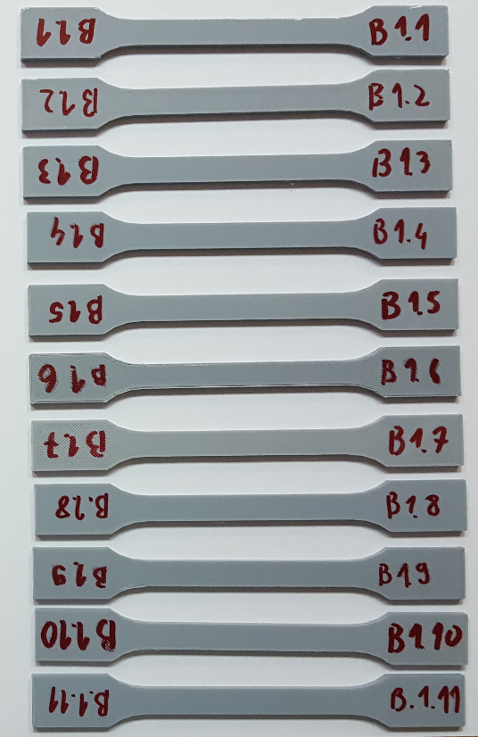 | 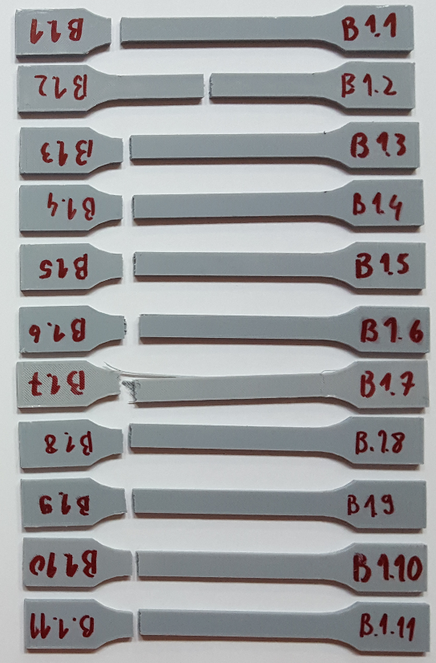
a) | b)
Figure 3: Tensile test “B” specimens before a) and after b) tensile test performance
A tensile strength test was conducted on in-house tensile test machine for polymer materials testing. The tensile test machine is designed for a load up to 6kN. It is driven by two servomotors, while each of these can produce a force of 3000N. The tensile test machine [12] and also the method of the experiment conduction is shown on Fig. 4.

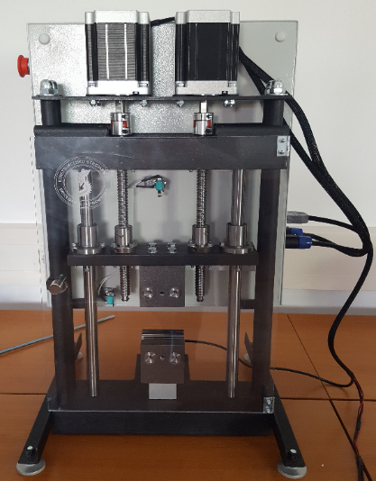 | 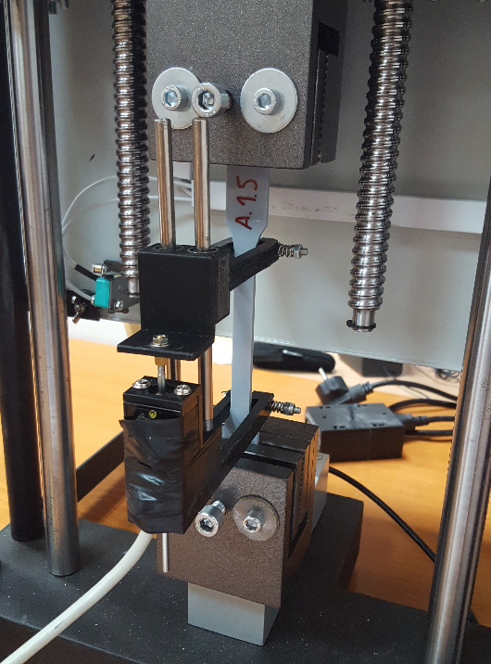
a) In-house tensile test machine | b) Conduction of tensile test experiment for A 1.5 specimen
Figure 4: Tensile test experiment

Table 2 shows the dimensions of the test samples which are measured before the tensile test experiment and also the measured values of the achieved force and the calculated values of the tensile strength after the tensile test experiment.

Table 2. Dimensions of the test samples with the achieved values ​​of force and tensile strength

Line infill pattern  A - test samples b₁ (mm) h (mm) A (mm) Fm (N) Rm (N/mm²)  A 1.1 10.05 3.95 39.697 1706.26 42.98  A 1.2 10.1 3.95 39.895 1637.51 41.05  A 1.3 10.1 4 40.4 1071.51 26.52  A 1.4 10.1 3.95 39.895 1091.06 27.52  A 1.5 10.15 3.95 40.092 1268.32 31.63  A 1.6 10.2 4 40.8 891.54 21.85  A 1.7 10.15 3.9 39.58 923.19 23.32  A 1.8 10.1 3.95 39.895 1011.60 25.35  A 1.9 10.1 4.05 40.90 1473.59 36.02  A 1.10 10.1 3.95 39.895 1038.13 26.02  A 1.11 10.1 3.9 39.39 1008.51 25.60 | Gyroid infill pattern  B - test samples b₁ (mm) h (mm) A (mm) Fm (N) Rm (N/mm²)  B 1.1 10.1 3.85 38.885 1548.41 39.82  B 1.2 10.1 3.85 38.885 1021.74 26.27  B 1.3 10.1 3.85 38.885 900.85 23.16  B 1.4 10.1 3.9 39.39 1004.99 25.51  B 1.5 10.15 3.85 39.077 797.44 20.40  B 1.6 10.05 3.85 38.692 1245.95 32.20  B 1.7 10 3.9 39 572.48 14.67  B 1.8 10.1 3.85 38.885 1071.34 27.55  B 1.9 10.2 3.9 39.78 1669.22 41.96  B 1.10 10.2 3.9 39.78 657.13 16.51  B 1.11 10.1 3.8 38.38 1170.70 30.50

RESULTS AND DISCUSSIONS
Table 3 shows the obtained tensile strength values for used different values of layer thickness and infill percentage of the material for Line and Gyroid infill patterns. The data from Table 3 were generated using the Design-Expert software. The results obtained from the experimental tests were statistically processed using the Design Expert computer program, and models were created to describe the influence of input factors on the measured size. The appropriateness of the obtained models was determined using the F-test as well as using the maximum value of the coefficient of determination, i.e. the adjusted and predicted coefficient of determination. The significance of the model and response polynomial terms was determined by analysis of variance (ANOVA). In order to obtain a mathematical model for describing the influence of 3D printing parameters on the tensile strength of PLA polymer material, i.e. a model that, depending on the input technological parameters, will be able to calculate and predict the tensile strength, it is necessary to statistically process the results obtained experimentally.
Table 3. Resultant matrix with corresponding response

Line infill Factor 1 Factor 2 Response  Std Run Infill Layer thickness Tensile strength  % mm MPa  2 1 100 0.1 42.98 max  6 2 94.1667 0.2 41.05  7 3 65 0.116667 26.52  10 4 65 0.2 27.52  5 5 35.8333 0.2 31.63  3 6 30 0.3 21.85 min  8 7 65 0.283333 23.32  11 8 65 0.2 25.35  4 9 100 0.3 36.02  1 10 30 0.1 26.02  9 11 65 0.2 25.60 | Gyroid infill Factor 1 Factor 2 Response  Std Run Infill Layer thickness Tensile strength  % mm MPa  2 1 100 0.1 39.82  6 2 94.1667 0.2 26.27  7 3 65 0.116667 23.16  10 4 65 0.2 25.51  5 5 35.8333 0.2 20.40  3 6 30 0.3 32.20  8 7 65 0.283333 14.67 min  11 8 65 0.2 27.55  4 9 100 0.3 41.96 max  1 10 30 0.1 16.51  9 11 65 0.2 30.50

The variance analysis showed that the dependence of the tensile strength of the material on the parameters of 3D printing for the Line infill of the material can best be described by a reduced quadratic mathematical model. The variance analysis showed that the dependence of the tensile strength of the material on the 3D printing parameters for the Gyroid infill of the material can best be described by a linear mathematical model. The aforementioned analysis of variance is shown in tables 4 (Line infill) and 5 (Gyroid infill).
The Table 4 represents the results of analysis of variance (ANOVA) for “Quadratic model” for tensile strength response for Line infill patterns. The Model F-value of 20.85 implies the model is significant. There is only a 0.23% chance that an F-value this large could occur due to noise. The p-values less than 0.05 indicate that the model terms are significant. In this case A, B, A², B² are significant terms of the model. Analysis of variance shows also a significant influence of factors A and A². This confirms the influence of the percentage of material infill on the tensile strength of the material.

Table 4. Results of analysis of variance for Quadratic model for Tensile strength response

Source | Sum of Squares | df | Mean Square | F-value | p-value
Model | 491.62 | 5 | 98.32 | 20.85 | 0.0023 | significant
A-Infill | 281.96 | 1 | 281.96 | 59.79 | 0.0006 | significant
B-Layer thickness | 35.32 | 1 | 35.32 | 7.49 | 0.0409 | significant
AB | 1.95 | 1 | 1.95 | 0.4127 | 0.5489 | not significant
A² | 172.07 | 1 | 172.07 | 36.49 | 0.0018 | significant
B² | 52.07 | 1 | 52.07 | 11.04 | 0.0209 | significant
Residual | 23.58 | 5 | 4.72
Lack of Fit | 20.76 | 3 | 6.92 | 4.91 | 0.1739 | not significant
Pure Error | 2.82 | 2 | 1.41
Cor Total | 515.19 | 10

Values greater than 0.1 indicate that the model terms are not significant. The Lack of Fit F-value of 4.91 implies the Lack of Fit is not significant relative to the pure error. There is a 17.39% chance that a Lack of Fit F-value this large could occur due to noise, which indicating a well-fitted model.

The table 5 represents the results of analysis of variance (ANOVA) for „Linear model“ for tensile strength response for Gyroid infill patterns. The Model F-value of 1.88 implies the model is not significant. There is a 25.32% chance that an F-value this large could occur due to noise.
The Lack of Fit F-value of 12.83 implies the Lack of Fit is not significant relative to the pure error. There is a 7.31% chance that a Lack of Fit F-value this large could occur due to noise, which indicating a non- well-fitted model and the reduction of model is needed.
For the Line infill, the deviations from the Lack of fit model are higher than 0.05, while for the Gyroid infill, a linear model is provided where the deviations from the Lack of fit model are lower than 0.05.

Table 5. Results of analysis of variance for Linear model for Tensile strength response

Source | Sum of Squares | df | Mean Square | F-value | p-value
Model | 478.31 | 5 | 95.66 | 1.88 | 0.2532 | not significant
A-Infill | 409.25 | 1 | 409.25 | 8.03 | 0.0365 | significant
B-Layer thickness | 0.5716 | 1 | 0.5716 | 0.0112 | 0.9198 | not significant
AB | 5.18 | 1 | 5.18 | 0.1015 | 0.7629 | not significant
A² | 48.28 | 1 | 48.28 | 0.9470 | 0.3752 | not significant
B² | 0.8489 | 1 | 0.8489 | 0.0166 | 0.9024 | not significant
Residual | 254.92 | 5 | 50.98
Lack of Fit | 242.33 | 3 | 80.78 | 12.83 | 0.0731 | not significant
Pure Error | 12.59 | 2 | 6.29
Cor Total | 733.23 | 10

By model reducing, i.e. removing a large number of insignificant members from the model, it can be improved, which is determined by the values of the adjusted and predicted coefficient of determination. The adjusted value of the coefficient of determination defines the amount of variation around the mean value explained by the model, and takes into account the number of members in the mathematical model in relation to the number of states in the experimental plan. The predicted value of the coefficient of determination is a measure of the amount of variation in the new data explained in the model. The difference between these two values must be less than 0.2.
The normality of the measured values for individual conditions of the experiment is tested with the normalized residual probability paper. Figure 5 shows the normal plot of residuals paper probability. We can see that residuals follow a normal distribution that represents a straight line. If the dots form the letter "S", it means that a transformation of the response is required in order to obtain a better analysis. For the case of Line infill, we conclude that the dots do not form the letter "S", which means that the residuals follow a normal distribution, while for the Gyroid infill, the dots indicate the shape of an "S", that is, the residuals do not follow a normal distribution.
Figure 6 shows a three-dimensional representation of the response surface for tensile strength expressed in MPa for PLA material as a function of material infill expressed in % and layer thickness expressed in mm. From Figure 6a and 6b, we can conclude that the highest values of tensile strength are achieved with the highest percentage of material infill and lower values of layer thickness, although the thickness of the layer has little influence with Line infill pattern. The thickness of the layer with Gyroid infill pattern has almost no effect on tensile strength.

a) Tensile strength response for line infill pattern | b) Tensile strength response for gyroid infill pattern
Figure 5. Tensile strength response for various pattern material infill

a) Line infill pattern | b) Gyroid infill patern
Figure 6. 3D representation of the response surface

CONCLUSIONS AND RECOMMENDATIONS
The thickness of the layer significantly affects to the printing time, for example for a test sample with 100% infill (Line pattern) and layer thickness 0.1 mm, the printing time is 2 hours and 9 minutes, while for infill with 100% and layer thickness 0.3 mm, the time printing is 51 minutes. Also, for an infill of 65% and a layer thickness of 0.11 mm, the printing time is 1 hour and 33 minutes, and for the same infill of 65% with a layer thickness of 0.2833, the printing time is 52 minutes. The conclusion is that the thickness of the layer significantly affects the printing speed, which directly affects to the costs. The percentage (%) of the material infill also significantly affects to the printing speed. However, when we consider the strength of the material, it is unquestionable that for the elements under some kind of static tensile load, should be used the highest possible percentage of material infill.
Gyroid pattern infill material required twice as long printing time compared to Line pattern infill for the same parameters. The results of the tensile test showed that the Gyroid type of the infill does not achieve higher tensile strength values than samples printed with the Line type of infill, which leads to the conclusion that the Gyroid type of the pattern infill is not cost-effective for application on the elements that are static tensile load.
For the Line type of the material pattern infill, it was determined experimentally that the tensile strength values increase with a decrease in the thickness of the layer, while in the case of the Gyroid pattern infill, it was shown that the thickness of the layer has no significant effect on the tensile strength.
For the static loaded elements, the highest possible percentage of infill (optimal 100%) is necessary because the test determined that the tensile strength values are significantly lower for infill values of 65% and also for 30%. The lower percentage of material infill is applicable for parts that are not under the load and for making a prototypes.
To obtain an additional conclusions regarding the type of pattern infill and its influence on the tensile strength of the material, it is necessary to carry out additional tests for different types of the infill patterns. The Gyroid infill pattern showed that it is weaker along the Z-axis (according to Table 1), and additional tests should be conducted to determine the strength of the material along the X and Y axes, which could certainly be a continuation of this research. Also, other non-brittle materials such as PLA polymer should be considered.

REFERENCES
- Acierno, D. and Patti, A. (2023). "Fused Deposition Modelling (FDM) of Thermoplastic-Based Filaments: Process and Rheological Properties-An Overview", Materials 16(24), 7664. https://doi.org/10.3390/ma16247664
- Kulinowski, P., Piotr Malczewski, P., Pesta, E., Łaszcz, M., Mendyk, A., Polak, S., Dorożyński, P. (2021)."Selective laser sintering (SLS) technique for pharmaceutical applications-Development of high dose controlled release printlets", Additive Manufacturing, 38,101761.
- Ma, X. L. (2013). "Research on Application of SLA Technology in the 3D Printing Technology". Applied Mechanics and Materials, 401–403, 938–941. https://doi.org/10.4028/www.scientific.net/amm.401-403.938.
- Patel. D.B. (2017). "Polyjet – An Additive Manufacturing Process", IJSRD - International Journal for Scientific Research & Development|, 5(05), 2321-0613.
- Hanon, M. M., Marczis, R. and Zsidai, L. (2021) “Influence of the 3D Printing Process Settings on Tensile Strength of PLA and HT-PLA”, Periodica Polytechnica Mechanical Engineering, 65(1), 38–46. 10.3311/PPme.13683
- Hanon, M.M., Dobos, J., Zsidai, L. (2021). "The influence of 3D printing process parameters on the mechanical performance of PLA polymer and its correlation with hardness", Procedia Manufacturing, 54,44-249, https://doi.org/10.1016/j.promfg.2021.07.038.
- Auffray, L., Gouge, PA. & Hattali, L. (2022). "Design of experiment analysis on tensile properties of PLA samples produced by fused filament fabrication", Int J Adv Manuf Technol 118, 4123–4137, https://doi.org/10.1007/s00170-021-08216-7.
- Chokshi, H., Patel, K., Shah, D., Patel, K. (2023). "Evaluation of Tensile Strength for 3D-Printed PLA Specimens", In: Dutta, K., Mallik, A., Kotadia, H.R., Das, S. (eds) Processing and Characterization of Materials. ACIEQ 2021. Springer Proceedings in Materials, vol 26. Springer, Singapore. https://doi.org/10.1007/978-981-99-5509-1_4
- Hsueh M-H, Lai C-J, Chung C-F, Wang S-H, Huang W-C, Pan C-Y, Zeng Y-S, Hsieh C-H. (2021). "Effect of Printing Parameters on the Tensile Properties of 3D-Printed Polylactic Acid (PLA) Based on Fused Deposition Modeling. Polymers", 13(14):2387. https://doi.org/10.3390/polym13142387
- M Rismalia et al. (2019). "Infill pattern and density effects on the tensile properties of 3D printed PLA material", J. Phys.: Conf. Ser. 1402 044041, doi 10.1088/1742-6596/1402/4/044041
- UltiMaker Cura software help, available: https://ultimaker.com/software/ultimaker-cura/
- Pezer, D., Vukas, F., & Butir, M. (2022). "Experimental study of tensile strength for 3D printed specimens of HI-PLA polymer material on in-house tensile test machine", Technium: Romanian Journal of Applied Sciences and Technology, 4(10), 197–206. https://doi.org/10.47577/technium.v4i10.7927
- Giljanović, T. (2023). "Tensile test for polymer test specimens". University Department of Professional Studies, University of Split, Croatia. Master Thesis.

