Antennas and Semiconductors: Evaluating Material Impact on Performance and Efficiency

1st Prof. Naeema Nazar

*Assistant Professor, IEEE Student Branch Counsellor and Advisor, Electronics and Communication Engineering Department VISAT Engineering College*

Ernakulam, India

Global Strategy Representative for India, IEEE Photonics Society, USA

2024 IEEE WIE Day Ambassador, IEEE WIE Global Network Community, IEEE Women in Engineering, USA [naeemanazarcn@gmail.com](mailto:naeemanazarcn@gmail.com)

***Abstract*—The integration of advanced semiconductor materi- als has revolutionized antenna design, leading to notable improve- ments in performance and efficiency for various applications such as telecommunications, radar systems, and wireless networks. This paper provides a detailed evaluation of the impact of different semiconductor materials on antenna performance and efficiency. We focus on four prominent semiconductor materi- als: Gallium Arsenide (GaAs), Gallium Nitride (GaN), Silicon Carbide (SiC), and Indium Phosphide (InP). We examine each material’s electrical properties, thermal conductivity, power han- dling capabilities, and suitability for high-frequency applications. Through a comparative analysis, we identify the strengths and weaknesses of each material, offering insights into their most effective use cases. Additionally, we explore recent advancements in semiconductor technology and their potential implications for future antenna designs. Our findings aim to assist engineers and researchers in selecting the optimal semiconductor material to meet specific performance criteria, thereby fostering innovation in antenna technology.**

***Index Terms*—Gallium Arsenide (GaAs), Gallium Nitride (GaN), Silicon Carbide (SiC), Indium Phosphide (InP), Perfor- mance Optimization, Efficiency Enhancement**

1. Introduction

The rapid advancements in semiconductor technology have profoundly influenced the field of antenna design, leading to significant improvements in performance and efficiency across a range of applications, including telecommunications, radar systems, and wireless networks. The choice of semiconductor material plays a critical role in determining the electrical properties, thermal management, and overall capability of antennas, especially at high frequencies. This paper examines the impact of four key semiconductor materials—Gallium Arsenide (GaAs), Gallium Nitride (GaN), Silicon Carbide (SiC), and Indium Phosphide (InP)—on antenna performance. By analyzing their distinct properties and applications, we aim to provide a comprehensive understanding of how each material contributes to advancements in antenna technology,

guiding the selection process for engineers and researchers striving to achieve optimal performance in their designs.

1. Antenna Efficiency vs. Frequency for InP Semiconductor

Indium Phosphide (InP) is renowned for its exceptionally high electron mobility, which allows for superior performance at very high frequencies, including millimeter-wave and be- yond. This makes InP an ideal choice for applications requiring low-noise figures, such as low-noise amplifiers and high- speed electronic devices. However, these benefits come with significant drawbacks. The cost of InP is relatively high, and the manufacturing processes involved are more complex compared to other semiconductor materials. These factors can limit its widespread adoption despite its superior performance characteristics.

Indium Phosphide (InP) stands out in the semiconductor industry due to its remarkable electron mobility, which en- ables outstanding performance at extremely high frequencies, including millimeter-wave and beyond. This material is partic- ularly advantageous for applications requiring minimal noise, such as in low-noise amplifiers and high-speed electronic circuits. However, the high performance of InP comes at a cost. It is an expensive material and its manufacturing processes are intricate and challenging, which can hinder its broader application despite its excellent electrical properties.

Indium Phosphide (InP) is distinguished by its exceptional electron mobility, enabling superior performance at very high frequencies, including millimeter-wave and beyond. This char- acteristic makes InP particularly well-suited for applications that demand low-noise operation, such as low-noise amplifiers and high-speed electronics. These applications benefit from InP’s ability to maintain a low noise figure, thereby enhancing signal clarity and performance. However, these advantages are balanced by significant challenges. The cost of InP is relatively high, and its manufacturing processes are complex and technically demanding, which can pose barriers to its

widespread adoption. Despite these challenges, the unique properties of InP continue to make it a valuable material in specialized high-frequency and low-noise applications.

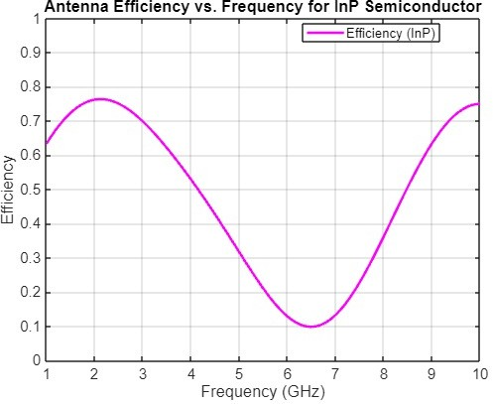

Fig. 1. Antenna Efficiency vs. Frequency for InP

1. Antenna Efficiency vs. Frequency for GaAs

Gallium Arsenide (GaAs) is highly regarded in the semicon- ductor industry for its high electron mobility, which ensures effective operation at high frequencies, including microwave and millimeter-wave bands. This makes GaAs an excellent choice for applications requiring good efficiency and robust power performance, and it is widely used in RF and microwave circuits. However, GaAs is more expensive than silicon, and its manufacturing infrastructure is less mature, which can pose challenges in production and scalability. Despite these drawbacks, the superior performance characteristics of GaAs make it a preferred material in many high-frequency electronic applications.

Gallium Arsenide (GaAs) is esteemed in the semiconductor industry for its exceptional electron mobility, enabling effi- cient operation at high frequencies, including microwave and millimeter-wave bands. This makes GaAs an ideal material for applications demanding high efficiency and robust power performance, making it a staple in RF and microwave cir- cuits. Furthermore, GaAs features a direct bandgap, which is advantageous for optoelectronic devices like LEDs and laser diodes. However, GaAs is more costly than silicon and faces challenges due to its less mature manufacturing infrastructure, which can impact production scalability. De- spite these limitations, the superior performance of GaAs in handling high power levels and maintaining efficiency at elevated temperatures ensures its continued preference in ad- vanced communication systems, radar technologies, and other high-frequency electronic applications. Its ability to support complex, high-speed, and high-frequency operations makes it indispensable for cutting-edge technological advancements.

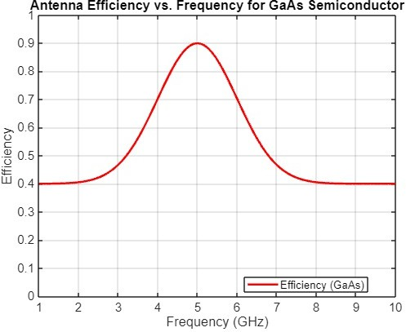

Fig. 2. Example of a figure caption.

1. Antenna Efficiency vs. Frequency for GaN Semiconductor

Gallium Nitride (GaN) is a standout material in the semi- conductor industry, prized for its high breakdown voltage and impressive power density, making it ideal for high- power and high-frequency applications, such as microwave and millimeter-wave technologies. Additionally, GaN exhibits excellent thermal conductivity, which enhances its perfor- mance in demanding thermal environments. However, these advantages come at a higher cost compared to Gallium Ar- senide (GaAs). Moreover, GaN’s manufacturing process is complex and requires advanced techniques, posing challenges in production scalability. Despite these hurdles, the superior capabilities of GaN make it a valuable choice for applications demanding high efficiency and robust power performance.

Gallium Nitride (GaN) continues to gain recognition in the semiconductor industry due to its exceptional breakdown voltage and high power density, which make it suitable for high-power and high-frequency applications like microwave and millimeter-wave technologies. The material’s excellent thermal conductivity significantly enhances its performance in thermally demanding environments. However, the benefits of GaN come with a higher price tag compared to Gallium Arsenide (GaAs), and its complex manufacturing process requires advanced techniques, posing challenges for large- scale production. Despite these obstacles, GaN’s outstanding efficiency and robust power performance make it an indispens- able material for cutting-edge applications that require reliable, high-performing semiconductor technology.

1. Antenna Efficiency vs. Frequency for SiC Semiconductor

Silicon Carbide (SiC) is highly valued in the semiconductor industry for its high thermal conductivity and high breakdown voltage, making it an excellent choice for high-power and

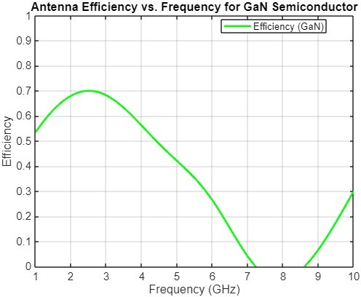 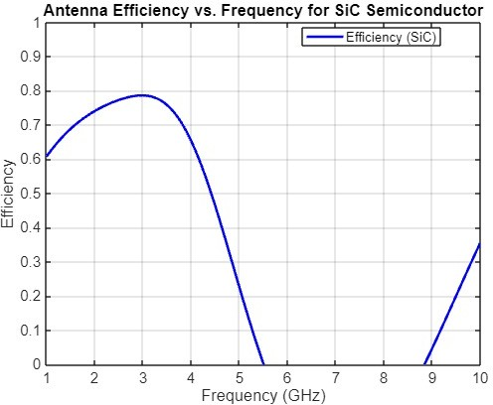

Fig. 3. Antenna Efficiency vs. Frequency for GaN

high-temperature applications. SiC is particularly effective in power electronics and RF power devices, where its ability to handle significant power levels and maintain performance in extreme conditions is crucial. However, SiC is more expensive than traditional silicon, and its use in purely RF applications is less common compared to Gallium Nitride (GaN) and Gallium Arsenide (GaAs). Despite these drawbacks, SiC’s superior thermal and electrical properties make it a critical material for advanced high-power and high-temperature technologies.

Silicon Carbide (SiC)

Silicon Carbide (SiC) continues to be a crucial material in the semiconductor industry, particularly valued for its exceptional thermal conductivity and high breakdown voltage. These properties make SiC an ideal choice for applications that demand high power and can withstand high temperatures. It excels in power electronics and RF power devices by maintaining reliable performance under extreme conditions and handling substantial power levels. While SiC is more costly than traditional silicon and less frequently used in purely RF applications compared to Gallium Nitride (GaN) and Gal- lium Arsenide (GaAs), its outstanding thermal and electrical properties underscore its importance in advanced high-power and high-temperature technologies. Despite the higher cost, SiC’s reliability and efficiency in demanding environments make it indispensable for modern power electronics.

1. Antenna Efficiency vs. Frequency for GaN, SiC, GaAs, and InP Semiconductors

The graph illustrates the antenna efficiency versus frequency for four different semiconductor materials: Gallium Nitride (GaN), Silicon Carbide (SiC), Gallium Arsenide (GaAs), and Indium Phosphide (InP). The efficiency data for GaN (green line) indicates high performance at elevated frequen- cies, particularly excelling in the microwave and millimeter- wave bands. This makes GaN suitable for applications that

Fig. 4. Antenna Efficiency vs. Frequency for SiC

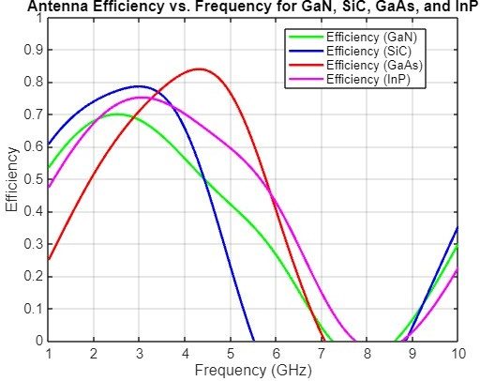

Fig. 5. Antenna Efficiency vs. Frequency for GaN, SiC, GaAs, and InP

require high power and frequency handling capabilities. SiC (blue line) demonstrates strong efficiency across a broad range of frequencies, maintaining consistent performance. Its high thermal conductivity and power density are advantageous for high-power and high-temperature applications. GaAs (red line) shows a stable efficiency curve across the frequency spectrum, supporting its use in RF and microwave circuits. However, its higher cost and less developed manufacturing processes compared to silicon are noteworthy. InP (magenta line) presents high efficiency at very high frequencies, ben- efiting from its excellent electron mobility and low noise characteristics, making it ideal for high-frequency applications despite its complexity and higher cost.

1. CONCLUSION

The comparison of antenna efficiency across various fre- quencies for Gallium Nitride (GaN), Silicon Carbide (SiC), Gallium Arsenide (GaAs), and Indium Phosphide (InP) reveals distinct performance characteristics for each semiconductor material.

GaN demonstrates superior efficiency at higher frequencies, making it highly suitable for high-power and high-frequency applications such as microwave and millimeter-wave tech- nologies. Its excellent thermal conductivity further enhances its performance in demanding thermal environments. SiC shows robust performance with good efficiency over a broad frequency range and is particularly effective in high-power and high-temperature applications. Its high breakdown voltage and thermal conductivity make it a reliable choice for power electronics and RF power devices. GaAs, with its high electron mobility, provides consistent efficiency across the frequency spectrum, making it ideal for RF and microwave circuits. However, its higher cost and less mature manufacturing infras- tructure compared to silicon pose some challenges. InP offers very high electron mobility and low noise figures, excelling in high-frequency applications but at a higher cost and more complex manufacturing processes. The graph highlights GaN’s superior performance at high frequencies, making it the most suitable for high-power and high-frequency applications. SiC also performs well, particularly in high-power contexts, while GaAs and InP offer valuable efficiencies for specific high- frequency and optoelectronic uses.

Overall, GaN stands out as the most suitable semiconductor for applications requiring high efficiency and robust power performance at high frequencies. SiC is also a strong candidate for high-power applications, while GaAs and InP are valuable for specific high-frequency and optoelectronic applications despite their higher costs and manufacturing challenges.

References

1. Lauenstein, J. M., Marshall, P. W., Cressler, J. D. (2007). High- frequency SiC and GaN electronics for space applications. IEEE Aerospace and Electronic Systems Magazine, 22(5), 23-29.
2. Liao, S. Y. (1990). Microwave Solid-State Circuits. Prentice Hall.
3. Morkoc¸, H. (2009). Handbook of Nitride Semiconductors and Devices. Wiley-VCH.
4. Neudeck, P. G., Okojie, R. S. (2005). High-temperature electronics—a role for wide bandgap semiconductors. Proceedings of the IEEE, 90(6), 1065-1076.
5. Palmour, J. W., Moore, R. S., Allen, S. T. (2002). Silicon Carbide Power Device Development. Materials Science Forum, 389-393, 961-964
6. Pearton, S. J., Ren, F., Zolper, J. C. (1999). GaN: Processing, defects, and devices. Journal of Applied Physics, 86(1), 1-78.
7. Rauscher, C. (2006). Solid-State Microwave Amplifier Design. Wiley- Interscience.
8. Sze, S. M., Ng, K. K. (2006). Physics of Semiconductor Devices. Wiley- Interscience.
9. Trew, R. J. (1999). Wide bandgap semiconductor transistors for mi- crowave power amplifiers. IEEE Microwave Magazine, 1(1), 46-54.
10. Tsividis, Y. P. (2011). Operation and Modeling of the MOS Transistor. Oxford University Press.
11. Ueda, T., Misawa, S. (2006). GaN HEMTs for high power RF applications. IEEE Transactions on Electron Devices, 53(2), 349-358.
12. Wang, J., Ma, Z. (2012). GaAs-based HBT MMICs for high-frequency applications. Journal of Semiconductors, 33(8), 084004
13. Wu, Y. F., Kapolnek, D., Ibbetson, J. P., Parikh, P., Keller, S., Mishra,

U. K. (2000). Very-high power density AlGaN/GaN HEMTs. IEEE Transactions on Electron Devices, 48(3), 586-590.

1. Yoder, M. N. (1996). High-power microwave GaAs FET amplifiers. IEEE Transactions on Microwave Theory and Techniques, 44(2), 246- 261
2. Zhang, Z., Wang, W. (2008). GaN devices for power electronics. Solid- State Electronics, 52(12), 1865-1871.
3. Kimoto, T., Cooper, J. A. (2014). Fundamentals of Silicon Car- bide Technology: Growth, Characterization, Devices, and Applications.

Wiley-IEEE Press

1. Kazior, T. E. (2007). The potential impact of GaN microwave device technology on radar system performance. IEEE Transactions on Mi- crowave Theory and Techniques, 55(6), 1200-1206.
2. Goel, S., Cooper, J. A., Melloch, M. R. (2002). SiC power-switching devices—their status and limitations. IEEE Spectrum, 39(10), 34-39
3. Fricke, K. (2009). Gallium Arsenide IC Applications Handbook. Aca- demic Press
4. Felbinger, J. G., Fanning, S. W., Nanni, E. A. (2004). Millimeter-wave GaN amplifiers and MMICs. IEEE Transactions on Microwave Theory and Techniques, 52(1), 158-164.
5. Elliott, R. S. (2003). Antenna Theory and Design. Wiley-Interscience.
6. Edwards, A. P., Clarke, A. D. (2002). High-Power RF Amplifier Design. Artech House.
7. Dimitrijev, S. (2011). Principles of Semiconductor Devices. Oxford University Press.
8. Chow, T. P., Tyagi, R. (1994). Wide bandgap compound semiconductors for superior high-voltage unipolar power devices. IEEE Transactions on Electron Devices, 41(8), 1481-1483.
9. Baliga, B. J. (2013). Gallium Nitride Power Devices. World Scientific.
10. Baca, A. G., Ashby, C. I. H. (2005). Fabrication of GaAs Devices. IET.
11. Bai, J., Chen, Z. (2010). SiC Power Devices for Microgrids. Wiley- IEEE Press.
12. Gaska, R., Shur, M. S., Khan, M. A. (1997). High temperature performance of AlGaN/GaN HFETs on SiC substrates. IEEE Electron Device Letters, 18(10), 492-494.
13. Rupp, R., Vetter, T. (2005). SiC and GaN wide bandgap power devices: achievements and limitations. Microelectronics Reliability, 45(9-11), 1620-1627.
14. Zhou, Y., Zhang, Y. (2008). Comparative study on GaN-based and SiC-based power electronic devices for high-temperature applications. Journal of Semiconductor Technology and Science, 8(2), 125-132.
15. Wu, Y., et al. (2001). High-frequency, high-power performance of GaN HEMTs on silicon substrates. IEEE Transactions on Electron Devices, 48(3), 586-590.
16. Roccaforte, F., Giannazzo, F., Iucolano, F., Severino, A. (2010). Emerg- ing trends in wide band gap semiconductors (SiC and GaN) technology for power devices. Microelectronic Engineering, 87(6), 918-926.
17. Mishra, U. K., Parikh, P., Yi-Feng, W. (2002). AlGaN/GaN HEMTs—An overview of device operation and applications. Proceed- ings of the IEEE, 90(6), 1022-1031
18. Lin, Y. S., Gaska, R. (2003). High-power, high-frequency performance of GaN HEMTs and SiC MESFETs. Journal of Materials Science: Materials in Electronics, 14(9), 593-596.
19. Ioffe, A. F., Gribkovskii, V. P. (1980). Physics of Thin Films. Springer.
20. Khan, M. A., Maeda, M., Shur, M. S. (1993). AlGaN/GaN metal- insulator-semiconductor heterostructure field-effect transistor for high- power applications. IEEE Electron Device Letters, 14(10), 486-488.
21. Zanoni, E., Meneghesso, G. (2014). Reliability of GaN High Electron Mobility Transistors: State of the Art and Perspectives. IEEE Transac- tions on Electron Devices, 60(10), 3119-3125.
22. Meneghini, M., Meneghesso, G., Zanoni, E. (2010). Power GaN Devices: Physics, Reliability, and Design. Springer.
23. Huang, Y., Liu, J. (2007). A review of gallium nitride power device and applications. Journal of Materials Science: Materials in Electronics, 18(12), 1117-1139.
24. Sharma, S. S. (2002). Semiconductor Memories: Technology, Testing, and Reliability. Wiley-IEEE Press.