**AN EVALUATION OF THE DAMAGING EFFECTS OF SHORTAGE OF CERTIFIED WORKFORCE IN ZAMFARA STATE CONSTRUCTION INDUSTRY**

**Adegbenga Raphael, Ashiru*1 and Kamaldeem Jide, Anifowose2**

1Construction and Quantity Surveying Department, EGIS, Heriot-Watt University, Edinburgh. UK. *[ashiruadegbenga@yahoo.com](mailto:ashiruadegbenga@yahoo.com);

2Department Of Architectural Technology, Federal Polytechnic, P.M.B Kaura –Namoda, Zamfara - State. Nigeria. anifowosekamaldeen@gmail.com

**ABSTRACT**

*The construction industry is typically characterised as a labour-intensive sector, particularly in developing nations. In a developed economy, when a significant portion of site activities have been automated, the importance of having a consistent supply of skilled and self-assured site workers, both in terms of their proficiency and numbers, cannot be overstated. The shortage of skilled people is a prevalent issue on a global scale, particularly impacting the industrial and manufacturing sectors in numerous countries. This phenomenon is also observable within the Nigerian construction industry. This paper seeks to evaluate the damaging effects of shortage of certified workforce in Zamfara state construction industry. The researchers employed a quantitative methodology, which facilitated a more comprehensive comprehension of the study. Chi square and descriptive statistical analyses were conducted using Statistical Package for the Social Sciences (SPSS Version 20). The results of the study indicate that there is an enough supply of workforce, but a deficiency in skilled labour, which pertains to occupations that include technical expertise and necessitate formal certification and ongoing training. The insufficient availability of skilled personnel can be linked to several factors, including inadequate provision of high-quality foundational education, the prevailing economic conditions, mandatory certification requirements for construction professionals, and the ageing demographic of the workforce. Additionally, a noteworthy correlation was observed between shortages in trained workforce and the necessity for labour certification. Moreover, it was observed that the absence of a certification requirement leads to subpar job productivity. From these results, the study draws the conclusion that the Zamfara State construction industry will continue to be hampered by a lack of certified skilled labour and poor work output quality so long as the local labour force is unable to obtain formal certification for the informal work experience gained through years of on-the-job training.*

***KEY WORDS****: Construction Industry, Certified Labour Shortage, Construction Firms, Technical*

*Education*

# Introduction

The construction industry is characterized as a sector that encompasses a diverse range of stakeholders, including professionals, contractors, sub-contractors, producers, suppliers, clients, advisors, products and materials, installers, and providers of building services. These entities collectively contribute to the design, construction, maintenance, and operation of various structures (True North Labour, 2020).The issue of labour shortage is a significant concern on a global scale, posing a substantial risk to the economic sustainability of numerous countries. This is mostly due to the adverse impact of a scarcity of competent labour on various aspects of organizational functioning, including productivity, job quality, project duration, firm profitability, as well as construction project timelines and costs.

As a result, it significantly hinders crucial construction endeavours and impedes the anticipated economic advantages associated with such undertakings (COAA, 2005; Ireland 2007). The current dearth of certified trained labour is a paramount concern in contemporary society, with significant repercussions for both the business sector and the overall economy (Connor, 2006; McCausland 2006). The construction sector, similar to other facets of industrial development, is currently facing significant and protracted shortages of labour. This scarcity of workers, both in terms of number and quality of certified workforce, poses a substantial risk to the global economy's growth (COOA, 2005; Connor, 2006; McCausland, 2006).

According to a recent research by the AGC, a significant majority of contracting organizations, namely eight out of ten, encountered difficulties in the recruitment of adequately skilled personnel to fulfil crucial positions. According to the aforementioned study, a notable proportion of contractors, specifically 56%, express concerns regarding the adequacy of training received by their personnel in order to develop proficiency in specialized labour. Nevertheless, the United States is currently grappling with a substantial lack of skilled labour in the construction industry, a situation that has not been observed to this extent since 2016. It is important to note that this issue is not exclusive to the United States, as other nations are also seeing similar challenges (True North Labour, 2020).

The UK has encountered comparable challenges, primarily because to insufficient readiness in terms of adequately trained personnel within the realm of education. Similarly, New Zealand is also not lagging behind. However, this difficulty is not confined to a singular sector. Various industries, including construction and manufacturing, encounter a same challenge in terms of their reliance on specialized labour. The increasing number of vacant posts each year is a cause for significant concern. Consequently, the suspension of programs might engender substantial ramifications for a corporation confronted with heightened expectations. Regrettably, resolving this matter also presents a challenging endeavour. Given the multitude of potential triggers, it is imperative to develop a comprehensive and effective solution for the problem at hand.

However, True North Labour, (2020)views construction labour refers to individuals who are engaged in the execution of physical tasks related to construction activities. The labour force required for the physical execution of the construction process comprises both skilled and unskilled workers. Construction, being a labour-intensive sector, is strongly dependent on the expertise and abilities of its staff (Agapiou, Price and McCaffer, 1995). Skill can be defined as the capacity to execute specific tasks with a certain degree of proficiency (Shah & Burke, 2005). These competences encompass the capacity to execute a defined set of activities, comprehend the actions and rationales of others, and effectively adjust to unexpected situations and changes (Department of Labour, 1997). The category of unskilled labour is characterized by its informal nature and lack of precise definition. It include those who lack the necessary qualifications, education, and training for specific types of work. (Shah & Burke, 2005). Uwakweh and Maloney (1991) posit that developing nations frequently encounter a surplus of labour that lacks skills and training.

The Nigerian construction industry has been consistently confronted with a significant challenge in the form of a skills deficit, which has emerged as a vital element (Akindoyeni, 2005; NHTG, 2005; Obiegbu, 2005; Erasmus & Breier, 2009; Makhene and Thwala, 2009). The concept of skills shortage refers to a situation where there is an inadequate availability of appropriately qualified individuals who are prepared to work within the current market conditions, specifically in relation to the prevailing pay. Extensive research has been conducted regarding the issue of a shortage of skilled labour in the construction industry, as well as potential strategies to mitigate this problem. However, limited knowledge exists regarding the utilization of construction labour qualifications to enhance the efficiency of skilled labour at both the organizational and project levels in Nigeria.

Zamfara State necessitates the assistance of recognized and proficient labour force in the domain of building, as the state is undergoing development accompanied by a burgeoning population and the corresponding demand for homes. Currently, there exists a substantial disparity between the supply and demand of certified skilled workers at the lower and intermediate levels (Akindoyeni, 2005; NHTG, 2005; Obiegbu, 2005). The elderly and seasoned Tradesmen exhibit a preference for their offspring to pursue higher education and professional careers rather than following in their own trade (Dennis 2007; McCausland, 2006; and Ireland 2007). While there is a lack of statistical data on the shortage of certified skilled workers in the construction sector of Zamfara State, industry experts and other stakeholders share the belief that there is indeed a scarcity of certified professional trades within the state. This research was conducted in light of the aforementioned context in order to address the following essential research questions:

* How can the connection between a certified labour shortage and construction projects be analysed from a holistic perspective?
* Is there a consideration for leveraging construction labour qualifications to improve the effectiveness of skilled labour within construction organizations and at the project level?

# The objective of this study is to evaluate the damaging effects of shortage of certified workforce in Zamfara state construction industry, specifically focusing on the scarcity of certified labour and its correlation with the obstacles faced in the certification process for construction labour within the state.

# LITERATURE REVIEW

## 2.0 General Overview of Construction Industry

The construction industry is a promising avenue for job creation, with the potential to benefit humanity (Alshahrani, et al, 2023). However, individuals engaged in this field must also bear significant responsibilities. After agriculture, it was widely recognized as the sector with the largest number of employees in the nation. Construction enterprises play a significant role in the economic development of a nation and contribute to the betterment of local communities by boosting the quality of life for individuals. The construction sector is accountable for the development of the built environment through its involvement in the design, manufacturing, maintenance, and demolition of structures (Schervayder, and Mayo, 2004; Juricic *et al*, 2021). The majority of construction contracts are often granted to a primary contractor, sometimes referred to as the builder, who subsequently delegates subcontracts to specialized contractors.

The construction sector is primarily characterized by the prevalence of small organizations, which constitute the majority of the sector's productive capacities (Mullins, 1999) and the project involves the collaboration of multiple organizations, combining their efforts to form teams that work together to complete the project. These teams apply their individual competencies in a rational manner to ensure that the project is completed according to the specified criteria.

The individuals involved in project delivery may include professionals from various sectors, such as clients/owners, the construction team (including general contractors/builders, suppliers, subcontractors, etc.), and the consultants’ team (including architects, quantity surveyors, civil and structural engineers, M&E engineers, land surveyors, etc.) (Dainty *et al,* 2007). The construction sector, despite its significant size and impact on social and economic development, continues to be inadequately comprehended (Mullins, 1999). Specifically, the management of the workforce within this sector has not been universally prioritized as a means of enhancing performance. Additionally, the sector faces challenges related to a scarcity of certified skilled construction labour, which detrimentally affects organizational productivity, work quality, project timelines, and firm profitability (Alshahrani, et al, 2023).

## 2.1 Factors That Influence Certified Construction Skilled Shortage In Zamfara State

The research conducted by Lill (2004) identified several causes that have contributed to the shortage of construction skills. These issues include developments in technology, which have led to a reconfiguration of the skills needed (Agapiou et al., 1995; SLIM Report 2002; Wells and Wall, 2003). The rise in self-employment and the reliance on subcontracted labour has resulted in a decrease in the level of dedication and investment in training within the industry [Chini et al., 1999; Druker, 2000; Haksever et al., 2002; Janssen, 2000]. The inability of self-employed artisans to address their qualification enhancement challenges is closely linked to the decline in the number of apprentice members [Crowley et al., 1997; Mackenzie et al., 2000; Sybenni, 1998; Dainty et al., 2004; Tarnoki, 2002; Liska, 2002].The negative perception of the industry has a detrimental impact on its desirability as a career option [SLIM Report 2002; Dainty et al., 2004; Tarnoki, 2002 and Shekhar et al., 2021].

According to Liska (2002), there is a prevailing negative perception of the construction industry among workers, as a significant proportion of construction workers across different age groups and levels of experience express reluctance in recommending their vocation to their offspring. The high rate of labour turnover among construction workers can be attributed to several factors, including a negative perception of the industry, inadequate workplace safety measures, inconsistent task patterns, a lack of professional recognition, and limited training possibilities (Shekhar et al., 2021). Several studies have indicated that construction organizations often cite an inconsistent workload as the primary factor for disengaging their personnel [Cahul and Postel-vinay, 2002; Haas et al. 2002; Smithers and Walker, 2000 and Alshahrani, et al, 2023].

According to Wells and Wall (2003) and Druker (2000), the site safety and quality of work are consistently given the least priority. Globalization has contributed to the unfavorable perception of ethnic and cultural distinctions within construction teams that include of individuals who speak many languages. (Belic, 2002; Bust et al., 2007; Jaselskis et al., 2007; Wilson, 2003) The confluence of these factors has resulted in a labor market in the state that heavily relies on a contingent workforce, characterized by significant levels of self-employment, inadequate investment in training, and consequently, a dearth of high-quality skills. (Dainty et al., 2004; Briscoe et al., 2000; Kashiwagi and Tam, 2002).

According to Odia and Omofonmwan (2007), there is a prevailing belief that the state's economic performance has been consistently hindered by a deficiency in competent and sufficient workforce. This perceived lack of manpower is also seen to be a significant factor contributing to the high levels of unemployment and other associated issues. The quantity of individuals who successfully complete their studies at higher institutions in Nigeria is significantly inadequate in comparison to the prevailing need for a proficient workforce within the nation. Furthermore, within the limited pool of annual graduates, a significant majority often exhibit a deficiency in the essential competencies required for successful integration into construction firms and making immediate substantial contributions to project execution.

In a study conducted by Odia and Omofonmwan (2007), it was found that a significant proportion of Nigerian graduates, as stated by Prof. Charles Soludo, the former governor of the Central Bank of Nigeria, exhibited a lack of employability and essential skills necessary for effective training in skilled work. Specifically, over 70% of Nigerian graduates were identified as falling into this category. The dearth of proficient local labour in the State poses a significant challenge to the building sector. A considerable number of prominent corporations within the region actively recruit highly skilled personnel from external sources to address the existing labour shortage.

This significantly contributes to their operational expenses and reduces their profit margins. This is mostly due to the necessity of offering greater salary to certified employees from out-of-state in comparison to local workers, as well as the requirement to provide suitable housing and security measures for these individuals. The deficiency of certified trained labour in Zamfara State poses a significant challenge that need the attention and collaboration of the government and other relevant stakeholders in order to foster the development of the construction industry.

## 2.2 Concept of Technical Education in Nigeria

Moreover, the educational system in Nigeria, which appears to be well-organized and closely supervised, should ideally facilitate and promote the production of an adequate number of highly skilled individuals to address the demands of local industries and the complexities of the global economy. However, the situation seems to be quite the opposite. According to Bolaji (2007), the Nigerian educational strategy has been unable to adequately address the nation's socio-economic challenges that were inherited from the colonial era in terms of manpower development. The National Curriculum conference of 1969 was convened with the purpose of assigning more emphasis to Technical and Vocational Education (TVET) in Nigeria. As a direct outcome of this conference, the National Policy on Education (NPE) was formulated and subsequently published in 1977. The NPE has since undergone revisions in the years 1981, 1998, and 2004.

The National Policy on Education (NPE) prioritized the development of technical education, specifically emphasizing the structure of technical education and the training of individuals in the fields of craftsmanship, artisanry, and technology. This initiative aimed to commence technical education at the secondary school level and continue it at the post-secondary level. The blueprint also emphasized the importance of providing training for technical teachers and promoting the inclusion of women in technical education. Additionally, efforts were made to provide a well-defined progression pathway from one level of training to another (Onjewu, 2005; Oranu, 1992; NQAI, 2008).

Moreover, the policy appears to be well-structured but lacks a clear direction as a result of frequent and ongoing modifications. According to Okafor's (2000) findings, there has been a significant deterioration in the quality of training facilities across all levels of the Nigerian education system. Numerous technical and vocational training institutes lack the essential resources required for facilitating successful teaching and learning, including instruments and well-equipped workshops, hence impeding comprehensive practical instruction (Odia & Omofonmwan, 2007; Olaitan, 1996; Essien, 1998). The progress of the nation's industrialization is being hindered by the inadequate performance of the technical education system and the limited provision of skills training, mostly resulting from insufficient financial resources and a misguided emphasis (Akindoyeni, 2005; Awe, 2005; and Obiegbu, 2005).

Finally, it can be observed that the Nigerian educational system places a greater emphasis on obtaining formal qualifications rather than on developing practical abilities that are in demand in the job market. As a result, individuals tend to prioritize the collection of qualifications above the acquisition of practical skills. Since the onset of the oil boom in the early 1970s, the construction industry in Nigeria has undergone significant changes in terms of the increasing complexity and quantity of projects. Numerous extensive construction endeavors, encompassing the erection of edifices, establishment of road networks, construction of dams and bridges, as well as the development of sewage and power plants, have been undertaken (Adeniji, 1994; Akindoyeni, 2005).

Given the involvement of both local and imported construction technology, it is crucial to ensure that workers receive continuous training and development in sustainable technical education. This will enable them to acquire and effectively adapt to the available technologies (Nwagwu, 2004; Onjewu, 2005; and Pathirana, 2021). Furthermore, the Construction Industry Development Programme (CIDP) in 2007 raises concerns regarding the efficacy of the skills imparted through different technical training programs. It argues that these skills fail to make a substantial impact on the specialized skills demanded by the construction sector.

## 2.3 Technical Education and Professional Membership as A Pivot for Sustainable Construction Industry

Technical education is a form of instruction that focuses on providing skill-based training at a sub-professional educational level. Its primary objective is to equip individuals with the necessary knowledge and abilities to pursue specific vocations. This type of education is typically offered at the lower tertiary level, and its aim is to prepare individuals for middle-level positions in various industries. For instance, it trains technicians for middle management roles and engineers and technologists at the university level for higher management positions. Technical education encompasses a wide range of instructional methods that aim to impart practical skills, technological knowledge, and related scientific principles that are relevant to occupations in different sectors of the economy. This definition is supported by various sources such as Oranu (1992), Tappin (2002), UNESCO (2005), Dike (2006), and David (2008). Technical education, thus, prioritizes the development of a self-sufficient community.

Nevertheless, it has been said that technical training programs in Nigeria are excessively specialized, overly focused on technical aspects, and closely resemble professional certification programs. The curriculum appears to closely resemble those of professional associations, prioritizing adherence to certain guidelines rather than providing students with comprehensive and adaptable foundations. The promotion of unique ideas and initiative is not actively encouraged by them. This method has the potential to generate construction professionals that possess mostly quantitative skills and may be limited in their ability to engage in broader aspects of the field.

These individuals may potentially attain the position of Chiefs within their respective professional associations, but are unlikely to ascend to the roles of company leaders or Chief Executive Officers (CEOs). The shift towards adopting a multi-dimensional approach in professional practice necessitates the acquisition of a diverse range of competence to effectively fulfil the expanding and diverse duties of construction professionals. Regardless of the specific direction, the construction sector in Zamfara state continues to have a shortage of trained labour in construction. This necessitates the need for highly competent individuals with intellectual and professional capabilities to effectively oversee construction activities.

In order to effectively address the formidable problems that lie ahead, it is imperative for construction professionals to undergo continuous training and re-training. This will enable them to effectively navigate the evolving dynamics of the construction industry and provide valuable guidance and support to government entities, clients, and the wider public. In addition, it is imperative to establish a more distinct delineation between the certificate acquired through technical training institutes and the professional certificate.

In addition, it is imperative for technical training institutes to prioritize the provision of a comprehensive and robust educational foundation, thereby allowing professional bodies to assume the responsibility of enhancing the technical proficiency of trained individuals. The integration of certificates acquired from technical training institutions and professional memberships can significantly contribute to the development of a versatile and knowledgeable workforce in the construction sector. This combination equips individuals with a comprehensive understanding of theoretical concepts and principles, enabling them to effectively address the evolving challenges and intricacies of the industry. This will enhance their versatility and adaptability in fulfilling the various jobs that may be required of them in the construction sector.

Furthermore, True North Labour raises concerns regarding the efficacy of the skills imparted through different training programs, asserting that these talents do not substantially contribute to the specialized skill set demanded by the construction sector. This suggests that the evolution of technology in construction services has led to shifts in the demand for different categories of skilled labour needed within the construction sector. According to True North Labour (2020), the integration of various credentials can effectively address the shortage of skilled labour in the construction sector of Zamfara State, which has hindered its growth for more than ten years.

## 2.4. The Role of a Project Manager in Addressing the Workforce Shortage in Zamfara's Construction Industry

Project managers play a pivotal role in transforming the narrative surrounding the shortage of certified workforce in Zamfara State's construction industry. Their influence extends beyond task management to strategic leadership, ensuring both project success and long-term sectoral development. Firstly, project managers serve as advocates for workforce development by emphasising the importance of certification and skills training. They can collaborate with local (educational institutions, government bodies, and professional organisations) to establish tailored training programs that align with industry needs. By highlighting success stories and economic benefits, they change perceptions about vocational education and construction careers.

Moreover, project managers can introduce robust talent management strategies for construction project. Through mentoring schemes and continuous professional development (CPD) initiatives, they can foster a culture of skill enhancement. Such measures not only address the immediate shortage but also build a sustainable pipeline of certified professionals. As Tóth (2021) suggested that investing in workforce competency can boost overall project performance and reduces delays linked to unskilled labour. Additionally, by ensuring compliance with regulatory standards and promoting certification as a prerequisite for employment, project managers can enhance construction industry credibility. They have the platform to lobby policymakers and industry leaders to enforce stricter accreditation standards. This approach elevates industry practices and incentivises workforce participation in certification programs (Smith and Mills, 2020).

Project manager also play a key role in public engagement in Zamfara State, driving awareness about the damaging effects of workforce shortages in construction industry. These shortages had led to project delays, substandard work, and increased costs, impacting regional development (Ofori, 2019). By clearly communicating these impacts to stakeholders, including investors and policymakers, project manager can foster a sense of urgency and collective responsibility. Furthermore, through their leadership, project manager model best practices in workforce planning and resource allocation, demonstrating how certified professionals enhance productivity and safety standards. They contribute to building a positive narrative that attracts talent and investment to the sector. Through advocacy, strategic workforce development, and stakeholder engagement, they can shift perceptions and drive systemic improvements.

## 3.0 RESEARCH METHODOLOGY

This study investigated the construction sector in Zamfara State, focusing on its workforce. The primary objectives were to ascertain the extent of skilled labour scarcity, evaluate the factors contributing to the shortage of certified labour, and analyse the impact of this shortage on the timely completion of construction projects. The study adopted a quantitative survey research design. Farrell (2011) avers that a survey design allows for the study of representative sampling and for correlational analysis in predicting the behaviour variables under investigation.



The study collected pertinent data with a well-structured and close-ended questionnaire of a four (4) response Likert scale of A = Always, B = Sometimes, C = Occasionally, D = Never (Naoum, 2013). The questionnaires were prepared and distributed with the aim of obtaining information from certified professionals in different fields, in order to gain insights into their perspectives of the significant challenges confronting the construction sector. The construction occupations that were chosen for the purposes of this research encompassed Architects, Builders, Service Engineers, Quantity Surveyors, and Craftsmen.

The selection of these occupations was predicated upon their significant prevalence within the construction sector. The questionnaires were distributed in order to ensure representation across the many parts or senatorial districts in Zamfara State. The selection of the twenty-four professionals including craftsmen sampled across five (5) professional practices within the senatorial districts was conducted using a systematic random sampling technique. However, the selection of each organisation was dependent on the total number of organisations operating in that specific location. The individuals who completed the questionnaires were the principals of the organisations or their designated representatives. The data underwent analysis using the Chi Square Method. The utilisation of descriptive statistics was employed to analyse the variables related to participation in decision making (Michelle & Lara, 2020).

# 4.0 RESEARCH FINDINGS

**Descriptive Analysis (Frequency Distribution Table): Respondent Affiliation**

**Table 1: Professional Affiliation**

|  |  |  |
| --- | --- | --- |
| Types of Affiliation | Frequency | Percentage (%) |
| Architect | 04 | 17 |
| Builder | 07 | 29 |
| Engineer | 07 | 29 |
| Quantity Surveyor | 04 | 17 |
| Craftsman | 02 | 8 |
| Total | 24 |  |

Field Survey, 2025

Based on the data presented in Table 1, it can be observed that both Builders and Engineers have the highest proportion, each accounting for 29% of the total. This suggests that Builders and Engineers are the most preferred and highly sought-after professionals in the field of study.

**Table 2: Professional Area of Practice**

|  |  |  |
| --- | --- | --- |
| Professional Practice | Frequency | Percentage (%) |
| Consultancy | 2 | 8 |
| Contracting | 2 | 8 |
| Project Management | 2 | 8 |
| Education | 9 | 38 |
| Facility Management | 9 | 38 |
| Total | 24 |  |

Field Survey, 2025

Based on the data shown in Table 2, it is evident that education and facility management have the highest proportions, both accounting for 38% each. Hence, education and facilities management constitute the primary domains of professional endeavours. This implies that the field of study primarily consists of professionals who are employed in educational institutions and engaged in facilities management.

**Table 3: Age Distributions**

|  |  |  |
| --- | --- | --- |
| Age | Frequency | Percentage (%) |
| 25 – 35 years | 05 | 21 |
| 36 -45 years | 12 | 50 |
| 46+ | 07 | 29 |
| Total | 24 |  |

Field Survey, 2025

Based on the data presented in Table 3, it can be observed that the age group ranging from 36 to 45 exhibits the highest frequency, accounting for 50% of the occurrences. This suggests that the age distribution of the construction industry's workforce is primarily determined by age. This finding provides additional support for the notion that professionals in the study region possess the necessary expertise and experience to effectively oversee construction operations.

**Table 4: Gender Distributions**

|  |  |  |
| --- | --- | --- |
| Gender | Frequency | Percentage (%) |
| Male | 23 | 99 |
| Female | 01 | 1 |
| Total | 24 |  |

*Field Survey, 2025*

Based on the findings presented in Table 4, it is evident that males constitute a significantly larger proportion (99%) of the entire workforce compared to their female counterparts. Hence, the labour force is predominantly male.

**Table 5: Work Position**

|  |  |  |
| --- | --- | --- |
| Positions | Frequency | Percentage (%) |
| Management | 13 | 54 |
| Middle | 10 | 42 |
| Low | 01 | 4 |
| Total | 24 |  |

*Field Survey, 2025*

Based on the findings shown in Table 5, it can be observed that the participants mostly consist of individuals occupying managerial positions, accounting for 54% of the sample. Additionally, middle-level personnel constitute 42% of the respondents. This suggests that the participants in the study are persons who are authorized to make choices on behalf of their employers about construction operations.

**Figure 1: Skill Labor Shortage**

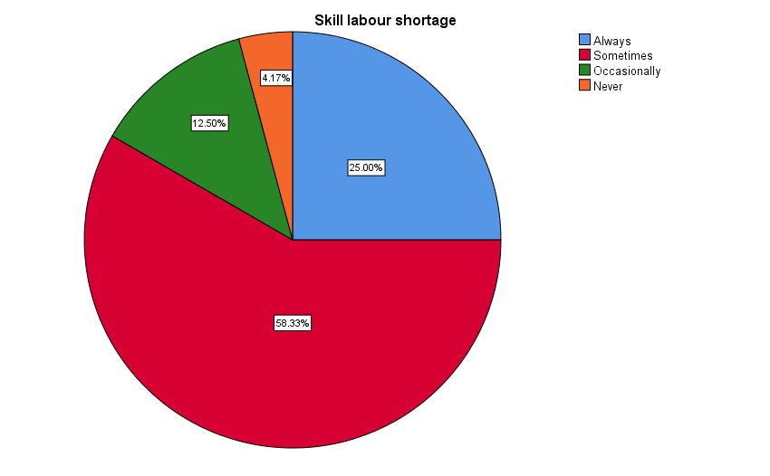

*SPSS Data, 2025*

Based on the data shown in Fig 1, the participants evident that skill labor shortage have significant impact in the study area, accounting for 58%. Hence, the study area faces a persistent skill labour shortage, hindering project timelines. To address this, they emphasised that investing in vocational training programs, promoting apprenticeships, and enhancing educational partnerships can attract and develop a skilled workforce. Additionally, fostering inclusivity and diversity in the construction sector can broaden the talent pool and alleviate labour shortages.

**Figure 2: Causes of Shortage Due to obsolete Training facilities**

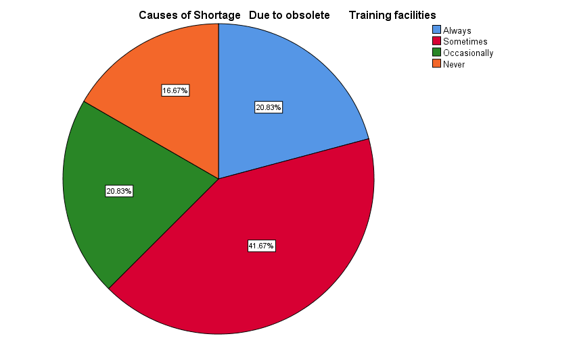

*SPSS Data, 2025*

Based on the data shown in Fig 2, the participants evident that the study area faces a skill labour shortage due to obsolete training facilities Aging infrastructure fails to meet modern construction demands. The recommended some solutions that involve investing in state-of-the-art training centres, updating curriculum to match industry needs, and fostering collaborations between educational institutions and construction firms to bridge the skills gap effectively.

**Figure 3: Causes of Shortage Due to limited practical training**

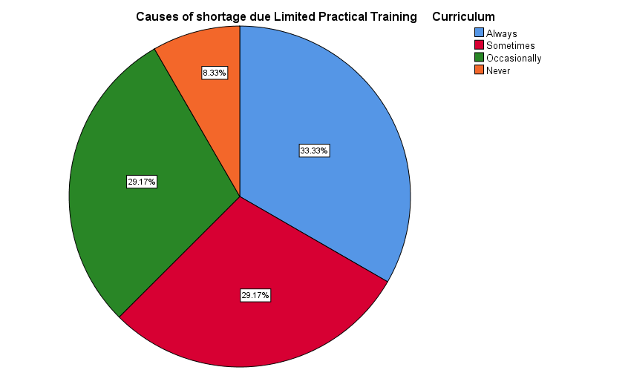

*SPSS Data, 2025*

Based on the data shown in Fig 3, the participants evident that the study area faces a skill labour shortage due to limited practical training. Inadequate emphasis on hands-on experience hampers workforce readiness. They suggested that the solutions that entails increased vocational training, apprenticeship programs, and collaboration between educational institutions and the construction sector to bridge the gap between theoretical knowledge and practical skills, fostering a more skilled workforce.

**Figure 4: Causes of Shortage Due to Unwillingness to Trainee to acquire training**

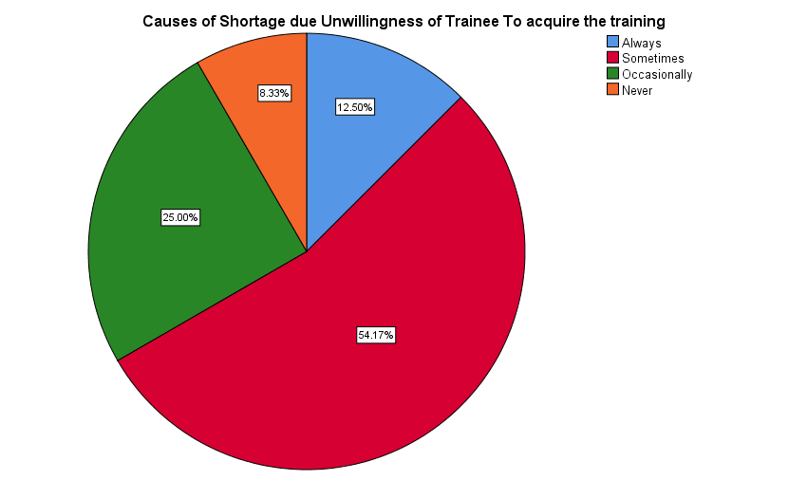

*SPSS Data, 2025*

Based on the data shown in Fig 4, the participants evident that the study area faces a skill labour shortage due to a reluctance among potential trainees to pursue training. They suggested that solutions lie in fostering awareness about the industry's rewarding career paths, incentivizing training programs, and establishing collaborations between educational institutions and construction companies. Encouraging a positive perception of skilled trades can attract more individuals to pursue construction training.

**Figure 5: Is technical education producing competent skilled labour**

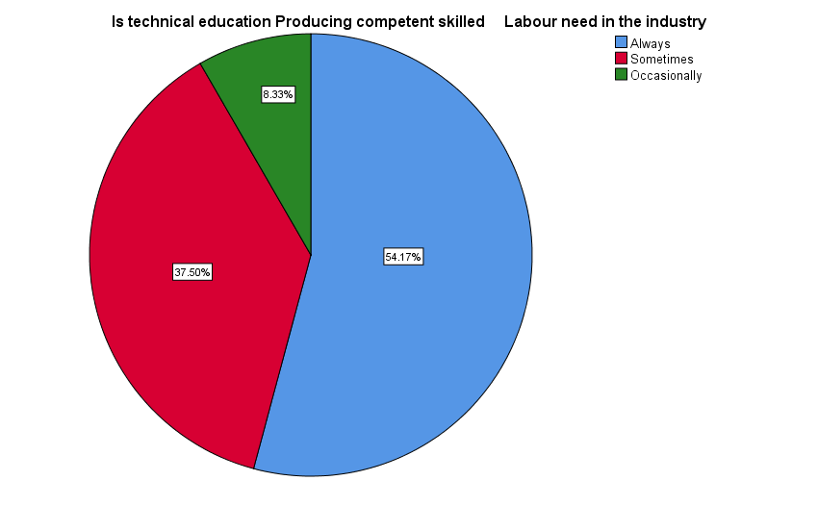

*SPSS Data, 2025*

Based on the data shown in Fig 5, the participants evident that technical education is pivotal in cultivating competent construction skilled labour. They suggested that integrating hands-on training and industry-specific coursework, students can gain practical expertise. Encouraging apprenticeships, fostering collaboration with construction firms, and updating curricula to reflect industry advancements are essential solutions to ensure a skilled workforce meets the evolving needs of the construction sector.Top of Form

**Figure 6: Is there regular training for permanent staff on construction job?**

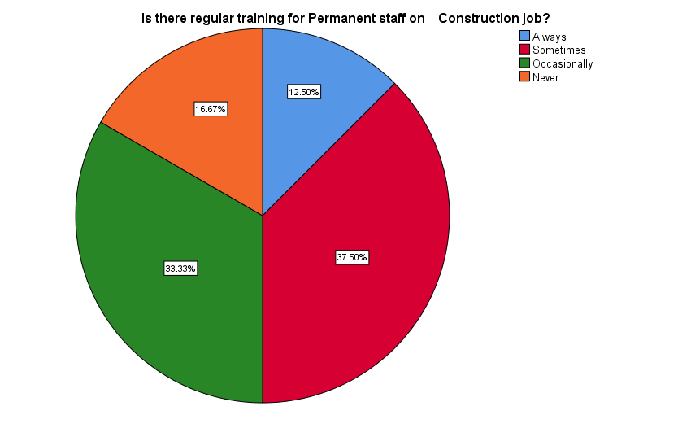

*SPSS Data, 2025*

Based on the data shown in Fig 6, the participants evident that regular training for permanent staff in construction jobs is imperative to keep pace with evolving industry standards and technologies. They maintained that continuous education enhances skills, safety practices, and efficiency where companies can establish robust training programs, leverage e-learning modules, and foster a culture of ongoing learning to ensure their workforce remains well-equipped and adaptive.

**Figure 7: Will you recommend your profession to your child?**

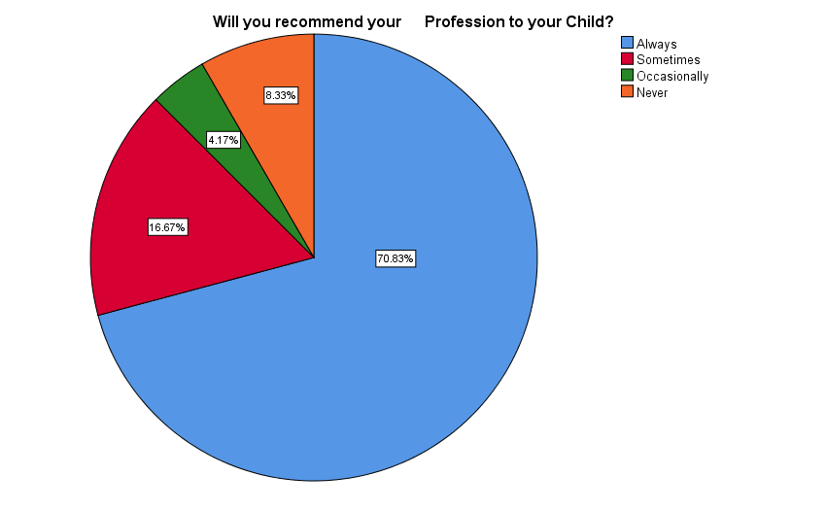

*SPSS Data, 2025*

Based on the data shown in Fig 7, the majority of the participants evident that they often hesitate to recommend the construction profession to their children but strenuous working conditions might be an obstacle. They recommended solutions that includes improving work environments, providing training opportunities, and highlighting the potential for career growth. Enhancing the industry's image can encourage skilled laborers to view construction as a viable and rewarding career for their children.

**Figure 8: Should skilled labour be certified before employment in construction industry?**

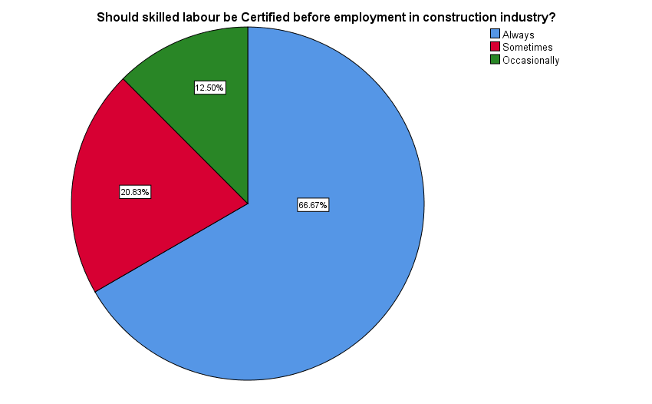

*SPSS Data, 2025*

Based on the data shown in Fig 8, majority of the participants evident that certification for construction skilled labor before employment is essential for ensuring competence and safety. They emphasised that standardized certifications can occasionally validate skills, enhance industry standards, and mitigate risks. Implementing a unified certification process, endorsed by industry stakeholders, would establish a baseline for competency, fostering a safer and more skilled workforce.

**Table 6:** **Chi-Square Test: On Certified Skilled Labour**

**A = Always, B = Sometimes, C = Occasionally, D = Never**

|  |  |  |  |  |  |
| --- | --- | --- | --- | --- | --- |
| **Questions** | **Always.** | **Sometimes.** | **Occasionally.** | **Never.** | **Total.** |
| Skill Labour Shortage | 6 | 14 | 3 | 1 | 24 |
|  | 8.88 | 8.88 | 4.38 | 1.88 |  |
|  | 0.931 | 2.960 | 0.432 | 0.408 |  |
| Causes of Shortage Due to obsolete Training facilities | 5 | 10 | 5 | 4 | 24 |
|  | 8.88 | 8.88 | 4.38 | 1.88 |  |
|  | 0.086 | 0.143 | 0.089 | 2.408 |  |
| Causes of shortage due Limited Practical Training Curriculum | 8 | 7 | 7 | 2 | 24 |
|  | 8.88 | 8.88 | 4.38 | 1.88 |  |
|  | 0.086 | 0.396 | 1.575 | 0.008 |  |
| Causes of Shortage due Unwillingness of Trainee To acquire the training | 3 | 13 | 6 | 2 | 24 |
|  | 8.88 | 8.88 | 4.38 | 1.88 |  |
|  | 3.889 | 0.917 | 0.604 | 0.008 |  |
| Is technical education Producing competent skilled Labour need in the industry | 13 | 9 | 2 | 0 | 24 |
|  | 8.88 | 8.88 | 4.38 | 1.88 |  |
|  | 1.917 | 0.002* | 1.269 | 1.875 |  |
| Is there regular training for Permanent staff on Construction job? | 3 | 9 | 8 | 4 | 24 |
|  | 8.88 | 8.88 | 4.38 | 1.88 |  |
|  | 3.889 | 0.002* | 3.004 | 2.408 |  |
| Will you recommend your Profession to your Child? | 17 | 4 | 1 | 2 | 24 |
|  | 8.88 | 8.88 | 4.38 | 1.88 |  |
|  | 7.438 | 2.678 | 2.604 | 0.008 |  |
| Should skilled labour be Certified before employment in construction industry? | 16 | 5 | 3 | 0 | 24 |
|  | 8.88 | 8.88 | 4.38 | 1.88 |  |
|  | 5.720 | 1.692 | 0.432 | 1.875 |  |

*Chi-Square Test, 2025*

**Table 6A- Summary of Chi- Square Analysis**

|  |  |  |
| --- | --- | --- |
| **Chi-Sq value** | **DF** | **P-Value** |
| 54.381 | 21 | 0.000 |

**H0:** Availability of certified skilled labour

**H1:** No availability of certified skilled labour

$α$ = 0.05

Based on the Chi-Square analysis results presented in Table 6A, it can be observed that the obtained P-value is smaller than the predetermined significance level (α = 0.05). Hence, we reject the null hypothesis and assert that there exists a deficiency of certified trained labour within the construction industry of Zamfara State.

**5.0 Conclusion**

This study investigates the availability of skilled labour in the construction industry of Zamfara and explores the potential correlation between many parameters, including certification, job quality, and the scarcity of labour skills. The research employed a mixed methods approach to collect empirical data from contractors located within the designated study area. It has been observed that the construction sector is facing a lack of certified skilled labour, and this shortfall is found to be associated with the requirement for certification. Furthermore, there exists a discernible disparity in the quality of work between certified skilled workers and their uncertified counterparts.

# The study also revealed that the primary determinants influencing the availability of skilled labour include inadequate foundational education, prevailing economic circumstances, and the requirement for certification from a hierarchical standpoint. Based on the aforementioned findings, the study posits that the construction sector in Zamfara state will persistently encounter deficiencies in skilled labour, particularly among professionals who necessitate precision, unless measures are taken to enhance the foundational educational system, facilitate professional certification for these individuals, and establish a framework for assessing the expertise acquired informally by workers over years of on-site experience. The scope of this study is confined to the Gusau and Kaura Namoda Local Government Councils, hence caution should be exercised when extrapolating its findings to the broader population of contractors in Nigeria.

# 5.1 Recommendations

The deficiency of skilled labour in Zamfara State cannot be attributed to any specific individual or entity. Undoubtedly, the emergence of technology-driven sectors appears to exert influence, alongside the escalating aspirations of younger generations. The issue is further exacerbated by the little attention given by the educational system to vocational trades.

The shortage of certified workforce in Zamfara State's construction industry poses significant challenges to its growth and sustainability. This evaluation aims to provide comprehensive recommendations to address these issues and foster a skilled, certified workforce, promoting both economic development and construction project quality. The study suggested the following recommendations;

1. **Capacity Building Programs:**
   * Construction industry should collaborate with vocational training institutions to design and implement specialized construction training programs.
   * Government should establish partnerships with industry associations and private companies to sponsor training initiatives.
   * The institutions should integrate practical on-the-job training to enhance hands-on skills.
2. **Certification Incentives by Government:**
   * Introduce incentives for construction professionals to obtain relevant certifications.
   * Provide subsidies or tax breaks for companies investing in employee certification programs.
   * Develop a recognition system for certified workers, creating a competitive advantage for certified professionals.
   * Implement proactive measures, such as providing subsidies for technical and vocational institutions, as well as enhancing secondary education, in order to enhance the participation of competent individuals in Federal Technical colleges and Polytechnics.
3. **Government-Industry Collaboration:**
   * Form a task force comprising government officials, industry leaders, and educational institutions to assess and address workforce shortages.
   * Allocate resources for research and development in construction education, focusing on emerging technologies and best practices.
   * Establish a Construction Skills Council to advise on workforce development policies and strategies.
4. **Apprenticeship Programs by the Industry:**
   * Establish apprenticeship programs, fostering skill transfer from experienced professionals to newcomers.
   * Provide financial incentives for companies offering apprenticeships, reducing the cost burden on employers.
   * Establish a standardized apprenticeship framework to ensure consistency in training quality.
   * Commencing recruitment efforts by targeting a younger and more motivated workforce, especially when coupled with the commitment to provide training, would be advantageous.
5. **Flexible Certification Pathways by** **Vocational Training Institutions:**
   * Develop flexible pathways for certification, recognizing prior experience and skills.
   * Allow for online and part-time certification programs to accommodate the working population.
   * Streamline certification processes to reduce bureaucracy and delays.
6. **Public Awareness Campaigns by the Industry and Vocational Training Institutions:**
   * Launch awareness campaigns to inform the public about the benefits of certified construction professionals.
   * Showcase success stories of certified workers and the positive impact on project outcomes.
   * Collaborate with media outlets and social platforms to reach a wide audience.
7. **Investment in Education Infrastructure by Government:**
   * Upgrade and expand existing technical and vocational training institutions to accommodate a larger student population.
   * Invest in state-of-the-art facilities and equipment to provide practical, industry-relevant training.
   * Establish scholarship programs to incentivize individuals to pursue construction-related education.
   * Future research should focus on investigating the challenges and barriers faced in the training and certification of the construction industry, specifically in at least one third of the North-West region of Nigeria.
8. **Regular Skill Assessments by the Industry:**
   * Implement a periodic skill assessment system to evaluate the proficiency of the existing workforce.
   * Use assessment results to tailor training programs to address specific skill gaps.
   * Encourage continuous professional development to maintain and update certifications.
9. **Research and Development Initiatives by Industry and Vocational Training Institutions:**
   * Allocate funds for research initiatives focused on identifying emerging skill requirements in the construction industry.
   * Establish partnerships with research institutions to conduct studies on global best practices in construction workforce development.
   * Use research findings to inform curriculum development and training programs.
10. **Monitoring and Evaluation by Industry and Government:**
    * Implement a robust monitoring and evaluation system to assess the effectiveness of workforce development initiatives.
    * Regularly review and adjust policies based on feedback and changing industry needs.
    * Engage in collaborative evaluations with industry stakeholders to ensure ongoing relevance.

By implementing these recommendations, Zamfara State can address the shortage of certified workforce in the construction industry, fostering sustainable growth and ensuring the delivery of high-quality construction projects.

# References

Agapiou, A., Price, A.D.F., & McCaffer, R. (1995). Planning future construction skill requirements: Understanding labour resources. Construction Management and Economics, 13(2), 149–161.

Akindoyeni, A. (2005) Nigerian Building Craftsmen; which way forward? Text of paper presented at the NIOB craftsmen’s summit at Yaba College of Technology, Lagos. 7th July, 2005.

Alshahrani, A., Alaboud, N., Leje, M. I., Karban, A., & Altowerqi, Z. (2023). Rating the significance of the factors influencing shortage of skilled labours for sustainable construction: a perception of Makkah construction practitioner. Journal of Umm Al-Qura University for Engineering and Architecture, 14(1), 13–25. <https://doi.org/10.1007/s43995-023-00013-5>

Awe, E.M. (2005) Repositioning Technical Education to meet Skilled/Semi Skilled Manpower need. Paper presented at NARD 4th annual National Conference held at University of Port Harcourt (UNIPORT), 15th-19th August.

Belic, S. (2002). Reality and preconceptions about the style of management in construction: 2nd SENET Conference on Project Management, Cavtat, 568-573

Bolaji, S. (2007) Evolving Creativity in Nigerian Education: A Paradigm. Conference Presentation, Philosophy of Education Society of Australasia.

Briscoe, G., Dainty, A.R. J & Millet, S.J. (2000). The impact of the tax system on self-employment in the British construction industry, international journal of manpower,21(8) 596-613.

Bust, P.D., Gibb, A.G.F., & Pink, S. (2007). Managing construction health and safety. Migrant workers and communication. Safety Message, Safety Science, in press, corrected proof.

Cahul, P. & Postel-vinay, F. (2002). Temporary jobs, employment protection and labour market performance, Labour Economics 9(1) 63-91.

Chini, A.R., Brown, B.H. & Drummond, E.G. (1999). Causes of the construction Skilled labour shortage and proposed solutions. ASC Proceeding of the 35th Annual conference. California Polytechnic State University, San luis Obispo, California, 187-196.

COOA (2005) Alberta's Future is Bright, But Could Be Dimmed By Labour Shortages. Construction Owners Association Release, December 2005. Canada.

Connor T.O. (2006), Worker Shortage Crisis in Alberta. Canada Wise Company. [Online] Assessed: May 3rd, 2021. Available at: <http://www.expats.org.uk/features/canadawiseworkershortagecrisis.html>

Crowley, L.G., Lutz, J.D. & Burleson, R.C. (1997). Functional illiteracy in construction industry. Journal of Construction Engineering and Management 123(2) 162-170

David, B. (2008). Using Vocational Education to Solve Employment Problem in Nigeria. [Online]Assessed: March 13, 2021, Available at: <http://allafrica.com/stories/200806021.html>

Dainty, A.R.J., Ison, S.G. & Root, D.S. (2004). Bridging the skill gap: A regionally driven strategy for resolving the construction labour market crisis, Engineering, Construction and Architectural Management, 11(4) 275-283

Dainty, A., Grugulis, I. and D. Langford, D. (2007) Understanding Construction Employment: The Need for a Fresh Research Agenda Personnel Review. 36, 501-508

Dennis, R (2007) Labour Shortages could worsen as Economy starts to Rebound. [Online] Central Penn Business Journal. Assessed: April 26th 2021. Available at: <http://findarticles.com/p/articles/mi_qa5295/is_200406/ai_n24280507/print>

Dike, V. E. (2006). Youth Unemployment in Nigeria: The Relevance of Vocational and Technical Education. NESG Economic Indicators, July-Sept., 12(3), 25-29. Department of Labour (DoL). (2007). Development implementation strategy report. Pretoria: DoL

Druker, Jac, R. (2000). National collective bargaining and employment flexibility in the European building and civil Engineering Industries Construction Management and Economics (18) 699-709.

Erasmus, J., & Breier, M. (2009). Skills shortages in South Africa, case studies of key professions [Online], World Rights Publishers, ISBN 978-07969-2266-3. Assessed April 02, 2021, Available at: <http://www.hsrcpress.ac.za/product.php?productid=2257>

Farrell, P. 2011. Writing a Built Environment Dissertation: Practical Guidance and Examples, 1st ed. United Kingdom: Blackwell.

Haksever, A.M; Demir, I.H. & Omer, G. (2002). Assessing the benefits of long-term relationship between contractors and subcontractors in the UK. International journal for construction marketing. No. 3, pp. 63-91

Haas, C.T., Rodrigues, A.M., Glover, R. & Goodrum, P.M. (2002). Implementing a multi-skilled workforce, construction management and economics.19 633-641

Ireland B. (2007). Wanted: Skilled Labour. Skilled Labour Shortage in America. A Robust Economy Strains the ranks of a Qualified Workforce. USA [Online]. Penton Media Inc. Assessed April 26, 2021, Available at: <http://ecmweb/mag/electric_wanted_skilled_labor/index.html>

Janssen, J. (2000). The European construction industry and its competitiveness: a construct of the European commission, construction management and economics, 18,711-720.

Jaselskis, E.J., Stong, K.C., Aveiga, F., Canales, A.E., Jahren, C. (2007). Successful multinational workforce integration program to improve construction site performance, safety science,

Juricic, B. B., Galic, M., & Marenjak, S. (2021). Review of the construction labour demand and shortages in the EU. Buildings, 11(1), 1–17. <https://doi.org/10.3390/buildings11010017>

Kashiwagi, T. & Tam, S. (2002). Solving the construction craft-person skill shortage problem through construction undergraduate and graduate education ASC 38th Annual Conference Virgina Polytechnic Institute and state University. Blacksburg, VA, 165-176.

Lill, I. (2004). Evaluation of labour management strategies in construction TUT Press, Tallinn, 115.

Liska, R.W. (2002). Attracting and retaining a skilled construction workforce. Construction innovation and global competitiveness: 10th international symposium RC press, Cincinati, 1270-1282

Mackenzie, S., Kilpatrick, A.R. & Akintoye, A. (2000), UK construction skill shortage response strategies and analysis of industry perception construction management and economics,18, 853-862.

Makhene, D., & Thwala, W.D. (2009). Skilled labour shortages in construction contractors: A literature review. Johannesburg: University of Johannesburg.

McCausland C. (2008). Labour Shortages Solutions. Combating the Lack of Skilled Craftsmen [Online]. The Builder News Magazine. USA. Assessed April 26th, 2021. Available at: <http://www.buildernewsmag.com/viewnews.pl?id>

Michelle E. Kiger and Lara Varpio., 2020. Thematic analysis of qualitative data: AMEE Guide 131, Medical Teacher, DOI: 10.1080/0142159X.2020.1755030

Mullins, L. J. (1999) “Management and Organizational Behaviour”, 5th Edition, Essex: Pearson Education.

Naoum, S. G. (2013) Dissertation Research and Writing for Construction Students. 3rd ed. London: Routledge

NHTG, (2005) Traditional Building Craft Skills: Assessing the Need, Meeting the Challenge [Online]. National Heritage Training Group, Skills needs analysis in England. Assessed May 11, 2021 from [www.nhtg.org.uk](http://www.nhtg.org.uk)

NQAI (2008). Nigeria - Description of Education System [Online] Qualifications Recognition. National Qualifications Authority, Ireland. Assessed: March 21, 2021, Available at: [http://www.qualificationsrecognition.ie/recognition/int_qual_databse/lithuania/NigeriaDescriptionofE ducationandTrainingSystem.html](http://www.qualificationsrecognition.ie/recognition/int_qual_databse/lithuania/NigeriaDescriptionofE%20ducationandTrainingSystem.html)

Nwagwu, J U (2004). Alleviating Poverty through Vocational Education: The Nigerian Experience [Online]. Faculty of Education, Imo State University, Owerri. Assessed: 17 March, 2021 from http://www.gla.ac.uk/centres/cradall/docs/Botswana-papers/Nwagwupaper_61pdf

Obiegu M.E. (2005). Nigerian Institute of Building craftsmen Summit, president’s Address, Yaba College of Technology, Lagos Nigeria. 7th July 2005.

Odia, L. O., & Omofonmwan, S.I. (2007). Educational System in Nigeria: Problems and Prospects. Journal of Social Science, 14 (1), 81-86.

Ofori, G. (2019) Construction in developing countries: a research agenda. London: Routledge.

Olaitan, S. O. (1996). Vocational and Technical Education in Nigeria: Issues and Analysis. Onitsha: Noble Graphic Press

Onjewu M.A (2005) Assessing Technical and Vocational Education in Nigeria. A situation analysis of Kaduna Polytechnic. Paper presented at 31st Annual Conference on International Educational Assessment, Abuja. 4th-9th September.

Oranu, R. N. (1992). Vocational and Technical Education in Nigeria [Online] February 16, 2021, Available at: <http://www.ibe.unesco.org/curriculum/Africapdf/lago2ora.pdf>

Pathirana, D. S. (2021). Construction Industry and Factor Condition Prospective Of Sri Lanka: A Special Reference to Skill Labour Shortage. Journal of Business and Management, 232(2), 35–41. <https://doi.org/10.9790/487X-2302073541>

Schervayder, J. and Mayo, R.S. (2004) Construction Fundamentals, 2nd Ed. New Yoon: McGrew Hill.

SLIM Report (2002). Craft and skilled trades SLIM learning theme report skills and learning intelligence module, 52.

Smith, J. and Mills, M. (2020) 'Skills shortages in construction: the role of training,' Journal of Construction Management, 12(4), pp. 300-315.

Smithers, G.L & Walker D.H.T. (2000). The effect of workplace on motivation and demotivation of construction professionals, construction management and economics,18, 833-841.

Shah, C., & Burke, G. (2005). Skills shortages: concepts, measurement and policy responses. Australian Bulletin of Labor, 31(1), 44–71

Shekhar, A., Waysal, S. M., & Kadam, M. P. (2021). Impact of Skilled Labour availability on the Performance of Construction Industry. International Research Journal of Engineering and Technology, 1886–1889. [www.irjet.net](http://www.irjet.net)

Sybenni, G. (1998). A qualification traps in the German construction industry: changing the production model and the consequences for the training system in the German construction industry. Construction management and economics 16,593-601.

Tappin, S. (2002). The UK Vocational Education and Training System. Professional Education and Competences, Brazil. March 18-20.

Tarnoki, P. (2002). The real world of managing project: ‘Soft-side’. 2nd SENET conference in project management, cavtat, Croatia, 555-559

Tóth, P. (2021) 'The impact of workforce certification on project outcomes,' International Journal of Project Management, 39(3), pp. 420-435.

## True North Labour (2020) Shortage of Skilled Labour-A Major Issue For Construction Sector [Online] Available at: <https://truenorthlabour.com/shortage-of-skilled-labour-a-mTajor-issue-for-construction-sector/> Assessed: 2nd May 2023

Uwakweh, B.O., & Maloney, W.F. (1991). Conceptual model for manpower planning for the construction industry in developing countries. Construction Management and Economics, 9(5), 451–465.

UNESCO (2005). Revitalizing Technical and Vocational Education in Nigeria. [Online] Assessed: March 12, 2021, Available at: <http://portal.unesco.org/education/en/ev.php-URL_ID>

Wells, J. & Wall, D. (2003). The expansion of employment opportunities in the building construction sector in the content of structural adjustment: some evidence from Kenya and Tanzania. Habitat international, 27 (3),325-337.

Wilson, F.D. (2003). Ethnic niching and metropolitan labour market, social science research,32 (3),429-466.