**Effect of the acid modified C5 petroleum resin on characteristics of bromobutyl rubber damping materials**

Jin-Seong Kim1, Seong-Hye Kim1, Gi-Yong Um1 and Jun-Ha Jeon1†

*1 Korea Institute of Materials Convergence Technology, Busan 47154, Republic of Korea*

_____________________________

† Corresponding author E-mail: *juna@kimco.re.kr*

**ABSTRACT:** In this paper, the main purpose of this paper is to study to simultaneously improve the loss factor at room temperature and mechanical properties of bromobutyl rubber (BIIR) damping materials. Although BIIR is beneficial for damping performance, restricts its use in a room temperature range because of the tan δ peak of BIIR is located at lower temperature region rather than room temperature. Acid modified C5 petroleum resins and unmodified C5 petroleum resins were added to enhance the damping performance of BIIR at a room temperature range. Acid modified C5 petroleum resins could accelerate the crosslinking of BIIR. In addition, it was found that mechanical properties and the loss factor were improved compared to the addition of unmodified C5 petroleum resin.

*Keywords: Damping materials; Bromobutyl rubber; C5 petroleum resin; crosslinking;   
loss factor; Tanδ peak ; Mechanical properties*

**I. Introduction**

Damping materials are gaining increasing attention due to the growing demand for suppressing unwanted vibrations and noise in the field of transportation, aerospace and ship [1-4]. Rubbers have often been used as damping materials due to their unique viscoelastic properties [5-7]. Generally, vibration energy can be dissipated into heat by the rubber when the time scale of vibration is comparable to that of rubber viscoelastic relaxation [8]. The damping performance of rubbers usually peak at or around the glass transition temperature (Tg), where the softening of the rubber leads to a rapid decrease in storage modulus and an increase in the loss factor (Tanδ) [9]. However, the Tg of most rubbers is relatively low temperature [10], indicating that most damping rubbers can only be used in low temperature ranges. Therefore, many approaches to developing damping rubber that can be used at room temperature have been investigated [11,12].  
 The damping performance of rubbers is related to the groups on the rubber molecular chains. Strong polarity and large number of side groups can effectively improve the damping performance of rubbers [13]. Butyl rubber (IIR) containing large amounts of methyl groups can lead to the increase of relaxation resistance and internal friction, which is beneficial for damping performance. However, its loss factor peak always occurs at low temperature, which restricts its use in a room temperature range. Because of the unique molecular structure, dense and symmetric side methyl group of IIR, its damping property can be adjusted by material modification, such as blending, copolymerization, interpenetrating polymer network, and hanging chain structure [14].   
 Many approaches have been investigated to improve the Tanδ peak of IIR at room temperature. Among these, blending with petroleum resin which has is an amorphous polymer with low molecular weights and its Tg is higher than room temperature has been identified as the simplest and most effective method to produce IIR with loss factor at high temperature. For example, Yin et al. [15] found that the Tanδ peak of IIR/petroleum resin blend increases with the increasing content of C5 petroleum resin. Blend of C5 petroleum resin can adjust the Tanδ peak of IIR from low to high temperature, however, the mechanical properties decrease with the increasing content of C5 petroleum resin. This indicates that C5 petroleum resin could inhibit the crosslinking of IIR and reduce its modulus as well. It may due to that C5 petroleum resin are oligomers with molecular weight of 1000–2000 and they have no active groups to react with crosslinking agents so that they cannot co-crosslinking with rubber. Thus, mechanical properties of IIR/petroleum resin blend vulcanizates decreased gradually.  
 We found the acid modified C5 petroleum resin (m-C5) that has active groups to react with crosslinking agents and good compatibility with halobutyl rubber (Bromobutyl rubber or Chlorobutyl rubber). C5 petroleum resins with acid modified and unmodified were used in this study as adding components to enhance the damping property of Bromobutyl rubber (BIIR). The effects of C5 petroleum resins with active groups on the damping property and mechanical properties of BIIR are characterized. The damping property of the composite were mainly characterized by rotational rheometer (ARES-G2, TA instrument, USA). In addition, the curing behavior and mechanical properties were studied as well.

**II. Experimental**

**1**. **Materials**  
 We used Bromobutyl rubber (BIIR), Bromobutyl 2244 (ExxonMobil, USA) with a bromine content of 2.0wt% and mooney viscosity of 46(ML1+8, 125℃). C5 petroleum resin (C5) and acid modified C5 petroleum resin (m-C5) (Kolon industries, Korea) with a softening point of 94~102℃ were used to improve the Tanδ peak of BIIR at room temperature. Calcium carbonate (CaCO3, Dongho Calcium Co., Korea) was used as a filler. Stearic acid (St/A, LG chem., Korea) was used as a dispersing agent and accelerator activator. Zinc oxide (ZnO, Hanil chemical Co., Korea) was used as a crosslinking agent. Formulations of the material were presented in Table 1.

Table 1

Basic formulations of the BIIR with various contents of petroleum resins.

|  |  |  |  |  |  |  |
| --- | --- | --- | --- | --- | --- | --- |
| Sample | BIIR | C5 | m-C5 | CaCO3 | St/A | ZnO |
|  |  |  |  |  |  |  |
| Control | 100 | 0 | 0 | 30 | 1 | 5 |
| C5-10 | 100 | 10 | 0 | 30 | 1 | 5 |
| C5-20 | 100 | 20 | 0 | 30 | 1 | 5 |
| C5-30 | 100 | 30 | 0 | 30 | 1 | 5 |
| C5-40 | 100 | 40 | 0 | 30 | 1 | 5 |
| m-C5-10 | 100 | 0 | 10 | 30 | 1 | 5 |
| m-C5-20 | 100 | 0 | 20 | 30 | 1 | 5 |
| m-C5-30 | 100 | 0 | 30 | 30 | 1 | 5 |
| m-C5-40 | 100 | 0 | 40 | 30 | 1 | 5 |
|  |  |  |  |  |  |  |

**2**. **Sample preparation**  
 To prepare damping materials, 30 phr CaCO3 and 1 phr St/A were firstly mixed with BIIR on a two-roll mill. Then, different dosage (10 phr, 20 phr, 30 phr, 40 phr) of C5 or m-C5 was added. ZnO was added at last. In the end, we got composites of BIIR/C5 or BIIR/m-C5. They were cured at 160 °C for their optimum cure time (T90) which was determined by RPA (rubber process analyzer) Elite produced by TA instrument.

**3**. **Characterization**

**3.1. Curing behavior analysis**  
 To evaluate the curing behavior of composites, the curing characteristic of the composites was tested by RPA elite under the temperature of 160 °C. The curing characteristic can be obtained by the minimum torque (ML), maximum torque (MH), and optimum cure time (T90).

**3.2. Damping behavior analysis**  
 To evaluate the damping property of cured composites, the dynamic mechanical analysis (DMA) was performed on a rotational rheometer (ARES-G2) from −60 °C to 60 °C in a torsion mode, the heating rate was 3 °C/min and the oscillation frequency were 10 Hz.

**3.3. Mechanical properties tests**  
 According to ASTM D 412, a dumbbell-shaped specimen was prepared to measure mechanical properties of cured composites. Tensile measurement was carried out using a universal tensile testing machine (UTM 3345, Instron, USA) with a 500N load cell at room temperature with a cross-head speed of 500mm/min. Hardness was measured by pressing the specimen using a Shore A durometer (Asker's model JIS K 6253, Japan) after overlapping the specimen to thickness of 6mm according to ASTM D 2240.

**III. Results and Discussion**

**1. Effect of C5 or m-C5 dosage on curing behavior**  
 Cure curves and ∆Torques of composites were measured as shown in Figure 1 and Figure 2. Curing properties of maximum torque (MH), minimum torque (ML), the difference between maximum and minimum torque (∆Torque) and optimum curing time (T90, time required for the torque to reach 90% of the maximum torque) were presented in Table 2.

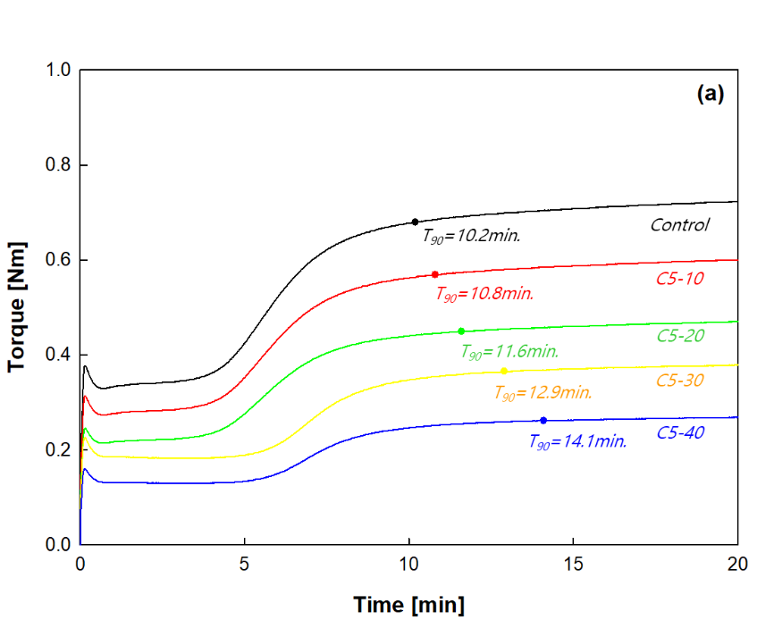

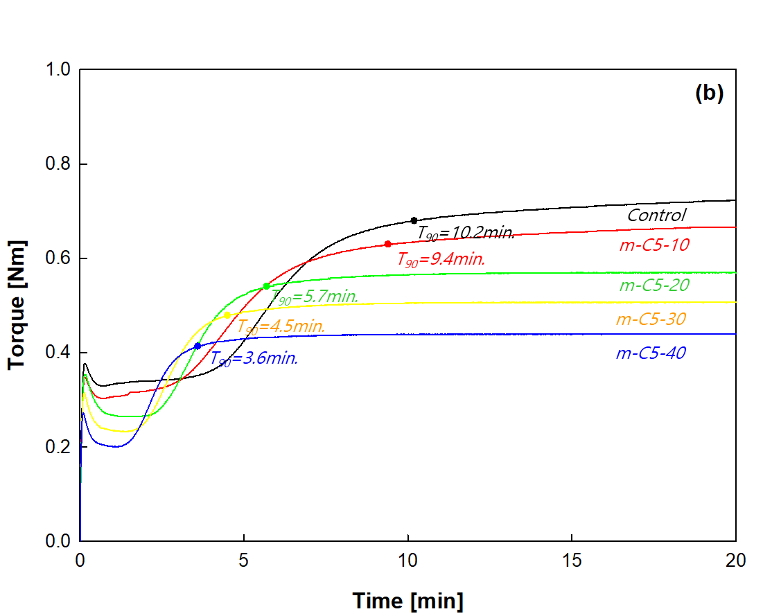

Figure 1. Cure curves of BIIR with various contents of petroleum resins at 160℃: (a) C5, (b) m-C5



Figure 2. ∆Torques of BIIR with various contents of petroleum resins at 160℃

Table 2

Cure properties of the BIIR with various contents of petroleum resins at 160℃.

|  |  |  |  |  |
| --- | --- | --- | --- | --- |
| Sample | MH [Nm] | ML [Nm] | ∆Torque [Nm] | T90 [min.] |
|  |  |  |  |  |
| Control | 0.723 | 0.330 | 0.393 | 10.2 |
| C5-10 | 0.600 | 0.274 | 0.326 | 10.8 |
| C5-20 | 0.470 | 0.215 | 0.255 | 11.6 |
| C5-30 | 0.379 | 0.185 | 0.194 | 12.9 |
| C5-40 | 0.269 | 0.129 | 0.140 | 14.1 |
| m-C5-10 | 0.665 | 0.304 | 0.361 | 9.4 |
| m-C5-20 | 0.569 | 0.264 | 0.305 | 5.7 |
| m-C5-30 | 0.507 | 0.231 | 0.276 | 4.5 |
| m-C5-40 | 0.439 | 0.201 | 0.238 | 3.6 |
|  |  |  |  |  |

As the content of C5 increased from 0 phr to 40 phr, the T90 of composites was increased (Figure 1. (a)). It suggests that the addition of C5 could inhibit the crosslinking of BIIR. It may due to that C5 has no active groups to react with crosslinking agents so that they cannot crosslinking with BIIR. As the content of m-C5 increased from 0 phr to 40 phr, the T90 of composites was decreased (Figure 1 (b). It indicates that the addition of m-C5 could accelerate the crosslinking of BIIR. It may due to that m-C5 has active groups to react with crosslinking agents.  
 As can be seen in Figure 2 and Table 2, as the content of petroleum resins increased from 0 phr to 40 phr, the ∆Torque of composites was gradually decreased. This may be attributed to the presence of petroleum resins with molecular weights of 1000~2000. The smaller ∆torque change observed with the addition of m-C5 compared to C5 is due to crosslinking with BIIR.

**2. Effect of C5 or m-C5 dosage on damping behavior**  
 According to damping theories, damping properties can be determined from the dynamic mechanical analysis [19]. DMA curves and Tanδ peak temperatures of composites were measured as shown in Figure 3 and Figure 4.





Figure 3. DMA curves of BIIR with various contents of petroleum resins: (a) C5, (b) m-C5

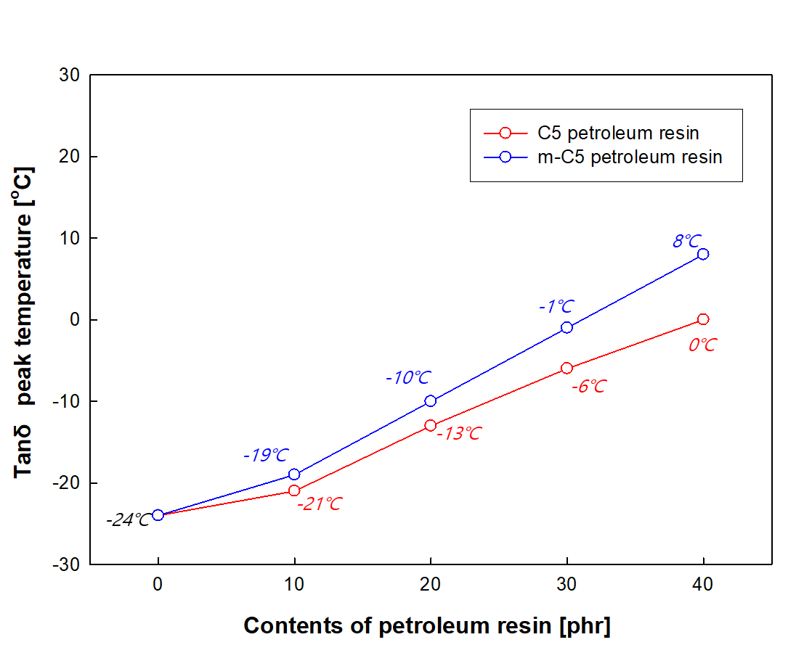

Figure 4. Tanδ peak temperatures of BIIR with various contents of petroleum resins

As can be seen in Figure 3, DMA curves of composites have a single Tanδ, which indicates that BIIR and petroleum resins have good compatibility. As the content of petroleum resins increased from 0 phr to 40 phr, the Tanδ peak temperature of composites was gradually increased. It indicates that the increase of petroleum resin content, the movement of BIIR chains becomes difficult and the Tanδ peak temperature of composites should move towards high temperature direction.   
 As can be seen in Figure 4, it observed that the higher change of Tanδ peak temperatures with the addition of m-C5 compared to C5. It may due to that m-C5 has crosslinking with BIIR, which makes the movement of BIIR chains becomes more difficult.

**3. Effect of C5 or m-C5 dosage on mechanical properties**  
 The stress-strain curve and Hardness of composites were measured as shown in Figure 5 and Figure 6. The tensile strength, elongation at break and hardness of composites were shown in Table 3.





Figure 5. Stess-strain curves of BIIR with various contents of petroleum resins: (a) C5, (b) m-C5



Figure 6. Hardness of BIIR with various contents of petroleum resins

Table 3

Mechanical properties of the BIIR with various contents of petroleum resins.

|  |  |  |  |
| --- | --- | --- | --- |
| Sample | Tensile strength [MPa] | Elongation at break [%] | Hardness [Shore A] |
|  |  |  |  |
| Control | 4.61 | 795 | 41 |
| C5-10 | 4.34 | 910 | 39 |
| C5-20 | 3.94 | 1052 | 37 |
| C5-30 | 3.75 | 1113 | 33 |
| C5-40 | 3.37 | 1149 | 29 |
| m-C5-10 | 4.51 | 828 | 41 |
| m-C5-20 | 4.43 | 890 | 40 |
| m-C5-30 | 4.42 | 938 | 39 |
| m-C5-40 | 4.36 | 1050 | 37 |
|  |  |  |  |

As can be seen in Figure 5 and Table 3, as the content of petroleum resins increased from 0 phr to 40 phr, the tensile strength of composites got worse and the elongation was gradually increased. Also, the hardness of composites was gradually decreased in Figure 6 and Table 3. This may be attributed to the presence of petroleum resins with low molecular weights. The smaller decrease in mechanical properties observed with the addition of m-C5 compared to C5 is due to crosslinking with BIIR.

**IV. Conclusion**  
 The effect of acid modified C5 petroleum resins on BIIR damping materials was investigated by studying the relationship between the crosslinking properties, damping behaviors and mechanical properties of composites prepared by adding petroleum resin with (unmodified C5 or acid modified C5) to BIIR. The higher petroleum resin (Tg is higher than room temperature) content added to the BIIR damping materials, the higher Tanδ peak temperature, but there are limits to its application to damping materials due to poor mechanical properties. Therefore, we attempted to simultaneously improve mechanical properties by acid modified C5 petroleum resins that has active groups to react with crosslinking. As the acid modified C5 petroleum resin content increased the optimal curing time of BIIR damping materials was decreased. It indicates that the addition of acid modified C5 petroleum resin could accelerate the crosslinking of BIIR. In addition, it was found that mechanical properties and the loss factor were improved compared to the addition of unmodified C5 petroleum resin.

**Acknowledgments**  
 The author(s) disclosed receipt of the following financial support for the research, authorship, and/or publication of this article: This work was supported by the Ministry of Trade, Industry, and Energy, Republic of Korea (2410001001).

**References**

[1] J.D. Adams, B.W. Erickson, J. Grossenbacher, J. Brugger, A. Nievergelt,

G.E. Fantner, Harnessing the damping properties of materials for high-speed

atomic force microscopy, Nat. Nanotechnol. 11 (2) (2016) 147e151.

[2] A. Eichler, J. Moser, J. Chaste, M. Zdrojek, I. Wilson-Rae, A. Bachtold, Nonlinear

damping in mechanical resonators made from carbon nanotubes and graphene,

Nat. Nanotechnol. 6 (6) (2011) 339e342.

[3] R.S. Lakes, T. Lee, A. Bersie, Y. Wang, Extreme damping in composite materials

with negative-stiffness inclusions, Nature 410 (6828) (2001) 565e567.

[4] J. Suhr, N. Koratkar, P. Keblinski, P. Ajayan, Viscoelasticity in carbon nanotube

composites, Nat. Mater. 4 (2) (2005) 134e137.

[5] X.Q. Zhou, D.Y. Yu, X.Y. Shao, S.Q. Zhang, S. Wang, Research and applications of

viscoelastic vibration damping materials: a review, Compos. Struct. 136 (2016)

460–480.

[6] W.C. Wu, C.H. Xu, Z.J. Zheng, B.F. Lin, L.H. Fu, Strengthened, recyclable shape

memory rubber films with a rigid filler nano-capillary network, J. Mater. Chem. A 7

(2019) 6901–6910.

[7] J.D. Nie, W.J. Mou, J.P. Ding, Y.K. Chen, Bio-based epoxidized natural rubber/

chitin nanocrystals composites: Self-healing and enhanced mechanical properties,

Compos. B. Eng. 172 (2019) 152–160.

[8] C.M. Roland, Viscoelastic Behavior of Rubbery Materials, Oxford University

Press, 2011.

[9] C. Zhang, K. Pal, J.U. Byeon, S.M. Han, J.K. Kim, A study on mechanical and

thermal properties of silicone rubber/EPDM damping materials, J. Appl. Polym. Sci.

119 (2011) 2737–2741.

[9] T.F. Lin, S.W. Ma, Y. Lu, B.C. Guo, New Design of shape memory polymers based

on natural rubber crosslinked via oxa-michael reaction, ACS Appl. Mater. Interfaces 6

(2014) 5695–5703.

[11] D.W. Yang, X.Y. Zhao, T. Chan, L.Q. Zhang, S.Z. Wu, Investigation of the damping

properties of hindered phenol AO-80/polyacrylate hybrids using molecular dynamics

simulations in combination with experimental methods, J. Mater. Sci. 51

(2016) 5760–5774.

[12] K. Liu, Q.Q. Lv, J. Hua, Study on damping properties of HVBR/EVM blends

prepared by in situ polymerization, Polym. Test. 60 (2017) 321–325.

[13] J. Brandt, K.K. Oehlenschlaeger, F.G. Schmidt, C.B. Kowollik, A. Lederer, State of

the art analytical methods for assessing dynamic bonding soft matter materials, Adv.

Mater. 26 (2014) 5758–5785.

[14] M. Shen, L. Xia, Q. Feng, J. Zhang, J. Li, S. Guo, Damping characteristics of a

multilayered constrained beam using viscoelastic butyl rubber layer with wide

temperature range, Mater. Express, 11 (2021) 372–380

[15] Yin, C., Zhao, X.Y., Zhu, J., Hu, H.H., Song, M. and Wu, S.Z., Experimental and

molecular dynamics simulation study on the damping mechanism of C5 petroleum

resin/chlorinated butyl rubber composites. J. of Mater. Sci., 54 (5) (2018) 3960–3974.

[16] Y.K. Chen, L.M. Cao, J.R. Huang, Dual Cross-linked Epoxidized Natural Rubber

Reinforced by Tunicate Cellulose Nanocrystals with Improved Strength and

Extensibility, ACS Sustainable Chem. Eng. 6 (2018) 14082–14811.

[17] C.H. Xu, J.D. Nie, W.C. Wu, L.H. Fu, B.F. Lin, Design of self-healable supramolecular

hybrid network based on carboxylated styrene butadiene rubber and nano-chitosan,

Carbohydr. Polym. 205 (2019) 410–419.

[18] C.H. Xu, W.C. Wu, J.D. Nie, L.H. Fu, B.F. Lin, Preparation of carboxylic styrene

butadiene rubber/chitosan composites with dense supramolecular network via solution

mixing process, Compos. Part A-appl. S. 117 (2019) 116–124.

[19] Q.Y. Li, H.Q. Wang, P. Yin, L.W. Sun, C.F. Wu, The mechanical properties of

damping rubber reinforced by wrap knitted spacer fabric, Polym. Compos. 39

(2017) 4434–4441.