**Effect of the potassium chloride and the high shear rate on melting point of reclaimed polyethylene**

Seong-Hye Kim1, Gi-Yong Um1 and Jun-Ha Jeon1†

*1 Korea Institute of Materials Convergence Technology, Busan 47154, Republic of Korea*

_____________________________

† Corresponding author E-mail: *juna@kimco.re.kr*

**ABSTRACT:** The purpose of this study is to control the melting point of reclaimed PE for recycling. Generally, reclaimed PE has several melting points due to the mixture of LDPE, LLDPE, and HDPE, which limits its usability. We present a hybrid chemo-mechanical approach using high shear rate of reactive twin-screw extrusion (TSE) and the potassium chloride (KCl) for tailoring the melting point (Tm) of reclaimed PE. As the KCl was added, only one melting point was observed and melt flow index (MFI) was increased. It indicates that the addition of KCl could accelerate the chain scission of reclaimed PE. The changes in Tm and MFI with the screw speed of the TSE at 390℃ were observed to be insignificant.

*Keywords: reclaimed PE(Polyethylene); potassium chloride (KCl); twin-screw extrusion (TSE); high shear rate; melting point (Tm); melt flow index (MFI)*

**I. Introduction**

Plastic production has sharply increased over the last 70 years. In 1950, the world produced just two million tonnes. It now produces over 450 million tonnes. Plastic has added much value to our lives: it’s a cheap, versatile, and sterile material used in various applications, including construction, home appliances, medical instruments, and food packaging. However, when plastic waste is mismanaged – not recycled, incinerated, or kept in sealed landfills – it becomes an environmental pollutant. One to two million tonnes of plastic enter our oceans yearly, affecting wildlife and ecosystems [1-4]. Recycling or reusing plastics in circulation is essential to prevent increased accidental or purposeful release of plastics into the environment, thereby curbing environmental pollution. [5]. The global plastics economy is largely linear. Plastics are produced, used and more than half of them are disposed with no recovery [6]. With this disposal necessitating more production the dependence on petroleum feedstock and resultant pollution of the planet grows. To preserve the environment while meeting consumption demands, a global effort to shift the linear economy into a circular model must be made [7].  
 The packaging industry alone accounts for 46% of all plastic waste [8], and more than 50% of this packaging plastic waste is polyethylene (PE), such as high-density polyethylene (HDPE), low-density polyethylene (LDPE), and linear low-density polyethylene (LLDPE). Thus, boosting PE recycling will facilitate recycling efforts significantly and will mitigate the plastic waste issue. However, the reclaimed PE has typically a mixture of PE, LLDPE and HDPE, limiting options for mechanical recycling. Interest in chemical recycling techniques such as pyrolysis and hydrothermal liquefaction is growing, but most of these processes face technoeconomic challenges that have limited commercial deployment [9].  
 We present a hybrid chemo-mechanical approach using high shear rate of reactive twin-screw extrusion (TSE) and the potassium chloride (KCl) for tailoring the melting point (Tm) of reclaimed PE. We hypothesize that the addition of KCl reduces the degradation temperature due to its high heat capacity and excellent thermal conductivity. For example, the thermal conductivity of PE is nearly 0.4 W/(m K) [10], while that of KCl is almost 6.53 W/(m K) [11]. Therefore, KCl facilitates the transfer of heat more readily. In addition, the high heat capacity of KCl allows it to absorb more heat that is then transferred to the reclaimed PE. These high heat spots trigger degradation, leading to an increase in chain scissions, which in turn lowers the Tm of reclaimed PE waste, as shown in Fig. 1. The effects of extrusion conditions and KCl on the Tm and mechanical properties of reclaimed PE are characterized. The melting point of reclaimed PE was mainly characterized by differential scanning calorimetry (DSC 250, TA instrument, USA). In addition, the melt flow index (MFI) was studied as well.

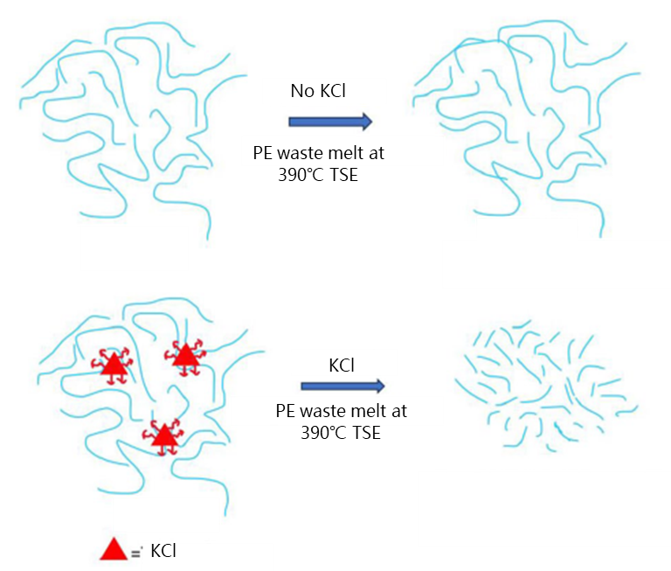

Figure 1. Schematic illustration of mechanism suggesting the role of KCl in the chemical upcycling of the PE waste

**II. Experimental**

**1**. **Materials and Extrusion**  
 The reclaimed PE as supplied by YnD chemical (MFI 5g/10min) and the KCl was purchased from OCI company. Compounds of reclaimed PE and KCl were prepared by melt extruding in an ultra-high speed co-rotating 15-mm-diameter twin-screw-extruder with a length-to-diameter (L/D) ratio of 60:1 (KZW15TW-45/60MG, Technovel, Japan). The TSE(KZW15TW-45/60MG) can reach up to 390°C. Formulations and extrusion conditions were presented in Table 1.

Table 1

Formulations and extrusion conditions used in this study

|  |  |  |  |  |
| --- | --- | --- | --- | --- |
| Sample | Materials | | Extrusion conditions | |
| **Reclaimed PE waste** | **KCl** | **Temperature\*** | **Screw speed** |
|  |  |  |  |  |
| PW-0-1 | 100 | 0 | 390°C | 500rpm |
| PW-0-2 | 100 | 0 | 390°C | 1000rpm |
| PW-5-1 | 95 | 5 | 390°C | 500rpm |
| PW-5-2 | 95 | 5 | 390°C | 1000rpm |
| PW-10-1 | 90 | 10 | 390°C | 500rpm |
| PW-10-1 | 90 | 10 | 390°C | 1000rpm |
|  |  |  |  |  |

* The maximum temperature of the TSE(KZW15TW-45/60MG)

**2**. **Characterization**

**2.1. Thermal analysis**  
 To evaluate the melting point of compounds, thermodynamic behaviors of the compounds characterized using differential scanning calorimetry (DSC 250). The sample was initially heated from room temperature to 200°C at a rate of 30°C/min for 5min to eliminate any thermal history of the crystal during processing. The sample was then cooled down 20°C at a rate of 10°C/min and kept at this temperature for 3min. Finally, the temperature was increased again to 200 °C at a rate of 10°C/min.  
 **3.2. Melt flow index test**  
 Melt flow index was measured by melt indexer (MP-1200, Tinius Olsen, USA) with 2.16kg load at 190℃ for 10 minutes.

**III. Results and Discussion**

DSC curves of compounds were measured as shown in Figure 2. The pure reclaimed PE exhibited melting points at 112°C and 123°C, indicating the presence of a mixture of LDPE and LLDPE. When the KCl was added, only one melting point was observed. Additionally, as the content of KCl increased, the melting point was decreased, which is presumed to be due to KCl inducing chain scission of PE. As the screw speed of TSE was increased, the melting point of the reclaimed PE was observed to decrease slightly.

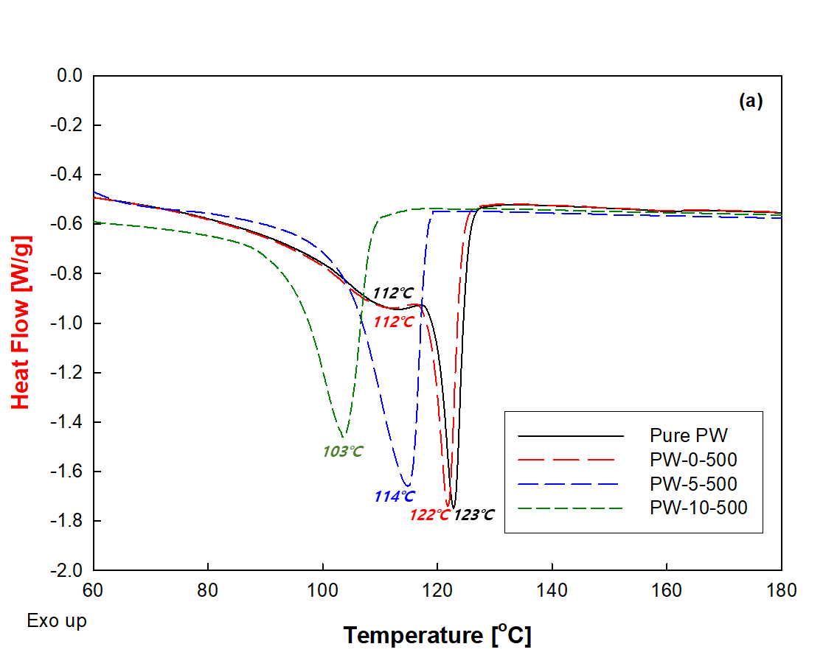

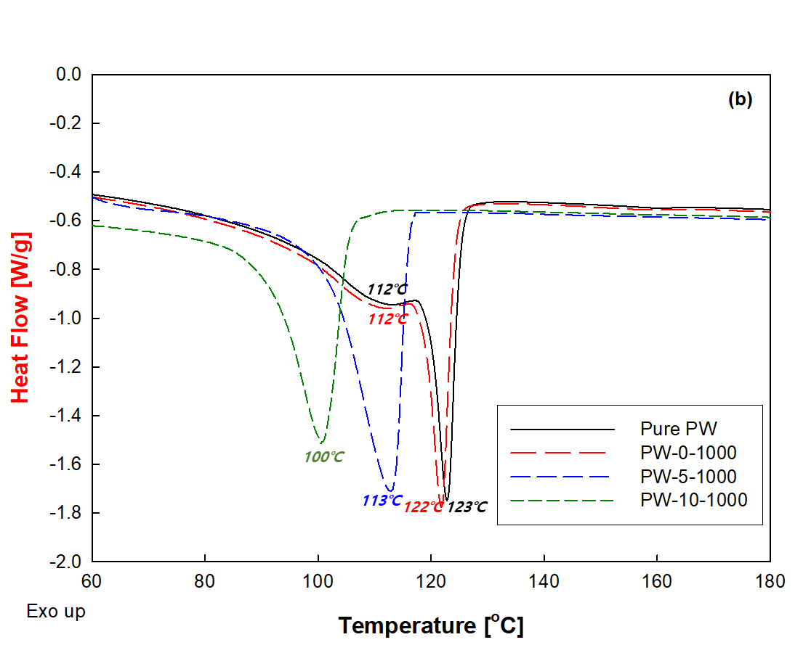

Figure 2. DSC curves of reclaimed PE with contents of KCl and the screw speed of the TSE: (a) Screw speed 500rpm, (b) Screw speed 1000rpm

The melt flow index (MFI) is defined as the amount of molten resin passing through a capillary equipment with defined length, diameter, and die geometry under prescribed conditions of temperature, load, and time interval. MFI of compounds were measured as shown in Figure 3. The pure reclaimed PE had the lowest MFI. As the content of KCl was increased, the MFI significantly was increased. However, as the screw speed of TSE was increased, a slight increase in MFI was observed.

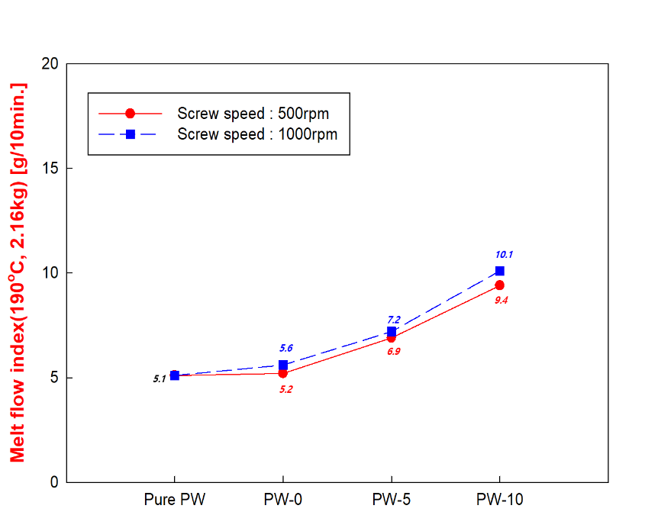

Figure 3. Melt flow index of reclaim PE with contents of KCl and the screw speed of TSE

**IV. Conclusion**  
 The effect of the potassium chloride (KCl) and the high shear rate of reactive twin-screw extrusion (TSE) on reclaimed PE was investigated by studying the melting point and the melt flow index (MFI) of compounds prepared in TSE by adding KCl to reclaimed PE. The higher KCl content added to compounds, the lower melting point and the higher MFI. When the KCl was added, only one melting point was observed. It indicates that the addition of KCl could accelerate the chain scission of reclaimed PE. However, it was observed that the melting point and MFI changes with the screw speed of TSE at 390℃ were not significant. Therefore, it was confirmed that the addition of KCl is more effective in tailoring the melting point of reclaimed PE than the high shear rate of TSE.

**Acknowledgments**  
 The author(s) disclosed receipt of the following financial support for the research, authorship, and/or publication of this article: This work was supported by Busan Metropolitan City, Republic of Korea (B-2024-02).

**References**

[1] OECD (2022), Global Plastics Outlook: Economic Drivers, Environmental Impacts

and Policy Options, OECD Publishing, Paris

[2] R. Geyer, J.R. Jambeck, K.L., Law Production, use, and fate of all plastics ever

made, Sci. Adv., 3 (7) (2017)

[3] A.L. Brooks, S. Wang, J.R. Jambeck, The Chinese import ban and its impact on

global plastic waste trade, Sci. Adv., 4 (6) (2018)

[4] T. Hundertmark, M. Mayer, C. McNally, T. Jan Simons, C. Witte, How plastics waste

recycling could transform the chemical industry,

[5] H. Thomson, K. Illingworth, H. McCoach, M. Jefferson, S. Morgan, Based on

Analysis of UK Grocery Packaging Data from – PlasticFlow2025

[6] Zoé O. G. Schyns & Michael P. Shaver, Macromol. Rapid Commun. 2021, 42

[7] G. Schyns, P. Shaver, Mechanical Recycling of Packaging Plastics: A Review,

Macromol. Rapid Commun. 2021, 42

[8] Balwada, J., Samaiya, S. & Mishra, R. P. Packaging plastic waste management for a

circular economy and identifying a better waste collection system using analytical

hierarchy

[9] S. Martey, B. Addison, N. Wilson, B. Tan, J. Yu, J. R. Dorgan and M. J. Sobkowicz,

Hybrid Chemomechanical Plastics Recycling: Solvent-free, High-Speed Reactive

Extrusion of Low-Density Polyethylene, ChemSusChem, 4 [19] (2021)

[10] Ma, J. et al. Thermal conductivity of electrospun polyethylene nanofibers,

Nanoscale 7, 16899–16908

[11] Mateck Potassium Chloride (KCl), <https://www.matweb.com/search/datasheet.

aspx?matguid=dd13aefb6c3f4b8b8048a88aa61d1dcd&n=1&ckck=1>