1. #1

Title Suitable for Abstract

**Planets. Exoplanet and Habitability: Characterization of exoplanet Habitability**

**“Are we Alone In The Universe ?. Illustration of Alien Planet”**

**Exoplanet; detection, Habitatablity , Biosignature**

**Exoplanet exploration : Planet Beyond our Solar system**

**R. K. Mishra1 and S.C.Dubey2**

1Department of Physics, A.P.S.University, Rewa (M.P.) India.

E-mail ~ rakesh\_response@rediffmail.com

2Department of Physics, S.G.S. Govt. P.G. College, Sidhi (M.P.) Pin-486661, India.

1Present address1 GHSS Kandel ,Disst Dhamtari C.G.

1. **Abstract**

Habitability means that availability of potential life support system. Such as Air, Liquid Water, Sunlight, Food Grains grows in habitable environment.

The habitability potential of planet critically depend upon the host starts characteristic, which can include stellar spectral energy distribution activity, X-rays? UV emission, magnetic field and stellar multiplicity. The capability to characterize the most promising planets for signs of habitability and Life, we are an establishing point in Human History where the answer to those questions that ARE WE Alone? Terrestrial Planet which orbit close to star that spent it early life in super-luminous state and maintains high stellar activity for an extended period of time. Exoplanet past, present and future based of finding on Habitable Zone. Scientist are identify potential habitable exoplanet nearly twenty years of detection. Ones 700 exoplanets have been recorded and confirmed by mission such as NASA Kepler Missions the Ashes discover of Pluto travels in space Crafts all space objects. man managed to stop only on the earth and moon., but technically maintained has long flown through outer solar system go to Pluto and continuous to Fly in Kuper Belt. Of course this is not about a living person, but dust traveling in Space craft. Understand well that Fly By mission are very essential to understand well.

Fly further and further. The search for habitable planets has revealed many habitable planet that can vary greatly from earth environment these include highly eccentric orbits, giants Planets, different bulk densities velocity achieve stars, and evolved starts all planets found to reside in habitable Zone boundaries. An interdisciplinary system science are approach are needed fully explore the depth and complexity of planetary habitability. An improved understanding. Identification of those exoplanet that are mistily to be habitable and item more interpretation of upcoming exoplanet data to be used to search life beyond Earth. How balance between out gassing and atmospheric escape sculpts the resulting terrestrial planet’s atmosphere.

**References:**

1. Dale Anderson’s 1996 Antartic Field Research photo Albums.
2. Deeg, H., Beltmonte;J.(eds) Hand Book of exoplanet, Springer,cham(2018).related DOI https//doi.org/10.1007/978-3-319-55333-7-67.
3. Ravi Kumar Kopparapu, Eric Wolf,Victoria S.Meadows. Planets , exoplanet and habitability characterstics of exoplanet habitability.
4. Web Link reference P. Von Paris 2013:Charcterization of potentially habitable Planets
5. C.Hall.,P.C. stencil., J.P. Terry and C.K. Ellison. Published 2023 may 15 , 2023 published by American Astronomical Society the Astrophysical Journals Letters Volume 948, Number 2 C Hall et al 2023 April 948L26 DOI 10.3847/2041-8213.accfb. article pdf.
6. Seager; bains W., Petkowski, J.,J., 2016, Toward a list of Molecules as Potential Biosignature gases for the search for life on exoplanets and Applications to terrestrial Biotechnology Astrobiology,16,465.
7. https://depts.washington.edu/astrobio/wordpress/research-areas/exoplanets-detection-habitability-biosignatures/
8. **#2**

**Planets. Exoplanet and Habitability:**

**Characterization of exoplanet Habitability**

**R. K. Mishra1 and S.C.Dubey2**

1Department of Physics, A.P.S.University, Rewa (M.P.) India.

E-mail ~ rakesh\_response@rediffmail.com

2Department of Physics, S.G.S. Govt. P.G. College, Sidhi (M.P.) Pin-486661, India.

1Present address1 GHSS SEGES Kandel ,Disst Dhamtari C.G.

Habitability means that availability of potential life support system. Such as Air, Liquid Water, Sunlight, Food Grains grows in habitable environment.

The habitability potential of planet critically depend upon the host starts characteristic, which can include stellar spectral energy distribution activity, X-rays? UV emission, magnetic field and stellar multiplicity. The capability to characterize the most promising planets for signs of habitability and Life, we are an establishing point in Human History where the answer to those questions that ARE WE Alone? Terrestrial Planet which orbit close to star that spent it early life in super-luminous state and maintains high stellar activity for an extended period of time. Exoplanet past, present and future based of finding on Habitable Zone.

Scientist are identify potential habitable exoplanet nearly twenty years of detection. Ones 700 exoplanets have been recorded and confirmed by mission such as NASA Kepler Missions the Ashes discover of Pluto travels in space Crafts all space objects. Man managed to stop only on the earth and moon. But technically maintained has long flown through outer solar system go to Pluto and continuous to fly in Kuiper Belt.

Of course this is not about a living person, but dust traveling in Space craft. Understand well that Fly By mission are very essential to understand well.

Fly further and further. The search for habitable planets has revealed many habitable planet that can vary greatly from earth environment these include highly eccentric orbits, giants Planets, different bulk densities velocity achieve stars, and evolved starts all planets found to reside in habitable Zone boundaries. An interdisciplinary system science are approach are needed fully explore the depth and complexity of planetary habitability. An improved understanding. Identification of those exoplanet that are mistily to be habitable and interim more interpretation of upcoming exoplanet data to be used to search life beyond Earth. How balance between out gassing and atmospheric escape sculpts the resulting terrestrial planet’s atmosphere.

**Introduction**

Exoplanets with possibility of life  are Potentially habitable exoplanets, which are planets outside our solar system that have similar conditions to Earth, such as temperature, atmosphere, and liquid water. Some examples are Kepler-186f, Kepler-452b, and Proxima Centauri b. Moons of gas giants, which have subsurface oceans that may harbor life. Some examples are Europa and Enceladus, which orbit Jupiter and Saturn respectively. Mars, which is the most Earth-like planet in our solar system and may have had life in the past or present. Venus, which has a thick atmosphere that may support microbial life in the upper clouds.

Habitability means that availability of potential life support system. Such as Air, Liquid Water, Sunlight, Food Grains grows in habitable environment.

The habitability potential of planet critically depend upon the host starts characteristic, which can include stellar spectral energy distribution activity, X-rays? UV emission, magnetic field and stellar multiplicity. The capability to characterize the most promising planets for signs of habitability and Life, we are an establishing point in Human History where the answer to those questions that ARE WE Alone? Terrestrial Planet which orbit close to star that spent it early life in super-luminous state and maintains high stellar activity for an extended period of time. Exoplanet past, present and future based of finding on Habitable Zone. Scientist are identify potential habitable exoplanet nearly twenty years of detection. Ones 700 exoplanets have been recorded and confirmed by mission such as NASA Kepler Missions the Ashes discover of Pluto travels in space Crafts all space objects. Man managed to stop only on the earth and moon. but technically maintained has long flown through outer solar system go to Pluto and continuous to Fly in Kuiper Belt. Of course this is not about a living person, but dust traveling in Space craft. Understand well that Fly By mission are very essential to understand well.

Fly further and further. The search for habitable planets has revealed many habitable planet that can vary greatly from earth environment these include highly eccentric orbits, giants Planets, different bulk densities velocity achieve stars, and evolved starts all planets found to reside in habitable Zone boundaries. An interdisciplinary system science are approach are needed fully explore the depth and complexity of planetary habitability. An improved understanding. Identification of those exoplanet that are mistily to be habitable and item more interpretation of upcoming exoplanet data to be used to search life beyond Earth. How balance between out gassing and atmospheric escape sculpts the resulting terrestrial planet’s atmosphere.

**Researchers are developing new techniques to search for and detect exoplanets**

Researchers are developing new techniques to search for and detect exoplanets that might be able to support life. The Virtual Planetary Laboratory (VPL) team of the NASA Astrobiology Institute and Nexus for Exoplanet System Science, NExSS, are interdisciplinary teams that focus on understanding exoplanet habitability and biosignatures. They use a comprehensive suite of computer models to simulate the formation, orbits, tides, atmospheres, and atmospheric evolution of extra-solar planets. These computer models, in combination with astronomical and planetary observations, explore the effects on habitability of radiative and gravitational interactions between a terrestrial planet, its parent star, and other planets in its planetary system. [They also use computer models, laboratory measurements, and field work to explore the interplay between life and its environment, to learn how to identify biosignatures using exoplanet spectra 1](https://depts.washington.edu/astrobio/wordpress/research-areas/exoplanets-detection-habitability-biosignatures/).

[In addition, researchers are exploring the possibility of detecting biosignatures that vary in time and atmospheric gases that shouldn’t exist without life to replenish them 2](https://astrobiology.nasa.gov/news/detecting-lifes-influence-on-planetary-atmospheres/). [The James Webb Space Telescope, which will observe small planets orbiting nearby M dwarf stars, is expected to provide the first opportunity to use observations to characterize small exoplanetary environments for signs of habitability — and perhaps even biosignatures 1](https://depts.washington.edu/astrobio/wordpress/research-areas/exoplanets-detection-habitability-biosignatures/).

It is important to note that the search for biosignatures is still ongoing and there is no conclusive evidence of life beyond Earth yet.

#### **[Exoplanets: Detection, Habitability, Biosignatures](https://depts.washington.edu/astrobio/wordpress/research-areas/exoplanets-detection-habitability-biosignatures/" \t "_blank)**

The instruments used in Venus and Mars missions vary depending on the mission’s objectives. Here are some examples of instruments used in recent missions:

[**Venus Express orbiter**: The orbiter carried several instruments, including ASPERA (Analyser of Space Plasma and Energetic Atoms), MAG (Venus Express Magnetometer), PFS (Planetary Fourier Spectrometer), SPICAV/SOIR (Ultraviolet and Infrared Atmospheric Spectrometer), VeRa (Venus Radio Science Experiment), VIRTIS (Visible and Infrared Thermal Imaging Spectrometer), and VMC (Venus Monitoring Camera) 1](https://www.esa.int/Science_Exploration/Space_Science/Venus_Express/Orbiter_instruments).

[**Mars Reconnaissance Orbiter**: The orbiter carries six science instruments, including HiRISE (High Resolution Imaging Science Experiment), CTX (Context Camera), MARCI (Mars Color Imager), CRISM (Compact Reconnaissance Imaging Spectrometer for Mars), MCS (Mars Climate Sounder), and SHARAD (Shallow Radar) 2](https://mars.nasa.gov/mro/mission/instruments/).

.

[**Mars Orbiter Mission**: The mission carries five scientific instruments, namely Mars Colour Camera (MCC), Thermal Infrared Imaging Spectrometer (TIS), Methane Sensor for Mars (MSM), Lyman Alpha Photometer (LAP), and Mars Exospheric Neutral Composition Analyser (MENCA) 3](https://science.nasa.gov/mission/veritas/science/).

[**DAVINCI+**: The mission will carry several instruments, including VMS (Venus Mass Spectrometer), VTLS (Venus Tunable Laser Spectrometer), VASI (Venus Atmospheric Structure Investigation), and VenDI (Venus Descent Imager) 4](https://mars.nasa.gov/mars2020/spacecraft/instruments/).

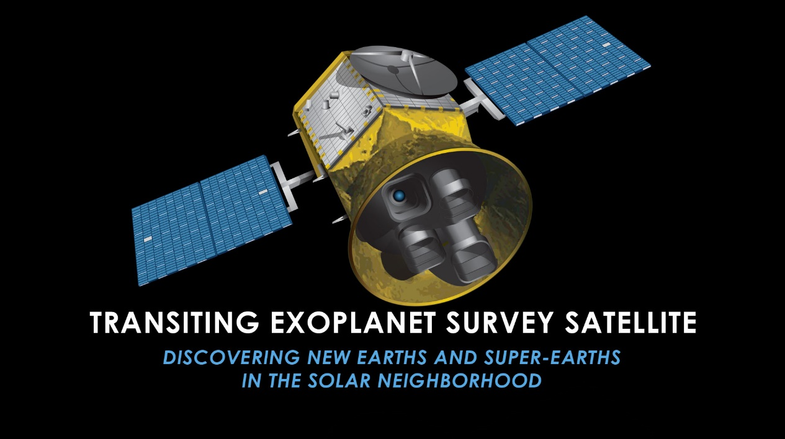

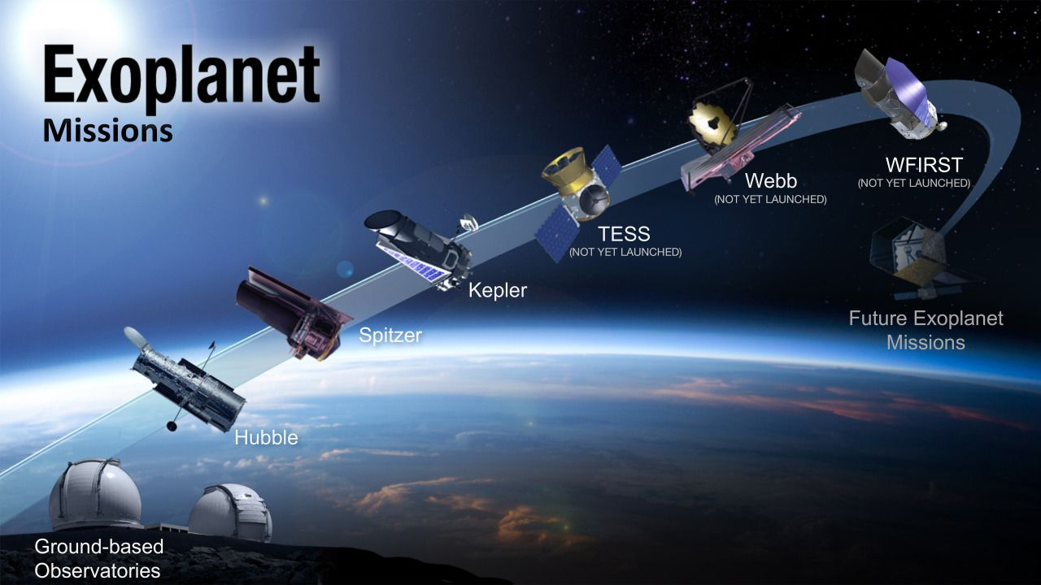

Exoplanet search and observe Outer space through Satellite

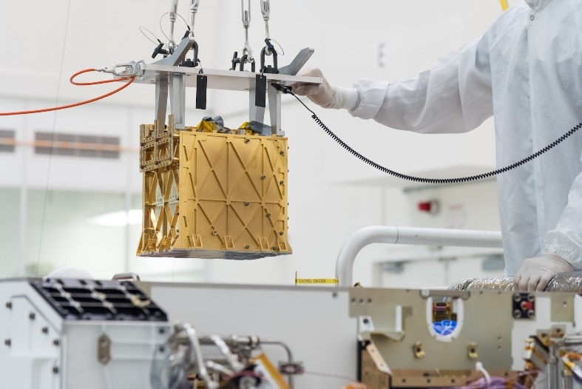

Image of MOXIE

# MOXIE

The Mars Oxygen In-Situ Resource Utilization Experiment, or MOXIE, is helping NASA prepare for human exploration of Mars. MOXIE will test a way for future explorers to produce oxygen from the Martian atmosphere for burning fuel and breathing.

**biosignature**

A **biosignature** (sometimes called **chemical fossil** or **molecular fossil**) is any substance – such as an element, [isotope](https://en.wikipedia.org/wiki/Isotope), [molecule](https://en.wikipedia.org/wiki/Molecule), or [phenomenon](https://en.wikipedia.org/wiki/Phenomenon) that provides [scientific evidence](https://en.wikipedia.org/wiki/Scientific_evidence) of past or present [life](https://en.wikipedia.org/wiki/Life).[[1]](https://en.wikipedia.org/wiki/Biosignature#cite_note-SSG-1)[[2]](https://en.wikipedia.org/wiki/Biosignature#cite_note-2)[[3]](https://en.wikipedia.org/wiki/Biosignature#cite_note-Biosignatures_2011-3) Measurable attributes of life include its complex physical or chemical structures and its use of [free energy](https://en.wikipedia.org/wiki/Thermodynamic_free_energy) and the production of [biomass](https://en.wikipedia.org/wiki/Biomass) and [wastes](https://en.wikipedia.org/wiki/Cellular_waste_product). A biosignature can provide evidence for living organisms outside the Earth and can be directly or indirectly detected by searching for their unique byproducts.

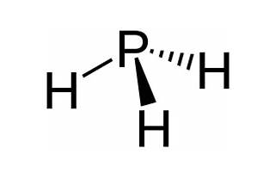

there is a **biosignature** that has been found in Venus. [In September 2020, a team of scientists announced the presence of **phosphine** in Venus’s atmosphere 1](https://www.planetary.org/articles/venus-phosphine-biosignature). [Phosphine is a molecule that is strongly associated with the chemistry of life and has few non-life methods of production, particularly on a rocky planet like Venus 1](https://www.planetary.org/articles/venus-phosphine-biosignature). [However, it is important to note that this does not guarantee the existence of life on Venus, but it is a compelling argument for further exploration 1](https://www.planetary.org/articles/venus-phosphine-biosignature). [The detection of phosphine in Venus’s atmosphere is one piece of evidence in support of the hypothesis that microbial life forms could be floating around the planet 1](https://www.planetary.org/articles/venus-phosphine-biosignature). [However, further independent scientific teams must confirm this signal 1](https://www.planetary.org/articles/venus-phosphine-biosignature).



:

What is phosphine?How can we confirm the presence of life on Venus?Is there any mission planned to explore more about this biosignature in Venus?

Habitability means that availability of potential life support system. Such as Air, Liquid Water, Sunlight ,Food Grains grows in habitable enviriounment.

The habitability potential of planet critically depend upon the host starts characteristic , which can include stellar specteral energy distribution activity, X-rays ?UV emission, magnetic field and stellar multiplicity. The capability to characterize the most promosing planets for signs of habitability and Life , we are an establishing point in Human History where the answer to those questions that ARE WE Alone ?. terrestrial Planet which orbit close to star that spent it early life in super-luminous state and maintains high stellar activity for and extended period of time . exoplanet past, present and future based of finding on Habitable Zone . scientist are identify potential Habitable exoplanet nearly twenty years of detection. Ones 700 exoplanets have been recorded and confirmed by mission such as NASA Keplar Missions the Ashes discover of Pluto travels in space Crafts all space objects . man managed to stop only on the earth and moon., but technically maintained has long flown through outer solar system go to pluto and continuous to Fly in Kuper Belt. Of course this is not about a living person, but dust traveling in Space craft. Understand well that Fly By mission are very essential to understand well.

Fly further and further.The search for habitable planets has revealed many habitable planet that can vary ggreatly from earth environment these include highly eccentric orbits, gaints Planets, different bulk densities velocity achieve stars ,and evoloved starts all planets found to reside in habitable Zone boundaries. An interdisciplinary system science are approach are needed fully explore the depth and complexity of planetary habitability. An improved understanding. Identification of those exoplanet that are mostlikly to be habitable and iterm more interpretation of upcoming exoplanet data to be used to search life beyond Earth. How balance between out gassing and atmospheric escape sculpts the resulting terrestrial planets atmosphere.

The Ashes of Discover of pluto travels in a Space Craft all space Craft objects man managed to step only on the earth and moon. , but technically mainkind has long flown trough outer solar system go to Pluto and continues to flyin Kuper belt.ofcourse this is not about a living Person, but dust traveling in space craft. Understand well Fly further and further

The ashes of discovers of pluto travels in space craft

Anscent Black holes can be unusually huge.

# The ashes of the discoverer of Pluto travels in a spacecraft



Of all space objects, man managed to step only on the Earth and the Moon. But technically, mankind has long flown through the outer solar system, got to Pluto and continues to fly in the Kuiper belt. Of course, this is not about a living person, but **dust** traveling in a spacecraft.

## Fly further and further

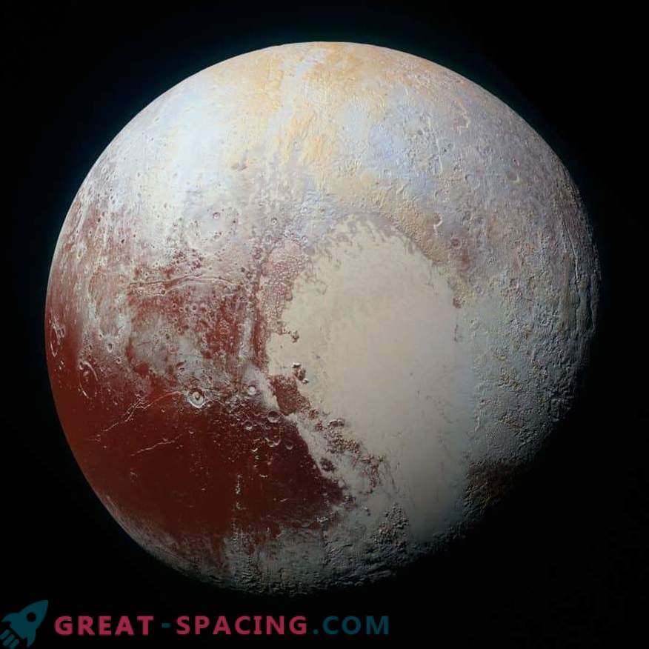

Photo of Pluto taken by New Horizons spacecraft

In **2006** one of the most important modern missions started. This is a NASA spacecraft **New Horizons**. Its main goal is to examine the dwarf planet **Pluto** and the nearby satellite **Charon** for the first time from an approximate distance. The apparatus performed research in flight, so no landings.

Along the way, New Horizons managed to cross the orbits of Mars and the gas giants, and in **2015** sent rare **photos** of the surface of Pluto. Moreover, the resolution level of the survey exceeded the known capabilities of the Hubble Space Telescope. After that, the ship moved on, photographed **Quavar** and analyzed the environment of trans-Neptunian objects. More recently (**January 1, 2019**), the mission moved to a new level, since the device made a close flight near asteroid **2014 MU69**.

However, the spacecraft does not travel alone. There is a passenger on board **, or more precisely, a piece of it. This is part of the dust of a famous astronomer Clyde Tombo. But how did he get there and how did he deserve such an honor?**

## Discoverer of Pluto

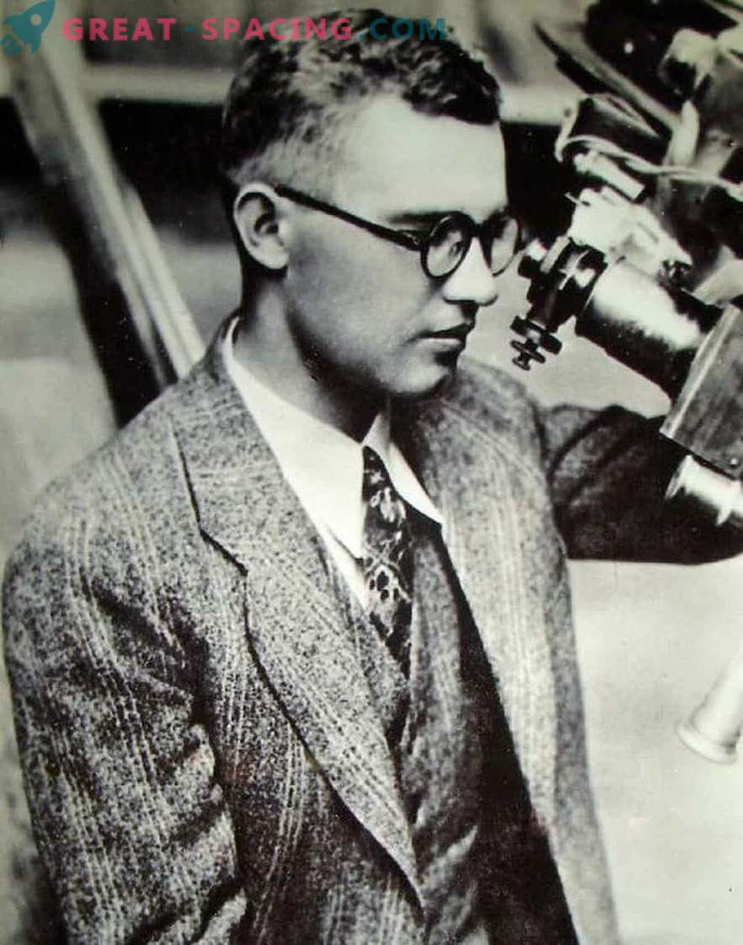

**Clyde Tombo, first of all, was remembered by the fact that found Pluto. As a young employee of the Lowell Observatory, he was assigned to view photographs obtained from the search program for planet X. In 1930 he noticed a moving object, which later turned out to be Pluto.**

**Tombo received many prestigious awards for the discovery. Also in his honor called the area on Pluto. He died in 1997 at the age of 90. The body was cremated, but some of the ashes were preserved.**

## Dust on a spaceship

**A part of the father to the dwarf planet decided to send the daughter Tombo - Annette. She said:**

**“When he looked at Pluto, he saw only a speck of light. I think he would like to see the planet discovered by him with his own eyes. This is simply amazing. ”**

**Engineers manufactured a special container for a small amount of dust (not more than an ounce) of Clyde Tombo. It was attached to the inside of the upper deck of the New Horizons apparatus. There is also a memo**

**“The remains of the American Clyde Tombo, the discoverer of Pluto and the third zone of the Solar System” are stored here.**

**New Horizons are moving deeper into the Kuiper belt. One day the ship will enter the interstellar space, and the first human remains will be beyond the Solar System! I wonder how the newcomers will react to the find?**

# Search for Alien Life Should Target Water, Oxygen and Chlorophyll

The next generation of space telescopes hunting for signs of extraterrestrial life should focus on water, then oxygen and then alien versions of the plant chemical chlorophyll, a new study suggests.

In the past 20 years or so, astronomers have confirmed the existence of nearly 2,000 worlds outside Earth's solar system. Many of these [exoplanets](https://www.space.com/16681-alien-planets-quiz.html) lie in the habitable zones of stars, areas potentially warm enough for the worlds to harbor liquid water on their surfaces. Astrobiologists hope that life may someday be spotted on such alien planets, since there is life pretty much everywhere water exists on Earth.

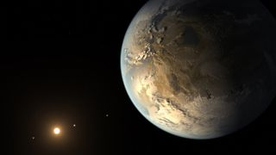

This artist's concept shows Kepler-186f, the first roughly Earth-size planet found to be orbiting in the habitable zone of its star. Searches for signs of life on worlds such as Kepler-186f could focus on water, oxygen and alien versions of chlorophyll, researchers say. (Image credit: NASA Ames/SETI Institute/JPL-Caltech)

The next generation of space telescopes hunting for signs of extraterrestrial life should focus on water, then oxygen and then alien versions of the plant chemical chlorophyll, a new study suggests.

In the past 20 years or so, astronomers have confirmed the existence of nearly 2,000 worlds outside Earth's solar system. Many of these [exoplanets](https://www.space.com/16681-alien-planets-quiz.html) lie in the habitable zones of stars, areas potentially warm enough for the worlds to harbor liquid water on their surfaces. Astrobiologists hope that life may someday be spotted on such alien planets, since there is life pretty much everywhere water exists on Earth.

One strategy to discover signs of such alien life involves looking for ways that organisms might change a world's appearance. For example, chemicals typically shape what are known as the spectra seen from planets by adding or removing wavelengths of light. Alien-hunting telescopes could look for spectra that reveal chemicals associated with life. In other words, these searches would focus on biosignatures — chemicals or combinations of chemicals that life could produce, but that processes other than life could not or would be unlikely to create. [[5 Bold Claims of Alien Life](https://www.space.com/11057-science-claims-alien-life.html)]

"Water is a very common molecule, and I think a mission to take spectra of [exoplanets](https://www.space.com/17738-exoplanets.html) should certainly look for water," said Brandt, the lead study author. "Indeed, we have found water in a few gas giants more massive than Jupiter orbiting other stars."

In comparison, oxygen is more difficult to detect than previously thought, requiring scientific instruments approximately twice as sensitive as those needed to detect water and significantly better at discriminating between similar colors of light.

"Oxygen, however, has only been a large part of [Earth's atmosphere](https://www.space.com/17683-earth-atmosphere.html) for a few hundred million years," Brandt said. "If we see it in an exoplanet, it probably points to life, but not finding oxygen certainly does not mean that the planet is sterile."

Although a well-designed space telescope could detect water and oxygen on a nearby [Earth twin](https://www.space.com/25540-kepler-space-telescope-earth-twin-search.html), the astrophysicists found the instrument would need to be significantly more sensitive, or very lucky, to see chlorophyll. Identifying this chemical typically requires scientific instruments about six times more sensitive than those needed for oxygen. Chlorophyll becomes as detectable as oxygen only

when an exoplanet has a lot of vegetation and/or little in the way of cloud cover, researchers said.

Chlorophyll slightly reddens the light from Earth. If extraterrestrial life does convert sunlight to energy as plants do, scientists expect that the alien process might use a different pigment than chlorophyll. But alien photosynthesis could also slightly redden planets

An exoplanet's color—or reflectance spectrum—can also be used as a biosignature due to the effect of pigments that are uniquely biologic in origin such as the pigments of phototrophic and photosynthetic life forms.

The UWAB community also encompasses the [Virtual Planetary Laboratory](http://vpl.astro.washington.edu/) (VPL) team of the NASA Astrobiology Institute and Nexus for Exoplanet System Science, [NExSS](https://nexss.info/). This interdisciplinary team focuses on understanding exoplanet habitability and biosignatures.

use biosignatures to determine if living [organisms](https://en.wikipedia.org/wiki/Organism) are or were present in a sample. These possible biosignatures include: (a) [microfossils](https://en.wikipedia.org/wiki/Microfossils) and [stromatolites](https://en.wikipedia.org/wiki/Stromatolites" \o "Stromatolites); (b) molecular structures ([biomarkers](https://en.wikipedia.org/wiki/Biomarkers)) and [isotopic compositions](https://en.wikipedia.org/wiki/Isotope) of carbon, nitrogen and hydrogen in [organic matter](https://en.wikipedia.org/wiki/Organic_matter); (c) multiple sulfur and oxygen isotope ratios of minerals; and (d) abundance relationships and isotopic compositions of redox-sensitive metals (e.g., Fe, Mo, Cr, and rare earth elements).[[19]](https://en.wikipedia.org/wiki/Biosignature#cite_note-PSARC-19)[[20]](https://en.wikipedia.org/wiki/Biosignature#cite_note-20)

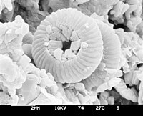

Electron micrograph of microfossils from a sediment core obtained by the [Deep Sea Drilling](https://en.wikipedia.org/wiki/Deep_Sea_Drilling_Program)

the particular [fatty acids](https://en.wikipedia.org/wiki/Fatty_acids) measured in a sample can indicate which types of [bacteria](https://en.wikipedia.org/wiki/Bacterium) and [archaea](https://en.wikipedia.org/wiki/Archaea) live in that environment. Another example is the long-chain [fatty alcohols](https://en.wikipedia.org/wiki/Fatty_alcohol) with more than 23 atoms that are produced by [planktonic](https://en.wikipedia.org/wiki/Plankton) [bacteria](https://en.wikipedia.org/wiki/Bacteria).[[21]](https://en.wikipedia.org/wiki/Biosignature#cite_note-21) When used in this sense, geochemists often prefer the term [biomarker](https://en.wikipedia.org/wiki/Biomarker). Another example is the presence of straight-chain [lipids](https://en.wikipedia.org/wiki/Lipids) in the form of [alkanes](https://en.wikipedia.org/wiki/Alkanes), [alcohols](https://en.wikipedia.org/wiki/Alcohols), and [fatty acids](https://en.wikipedia.org/wiki/Fatty_acids) with 20-36 [carbon](https://en.wikipedia.org/wiki/Carbon) atoms in soils or sediments. [Peat](https://en.wikipedia.org/wiki/Peat) deposits are an indication of originating from the [epicuticular wax](https://en.wikipedia.org/wiki/Epicuticular_wax" \o "Epicuticular wax) of higher [plants](https://en.wikipedia.org/wiki/Plant).

Life processes may produce a range of biosignatures such as [nucleic acids](https://en.wikipedia.org/wiki/Nucleic_acids), [lipids](https://en.wikipedia.org/wiki/Lipid), [proteins](https://en.wikipedia.org/wiki/Protein), [amino acids](https://en.wikipedia.org/wiki/Amino_acid), [kerogen](https://en.wikipedia.org/wiki/Kerogen)-like material and various morphological features that are detectable in rocks and sediments.[[22]](https://en.wikipedia.org/wiki/Biosignature#cite_note-Beegle-22) [Microbes](https://en.wikipedia.org/wiki/Microbes) often interact with geochemical processes, leaving features in the rock record indicative of biosignatures. For example, bacterial micrometer-sized pores in [carbonate rocks](https://en.wikipedia.org/wiki/Carbonate_rock) resemble inclusions under transmitted light, but have distinct sizes, shapes, and patterns (swirling or dendritic) and are distributed differently from common fluid inclusions.[[23]](https://en.wikipedia.org/wiki/Biosignature#cite_note-23) A potential biosignature is a phenomenon that *may* have been produced by life, but for which alternate [abiotic](https://en.wikipedia.org/wiki/Abiotic_component) origins may also be possible.

#### Methane on Mars

[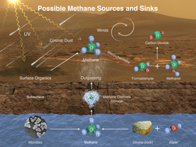](https://en.wikipedia.org/wiki/File:PIA19088-MarsCuriosityRover-MethaneSource-20141216.png)

[Methane](https://en.wikipedia.org/wiki/Atmosphere_of_Mars#Methane) (CH4) on Mars - potential sources and sinks.

The presence of methane in the [atmosphere of Mars](https://en.wikipedia.org/wiki/Atmosphere_of_Mars) is an area of ongoing research and a highly contentious subject. Because of its tendency to be destroyed in the atmosphere by [photochemistry](https://en.wikipedia.org/wiki/Photochemistry), the presence of excess methane on a planet can indicate that there must be an active source. With life being the strongest source of methane on Earth, observing a disequilibrium in the methane abundance on another planet could be a viable biosignature.[[63]](https://en.wikipedia.org/wiki/Biosignature#cite_note-:0-63)[[64]](https://en.wikipedia.org/wiki/Biosignature#cite_note-:1-64)

A biosignature gas is defined as one that is produced by life and accumulates in an atmosphere to detectable levels. Any kind of ab initio approach to predicting what biosignature gases might be is so challenging that nearly all work done to date basically follows the “We know what Earth life produces, so what might Earth s products look like if transplanted to another, slightly different, Earth-like planet” (Earth-like refers to a planet with about the same size and mass as Earth, with oceans and continents, a thin N2-CO2-O2 atmosphere, and a radiation environment similar to that of Earth’s. Gases studied in this context include oxygen, the otherwise unexplained simultaneous presence of gases out of thermodynamic equilibrium (specifically methane with oxygen), methyl halides, sulfur compounds, and some other gases

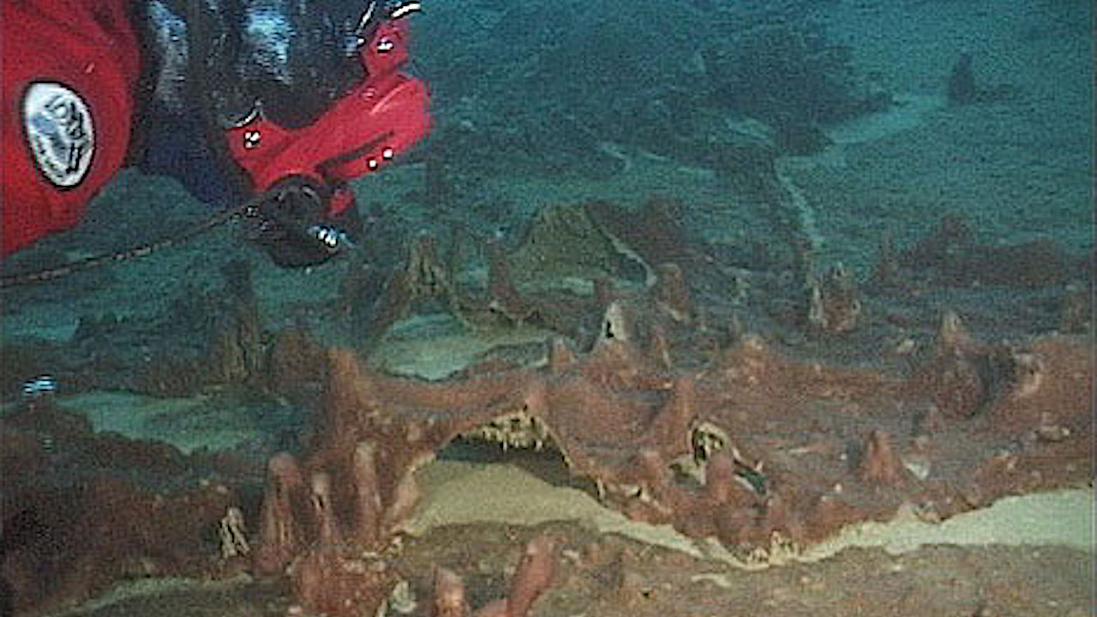

Biosignature image in antratica

Signs of life that we can detect in a planet’s atmosphere are called ‘biosignatures’. These are gases that would be unlikely to occur without the presence of life. Earth’s main biosignature is a very important gas for all of us: oxygen.

An atmosphere with as much oxygen as Earth’s – 20 per cent of the total – simply shouldn’t exist under normal circumstances. This is because oxygen is an extremely reactive gas. That means that it readily combines with other chemicals to form something completely different. So, generally, oxygen doesn’t hang around for long.

We experience oxygen’s tendency to react with other chemicals every day. When you light a fire, you are adding enough heat to prompt the chemicals in the fuel to combine with the oxygen in the air. After a while, rust forms on iron products left uncoated – this is caused by oxygen in the air reacting with the iron.

Future Challenge In Venus Mission

**Corrosive sulfuric clouds**: Venus’s atmosphere is composed of sulfuric acid, which can corrode spacecraft materials.

**Crushing atmosphere**: Venus’s atmosphere is 90 times denser than Earth’s, which makes it difficult to design spacecraft that can withstand the pressure.

**Surface activity**: Venus offers different challenges compared to Mars, given the thick atmosphere and surface activity, which make it a complex planet.

**Limited data**: In order to have a deeper understanding of Venus, the instruments need to go deep through the atmosphere. With a flyby mission like this, only a few hours of data would be possible on the inbound and outbound trajectories.

Outer space, commonly referred to simply as space, is the expanse that exists beyond Earth and its atmosphere and between celestial bodies. Outer space is not completely empty; it is a near-perfec…

[Wikipedia](https://en.wikipedia.org/wiki/Outer_space)

These high-energy particles arriving from outer space are mainly (89%) protons –**nuclei of hydrogen,** the lightest and most common element in the universe – but they also include**nuclei** of**helium** (10%) and heavier**nuclei** (1%), all the way up to uranium



[**Cosmic-Ray Experiments at CERN**](https://home.cern/science/physics/cosmic-rays-particles-outer-space#Cosmic-Ray%20Experiments%20at%20CERN)

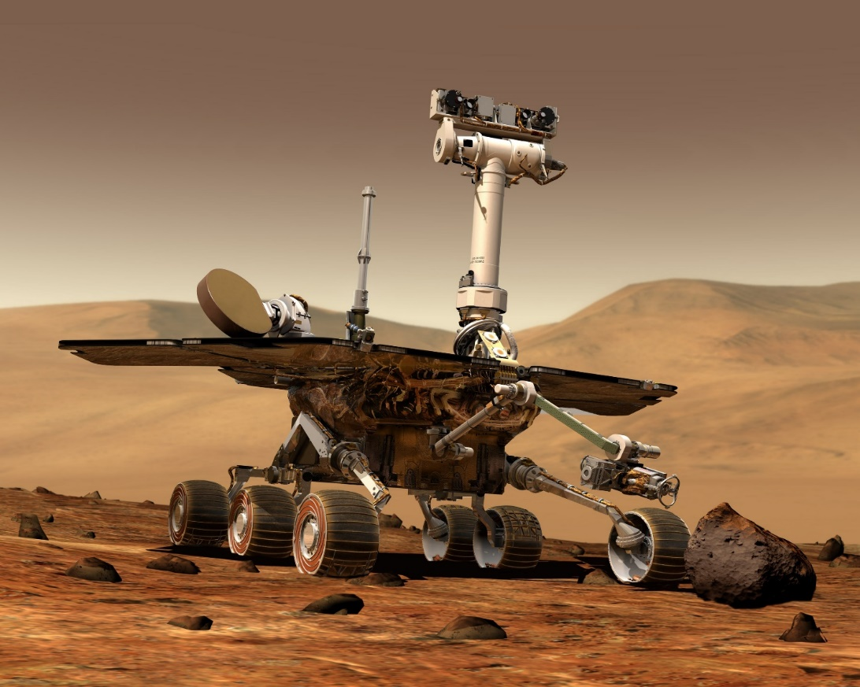

Mars Rover Preservance search Biosignature in Marsian Surface

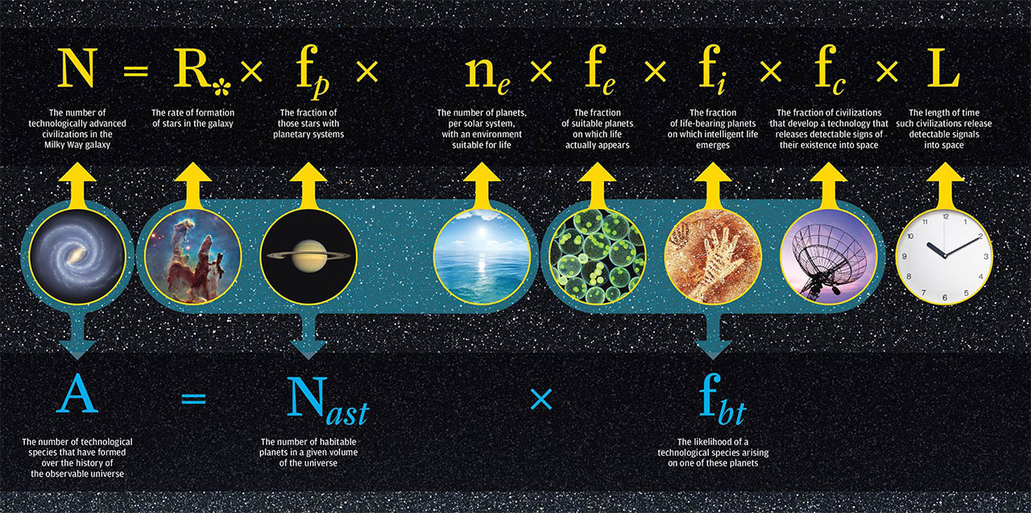

**the**[**Drake equation**](https://en.wikipedia.org/wiki/Drake_equation)**are closely related to the Fermi paradox**

The theories and principles in the [Drake equation](https://en.wikipedia.org/wiki/Drake_equation) are closely related to the Fermi paradox.[[29]](https://en.wikipedia.org/wiki/Fermi_paradox#cite_note-30) The equation was formulated by [Frank Drake](https://en.wikipedia.org/wiki/Frank_Drake) in 1961 in an attempt to find a systematic means to evaluate the numerous probabilities involved in the existence of alien life. The equation is presented as follows:

The formula for the Drake equation is:

N = R\* x 𝑓p x ne x 𝑓1 x 𝑓i x 𝑓c x L

R\* = average rate of star formation in [Milky Way](https://www.livescience.com/tag/milky-way)

𝑓p = fraction of stars supporting planets

ne = average number of planets that could potentially support life for each star that hosts planets

𝑓1 = fraction of those planets that "could" support life that actually develop life

𝑓i = fraction of planets that develop intelligent life, and thus intelligent civilizations

𝑓c = fraction of those civilizations that develop a technology to communicate their existence

L = length of time over which these civilizations send those detectable signals into space

By including all of these factors in the equation, the idea is you might be able to work out how many other intelligent civilizations exist in the universe.

�=�∗⋅�p⋅�e⋅�l⋅�i⋅�c⋅�

The Drake equation has been used by both optimists and pessimists, with wildly differing results. The first scientific meeting on the [search for extraterrestrial intelligence](https://en.wikipedia.org/wiki/Search_for_extraterrestrial_intelligence) (SETI), which had 10 attendees including Frank Drake and [Carl Sagan](https://en.wikipedia.org/wiki/Carl_Sagan), speculated that the number of civilizations was roughly between 1,000 and 100,000,000 civilizations in the Milky Way galaxy.[[31]](https://en.wikipedia.org/wiki/Fermi_paradox#cite_note-32) Conversely, [Frank Tipler](https://en.wikipedia.org/wiki/Frank_J._Tipler) and [John D. Barrow](https://en.wikipedia.org/wiki/John_D._Barrow) used pessimistic numbers and speculated that the average number of civilizations in a galaxy is much less than one.[[32]](https://en.wikipedia.org/wiki/Fermi_paradox#cite_note-33) Almost all arguments involving the Drake equation suffer from the [overconfidence effect](https://en.wikipedia.org/wiki/Overconfidence_effect), a common error of probabilistic reasoning about low-probability events, by guessing specific numbers for likelihoods of events whose mechanism is not yet understood, such as the likelihood of [abiogenesis](https://en.wikipedia.org/wiki/Abiogenesis) on an Earth-like planet, with current likelihood estimates varying over many hundreds of [orders of magnitude](https://en.wikipedia.org/wiki/Order_of_magnitude).

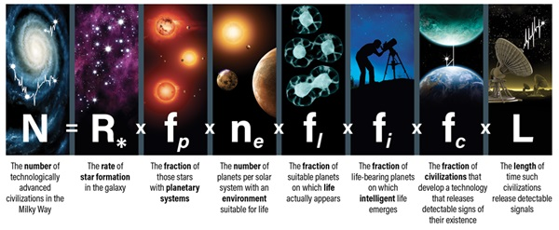

The Drake equation is used to estimate the number of advanced civilizations in the Milky Way. Because researchers work with a number of uncertainties within each variable, the equation can never be solved.

Astronomy: Roen Kelly

The formula for the Drake equation is:

N = R\* x 𝑓p x ne x 𝑓1 x 𝑓i x 𝑓c x L

R\* = average rate of star formation in [Milky Way](https://www.livescience.com/tag/milky-way)

𝑓p = fraction of stars supporting planets

ne = average number of planets that could potentially support life for each star that hosts planets

𝑓1 = fraction of those planets that "could" support life that actually develop life

𝑓i = fraction of planets that develop intelligent life, and thus intelligent civilizations

𝑓c = fraction of those civilizations that develop a technology to communicate their existence

L = length of time over which these civilizations send those detectable signals into space

By including all of these factors in the equation, the idea is you might be able to work out how many other intelligent civilizations exist in the universe.

**References:**

1. Dale Anderson’s 1996 Antartic Field Research photo Albums.
2. Deeg, H., Beltmonte;J.(eds) Hand Book of exoplanet, Springer,cham(2018).related DOI https//doi.org/10.1007/978-3-319-55333-7-67.
3. Ravi Kumar Kopparapu, Eric Wolf,Victoria S.Meadows. Planets , exoplanet and habitability characterstics of exoplanet habitability.
4. Web Link reference P. Von Paris 2013:Charcterization of potentially habitable Planets
5. C.Hall.,P.C. stencil., J.P. Terry and C.K. Ellison. Published 2023 may 15 , 2023 published by American Astronomical Society the Astrophysical Journals Letters Volume 948, Number 2 C Hall et al 2023 April 948L26 DOI 10.3847/2041-8213.accfb. article pdf.
6. Seager; bains W., Petkowski, J.,J., 2016, Toward a list of Molecules as Potential Biosignature gases for the search for life on exoplanets and Applications to terrestrial Biotechnology Astrobiology,16,465.
7. https://depts.washington.edu/astrobio/wordpress/research-areas/exoplanets-detection-habitability-biosignatures/
8. Gowdy Robert H, VCU departmental of Physics SETI search for Extra Terrestrial Telescope The Interstellar Distance Problam December 26,2018.
9. Sandberg Anders, Drexler Eric. Ord Toby(June 6, 2018)”Dissolving the Fermi Paradox arXiv 1806.02404.
10. Drake F; Sobel D.(1992) Is any one out there?. The scientific Search for extra Terrestrial Intelligence Delta. Pp 55-62. ISBN 978-0-385-31122-9.
11. Barrow John D; Tipler Frank J.(1986) The Antropic Cosmological Principle (Isted.) Oxford University Press P. 588. ISBN:978-0-19-282147-8.
12. **References:**
13. Dale Anderson’s 1996 Antartic Field Research photo Albums.
14. Deeg, H., Beltmonte;J.(eds) Hand Book of exoplanet, Springer,cham(2018).related DOI https//doi.org/10.1007/978-3-319-55333-7-67.
15. Ravi Kumar Kopparapu, Eric Wolf,Victoria S.Meadows. Planets , exoplanet and habitability characterstics of exoplanet habitability.
16. Web Link reference P. Von Paris 2013:Charcterization of potentially habitable Planets
17. C.Hall.,P.C. stencil., J.P. Terry and C.K. Ellison. Published 2023 may 15 , 2023 published by American Astronomical Society the Astrophysical Journals Letters Volume 948, Number 2 C Hall et al 2023 April 948L26 DOI 10.3847/2041-8213.accfb. article pdf.
18. Seager; bains W., Petkowski, J.,J., 2016, Toward a list of Molecules as Potential Biosignature gases for the search for life on exoplanets and Applications to terrestrial Biotechnology Astrobiology,16,465.
19. https://depts.washington.edu/astrobio/wordpress/research-areas/exoplanets-detection-habitability-biosignatures/

**Planets. Exoplanet and Habitablity:**

**Characterization of exoplanet Habitability**

Habitability means that availability of potential life support system. Such as Air, Liquid Water, Sunlight ,Food Grains grows in habitable enviriounment.

The habitability potential of planet critically depend upon the host starts characteristic , which can include stellar specteral energy distribution activity, X-rays ?UV emission, magnetic field and stellar multiplicity. The capability to characterize the most promosing planets for signs of habitability and Life , we are an establishing point in Human History where the answer to those questions that ARE WE Alone ?. terrestrial Planet which orbit close to star that spent it early life in super-luminous state and maintains high stellar activity for and extended period of time . exoplanet past, present and future based of finding on Habitable Zone . scientist are identify potential Habitable exoplanet nearly twenty years of detection. Ones 700 exoplanets have been recorded and confirmed by mission such as NASA Keplar Missions the Ashes discover of Pluto travels in space Crafts all space objects . man managed to stop only on the earth and moon., but technically maintained has long flown through outer solar system go to pluto and continuous to Fly in Kuper Belt. Of course this is not about a living person, but dust traveling in Space craft. Understand well that Fly By mission are very essential to understand well.

Fly further and further.The search for habitable planets has revealed many habitable planet that can vary ggreatly from earth environment these include highly eccentric orbits, gaints Planets, different bulk densities velocity achieve stars ,and evoloved starts all planets found to reside in habitable Zone boundaries. An interdisciplinary system science are approach are needed fully explore the depth and complexity of planetary habitability. An improved understanding. Identification of those exoplanet that are mostlikly to be habitable and iterm more interpretation of upcoming exoplanet data to be used to search life beyond Earth. How balance between out gassing and atmospheric escape sculpts the resulting terrestrial planets atmosphere.

The Ashes of Discover of pluto travels in a Space Craft all space Craft objects man managed to step only on the earth and moon. , but technically mainkind has long flown trough outer solar system go to Pluto and continues to flyin Kuper belt.ofcourse this is not about a living Person, but dust traveling in space craft. Understand well Fly further and further

The ashes of discovers of pluto travels in space craft

Anscent Black holes can be unusually huge.

# The ashes of the discoverer of Pluto travels in a spacecraft



Of all space objects, man managed to step only on the Earth and the Moon. But technically, mankind has long flown through the outer solar system, got to Pluto and continues to fly in the Kuiper belt. Of course, this is not about a living person, but **dust** traveling in a spacecraft.

## Fly further and further



Photo of Pluto taken by New Horizons spacecraft

In **2006** one of the most important modern missions started. This is a NASA spacecraft **New Horizons**. Its main goal is to examine the dwarf planet **Pluto** and the nearby satellite **Charon** for the first time from an approximate distance. The apparatus performed research in flight, so no landings.

Along the way, New Horizons managed to cross the orbits of Mars and the gas giants, and in **2015** sent rare **photos** of the surface of Pluto. Moreover, the resolution level of the survey exceeded the known capabilities of the Hubble Space Telescope. After that, the ship moved on, photographed **Quavar** and analyzed the environment of trans-Neptunian objects. More recently (**January 1, 2019**), the mission moved to a new level, since the device made a close flight near asteroid **2014 MU69**.

However, the spacecraft does not travel alone. There is a passenger on board **, or more precisely, a piece of it. This is part of the dust of a famous astronomer Clyde Tombo. But how did he get there and how did he deserve such an honor?**

## Discoverer of Pluto



**Clyde Tombo, first of all, was remembered by the fact that found Pluto. As a young employee of the Lowell Observatory, he was assigned to view photographs obtained from the search program for planet X. In 1930 he noticed a moving object, which later turned out to be Pluto.**

**Tombo received many prestigious awards for the discovery. Also in his honor called the area on Pluto. He died in 1997 at the age of 90. The body was cremated, but some of the ashes were preserved.**

## Dust on a spaceship

**A part of the father to the dwarf planet decided to send the daughter Tombo - Annette. She said:**

**“When he looked at Pluto, he saw only a speck of light. I think he would like to see the planet discovered by him with his own eyes. This is simply amazing. ”**

**Engineers manufactured a special container for a small amount of dust (not more than an ounce) of Clyde Tombo. It was attached to the inside of the upper deck of the New Horizons apparatus. There is also a memo**

**“The remains of the American Clyde Tombo, the discoverer of Pluto and the third zone of the Solar System” are stored here.**

**New Horizons are moving deeper into the Kuiper belt. One day the ship will enter the interstellar space, and the first human remains will be beyond the Solar System! I wonder how the newcomers will react to the find?**

# Search for Alien Life Should Target Water, Oxygen and Chlorophyll

The next generation of space telescopes hunting for signs of extraterrestrial life should focus on water, then oxygen and then alien versions of the plant chemical chlorophyll, a new study suggests.

In the past 20 years or so, astronomers have confirmed the existence of nearly 2,000 worlds outside Earth's solar system. Many of these [exoplanets](https://www.space.com/16681-alien-planets-quiz.html) lie in the habitable zones of stars, areas potentially warm enough for the worlds to harbor liquid water on their surfaces. Astrobiologists hope that life may someday be spotted on such alien planets, since there is life pretty much everywhere water exists on Earth.



This artist's concept shows Kepler-186f, the first roughly Earth-size planet found to be orbiting in the habitable zone of its star. Searches for signs of life on worlds such as Kepler-186f could focus on water, oxygen and alien versions of chlorophyll, researchers say. (Image credit: NASA Ames/SETI Institute/JPL-Caltech)

The next generation of space telescopes hunting for signs of extraterrestrial life should focus on water, then oxygen and then alien versions of the plant chemical chlorophyll, a new study suggests.

In the past 20 years or so, astronomers have confirmed the existence of nearly 2,000 worlds outside Earth's solar system. Many of these [exoplanets](https://www.space.com/16681-alien-planets-quiz.html) lie in the habitable zones of stars, areas potentially warm enough for the worlds to harbor liquid water on their surfaces. Astrobiologists hope that life may someday be spotted on such alien planets, since there is life pretty much everywhere water exists on Earth.

One strategy to discover signs of such alien life involves looking for ways that organisms might change a world's appearance. For example, chemicals typically shape what are known as the spectra seen from planets by adding or removing wavelengths of light. Alien-hunting telescopes could look for spectra that reveal chemicals associated with life. In other words, these searches would focus on biosignatures — chemicals or combinations of chemicals that life could produce, but that processes other than life could not or would be unlikely to create. [[5 Bold Claims of Alien Life](https://www.space.com/11057-science-claims-alien-life.html)]

"Water is a very common molecule, and I think a mission to take spectra of [exoplanets](https://www.space.com/17738-exoplanets.html) should certainly look for water," said Brandt, the lead study author. "Indeed, we have found water in a few gas giants more massive than Jupiter orbiting other stars."

In comparison, oxygen is more difficult to detect than previously thought, requiring scientific instruments approximately twice as sensitive as those needed to detect water and significantly better at discriminating between similar colors of light.

"Oxygen, however, has only been a large part of [Earth's atmosphere](https://www.space.com/17683-earth-atmosphere.html) for a few hundred million years," Brandt said. "If we see it in an exoplanet, it probably points to life, but not finding oxygen certainly does not mean that the planet is sterile."

Although a well-designed space telescope could detect water and oxygen on a nearby [Earth twin](https://www.space.com/25540-kepler-space-telescope-earth-twin-search.html), the astrophysicists found the instrument would need to be significantly more sensitive, or very lucky, to see chlorophyll. Identifying this chemical typically requires scientific instruments about six times more sensitive than those needed for oxygen. Chlorophyll becomes as detectable as oxygen only

when an exoplanet has a lot of vegetation and/or little in the way of cloud cover, researchers said.

Chlorophyll slightly reddens the light from Earth. If extraterrestrial life does convert sunlight to energy as plants do, scientists expect that the alien process might use a different pigment than chlorophyll. But alien photosynthesis could also slightly redden planets

An exoplanet's color—or reflectance spectrum—can also be used as a biosignature due to the effect of pigments that are uniquely biologic in origin such as the pigments of phototrophic and photosynthetic life forms.

A **biosignature** (sometimes called **chemical fossil** or **molecular fossil**) is any substance – such as an element, [isotope](https://en.wikipedia.org/wiki/Isotope), [molecule](https://en.wikipedia.org/wiki/Molecule), or [phenomenon](https://en.wikipedia.org/wiki/Phenomenon) that provides [scientific evidence](https://en.wikipedia.org/wiki/Scientific_evidence) of past or present [life](https://en.wikipedia.org/wiki/Life).[[1]](https://en.wikipedia.org/wiki/Biosignature#cite_note-SSG-1)[[2]](https://en.wikipedia.org/wiki/Biosignature#cite_note-2)[[3]](https://en.wikipedia.org/wiki/Biosignature#cite_note-Biosignatures_2011-3) Measurable attributes of life include its complex physical or chemical structures and its use of [free energy](https://en.wikipedia.org/wiki/Thermodynamic_free_energy) and the production of [biomass](https://en.wikipedia.org/wiki/Biomass) and [wastes](https://en.wikipedia.org/wiki/Cellular_waste_product). A biosignature can provide evidence for living organisms outside the Earth and can be directly or indirectly detected by searching for their unique byproducts.

The UWAB community also encompasses the [Virtual Planetary Laboratory](http://vpl.astro.washington.edu/) (VPL) team of the NASA Astrobiology Institute and Nexus for Exoplanet System Science, [NExSS](https://nexss.info/). This interdisciplinary team focuses on understanding exoplanet habitability and biosignatures.

use biosignatures to determine if living [organisms](https://en.wikipedia.org/wiki/Organism) are or were present in a sample. These possible biosignatures include: (a) [microfossils](https://en.wikipedia.org/wiki/Microfossils) and [stromatolites](https://en.wikipedia.org/wiki/Stromatolites" \o "Stromatolites); (b) molecular structures ([biomarkers](https://en.wikipedia.org/wiki/Biomarkers)) and [isotopic compositions](https://en.wikipedia.org/wiki/Isotope) of carbon, nitrogen and hydrogen in [organic matter](https://en.wikipedia.org/wiki/Organic_matter); (c) multiple sulfur and oxygen isotope ratios of minerals; and (d) abundance relationships and isotopic compositions of redox-sensitive metals (e.g., Fe, Mo, Cr, and rare earth elements).[[19]](https://en.wikipedia.org/wiki/Biosignature#cite_note-PSARC-19)[[20]](https://en.wikipedia.org/wiki/Biosignature#cite_note-20)



Electron micrograph of microfossils from a sediment core obtained by the [Deep Sea Drilling](https://en.wikipedia.org/wiki/Deep_Sea_Drilling_Program)

The UWAB community also encompasses the [Virtual Planetary Laboratory](http://vpl.astro.washington.edu/) (VPL) team of the NASA Astrobiology Institute and Nexus for Exoplanet System Science, [NExSS](https://nexss.info/). This interdisciplinary team focuses on understanding exoplanet habitability and biosignatures.

use biosignatures to determine if living [organisms](https://en.wikipedia.org/wiki/Organism) are or were present in a sample. These possible biosignatures include: (a) [microfossils](https://en.wikipedia.org/wiki/Microfossils) and [stromatolites](https://en.wikipedia.org/wiki/Stromatolites" \o "Stromatolites); (b) molecular structures ([biomarkers](https://en.wikipedia.org/wiki/Biomarkers)) and [isotopic compositions](https://en.wikipedia.org/wiki/Isotope) of carbon, nitrogen and hydrogen in [organic matter](https://en.wikipedia.org/wiki/Organic_matter); (c) multiple sulfur and oxygen isotope ratios of minerals; and (d) abundance relationships and isotopic compositions of redox-sensitive metals (e.g., Fe, Mo, Cr, and rare earth elements).[[19]](https://en.wikipedia.org/wiki/Biosignature#cite_note-PSARC-19)[[20]](https://en.wikipedia.org/wiki/Biosignature#cite_note-20)



Electron micrograph of microfossils from a sediment core obtained by the [Deep Sea Drilling Program](https://en.wikipedia.org/wiki/Deep_Sea_Drilling_Program)

the particular [fatty acids](https://en.wikipedia.org/wiki/Fatty_acids) measured in a sample can indicate which types of [bacteria](https://en.wikipedia.org/wiki/Bacterium) and [archaea](https://en.wikipedia.org/wiki/Archaea) live in that environment. Another example is the long-chain [fatty alcohols](https://en.wikipedia.org/wiki/Fatty_alcohol) with more than 23 atoms that are produced by [planktonic](https://en.wikipedia.org/wiki/Plankton) [bacteria](https://en.wikipedia.org/wiki/Bacteria).[[21]](https://en.wikipedia.org/wiki/Biosignature#cite_note-21) When used in this sense, geochemists often prefer the term [biomarker](https://en.wikipedia.org/wiki/Biomarker). Another example is the presence of straight-chain [lipids](https://en.wikipedia.org/wiki/Lipids) in the form of [alkanes](https://en.wikipedia.org/wiki/Alkanes), [alcohols](https://en.wikipedia.org/wiki/Alcohols), and [fatty acids](https://en.wikipedia.org/wiki/Fatty_acids) with 20-36 [carbon](https://en.wikipedia.org/wiki/Carbon) atoms in soils or sediments. [Peat](https://en.wikipedia.org/wiki/Peat) deposits are an indication of originating from the [epicuticular wax](https://en.wikipedia.org/wiki/Epicuticular_wax" \o "Epicuticular wax) of higher [plants](https://en.wikipedia.org/wiki/Plant).

Life processes may produce a range of biosignatures such as [nucleic acids](https://en.wikipedia.org/wiki/Nucleic_acids), [lipids](https://en.wikipedia.org/wiki/Lipid), [proteins](https://en.wikipedia.org/wiki/Protein), [amino acids](https://en.wikipedia.org/wiki/Amino_acid), [kerogen](https://en.wikipedia.org/wiki/Kerogen)-like material and various morphological features that are detectable in rocks and sediments.[[22]](https://en.wikipedia.org/wiki/Biosignature#cite_note-Beegle-22) [Microbes](https://en.wikipedia.org/wiki/Microbes) often interact with geochemical processes, leaving features in the rock record indicative of biosignatures. For example, bacterial micrometer-sized pores in [carbonate rocks](https://en.wikipedia.org/wiki/Carbonate_rock) resemble inclusions under transmitted light, but have distinct sizes, shapes, and patterns (swirling or dendritic) and are distributed differently from common fluid inclusions.[[23]](https://en.wikipedia.org/wiki/Biosignature#cite_note-23) A potential biosignature is a phenomenon that *may* have been produced by life, but for which alternate [abiotic](https://en.wikipedia.org/wiki/Abiotic_component) origins may also be possible.

#### Methane on Mars

[](https://en.wikipedia.org/wiki/File:PIA19088-MarsCuriosityRover-MethaneSource-20141216.png)

[Methane](https://en.wikipedia.org/wiki/Atmosphere_of_Mars#Methane) (CH4) on Mars - potential sources and sinks.

The presence of methane in the [atmosphere of Mars](https://en.wikipedia.org/wiki/Atmosphere_of_Mars) is an area of ongoing research and a highly contentious subject. Because of its tendency to be destroyed in the atmosphere by [photochemistry](https://en.wikipedia.org/wiki/Photochemistry), the presence of excess methane on a planet can indicate that there must be an active source. With life being the strongest source of methane on Earth, observing a disequilibrium in the methane abundance on another planet could be a viable biosignature.[[63]](https://en.wikipedia.org/wiki/Biosignature#cite_note-:0-63)[[64]](https://en.wikipedia.org/wiki/Biosignature#cite_note-:1-64)

A biosignature gas is defined as one that is produced by life and accumulates in an atmosphere to detectable levels. Any kind of ab initio approach to predicting what biosignature gases might be is so challenging that nearly all work done to date basically follows the “We know what Earth life produces, so what might Earth s products look like if transplanted to another, slightly different, Earth-like planet” (Earth-like refers to a planet with about the same size and mass as Earth, with oceans and continents, a thin N2-CO2-O2 atmosphere, and a radiation environment similar to that of Earth’s. Gases studied in this context include oxygen, the otherwise unexplained simultaneous presence of gases out of thermodynamic equilibrium (specifically methane with oxygen), methyl halides, sulfur compounds, and some other gases



Biosignature image in antratica

Signs of life that we can detect in a planet’s atmosphere are called ‘biosignatures’. These are gases that would be unlikely to occur without the presence of life. Earth’s main biosignature is a very important gas for all of us: oxygen.

An atmosphere with as much oxygen as Earth’s – 20 per cent of the total – simply shouldn’t exist under normal circumstances. This is because oxygen is an extremely reactive gas. That means that it readily combines with other chemicals to form something completely different. So, generally, oxygen doesn’t hang around for long.

We experience oxygen’s tendency to react with other chemicals every day. When you light a fire, you are adding enough heat to prompt the chemicals in the fuel to combine with the oxygen in the air. After a while, rust forms on iron products left uncoated – this is caused by oxygen in the air reacting with the iron.

Future Challenge In Venus Mission

**Corrosive sulfuric clouds**: Venus’s atmosphere is composed of sulfuric acid, which can corrode spacecraft materials.

**Crushing atmosphere**: Venus’s atmosphere is 90 times denser than Earth’s, which makes it difficult to design spacecraft that can withstand the pressure.

**Surface activity**: Venus offers different challenges compared to Mars, given the thick atmosphere and surface activity, which make it a complex planet.

**Limited data**: In order to have a deeper understanding of Venus, the instruments need to go deep through the atmosphere. With a flyby mission like this, only a few hours of data would be possible on the inbound and outbound trajectories.

**Outer space,** commonly referred to simply as space, is the expanse that exists beyond Earth and its atmosphere and between celestial bodies. Outer space is not completely empty; it is a near-perfec…

[Wikipedia](https://en.wikipedia.org/wiki/Outer_space)

These high-energy particles arriving from outer space are mainly (89%) protons –**nuclei of hydrogen,** the lightest and most common element in the universe – but they also include**nuclei** of**helium** (10%) and heavier**nuclei** (1%), all the way up to uranium



[**Cosmic-Ray Experiments at CERN**](https://home.cern/science/physics/cosmic-rays-particles-outer-space#Cosmic-Ray%20Experiments%20at%20CERN)

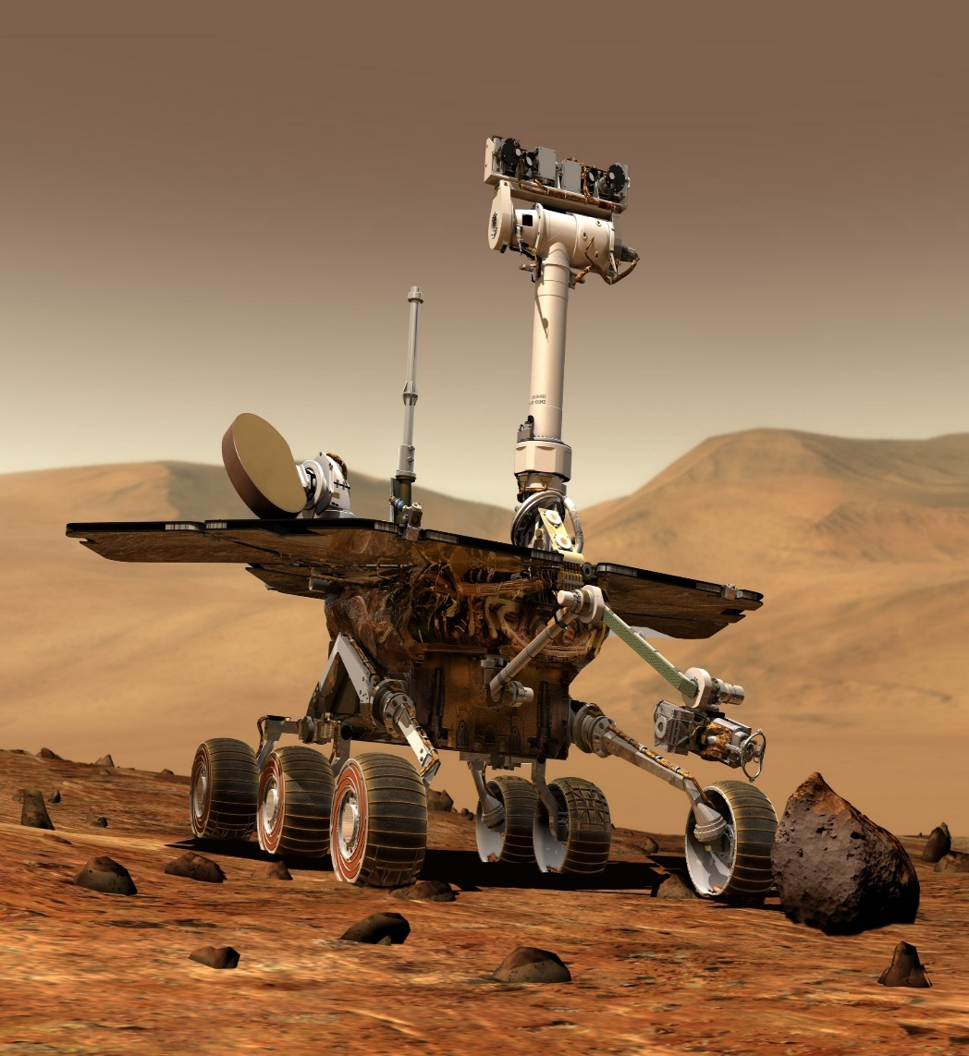

Mars Rover Preservance search Biosignature in Marsian Surface



**the**[**Drake equation**](https://en.wikipedia.org/wiki/Drake_equation)**are closely related to the Fermi paradox**

The theories and principles in the [Drake equation](https://en.wikipedia.org/wiki/Drake_equation) are closely related to the Fermi paradox.[[29]](https://en.wikipedia.org/wiki/Fermi_paradox#cite_note-30) The equation was formulated by [Frank Drake](https://en.wikipedia.org/wiki/Frank_Drake) in 1961 in an attempt to find a systematic means to evaluate the numerous probabilities involved in the existence of alien life. The equation is presented as follows:

The formula for the Drake equation is:

N = R\* x 𝑓p x ne x 𝑓1 x 𝑓i x 𝑓c x L

R\* = average rate of star formation in [Milky Way](https://www.livescience.com/tag/milky-way)

𝑓p = fraction of stars supporting planets

ne = average number of planets that could potentially support life for each star that hosts planets

𝑓1 = fraction of those planets that "could" support life that actually develop life

𝑓i = fraction of planets that develop intelligent life, and thus intelligent civilizations

𝑓c = fraction of those civilizations that develop a technology to communicate their existence

L = length of time over which these civilizations send those detectable signals into space

By including all of these factors in the equation, the idea is you might be able to work out how many other intelligent civilizations exist in the universe.

�=�∗⋅�p⋅�e⋅�l⋅�i⋅�c⋅�

The Drake equation has been used by both optimists and pessimists, with wildly differing results. The first scientific meeting on the [search for extraterrestrial intelligence](https://en.wikipedia.org/wiki/Search_for_extraterrestrial_intelligence) (SETI), which had 10 attendees including Frank Drake and [Carl Sagan](https://en.wikipedia.org/wiki/Carl_Sagan), speculated that the number of civilizations was roughly between 1,000 and 100,000,000 civilizations in the Milky Way galaxy.[[31]](https://en.wikipedia.org/wiki/Fermi_paradox#cite_note-32) Conversely, [Frank Tipler](https://en.wikipedia.org/wiki/Frank_J._Tipler) and [John D. Barrow](https://en.wikipedia.org/wiki/John_D._Barrow) used pessimistic numbers and speculated that the average number of civilizations in a galaxy is much less than one.[[32]](https://en.wikipedia.org/wiki/Fermi_paradox#cite_note-33) Almost all arguments involving the Drake equation suffer from the [overconfidence effect](https://en.wikipedia.org/wiki/Overconfidence_effect), a common error of probabilistic reasoning about low-probability events, by guessing specific numbers for likelihoods of events whose mechanism is not yet understood, such as the likelihood of [abiogenesis](https://en.wikipedia.org/wiki/Abiogenesis) on an Earth-like planet, with current likelihood estimates varying over many hundreds of [orders of magnitude](https://en.wikipedia.org/wiki/Order_of_magnitude).



The Drake equation is used to estimate the number of advanced civilizations in the Milky Way. Because researchers work with a number of uncertainties within each variable, the equation can never be solved.

The formula for the Drake equation is:

N = R\* x 𝑓p x ne x 𝑓1 x 𝑓i x 𝑓c x L

R\* = average rate of star formation in [Milky Way](https://www.livescience.com/tag/milky-way)

𝑓p = fraction of stars supporting planets

ne = average number of planets that could potentially support life for each star that hosts planets

𝑓1 = fraction of those planets that "could" support life that actually develop life

𝑓i = fraction of planets that develop intelligent life, and thus intelligent civilizations

𝑓c = fraction of those civilizations that develop a technology to communicate their existence

L = length of time over which these civilizations send those detectable signals into space

By including all of these factors in the equation, the idea is you might be able to work out how many other intelligent civilizations exist in the universe.

**References:**

 Dale Anderson’s 1996 Antartic Field Research photo Albums.

Deeg, H., Beltmonte;J.(eds) Hand Book of exoplanet, Springer,cham(2018).related DOI https//doi.org/10.1007/978-3-319-55333-7-67.

Ravi Kumar Kopparapu, Eric Wolf,Victoria S.Meadows. Planets , exoplanet and habitability characterstics of exoplanet habitability.

Web Link reference P. Von Paris 2013:Charcterization of potentially habitable Planets

C.Hall.,P.C. stencil., J.P. Terry and C.K. Ellison. Published 2023 may 15 , 2023 published by American Astronomical Society the Astrophysical Journals Letters Volume 948, Number 2 C Hall et al 2023 April 948L26 DOI 10.3847/2041-8213.accfb. article pdf.

Seager; bains W., Petkowski, J.,J., 2016, Toward a list of Molecules as Potential Biosignature gases for the search for life on exoplanets and Applications to terrestrial Biotechnology Astrobiology,16,465.

https://depts.washington.edu/astrobio/wordpress/research-areas/exoplanets-detection-habitability-biosignatures/

Gowdy Robert H, VCU departmental of Physics SETI search for Extra Terrestrial Telescope The Interstellar Distance Problam December 26,2018.

Sandberg Anders, Drexler Eric. Ord Toby(June 6, 2018)”Dissolving the Fermi Paradox arXiv 1806.02404.

Drake F; Sobel D.(1992) Is any one out there?. The scientific Search for extra Terrestrial Intelligence Delta. Pp 55-62. ISBN 978-0-385-31122-9.

Barrow John D; Tipler Frank J.(1986) The Antropic Cosmological Principle (Isted.) Oxford University Press P. 588. ISBN:978-0-19-282147-8.

Astronomy: Roen Kelly

#2 Research Paper for conf.

**Solar Wind- Magnetosphere –Ionosphere coupling on Polar Cusp**

**R. K. Mishra1 and S.C.Dubey2**

1Department of Physics, A.P.S.University, Rewa (M.P.) India.

E-mail ~ rakesh\_response@rediffmail.com

2Department of Physics, S.G.S. Govt. P.G. College, Sidhi (M.P.) Pin-486661, India.

Present address1 GHSS Kandel ,Disst Dhamtari C.G.

ABSTRACT

The Earth’s magnetosphere and upper atmosphere can be greatly perturbed by variations in the solar luminosity caused by disturbances on the Sun. The polar cusp ionosphere important part of near- earth space which best monitored by ground based observation made in the remote polar regions, Antarctica seems certain to play a key role in the future exploration. The polar region is characterized by direct entry of solar wind particles along magnetic field line projecting to the dayside magnetopause (outer boundary of the magnetosphere). Thus polar cusp ionosphere provides splendid window for examining processes transferring solar wind mass and momentum to the magnetosphere. The state of near-Earth space environment is governed by the Sun and is very dynamic on all spatial and temporal scale. The geomagnetic field which protects the Earth from solar wind and cosmic rays is also essential to the evolution of life; its variations can have either direct or indirect effect on human physiology and health state even if the magnitude of the disturbance is small. Geomagnetic storms are seen at the surface of the Earth as perturbations in the components of the geomagnetic field, caused by electric currents flowing in the magnetosphere and upper atmosphere. Ionospheric and thermospheric storms also result from the redistribution of particles and fields. Global thermospheric storm winds and composition changes are driven by energy injection at high latitudes. Storm effects may penetrate downwards to the lower thermosphere and may even perturb the mesosphere. Many of the ionospheric changes at mid-latitude can be understood as a response to thermospheric perturbations. The transient bursts of solar energetic particles, often associated with very large solar flares, have been observed to have effects on the Earth’s middle and lower atmosphere, including the large-scale destruction of polar stratospheric and tropospheric ozone. In the present, we have discussed effect of solar influences on earth’s magnetosphere and upper atmosphere that are useful to space weather and global warming.

**Keywords:** Magnetosphere, Ionosphere,Polar Cusp, Solar wind interaction, Geomagnetic storms.

**Polar Cap and Auroral Zone Geomagnetic Indices**

**The polar Cap index is characterstics of the Polar Cap magnetic activity generated by geoeffective Solar Wind acting on the Magnetosphere. The index is derived by magnetic data of only two station Thule and Vostak located in northern (PCN) and Southern (PCS).**

**Near –Pole regions , in 2013 the international of Geomagnetisim and aeronomy (IAGA) recommended to international scientific community to use PC Index as a proxy for energy that eneter that into magnetosphere during Solar Wind\_Magnetosphere-ionosphere Coupling. The Procedure adopt in AARI and DTU. Provide on line calculation of the PCS and PCN indices corresponding to geo effective interplanetary electric Field Ekl value irrespective of time,season and Solar Cycle.**

The polar cap (PC) index is measure of the high-latitude geomagnetic disturbances due to hall effect field-aligned currents. the index is well correlated with the auroral electrojet AL and AU indices (correlation with the PC index is 76% and 60% resp.). several type database relate to the PC to the AL and AU indices in the winter time, when the ionospheric conductivity is mostly due to precipitating particles of the field- aligned currents.

The Polar Cap (PC) index measure geomagnetic disturbances at the polar cap which are due to ionospheric and Field-aligned Currents (Troschichev,1988;Vennerstroem et al.,1991).The Former ones are hall Currents induced by the field time convection and form a part of DP2 current system. The relative importance of each current type depends on the ionospheric conductivity which is modulated on the dayside by the seasonally and daily varying solar illumination and on the night side by particle precipation. The index is derived from Horizontal geomagnetic disturbances HDP2 at a standard high-latitude station which for the Northern polar cap is THULE at 83.3˚N (a separate index is calculated for Southern cap.). the PC index was designed to measure the part of HDP2 disturbances due to magnetosphere field aligned convection. Convection is assumed to be linearly correlated with Solar wind input and hence PC index is the part of HDP2 disturbances correlated with solar wind input and normalized to its unit (mV/m). the relation between the PC index and solar wind input varies as a function of season and UT (Troshichev,1988; Vennerstroem et al.,1991). The second source for Polar cap geomagnetic disturbances are field aligned currents which become dominant in the winter and summer time, when the polar cap is dark and convection-induced currents wane significantly. At the time the PC index becomes well-correlated with the AU and AL indices. The indices measure the geomagnetic effects of the auroral electro jets, which connect the foot point of field aligned currents in the ionosphere (Mayaud, 1980; Holzer and slavin, 1981; Akasofu et al.,1983;Baumjohan,1986; Korehl,1989). In winter(November-February) the correlation with AL varry with UT in The range 85-90% and AU 60-85% (Troshichev et al.,1988;Vennerstroem et al.,1991). Intermediate correlation occur during the enquinax periods.Geomagnetic disturbances due to other current types, for example the DPY current,Have a negligible correlation with the PC index(Vennerstroem et al.,1991). The database of PCThule is from November 1, 1978 to February 28,1979.The 1-minAL/AU indices Compete,the 15- min PC index,and the 5-min ISEE-3-Measured solar wind input, are linearly interpolated to time resolution of 2.5 min.

The correlation is maximum(77%) when PC is shifted in time to precede AL by 7.5 min. but individual events each index may precede the other by more than 10 minutes. the PC-AU correlation is 66% for individual UT(Vennerstroem et al.,1991). And the correlation is maximum AL-AU correlation occurs when AL Leads by 10 min.) Thus typical disturbances begins at polar latitudes on the night side and then spreads equatorward reaching the auroral zone stations in several minutes (Rostoker and Phan,1986). Even when AU starts increasing before PC,the PC index reaches its maximum level faster., which might shows a relation between rate of polar cap expansion and driven and loading-unloading effects, but we did not find a systematic dependences. The high correlation between geomagnetic activity from the polar cap and auroral zone shows that the two regions are strongly coupled. The electromagnetic coupling allows the two magnetospheric regions to produce Coordinated, organized activity (Baker et al.,1990;Klimas et al., 1996).

The PC index is expected to rapidly become important for specification of the magnetospheric state, and useful in scientific and Space Weather applications.

Conclusion:

Solar wind-magnetosphere-ionosphere coupling are dominated with solar wind Plasma mediated by magnetic reconnection at magnetopause interface. As consequences earth’s magnetosphere dynamics depends primarily on concurrent orientation of the Interplanetary magnetic field. The polar Cusp is region in which the magneto sheath plasma has direct access to the Ionosphere. It is exisiting weather the Interplanetary magnetic field is northward or southward. In no-reconnecting magnetosphere the location of the cusp depend on the shape of magnetosphere but when the magnetosphere reconnection with either southward or north ward Interplanetary magnetic field the location of the polar cusp altered polarity.

Solar wind-magnetosphere-ionosphere coupling has major relevance as the plasma medium in which space craft must designed to operate in space. Using e.g. for communication, Navigation,meterology and defence.

Key point of conclusion of research paper

Demonstration of close relationship between Solar wind-parameter, Polar Cap(PC) indices and Major magnetospheric current system.

Specification of relation between polar cusp(PC) auroral Al,Au and SMLand ring current Dst, SYm-H ,Asy-H indices.

Acknowledgement

I here by acknowledge and support of all academic and Non academic staff of department of Physics in A.P.S.Univ .Rewa (M.P), India for success of research study.

The authors would like to acknowledge the encouragement and motivation of Dr. Peter Carter work as climate agency institute, and Dr. Anil Bhardwaj sir, director Physical research laboratory Ahmedabad, India

Competing Interest and Disclosure of conflict interest

The author declare that they have no competing interest.Athour disclosed that there is no conflict interest in carrying out this research study.

References

Akasofu,S-I,B-H,Ahn,Y, Kamide,andJ.H.Allen,A note on the accuracy of auroralelectrojet indices,J.Geophys.Res.,88(A7),5769-5772,1983.

Baker,D.N.,A.J.Klimas,R.L.McPherron,andJ.Büchner, the evolution from weak to strong geomagnetic activity: An interpretation in term of deterministic Chaos,Geophys.Res.Lett.,17,1990.

Baumjohann,W.,Merits and Limitation of the Use of geomagnetic indices in Solarwind-magnetospherecouplingstudies,insolarWind-MagnetosphereCoupling,Kamide,Y.,and J.A.Slavin ,editors,p-3-15,Tokyo,Terra Scientific,1986.

Holzer,R.E., andJ.A. Slavin,Processes influencing the diurnal variation of the AL index and its reliability,J.Geophys.Res.,86(A11),8977-8980,1981.

Klimas,A.J.,D.VassiliadisD.N.Baker,and D.A. Roberts,The organized nonlinear Dynamics of the magnetosphere,J.Geophys.Res.,101(A6),13089,1996.

Mayud,P.N.,Derivationevalution of The AE indices,

J.Geomag.Geoelectr.41,317-329,1989.

Rostoker,G.,and T.D.Phan,Varriation of Aurroralelectrojet spatial location as a function of the level of magnetospheric activity,

G.Geophys.Res.,91(A2)1716-1722,1986.

Kroehl,H.W., A critical evalution of the AE indices, J.Geomag. Geooelectr., 41,317-329,1989.

Troschichev,O.A.,The physics and meaning of the exisiting and proposed high-latitude geomagnetic indices,Annales Geophysicae,6(6),601-610,1988.

Vennerstroem,S.E.,Friss-Christension,O.A.Troshichev,and V.G. Andrezen,Comparision between the polar cap,PC,and auroral indices AE,AL., and AU,J.of Geophys.Res.,96(A1),101-113,1991.

External sources and Note

WWW.Bill.srnr.arizona.edu

Decplayers.net

M.J. Burnasanto,”Stride made in in understand weather at Earth”,EOS. Transaction American Geophysical Union 1997.

WWW. Prl.res.in

Geomagnetic observation and model,2011.

Escscholarship.org

Kraws,S.,M.Temmer,A Verong,o,Baur,and H.Lammer,” thermospheric and Geomagnetic response to interplanetary coronal Mass ejections observed by ACE and GRACE: statistical result’s Near Earth response to ICMEs” Journal of Geophysical Research Space Physics.

Chao-song huang,”variations of Polar Cap Index in response to solar Wind charges and magnetospheric Substorm;Journal of Geophysical Research,2005.

S.Vennestorm”comparision Bteween the polar Cap index, PC and Aurural Electrojet indices AE AL and AU” journal of Geophysical Research,1991.

Hdl.handel.net

Saunder,M.A.,”Magnetosheath magnetopause and Low Latitude boundary layer research,1989”,Journal of Atmospheric and terrestrial Physics 19012.

Oleg Troshichev”Unified PCN and PCS indices” ,method of Calculation physical sense , and dependence on the IMF azimuthal and Northward components”,Journal of Geophysical Research,2006.

T.E.Pulkkinen”Magnetotail Flows can consume as Much Solar Wind Energy as a Substorm” journal of Geophysical Research.,2003.

Youuke Kamade.”Geomagnetic of Space weather: Classic Picture and recent Issues”, NATO Science Series Mathematics Physics and Chemistry 2001.

Wayne Keith; Walter Heikkila, “Historical Introduction”, Elsevier DV, 2021.

[WWW.Tropmet.res.in](http://WWW.Tropmet.res.in)

[WWW.research](http://WWW.research) gate,net

P staining Oleg Troschichev, Alexander Janzhura,”the polar Cap (PC) indices:relation to solar wind parameters and global magnetic activity”, Journal of Atmosphereic and Solar-Terrestrial Physics,2008.

[www.world](http://www.world) wide Journals.com

Scholarship.org

T.I Pulkkinen”magnetotail Flows can consume as much as Solar wind energy as Substorm” ,journal of Geophysical Research 2003.

“Magnetospheric in Solar System” Wiley 2021.

X-shao”Phase transition like Behaviour of Magnetospheric substorms : Global MHD simulation result’s” ,Journal of Geophysical research 2003.



**Figure1(a) Shows Ionospheric Convection pattern derived by AMIE procedure for the Summer and Winter Polar regions**

[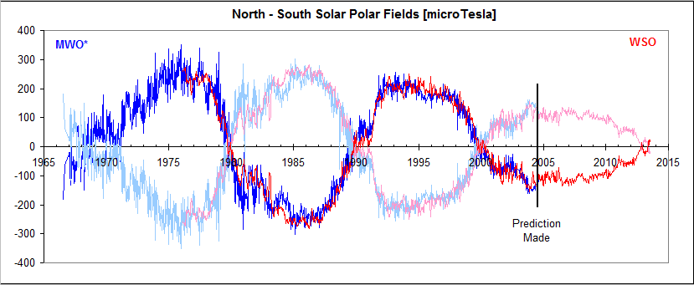](http://www.leif.org/research/Solar-Polar-Fields-1966-now.png)

**Figure 1(b)shows North-South Solar Polar Field(Micro tesla)**



Govt. Higher Secondary School Kandel



**Dr.Rakesh Kumar Mishra**

**Biography of Author**

**Dr.Rakesh kumar Mishra has devoted countless Hour to searching many years to Water science and Solar physics and researching on Solar transient’s and their impact on Geomagnetic Field a book madeup in solar and Water research and make contribution from colleagues (Past and Present. We urge you to read my book and get inspired about it how to work in services for the greater good of Water.**

**Email**: [**rakesh\_response@rediffmail.com, rakesh123av@gmail.com**](mailto:rakesh_response@rediffmail.com,%20%20%20rakesh123av@gmail.com)