Paper Title (16 Bold)

Author (14)

*1PhD, Team Leader of Environmental Rehabilitation Projects, MEW, Kuwait.*

*2Lecturer of Hydr. and Irrigation, Civil Eng. Division,Fac. of Eng., El Mataria, Helwan Univ., Egypt.*

*3Prof.Emeritus, Hydrology Division, Desert Research Center, Cairo, Egypt.*

*Corresponding Author: xxxx (10)*

*ABSTRACT: (10 Bold) Jaber Al-Ahmad Wetland Area (JAWA) in Kuwait state is widespread in moraine landscapes and nowadays is under urbanization development. Its hydrological properties may be vulnerable to changes in gardens' irrigation conditions with bad drainage system which affects negatively the urbanization development. In this paper, Markov chain model with time-varying parameters is developed to capture the daily cycle and day-to-day variation of the soil water level using statistical parameters estimated from gage records in three measurement sites in JAWA. Based on the results of the Standard Boxplotsincluding the three quartiles (Q25%, Q50%, Q75%) in addition to the extreme outliers, the mean soil water level is decreased from 5 Am up to 11 Am and from 5 Pm up to 9 pm which indicates the high pumping time. In addition, the measured-predicted scatter plot shows that the distribution of the simulation is almost similar to the measured.The simulation results for soil water level fluctuations show that MAE values for the three monitoring wells vary between 7.65 and 8.2 mm while MAPE reads 0.13, 0.16 and 1.47% respectively. In addition, RMSE values vary between 9.82 and 10.23 mm. Morover, it is noticed that soil water level predictions from shorter fitting periods frequently were biased because a longer-term trend was not reproduced by the synthetic soil water levels. It is highly recommended to investigate the model behavior with different distributions as well as the possible use of nonlinear random number generators.*

***KEY WARDS: (10 Bold)*** *Markov chain analysis, Soil water level fluctuations, Jaber Al-Ahmadwetland, Kuwait*

---------------------------------------------------------------------------------------------------------------------------------------

Date of Submission: xx-xx-xxxx Date of acceptance: xx-xx-xxxx

---------------------------------------------------------------------------------------------------------------------------------------

# INTRODUCTION (10 Bold)

Time series is a sequence of numerical data obtained at regular time intervals. The aims of time series analysis are to describe and summarize time series data, fit models, and make forecasts.These time series require periodic measurements of soil water levels for long time to choose the best location for urbanization development.It is widely recognized that time series modeling can be the better option for the area where nothing, but the hydrological time series data is in hand. A time series model is an empirical modelfor stochastically simulating and forecasting the behavior of uncertain hydrologic systems [1].For the prediction of the future soil water level fluctuations, recently more researches have become interested in the application of the time series models to detect any changes occur to the soil water of the wetlands[2]and [3]. Time series analysis objective is to forecastand find the changes model[4] and [5]. Box – Jenkins method is one of the techniques to forecast the time series behavior[6]. Box-Jenkins methodology where use in order to make forecasting, autoregressive moving average ARMA or ARIMA models was applied to find the best fit of a time series to past values of this time series.Analysis of time series as related to soil water table seeks two objectives; modeling of random variables to have an understanding of historical data andforecasting future data behavior based on the past data[7].Extensive usage of time series and/or stochasticmodeling of soil water level fluctuations are cited in the literature [8]and [9].In general, this paper describestime series analysis of soil water fluctuations in (JAWA) usinga practical application of the Monte Carlo simulation in forecasting by setting up a simple spreadsheet and time-dependent historical data[10].

***1.1 Site Description and Climate***

JAWA is located west of Kuwait City by about 30 Km and south of Arabian Gulf by about two Km (Fig.1). It is limited between latitudes 3240290 and 3253453 due North and longitudes 758015 and 779143 due East with an area of 278 Km2. The climate of JAWA can be divided into two main seasons, hot with temperature ranges between 46 oC and 50 oC and from 20 oC to Zero oC during winter months (November through March). The mean annual precipitation reaches 115 mm while the mean daily Pan-A evaporation rate is 16.6 mm [11].

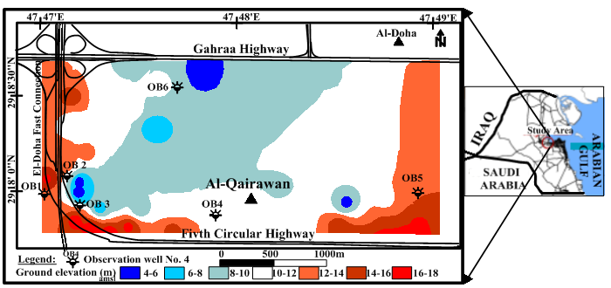

**Figure 1: Location map of the observation wells and groundelevation (m) inJAWA**

***1.2 Geomorphological features***

Geomorphological features play a vital part in accumulation of rainwater and irrigated drainage water in low depressions and consequently raise the soil water levels. JAWA is classified geomorphologically into four units. They are Coastal hills, Sand dune fields, Flat desert surfaces and Wadis. The coastal hills occupy the northern and southern parts of Kuwait, which are a hard, flat desert with shallow depressions and small conical hills with an average height of about 40m. The sand dune fields and dust accumulation pattern occupy an area covering 350-500 km2. Flat desert surfaces cover most of the lowland of southern Kuwait and are controlled by wind action. Wadi Al-Batin is a large valley that forms a natural boundary between the State of Kuwait and the Republic of Iraq and varies in width from 7 to 10 km with relief up to 57 m [12].

***1.3Geological features***

Since the Triassic time, the Kuwait region has occupied an intermediate position between the Arabian Gulf, to the north-east, and the Arabian massif to the southwest, leading to a thick sedimentary sequence present in the subsurface [13] and [14]. A sequence of Arabian platform sedimentary rocks overlying the Arabian Shield is dominating south and south-west of Kuwait. Sediments ranging from early Miocene to Quaternary are exposed on the surface throughout Kuwait. The region is underlain by 6000 m of sedimentary rocks, whose age ranges from Triassic to Pleistocene. The regional dip of strata is about 2 m/km towards the northeast and is interrupted by the Kuwait and Dibdibba Arches.Tertiary geological events in Kuwait influenced the present lithology, depth, thickness, and geometry of the major rock units in Kuwait. Pre-Miocene movement shaped the configuration of the Paleogene rocks of the Hasa Group and determined the geometry of the pre- Neogene unconformity surface, on which the Kuwait Group was deposited[15] and [16].

***1.4Water bearing formations***

Generally speaking, there are three main aquifers in Kuwait: the first is the Dibdibba Formation—unconfined to semi-confined forms the uppermost formation of the Kuwait Group, and is only found in northern Kuwait. The second is the Kuwait Group found throughout Kuwait. This aquifer has been subdivided, on the basis of lithology, into the upper aquifer (Lower Fars) which is generally unconfined in southern and central Kuwait and the lower aquifer (Ghar) which is semi-confined. The third is the Dammam Formation part of the Hasa Group, which is confined and hosted in the middle chalky limestone unit. This unit may be further divided into the upper, middle and lower parts of the aquifer. For convention, the three aquifers are described as the Dibdibba, Lower Fars, Ghar and Dammam to avoid confusion with other definitions of the aquifers.As aforesaid, generally, an upward movement of water from the Dammam formation to the Kuwait Group aquifer is expected over most of Kuwait. In the central and southwestern parts of Kuwait, this natural order of movement has been reversed due to human exploitation of the aquifers in these areas[17]. The effects of this flow reversal on soil water level rise may be monitored through observation wells. Accordingly, the conceptual model of soil water rise in the JAWAwas constructed taking into account the key factors influencing the hydrogeology of the area of interest[18]. The conceptual hydrogeological model used to time series analysisis given in (Fig.2)[19] and [20].



**Figure2: Idealized conceptual model of the fresh water aquifer systems in JAWA**

On the other hand, the JAWAis poor in hydraulic properties where the porosity ranges from 5% to 20% [21], while the hydraulic conductivity (K) ranges from 17 to 71.35 m/day(Table 1). The soil water rise reaches 0.8 m/year[22].

***Table I.* Hydraulic parameters of Kuwait Group aquifer in JAWA**

|  |  |  |  |  |  |  |
| --- | --- | --- | --- | --- | --- | --- |
| Location | X (UTM) | Y (UTM) | Q (m3/d) | T (m2/d) | K(m/d) | Ss |
| JB-A | 769,617 | 3,247,120 | 916.47 | 987.56 | 35.27 | 1.8 x 10-4 |
| JB-B | 768,828 | 3,247,669 | 916.47 | 466.18 | 16.64 | 1.8 x 10-4 |
| JB-C | 770,069 | 3,248,464 | 654.62 | 1997.9 | 71.35 | 1.8 x 10-4 |
| JB-D | 770,016 | 3,248,400 | 916.47 | 645.48 | 23.05 | 1.8 x 10-4 |
| JB-E | 767,695 | 3,250,053 | 589.16 | 263 | 17 | 1.8 x 10-4 |

***1.5 Problem statements***

Soil water level fluctuations problem is age-old nemesis of urbanized areas and it continues to plague urbanization development around the world. In Kuwait state, [23] mentioned that the soil water level rises by about 3 m in urban areas which threatening the integrity of several investments, buildings and roads. The rise of the soil waterlevel in the vicinities of JAWA can be attributed to a combination of the reasons as follows: the relatively shallow depth (within 2 – 3 m from the ground surface) of water table in the JAWA under natural conditions, presence of impermeable clay lenses in the sub-soil of JAWA which prevents the vertical soil water seepage, slow but continuous upward seepage of soil water from the Dammam Formation aquifer and the location of JAWA in a relatively low land surrounded by hilly areas leading to ponding of water after rainfalls and its infiltration to the logged soil zone**.** To study this problem, Time Series of Soil Water Level Fluctuations (TSSWLF) of JAWAare required which is very difficult practically. So, the need for time series simulation and prediction is essential. This paper describes a practical application of the Monte Carlo simulation in forecasting by setting up a simple spreadsheet and time-dependent historical data.

# MATERIAL AND METHODS (10 Bold)

The materials used in this paper were collected through carrying out four field trips in JAWA during the period 2015-2016. A network of four well distributed observation wells penetrating the Quaternary aquifer in JAWA was chosen for (TSSWLF) during the period May-August 2015 (Fig.1). Installation of one Micro Diver inside the observation well (OB1) required for soil water fluctuationtime series beside one Baro Diver for recording the Barometric pressure were done during these field trips. In the end of the time series the records were downloaded by Diver-Office 2012.1 software program (Fig.3).



**Figure 3: The recorded TSSWLF in OB1in JAWA**

To calculate the water level in relation to a vertical reference datum using the Diver and Baro-Diver’s measurements, Fig. (4) represents a typical example of a monitoring well in which a Diver has been installed. The Diver is suspended with a cable with a length equal to CL cm. The Baro-Diver measures the atmospheric pressure (Pbaro) and the Diver measures the pressure exerted by the water column (WC) and the atmospheric pressure (P-Diver). The water level (WL) in relation to the vertical reference datum can be calculated as follows:



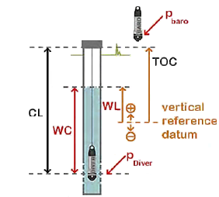

**Figure4: Schematic diagram for water level calculation from Diver data**

The records of TSSWLF in the study area wereobtained automatically every 5 minutes which resulted in 23328of data sets for each diver during the period from 27/5/2015 to 16/8/2015. These temporal data sets were classified statistically into 12 classes with time interval of 2-hours delta level for every class. The Standard Boxplots, a very useful and concise graphical display for summarizing the distribution of the data sets, is used to describe the 12 classes including the three quartiles (Q25%,Q50%, Q75%) in addition to the extreme outliers (Fig. 5). Further, the mean soil water level is also given in Fig.5 for the three divers. It is noticed thatsoil water levelsare decreased from 5 Am up to 11 Am and from 5 Pm up to 9 pm which indicates the high pumping time.

In this paper, a modification of [24] method will be introduced and applied to simulate the change in soil water level. The method suggested that the four statistical parameters (mean, standard deviation, coefficient of skew, correlation coefficient) have an important role in the data synthesis of water level and should be considered for good simulation. The method will be summarized as follow:

|  |
| --- |
| **Figure 5: The Standard Boxplots for the three divers' data sets** |

* 1. ***Identifying and removing the trend in the mean daily soil water level***

Several parametric and non-parametric tests were used previously for the detection of trends in time series data. [25] and [26] gave a good revision of these methods. Generally, non-parametric method is preferable because the parametric tests assume normality of data which is rarely happen [27]. A widely used test to identify trend in time series, Mann-Kendall (MK) non-parametric test, will be used in this study to investigate the null hypothesis that there is no trend in the analyzed variable. MK is considered the most significant trend test in hydrological applications [28],[29],[30]and [31]. The mathematical concept of the MK can be described as:

$S=\sum_{i=1}^{n-1}{\sum_{j=i+1}^{n}{sgn\left(X_{j}-X_{i}\right)}}$………………………………………....….…(2)

$Var\left(S\right)=\frac{1}{18}\left\lfloor n\left(n-1\right)\left(2n+5\right)-\sum_{i=1}^{n_{t}}{t_{i}(t_{i}-1)(2t_{i}+5)}\right\rfloor$…………….........…..(3)

$Z_{mk}=\left(\begin{matrix}\frac{S+1}{\sqrt{Var\left(S\right)}}S<0 \\ \frac{S}{\sqrt{Var\left(S\right)}}S=0 \\ \frac{S}{\sqrt{Var\left(S\right)}}S>0\end{matrix}\right)$………………………………………….............….(4)

Where n is the number of days, Xi and Xj are the mean daily soil water level in the dayi and j, respectively. The function sgn(Xj − Xi)takes the value 1, 0, or−1 according to the sign of the difference (Xj − Xi); where j >i. The MK statistic Zmk is used to determine the significance of any trend in the data (A positive value indicates an upward trend, while a negative value shows a downward trend).If |Zmk| > Z1-α/2,the null hypothesis (Ho) is rejected at significance level α which indicates the trend strength. In this study, statistical significance of the trends is evaluated at the 5% level of significance. In this case, the line that best fit through the observed soil water level can help to determine the magnitude of any trend in soil water level (Fig. 6).

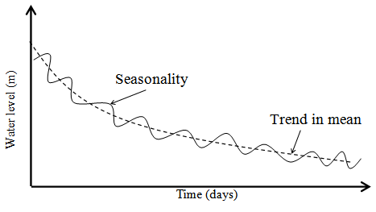

**Figure 6: The trend in mean daily soil water level**

* 1. ***Identifying and removing seasonality in the mean and standard deviation***.

The soil water level exhibits a periodic hourly variation in their average value and standard deviation according to the change in pumping rate during the day. When long period of data is available, the mean and standard deviation can be estimated for each 2-hours during the day, and the data standardized by subtracting the mean and dividing by the standard deviation:

$Z_{t}=\frac{S_{t}-\overline{S}}{σ}$……………………………………………………...(5)

Where:

$\overline{S}$ and $S_{t}$ is the average seasonal and irregular component of 2-hours daily water level;

σ is the standard deviation;

Ztis de-seasonalized 2-hours daily measured soil water level.

* 1. ***Removing Autocorrelation***

The created Ztdata have zero mean and unit variance, but are likely to exhibit autocorrelation, as measured by the lag-one correlation coefficient. It is possible that the lag-one correlation varies with time for the whole day. The de-correlated, zero-mean, unit standard deviation noise variable Kt can be estimated from the time series of Z as follows:

$K_{t}=\frac{Z_{t}-{Corr}_{1,t}Z_{t-1}}{\sqrt{1-{{Corr}_{1,t}}^{2}}}$…………………………..….…...........................…..(6)

Where:

Kt is the de-correlated 2-hours daily measured water level.

Zt-1 is the lag one-time step free seasonality data;

Corr1,t is the lag one-time step correlation data.

* 1. ***A random noise***

The de-correlated 2-hours daily measured soil water level Kt could be consider as a random noise. The distribution of this random noise with zero mean, unit standard deviation, and skew equal to the observed value, could be best predicted using the Pearson III shifted gamma distribution with three parameters (α, β, and shift):

$f\left(X,α,β,shift\right)=\frac{1}{β^{α}Γ\left(α\right)}{\left(X-shift\right)}^{\left(α-1\right)}e^{-\left(\frac{X-shift}{β}\right)}$………………………...(7)

Where:

X is a uniform random value between 0 and 1

α =(2/Skewness)2

β =

Shift = -αβ

* 1. ***Soil water level prediction***

Finally, the predicted 2- hours daily water level could be calculated as:

$WL=$ St……………………….……………………………….(8)

…………………..……………..…………………....(9)

……………..……......(10)

* 1. ***Performance measures***

To evaluate the performance of prediction model, three different prediction performance measures are used to estimate the error of the model. Smallervaluesofthesemeasurements indicatehigheraccuracy in prediction. The ﬁrst is the mean absolute error (MAE), which is described as:

$MAE=\frac{1}{N}\sum_{i=1}^{N}{\left|{WL}_{i}-{WL}_{i}^{'}\right|}$…………………………….........…(11)

The second is the mean absolute percentage error (MAPE) that can be written as:

$MAPE=\frac{1}{N}\sum_{i=1}^{N}{\left|\frac{{WL}_{i}-{WL}_{i}^{'}}{{WL}_{i}}\right|}$……………………………….................(12)

The third is the root mean squared error (RMSE), which can be presented as:

$RMSE=\sqrt{\frac{1}{N}\sum_{i=1}^{N}{{\left({WL}_{i}-{WL}_{i}^{'}\right)}^{2}}}$………………………….............(13)

Where: N is the total number of the soil water level data.***WLi*** and ***WLi'***represent the measured and predicted soil water level values respectively.

# RESULTS AND DISCUSSIONS (10 Bold)

The principal statistics of the 2-hours delta data records of TSSWLF in JAWAreflect soil waterlevel range from 5.64to 5.82m at DiverA monitoring point, 5.15 to 5.31 m at monitoring point of Diver B, and 5.41 to 5.52 m at monitoring point of Diver C (Table 2).

***Table II*. Mann Kendall test results**

|  |  |  |  |  |  |
| --- | --- | --- | --- | --- | --- |
| Location | S | Var(S) | Zmk | Z(95%) | Null hypothesis (Ho) |
| Diver A | -2960 | 57933.33 | -12.29 | -1.96 | Rejected |
| Diver B | -2646 | 57933.33 | -10.99 | -1.96 | Rejected |
| Diver C | -2816 | 57933.33 | -11.70 | -1.96 | Rejected |

In addition, Mk test was performed for the soil water level results as shown in Table (2) and the results show that the null hypothesis (Ho) is rejected at significance level α=0.05 which indicates the trend strength. The negative values of Zmk show a downward trend in all monitoring divers.Several linear and nonlinear regression analyses were done for the soil water level – time relation and the relations that best fit through the observed soil water level areshown in Fig. 7 as:

|  |  |  |
| --- | --- | --- |
| Diver A: | WL = -0.00228 (Day) + 5.8196 | R2 = 0.978…………………(14) |
| Diver B: | WL = 5.325 (Day) -0.066 | R2 = 0.978……………....…(15) |
| Diver C: | WL = -0.00097 (Day) + 5.5015 | R2 = 0.9342…….……….....(16) |
|  |  |  |

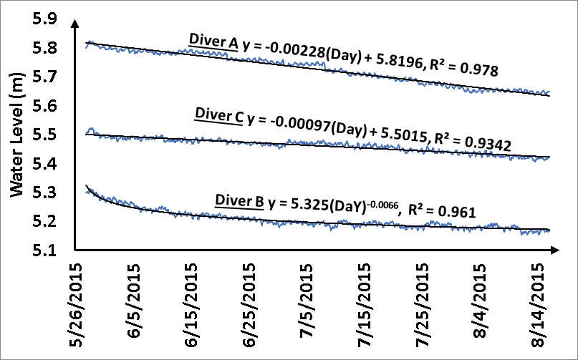

**Figure 7:Daily mean trend of processed raw daily data records without daily errors**

Removing trend in soil water level can be done by subtraction the best fit regression equation soil water level from the original data. The remaining de-trended irregular component include periodic component and random component as show in Fig. 8.

**Irregular component = original water level – trended water level**……………………………..(17)

Standardize the irregular component remove the variation in mean and standard deviation and convert the data mean to be zero and standard deviation to be one while the correlation between each to successive period should be removed. The remaining part of the data is pure random noise component. Pearson developed a form of gamma distribution with three shifted parameters called the Pearson III shifted gamma distribution. Fig. 9 compares the cumulative distribution function for the 2-hours daily measured random noise and Pearson distribution for Diver A. From this figure it is noticed for all time interval, the measured random noise mimic the Pearson distribution while a very small shift can be seen in the time interval of 2-hours (from time 0.0 to 2.0 and from 8.0 to 10.0).

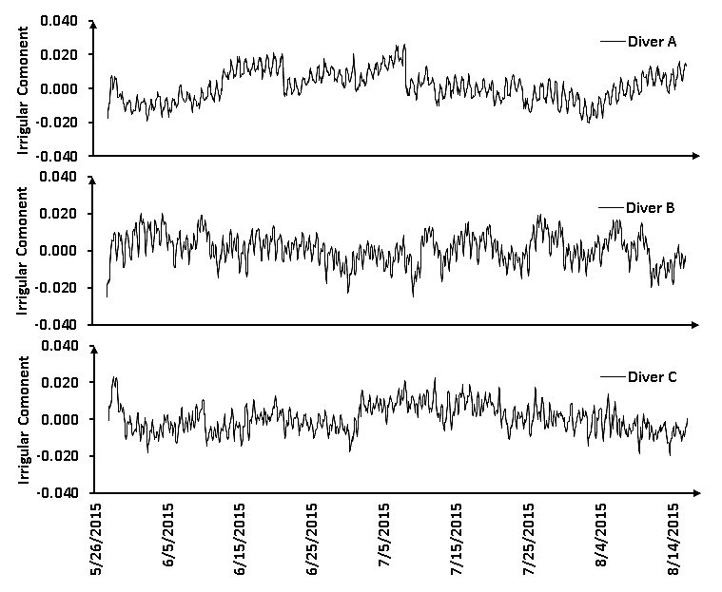

**Figure 8: Seasonal irregular component of 2-hours soil water level (m) data records**

|  |  |  |
| --- | --- | --- |
|  |  |  |
|  |  |  |
|  |  |  |
|  |  |  |
| **Figure 9: Comparison between the de-correlated 2-hours daily measured soil water level records and Pearson III shifted gamma distribution for Diver A** | | |

Based on these distributions, 2- hours daily soil water level was simulated for the same period and compared with the measured soil water level (Fig. 10).

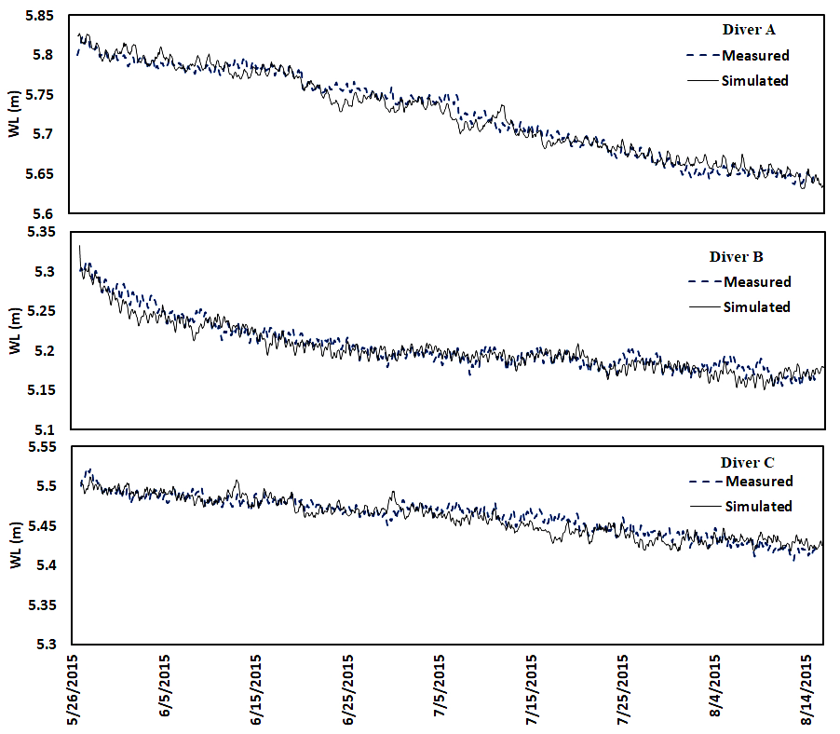

**Figure10: Comparison between Measured and Simulated 2- hours daily soil water level.**

On the other hand, Table 3 shows the performance measures of the predicted soil water level in JAWA. It is noticed that MAE values for the three monitoring wells vary between7.65 and 8.2 mm while MAPE (%) for the three monitoring wells are 0.13, 0.16 and 1.47%respectively.In addition, RMSE values vary between 9.82 and 10.23 mm. These results indicate that the model can capture the variation in soil water level and provides a good prediction performance of the ﬂuctuation of soil water level through the day in JAWA.

**Table III: Comparison between average performancesover the three monitoring divers**

|  |  |  |  |
| --- | --- | --- | --- |
| Monitoring wells | MAE (mm) | MAPE(%) | RMSE (mm) |
| Diver A | 7.65 | 0.13 | 9.82 |
| Diver B | 8.20 | 0.16 | 10.23 |
| Diver C | 8.04 | 1.47 | 10.09 |

Also, the measured- predicted scatter plot (Fig. 11)shows that the distribution of the simulation is almost similar to the one from the measured. It can be seen that the predicted soil water levels are more or less equal to the measured one.

|  |  |  |
| --- | --- | --- |
| Diver A | Diver B | Diver C |
| **Figure 11: Scatter plot of the Measured- Predicted 2-hours soil water level (m) for JAWA.** | | |

Moreover, the developed model could be used to predict the soil waterlevels at the three monitoring sites. It is noticed that soil waterlevel predictions from shorter fitting periods frequently were biased because a longer-term trend was not reproduced by the synthetic soil water levels (Fig. 12).

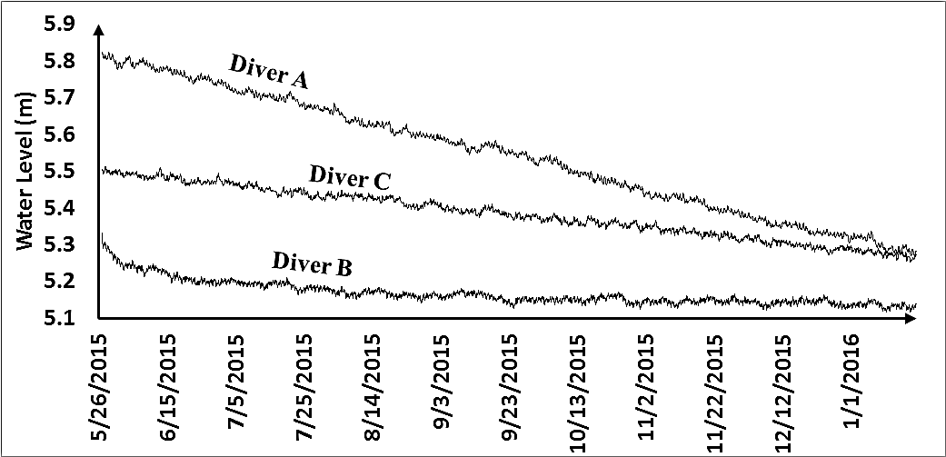

**Figure 12: Predicted 2-hours soil water level data records (m) for the three divers.**

One more application of the model is to predict the soil water level at any point using the three divers. Figure 13 shows the position of an intermediate imaginary well. The soil water level at this imaginary well is interpolated using inverse distance method as shown in (Fig. 14).

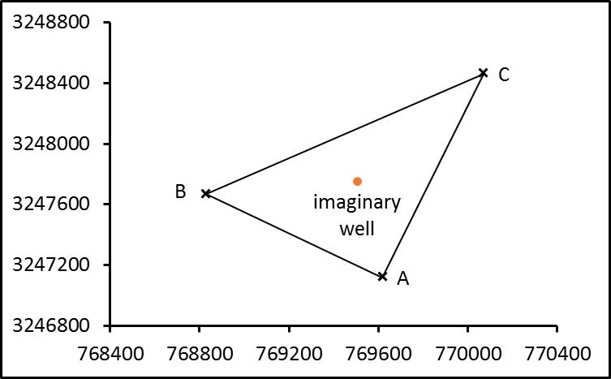

**Figure 13: Position of the intermitted imaginary well.**

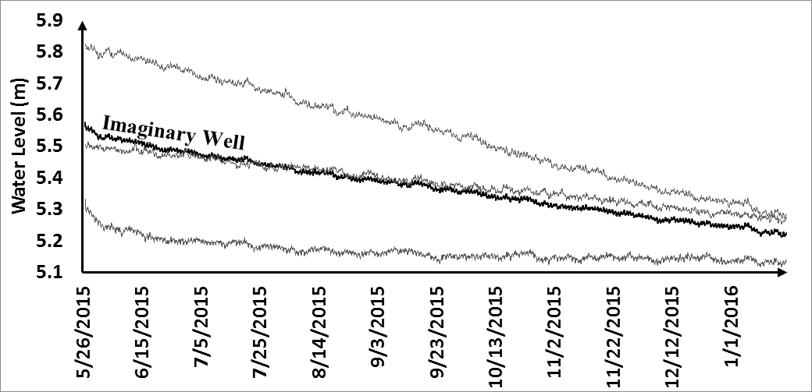

**Figure 14: Predicted 2-hours soil water level (m) data records for the imaginary well.**

# CONCLUSIONS AND RECOMMENDATIONS (10 Bold)

Based on the results of this study, it is concluded that MAE values for the three monitoring wells vary between7.65 and 8.2 mm while MAPE reads 0.13, 0.16 and 1.47% respectively. In addition, RMSE values vary between 9.82 and 10.23 mm. Also, the measured-predicted scatter plot shows that the distribution of the simulation is almost similar to the one from the measured.These results indicate that the model can capture the variation in soil water level and provides a good prediction performance of the ﬂuctuation of soil water level. Moreover, the results of the Standard Boxplots showed that soil water levels in the study area were decreased from 5 Am up to 11 Am and from 5 Pm up to 9 pm.In the contrary, the results of the developed statistical model used to predict the soil water levels in the study area were biased in case of shorter fitting periods.Based on the results of time series analyses of soil water level fluctuation in JAWA by application of Markov chain time series analysis, the following recommendations are interested:

1. Close monitoring of the soil water quality and levels in these areas should be of high priority.
2. The typical up and downstream monitoring wells scheme to calibrate the results of the Markov chain time series analysis is highly recommended.
3. With the data available for other time series of soil water level fluctuations, it would be interesting to also investigate the relationship between different time series in the JAWA and build a Monte Carlo model that takes more dimensions into account.
4. It is highly recommended to investigate the models behavior with more and different distributions as well as the possible use of nonlinear random number generators.

**REFERENCES (10 Bold)**

1. Kim, S.J., Hyun, Y. and Lee, K.K., (2005)."Time series modeling for evaluation of groundwater discharge rates into an urban subway system", Geosciences Journal, 9 (1), 15-22.
2. Woodward, W.A., Gray, H.L. and Elliot, A.C. (2012)."Applied Time Series Analysis". CRC Press, Boca Baton.
3. Roy, R., & Dhali, M. K., (2016)."Seasonal Water logging Problem In A Mega City: A Study of Kolkata, India", Journal of Research in Humanities and Social Science Volume 4 ~ Issue 4, pp: 01-09.
4. Bisgard, S. and Kulachi, M. (2011). "Time Series Analysis and Forecasting by Example", Wiley & Sons Inc., New York.
5. Kirchgässner, D., Wolters, J. and Hassler, U.,(2013). "Introduction to Modern Time Series Analysis" 2nd Edition, Springer Heidelberg, New York.
6. Box, G.E.P., Jenkins, G.M. and Reinsel, G.C.,(2008). "Time Series Analysis. Forecasting and Control", 4th Edition, Wiley & Sons Inc., New Jersey.
7. Ahn, H.,(2000). "Modeling of groundwater heads based on second order difference timeseries modeling", J. Hydrol., 8234: 8249.
8. Chow VT, Kareliotis SJ.,(1970). "Analysis of stochastic hydrology systems", Water Resour. Res., 16: 1569-1582.
9. Chow VT.,(1978). "Stochastical modeling of watershed systems", Academic press, NY. Adv. Hydrosci., 11: 259.
10. Kroese, D. P.; Taimre, T.; Botev, Z.I.,(2011). "[Handbook of Monte Carlo Methods](http://www.montecarlohandbook.org)", New York: [John Wiley & Sons](https://en.wikipedia.org/wiki/John_Wiley_%26_Sons). 772 P.
11. Safar, M. I., (1985)."Dust and dust storms in Kuwait", Civil Aviation Meteorological Dept., Kuwait.
12. Hamoud N. Alalati, Mohamed I. GAD, (2018). " Study The Seasonal Fluctuations of Groundwater Characteristicsin Al-Raudhatain And Umm Al-Aish Depressions, North Kuwait", Int. Journal of Engineering Research and Application www.i jera.com ISSN : 2248-9622, Vol. 8, Issue 1, ( Part -III), pp.43-56, January 2018.
13. Mukhopadhyay, A. Al-Sulaimi, J., Al-Awadi, E. and Al-Ruwaih, F., (1996). "An overview of the Tertiary geology and hydrogeology of the northern part of the Arabian Gulf region with special reference to Kuwait", Volume 40, Issues 3–4, June 1996, Pages 259–295.
14. SMEC, (2004). "Groundwater modelling of the Raudhatain and Umm Al-Aish freshwater aquifers of Kuwait", Program for the monitoring and assessment of the environmental consequences of the Iraqi aggression in Kuwait.
15. Al-Sulaimi, J. and Mukhopadhyay, A., (2000). "An overview of the surface and near-surface geology, geomorphology and natural resources of Kuwait", Earth Science Reviews, v. 50, p. 227-267.
16. Al-Sulaimi, J.S. and Al-Ruwaih, F.M., (2004). "Geological, Structural and Geochemical Aspects of the Main Aquifer Systems in Kuwait", Kuwait J. Sci. Eng. 31(1) pp. 13-174.
17. Al-Senafy, M.; Fadlelmawla, A.; Mukhopadhyay, A.; Al-Khalid, A. and Al-Fahad, K.,(2016). "Groundwater Protection in Kuwait: Design of Monitoring Network and Recommended Path", Proceeding of Nineteenth International Water Technology Conference, IWTC19, 21-23 April 2016. Pp 13-20.
18. Yihdego, Y. and Al-Weshah, R. A., (2016). "Assessment and Prediction of Saline Sea Water Transport in Soil water Using 3-D Numerical Modelling", Springer International Publishing Switzerland 2016. Environ. Process. DOI 10.1007/s40710-016-0198-3.
19. Yihdego, Y. and Al-Weshah, R. A., (2016). "Gulf war contamination assessment for optimal monitoring and remediation cost-benefit analysis", Kuwait. Environ Earth Sci 75:1234 DOI.
20. Al-Weshah R, Yihdego Y.,(2016). "Modelling of strategically vital fresh water aquifers, Kuwait", Environ Earth Sci., 75:1315. doi:10.1007/s12665-016-6132-1.
21. Gulf Inspection International Company (GII),(2010). "Technical report on drilling and construction of one drainage and monitoring well for Jaber Al-Ahmed" “W” 300/132/11Kv Substation.
22. Gad, M. I.; Al-Nimr, A. E. and Alalati, H. N.,(2017). "Numerical Modelling of Waterlogging Problem in New Urbanized Communities in Al-Qairawan area, Kuwait", Int. Journal of Engineering Research and Application, ISSN:2248-9622, Vol.7, Issue 2,(Part-5): pp. 59-71.
23. Al-Rashed, M., Al-Senafy, M., Viswanathan, M. and Al-Sumait, A., (1998). "Ground water Utilization in Kuwait: Some Problems and Solutions", Volume 14, Number 1, 1 March 1998, pp. 91-105(15).
24. Salas, J.D., (1993). " Analysis and modeling of hydrologic time series", The Mc Graw- Hill Handbook of Hydrology, D.R Maidment, ed., 19.1-19.71.
25. Kundzewicz, Z.W., Radziejewski, M., (2006). "Methodologies for trend detection Climate Variability and Change-Hydrological Impacts", Proceedings of the Fifth Friend World Conference held at Havana, Cuba, November 2006, IAHS Publ. 308.
26. Chen, H., Guo, S., Xu, C. and Singh, V.P.,(2007). "Historical temporal trends of hydro-climatic variables and runoff response to climate variability and their relevance in water resource management in the Hanjiang basin", J. Hydrol., 344: 171-184.
27. Sharif, M. and Burn, D.,(2009). "Detection of Linkages between Extreme Flow Measures and Climate Indices", World Academy of Science, Engineering and Technology, 60: 871-876.
28. Diop L, Yaseen Z M, Bodian A, Djaman K, Brown L.,(2017). "Trend analysis of streamflow with different time scales: a case study of the upper Senegal River", ISH J. of Hydraulic Engineering, ISSN: 0971-5010 (Print) 2164-3040 (Online).
29. Tabari, H., Taye, M.T., and Willems, P.,(2015). "Statistical assessment of precipitation trends in the upper Blue Nile River basin", Stochastic Environ. Res. Risk Assess, 29(7), 1751–1761.
30. Karmeshu, N.,(2015). "Trend detection in annual temperature & precipitation using the Mann Kendall test – A case study to assess climate change on select states in the Northeastern United States", Mausam, 66(1), 1–6.
31. Gocic, M., and Trajkovic, S.,(2013). "Analysis of changes in meteorological variables using Mann-Kendall and Sen’s slope estimator statistical tests in Serbia", Global Planet. Change, 100, 172–182.